- Create a VPC for multiple regions with alias concept.

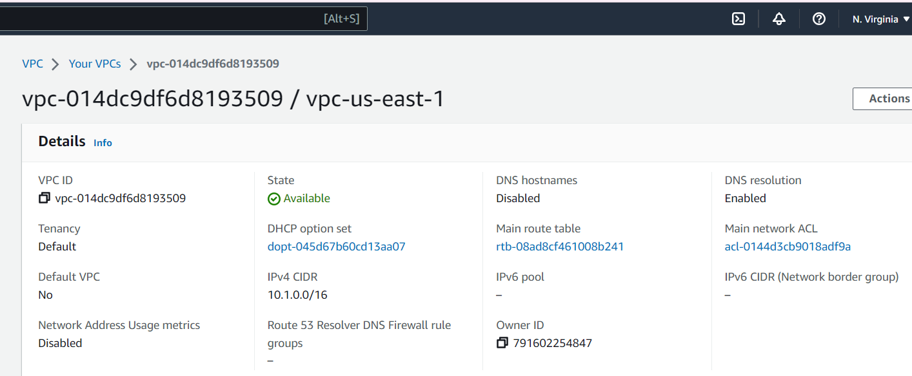

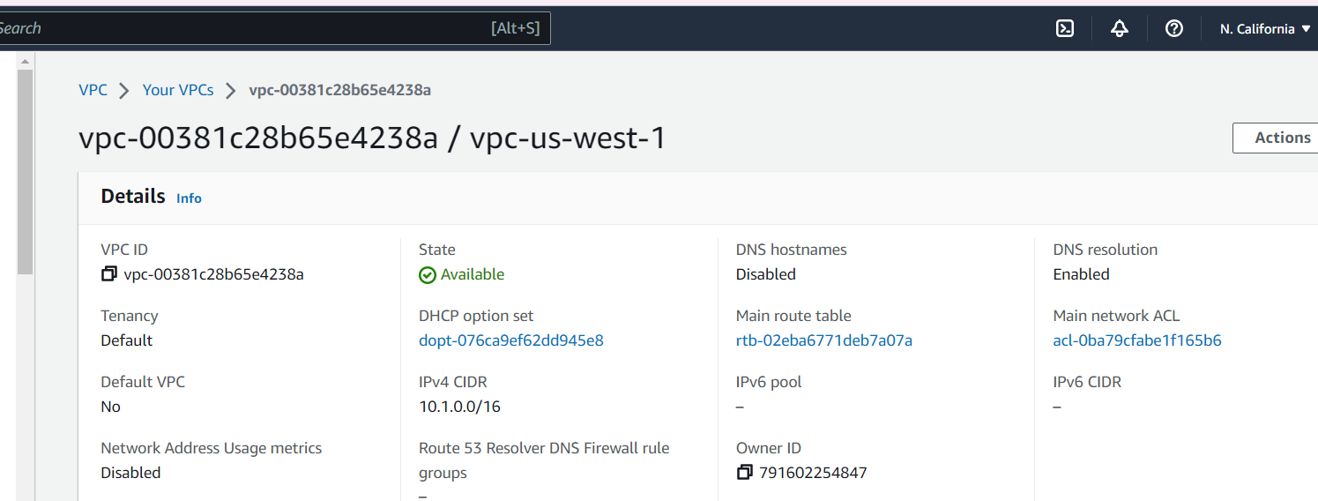

- Creating EC2 Server with Security groups:

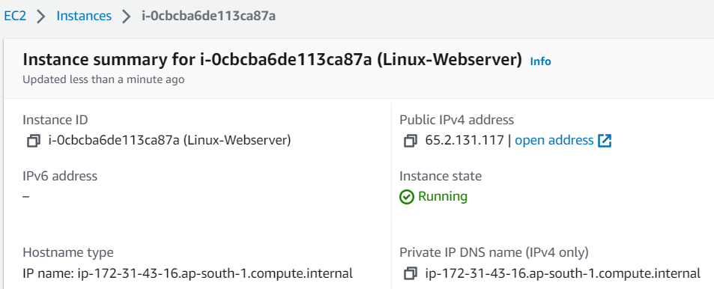
Security groups ssh and http :

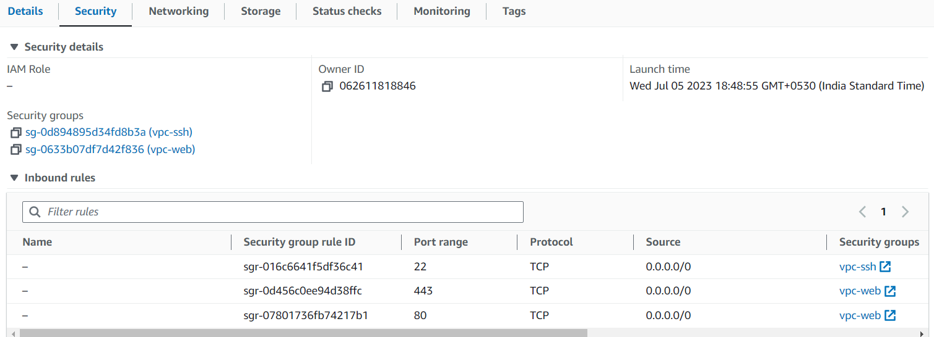

Configuring Static Webserver :

Output for Security groups and EC2 Public & Private IP :

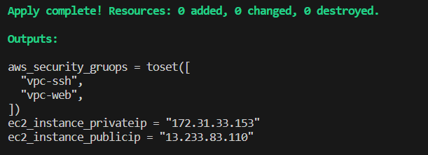

Variable

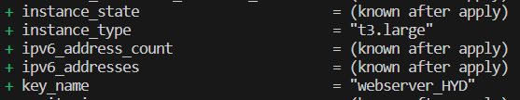

S3 - Backend

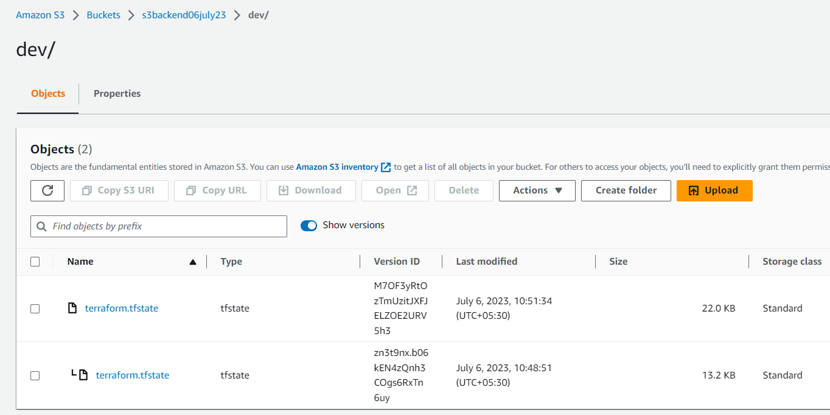

Workspace :

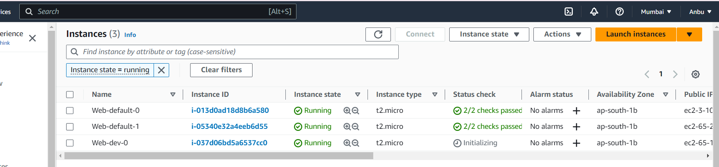

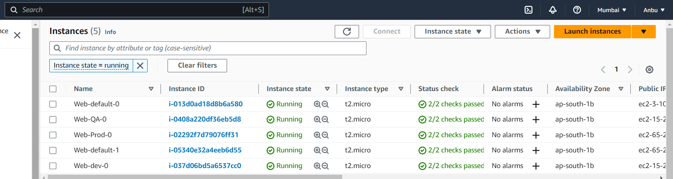

In Remote backend

