Serialization:
- Introduction
- Object graphs in serialization
- Customized serialization
- Serialization with Inheritance
- Externalization
- SerialVersionUID

- Introduction

What is serialization?
- Process of writing state of an object into a file is called serialization but strictly speaking, it is the process of converting an object from java supported form into either file supported form or network supported form.
- By using FileOutputStream and ObjectOutputStream classes, we can implement serialization.
- The serialized file extension can be anything like .ser, .abc.
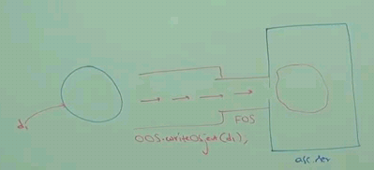

What is Deserialization?
- Process of reading state of an object from a file is called deserialization but strictly speaking, it is the process of converting an object from either file supported form or network supported form into java supported form.
- By using FileInputStream and ObjectInputStream classes, we can implement deserialization.
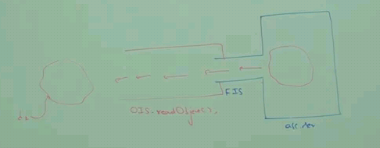

Example:
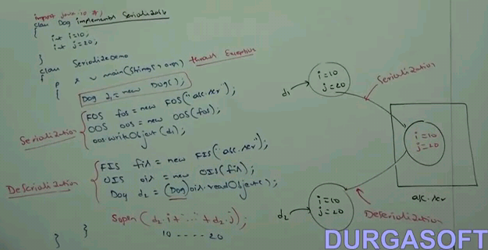

If above dog is not implemented Serializable interface, then the code compiles fine but at runtime while executing writeobject(), it throws RuntimeException which says NotSerializableException:Dog

Serializable interface:
- Serializable interface is a marker interface and it doesn’t contain any methods.
- If we are trying to serialize a non serializable object, then we will get runtime exception saying NotSerializableException

Transient keyword:
- It is applicable for variables only
- At the time of serialization, if we don’t want to save the value of particular variable to meet security constraints. Then we should declare that variable as transient.
- While performing serialization, the jvm ignores the original value of transient variable and save default value to the file. (for int default value is 0, string - null)

Transient vs static:
- Static variables won’t take participate in serialization cause it is not part of object state.
- Declaring static variables as transient is not use.

Transient vs final:
- Every final variable is replaced by the value directly at compile time itself.
Final int x=10;
Sop(x); -> at compile time itself it replaces like sop(10); at compile time, there is no variable needed for final type and it uses the value directly. There is no concept of final variable at compile time.
- Final variables will be participated in serialization directly by the value but not by variable because there is no concept of final variable at compile time.
- Declaring the final variable as transient, there is no impact.

Declarations and corresponding output:
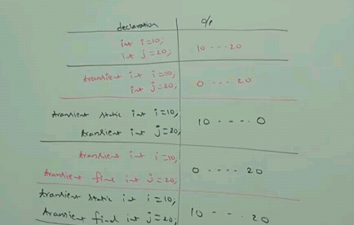

Serialization and DeSerialization Order:
- We can serialize any number of objects to the file but in which order we serialized, in the same order only we have to deserialize.
- Order of object is important in Serialization.

Example:
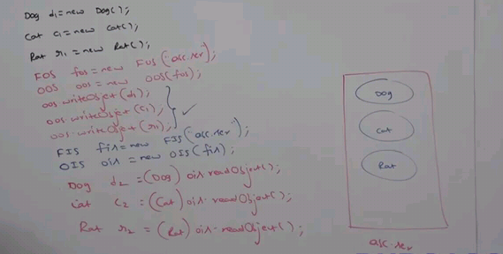

If we don’t know order of objects in serialization, then how to handle?.
Consider if x person is doing serialization and Y person is deserialization. The Y person need to know in order, the objects serialized so that in the same order, Y person can deserialize.

We can overcome this, by using Parent references to hold the objects.
- Parent references can be used to hold child objects.
- Child specific methods cannot be called using parent references.
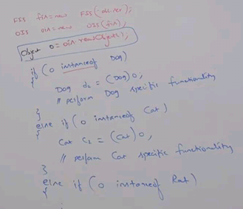

- Object graphs in serialization
- Whenever we are serialization an object, the set of all objects which are reachable from this object will be serialized automatically. This group of objects is called Object graph.
- In object graph, every object should be serializable. If atleast one object is not serializable, then we will get runtime exception saying NotSerializableException.

Example:
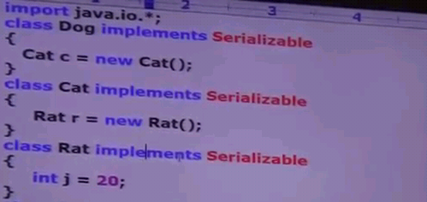
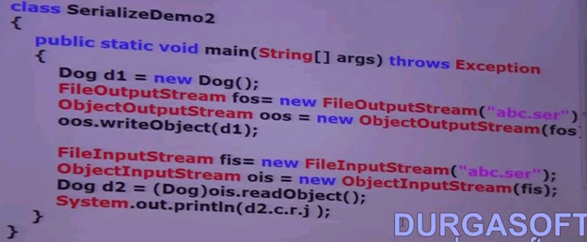

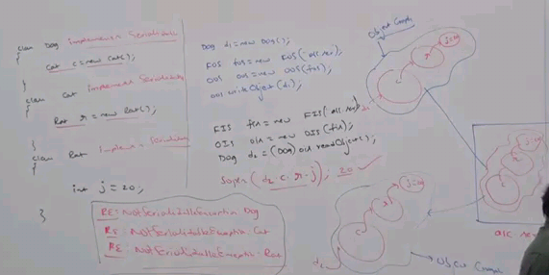

- Customized serialization
During default serialization, there may be a chance of loss of data due to transient. To recover the loss of information because of transient keyword, we can use customized serialization.

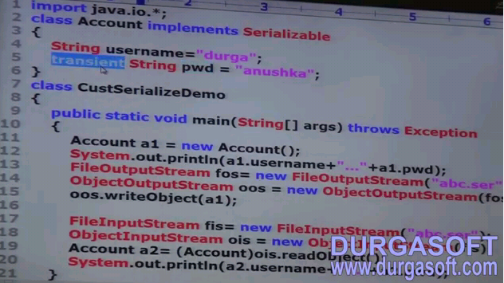



In above program, password information is loosed due to transient keyword.
In order to avoid loss of data, we can encrypt the above password and write to the file using customized serialization.

We can do customized serialization by using below two methods.

Private void writeObject(ObjectOutputStream ob) throws Exception
Private void readObject(ObjectinputStream ob) throws Exception

- Above methods are executed, automatically at the time of serialization and de serialization. At the time of serialization and de serialization, if we want to perform any activity, then we have to define that in these methods only.
- While performing which object serialization, we have to do extra work in the corresponding class we have to define above two methods.

Example:
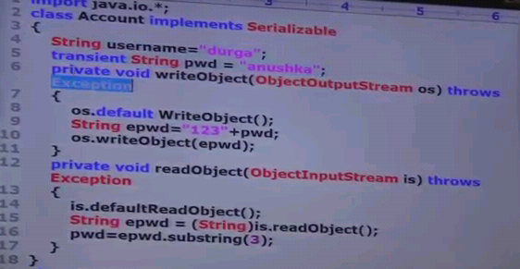
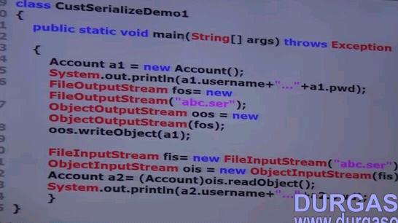

Example: if more than one transient variable is there, then how do we handle in customized serialization?
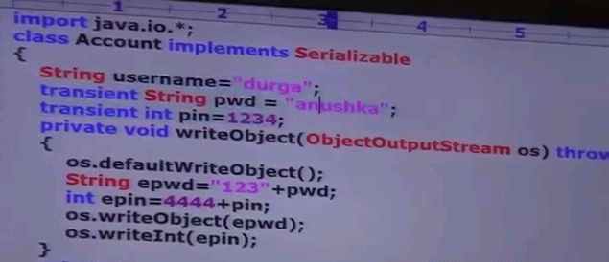
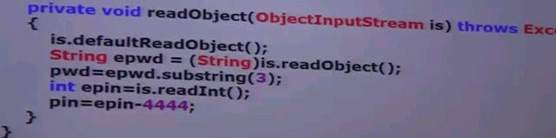
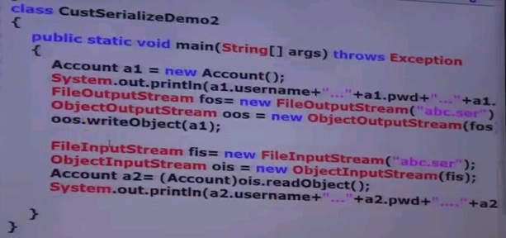

Case1: If we commented readObject and writeObject in above Account class, then o/p will be like below.

Case2: If we add both readObject and writeObject in Account class, then o/p will be like below,


- Serialization with Inheritance

Case1:

