**3.tv-show-adviser-cleaning-searchbar**

 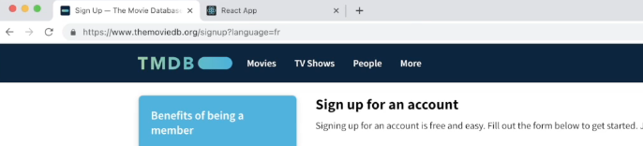

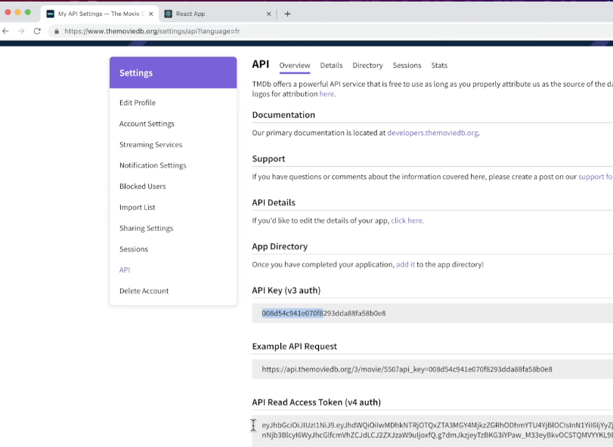

Project architecture

Bootstrap (optional)

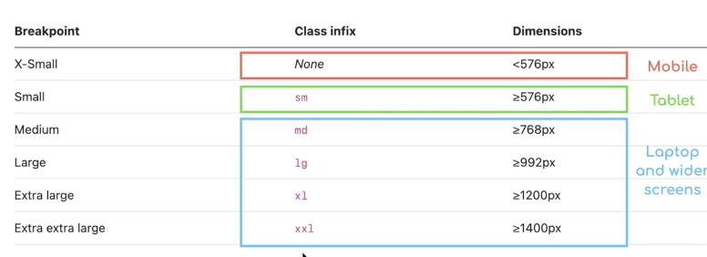

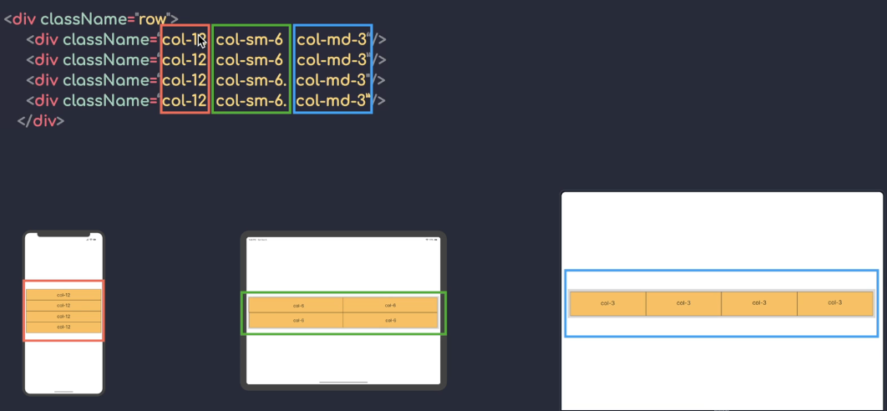

by default, it's the mobile that is targeted first when you don't specify a

keyword and then that you can specify a keyword for each screen resolution you want to target.

Layouting the app

the search bar should take the whole page when the size of the screen

is medium. Otherwise it's going to take the third of the remaining space if it's large.

 (optional) - Handling errors with Try, Catch, Finally and Throw

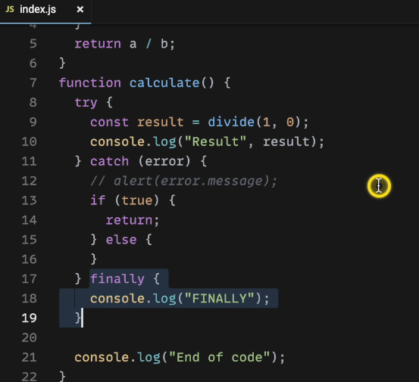 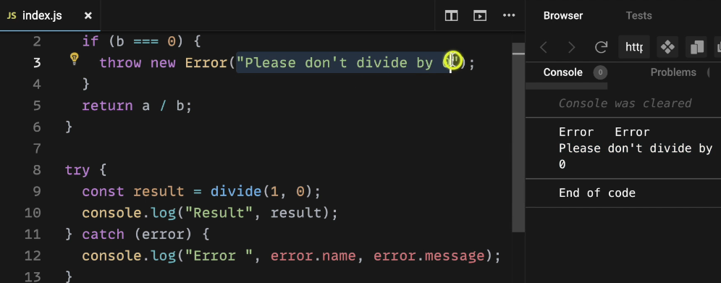

(optional) - ES6 Promises - Async/Await

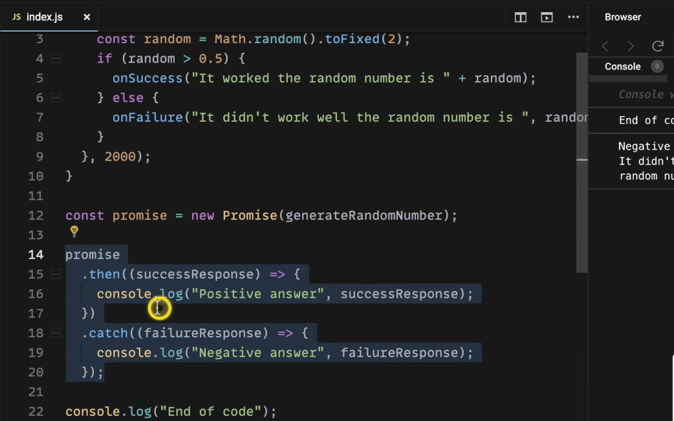

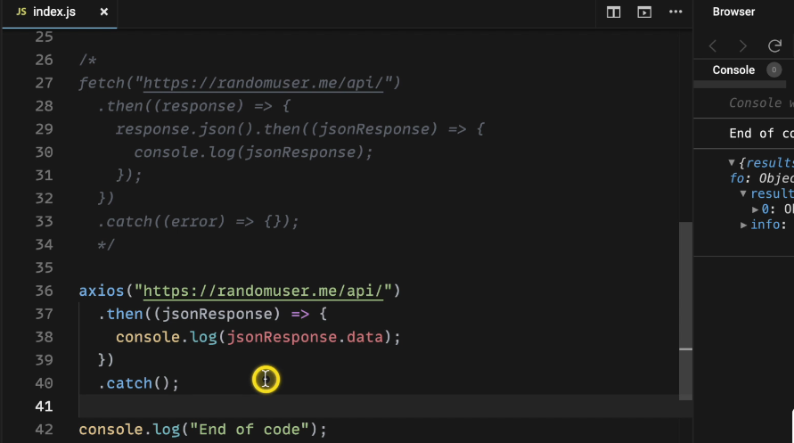

Synchronous calling

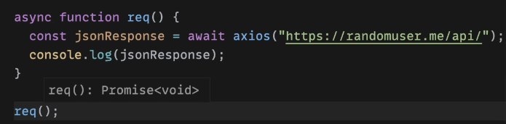

Data fetching - fetch popular shows

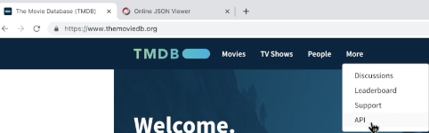



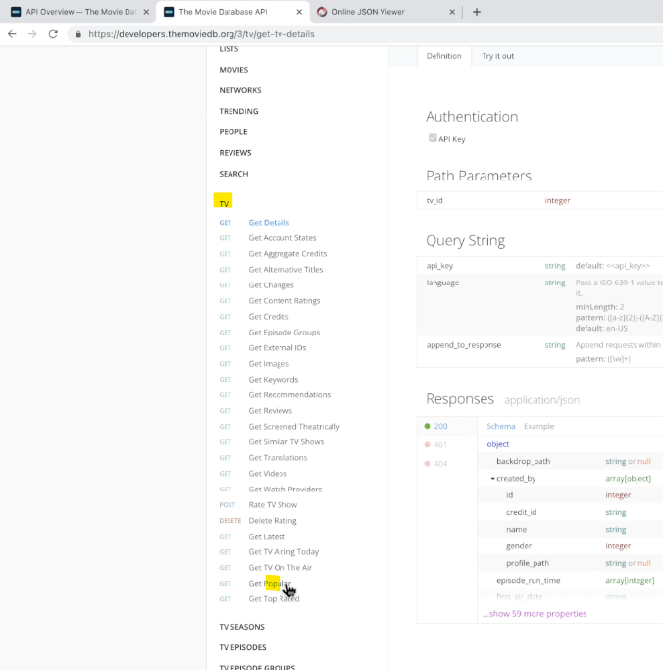

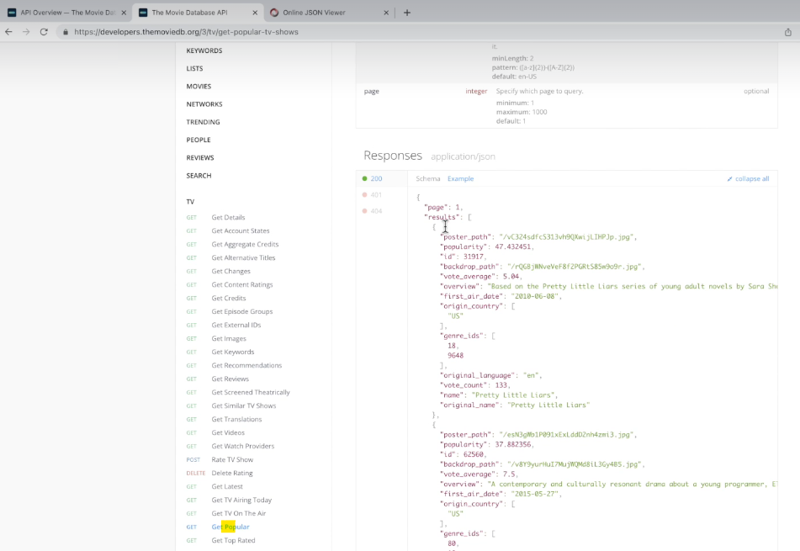

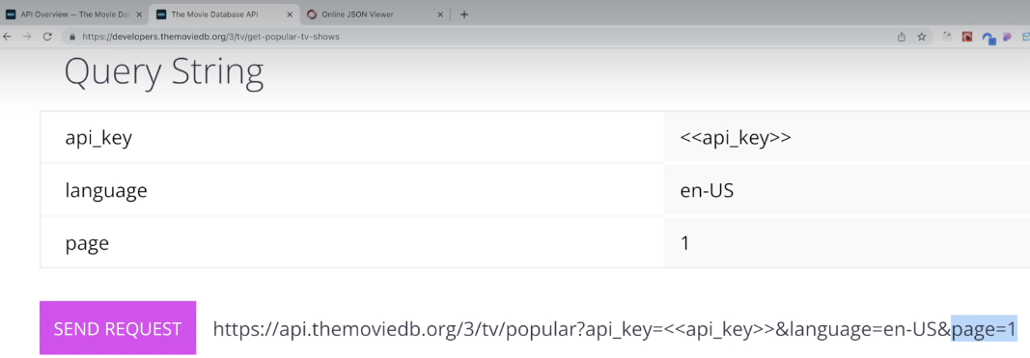

Hook - useEffect()

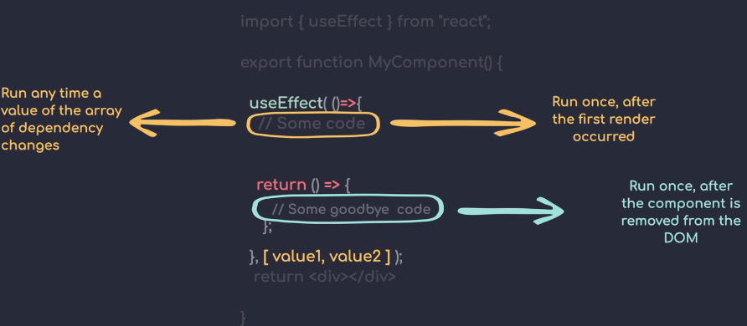

The app start, then you type one letter into the input and then you click once on the button "Update fruit"

How many time will "Hey" be displayed in the browser console ?

1. import { useEffect, useState } from "react";
3. export function App() {
5. const [color, setColor] = useState("red");
6. const [fruit, setFruit] = useState("Apple");
8. useEffect(() => {
9. console.log("Hey");
10. });
12. return (
13. <>
14. <input onChange={() => setColor("blue")} />
15. <button onClick={() => setFruit("Banana")}>Update fruit</button>
16. </>
17. );
18. }

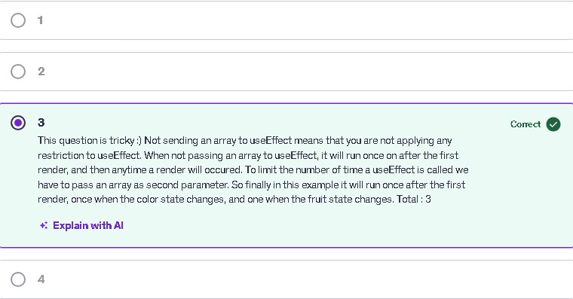

The user-selected answer "1" is incorrect because the **useEffect** hook in the code does not have a dependency array. When no array is provided, **useEffect** runs after every render. In this case, the console logs "Hey" once after the initial render, then logs again whenever the state changes—for instance, when the "color" is updated after typing in the input and when the "fruit" is updated by clicking the button. This results in more occurrences than just one. Keep in mind that **useEffect** reacts to all renders without dependency restrictions.

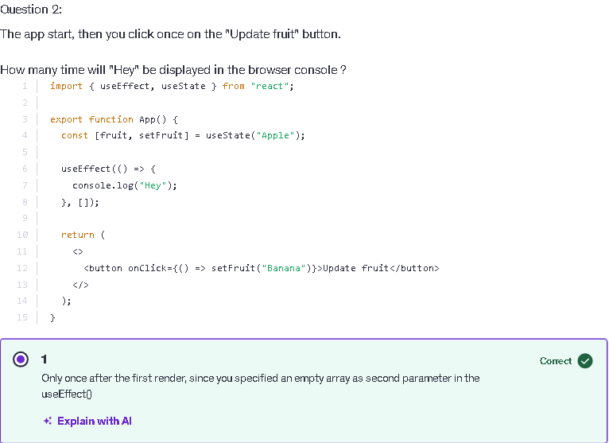

Top of Form

Question 3:

The app start, you click on the button once, and then type "GO" in the input.  
  
How many time will "Hey" be printed in the browser console ?

1. import { useEffect, useState } from "react";
3. export function App() {
4. const [fruit, setFruit] = useState("Apple");
5. const [color, setColor] = useState("red");
7. useEffect(() => {
8. console.log("Hey");
9. }, [fruit]);
11. return (
12. <>
13. <button onClick={() => setColor("blue")} >Change color </button>
14. <input onChange={() => setFruit("Banana")} />
15. </>
16. );
17. }

**2 Correct**

Only 2. Once after the first render (1) , and then any time the value of fruit is going to be updated.  When typing "G" the value will change from Apple to Banana ( 1 ). But then any other change in the input will set the fruit value to “Banana" again, so there will be no other update.  Also when clicking on the button you change the color, but the useEffect is not listening to color, so it

 useEffect cleanup function

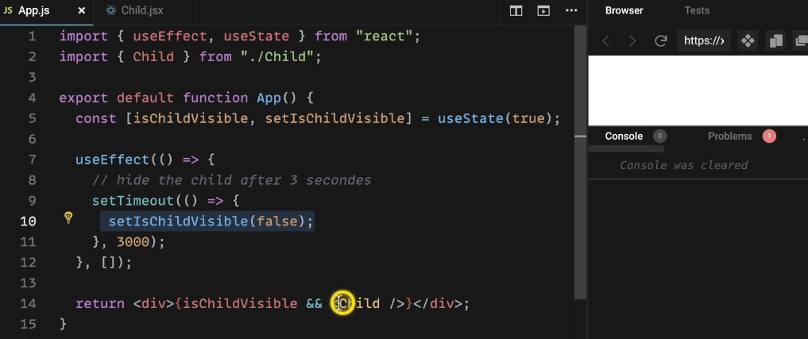

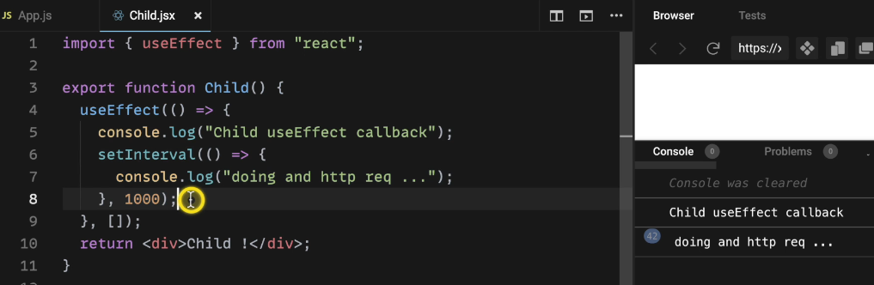

change count here anytime I change it cleanup is called

first so the previous cleanup and then the current use effect

is going to run

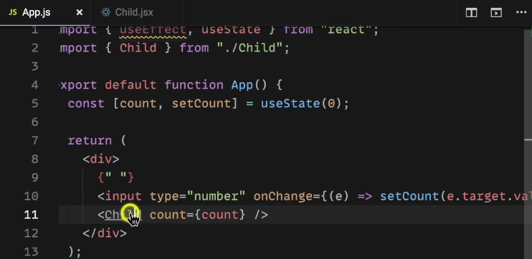

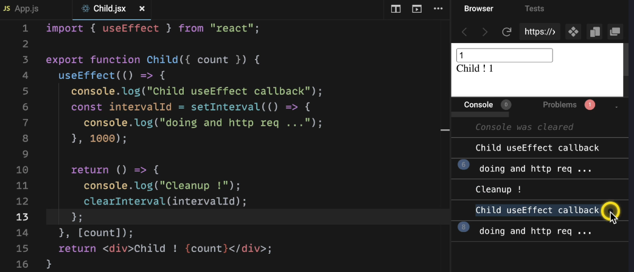

Rating component

