Deadlock:
- If two threads are waiting for each other forever. Such type of infinite waiting is called deadlock. First thread waiting for second thread and vice versa forever.
- First thread is waiting for the lock holding by second thread and second thread waiting for the lock holding by first thread. So both threads waits forever - deadlock
Synchronized keyword is the only reason for deadlock situation. Hence while using synchronized keyword, we have to take special care to prevent deadlock. There are no resolution techniques for deadlock but several preventions techniques are available.
Example: How synchronized keyword cause deadlock?
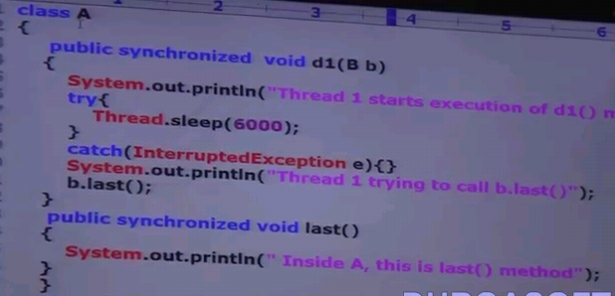
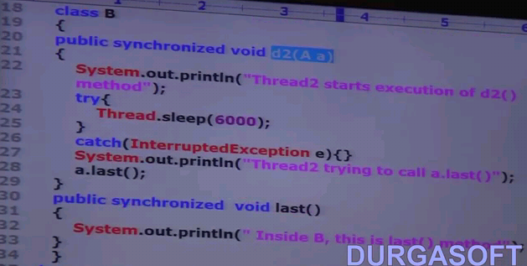
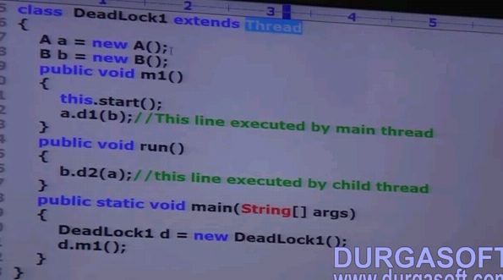
Case1: if we remove synchronized keyword in d1(),d2() and both last(), then we get below output.
Case2: if we synchronized keyword from atleast both last(), then also we get below output.
Case3: if d1(), d2() and also both last() methods are synchronized, then it will go to dead lock situation.
O/P for case1 & case2:
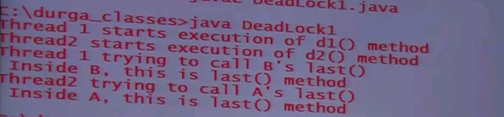
O/p for case3 – deadlock state:
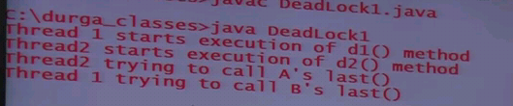
Case Study of above program:
Here main thread acquire the A’s object lock and execute d1(). In mean while, child thread acquire the B’s object lock and execute d2(). In d1(), the main thread has to call last() of B’s object but B’s object is already acquired by child thread, so main thread entered into waiting state to get the lock of B’object. Similiarly, in d2() the child has to call last() of A’s object but which is already acquired by main thread, child thread entered into waiting state to get the lock of A’s object.
Both threads are in waiting state to get the lock of A and B’s object which wont happen cause those locks are already acquired by them. So this will entered into deadlock which means both threads has to be in waiting state infinitely and both locks has been never released.
If we remove atleast one synchronized keyword, then the program won’t entered into deadlock state. Hence synchronized keyword is the only reason for deadlock situation. So while using synchronized keyword, we have to take special care.
Deadlock Vs Starvation
Both are related but minor differences.
- Long waiting of a thread where waiting never ends – deadlock
- Long waiting of a thread but waiting ends at certain point - starvation
Example: Low priority thread have to wait for long time to acquire the lock until all the high priority threads (consider some 100 or more threads) complete or release the lock). But waiting of low priority thread ends at some point which is nothing but starvation.

