Streams
- Streams are related to Collection
- Java.util.streams are used to process the Collection objects.
How to use streams:
Example to filter even nos using streams - filter
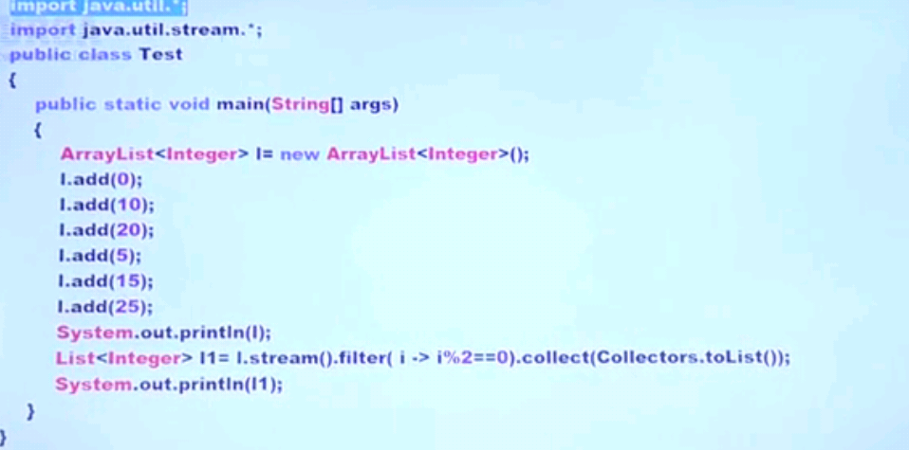
Example to double the values of List elements using map:
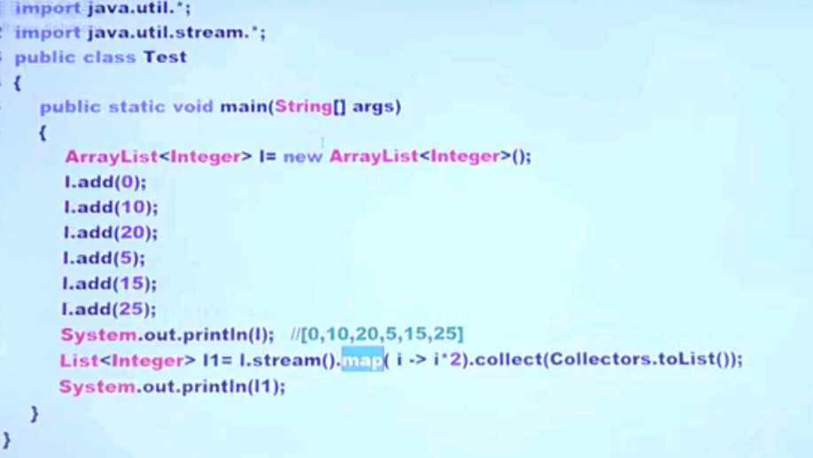

Stream:
It is an interface present in java.util.streams.
How to create Stream:
Stream s =collectionObject.streams();
streams() is default method present in Collection interface.
Once we got stream object like above, we can process the Collection elements.
Processing the Collection elements involve two stages:
- Configuration
  - Filter Mechanism
  - Map Mechanism
- Processing

Filter:
- Filter elements in a collection based on a Boolean condition using filter mechanism.
- Filter works based on predicate interface
Ex: filter only even nos
Map:
- For every elements in a collection, generate a new object based on a function using map mechanism.
- Map works based on Function interface
Ex: For every elements, double the values. Apply doubling function to each elements in collection.

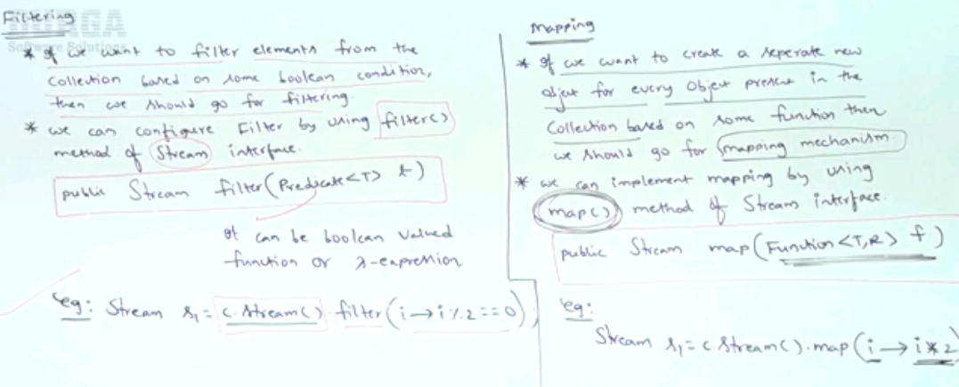

Processing:
Process by collect method:
- This method collects the elements from the stream and add it to the specified Collection.
After configuring the stream by either filter or map, process the elements from the stream and add it to a specified collection.

Example: filter the collection elements whose names are greater than 9 chars.
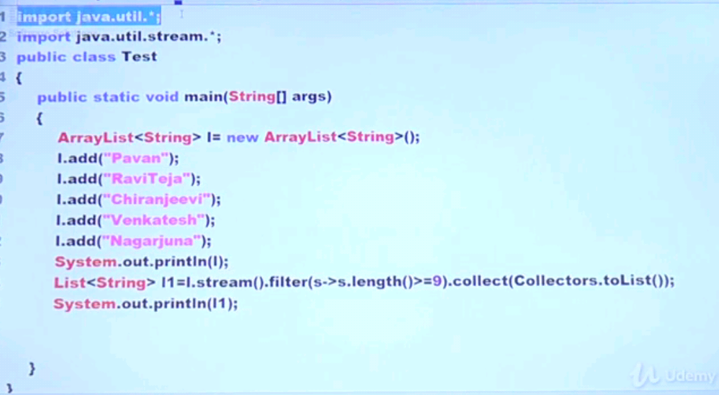
Example to convert the elements names to uppercase.
Processing by count method:
- This method returns the no of elements present in a stream.
Public long count(); -> present in stream interface
Example:

Processing by sorted method:
- We can use sorted method to sort elements present in stream
- We cann sort either based on default sorting order or based on our own customized sorting by Comparator object.
- There are 2 sorted methods present in stream
  - Sorted() -> default natural sorting order
  - Sorted(Comparator c) -> customized sorting order
Example to sort collection based on natural sorting order
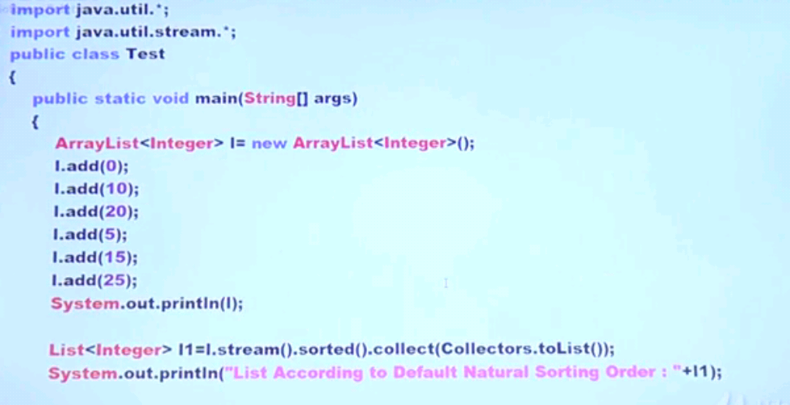
Example to sort based on customized sorting order:
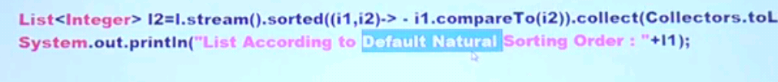
Example to get Min/Max value:
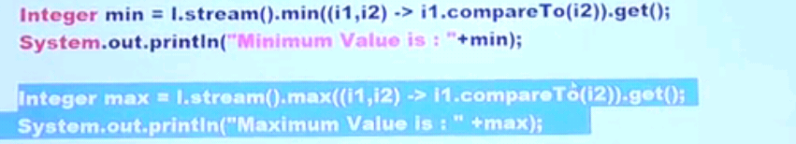

Example – forEach
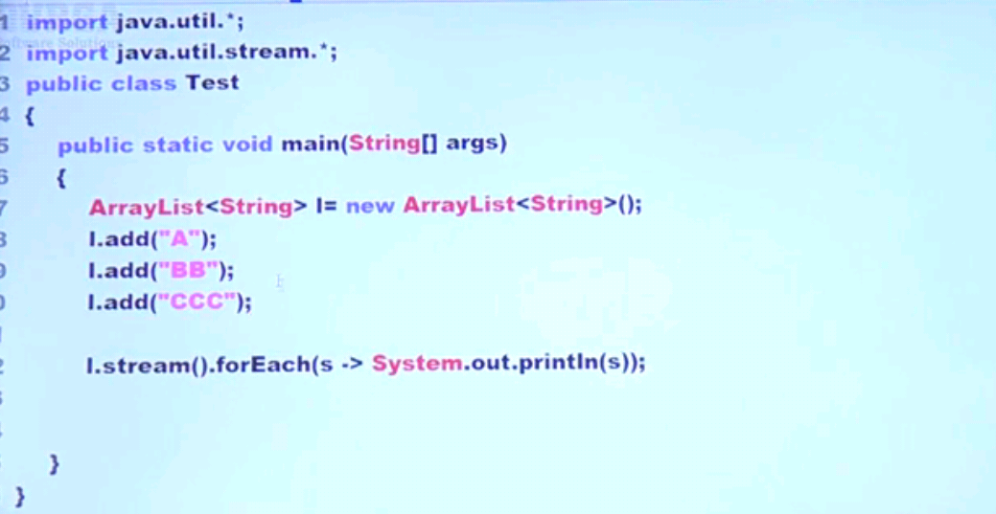

Example – forEach with method reference operator

Processing by toArray method:
We can use toArray method to copy elements present in the stream into specified array.
Example:
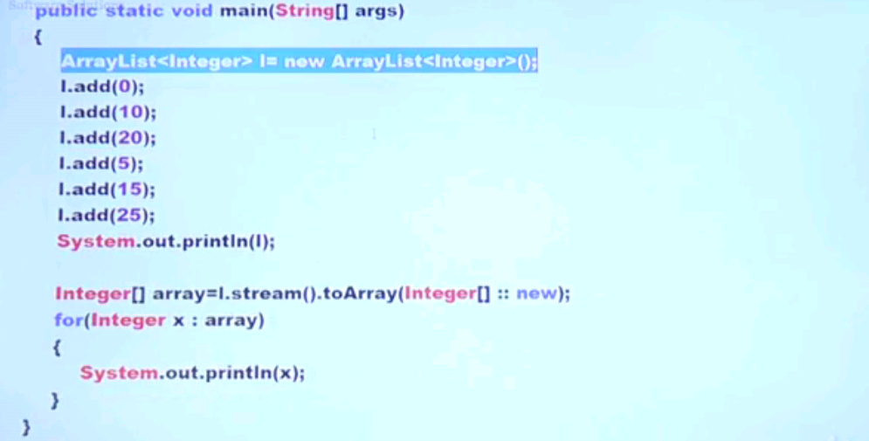

We can process the stream using below
- Collect()
- count()
- sorted()
- min / max()
- forEach()
- toArray()

Stream of() method:
We can also apply streams for group of values and for arrays. For that, streams provide a factory method called of method.
- For group of values
Stream<Integer> s= Stream.of(9.99,999,9999);

Example:
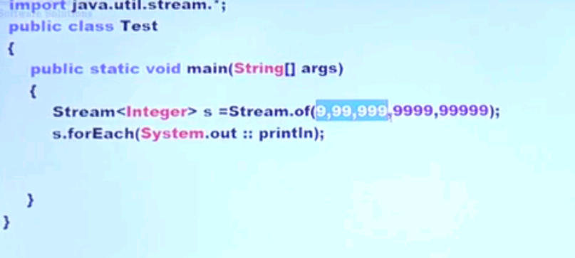
- For arrays
