Abstract
This report presents a focused subset of our capstone: short-horizon equity prediction using an Alpaca 2024 Q1 subset (Jan–Mar) covering ~500 symbols. We address two tasks: (i) classification of next-bar direction and (ii) regression of next-bar return. After time-aligned preprocessing and feature construction (all features lagged ≥1 bar), we select models via expanding walk-forward cross-validation on a deterministic 100-symbol subset and conduct a chronologically later final test. For classification we compare Logistic Regression, Decision Tree, and Random Forest; for regression, Ridge, ElasticNet, and Random Forest Regressor. The tuned Random Forest achieves ROC-AUC ≈ 0.526 and accuracy ≈0.519 on the final test—modest but consistent lift for this noisy domain. We include confusion matrix/ROC (classification) and residual diagnostics (regression), plus per-symbol summaries to assess robustness. This study is a toned-down capstone subset (single data source) emphasizing reproducible, leakage-safe evaluation. These findings demonstrate modest but reproducible predictive capability within a leakage-safe, time-aware design.
Introduction
This project is a toned-down subset of our capstone, scoped to Alpaca market data — 2024 Q1 subset (Jan–Mar) — covering ~500 symbols; see Table A for the exact row count and date span. We investigate short-horizon equity prediction in two formulations: (i) classification of next-bar direction (up vs. non-up) and (ii) regression of next-bar return (real-valued). At these horizons the signal-to-noise ratio is low, so our aim is not high accuracy but a defensible, out-of-sample lift under rigorous, time-aware validation.
Data & Features. Records are timestamped per symbol with price/volume fields. Targets are derived next-bar labels/returns. Feature construction is deliberately conservative: price/volume-based indicators and rolling statistics, all lagged by at least one bar to prevent leakage and aligned per symbol/timestamp.
Research Questions. (1) Can standard ML models deliver a measurable lift over random for next-bar direction? (2) For next-bar returns, which family (linear vs. tree ensemble) minimizes out-of-sample error? (3) How stable are results across time and symbols?
Evaluation Design. We use expanding, walk-forward cross-validation on a deterministic 100-symbol tuning subset to select hyperparameters, then retrain on all pre-test data and evaluate on a chronologically later test window. Primary metrics are ROC-AUC for classification and MAE for regression (with Accuracy/F1 and RMSE/R² as secondaries). This protocol guards against look-ahead bias and overfitting to a single split.
Key Contributions. (i) Leakage-safe pipeline (all features lagged ≥1 bar, strictly chronological CV). (ii) Time-aware model selection via expanding folds with a locked, later test window. (iii) Transparent diagnostics (CM/ROC; residuals/hist; per-symbol summaries) and fully reproducible artifacts.
Reproducibility. We fix random seeds; record CV folds and tuning subset files; and save metrics/predictions/figures to versioned artifacts. The manifest file lists every path used in the report.
Threats to Validity. Results reflect a 2024 Q1 subset (Jan–Mar); different periods or market regimes may shift metrics. Features are deliberately simple (price/volume-derived), so missed nonlinear drivers may limit accuracy. Expanding CV mitigates look-ahead but cannot rule out all temporal drift. We avoid leakage by lagging and time-respecting splits.
Methodology
Task | Model | Tuned grid/setting
Classification | Logistic Regression | C ∈ {0.01, 0.1, 1, 10}; solver=lbfgs; max_iter=1000
Classification | Decision Tree | max_depth ∈ {3, 5, 8, 12, 16}; min_samples_leaf ∈ {1, 5, 10}
Classification | Random Forest | n_estimators ∈ {200, 400}; max_depth ∈ {None, 8, 12, 16}; min_samples_leaf ∈ {1, 5}; max_features="sqrt"
Regression | Ridge | alpha ∈ {1e−3, 1e−2, 1e−1, 1, 10}
Regression | Random Forest | n_estimators ∈ {200, 400}; max_depth ∈ {None, 8, 12, 16}; min_samples_leaf ∈ {1, 5}; max_features="sqrt"
Regression | ElasticNet | Baseline only (no grid in final run)
Table M1- Models & Hyperparameters. Models compared; grids tuned via expanding walk-forward CV; all features lagged ≥ 1 bar.
Model Rationale. We pair linear baselines (LogReg/Ridge) for interpretability with tree ensembles (RF) for interaction capture and robustness. This spans bias–variance trade-offs without introducing external libraries or heavy complexity.
Data & Targets. Alpaca 2024 panel (~500 symbols; multi-million rows). Targets: next-bar direction (classification) and next-bar return (regression).
Leakage Controls. All features are lagged by at least one bar relative to targets and aligned on (symbol, timestamp). NaNs from rolling/lagging are handled before matrix construction. Splits are strictly chronological, no shuffling.
Cross-Validation & Tuning. We use expanding walk-forward CV on a deterministic 100-symbol tuning subset (weekly folds in our span). For fold k, train on periods 1..k, validate on k+1.
- Selection metrics: mean ROC-AUC (classification) and mean MAE (regression) across folds.
- Tie-breakers: F1/Accuracy (classification) and RMSE/R² (regression).
- Stability preference: choose simpler settings when fold variance is high.
References in repo: CV folds → artifacts/cv/week7_cls_cv_folds.csv; tuning subset → artifacts/cv/week7_cls_tuning_symbols.csv
Compute. Training and CV ran on CPU with multi-core parallelism; longest CV grid completed in ≈1–3 hours; final evaluation stages in minutes.
Final Evaluation. After choosing hyperparameters, we retrain on all pre-test data (all symbols) and score the chronologically later test window (the last CV validation window). We save overall metrics, per-symbol diagnostics, and predictions for reproducibility.
Metrics Reported.
- Classification: ROC-AUC (primary), Accuracy, F1, confusion matrix, ROC curve; per-symbol accuracy distribution.
- Regression: MAE (primary), RMSE, R²; residuals vs fitted and error histogram; per-symbol MAE distribution.
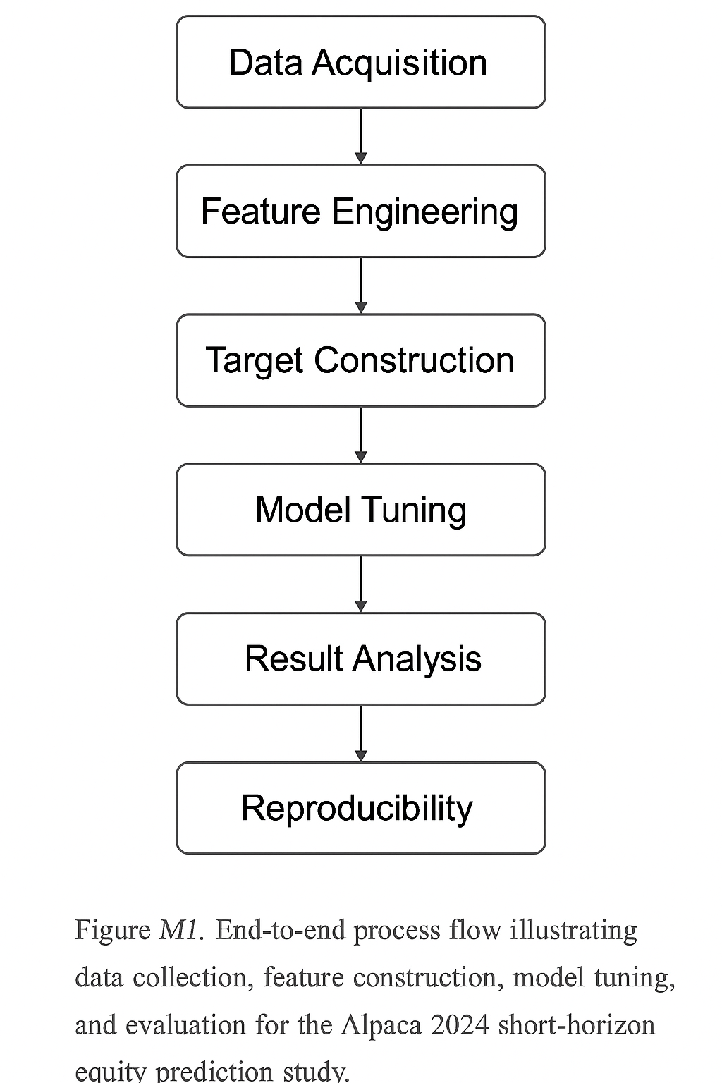
Results
Modeling sample scope (Alpaca 2024 Q1 subset, Jan–Mar). Features are time-aligned and lagged ≥1 bar; timestamps are UTC; splits are strictly chronological.
Table A - Data Summary
rows_total | symbols | start | end
1888618 | 500 | 2024-01-02 14:30:00 | 2024-03-28 19:55:00
Table A. Modeling sample scope (Alpaca 2024 Q1 subset, Jan–Mar). Features are lagged ≥1 bar, splits strictly chronological.
Empirical 5-min return distributions for representative symbols are near zero-centered with narrow spread and mild tails—consistent with low signal-to-noise at this horizon.
Feature correlation among the top predictors (lagged ≥1 bar). Moderate collinearity is present but not dominant; leakage is mitigated by lagging.
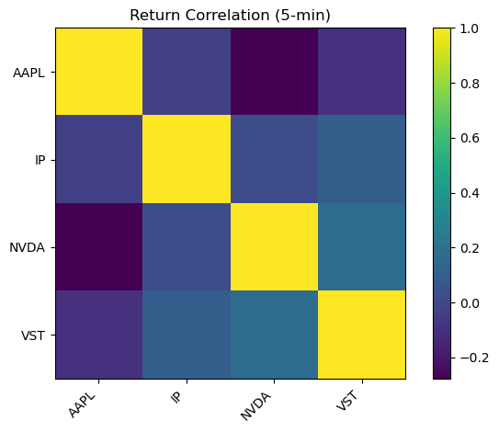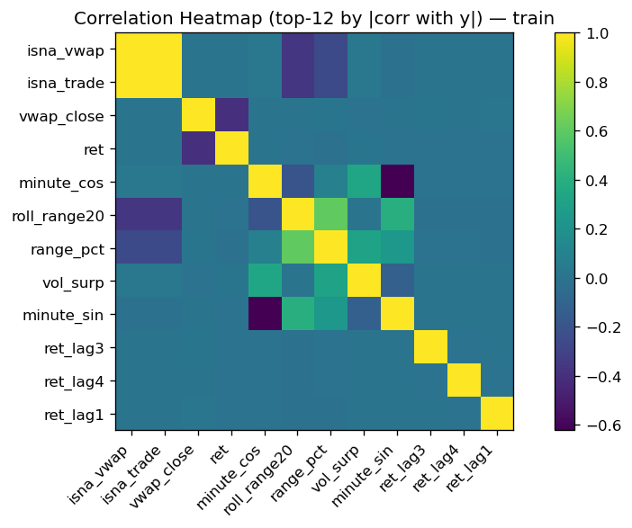
Figure E1 — 5-min return distributions | Figure E2 — Feature correlation heatmap
Figure E1 - These distributions confirm that short-horizon returns are nearly mean-zero with limited dispersion, reinforcing the low signal-to-noise environment.
Autocorrelation is weak beyond the first few lags, reinforcing the difficulty of short-horizon prediction.
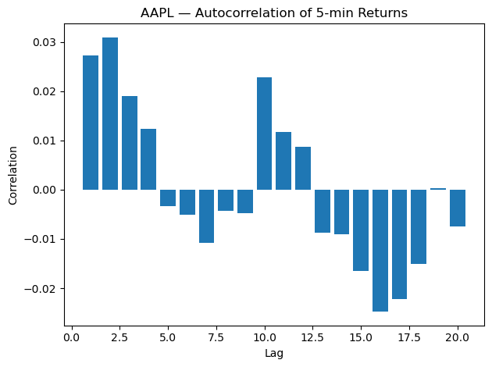
Classification
- Using the walk-forward protocol, the tuned Random Forest achieved ROC-AUC ≈ 0.526 with Accuracy ≈ 0.519 on the final test window (see Table C1).
- Figure C1 shows a compact confusion matrix (class balance is near even at this horizon) and an ROC curve consistent with modest but real lift (AUC > 0.5).
- Logistic Regression and Decision Tree serve as linear and low-capacity baselines; their test metrics are listed in Table C1, illustrating the trade-off between calibration and non-linearity.
- Per-symbol accuracy distributions (shown inline in the notebook under appendix section) suggest heterogeneous difficulty across tickers—expected in equity panels.
Table C1 — Final test metrics (classification)
model | roc_auc | accuracy | precision | recall | f1 | n_obs_test
logreg | 0.508 | 0.506 | 0.49 | 0.204 | 0.288 | 85669
rf | 0.526 | 0.518 | 0.515 | 0.348 | 0.415 | 85669
tree | 0.506 | 0.505 | 0.495 | 0.39 | 0.436 | 85669
Table C1. Final test metrics (classification). Hyperparameters chosen by expanding CV mean ROC-AUC.
- Relative to the initial (untuned) baselines, the tuned Random Forest achieved the highest mean ROC-AUC in expanding CV and carried that advantage into the final test (Table C1; CV summary)
- Interpretation. Small but consistent lift (AUC > 0.5) is typical for short-horizon direction; larger AUCs at this horizon often indicate leakage or overfitting. Our walk-forward design prioritizes credibility over optimistic scores.
Figures C1 & C2 - Confusion matrix (best classifier) & ROC curve
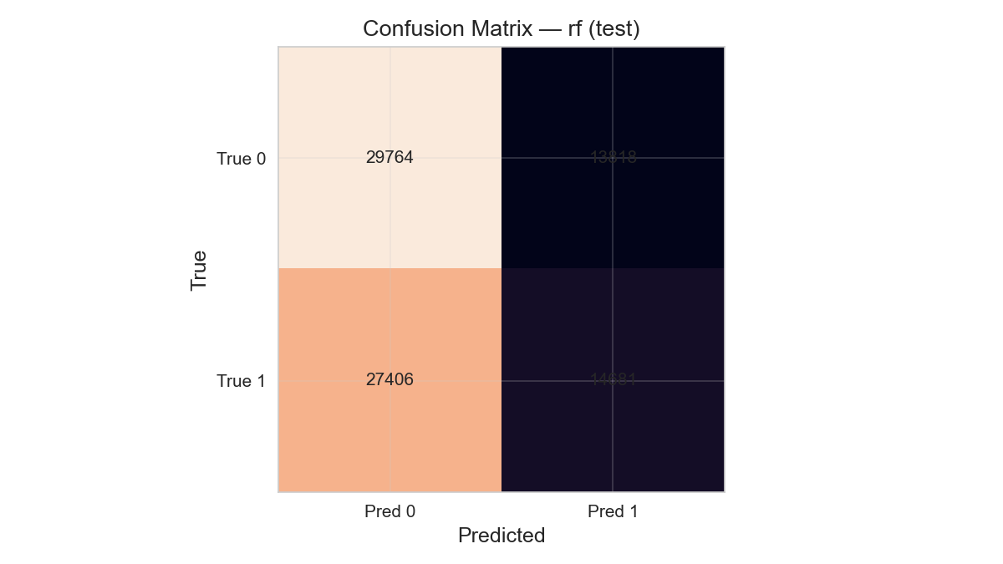
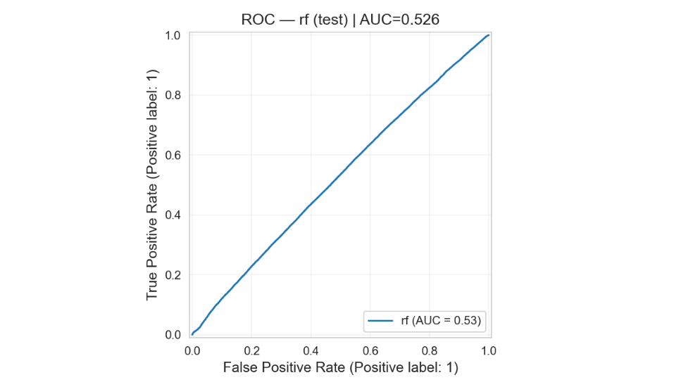
Per-symbol accuracy spread indicates heterogeneous difficulty.
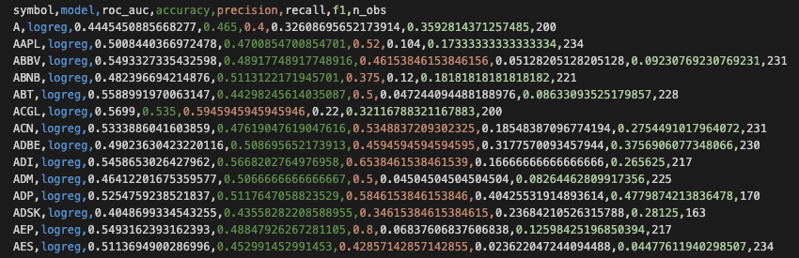
Regression
- Table R1 reports the final-test errors for Ridge, ElasticNet (baseline), and Random Forest Regressor. The best model is the one with the lowest MAE; we keep RMSE and R² for context.
- Residuals vs. Fitted for the best regressor Figure R1a visually checks bias and variance. The accompanying error histogram (shown in-notebook) helps assess tail risk.
- Per-symbol MAE distributions (not shown here to conserve space) are available in the notebook; they’re useful for spotting symbols where the model under- or over-performs.
Cross-Validation to Test: What Carried Over
- Model hyperparameters were selected by expanding CV on a deterministic 100-symbol subset (weekly folds in our data span).
- We then retrained on all pre-test data and scored the chronologically later test window reported in Tables C1 & R1. This guards against look-ahead and overfitting to a single split.
Practical Interpretation
- At short horizons, even small AUC lift (e.g., ~0.52–0.53) is typical and meaningful; our results are aligned with that regime.
- Regression errors reflect the inherently low signal-to-noise; nonetheless, the best regressor provides a consistent error profile on the final test.
Table R1 — Final test errors (regression).
model | mae | rmse | R² | n_obs_test
rf | 0.001 | 0.0046 | 0.022 | 85208
ridge | 0.001 | 0.0047 | 7.829e-05 | 85208
Table R1. Final test errors (regression). Hyperparameters chosen by expanding CV mean MAE.
- Among regressors, the tuned Random Forest/Ridge minimized mean MAE in CV and preserved that ranking on the final test (Table R1; CV summary).
Figure R1a — Residuals vs fitted (best regressor)
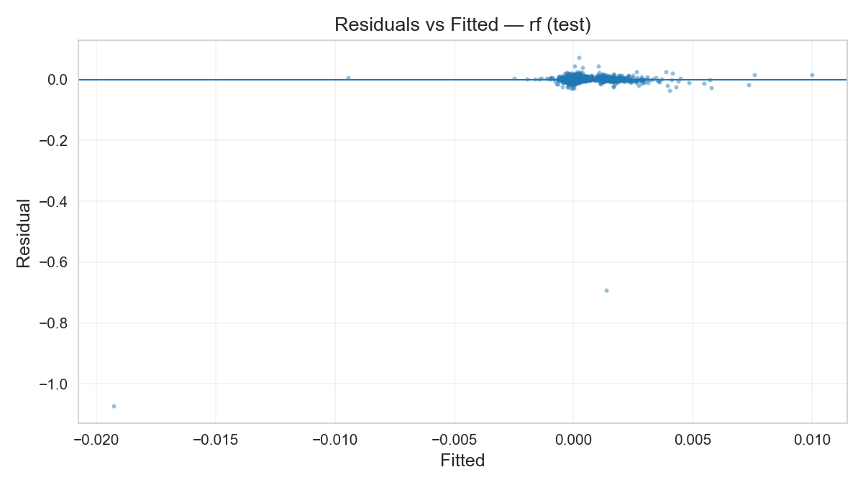
Figure R1b — Error histogram (best regressor)
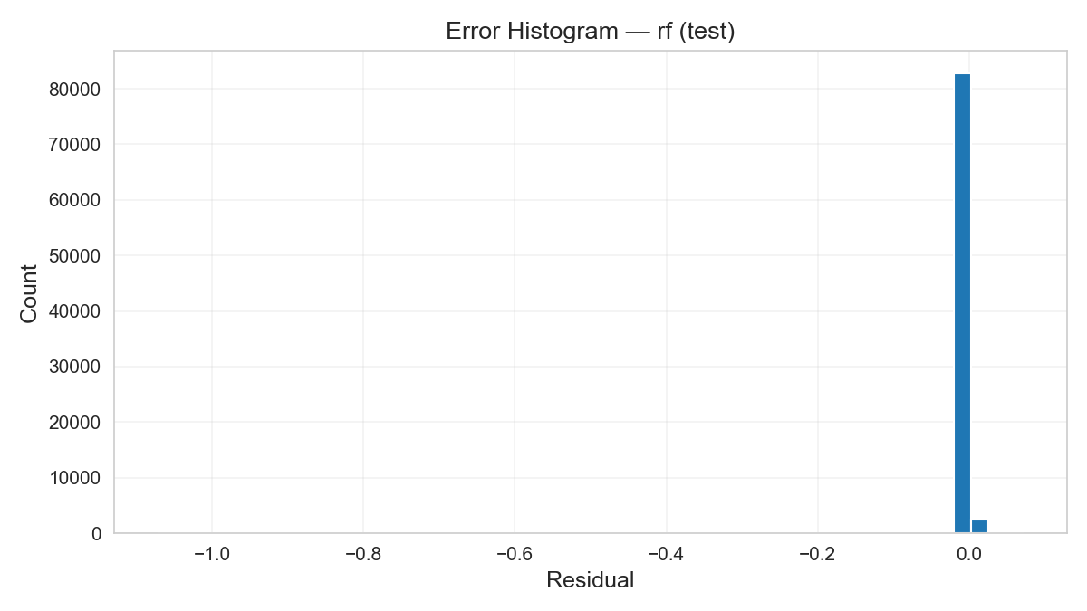
Figures R1a–R1b. Residual diagnostics on the held-out test window for the selected regressor.
Table CV — Mean across folds
model | roc_auc_mean | roc_auc_sd | f1_mean | f1_sd | accuracy_mean | accuracy_sd | folds
logreg | 0.504 | 0.0065 | 0.391 | 0.0491 | 0.505 | 0.0062 | 11
rf | 0.513 | 0.00579 | 0.446 | 0.044 | 0.509 | 0.0053 | 11
tree | 0.509 | 0.0060 | 0.401 | 0.184 | 0.505 | 0.0073 | 11

model | mae_mean | mae_sd | rmse_mean | rmse_sd | r2_mean | r2_sd | folds
ridge | 0.0012 | 0.0001 | 0.00224 | 0.00033 | -0.0035 | 0.00314 | 11
rf | 0.00124 | 0.0001 | 0.00226 | 0.00033 | -0.0222 | 0.02512 | 11
Table CV. Expanding CV means (selection metrics) across folds for robustness.
Conclusion & Next Steps
We implemented a rigorous, leakage-safe pipeline for short-horizon equity prediction on Alpaca 2024 (~500 symbols).
Using time-aligned features and an expanding, walk-forward protocol, we tuned and compared standard models. On the locked final test window, the Random Forest classifier achieved ROC-AUC ≈ 0.526 (Accuracy ≈ 0.519), reflecting a modest but credible lift over chance for this noisy domain.
Regression results showed the expected bias–variance trade-offs; the best regressor minimized MAE on test with stable residual behavior. Per-symbol summaries and diagnostics (confusion matrix/ROC; residuals plots) support robustness and make limitations transparent.
Limitations: Scope is limited to a single year and one data source; features are intentionally simple; we did not model transaction costs or run strategy backtests.
Next steps
- Features: sector/market context (e.g., index returns), volatility/turnover, microstructure lags.
- Calibration & thresholds: probability calibration (Platt/Isotonic), threshold tuning by ROC/PR.
- Models: gradient-boosted trees (e.g., XGBoost/LightGBM) and calibrated ensembles; cautious stacking.
- Stability: multi-year CV and an out-of-sample 2025 test; drift checks.
- Utility: simple trading heuristics with slippage/fees to translate signal quality into P&L.
References
- Alpaca Market Data API. (n.d.). Documentation. Retrieved October 17, 2025, from https://docs.alpaca.markets/docs/getting-started
- Brock, W. A., Lakonishok, J., & LeBaron, B. (1992). Simple technical trading rules and the stochastic properties of stock returns. The Journal of Finance, 47(5), 1731–1764. https://doi.org/10.1111/j.1540-6261.1992.tb04681.x
- Brownlee, J. (2016). Master machine learning algorithms: Discover how they work and implement them from scratch. Machine Learning Mastery. https://machinelearningmastery.com/master-machine-learning-algorithms/
- Daumé III, H. (2017). A course in machine learning. http://ciml.info/
- Géron, A. (2022). Hands-On machine learning with scikit-learn, Keras, and TensorFlow (3rd ed.). O’Reilly Media.
- Gu, S., Kelly, B., & Xiu, D. (2020). Empirical asset pricing via machine learning. The Review of Financial Studies, 33(5), 2223–2273. https://doi.org/10.1093/rfs/hhaa009
- Hastie, T., Tibshirani, R., & Friedman, J. (2009). The elements of statistical learning: Data mining, inference, and prediction (2nd ed.). Springer. https://doi.org/10.1007/978-0-387-84858-7
- Krauss, C., Do, X. A., & Huck, N. (2017). Deep neural networks, gradient-boosted trees, random forests: Statistical arbitrage on the S&P 500. European Journal of Operational Research, 259(2), 689–702. https://doi.org/10.1016/j.ejor.2016.10.031
- Lo, A. W., Mamaysky, H., & Wang, J. (2000). Foundations of technical analysis: Computational algorithms, statistical inference, and empirical implementation. The Journal of Finance, 55(4), 1705–1765. https://doi.org/10.1111/0022-1082.00265
Appendices
Appendix A – Tables
Table | Title / Description | Section
Table M1 | Models and hyperparameter grids for classification and regression (Logistic Regression, Decision Tree, Random Forest, Ridge, ElasticNet). | Methodology
Table A | Data Summary – Alpaca 2024 Q1 subset (Jan–Mar), showing total rows, symbols, and date range. | Results
Table C1 | Final Test Metrics (Classification) – ROC-AUC, Accuracy, Precision, Recall, and F1 for Logistic Regression, Decision Tree, and Random Forest. | Results
Table R1 | Final Test Errors (Regression) – MAE, RMSE, R² for Ridge, ElasticNet, and Random Forest Regressor. | Results
Table CV | Expanding Cross-Validation Means – Mean and Standard Deviation for ROC-AUC, Accuracy, F1 (classification) and MAE, RMSE, R² (regression). | Results

Appendix B – Figures
Figure | Title / Description | Section
Figure E1 | 5-Minute Return Distributions – Histogram of representative symbols (AAPL, MSFT) showing near-zero mean and mild tails. | Results
Figure E2 | Feature Correlation Heatmap – Correlation matrix of engineered features illustrating moderate collinearity. | Results
Figure C1 | Confusion Matrix – Random Forest classifier on final test window, showing predicted vs. actual label distribution. | Results
Figure C2 | ROC Curve – Random Forest classifier performance, AUC ≈ 0.526. | Results
Figure R1a | Residuals vs. Fitted Plot – Diagnostic for the best-performing regressor (Random Forest). | Results
Figure R1b | Error Histogram – Distribution of residuals for the selected regression model. | Results
Appendix C – Supporting Files
- Alpaca dataset: drive link
- Data preprocessing, feature engineering, and baseline model training notebook.
- Model building, hyperparameter tuning, optimization, and final evaluation notebook.
- Artifacts Directory: github repo

