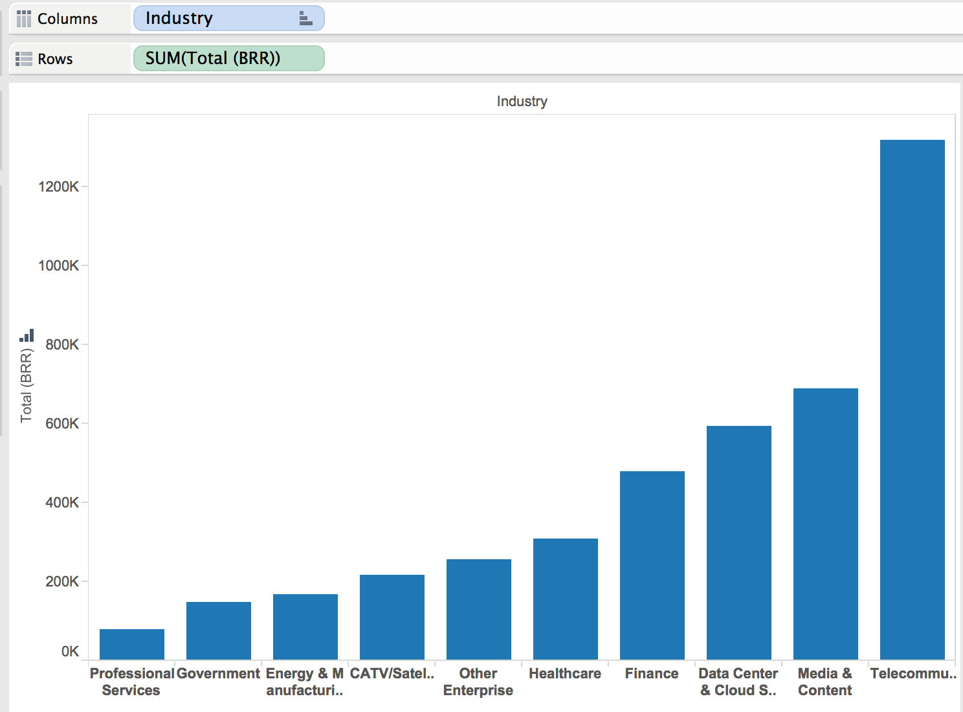

From this bar chart we can see that the majority of Zayo’s customer’s BRR is coming from telecommunication sources, with the next industry, media & content, being nearly half of the BRR of telecommunication.

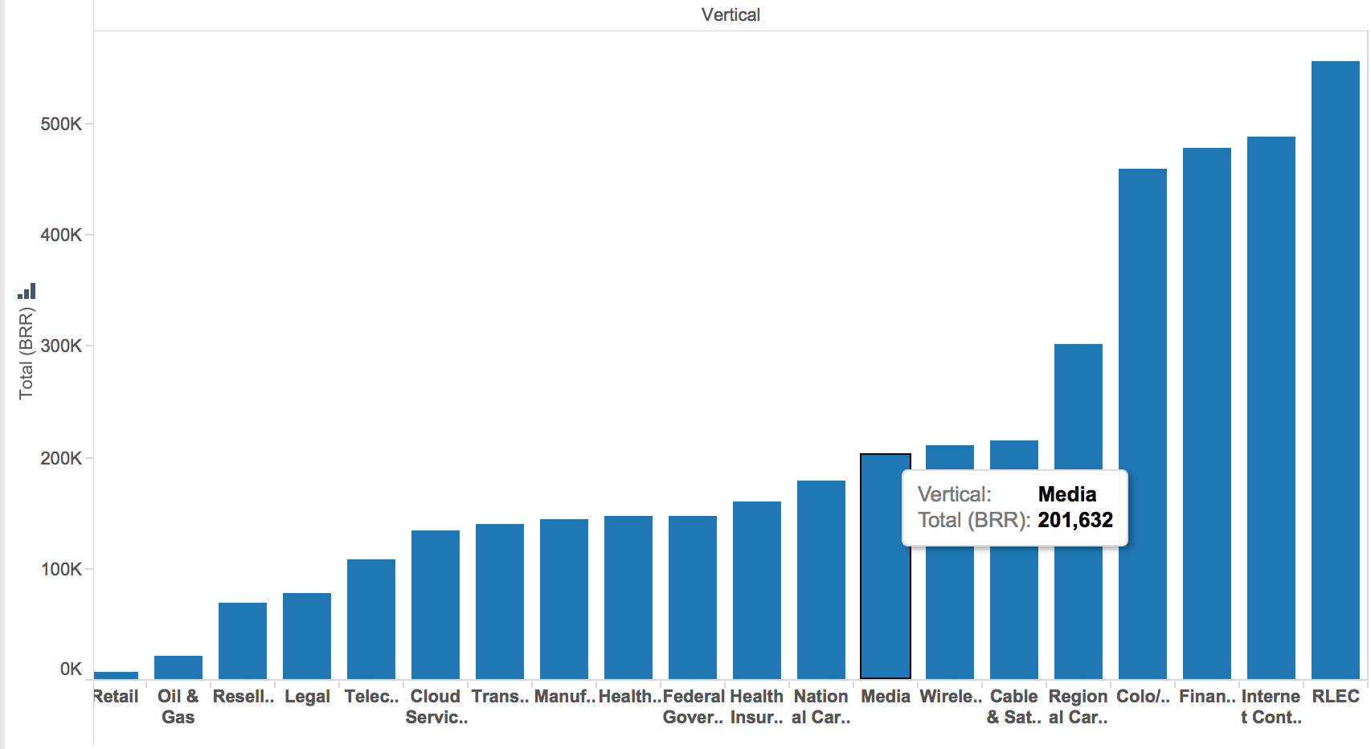

This bar chart shows a similar picture to the first, with RLEC being the main vertical source and Internet content and software being a close second.

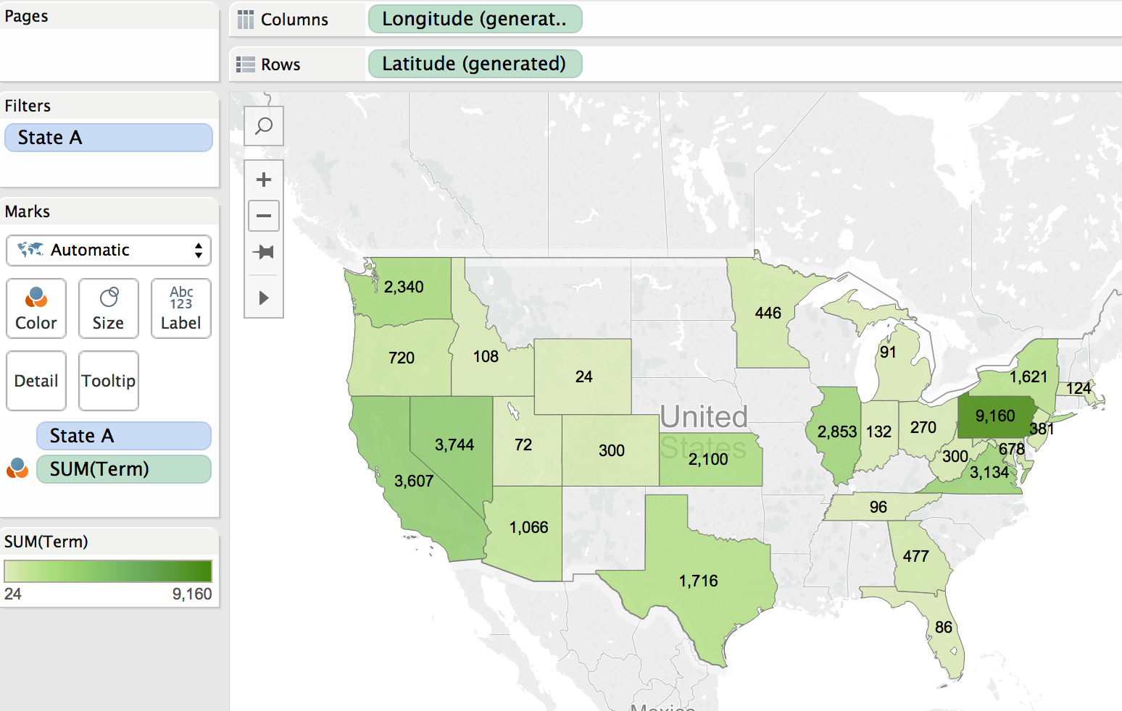

This graph shows that Pennsylvania has the largest number of terms, with Nevada in second with nearly 3 times less than Pennsylvania.

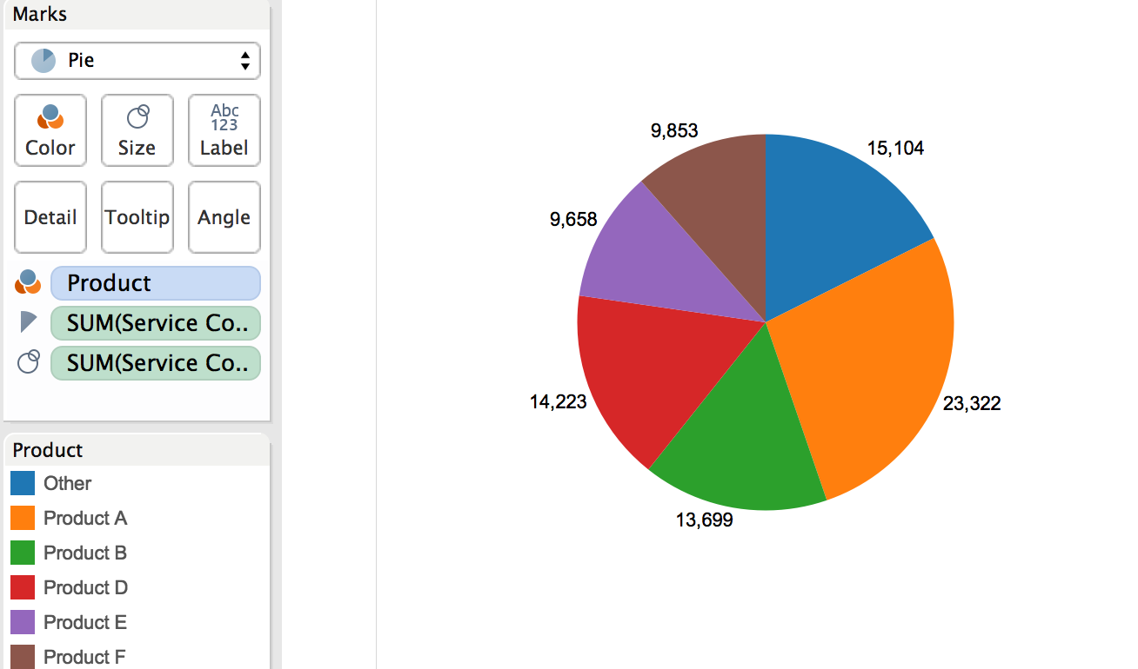

This pie chart is showing the number of service counts per product. We can see from the data that Product A has the most service counts compared to the others, with ‘other’ and product B being in second and third, respectfully.