**ITS-2592**

**In Class Quiz 06**

**Name: Adam Boas**

**Nov 10, 2014**

**This quiz is worth 21 points.**

**CLOSED BOOK ONLY.**

**NO OPEN DIGITAL MEDIA. Closed Internet.**

Put your name on this document and in your program file.

Put screenshots below as you do for your homework assignments.

Upload this template and a jar of the completed product to In Class Quiz 06.

1. Make a project in Eclipse; name it XXX_Q06. XXX are your initials.
2. Import the jar file C19_Quiz into the project.
3. Run the StringListDemo and paste your results here.

**Paste screenshots of your results here.**

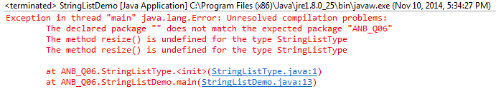

1. Then modify the StringListType Class at line 235 to add a resize method, run the StringListDemo again and paste your updated results here.

**Paste screenshots of your resize method here.**

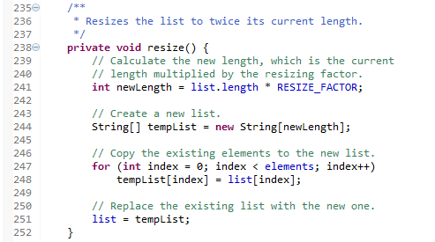

**Paste screenshots of your updated results here.**

