ITS-2592 FINAL EXAM - Part 02 FA 2014

**Name: Adam Boas**

**ITS-2592**

**Honor Code:**

This exam is to be done entirely on your own. You many not use the Web except for uploading to blackboard. It is open book and open notes. You will receive a zero for a late or email submission. Please make sure you have proper comments and you use the coding standards distributed in this class.

I pledge that this program represents my own work.

Assignment Instructions

**Failure to follow these instructions will result in a significant grade reduction.**

**OBSERVE ALL ITS-2592 Java Programming Standards.**

Please name this document XXX_ FE where XXX are your initials.

**The deliverables that are to be uploaded to the assignment are:**

1. This completed document.
2. All Java source code in a jar file. (**Include line numbers in all programs).**
3. PLEASE DO NOT INCLUDE THE TEMPLATE IN THE JAR FILE, submit it as a separate document.

Do the screenshots for this exam exactly as they are required to be done in the homework assignments. If a problem has several classes in it, show screenshots of all the classes with your submission.

1. Problem 01 - 60 points.

Given the class EmployeeFX with the fields: id, firstName, lastName, salaried and salary.

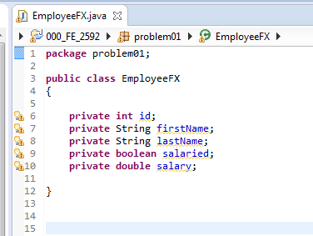

Make instances of the class using the following data:

|  |  |  |  |  |
| --- | --- | --- | --- | --- |
| **id** | **firstName** | **lastName** | **salaried** | **salary** |
|  |  |  |  |  |
| 200 | Caroline | James | false | 37654 |
| 2 | Julian | James | false | 46499 |
| 1 | Conor | Habgren | true | 88767 |
| 10 | Tillie | Donalan | true | 98456 |
| 15 | Alice | Jeanu | true | 72821 |
| 12 | Fred | Habgren | false | 28767 |
| 103 | Mary | Donalan | false | 28456 |
| 135 | Ed | Jeanu | true | 52821 |

and use those instances to populate a list in the order the data is shown above. **Make sure that all data that is input is validated.** Print the list first ordered by id and then by salary. (Two different sets of output). Show screen shots of these three cases. You may add methods to the EmployeeFX class. **You must use comparators to solve this problem.**

PLACE SCREEN SHOT OF PROGRAM CODE AND CONSOLE PROGRAM OUTPUT HERE

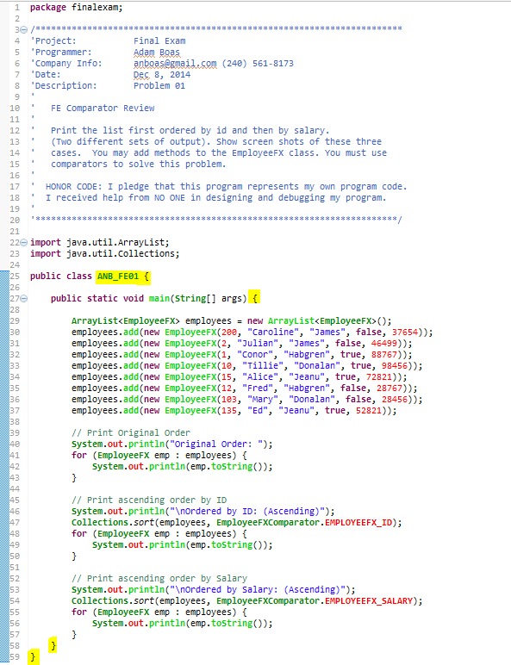 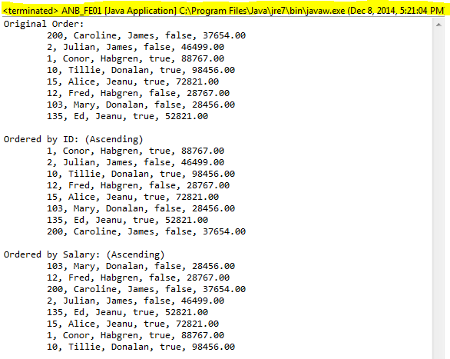 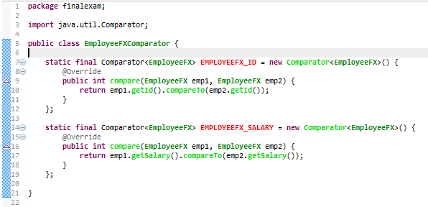 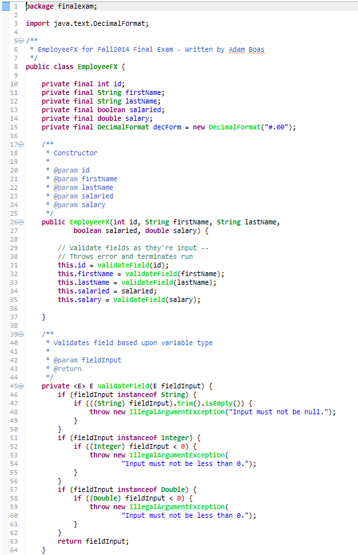 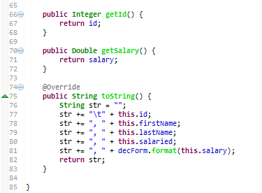

1. Problem 02 - 50 points.

Read the data file ***FA14_Names.txt*** which contains last names and find out how many duplicate names there are in the file; output that number. Then calculate how many occurrences of each duplicate name there are. Print those duplicate names and the number of occurrences of each name in alphabetical order.

CONSOLE PROGRAM OUTPUT HERE

