Assignment 01 - Chapters 13, 14 and 15

Name: Adam Boas
ITS 2592

Honor Code:
I pledge that this program represents my own work.

Assignment Instructions

Failure to follow these instructions will result in a significant grade reduction.

- Please name this document XXX_ Assignment01 where XXX are your initials.
- Please name each JAVA problem PNN where NN is the problem number. (01,02,03 etc.)
- According to the standard java documentation style, every class, every method, every parameter, and every return value should have a comment. This is a requirement for all homework assignments.

The deliverables that are to be uploaded to the assignment are:
- This completed document.
- All Java source code in a jar file. (Include line numbers in all programs).
- PLEASE DO NOT INCLUDE THE TEMPLATE IN THE JAR FILE, submit it as a separate document.

Precisely follow the instructions in the video “Instructions for the Submission of Homework Assignments”.

If a problem has several classes in it, show screenshots of all the classes with your homework submission.

This assignment is worth 60 points. See the grading form for individual problem point values.

- Input and Run Page 850 Problem 01. (Page 65 2014 ed)

PLACE SCREEN SHOT OF PROGRAM CODE AND CONSOLE PROGRAM OUTPUT HERE
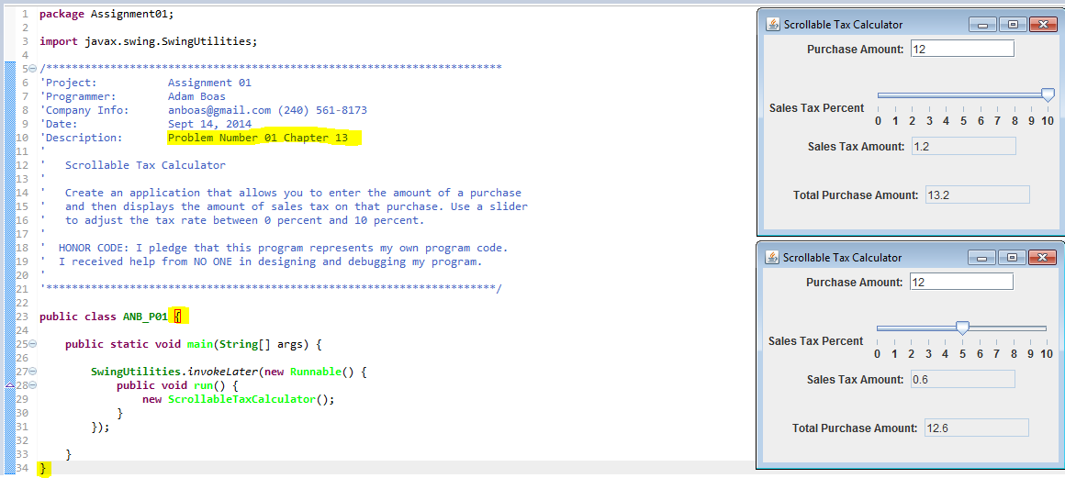

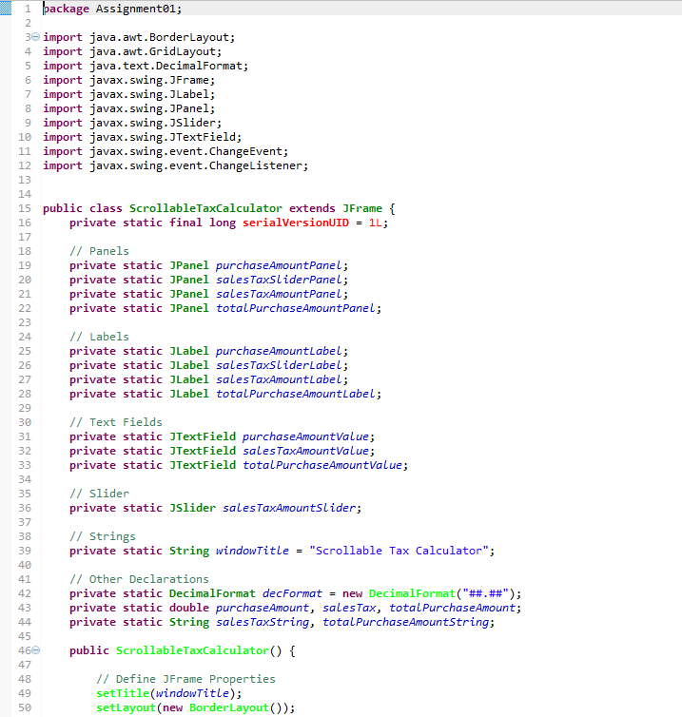
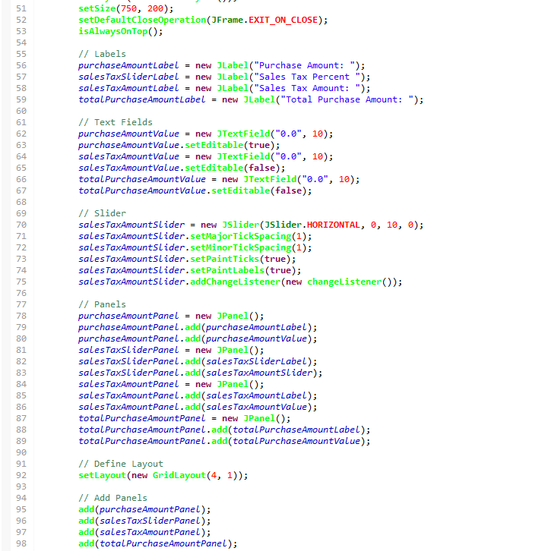

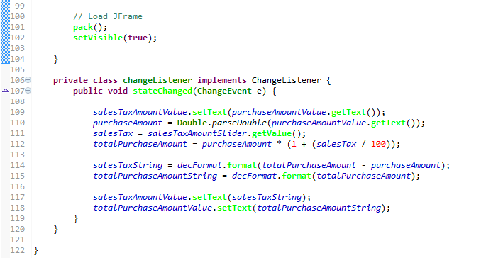

- Input and Run Page 927 Problem 01. (Page 145 2014 ed)

PLACE SCREEN SHOT OF PROGRAM CODE AND CONSOLE PROGRAM OUTPUT HERE

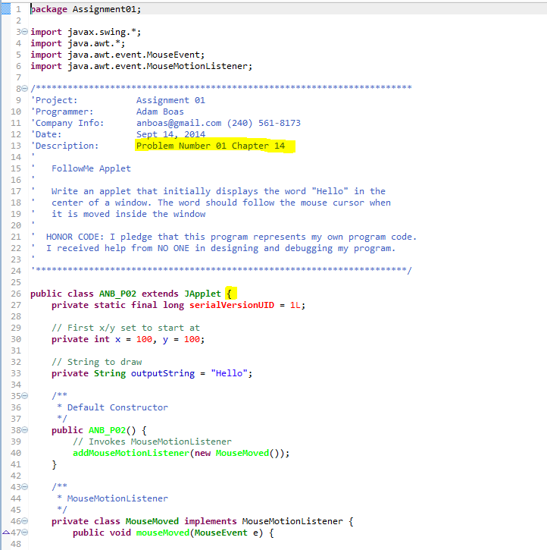
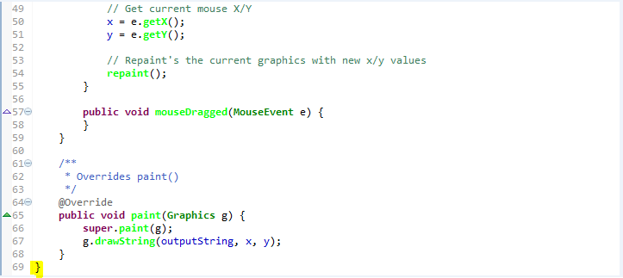

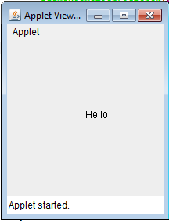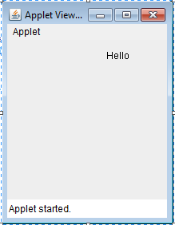

- Input and Run Page 951 Problem 01. (Page 173 2014 ed) Use 6 and 9 as input. Note you must use recursion.

PLACE SCREEN SHOT OF PROGRAM CODE AND CONSOLE PROGRAM OUTPUT HERE

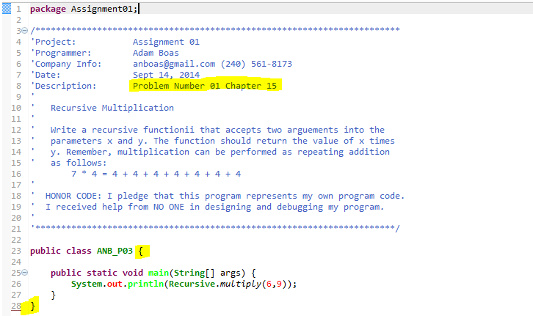
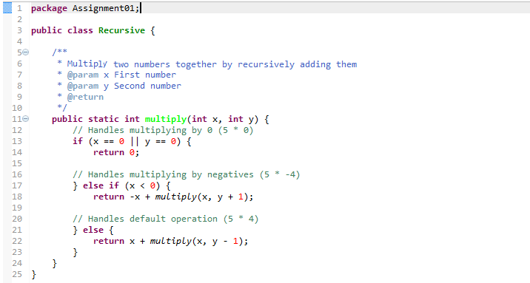

- Develop a class Sentence with a recursive method
public static void reverse(String sentence, int sentenceLength) that reverses a sentence.
Please note your method must have exactly the same call line as above.

Implement the following code in your driver program (called SentenceDemo):

String word = " Federal court officials did not immediately respond to calls on Saturday.";
System.out.print("The reverse word is: ");
Sentence.reverse(word, word.length());
System.out.println();

This will print the string:

The reverse sentence is: .yadrutaS no sllac ot dnopser yletaidemmi ton did slaiciffo truoc laredeF

Implement a recursive solution. by removing the first character, reversing a sentence consisting of the remaining text, and combining the two.

Demonstrate this with a driver program called SentenceDemo; use the string
"Europe’s labor market remained in the doldrums in December, while the inflation rate ticked back down to the same level that recently led the European Central Bank to cut interest rates."

PLACE SCREEN SHOT OF PROGRAM CODE AND CONSOLE PROGRAM OUTPUT HERE

