Assignment 02 - Chapter 16

Name: Adam Boas
ITS 2592

Honor Code:
I pledge that this program represents my own work.

Assignment Instructions

Failure to follow these instructions will result in a significant grade reduction.

Please name this document XXX_ Assignment01 where XXX are your initials.
Please name each JAVA problem XXX_PNN where XXX are your initials and NN is the problem number. (01,02,03 etc.)

The deliverables that are to be uploaded to the assignment are:
- This completed document.
- All Java source code in a zipped file. (Include line numbers in all programs).
- PLEASE DO NOT INCLUDE THE TEMPLATE IN THE ZIPPED FILE, submit it as a separate document.

Precisely follow the instructions in the video “Instructions for the Submission of Homework Assignments”.

If a problem has several classes in it, show screenshots of all the classes with your homework submission.

Each problem is worth 15 points. See the grading form for point values.

- Input and Run Page 1002 Problem 01. (Page 300 2014 ed) Use - photograph, taken, from, Houston, Texas, juxtaposes, Earth, oldest, satellite, with, one, of, its, youngest - as input strings.

PLACE SCREEN SHOT OF PROGRAM CODE AND CONSOLE PROGRAM OUTPUT HERE 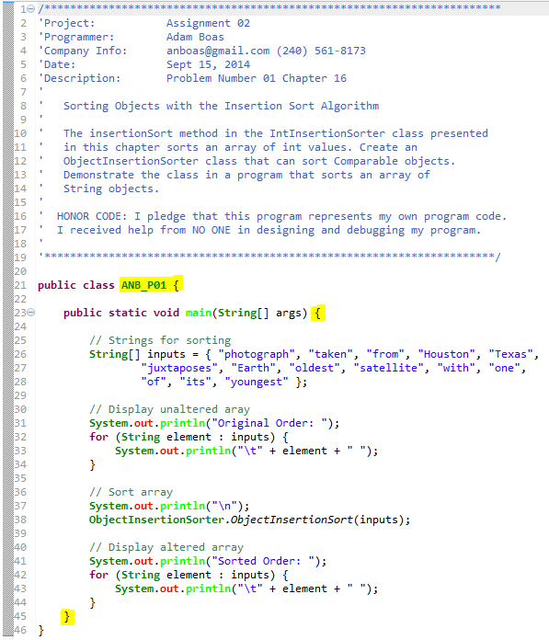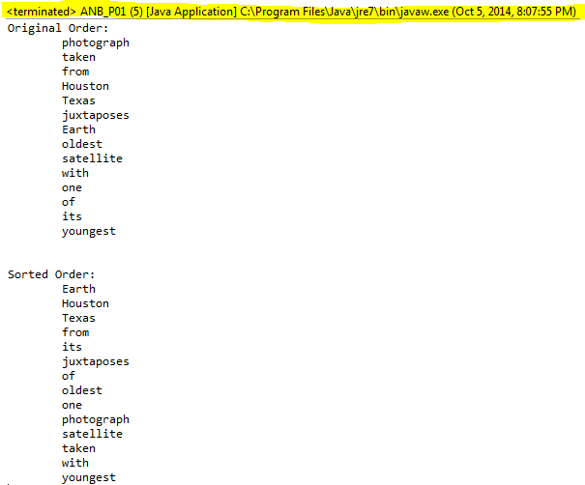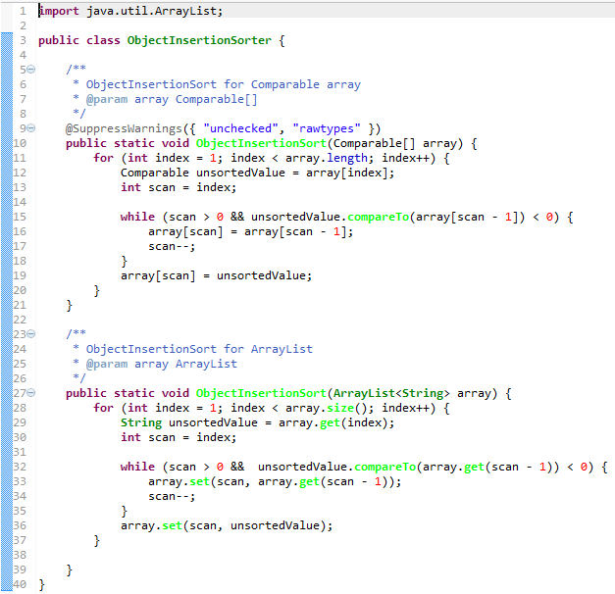

- Input and Run Page 1002 Problem 03. (Page 300 2014 ed)
PLACE SCREEN SHOT OF PROGRAM CODE AND CONSOLE PROGRAM OUTPUT HERE
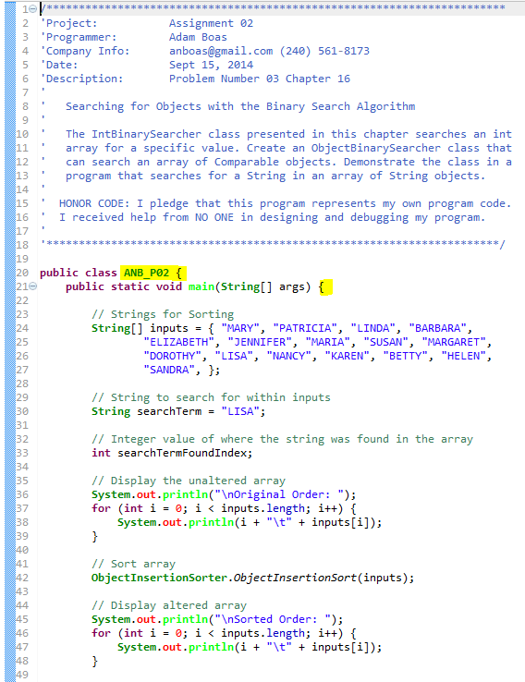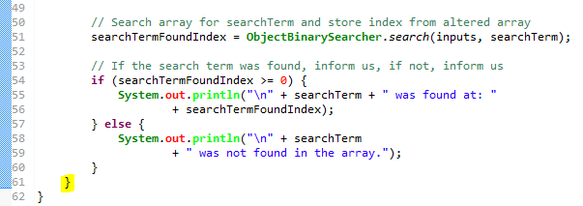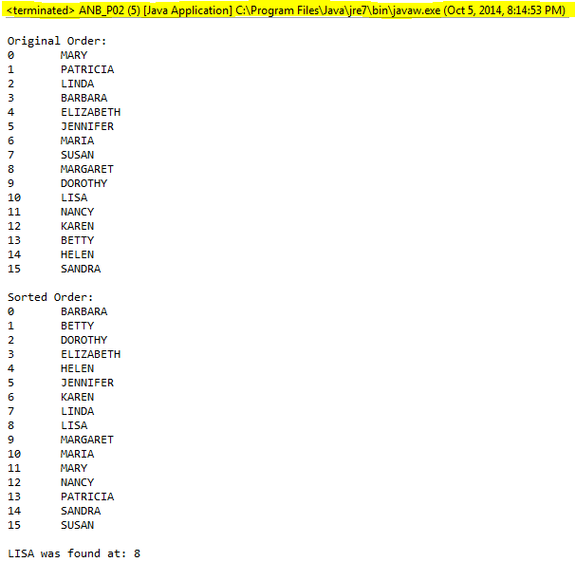

- Input and Run Page 1002 Problem 04. (Page 300 2014 ed) Use an number that is in the array and one that is not in the array to demonstrate your program.

PLACE SCREEN SHOT OF PROGRAM CODE AND CONSOLE PROGRAM OUTPUT HERE
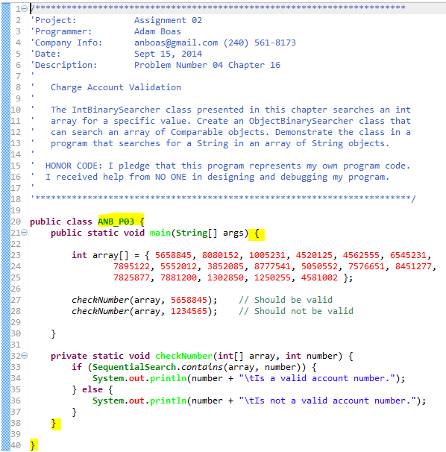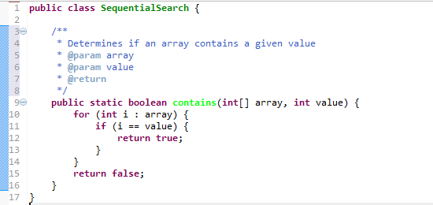

- Input and Run Page 1002 Problem 06. (Page 300 2014 ed) The name file is included as a zipped file.

PLACE SCREEN SHOT OF PROGRAM CODE AND CONSOLE PROGRAM OUTPUT HERE
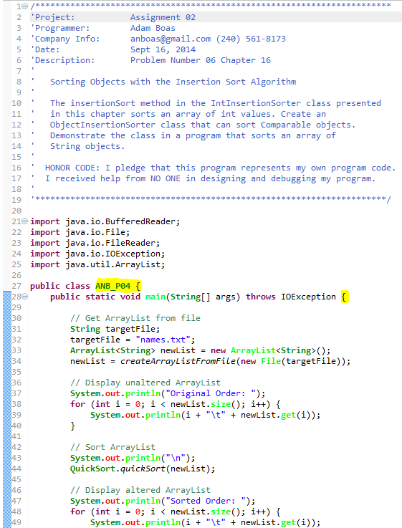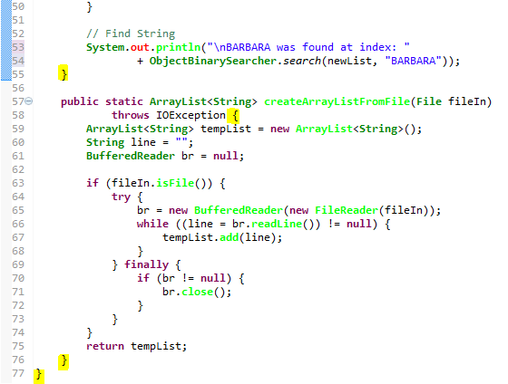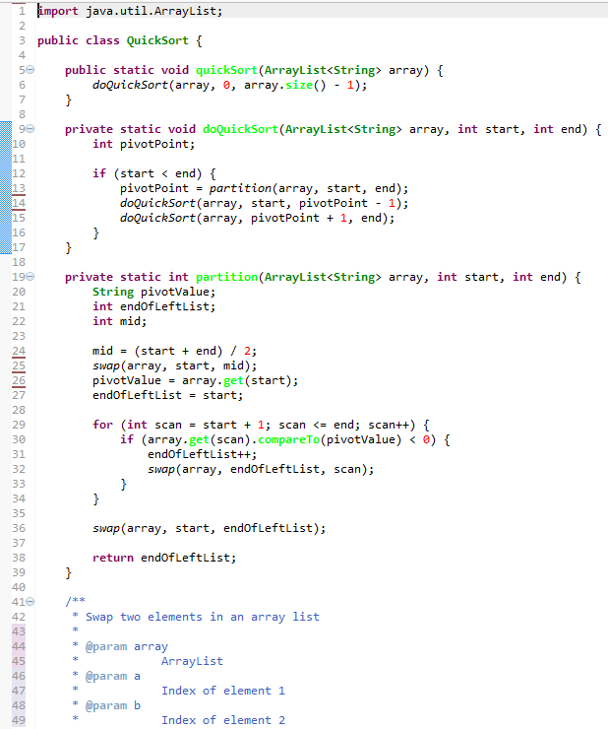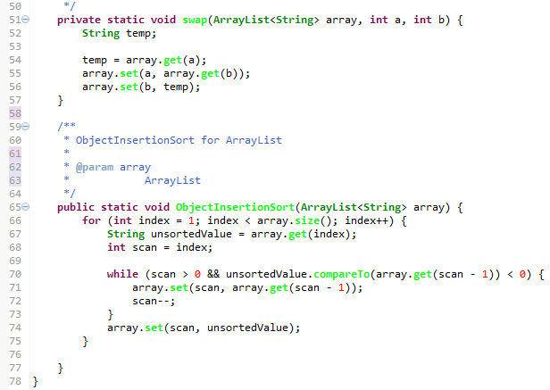

Truncated sample of output:
