Assignment 03 - Chapters 17 and 18

Name: Adam Boas
ITS 2592

Honor Code:
I pledge that this program represents my own work.

Assignment Instructions

Failure to follow these instructions will result in a significant grade reduction.

Please name this document XXX_ Assignment01 where XXX are your initials.
Please name each JAVA problem XXX_PNN where XXX are your initials and NN is the problem number. (01,02,03 etc.)

The deliverables that are to be uploaded to the assignment are:
- This completed document.
- All Java source code in a zipped file. (Include line numbers in all programs).
- PLEASE DO NOT INCLUDE THE TEMPLATE IN THE ZIPPED FILE, submit it as a separate document.

Precisely follow the instructions in the video “Instructions for the Submission of Homework Assignments”.

If a problem has several classes in it you must show screenshots of all the classes with your homework submission.

Each problem is worth 15 points. See the grading form for point values.

- Input and Run Page 1048 Problem 01. (Page 348 2014 ed) Use 7, -9, 23, 18 and 12 as input.

PLACE SCREEN SHOT OF PROGRAM CODE AND CONSOLE PROGRAM OUTPUT HERE
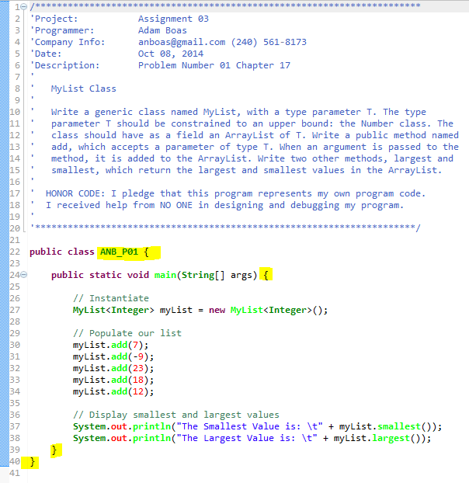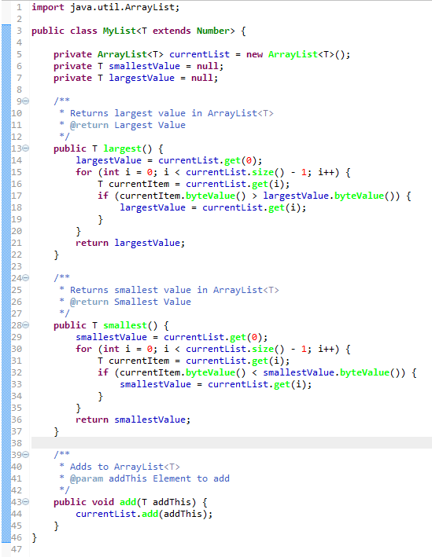

- Input and Run Page 1048 Problem 02. (Page 348 2014 ed) Use Use 7, -9, 23, 18 and 12 as input and

MARY
PATRICIA
LINDA
BARBARA
ELIZABETH

PLACE SCREEN SHOT OF PROGRAM CODE AND CONSOLE PROGRAM OUTPUT HERE
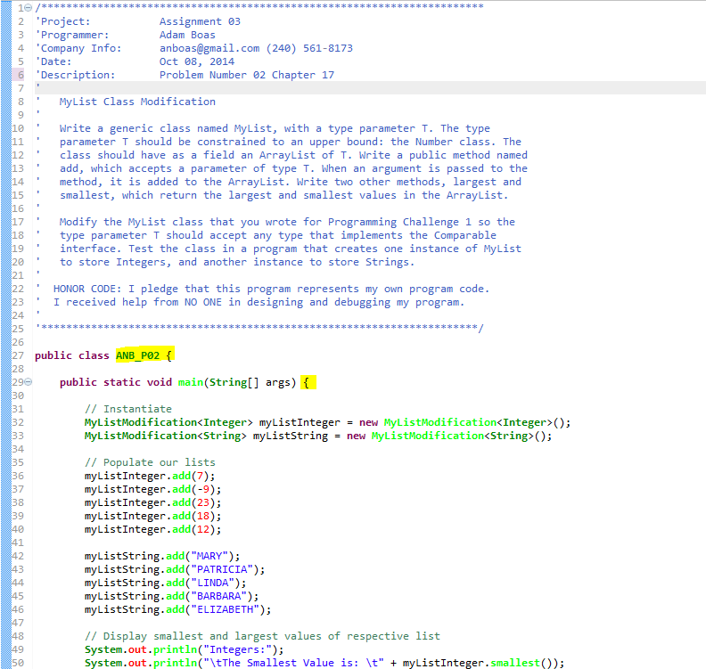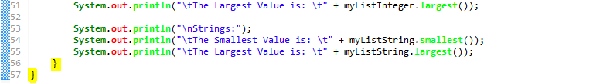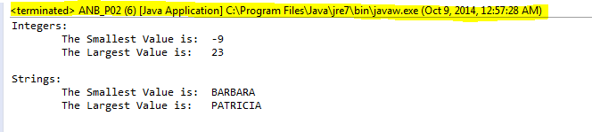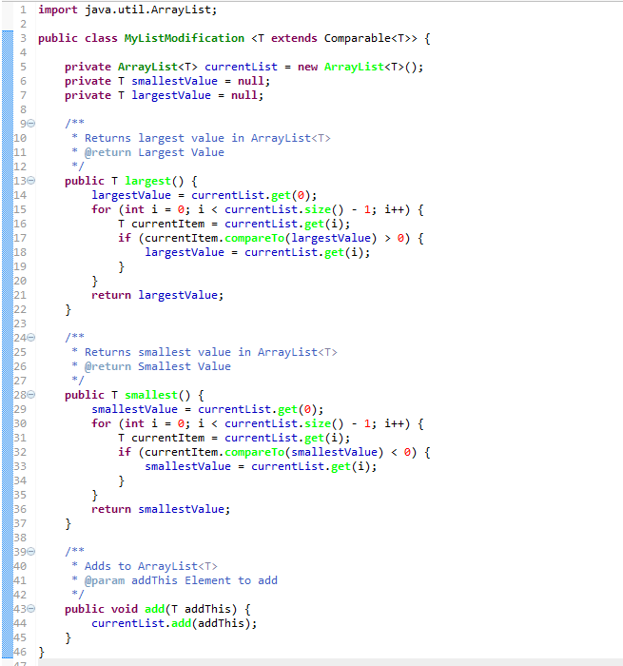

- Input and Run Page 1117 Problem 01. (Page 419 2014 ed) Use:
The Moon orbits the Earth at an average distance of 324,400 kilometers , while the ISS orbits at altitudes ranging from approximately 338 to 410 kilometers .
as the input line.

PLACE SCREEN SHOT OF PROGRAM CODE AND CONSOLE PROGRAM OUTPUT HERE

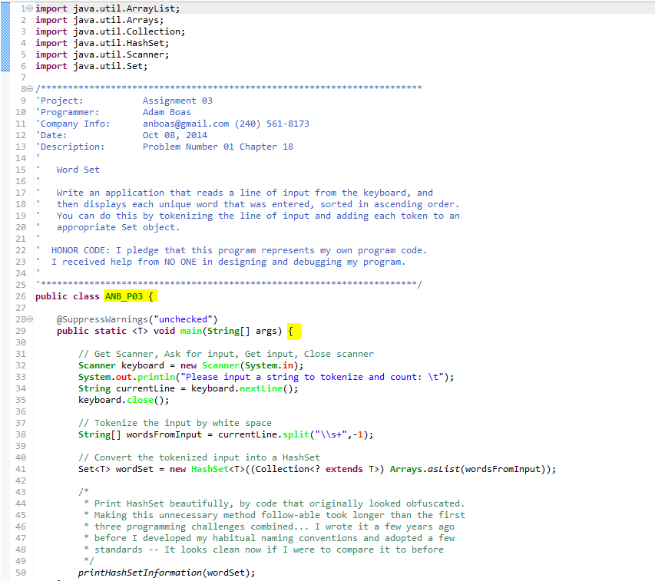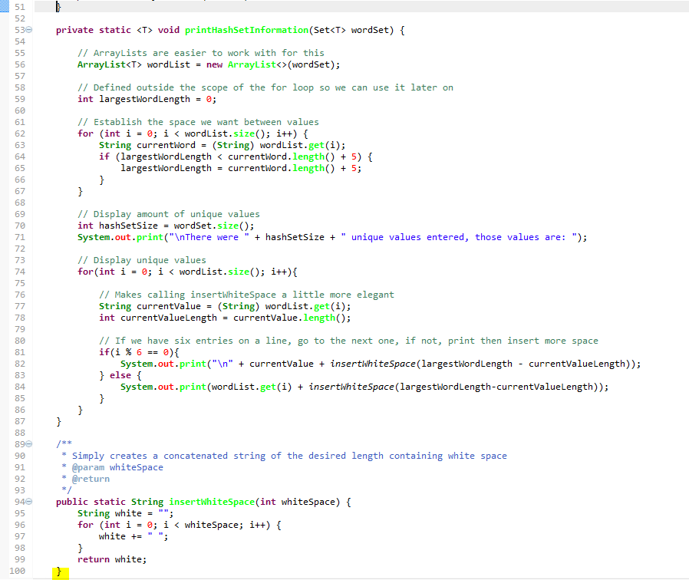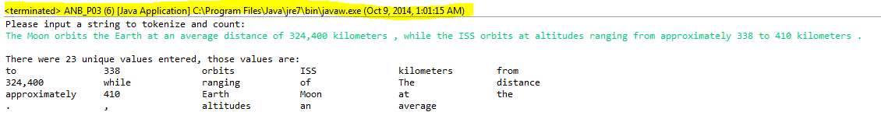

- Input and Run Page 1117 Problem 03. (Page 419 2014 ed) Use the following as input.

ID | FIRST NAME | LAST NAME
A3208x | BRENDA | PENYA
B2384z | NANCY | ZARKOZI
A4393c | SANDRA | MELON
C9802z | PATRICK | LOZE
C9832x | LOUIS | JONES

Look up C9802z.

PLACE SCREEN SHOT OF PROGRAM CODE AND CONSOLE PROGRAM OUTPUT HERE
