Assignment 04 - Chapters 19 and 20

Name: Adam Boas
ITS 2592

Honor Code:
I pledge that this program represents my own work.

Assignment Instructions

Failure to follow these instructions will result in a significant grade reduction.

Please name this document XXX_ Assignment01 where XXX are your initials.
Please name each JAVA problem XXX_PNN where XXX are your initials and NN is the problem number. (01,02,03 etc.)

The deliverables that are to be uploaded to the assignment are:
- This completed document.
- All Java source code in a zipped file. (Include line numbers in all programs).
- PLEASE DO NOT INCLUDE THE TEMPLATE IN THE ZIPPED FILE, submit it as a separate document.

Precisely follow the instructions in the video “Instructions for the Submission of Homework Assignments”.

If a problem has several classes in it, show screenshots of all the classes with your homework submission.

Each problem is worth 30 points. See the grading form for point values.
- Input and Run Page 1166 Problem 01. (Page 538 2014 ed)

PLACE SCREEN SHOT OF PROGRAM CODE AND CONSOLE PROGRAM OUTPUT HERE

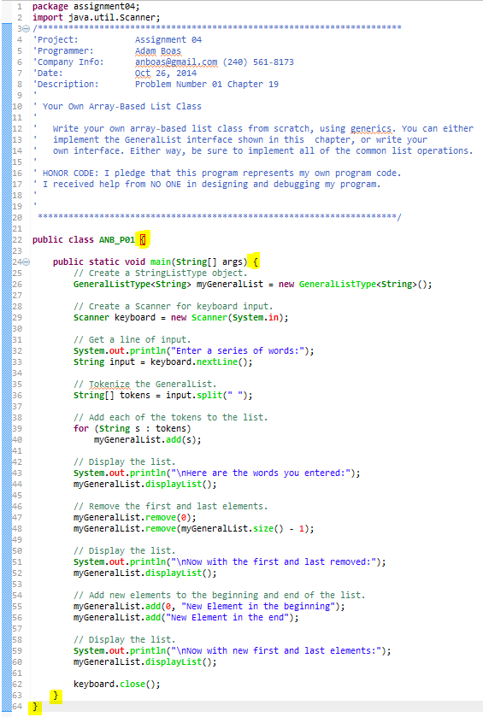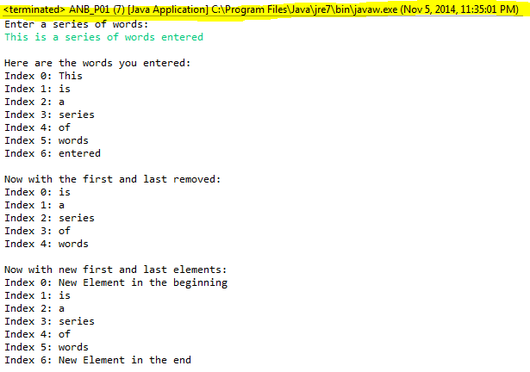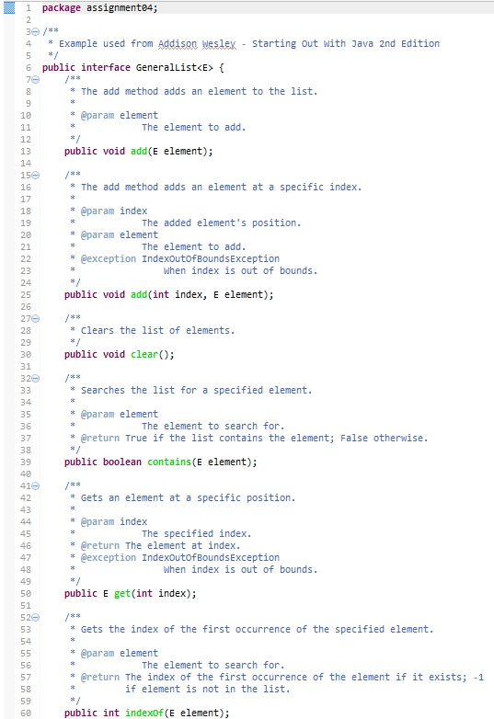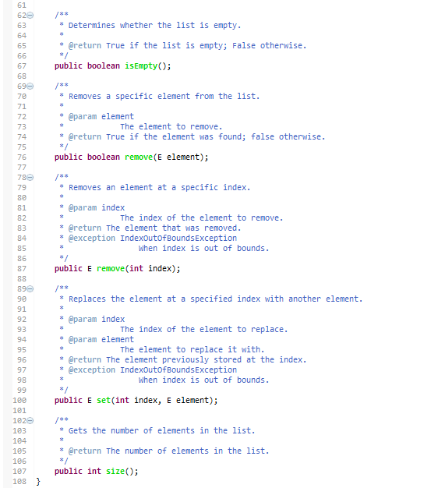
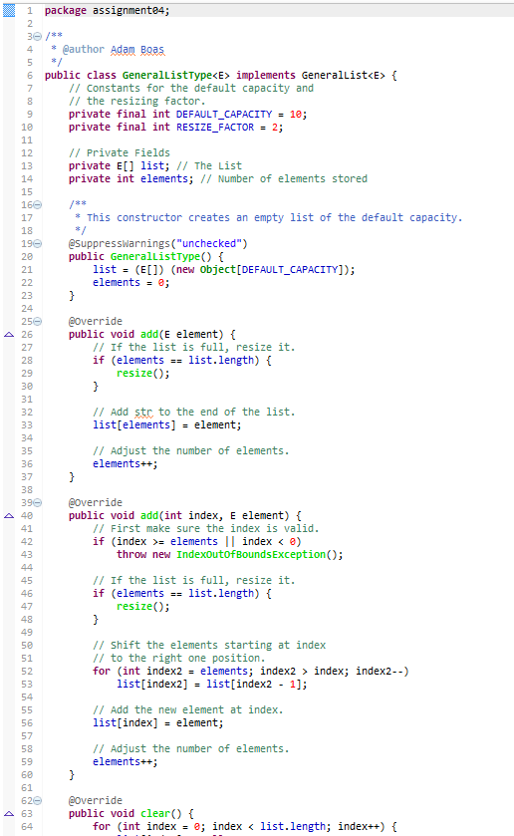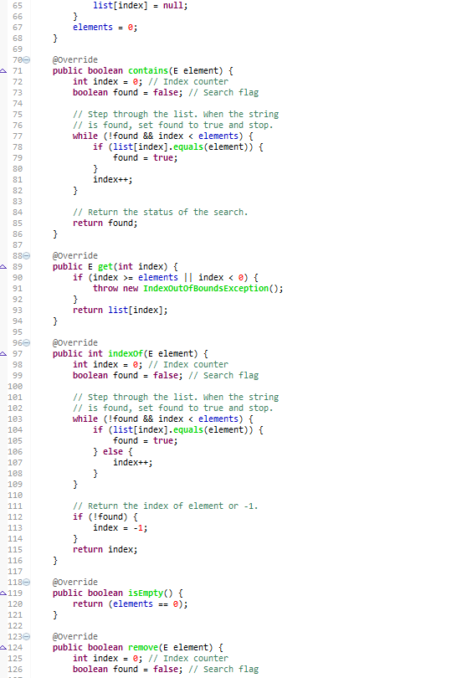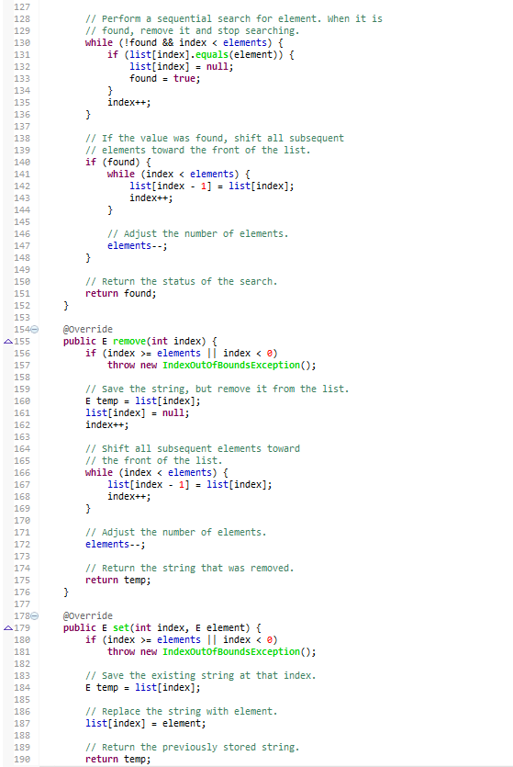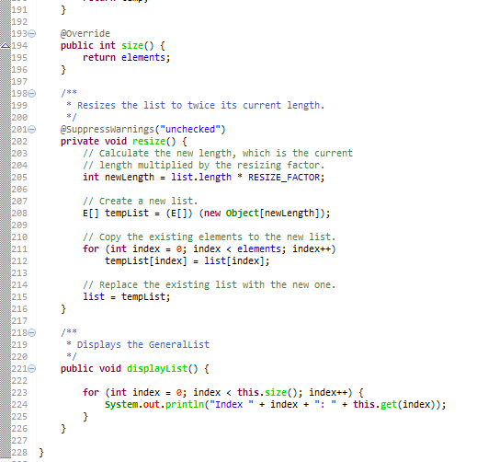

- Input and Run Page 1215 Problem 01. (Page 539 2014 ed) Use: 23.2, -9.8, 567.32, 2.0, -756.4 as input.

PLACE SCREEN SHOT OF PROGRAM CODE AND CONSOLE PROGRAM OUTPUT HERE
