Assignment 05 - Chapter 21

Name: Adam Boas
ITS 2592

Honor Code:
I pledge that this program represents my own work.
Assignment Instructions

Failure to follow these instructions will result in a significant grade reduction.

Please name this document XXX_ Assignment01 where XXX are your initials.

Use all coding standards that have been addressed in class.

The deliverables that are to be uploaded to the assignment are:
- This completed document.
- All Java source code in a zipped file. (Include line numbers in all programs).
- PLEASE DO NOT INCLUDE THE TEMPLATE IN THE ZIPPED FILE, submit it as a separate document.

Precisely follow the instructions in the video “Instructions for the Submission of Homework Assignments”.

If a problem has several classes in it, show screenshots of all the classes with your homework submission.

This assignment is worth 60 points. See the grading form for individual problem point values.

- A deque is a list based collection that allows additions and removals to take place at both ends but nowhere else. A deque supports the operations addFront(x), removeFront(), addRear(x), removeRear(), size() and empty. Write a class that implements a deque that stores strings using a doubly linked list that you code yourself. Demonstrate all your class operations (print list on console after each operation) with five strings. Use the strings alpha, beta, gamma, delta and epsilon.

PLACE SCREEN SHOT OF PROGRAM CODE AND CONSOLE PROGRAM OUTPUT HERE
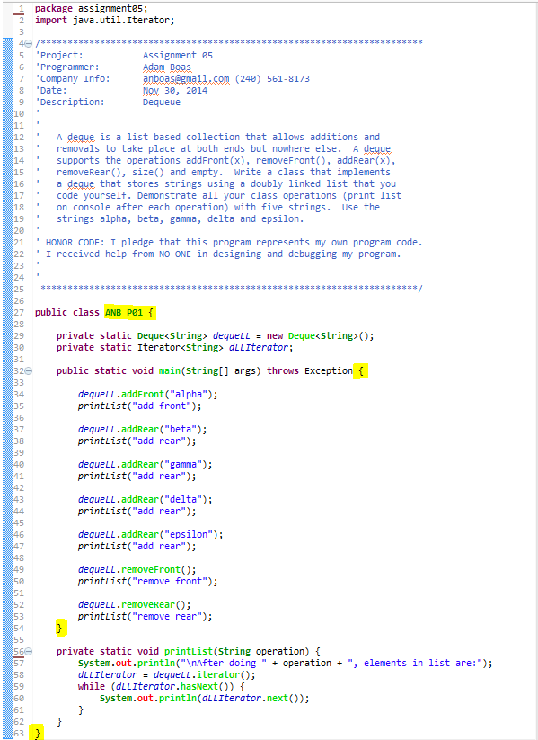
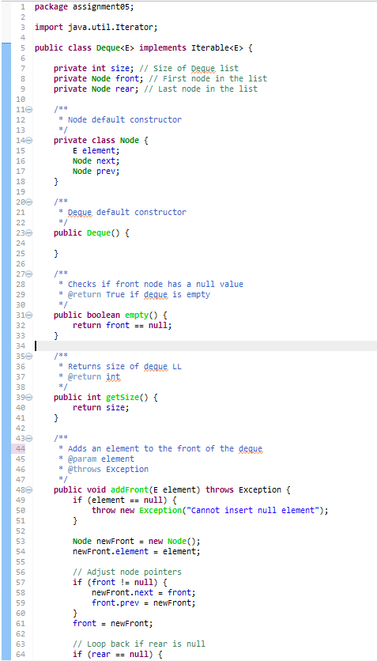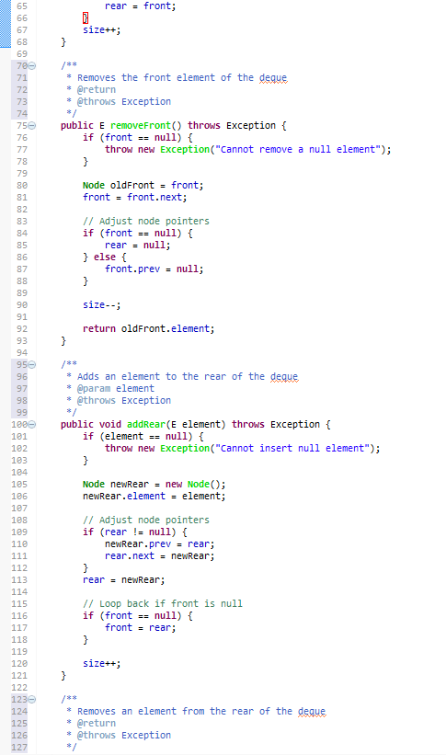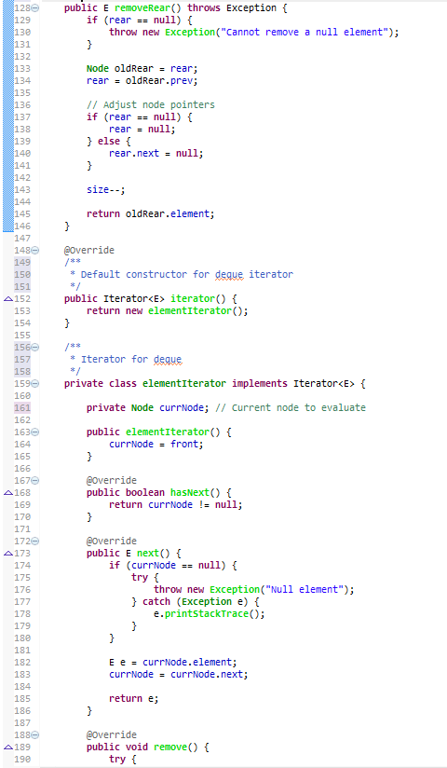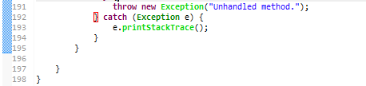
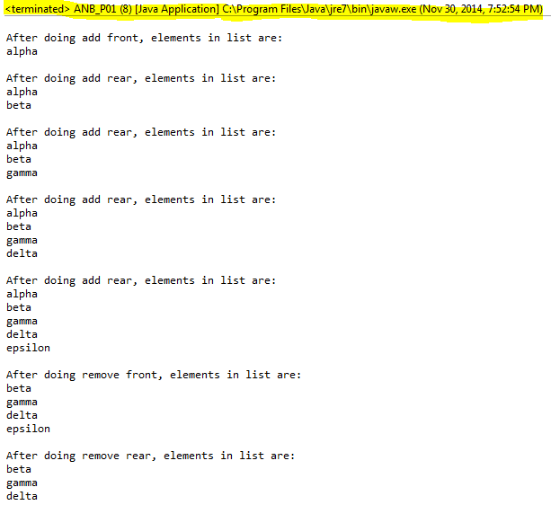

- Implement a deque as described in problem one, except base your implementation on an array. The constructor for the class should accept an integer parameter for the capacity of the deque and create an array of that size. Test your class by constructing a deque with capacity 10. Demonstrate all your class operations (print list on console after each operation) with five strings. Use the strings alpha, beta, gamma, delta and epsilon.

PLACE SCREEN SHOT OF PROGRAM CODE AND CONSOLE PROGRAM OUTPUT HERE

