Building 3 Front Entrance Handrail

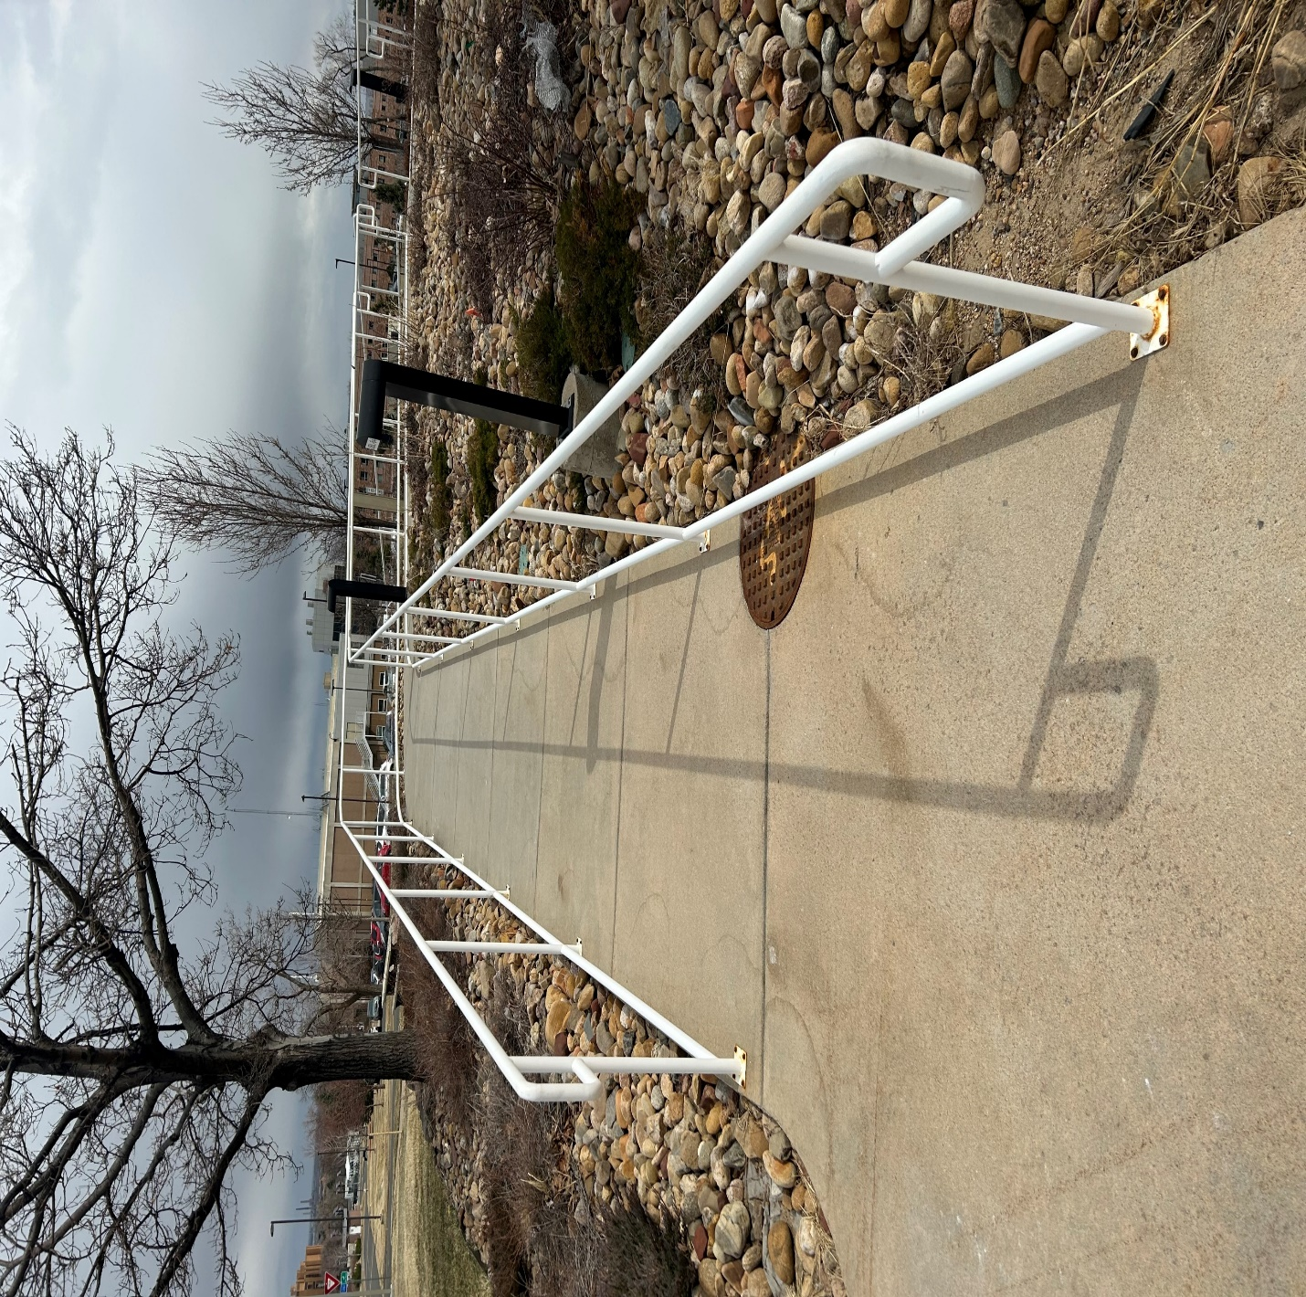

Building 3 Front Entrance Handrail

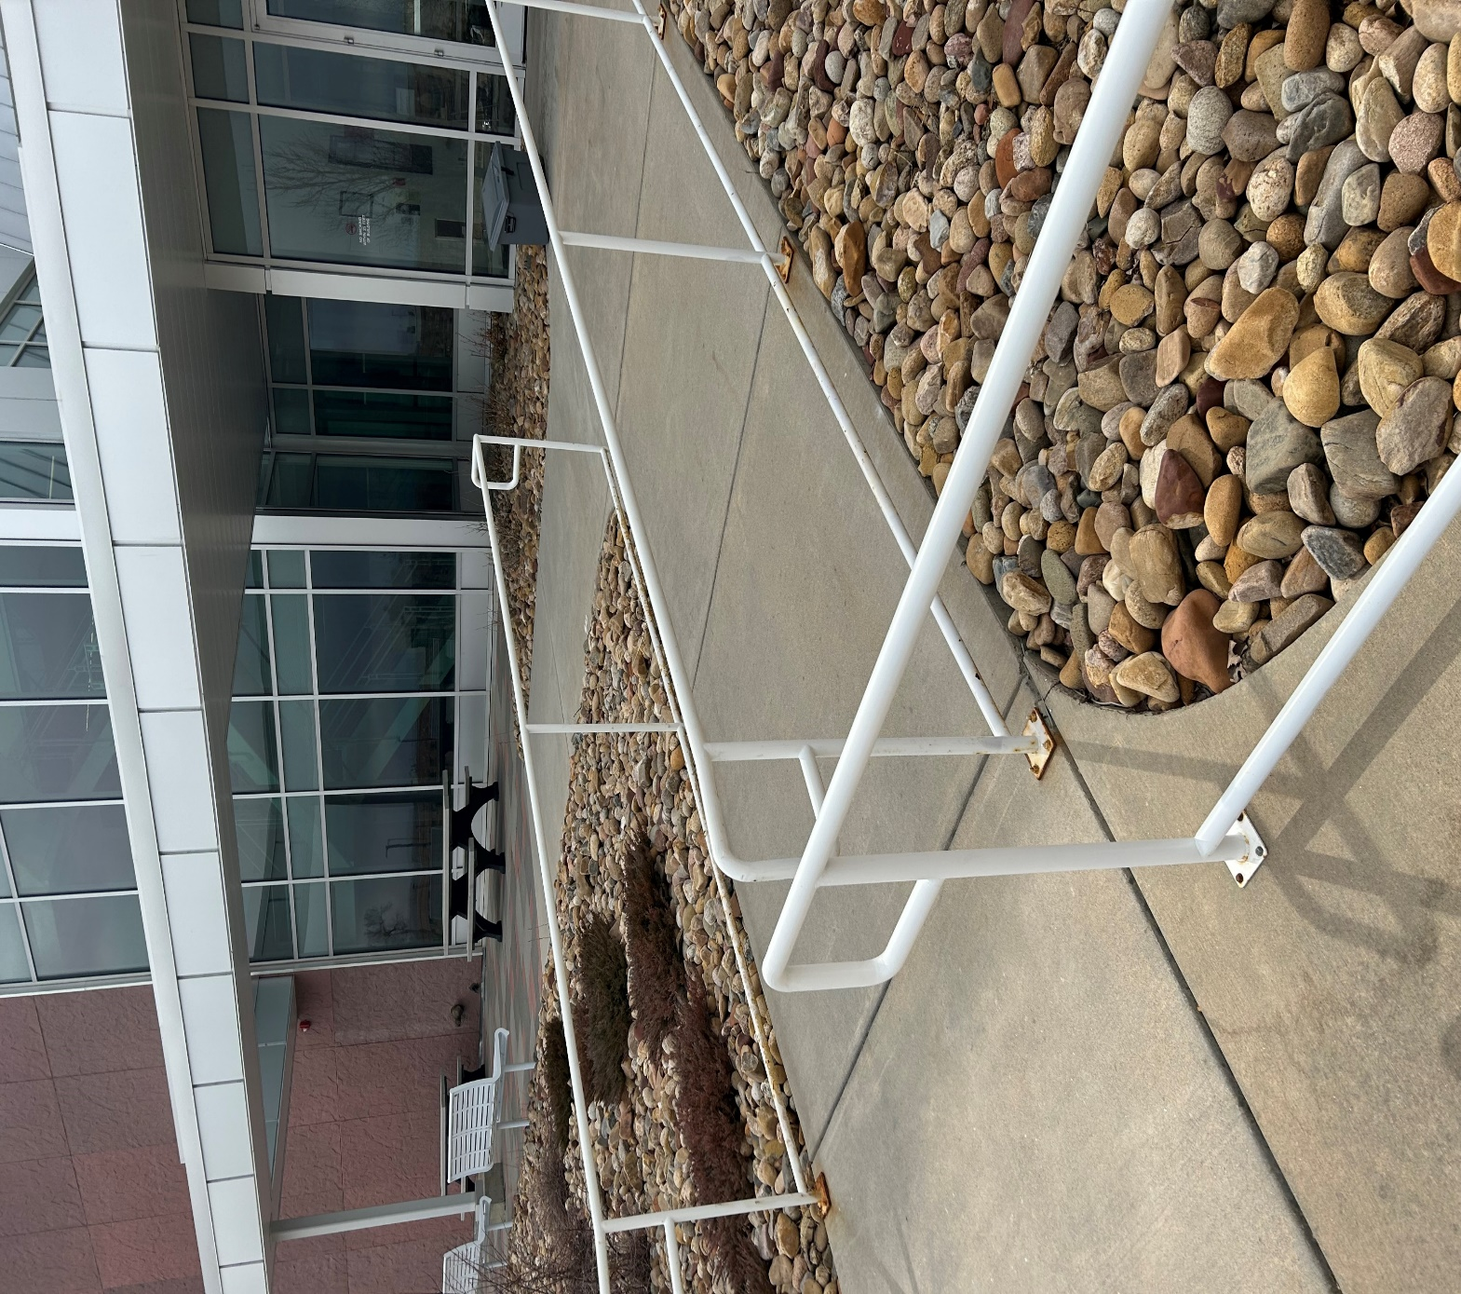

Building 3 Front Entrance Handrail

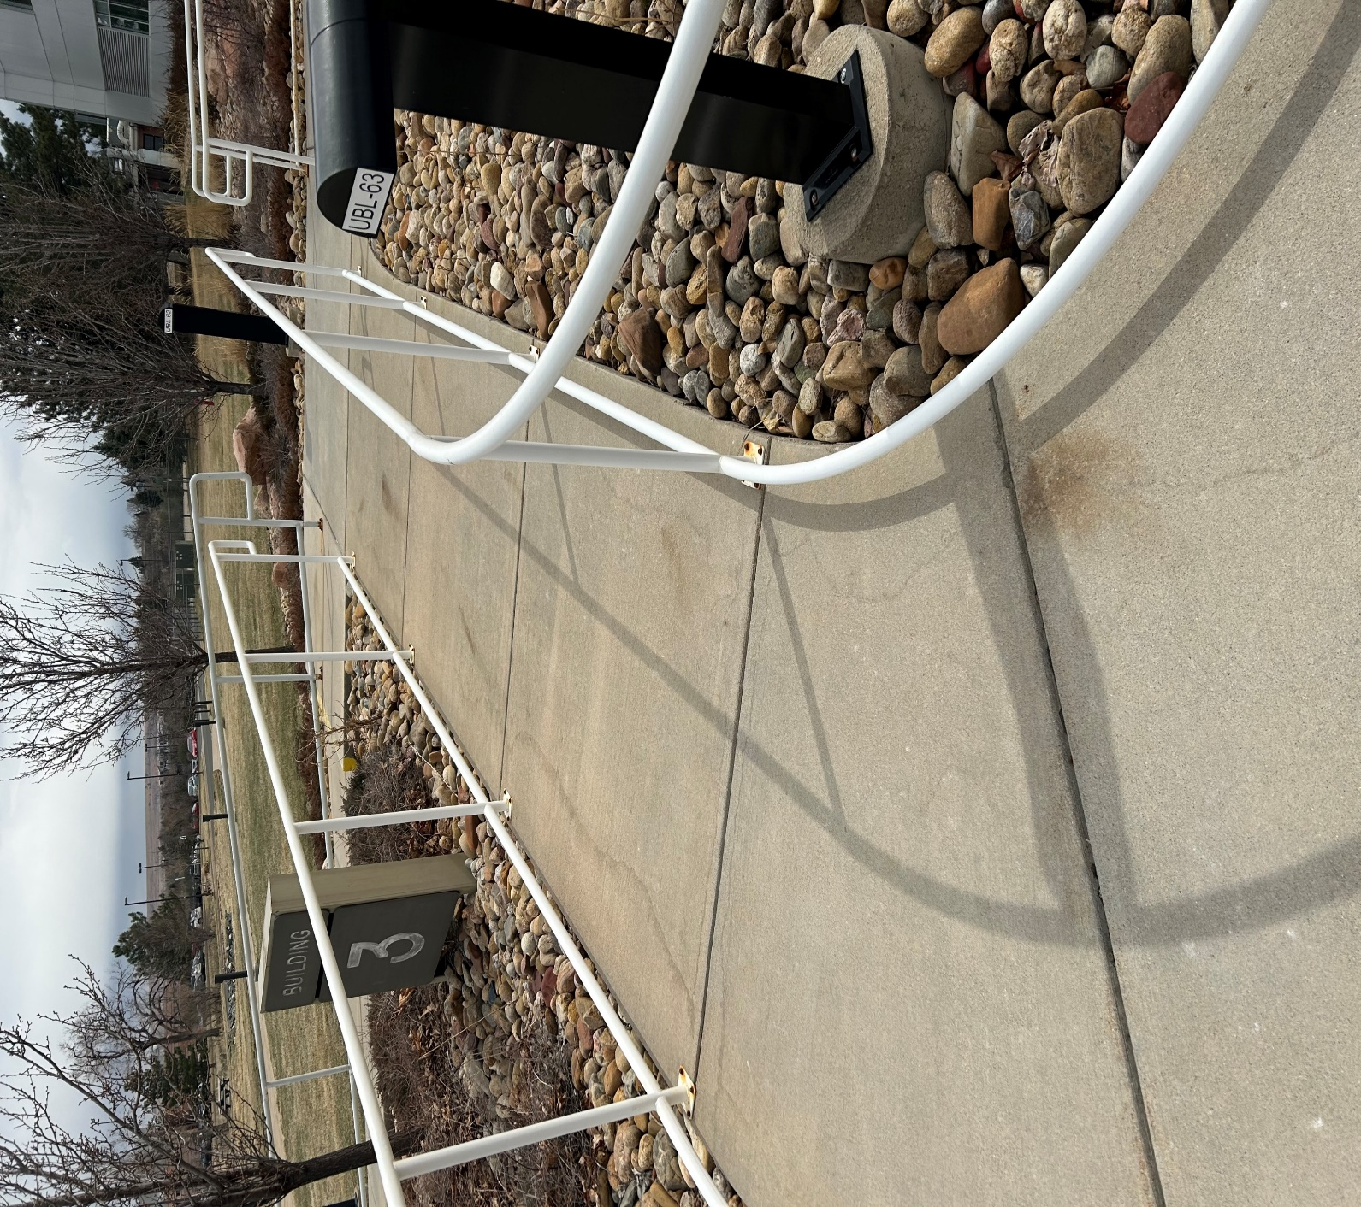

Building 1 Wing 3 Staircase and Handrails

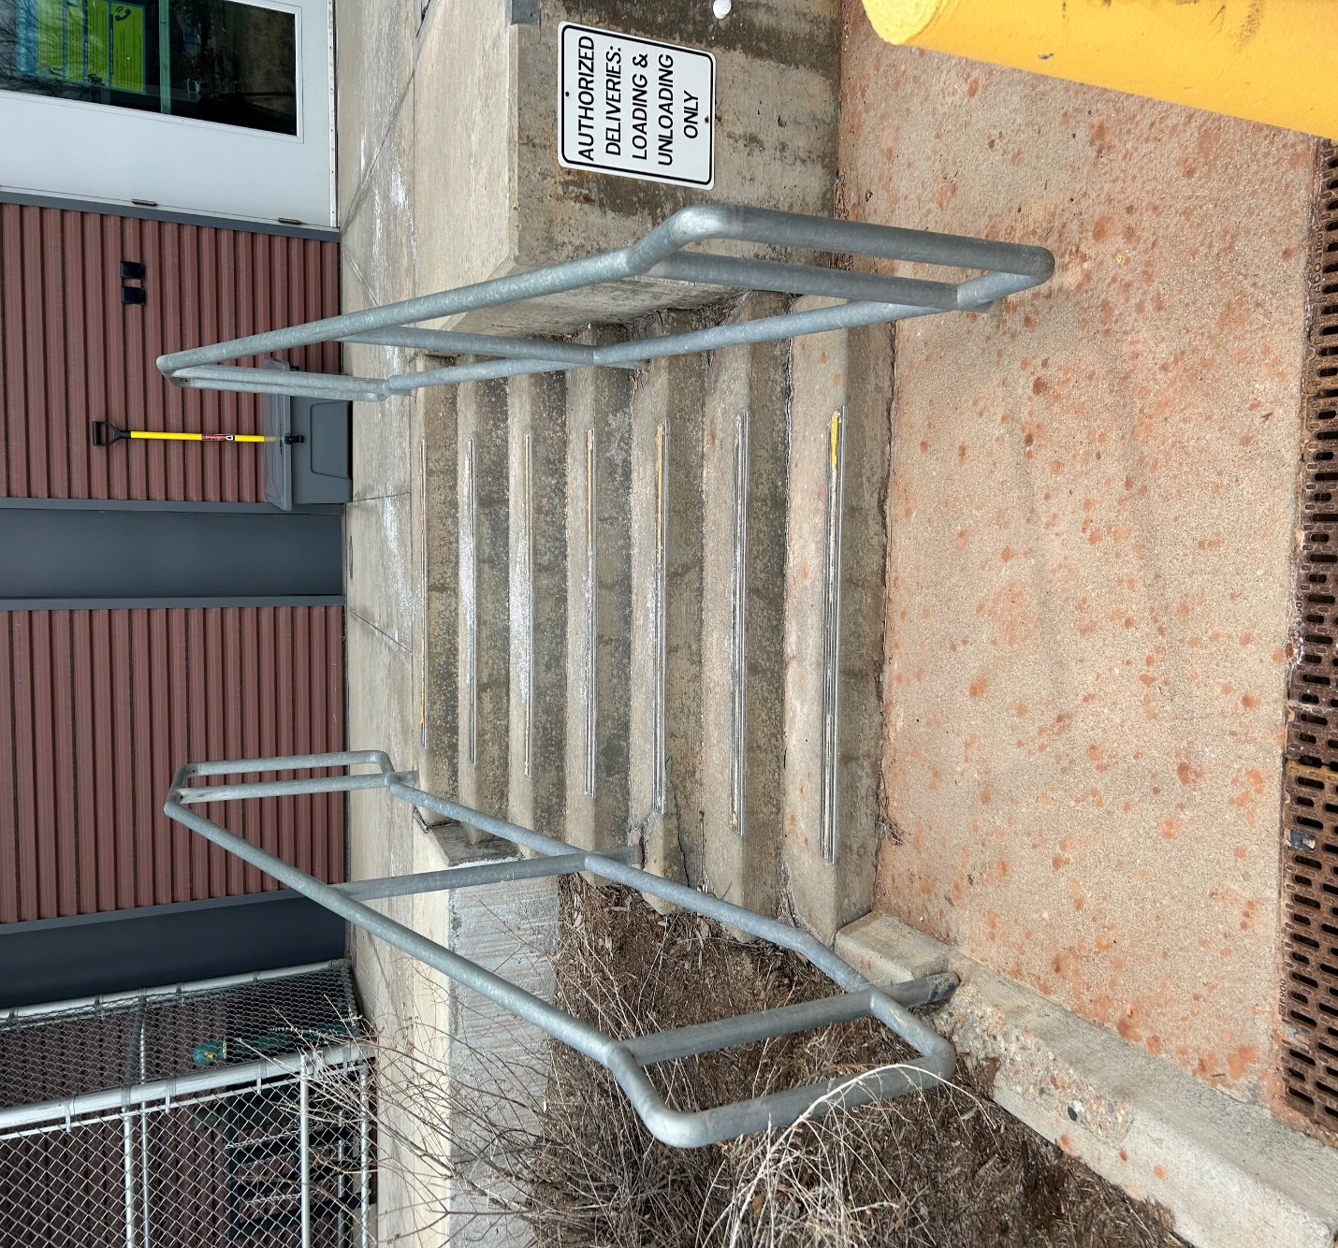

Building 22 East Entryway Staircase and Handrail

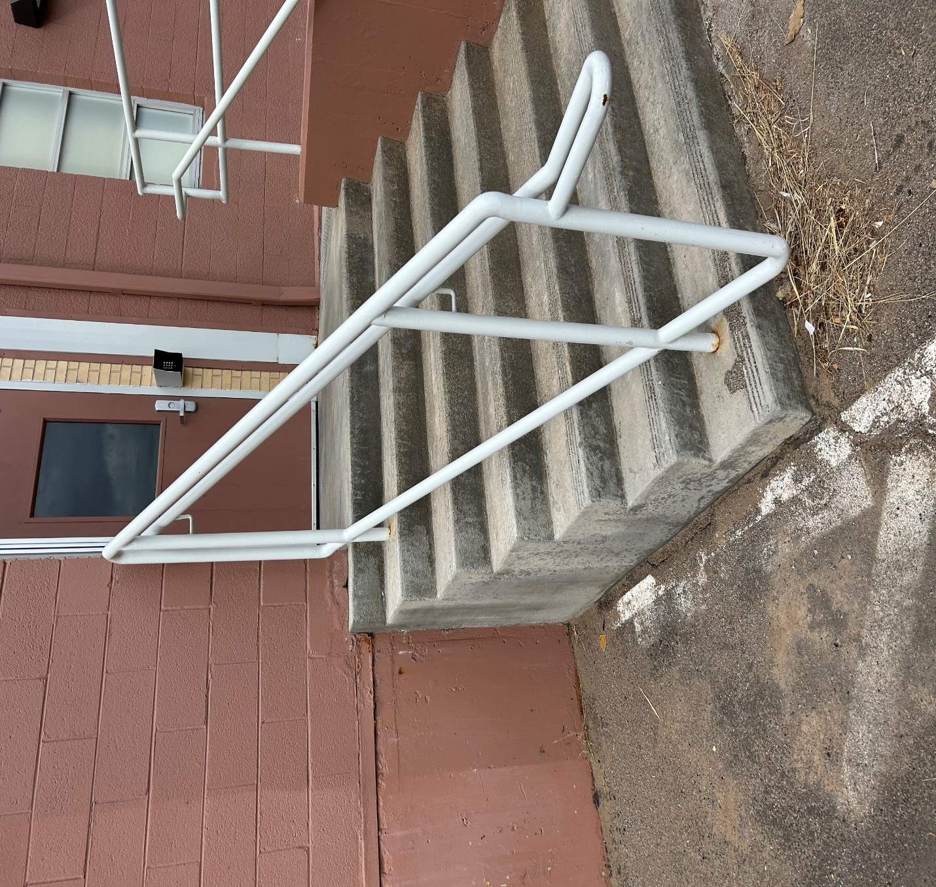

Building 3 Front Entrance Handrails

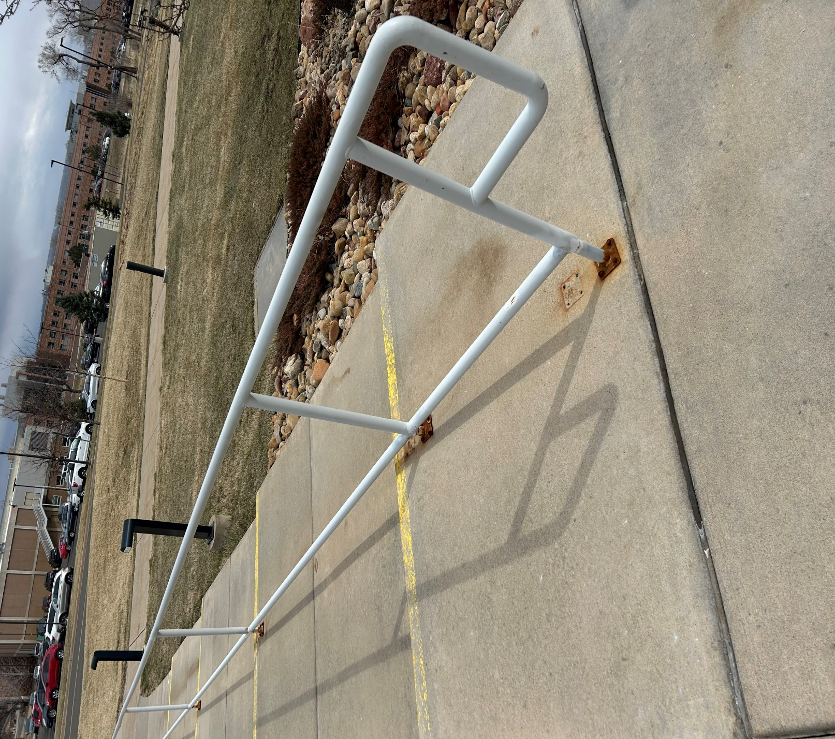

Building 3 Front Entrance Handrails

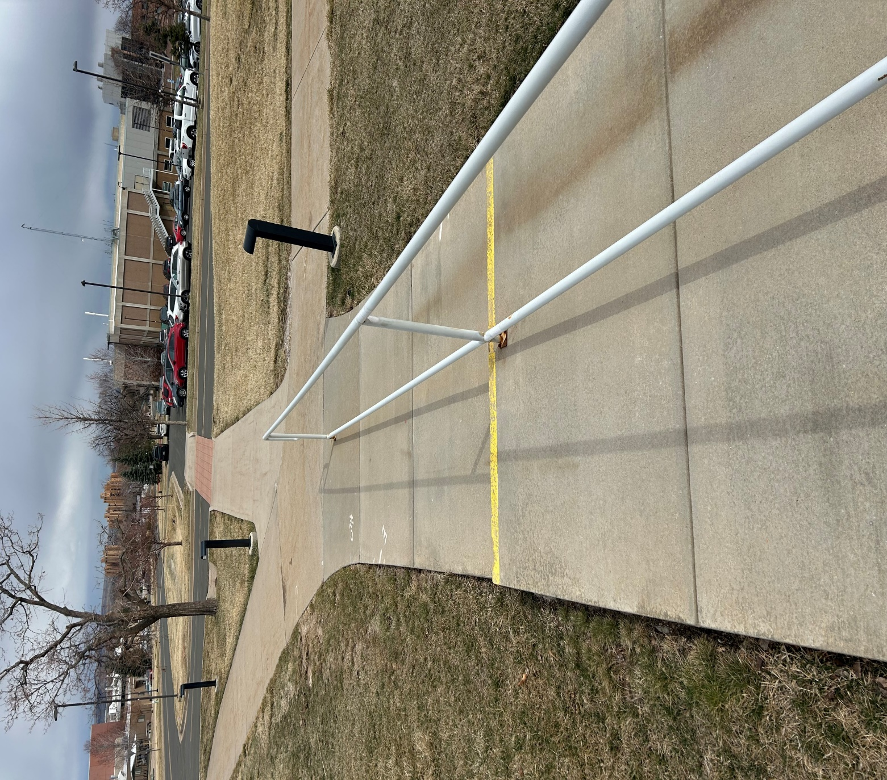

Building 1 Wing 3 Ramp Guardrails

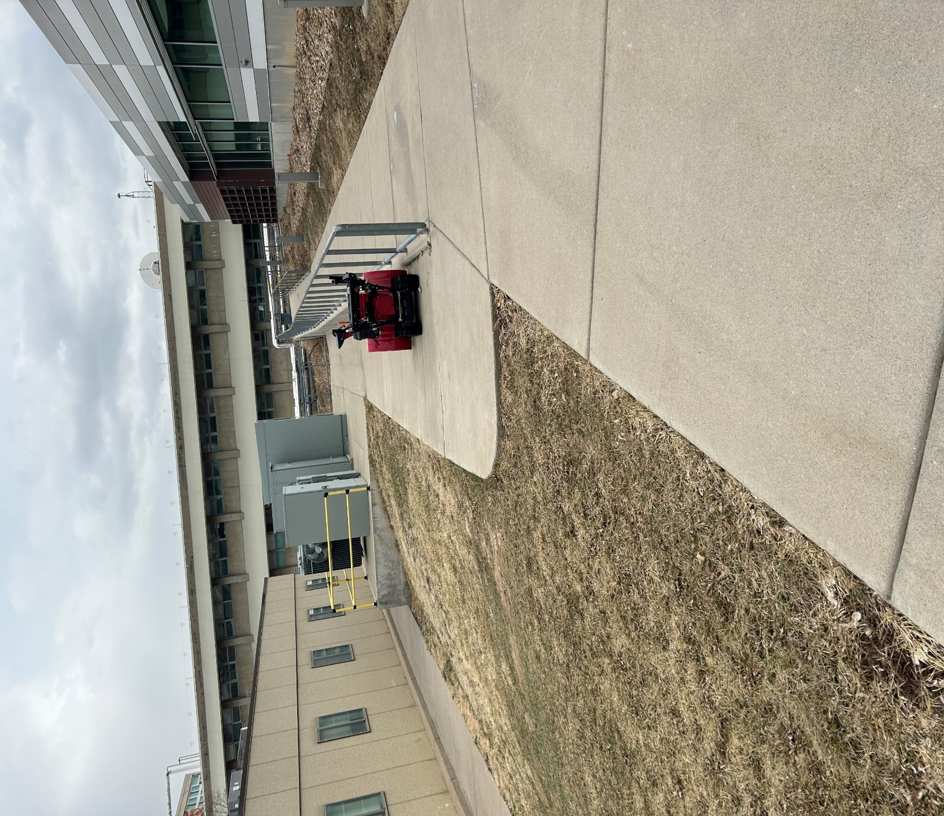

Building 1 Annex D Guardrails
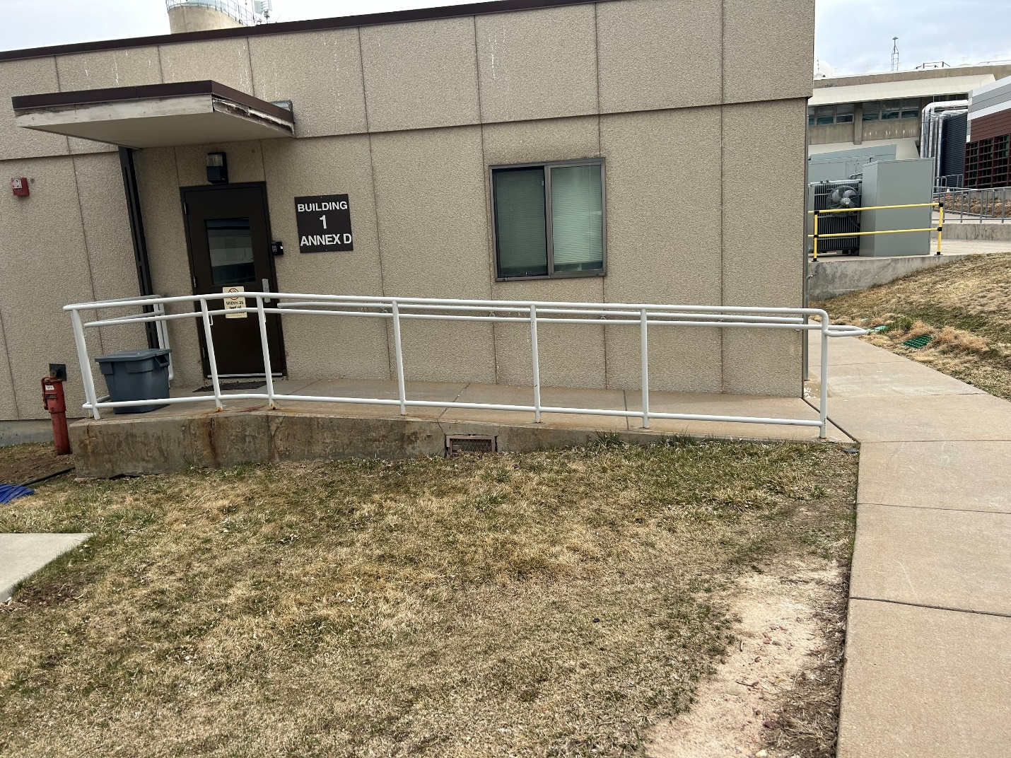

Wing 6 Dock Stairs and Handrail

