THERE IS NO SOLICITATION AT THIS TIME. This is a Sources Sought Notice (SSN) only and does not constitute a request for proposals. Submission of any information in response to this SSN is purely voluntary. The Government assumes no financial responsibility for any costs incurred associated to this SSN.

Notice: This notice is for market research purposes for a potential opportunity. This notice is not a solicitation for offers, nor is it a request for proposals. The purpose of this notice is to identify potential sources and suitable locations and is not intended to pre-qualify or disqualify any potential offers. The Government will not pay for any costs incurred because of this notice. The Government cannot provide any warranty, expressed or implied, as to the accuracy, reliability, or completeness of contents of the furnished information found within this advertisement. Respondents are advised that the Government assumes no responsibility to award a lease based upon responses to this notice.
Description: The VA seeks to lease approximately 4,833 American National Standards Institute/Building Owners and Managers Association (ANSI/BOMA) Occupant Area (ABOA), not to exceed 5,166 Rentable Square Feet (RSF) of real property space in Columbus, GA for use as a Vet Center for a term up to 20 years (firm and soft). Space must be contiguous, outside 100-year flood plain, and VA prefers space located on the first floor; space must be accessible by elevators if not on first floor. The Department of Veterans Affairs will consider existing space that complies with all current building, seismic, and ADA code requirements. On-site, 25 total dedicated parking spaces including designated ADA compliant spaces are required
Delineated Area:
Space within or fronting on the following boundaries will be considered:
- South: Andrews Rd
- West: Schatulga Rd
- North: US 85
- East: US 280
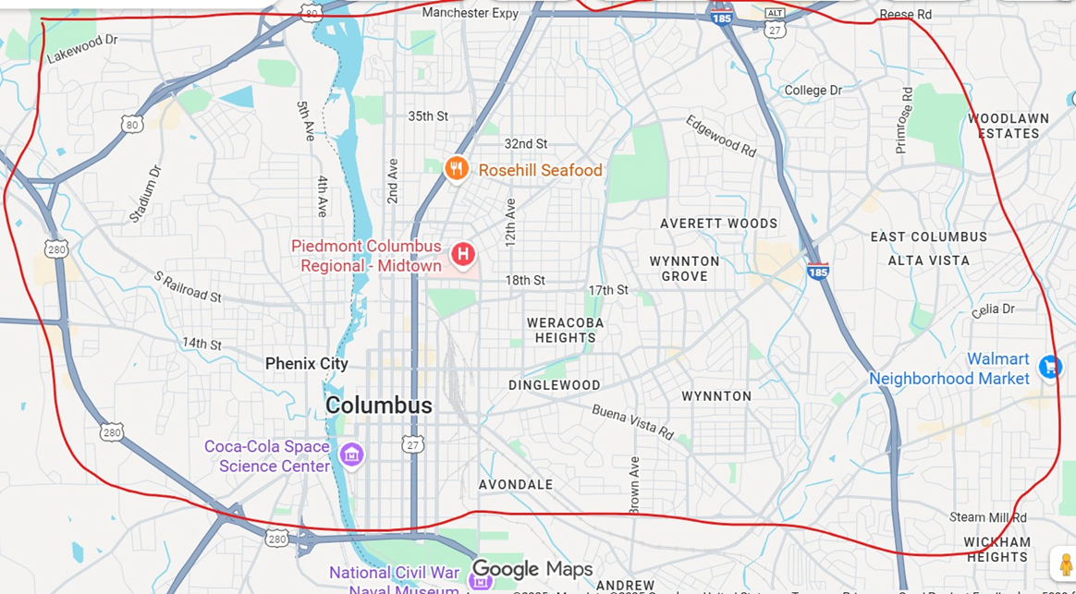

The following is an estimate of needed rooms/space:

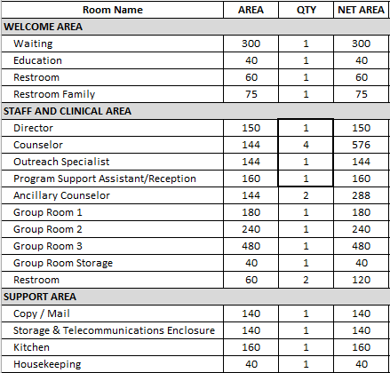
Access to public transportation shall be located within the immediate vicinity of the building, but generally not to exceed a walkable one mile as determined by the Lease Contracting Officer. Alternatively, two or more public or campus bus lines shall be located within the immediate vicinity of the building, but generally not to exceed a walkable mile.

Space shall be located on the first floor; space must be accessible by elevators if not on first floor. Proximity to gun stores, pawn shops, adult entertainment clubs, liquor stores, medical (or otherwise) marijuana distributors or methadone clinics are precluded within a walkable mile of the building.
All interested parties are invited to respond to this SSN. Expressions of Interest must be submitted to the Lease Contract Specialist, Ashley Saeler (Ashley.Saeler@va.gov), electronically by the deadline publicized in the Sources Sought Notice and must include the following information:

- Building name, address, and location of available space; or address and location/acreage of location to be developed
- Amount of available space in Rentable Square Feet (RSF) and American National Standards Institute/Building Owners and Managers Association (ANSI/BOMA) Occupant Area (ABOA)
- Building ownership information, brokers or legal representatives must show written acknowledgement and permission to represent the property
- Amount of parking available on-site
- Business socio-economic category if other than a large business
The Capabilities Statement Requirements below apply to SDVOSB and VOSB Firms:
SDVOSB and VOSB firms are invited to provide information in response to this SSN to
contribute to the market research for this project. SDVOSB and VOSB firms must be registered
in SBA’s Small Business Search (SBS) site at https://search.certifications.sba.gov/
and have the technical skills and financial capabilities necessary to perform the stated
requirements. Only SDVOSB and VOSB firms are requested to submit a Capabilities Statement
to VA for review. SDVOSB and VOSB firms may provide a Capabilities Statement if they are
interested in participating in this project
Capabilities Statement Will Include:
- Company name, address, point of contact, phone number, System for Award Management identification (if registered at www.SAM.gov), and e-mail address
- Evidence of SDVOSB or VOSB status through registration through SBA’s Small Business Search (SBS) at https://search.certifications.sba.gov/
- Evidence of ability to offer under NAICS Code 531120 and listing in the System for Award Management (www.SAM.gov), including a copy of the representations and certifications made in that system
- A summary describing up to three (3) projects of similar size and scope completed in the past five (5) years that demonstrate your company’s experience designing, constructing, and managing Federal leased facilities or health care facilities relevant to the project described above. (3-page limit)
- Evidence of capability to obtain financing for a project of this size.
- If desired, the company may also submit a narrative describing its capability.
The Government is limited by law (40 USC 278a, as Amended 10-1-81) to pay no more than the appraised fair rental value for space.

