SUBJECT* | Toledo Vet Center (New/Replacing)

GENERAL INFORMATION
CONTRACTING OFFICE’S ZIP CODE* | 46240
SOLICITATION NUMBER* | 36C250-25-AP-5880
BASE NOTICE TYPE | P
RESPONSE DATE/TIME/ZONE | 12-05-2025 13:00 EASTERN TIME, NEW YORK, USA
ARCHIVE | 99 DAYS AFTER THE RESPONSE DATE
RECOVERY ACT FUNDS | N
SET-ASIDE
PRODUCT SERVICE CODE* | X1DB
NAICS CODE* | 531120
CONTRACTING OFFICE ADDRESS | Department of Veterans Affairs  Network Contracting Office 10  8888 Keystone Crossing  Suite 325  Indianapolis IN 46240
POINT OF CONTACT* | Lease Contract Specialist  Lisa Newlin  Lisa.Newlin@va.gov  317-697-9786  Lee.Grant@va.gov  Lori.Howard@va.gov

PLACE OF PERFORMANCE
ADDRESS
 | Toledo Ohio
POSTAL CODE
COUNTRY | USA

ADDITIONAL INFORMATION
AGENCY’S URL | https://www.va.gov/
URL DESCRIPTION | VA
AGENCY CONTACT’S EMAIL ADDRESS | Lori.Howard@va.gov
EMAIL DESCRIPTION | Point of Contact

DESCRIPTION
PRE-SOLICITATION NOTICE 36C250-25-AP-5880
SAM-NOTICE 36C25025R0118
TOLEDO, OHIO
The U.S. Department of Veterans Affairs (VA) Seeks Expressions of Interest for
5,000 American National Standards Institute/Building Owners & Managers Association (ANSI/BOMA) of Space in Toledo, Ohio

Amended due to the change in Delineated Area. New Delineated Area is as follows. All other requirements in pre-solicitation notice remain the same.
Toledo Vet Center Delineated Map

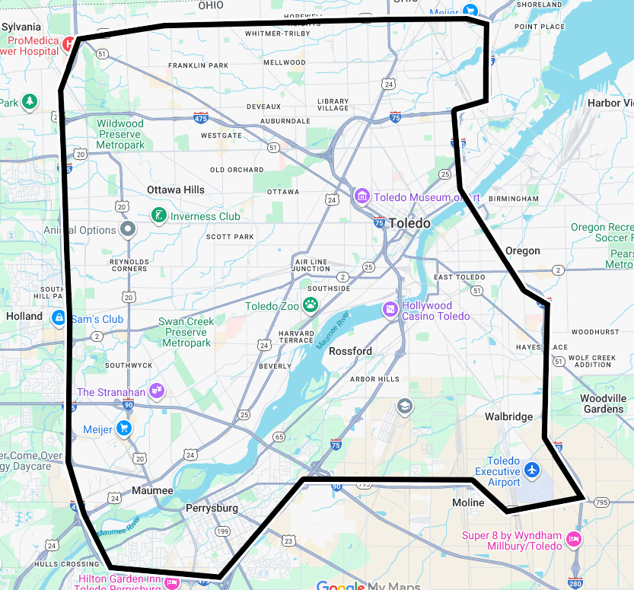

North: Alexis Road / State Route 184
East: I-75 and I-280
South: State Route 795 and I-75
West: I-475

