STATEMENT OF WORK

New Furniture – Purchase/Deliver/Installation

Black Hills National Cemetery
National Cemetery Administration
20901 Pleasant Valley Drive,
Sturgis, SD 57785

STATEMENT OF SERVICES: This project involves procuring, manufacturing, delivering, and installing all new office furniture (desks, cubicles, conference room furniture, lunchroom furniture, chairs, wardrobe lockers, and supporting storage shelves) to ensure veteran and administrative safety and a healthy work environment. The furniture will be used in the cemetery Administration Building to support Veterans area that serves our Veterans in support of the National Cemetery Administration, Black Hill National Cemetery.

PROJECT OVERVIEW: It is the responsibility of the contractor to abide by all local ordinances governing the project location.

This Project Includes: See Product Data (below) for room-by-room minimum technical requirements.

Work Requirements:

- Contractors must have valid identification.
- Leave all work areas in clean and orderly conditions.

Installation Timeframe:

- To be coordinated by the CO/COR, or their appointee.
- To be completed during the hours of 8:30AM-4:00PM (adjusted/modified as needed, approved by the CO/COR or Appointee).

Manufacturing Requirements:

- The manufacturer shall be expected to provide commercial furniture.
- Manufacturers shall meet the design, manufacturing, and warranty requirements as outlined in these specifications.
- Lead time should be within the industry standard of 6-8 weeks from receipt of order. Please notify POC on to expected manufacturing lead times.

Delivery Requirements:

- Indicated by Contracting Officer (CO)/Contracting Officer’s Representative (COR).
- Products to be stored by manufacturer/dealer and be delivered/installed to the NCA specific site when date/schedule is approved by CO/COR.
- Delivery method includes trucks direct to site, contractor removal, loading and disposal of old excess furniture, new furniture unpackaged, installed and trash taken away, etc.

Installation Requirements:

- Coordinate delivery and installation of items with the CO/COR.
- The installation shall occur Monday -Friday between the hours of 8:30 AM- 4:00 PM.
- Installation: Ideal completion date: 90 Days after receipt of order (ARO).
  - Products to be stored by manufacturer/dealer and be delivered to the NCA jobsite when date approved by CO/COR. The vendor is to contact the CO/COR to schedule delivery - to confirm the date, time, and the location.
  - Protect doors, doorways, and corridor walls during delivery.
  - All services shall be delivered by certified technicians in accordance with manufacturer's recommended instructions.
  - Contractors must be able to complete each room and demobilize according to the expected and approximate timeframes. Contractor must supply detailed staffing and project schedule for each phase of this project.
  - Contractor is responsible for repair of these areas for any damage caused by the Contractor.
  - All packaging material and debris shall be removed from the site and properly disposed of by the Contractor.
  - Any defects in material from installation shall be repaired and damaged products that cannot be satisfactorily repaired shall be replaced.
  - Once installation is complete and prior to the punch list walk-through, all products shall be cleaned and dusted, and the area shall be left in a neat, clean condition and ready for occupancy.
  - A punch list walk through shall be performed with the COR. Items on the punch list shall be noted and a response to the completion time (expected date of completion) of each item shall be provided from the contractor.

Design Efforts Required:

- The VAMC Interior Designer has completed the programming and interior design selection for supplying and installing furniture, fixtures, and equipment for the Administration Building, and Maintenance Building located at Black Hills National Cemetery.
- The specification sheets indicate that a specific product or equal are required for this project.
- Floor Plans are submitted separately.

Vendor Responsibility:

- Vendor is responsible for any damage to products/NCA property until CO/COR has accepted complete installation of products.
- Vendor must ensure protection of products/NCA property by guaranteeing the repair/replacement of any damages to said product/NCA property.

Warranty: Provided warranty information must indicate the warranty length, terms of coverage, and

the usage that warranty covers, and must meet or exceed the following criteria:

- Industry standard minimum of 10 years.
- Includes all components and moving mechanisms.
- Warranty work is performed on location at manufacture's expense.
- Warranties shall be signed by the Contractor’s authorized representative. Warranties accompanied by document authenticating the signer as an authorized representative of the guarantor, shall be presented to the owner upon the completion of the project.
- The vendor shall guarantee that the products are free from any defects in workmanship from the date of delivery/installation.

GENERAL PRODUCT REQUIREMENTS:

All finished surfaces shall be free of scratches, marks, dents, or blemishes, and withstand staining, and exhibit flaking, cracking, or loss or adhesion. Furnishings shall have smooth finishes with no hazardous projections, sharp comers, or detail, which can be hazardous and cause personal injury or damage to clothing.

All products and components will be new; refurbished products will not be accepted.

Substitutions of the finishes shown/identified in the General Requirements section shall not be accepted.

Pricing shall include these exact finishes and colors or as chosen by the CO/COR.

All contracted personnel must always have identification on them while on site.

It is the responsibility of the vendor to confirm correct quantities prior to order.

All finishes to be confirmed prior to manufacturing/delivery by CO/COR.

Contractor must supply detailed staffing and project schedule for this installation.

After award, vendor shall be able to field verify the install site. Any modification after award shall be approved by the NCA Contracting Officer and POC/COR prior to order/implementation.

BASIS OF DESIGN:

PRODUCT REQUIREMENTS: Standard equipment for this furniture package should meet the following specifications:

- Maintain a consistent or complimentary color scheme in neutral tones (such as tan, gray, greige, etc.), avoid red or red-orange shades to ensure harmony with the paint color palette shown below. Final color TBD by COR.

Paint color palette:


Preferred furniture color examples:

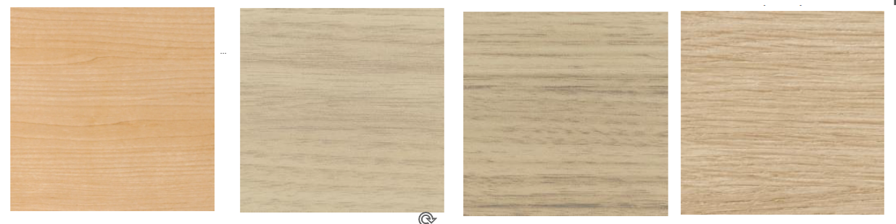

- All fabrics and materials used should be durable, stain-resistant, and easy to clean, ensuring they withstand normal wear and tears.
- Desktop workstations should feature high-pressure laminate finish in a neutral color. Final colors will be determined by COR or cemetery director upon award.
- Requirements per room are as follows:

ADMINISTRATIVE BUILDING 1001

Room 2 (Lobby):

MD1-Reception Counter includes (2) 24” D x 72” W Reception Shells-Laminate with 12” high acrylic Divider w/Laminate transaction counters or (2) Reception set-on with Sliding Doors. FINISHES: TBD
Three (3) | WSG1-Guest Chairs, Metal frame w/ Wall Saver & Clean Out, Vinyl Seat/Back & Urethane Arm Caps. FINISHES: TBD
One (1) | Under desk lateral File, Locking
One (1) | File/File, locking, reception furniture & wall
 | Trim Filler (if needed for reception desk between wall and door

Room 3 (Admin Office):

One (1) | MD1 – Desk, Single Pedestal (BBF) RH, 30” D x 72” W, Grommet LH location. FINISHES: TBD
One (1) | HAW3 – Desk, Adjustable Height (Electric), 24” x 48”, HPL, includes under desk wire management, power unit, clamp on w/ Outlets & USB. FINISHES: TBD
One (1) | MD1 - Credenza, 24” x 72”, LH lateral. FINISHES: TBD
One (1) | MD1 - Overhead hutch, 72” x 36” High, closed w/ doors, locking. Tackboard, mounted on overhead hutch. Task light, mounted under hutch. FINISHES: TBD
One (1) | SC2- Tower, 30” W x 24” D x 66” H, Wardrobe, LH, File/File & Shelves w/Door RH. FINISHES: TBD
One (1) | TS1 - TASK CHAIR, Mid-Back, 4D T-arms, Sliding Seat, Mesh Mid Back, Left, Right or Both side Lumbar Support, Pneumatic Height Adjustable, Upholstered or Mesh Seat, Soft Floor Casters for hard floor surface. FINISHES: TBD
Two (2) | GC1 – Side Chair, Arms, Mesh Back w/ Vinyl seat.

Room 4 (Director’s Office):

One (1) | MD1 – Desk, Single Pedestal (BBF) RH, 30” D x 72” W, Grommet LH location. FINISHES: TBD
One (1) | HAW3 – Desk, Adjustable Height (Electric), 24” x 48”, HPL, includes under desk wire management, power unit, clamp on w/ Outlets & USB. FINISHES: TBD
One (1) | MD1 - Credenza, 24” x 72”, LH lateral. FINISHES: TBD
One (1) | MD1 - Overhead hutch, 72” x 36” High, closed w/ doors, locking. Tackboard, mounted on overhead hutch. Task light, mounted under hutch. FINISHES: TBD
One (1) | SC2- Tower, 30” W x 24” D x 66” H, Wardrobe, LH, File/File & Shelves w/Door RH. FINISHES: TBD
One (1) | TS1 - TASK CHAIR, Mid-Back, 4D T-arms, Sliding Seat, Mesh Mid Back, Left, Right or Both side Lumbar Support, Pneumatic Height Adjustable, Upholstered or Mesh Seat, Soft Floor Casters for hard floor surface. FINISHES: TBD
Two (2) | GC1 – Side Chair, Arms, Mesh Back w/ Vinyl seat.

Room 8 (Open Office):

Two (2) | HAW3 – 30” x 48” Adjustable Height Desk w/ Grommets & Wire Management, includes Worksurface power unit w/ outlets & USB. FINISHES: TBD
Two (2) | MD1 – Desk Shell, Laminate, 24” x 72” w/grommets. FINISHES: TBD
Two (2) | MD1 - 72" (FLT) SURFACE MOUNTED HUTCH. FINISHES: TBD
Two (2) | MD1 - Mobile File, Box/Box/File. FINISHES: TBD
Two (2) | MD1 – Overhead Hutch, 72” wide w/Doors, locking. Tackboard, Mounted on Overhead Hutch. Task light, Mounted under hutch. FINISHES: TBD
MSP2- Panels, Frames, Tiles, Glass Stacker to include:
One (1) | 24” Full or Segmented Tackable.
Three (3) | 28” Segment Panel with Glass Stacker (Approx 12”)
Two (2) | 30” Segmented Panel with Glass Stacker (Approx 12”)
 | **Panels 64”-72” High (Including Glass Stacker)
Two (2) | Tower, 24” x 24” w/Wardrobe, File/File, Shelves w/door, 1 LH Wardrobe, 1 RH Wardrobe. FINISHES: TBD
Two (2) | TS2 - TASK CHAIR, Mid-Back, 4D T-arms, Sliding Seat, Mesh Mid Back, Left, Right or Both side Lumbar Support, Pneumatic Height Adjustable, Upholstered or Mesh Seat, Soft Floor Casters for hard floor surface. FINISHES: TBD
Room 9 (Admin Office):

One (1) | HAW3-Desk, Adjustable Height, Electric, 30” x 48”, HPL, includes under desk wire management, power unit, clamp on w/ Outlets & USB. FINISHES: TBD
One (1) | MD1 – Desk/Credenza Shell, 24” x 72”. FINISHES: TBD
One (1) | MD1- Mobile File, Box/Box/File.
One (1) | MD1-Overhead Hutch, 72” x 42.5 H, 2 doors & Open Center. FINISHES: TBD
One (1) | SC2-Tower, 24” x 24” w/wardrobe, file/file, shelves w/door, LH Wardrobe. FINISHES: TBD
One (1) | TS2 - TASK CHAIR, Mid-Back, 4D T-arms, Sliding Seat, Mesh Mid Back, Left, Right or Both side Lumbar Support, Pneumatic Height Adjustable, Upholstered or Mesh Seat, Soft Floor Casters for hard floor surface. FINISHES: TBD

Room 13 (Multipurpose Breakroom):

One (1) | DT1- Table, 26” Diameter, Round, PVC Edge, HPL, Metal Base. FINISHES: TBD
Four (4) | TS2 – Task Chair, Arms, Mesh Back. FINISHES: TBD

Room 12 (Conference/Training):

Two (2) | CC2-Table, Conference 42” W X 144” L, (3) column metal base or laminate panel base, wire management under top & down table base, (1) power/data/USB Units (LH, RH). FINISHES: TBD
Twelve (12) | TS3-Task Chair, High Mesh Back, Adj Height Arms. FINISHES: TBD

MAINTENANCE BUILDING 3001

Room 1 (Foreman’s Office):

One (1) | TS2 - TASK CHAIR, Mid-Back, 4D T-arms, Sliding Seat, Mesh Mid Back, Left, Right or Both side Lumbar Support, Pneumatic Height Adjustable, Upholstered or Mesh Seat, Soft Floor Casters for hard floor surface. FINISHES: TBD
One (1) | MD2 – Desk Shell, 30” x 71”, HPL Work surface metal Chassis, Grommets. FINISHES: TBD
One (1) | MD2 – Overhead Hutch 72” W, Metal w/Doors. Includes tackboard, task light, Wire Management. FINISHES: TBD
One (1) | HAW3- Adjustable height Desk, 24” x 72”, Electric, Grommets, w/Wire Management. FINISHES: TBD
One (1) | MD2-File-Mobile, Box/Box/File, Metal.
One (1) | MD2-File-Mobile, File/File, Metal.
One (1) | SC1- Tower, 24” W x 24” D, Wardrobe, File Drawers & Shelves w/Door, locking. FINISHES: TBD
Two (2) | GC1-Side Chair, Arms, Mesh Back w/ Vinyl Seat. FINISHES: TBD

Room 1 (Open Office / Training Room):

Three (3) | MD2-Standard 24” x 48” computer desk. FINISHES: TBD
Three (3) | TS2 – Task Chair, Arms, Mesh Back. FINISHES: TBD

Room 14 (Breakroom/Lounge):

One (1) | DC1-Table-Rectangle, 36” x 96”, HPL, Metal Bases. FINISHES: TBD
Two (2) | DC1- Table-Rectangle, 36” x 60”, HPL, Metal Bases. FINISHES: TBD
Sixteen (16) | TS2 – Task Chair, Arms, Mesh Back. FINISHES: TBD
Room 17 (Mechanic’s Office):

Two (2) |  | TS2 – Task Chair, Arms, Mesh Back. FINISHES: TBD
Two (2) |  | MD2-Desk Shell, 24” x 60”, HPL, Work surface Metal Chassis, Grommets. FINISHES: TBD
One (1) |  | MD2-Bullet Table, Freestanding, 24” x 60”, HPL. FINISHES: TBD
Two (2) |  | MD2- File-Mobile, Box/Box/File. Metal.
One (1) |  | MD2-Stack-On Bookcase for Bullet table, 30” W x 36” H, Wood or Laminate, FINISHES: TBD

ROLES AND RESPONSIBILITIES

The Contractor employees shall behave with appropriate decorum, courtesy, and respect while within the Cemetery or at its perimeter or entrances. See Attachment A Dignity Clause for more information.

All personnel delivering material must be trained in NCA rules of behavior and aware of their surroundings at all times to prevent any damage to Government property. Any material that does not meet the minimum technical requirements will not be accepted.

- Protection of Property:

    - The Contractor shall perform an inspection of the buildings and grounds with the COR prior to commencing work. Contractor shall protect all items from damage.
    - The Contractor shall take precaution against damage to the buildings, grounds, and furnishings. The Contractor shall repair or replace any items related to buildings or grounds damaged accidentally, or on purpose due to actions by the Contractor, utilizing materials of the same quality, size, grade and color, to match existing work.
    - To ensure that the contractor shall be able to repair or replace any items, components, on the buildings or grounds damaged due to negligence and/or actions taken by the Contractor.
    - The Contractor shall communicate with the COR to resolve all repairs beyond simple surface cleaning. Concurrence of the COR is required before the Contractor may perform any significant repair work. In all cases, repairs shall utilize materials of the same quality, size, texture, grade, and color to match adjacent existing work.
    - The Contractor shall be responsible for the security of the areas in which the work is always performed prior to completion.
    - The Contractor shall maintain accountability and control of any keys provided and shall return them to the COR upon completion of the work. Contractors shall provide floor protection while working in all NCA facilities. All material handling equipment shall have rubber wheels.

- Delivery:

    - Contractor shall contact the COR at least 14 business days prior to the start of work/shipping to ensure that the building is ready for installation.
    - In the event there is a delay in delivery, Contractor must notify the assigned COR immediately in writing, preferably via email.
    - Contractor shall provide the COR with scheduled date and time that the delivery truck will be arriving at least 24 hours minimum in advance.
    - Contractor must ensure that the driver of the delivery vehicle has copies of the Bill of Materials/ delivery orders and shall not attempt to deliver any items before the scheduled delivery date.

- Receive and Unload:

    - If the Contractor is unable to complete the assembly and placement of all unloaded items before the end of the workday, the Contractor will be responsible for moving these items to a secure location, until the next available workday. The Contractor will be responsible for moving the items from the overnight storage site to its designated position in the building.
    - The Contractor shall verify and inspect all items. All deficiencies (damage/overage/shortage) shall be brought to the attention of the assigned CO in writing, preferably via email, immediately upon identification.
    - The Contractor shall store damaged items in the location designated by the COR. The Contractor shall maintain a complete file of all documents relating to each discrepancy and copies of all Discrepancy Reports shall be forwarded to the COR daily.
    - Contractor shall repair or coordinate with the COR for replacement of damaged, defective, or missing items.

- Assembly and final acceptance:

    - Contractor shall be responsible for all safety and security guidelines within the area in which work is being performed, to include securing any contractor-owned tools or equipment, and any on-site storage being utilized.
    - The contractor shall install all items in accordance with each requirement statement and basic component floor plan, panel plan and electrical plan, designed and provided by the contractor with each task order.
    - Contractor shall uncrate all items received and perform all required assembly in accordance with the manufacturers' instructions.
    - Contractors shall prevent its personnel from entering any area other than the designated work area.
    - The Contractor shall maintain a means of egress within all designated work areas to comply with fire codes.
    - Contractor shall inspect to ensure that the furniture is free of surface dirt, clean and polished, free of defects, and that the installation is complete and ready for use.
    - The Contractor shall do a final walkthrough with COR and provide a punch list before releasing crew for the day.

- Jobsite Cleanliness:

    - Contractor will be responsible for the removal and disposal of all trash/debris connected with uncrating and assembling all items installed under this contract.
    - Final Acceptance by the Government will not occur until all installed items have been wiped cleaned and debris/dust connected with installation is removed from the NCA site.
    - Recyclable cardboard products shall be disposed of in accordance with applicable statutes, in respective containers. The contractor is responsible for providing trash containers at an offsite facility.
    - Packing materials will not be stored in the buildings for any period exceeding 24 hours. The Contractor shall ensure its personnel eat, drink, or smoke only in designated areas.
    - Personal trash (food wrappers, drink containers, etc.), shall be removed from the site daily by the Contractor.

- Warranty Items:

    - The warranty for an item is to start on the date of acceptance of the products/services by the Government COR.
    - The Contractor agrees to furnish, without cost to the Government, replacement of all parts and material which are found to be defective during the warranty period. The cost of installation and travel of replacement material and parts shall be borne by the Contractor.

LIST OF ATTACHMENTS

a. Attachment A - Cemetery Map
b. Attachment B - Floor Plans

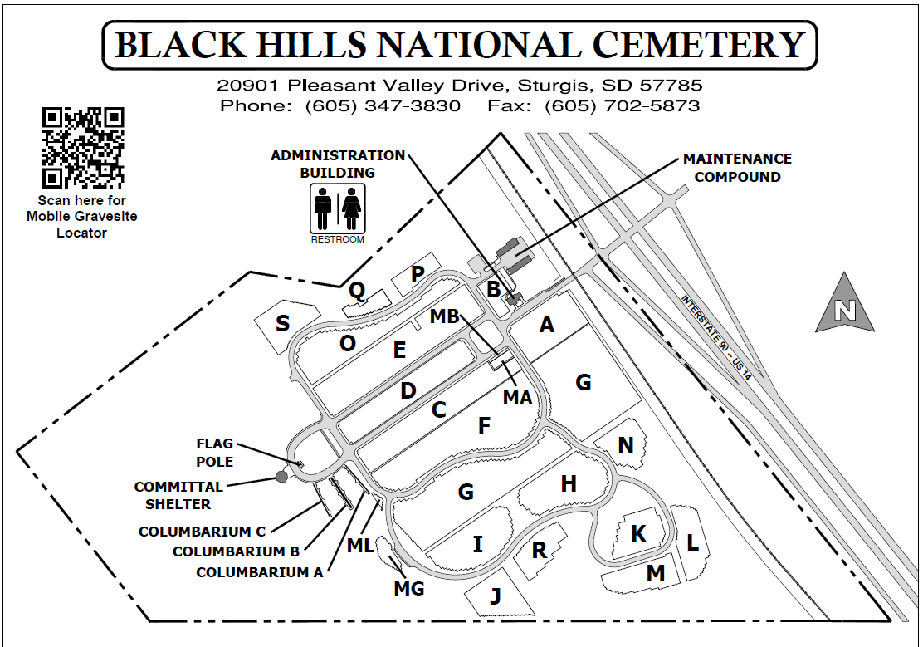

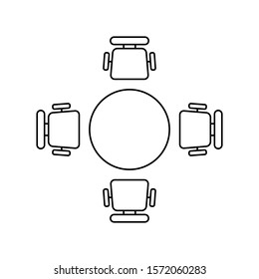
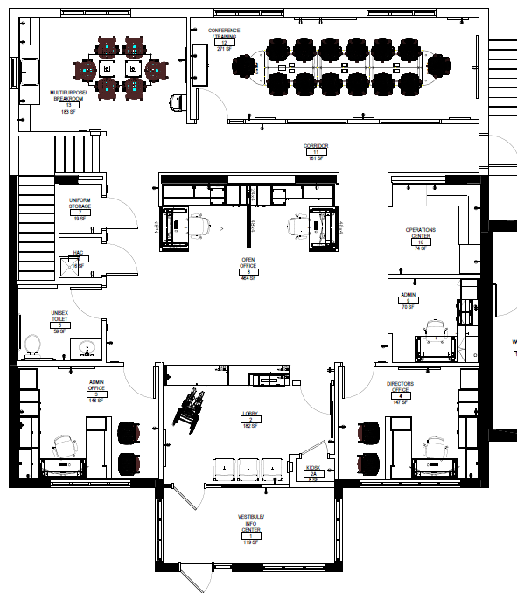
ADMINISTRATIVE BUILDING 1001

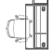
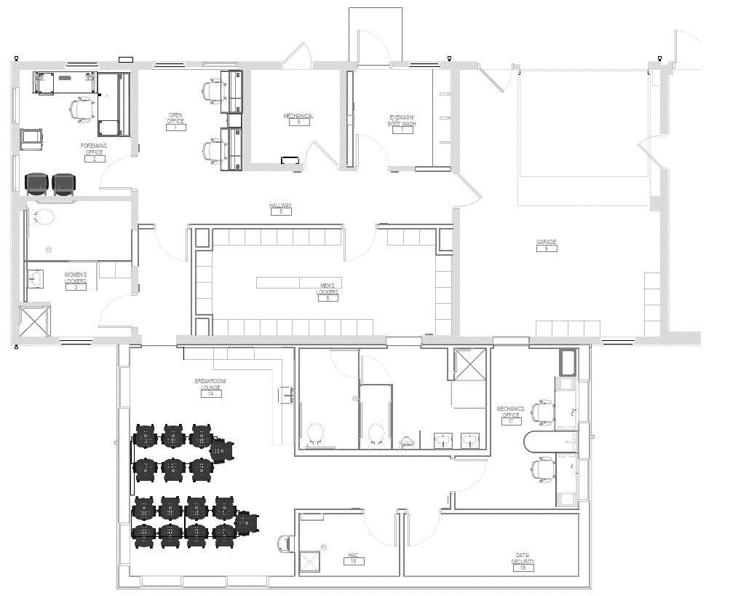
MAINTENANCE BUILDING 3001

