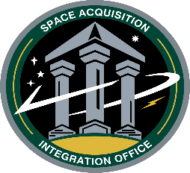
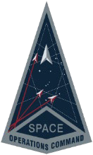
Commercial and Military Satellite Communications Operations Support (COSMOS)

Virtual Industry Day
Vendor Registration
Presented by: Space Operations Command Space Acquisition and Integration Office (SpOC/SAIO)

Company Name:
Primary POC Name |  | Email | Phone

Virtual One-on-One Registration: Please indicate your top three preferences below by annotating the time slot with 1, 2 or 3.
Day 1: 10 June 2025

1430 – 1510 Vendor One-on-One Session
1530 – 1610 Vendor One-on-One Session

Day 2: 11 June 2025

0800 – 0840 Vendor One-on-One Session
0900 – 0940 Vendor One-on-One Session
1000 – 1040 Vendor One-on-One Session
1230 – 1310 Vendor One-on-One Session
1330 – 1410 Vendor One-on-One Session
1430 – 1510 Vendor One-on-One Session

Day 3: 12 June 2025

0800 – 0840 Vendor One-on-One Session
0900 – 0940 Vendor One-on-One Session
1000 – 1040 Vendor One-on-One Session
1230 – 1310 Vendor One-on-One Session
1330 – 1410 Vendor One-on-One Session
1430 – 1510 Vendor One-on-One Session

This section to be completed by the Government
Date received | Initials | Notes
Date company notiﬁed of  One-on-Session Time | Initials | Notes

