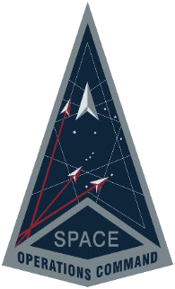

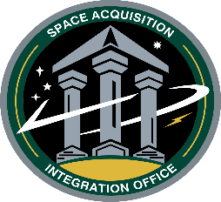
Commercial and Military Satellite Communications
Operations Support (COSMOS)
Virtual Industry Day Agenda
Presented by: Space Operations Command
Space Acquisition and Integration Office (SpOC/SAIO)

Tuesday, June 10, 2025

Time | Event | Speaker
0830 – 0840 | Forum Overview / Rules of Engagement | Ms. Carol Rogers  - COSMOS Program Manager
0840 – 0910 | Opening Remarks / Mission Delta Brief | Col Jeffrey Weisler  - DEL 8 Commander
0910 – 0920 | SAIO Overview | Ms. Nicole Pilato  - SAIO Deputy Director for Program  Management
0920 – 0930 | Project Overview  COSMOS Program Overview | Ms. Carol Rogers  - COSMOS Program Manager
0930 – 1015 | Mission Partner Brief  and Q&A | Mr. Eric McCullough  - COSMOS COR  Mr. Vincent Yacono  - COSMOS Alternate COR
Break (15 min)
1030 – 1100 | Contract Scope  PWS Highlights | Ms. Carol Rogers  - COSMOS Program Manager
1100 – 1200 | COSMOS Acquisition & Solicitation Overview and Q&A | Ms. Carol Rogers  - COSMOS Program Manager  Ms. Christina Ming  - COSMOS Contracting Officer
1200 – 1330 | Lunch break
1330 – 1400 | Discussion Panel – Responses to Submitted Questions
1400 – 1600 | Individual One-On-One Sessions

Virtual One-On-One Sessions continue on Jun 11 – 12, 2025

as scheduled by the government.

