SUBJECT* | Toledo Vet Center (New/Replacing)

GENERAL INFORMATION
CONTRACTING OFFICE’S ZIP CODE* | 46240
SOLICITATION NUMBER* | 36C250-25-AP-5880
RESPONSE DATE/TIME/ZONE | 10-29-2025 15:00 EASTERN TIME, NEW YORK, USA
ARCHIVE | 99 DAYS AFTER THE RESPONSE DATE
SET-ASIDE
PRODUCT SERVICE CODE* | X1DB
NAICS CODE* | 531120
PLACE OF PERFORMANCE
 | Toledo Ohio
POSTAL CODE
COUNTRY | USA
CONTACT INFORMATION
CONTRACTING OFFICE ADDRESS | Department of Veterans Affairs  Network Contracting Office 10  8888 Keystone Crossing  Suite 325  Indianapolis IN 46240
POINT OF CONTACT* | Lease Contract Specialist  Lisa Newlin  Lisa.Newlin@va.gov  317-697-9786  Lee.Grant@va.gov  Lori.Howard@va.gov
ADDITIONAL INFORMATION
AGENCY’S URL | https://www.va.gov/toledo-vet-center/
URL DESCRIPTION | Toledo Vet Center
AGENCY CONTACT’S EMAIL ADDRESS | Lori.Howard@va.gov
EMAIL DESCRIPTION | POC

DESCRIPTION
PRE-SOLICITATION NOTICE 36C250-25-AP-5880
SAM-NOTICE 36C25025R0118
TOLEDO, OHIO
The U.S. Department of Veterans Affairs (VA) Seeks Expressions of Interest for
5,000 American National Standards Institute/Building Owners & Managers Association (ANSI/BOMA) of Space in Toledo, Ohio

Notice: This advertisement is a notice of a potential opportunity. This advertisement is not a solicitation for offers, nor is it a request for lease proposals. The purpose of this advertisement is to identify potential sources and suitable locations and is not intended to pre-qualify or disqualify any potential offers. The Government will not pay for any costs incurred as a result of this advertisement. An RLP may or may not be released. The Government cannot provide any warranty, expressed or implied, as to the accuracy, reliability, or completeness of contents of the furnished information found within this advertisement; Government is under no obligation to respond to and is unable to answer any inquiries regarding this advertisement. The NAICS Code is 531120 Lessors of Nonresidential Buildings, and the small business size standard is $34 Million.
The Department of Veterans Affairs (VA) IS ALSO conducting market research, seeking capable sources that are classified and registered at https://veterans.certify.sba.gov/ as either Service Disabled Veteran Owned Small Business (SDVOSB) or Veteran Owned Small Business (VOSB) that are interested in leasing space to the Department of Veterans Affairs.
Respondents are advised that the Government assumes no responsibility to award a lease based upon responses to this advertisement.
Contracting Office Address: Network Contracting Office 10, Suite 325 - 8888 Keystone Crossing Indianapolis, IN 46240
Description: The Department of Veterans Affairs seeks to lease 5,000 ABOA square feet (SF) of space and 30 parking spaces with 8 being ADA compliant for use by the VA as a Veteran Center. The space shall be located within the delineated area stated below. VA will consider space located in an existing building as well as a building being constructed for multi-tenant use and not specifically a build-to-suit for VA use only. Public Utilities shall be available onsite. ABOA is generally defined as the space remaining once common areas, lessor areas, and non-programmatic areas required by code are deducted from the rentable square feet of the facility. ABOA does not include areas such as stairs, elevators, mechanical and utility rooms, ducts, shafts, vestibules, public corridors, and public toilets required by local code.
VA will provide all detailed definitions, should a solicitation for offers or request for proposals be issued for this project.
Lease Term: Not to Exceed 20 years.
Delineated Area: To receive consideration, submitted properties must be located within the following area described below, which is bound by the following roads, or must front on any of the following boundary lines:
North: Alexis Road / State Route 184
South: I-75, I-280, State Road 25
East: State Road 24
West: I-475

See the below-delineated area map for further clarification of the boundaries of the delineated area.
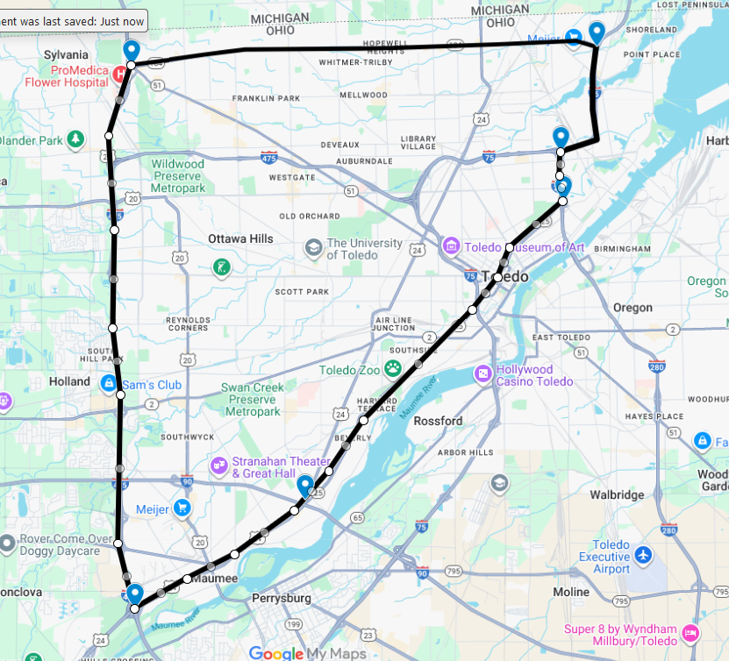

ADDITIONAL REQUIREMENTS FOR SUBMISSIONS:
- Offered Space must be located within one building.
- Offered Space should preferably be located on the first (1st) floors and one single floor.
- If the offered space is above the first (1st) floor, a minimum of one (1) passenger elevator and one (1) combination (passenger/freight) elevator must be provided.
- Bifurcated sites, inclusive of parking, are not permissible.
- The following space configurations will not be considered: Space with atriums, extremely long or narrow runs of space (more than twice as long as wide), irregularly shaped space configurations or other unusual building features adversely affecting usage.
- Column size cannot exceed two (2) feet square and space between columns and/or walls cannot be less than twenty (20’) feet
- Offered space cannot be in the FEMA 1-percent-annual-chance floodplain (formerly referred to as 100-year floodplain)
- Offered space must be zoned for VA’s intended use by the time initial offers are due.
- Offered space will not be considered if located in close proximity to a property with incompatible uses, including but not limited to the following uses: liquor establishments, dispensaries, treatment centers, correctional facilities, where firearms are sold/discharged, railroad tracks, or within flight paths.
- Offered space will not be considered if located in close proximity to residential or industrial areas.
- Offered space must be located in proximity to public transportation. A commuter rail, light rail, or bus stop shall be located within the immediate vicinity of the building;
- Offered space will not be considered if the location is irregularly shaped.
- Space will not be considered where apartment space or other living quarters are located within the same building.
- Offered space must be located in close proximity to amenities including but not limited to restaurants, hotels, pharmacies, and shopping.
- Offered space must be located in close proximity to a hospital or stand-alone emergency room center and a fire department;
- Offered space must be easily accessible to multiple major highways which provide multiple routes of travel;
- Structured parking under the space is not permissible.
- Offered space must meet Federal and Local Government requirements for fire safety, physical security, accessibility, seismic, and sustainability standards per the terms of the solicitation for offers or requests for proposals.
- A fully serviced lease is required.
- Offered space must be compatible with VA’s intended use.

ALL SUBMISSIONS MUST INCLUDE THE FOLLOWING INFORMATION:
- Name and address of current property owner;
- Address or described location of building;
- Location on a map, demonstrating the building lies within the Delineated Area; A statement as to whether the building lies within the Delineated Area;
- Description of ingress/egress to the building from a public right-of-way;
- Description of the uses of adjacent properties;
- FEMA map of location evidencing floodplain status;
- A description of any planned land development or construction that will affect the site, including neighboring projects and road/utility line construction;
- A document indicating the type of zoning;
- A description of any changes to the property necessary to be compatible with VA’s intended use;
- Building owners shall provide evidence of ownership. Non-owners (e.g. prospective developers/lessors) submitting a building shall provide evidence of permission or authority granted by the property owner to submit the building to VA for development;
- Any information related to title issues, easements, and restrictions on the use of the building;
- A statement indicating the current availability of utilities serving the proposed space or property.
- If you are qualified as a Veteran Owned Small Business (VOSB) or Service-Disabled Veteran Owned Small Business (SDVOSB) under NAICS Code 531120 Lessors of Nonresidential Buildings with a small business size standard of $34 million, please read the below attachment, entitled, “VOSB or SDVOSB Status”. You are invited, but not required to submit a Capabilities Statement;

Market Survey (Estimated): November or December 2025
Occupancy (Estimated): FY 2026-2027
All interested parties must respond to this advertisement no later than October 29, 2025, at 3:00 P.M. LOCAL TIME.
Please submit your response (electronic) to: Lisa Newlin – Lisa.Newlin@va.gov
Lee Grant– Lee.Grant@va.gov
Lori Howard– Lori.Howard@va.gov

Attachment - VOSB or SDVOSB Status
This is not a request for proposals, only a request for information for planning purposes, and does not constitute a solicitation. A solicitation may or may not be issued.
The NAICS Code for this procurement is [531120 Lessors of Nonresidential Buildings], and the small business size standard is $34 million. Responses to this notice will assist in determining if the acquisition should be set-aside for SDVOSB or VOSB concerns in accordance with 38 USC § 8127.
The magnitude of the anticipated construction/buildout for this project is:
__ (a) Less than $25,000;
__ (b) Between $25,000 and $100,000;
__ (c) Between $100,000 and $250,000;
__ (d) Between $250,000 and $500,000;
__ (e) Between $500,000 and $1,000,000;
__ (f) Between $1,000,000 and $2,000,000;
__ (g) Between $2,000,000 and $5,000,000;
X_ (h) Between $5,000,000 and $10,000,000;
__ (i) Between $10,000,000 and $20,000,000;
__ (j) Between $20,000,000 and $50,000,000;
__ (k) Between $50,000,000 and $100,000,000;
__ (l) More than $100,000,000.

VA makes monthly rental payments in arrears upon facility acceptance and may elect to make a single lump-sum payment or amortize over the course of the firm term for specified tenant improvements. VA makes no progress payments during the design or construction/build-out phases of the project.
Project Requirements: This Pre-Solicitation Notice seeks information from Potential Offerors who are capable of successfully performing a lease contract, including design and construction of the facility described above, for a term of up to 20 years, inclusive of all options, as well as all maintenance and operation requirements for the duration of the lease term, at a fair and reasonable price. More information on VA’s requirements can be found on the Technical Information Library at the following link: https://www.cfm.va.gov/til/leasing.asp .
SDVOSB and VOSB firms are invited to provide information to contribute to the market research for this project. SDVOSB and VOSB firms must be registered in https://veterans.certify.sba.gov/. All business concerns must have the technical skills and financial capabilities necessary to perform the stated requirements. All business concerns are requested to submit a Capabilities Statement if they are interested in participating in this project. A submission checklist and information sheets are provided below for firms to fill out and submit, which will serve as the firm’s Capabilities Statement.

Capabilities Statement:

1. Company name, address, point of contact, phone number, Experian Business Identification Number, and e-mail address;
2. Evidence of SDVOSB or VOSB status through registration at https://veterans.certify.sba.gov/;
3. Evidence of ability to offer as a small business under NAICS Code [531120] and listing in the System for Award Management (www.SAM.gov ), including a copy of the representations and certifications made in that system;
4. A summary describing at least three (3) projects of similar size and scope completed in the past five (5) years that demonstrate your company’s experience designing, constructing, and managing Federal leased facilities or health care facilities relevant to the project described above. (3-page limit); and
5. Evidence of capability to obtain financing for a project of this size.
If desired, the company may also submit a narrative describing its capability.
Although this notice focuses on SDVOSB and VOSB, we encourage all small businesses and other interested parties to respond for market research purposes.

CAPABILITIES STATEMENT
SUBMISSION CHECKLIST AND INFORMATION SHEET

Toledo, OH Lease Pre-Solicitation Notice

Company name: __________________________________________
Company address: __________________________________________
Experian Business ID Number: __________________________________________
UEI Number: __________________________________________
Point of contact: __________________________________________
Phone number: __________________________________________
Email address: __________________________________________
The following items are attached to this Capabilities Statement:
- Evidence of SDVOSB or VOSB status through registration at https://veterans.certify.sba.gov/;
- Evidence of ability to offer as a small business under NAICS Code [531120] and listing in the System for Award Management (www.SAM.gov), with representations and certifications;
- A summary describing at least three (3) projects of similar size and scope completed in the past five (5) years that demonstrate the company’s experience designing, constructing, and managing Federal leased facilities or health care facilities relevant to (input project specific NUSF). (3-page limit); and
- Evidence of capability to obtain financing for a project of this size.

If desired, the company may also submit a narrative describing its capability, not to exceed two (2) pages.

By: _________________________________________________
(Signature)

__________________________________________________
(Print Name, Title, Date)

