

Southwest VA CMOP Performance Work Statement (PWS) –
Tablet Counting Automation Upgrade and Additional New Back Order Finger

Tucson, AZ

Updated - DATE: 20 February 2025
Site: Southwest VA CMOP, Tucson, AZ - 85706

TABLE OF CONTENTS

1. GLOSSARY OF TERMS 5
1.1. General Terms 5
1.2. Operational Terms 6
1.3. Order Type Definitions: 6
1.4. Area Definitions: 7
2. overview 8
2.1. Facility Location 9
2.2. STATEMENT OF NEED 9
2.3. Operation Hours 9
2.4. Confidentiality 9
2.5. Drawings Supplied 10
2.6. Contractor Qualifications 10
2.7. Technical Submissions with the Quotation 10
2.8. Training, Maintenance, and Warranty Submissions 11
2.9. Prices, Risk of Loss, and Title 11
2.10. Exceptions and Alternates 11
2.11. Proposal Contents 12
2.11.1. Attachment 1 - Project Overview 12
2.11.2. Attachment 2 - Product Information 12
2.11.3. Attachment 3 - Subcontractors and Contractors 12
2.11.4. Attachment 4 - Contractor Offered Alternatives 12
2.11.5. Attachment 5 - References and Qualifications 12
2.11.6. Attachment 6 - Technical Submissions 13
2.11.7. Attachment 7 - Training, Maintenance and Warranty Submissions 13
2.11.8. Attachment 8 - Bill of Materials 13
2.12. Oral Presentations 13
3. Project Schedule 14
3.1. Project Schedule Requirements 14
3.2. Project Schedule Submissions 15
4. Operational Requirements 16
4.1. Overall Pharmacy Process 16
4.1.1. Tablet Dispensing Area Layout 17
4.2. Current Tablet Dispensing Flow and Process 17
4.3. Puck Conveyor Design Requirements 22
4.3.1. Puck Size 22
4.3.2. Puck Identification 22
4.3.3. Puck Weight 22
4.3.4. Equipment Noise Exposure 22
4.4. Proposed Automated Tablet Dispensing Upgrades 22
4.4.1. Current ATD Finger Design 23
4.4.2. Proposed ATD Finger Upgrades 26
4.4.3. Backorder ATD Finger 27
4.5. Transition Planning 31
4.6. Tucson CMOP Implementation Phasing 32
4.7. Interface to POS 32
5. Automation DESIGN AND FABRICATION requirements 33
5.1. General Design Criteria 33
5.1.1. Safety Standards and Codes 33
5.1.2. Quality Requirements 33
5.2. Mechanical 34
5.2.1. Guarding 35
5.2.2. Supports and Connectors 35
5.2.3. Mechanical Requirements 36
5.2.4. Material Requirements 36
5.2.5. Dimensions and Tolerances 37
5.2.6. Sensor Mounting 37
5.2.7. Compressor/Air Lines and Air Quality 37
5.2.8. Labeling 41
5.2.9. Welding 41
5.2.10. Touch Up 41
5.2.11. Installation Factors 41
5.2.12. Electrical and Control System Requirements and Architecture 41
5.2.12.1. Power Distribution 41
5.2.12.2. Device Layer 41
5.2.12.3. Control Layer 42
5.2.12.4. Control Cabinets and Enclosures 42
5.2.12.5. Information Layer 43
5.2.12.6. SCADA Layer 44
5.2.12.7. Interconnects 44
5.2.13. Electrical/Control Requirements 44
5.2.13.1. Static Electricity 44
5.2.13.2. Location of Controls 44
5.2.14. Equipment Control Concepts 45
5.2.14.1. Emergency Stops (E-Stops) 45
5.2.14.2. Interlocks 45
5.2.14.3. Separate Zone Stop and Emergency Stop Circuits 45
5.2.14.3.1. Emergency Stop Circuits 45
5.2.14.3.2. Emergency Stop 47
5.2.14.3.3. Restart 48
5.2.14.4. Wiring 48
5.2.14.4.1. Grounding 48
5.2.14.4.2. Terminations 48
5.2.14.4.3. Protection 48
5.2.14.4.4. Wire Color Codes 49
5.2.14.4.5. AC and DC Wiring Separation 49
5.2.14.4.6. Low-Voltage Signal Wiring 49
5.2.14.4.7. Conductor Sizes 49
5.2.14.4.8. Spare Wires 49
5.2.14.4.9. Conduit 50
5.3. PLC Hardware 50
5.3.1. PLC Preferred Contractors 50
5.3.2. Electrical Noise Immunity 50
5.3.3. Hard-Wired Circuitry 50
5.3.4. Control Circuit Ground 50
5.3.5. Spare Capacities 50
5.3.5.1. Free I/O Requirements 50
5.3.5.2. Free Memory Requirements 50
5.3.6. Rack Grounding 50
5.4. System Installation and Cabinet Construction 50
5.4.1. Recommended Hardware 51
5.4.1.1. Switches: 51
5.4.1.2. Sensors 52
5.4.1.3. Contactors and Power Switching Devices 52
5.4.1.4. Labeling 52
5.4.1.5. Enclosures, Operator Panels, and Wire Troughs 53
5.4.1.6. General Wire and Wiring Conventions 53
5.4.1.7. Standard Numbering Convention for Control Wiring 54
5.4.1.8. Motors and Clutches 55
6. Installation Requirements 56
6.1. Installation and Technical Support 56
6.2. Use of Premises by Contractor Personnel 56
6.3. Coordination of Laydown 56
6.4. Delivery and Unloading 57
6.5. Site Cleanliness 57
6.6. Site Storage 57
6.7. Trash Removal 57
6.8. Sanitation 57
7. INSTALLATION SITE WORKING CONDITIONS 58
7.1. Purchaser Access and Cooperation 58
7.2. Protection of Persons and Property 58
7.3. Equipment Contractor's Personnel and Workmanship 58
7.4. Working Hours 58
7.5. Materials Handling and Unloading 58
7.6. Site Cleanliness and Order 59
7.7. Use of Premises 59
7.8. Temporary Storage 59
7.9. Safety 59
8. DOCUMENTATION 60
8.1. Pre-Installation Drawings and Specifications 60
8.2. Drawing Submittal Requirements 60
8.3. As-Constructed Drawings 60
8.4. Required Final Documentation 61
8.5. Maintenance Instructions and Manuals 61
8.6. Documentation Submittals Summary 61
9. PURCHASER TRAINING 63
9.1. User Training 63
9.2. Control System Training 63
10. System Warranty, Reliability, Maintainability and Support 64
10.1. Warranty 64
10.2. Customer Support 64
10.3. Customer Support Program (Technical) 64
10.4. Telephone Support 64
10.5. On-Site Support 65
11. Testing and Validation Requirements 67
11.1. Functional Equipment Testing 67
11.2. Site Acceptance Tests 67
12. Project Management Requirements 68
12.1. Project Schedule 68
12.2. Implementation Requirements 68
12.3. As-Constructed Drawings 68
12.4. Required Final Documentation 69
12.5. Maintenance Instructions and Manuals 69

GLOSSARY OF TERMS

General Terms
VA – U.S. Department of Veterans Affairs
CMOP – Consolidated Mail Outpatient Pharmacy – VA’s high-volume prescription filling unit.
SW-CMOP – Southwest Consolidated Mail Outpatient Pharmacy Tucson, AZ
VISTA/CERNER – VA’s central systems for veteran’s EHR information storage & processing
CDB –Central Database hosting the patient orders at VA’s central location
CO - Contracting Officer
COR –Contracting Officer’s Representative – Local VA official who acts on behalf of the Contracting Officer and is the primary point of contact for the VA Team.
COTS – Commercial -off-the -shelf for parts and assemblies.
APFS – Automated Prescription Fulfillment System
NFPA – National Fire Protection Association
POS – Pharmacy Operating System [this includes sub-systems such as control systems (PLC) and routing logic]
PWS – Performance Work Statement describes the performance and design standards for the system.
FMEA – Failure Mode and Effects Analysis is a process used by the VA to identify weaknesses that can cause error or harm in order to identify and reduce unanticipated adverse events and safety risks by identifying where a process can fail. The goal is a quality level of 6-Sigma for the entire system (3.4 errors per 1 million opportunities). The FMEA team at the CMOP will develop internal test documents, data validation checklists, and Standard Operating Procedures (SOPs), which include vendor subject matter experts (SME) for assistance. Additionally, the team includes training processes and supporting documents. The team will also determine validation processes for final acceptance for each step of the FMEA process.
FTP – File Transfer Protocol
I–C - International Electrotechnical Commission
IT – Information Technology
SCADA – Supervisory Control and Data Acquisition
SFTP – Secure File Transfer Protocol
Turnkey System – A complete, designed, or constructed system that is completely ready for operation; fully equipped and ready to independently and interdependently operate.
VTD – Vendor to Determine.
UPS - Uninterruptable Power Source with surge suppression protecting all connected automation equipment.

Operational Terms
AUOU – Automated Unit of Use -Typically refers to dispensing of manufacturers packaged items or prepacked single unit dispense of NDCs from A-Frames or automatic dispensing system.
UOU – Unit of Use Container (ex: retail pack format)
Container – a logistical entity that contains tablet/capsule or a Unit of Use retail pack dispensed on a prescription. Sometimes referred to as Item being dispensed.
Item – Drug or ancillary item. Sometimes interchangeably referred to as Container. See Container.
NDC - National Drug Code, a unique 10-digit or 11-digit code and universal product identifier for human drugs dispensed in a pharmacy. NDCs define a specific manufacture, drug, strength, dosage form, and packaging code/quantity.
RPh or PharmD– Abbreviation for Registered Pharmacist or Doctor of Pharmacy
Package – A collection of one or more patient orders and/or prescriptions in a shippable form (bag/box/cooler etc.)
Patient Order – Identifies a single order to a specific patient and all the associated RX prescriptions contained in that order. Patient orders are unique to a package and may contain multiple RX prescriptions and multiple containers. For the purposes of this request, it can be assumed that there will be ONLY ONE DELIVERY PACKAGE PER ORDER PIL – Patient Information Literature
RX – Referred to as a Patient Prescription, is a formal written, electronic, or verbal order from a licensed healthcare provider that directs the dispensing, administration, or use of medication for a patient. Prescriptions serve as a communication between the prescriber, pharmacist, and patient, ensuring that the patient receives the appropriate medication and instructions for its use.
PV– Referred to as Pharmacist Verification, is the process where an RPh reviews a patient order prior to packaging and confirms the accuracy and quality of the order. The RPh insures to proper drugs, quantity and dosages have been dispensed, the correct patient identification is on the prescription and the prescription is complete. This is a requirement before ANY patient order can be packed complete.
Throughput – The amount of material or items passing through a system or process.
TOTE – Plastic container that transports patient orders through the tote system. Each carrier is uniquely identified with a serial number and RFID tag that is read through the tote fulfillment system.
UUA - Unit of Use Automation. Typically, an A-Frame or Automated Dispense System
ORDER – Single mailing unit to patient with all requested items/prescriptions. SEE PATIENT ORDER
PUCK – Single container carrier for tablet/capsule countable prescriptions counted into a vial. Can be TCA or Manual Vial Dispensers
Tablet/Capsule Vial (ex: countable pills in a bottle)

Order Type Definitions:
MANUAL – Orders filled entirely in manual work area currently
PUCK – Orders filled entirely in tablet counting automation area.
TOTE – Orders that will reach their pack area in totes; this includes orders with:
UOU: >=1 UOU containers dispensed from the AUOU work area
COMBO: >=1 UOU container and >=1 TCA container dispensed from AUOU/ATD, respectively

Area Definitions:
AUOU-Automated Unit of Use Dispensing
ATD-Automated Tablet Dispensing
ATC – Automated Tablet Counting (same as ATD)
MTD – Manual Tablet Dispensing
MUOU – Manual Dispensing for Unit of Use Items

overview
The United States Department of Veterans Affairs Consolidated Mail Outpatient Pharmacy (VA CMOP) processes over 500,000 prescriptions per day at seven regional sites. Prescriptions are entered into the patient’s Electronic Health Record (EHR) at VA hospitals and clinics, then transmitted to the assigned CMOP for processing and mailing to the veteran.
Currently, the Tucson CMOP processes an average of 80,000 scripts per day. The Tucson facility operates on a two-shift operation. The current APFS in the facility consists of automated tablet dispensing, manual tablet dispenses, automated unit of use dispensing, manual unit of use dispensing, manual unit of use labeling and manual pharmacist verification and a mix of manual and semi-automated packing predominately in poly bag mailers. The patient orders are processed, packed in poly bag mailers and consolidated at a 3rd party mailing consolidator located off site.
The Tucson CMOP has recently engaged in projects to upgrade pharmacy operations. The pending upgrades will include the following:
- New Puck Semi-Automated Pack Stations
- New Tote Semi-Automated Pack Stations
- New Tote Marriage Stations to place vials into order totes for combo orders
- New Manual Tote Dispense Stations relocating manual tote dispense in a more consolidated and efficient layout
- New A-Frame Sortation/Diverts to provide independent routing to each A-Frame, more recirculation for A-Frame totes and an overall reduced A-Frame Dispense Cycle Time
- New SAP Sortation/Diverts to provide more efficient tote flow to pack stations, larger pack station queues, more recirculation for pack station totes and an improved flow of empty totes back into the tote loop
- New consolidated Vial Labeling and Tare Weight area with a Puck Accumulation Table
These upgrades are expected to be completed through 2025 to 2027. The upgrades will provide much improved functionality and performance over the current antiquated systems.
It is the intent of this PWS to upgrade the current tablet counting automation with new Automated Tablet Dispense cells and the addition of an extra finger containing 60 new upgraded Automated Tablet Dispense cells to support future volume and throughput increases expected for Tucson operations.

Facility Location

US Department of Veterans Affairs
Southwest CMOP
3675 East Britannia Drive
Tucson, AZ 85706

STATEMENT OF NEED
The purpose of this procurement is to obtain the following items from qualified Contractors with proven track record of professionally handling the delivery installation, commissioning and integration with the existing pharmacy operating systems:
- Upgrade to proven industry standard puck conveyor to replace the old puck conveyor in the Kalish Automated Tablet Dispensing Area, improving performance and reliability and maintainability.
- New Upgraded Automated Tablet Dispenser Fingers increasing each from 40 cell fingers to at least 60 cell fingers (base of 5 fingers but up to a total of 11 fingers and total increase from 400 to 600 dispensers or more)
- Additional NEW Automated Tablet Dispensing Finger with at least 60 new cells for back orders that includes software change to isolate system for controlled backorder orders sent.
Included with installation of new equipment, the selected contractor will be required to disconnect, remove and dispose of existing equipment that is being replaced or upgraded. This will include all conveyors and dispensing equipment identified in this document. The contractor will be responsible for the coordination and management of the removal and disposal of the identified equipment.
The remainder of this document will describe the functional, technical and compliancy requirements for the items being sought by the SW CMOP.

Operation Hours
The current pharmacy operating hours are between the hours of 6:00 am to midnight Monday thru Friday. Tucson is a 2-shift operation. The Tote Lines runs continuously from 6 am to midnight and the puck line runs continuously from 7 am to 11 pm. The shifts are 8.5 hour staggered starts and breaks allowing each shift 9 hours of production including lunches and breaks. There are a total of 18 operational hours per day. Weekend overtime is often worked on Saturday.

Confidentiality
VA CMOP considers all equipment, systems, distribution processes, and documentation relating to such equipment, systems and processes to be confidential and proprietary information. The Contractor will not distribute, disclose, or disseminate, in any way, such information to anyone except its employees who are involved in this proposal response effort.
All information relating to this project is considered confidential business information. This includes not only technical and requirements information but also non-technical information such as costs, prices, and sizes of equipment, quantities, material, etc. The contractor agrees to keep such information confidential. No information related to the project shall be released by the contractor, either before or after completion of the project, for publication or advertising purposes without the prior written consent of the US Department of Veterans Affairs (VA).

Drawings Supplied
Plan views of the existing and planned Tucson pharmacy automated tablet dispensing area are provided to scale in the attached drawing file: 2024.0432_01_01_B1G_PN_RA. The drawings will highlight the areas of tablet dispensers and puck conveyor to be replaced and the new backorder dispensing finger. These will show an approximate location for the new equipment.
The provided drawings are close estimates of current state and expected future conditions at Tucson. Contractors will be afforded the opportunity to visit the SW CMOP facility in advance of the due date of this proposal to make field measurements of the existing equipment and facility.

Contractor Qualifications
Contractors should recognize that the Purchaser’s selection team may visit one or more installed and operational sites in an analogous environment and contractor should be prepared to support these requests. In lieu of travel, the Purchaser evaluation team may choose to interview past performance references without the presence of the contractor.

Technical Submissions with the Quotation
The contractor shall recommend the content and quantity of spare parts that should be maintained by the Purchaser with all prices and estimated delivery times. This information shall be submitted with the quotation.
All physical characteristics of the proposed equipment are to be submitted. These include the critical dimensions related to length, width, height, capacity, and clearances.
Mechanical and electrical requirements (power, air, voltage, current, etc.) of the contractor’s proposed solution shall be provided.
Any and all control software / systems and its interfaces for operating the contractor’s equipment shall be clearly specified and identified in the solution provided. Any software firmware and source code shall be archived locally after installation to provide ability to restore the equipment to its last known accepted good working condition. If software is required to restore this equipment 2 copies of licensed software shall be provided to the VA for the Servicing of the equipment, absent a current service and warranty contract with the VA. All applications and software code will be the property of the VA upon completion.
Numerous requirements are elicited in this PWS. Contractors are advised to respond in as much technical detail as possible with the quotation.
System design shall include ergonomics assessment on ease of access to dispensing systems for cleaning and movement of new dispensers into and out of the dispensing mounts. Access and ability of the dispensing area to also clean and clear jams and contain an pills not entering the vial, shall be considered.

Submissions shall contain a contractor-developed plan view and elevations to demonstrate the contractor’s proposed equipment installation details. The plan view and elevations should be in AutoCAD .dwg format and be provided electronically with the submission. The contractor may use other drawing programs to illustrate or explain the solution; however, the final submission must be in AutoCAD. The equipment provided in the drawing shall match exactly the contractor’s proposed solution. 2D with isometric views is preferred to the 3D models or software shall be provided to view the 3D models to the VA, but the submission should be in 2D and include Isometric views, as installed.

Training, Maintenance, and Warranty Submissions
- Contractors are requested to submit information regarding available services for repair and maintenance. The information shall include the names and locations of a local representative, service hours, factory branches, or manufacturer’s representatives capable of supplying spare parts, maintenance, and warranty service to the Purchaser’s facility.
- The Contractor is to provide training for the Purchaser in the proper repair and preventive/corrective maintenance of the equipment.
- The Contractor shall provide a listing of the top three repairs to be expected for each type of electro-mechanical system proposed, necessary corrective action, and the expected mean time between failures for these occurrences.
- There shall be a listing of the top 10 most common faults and errors on the equipment and the remedies to return the system back to good working order, after the first 3 months of the warranty start period.
- The equipment shall be warrantied for workmanship, materials, design, installation, and performance for a period of time to be agreed upon from day of beneficial use at VA CMOP. Specific warranty and guarantee information is to be submitted with the quotation. For all key subcomponents (defined as those listed on the recommended spare parts inventory list), contractor shall provide information from subcomponent vendor on the anticipated life cycle of each key subcomponent. Warranty offerings will be considered in the quotation evaluation. Expected life cycle of the equipment covered in this contract is 15 years.
- Any warranty shall be a minimum one-year unconditional extended warranty, which will include all parts and labor. Normal wear items are excluded.

Prices, Risk of Loss, and Title
All prices quoted shall be in US dollars utilized at the date of the quotation. The pricing proposed is to be FOB to the SW CMOP in Tucson, AZ. Notwithstanding the FOB point, risk of loss, or damage to the materials and title, the material ownership shall remain with the Contractor and shall pass to the Purchaser only upon Acceptance and with proper transfer documentation.

Exceptions and Alternates
Exceptions taken to the base scope, technical requirements, working conditions, project management requirements, or commercial terms and conditions are to be clearly noted in the Contractor Quotation.
Contractors are encouraged to present, as alternatives, any changes or modifications that would improve the overall operations or offer cost-reduction potential to the Purchaser with no impairment to the performance requirements set forth in the PWS. Such modifications shall be presented in the form of an addition, deletion, or substitution to the base bid described in the PWS. Layout and elevation drawings of alternatives or modifications will add clarification to such submittals.
Preference will be for demonstrated compatibility to existing Pharmacy fulfillment systems.

Proposal Contents
Contractors are required to follow the prescribed format and supply all required information to be considered in the evaluation. Furthermore, all quotations must reflect the requirements identified in this request with no deviations. The quotation format will be as follows:

Attachment 1 - Project Overview
A narrative summary identifying the Contractor’s understanding of the job content and an overview of the proposed system shall be provided.

Attachment 2 - Product Information
All available product literature, including technical literature relating to the equipment and operating software required for this project, shall be supplied as part of the quotation.

Attachment 3 - Subcontractors and Contractors
List of all Contractors/subcontractors shall be attached to the Proposal Form. The list shall contain the names and addresses of tentative Contractors/subcontractors and identify major components or services that would be provided. The socio-economic status of any proposed subcontractor shall be provided. Written confirmation from key subcontractors that they have agreed to be part of the Contractor’s team shall be provided. Prior to the award of any contract, the Purchaser must approve the actual Contractors/subcontractors.
All contractors shall have to pass security background checks and be fingerprinted to get approval to be onsite at the VA facility.

Attachment 4 - Contractor Offered Alternatives
The base quotation is to be bid per this substitute, which shall include all “standard” equipment and will consist of the “minimum” design requirements set forth by this request. HOWEVER, CONTRACTOR-OFFERED ALTERNATIVES ARE SOLICITED WHERE THE CONTRACTOR FEELS THE PERFORMANCE OF THE SYSTEM CAN BE IMPROVED. A DESCRIPTION OF THESE OPTIONS AND THE COST IMPACT OF EACH MUST BE CLEARLY IDENTIFIED AS AN “ADD,” “DEDUCT,” OR “ALTERNATIVE” FROM THE BASE QUOTATION.

Attachment 5 - References and Qualifications
A list of current and/or recently completed projects of similar scope and nature showing contract value, type of system supplied, and when completed, shall be provided in the quotation. A contact’s name and phone number for each project shall be included. A minimum of three such projects are to be listed. Contacts provided should be knowledgeable in the history of the installation, operating performance, and maintenance history of the installation. Contacts in the Mid-South region are preferred but need not be limited to this geographical area. If applicable, federal government procurements should be included.

Attachment 6 - Technical Submissions
As described in the related sections of this document.

Attachment 7 - Training, Maintenance and Warranty Submissions
As described in the related sections of this document.

Attachment 8 - Bill of Materials
A complete Bill of Materials shall be supplied with the quotation reflecting total component quantities, required software, delivery weight, and expected number of truckloads to be shipped.

Oral Presentations
In addition to the written response, Contractors may be invited to conduct oral presentations, such invitations will be at the discretion of the VA and will take place at the SW CMOP.
Travel and labor funding for oral presentations will be the responsibility of the Contractor. The Government will not provide any reimbursement for oral presentations.

Project Schedule

Project Schedule Requirements
As part of the quotation, Contractors are to provide a proposed schedule for the work. The Purchaser envisions the schedule below. The Contractor shall perform the work in phases. With the quotation, the Contractor shall submit a firm schedule for the system delivery and installation. As a minimum, this schedule shall detail the elements and duration relating to the following milestones. It is expected that fabrication, shipment, and installation are overlapping and be concurrent activities.

Event | Date
Solicit RFPs From Vendors | TBD
Industry Day Visit | TBD
Proposal Due Date | TBD
Oral Presentations (if required) | TBD
Final Award Date | TBD
Functional Design Review and Approval | TBD
Functional Equipment Testing | TBD
Installation Transition Plan Approval | TBD
Start Delivery to Site | TBD
Installation and Training Complete | TBD
Beneficial Use of the Equipment | TBD
Complete Acceptance – Warranty Period Begins | TBD

Project Schedule Submissions
With the quotation, the Contractor shall submit a firm schedule for the automation equipment being quoted. At a minimum, this schedule shall detail the elements and duration relating to the following milestones.
- Functional Design Review and Approval by Purchaser. This milestone constitutes the approval of the equipment design for the physical layout and mechanical configuration. All design criteria listed in the PWS must be met. This approval does not relieve the equipment Contractor of the responsibility for the operational or structural integrity of the designs. Functional design review/approval meetings will be held at the SW CMOP in Tucson, AZ, or remotely.
- Installation Transition Plan. This milestone constitutes a schedule sequence approval for the installation and the plan to maintain continuous operations on the puck line. This plan shall be reviewed and updated by the Contractor with approval by the VA COR.
- Fabrication Timeline. This milestone constitutes a schedule approval for the procurement and fabrication of major components. This schedule shall be reviewed and updated by the Contractor with approval by the VA COR.
- Functional Equipment Testing – FET- Reduced scale system testing of key components (diverts & limited workstations) at the Contractor’s facility prior to shipping to the site if required. The purpose of the FET is to demonstrate the functionality of the equipment prior to delivery.
- Shipment to Site. Includes any time required to pack and prepare the shipment including time required in-transit. This milestone constitutes the approval by the Purchaser of the scheduled delivery date(s) to the job site. Any deviations from the required schedule defined in this document are to be approved in writing at least ten working days prior to shipment.
- Installation Timeline. Upon receipt at the facility, the equipment components will be unloaded by the equipment Contractor. The Purchaser reserves the right to make a complete inspection of the delivered materials. Upon Purchaser approval, the Contractor shall begin or continue installation, training, and commissioning as required for the respective system.
- Acceptance. The Purchaser shall conduct acceptance testing as defined in this PWS. The Contractor shall be responsible for a quality, reliable product that meets the criteria, capacity, and loading described in all sections of this request. Beneficial use of the equipment may take place before full project installation and acceptance are complete. Acceptance cannot be given verbally of any part of this project and shall be submitted in writing with proof of meeting that milestone.

Operational Requirements

Overall Pharmacy Process
The Consolidated Mail Outpatient Pharmacy (CMOP) in Tucson is part of network of automated pharmacies that fills and mails prescriptions for the Department of Veterans Affairs (VA). The operation fills prescription for counted tablets in vials and/or unit of use drugs in manufacturers packaging. Each prescription is dispensed, labeled with a unique patient label, is pharmacist verified, is consolidated/sorted (if required), and is packaged for shipment.
The diagram below graphically illustrates the future state fulfillment process within the Tucson CMOP facility:
Southwest CMOP – General Pharmacy Flow Diagram
This project will address the dispensing of orders from automated tablet dispensing (ATD) units. This project aims to upgrade the ATD lines and add a new line of ATD units to expedite and handle daily back-order prescriptions.

Tablet Dispensing Area Layout
Below is the Current Southwest CMOP tablet dispensing area and overall pharmacy layout with the areas highlighted for upgrades in this proposal.
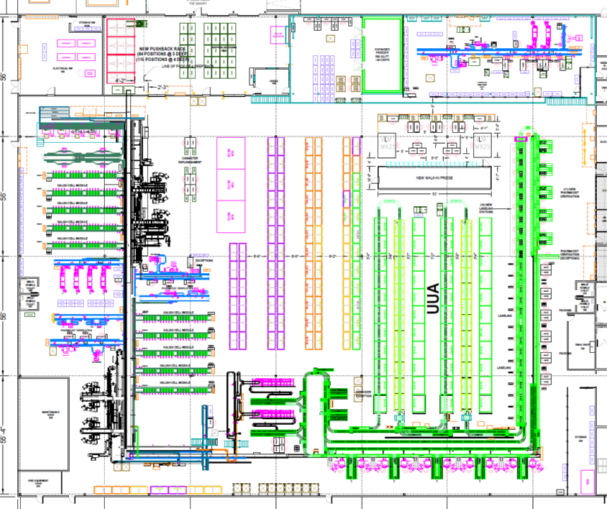
Tablet Dispensing Area
ATD Fingers
Tablet Dispensing Area show above with ATD Fingers highlighted in RED

Current Tablet Dispensing Flow and Process
This section describes the tablet dispense process on the puck side of the CMOP facility. Tablet dispensing involves counting specific quantities of an NDC into a vial. This process can be done manually, semi-automated, or fully automated.

- Tablet Dispensing Area Setup
  - The current automated tablet dispensing is bifurcated into East and West side dispensing areas. Both areas are capable of all TCA processes to include labeling, tare weighing, and dispensing both 120cc and 250cc vials, pharmacist verification, fill weighing, vial imaging, capping and sealing. The plan for future vial dispensing is to move to a single vial size of 120cc, however, the functionality to handle both current vial sizes will be retained. Each side can process vial prescriptions, and each side is connected by a conveyor cross-over that pucks can travel between the two sides if required.
  - Currently, there are automated vial labelers for both vial sizes in each dispensing area. There are a total of five labelers, three on the north end of the tablet dispensing area and two on the south end of the tablet dispensing area. Each labeler area is approximately 150 feet apart from one another, divided by the dispensing areas. Each labeling area has at least one 250 cc vial labeler. To make space for the additional tablet counting automation line for the backorders, the vial labelers must be consolidated to the west side automation. The future state will place the vial labelers centrally located on the north end of the tablet dispensing area freeing space on the south end of the tablet counting automation area.
- Puck Dispatch and Vial Labeling
  - The tablet dispense orders are released and empty RFID enabled pucks are queued for each vial labeler line. Each vial labeler has a dedicated inbound and outbound line of plastic chain conveyor. The vial labeler places a patient label on the vial, scans the label barcode, reads the current puck RFID tag in place and the system associates the order information to the puck. Each puck is tracked by RFID readers throughout the system at various points.
- Tare Weight Check
  - After the label is applied the puck then moves to the inline weighing station where the tare weight is recorded. If the vial tare weight is captured, it is transported to the dispensing fingers. If the vial fails to record a tare weight, it is moved to the exceptions processing area. The vial labelers on the north side of the tablet dispensing area feed the west side dispensing fingers and the vial labelers on the south side of the tablet dispensing area feed the east side dispensing fingers. The labeler consolidation project will also consolidate and centralize the in-line tare weight scales. Any scale has the opportunity to weigh any puck from any labeler. This allows for redundancy and level loading across scales.
- Tablet Dispensing
  - After the system records a vial tare weight, it is sent to tablet dispensing. There are 3 areas of tablet dispensing, the ATD fingers, the iA Robotic Dispensers and manual dispensing. The primary automated dispensing volume happens on the ATD fingers where it is filled by an ATD unit (cell). Pucks are diverted onto a finger loop and then into each cell as required for the dispense. The cells are pass-through and the pucks travel from the inbound side of the loop to the outbound side of the loop through the cell dispense conveyor. Once the dispense is complete, the puck travels the outbound side of the loop off the finger and back onto the main puck conveyor line for routing to the next operation.
- In-Line Imaging and Weighing
  - After the tablets are dispensed, the filled vial and puck move along to the scan and weighing lines where each vial is imaged by a camera and weighed by an inline scale. This check point is to assist the pharmacists in prescription verification by identifying the NDC contents of the vial through imaging and identifying the correct tablet count through weight measurement. Any vials that fail the image and weigh station check point are diverted to an exceptions processing station.
- Pharmacist Verification
  - Vials that are successfully imaged and weighed are conveyed to the pharmacist verification (PV) stations where they can be manually inspected and cleared by a pharmacist. Vials that fail the PV process are routed to an exception station where the error is resolved, and the vials are placed back onto the main line for the next operation.
- Cap & Seal
  - After a vial passes pharmacist verification, it is conveyed to the capping line where it is capped, sealed, and retorqued. The cap, seal and retorque processes are inline. Vials that fail the capping process are pushed off to an exception station at the capper/sealer and are hand capped and placed back on the line. Once a vial has been capped and sealed it is ready for packing. The pucks are conveyed to the next process.
- Packing & Outbound
  - Vial only orders are packed in the puck tablet/pill dispense area at semi-automated puck pack stations. These stations consolidate, manually depuck and pack the puck only orders. Orders that have a combination of vials and unit of use (“Combo Orders”) are conveyed over to the tote marriage area where the vials are depucked into totes. The empty pucks are conveyed on return lines to the vial labeling lines where the process begins again.
There are four main types of vial orders handled by the tablet dispensing lines. The four types of orders are the following:
- Single Puck Orders – Orders where the prescription is for a single vial of tablets only. This is the most common type of order in the automated tablet dispensing area.
- Multi Puck Orders – Orders where the prescription is for more than one vial of tablets. These vials can be for the same NDC or multiple different NDC’s.
- Combo Orders Single Puck – Orders where the prescription is for one vial of dispensed tablets and at least one piece of unit of use. These orders are packed in a separate area of the warehouse on the tote line. Pucks for these orders are conveyed over to the tote marriage line where the vials are depucked and married to totes.
- Combo Orders Multi Puck – Orders where the prescription is for more than one vial of dispensed tablets and at least one piece of unit of use. Like the Single Puck Combo Orders, these orders are packed in a separate area of the CMOP on the tote line. Pucks for these orders are conveyed to the tote marriage line where the vials are depucked and married to totes.
Note: The current methods and equipment used for depucking will be upgraded in late CY 2025.

Peak System Demand for Tablet Dispensing Area

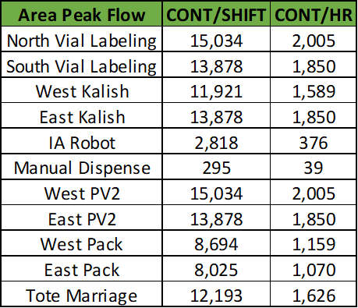
Peak Flow by Area
These numbers represent current dispenses by area and demonstrate the need for more ATD cells

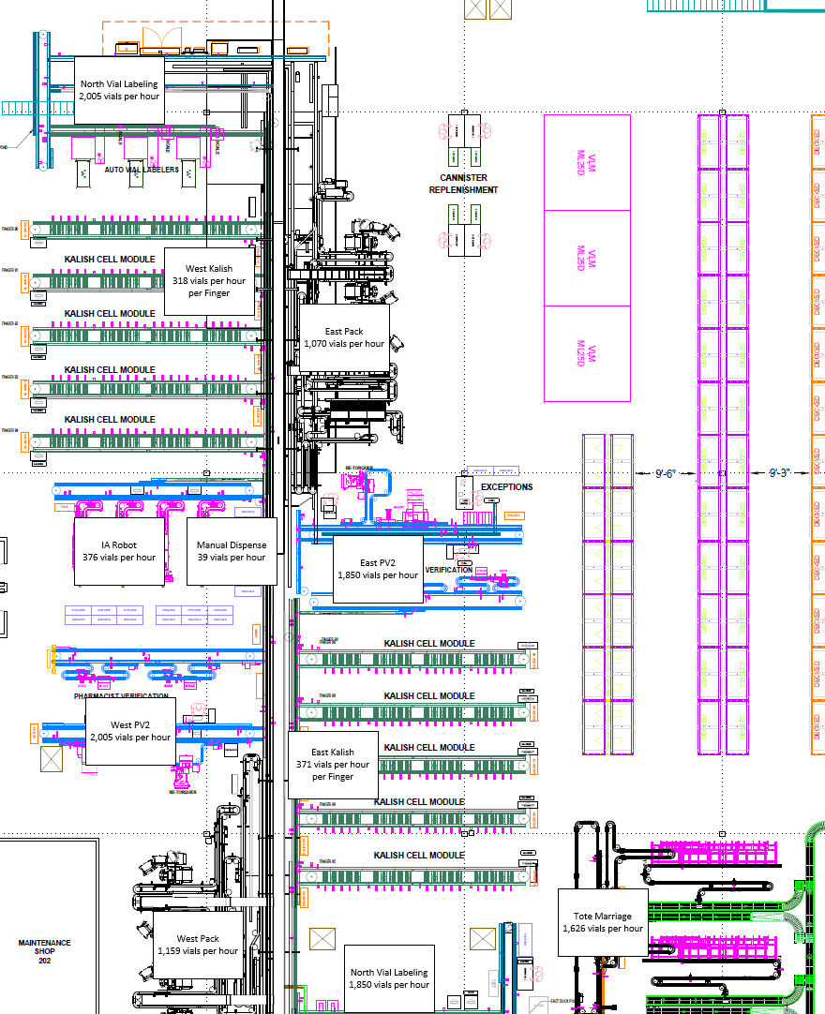
Visual Diagram of Peak Flow by Area

Puck Conveyor Design Requirements
Puck conveyor is designed to be compatible with existing puck conveyor already installed in the SW CMOP. Plastic chain conveyor is currently being used to convey the pucks in the tablet dispensing area. In the future, pucks will only handle a single vial size and are Ultra-High Molecular Weight (UHMW) plastic carriers for 120 cc vials. It is anticipated that the new puck will be similar in size to the existing puck configuration. And confirmation that it will work with all other equipment in the system is a must. Each puck is embedded with an RFID tag that is tracked by the conveyor system. Contractors shall ensure all designs incorporate the use of pucks similar in size to the existing pucks.

Puck Size
Current puck size is 3” in diameter and 2” high. Prescription vials can be up to 3.5” high. The current pucks will be used in any upgraded conveyor solution and shall be considered a hard requirement for any vendor design solutions.

Puck Identification
Pucks will be identified with a 3 or 4-digit puck ID and each puck will have an RFID chip located in the center of the puck bottom that will be readable from the underside of the puck.

Puck Weight
The maximum weight of any order puck is expected to be less than 800 grams.

Equipment Noise Exposure
The SW CMOP is committed to limit noise exposure within the pharmacy consistent with OSHA standard per 29 CFR 1910.95 "Occupational Noise Exposure". The OSHA guidelines for permissible exposure limit (PEL) is 90 decibels (dBA) for an 8-hour time-weighted average (TWA). If noise levels reach or exceed an 8-hour TWA of 85 dBA, employers are required to implement a hearing conservation program. It is the desire of the SW CMOP to go beyond the OSHA standard, and any new conveyor system shall not exceed 80 dBA for an 8-hour TWA.

Conveyor design
Conveyance structure shall include a removable section of the conveyor structure mid span on any conveyor over 30 ft in length, in an accessible area providing ease of maintenance and repair.
The structure shall be designed in a vertical design providing cleaning and access to under the conveyor area, with no cables and/or wireway on the floor but mounted to and retained on the structure of the conveyors.

Proposed Automated Tablet Dispensing Upgrades
This outlines upgrades to the Automated Tablet Dispensing fingers and creation of a new back-order finger expediting the release of back-ordered prescriptions and fluctuations in volume. It will be tied into the main puck conveyor system and feed vials from the main vial dispensing units on the north end and send filled vials to the PV and Pack areas on the East Side of the tablet area.
The upgraded ATD Fingers will consist of the following major components:
- Plastic Chain Link Conveyor
- Flow through queues for dispensing units
- Automated diverts & RFID readers
- 60 automated dispensing units (Kalish EKC 3410-DRS’s are preferred and requested by the client)
- Back pressure relief on conveyors & stops not to exceed 5 pucks
- Single puck backpressure relief for diverts of pucks

Considering existing operations, proven past performance, existing canister support equipment, and bulk fill stations and the need to minimally impact operations, the VA CMOP team is requesting the upgraded fingers will functionally resemble the current units with the expectation that there will be 60 ATD units (cells) on every line (finger) instead of 40 ATD units (cells).

Current ATD Finger Design
- The current ATD fingers contain an outer ring of plastic chain link conveyor, four blocks of ten ATD units, internal plastic chain link conveyor to feed the dispensers, two puck turntables on either end and a divert line connecting the outbound conveyor to the inbound conveyor
- The fingers are connected to the main puck conveyor lines and receive empty vials from the vial labelers and send filled vials to the pharmacist verification stations through these connections

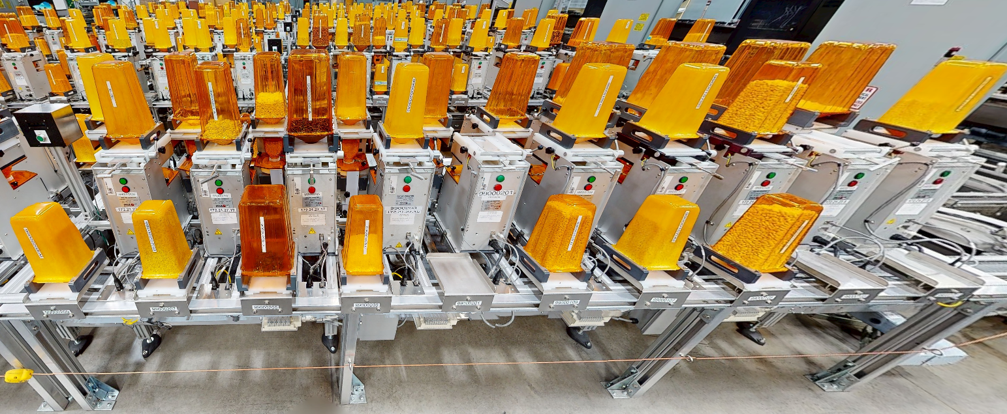
ATD Dispensing units
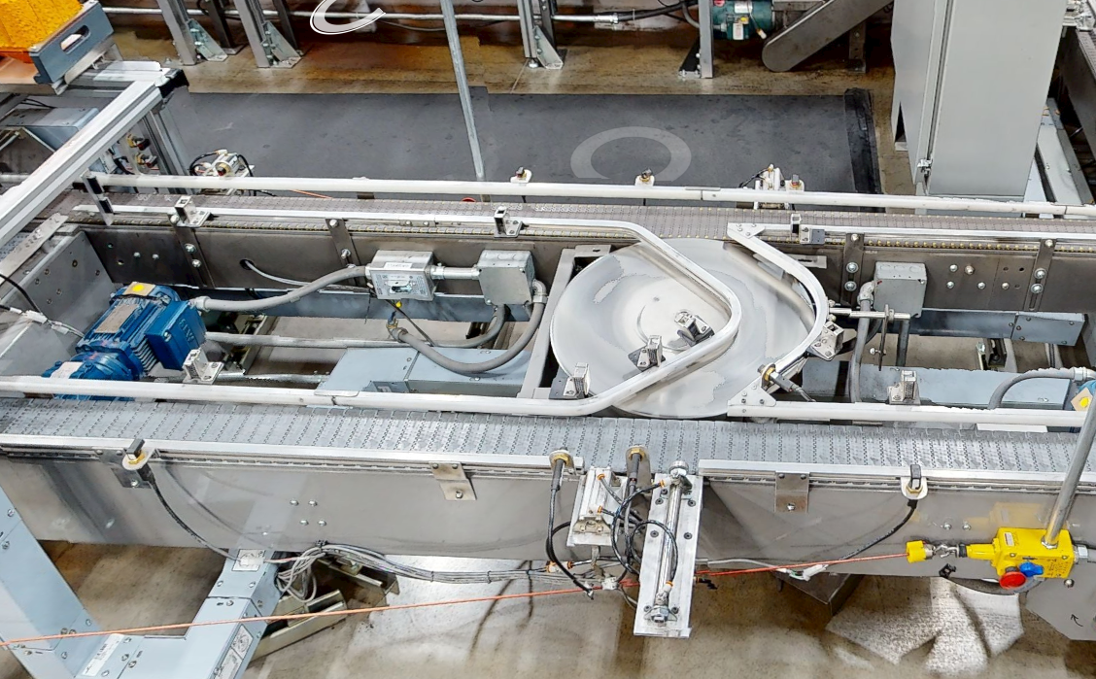
Inbound Conveyor (GREEN), Outbound Conveyor (RED), Turntable & Divert Lane (BLUE)

Internal plastic chain link conveyor
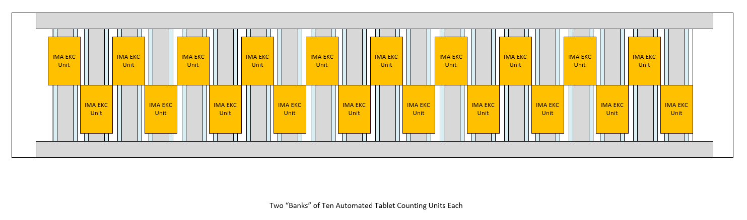
Current ATD Finger Layout Diagram
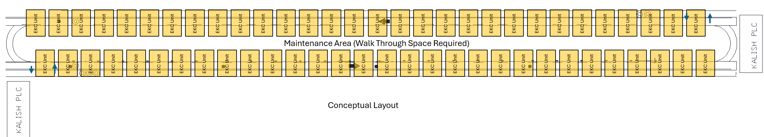
Future ATD Finger Layout Diagram
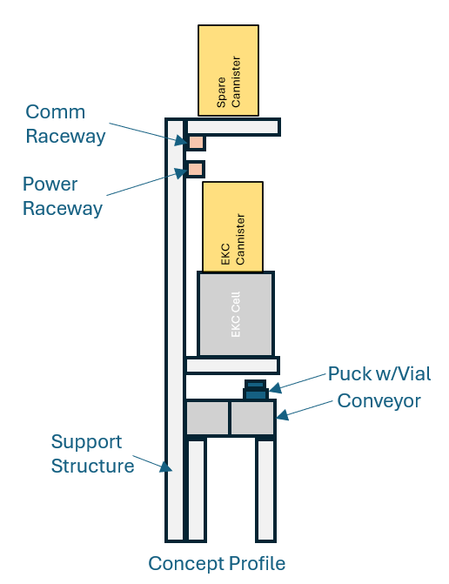
Future ATD Conceptual Profile

Proposed ATD Finger Upgrades
The current layout places ATD units directly over plastic chain conveyor. The ATD units sit corner to corner. Each unit is ~8” wide and the plastic chain conveyor is ~4” wide. This configuration leaves space for more dispensing units. The future layout would take advantage of the existing space by placing ATD units and internal plastic chain conveyor, closer to one another and increasing the number of ATD units from 40 to 60.
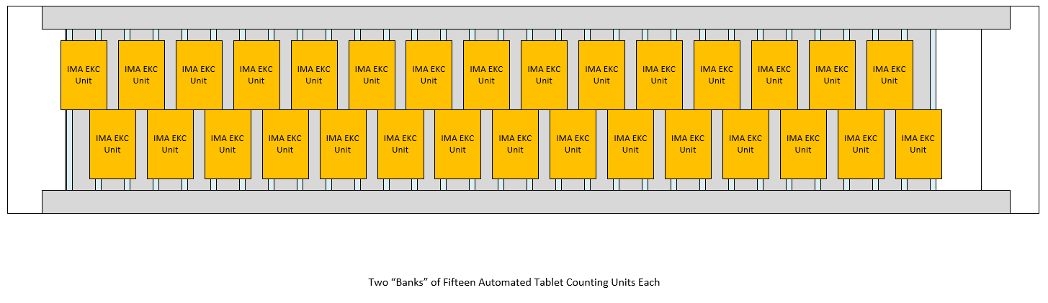
Future ATD Finger Flow Diagram
ATD Finger Process Flow
- Empty vial puck enters the finger on the inbound side of the conveyor (green)
- Vial is diverted to the correct ATD unit and enters the conveyor queue directly under the ATD unit
- Tablets are counted and dispensed into the vial
- The filled vial is then released to the opposite side of the finger and travels along the conveyor until it is diverted back on to the main puck conveyor and sent to pharmacist verification
- In the event that the queue for an ATD unit is full, the empty vial puck will travel along the outside of the finger and follow through the divert path until space is available at its destination
- Please note that in the future, the vial labelers will be upgraded and relocated to a single location at the north end of the ATD area. The vial labelers on the south side of the ATD are to be removed. This relocation creates an optimized flow for logistics operations in the facility and simplifies the conveyor layout. Empty vials in the future will originate from a single source.

Backorder ATD Finger
In addition to upgrading all existing ATD Fingers, a new ATD Finger will be installed on the south end of the ATD area. This finger is envisioned to process weekly backordered prescriptions. Due to changes in supply chain conditions, prescriptions will sometimes not be able to be fulfilled until a bulk order of the required drug arrives. When this happens, a large number of backorders are released in a short period of time which can bottleneck the tablet dispensing operation. This new finger will help to relieve that bottleneck and increase the overall capacity of the ATD operation.
The new ATD finger will connect to existing main line puck conveyor in the same manner as the existing fingers. It will receive empty vials from the same vial dispenser operation and send filled vials in the same manner as the other fingers.
The area that the Backorder ATD Finger will be placed in currently has equipment and conveyors that need to be decommissioned and removed prior to construction.
Backorder Software modification of the Main system shall be accomplished to control the release flow of backorders through the system.
Backorders shall have parameters that limit the number of Prescriptions per hour released for processing allowing other drugs to be processed.
The pill count dispensing system shall track and have a parameter after so many dispenses to issue a canister replenishment order. This shall be adjustable to the number of pills dispensed.

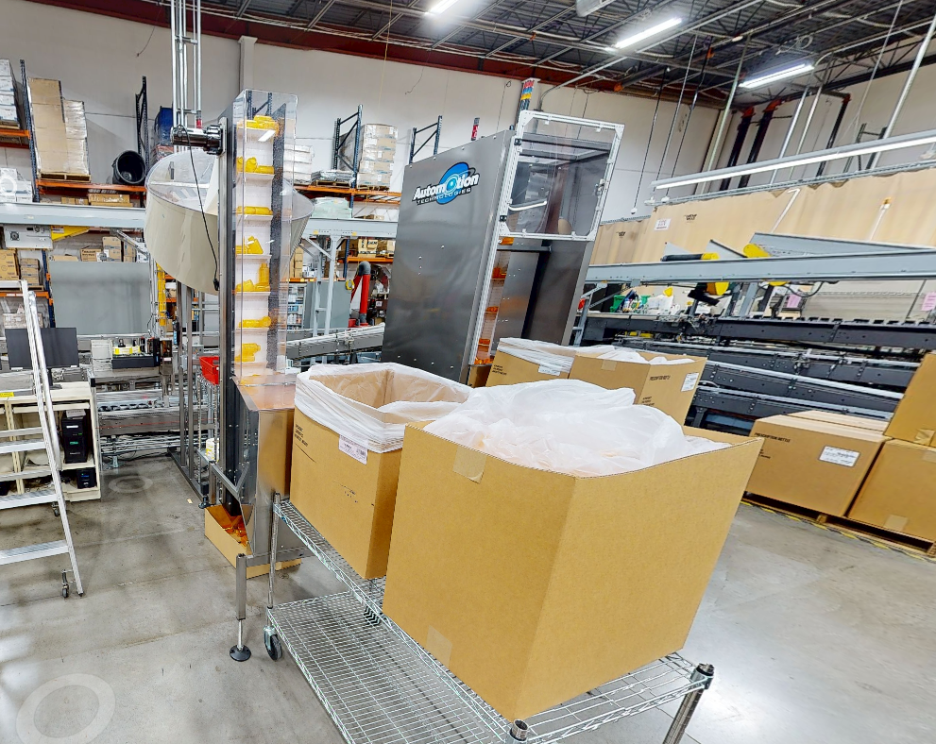 | 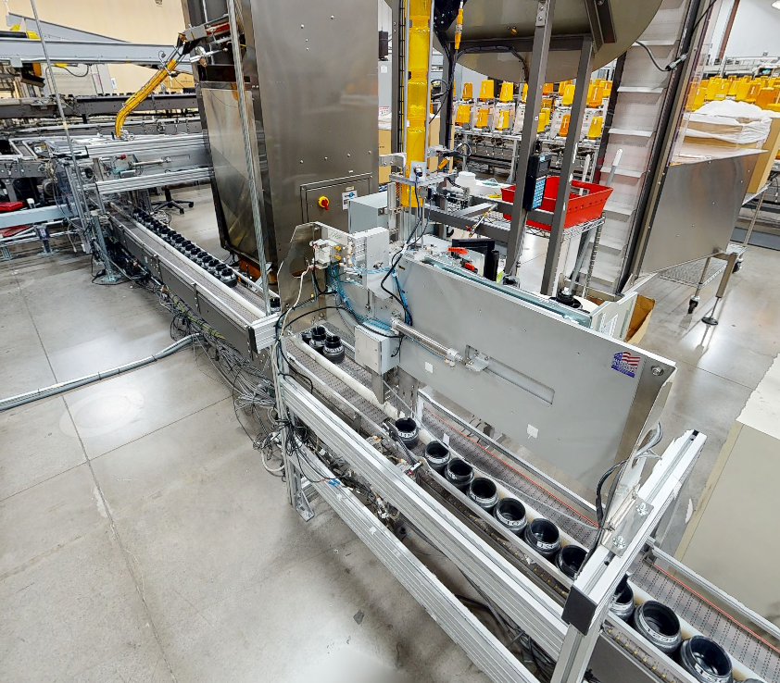
Old Vial Labelers | Old Puck Lines
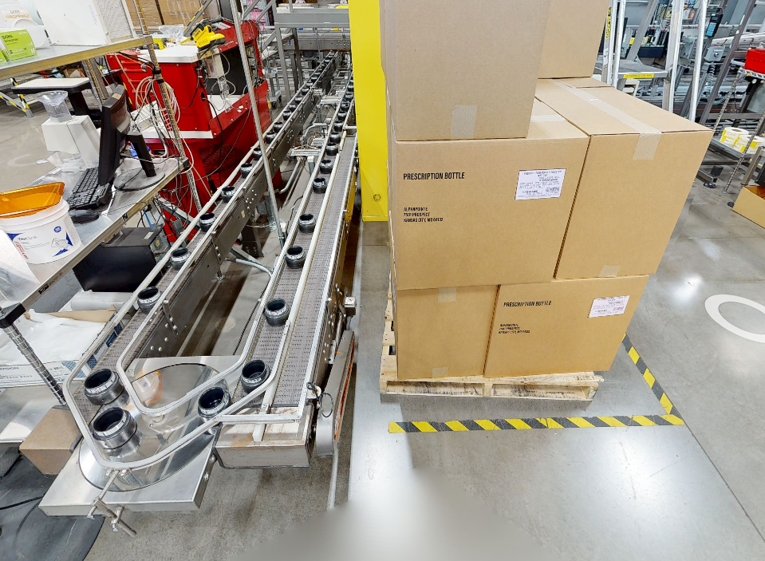 | 
Old Puck Conveyor | Old Testing Workstations
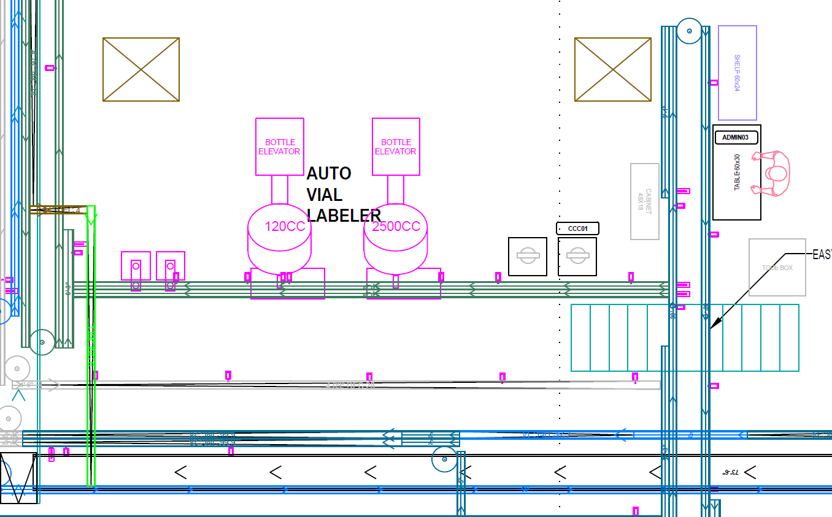
Current Layout Drawing – Highlighted Equipment to be Removed

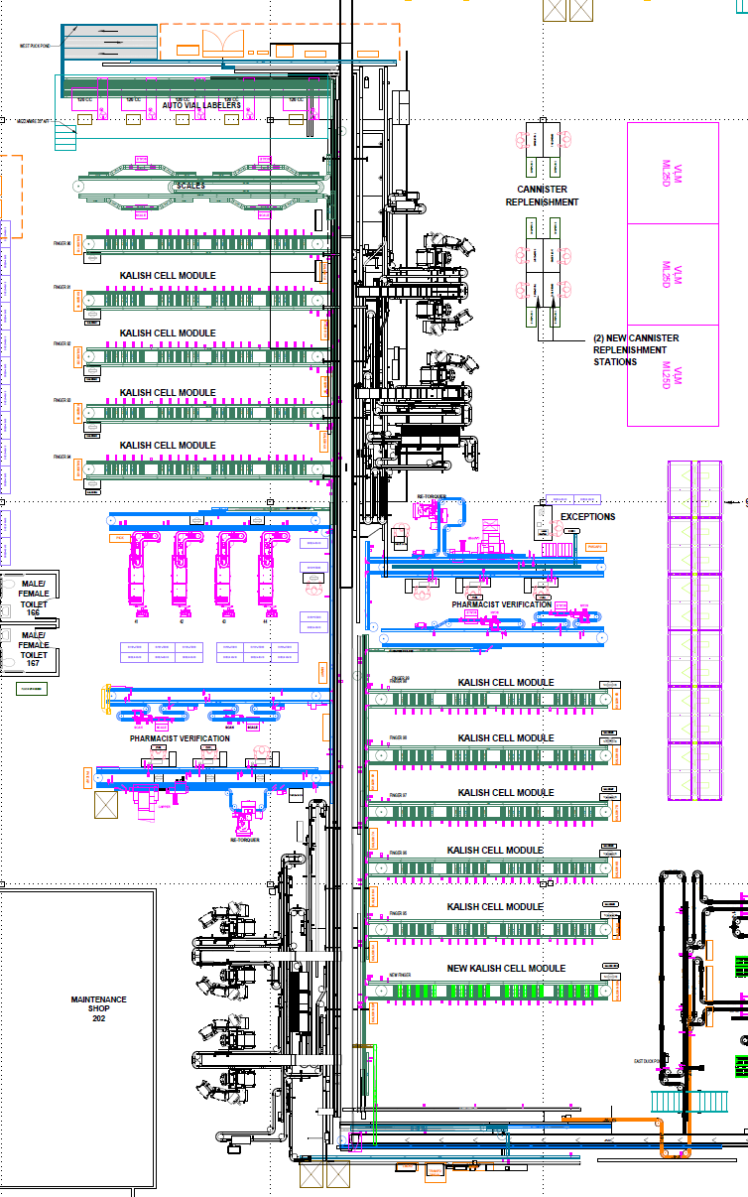
Backorder ATD Finger Location
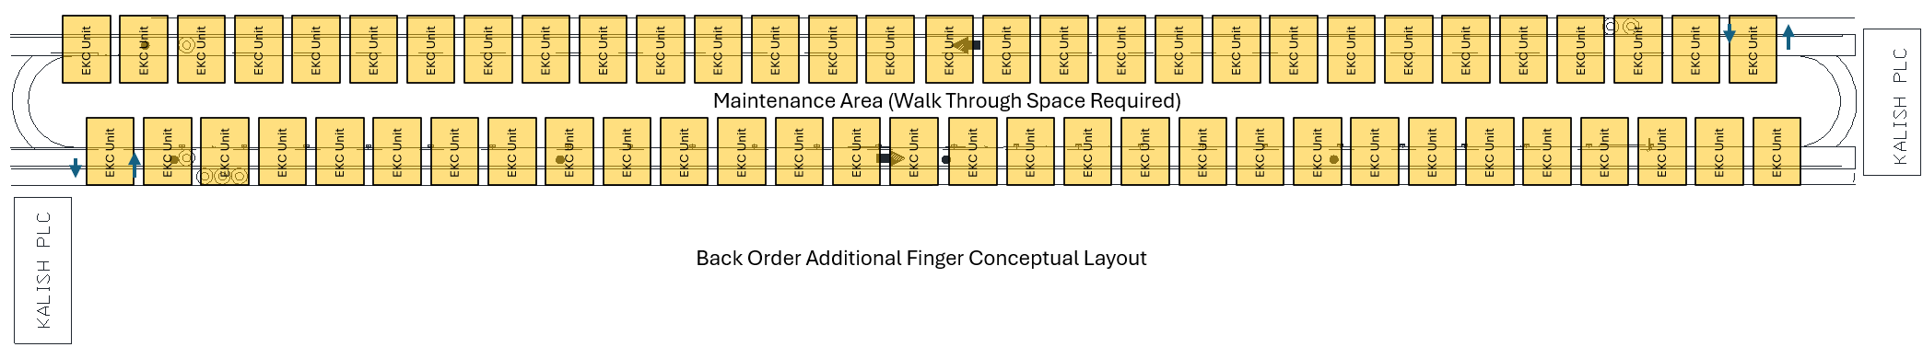
Backorder ATD Finger Detail

Transition Planning
All Vendors will need to provide a high-level transition plan with the PWS response. Immediately after project award, a complete transition plan of the recommended solution will be provided by the Selected Vendor. The transition plan must contain the following elements.
- Phased Layout of Equipment Installation
- Detailed Project Plan and Timeline
  - Equipment Installation
  - Systems Integration
- Support Required from Tucson CMOP Operations in Transition Plan
- Facility Upgrades to Support Transition
- Risk Assessment and Contingencies for Transition
- Equipment Removal and Demolition Plan in Coordination with Installation Plan
Additionally, the Backorder ATD Finger is to be built first. This will allow the operation to run at full capacity while giving technicians time to test out the design and work through any installation growing pains before attempting to upgrade the existing ATD fingers. Upgrading the current ATD fingers is envisioned to be done sequentially so that the ATD area is running at or near full capacity during the transition and upgrades. The current plan is to build the Backorder ATD Finger first, then upgrade ATD fingers sequentially as volume and capacity dictate.
The transition planning must support continued operations and be “as least impactful to operations as possible”. Continued operations would include phasing of various production areas to keep as many areas open as equipment is being installed. This would include tentative, short-term work around, to keep operations running at a minimal level.
In addition, it is expected that transitions will minimize impact on staffing functions during regular hours of operation and to utilize off-shift hours and weekends, when possible, to limit disruptions. The planning shall include expected pharmacy output during the phases of transition and account for any risks associated with the transition, strategies employed for managing the risks and the contingency plans in place to reduce the impact of the risks.

Tucson CMOP Implementation Phasing
Vendors will need to coordinate with the Contracting Officer’s Representative (COR) to develop an effective integration and implementation plan that will minimize interference with existing operations. This may require off-hours and weekend installation.

Interface to POS
The pharmacy operating system will maintain all data required for processing patient orders. Pharmacy operating system will send signals to new conveyor and diverts based on puck RFID tag reads prior to divert. The conveyor control must send the puck RFID tag back to the POS and the POS will return the required action.

Automation DESIGN AND FABRICATION requirements
This section outlines general requirements for the new upgraded conveyor system. These are general requirements applicable to systems of this nature. It is the vendor’s responsibility to read and understand the intent of these general requirements. Vendors shall accept or object to the general guidelines in the response and make any suggestions or recommendations for additional requirements deemed appropriate for this specific system proposed.

General Design Criteria
Vendors shall confirm understanding and acceptance of requested design criteria. Vendors may object to or have more vigorous requirements than those provided here. Vendor-proposed deviations from specifications presented in this section must be explained in the proposal submittal response. The materials provided by the Vendor must meet the performance requirements of this specification.
Vendor shall identify location of all Mechanical (Power, Air & Networking) Drops, PLC Cabinets and Panels in preliminary design reviews for Customer approval prior to final design and installation.
Work that fails to conform to the Design Criteria shall be repaired or replaced in an approved manner to assure design strength and function. Such work shall be executed by the Vendor at no additional expense to the Purchaser and shall include laboratory tests and costs for re-examination if the Purchaser deems it necessary.

Safety Standards and Codes
All equipment shall conform to appropriate safety requirements. Equipment shall be designed in conformance with the current version of the following standards:
- Occupational Safety and Health Act Regulations (OSHA)
- American National Standards Association (ANSI)
- American Society of Mechanical Engineers (ASME)
- NFPA 79: Electrical Standard for Industrial Machinery
- National Electrical Code (NEC) 2017 or later
- ISO 13849
- UL 508A
- National Electrical Manufacturers Association (NEMA) or equivalent
- All applicable Federal, State, and Local Codes, Laws, and Regulations

Quality Requirements
The equipment Contractor will maintain an in-process and end-item quality control program to ensure shipments to the Purchaser do not include defective or non-conforming items. The Purchaser reserves the right to review and evaluate the program and to conduct periodic inspections. Items furnished under the contract are subject to inspection and test at all reasonable times and all reasonable places, including but not limited to the manufacturing plant, shipping point, depot, and installation site, including before and after uncrating at site.
The Purchaser, its nominees, or representatives shall be permitted to enter the equipment Contractor’s facility and any other site or facility where a portion of the work is being performed by or on behalf of the Contractor to inspect and/or examine the Contractor’s progress. Such inspections are not intended to disrupt or interfere with the normal business operations at the facility. Any such inspection shall be without prejudice whatsoever to any right or remedy to which Purchaser shall be under the Contract. These visits shall be scheduled with the contractor and shall not compromise government and or other customer confidentiality.

Mechanical
The following general requirements apply to the equipment and system being provided:
- Vendor shall identify location of all Mechanical (Power, Air & Networking) Drops, PLC Cabinets and Panels in preliminary design reviews for Customer approval prior to final design and installation.
- All materials shall be non-toxic.
- All materials shall be new; all cuts are to be made square with work free from lips, burrs, or projecting sharp edges.
- All exposed corners of steel members shall be rounded and smooth to remove accident hazards.
- All holes for connection of one section to another, for securing bearings, take-ups, or other machine parts shall be drilled or punched and be clean and free from burrs.
- All bolted connections shall include lock washers or approved locking hardware.
- All sprockets, chains, and gears subject to personnel contact shall be fully enclosed in readily removable split-type guards. Belt and belt drive units shall be easily replaceable without the use of tools
- If applicable, all meshing gears shall be marked with a permanent, easily detectable notch for gear alignment.
- If applicable, all sprockets shall be keyed.
- The mechanical and electrical design should be of modular design for ease of maintenance and repair. This shall include a vertical design to minimize floor space used.
- The system shall be appropriately guarded such that components or products cannot be added or removed from within the confines of the guarding when the equipment is running.
- The equipment design will include a focus on ease of cleaning.
- The system shall not damage, scuff, mark, or constitute any aesthetic or structural damage to the in-process or finished product.
- The system shall be finished in such a manner as to avoid rusting, corrosion, and/or excessive wear and tear.
- The system shall be vertically adjustable (at least ± 2”) to allow for leveling.
- If a surface is painted, it must be an epoxy-based steel-it paint. This does not apply to standard products that are already painted.
- All welds on product contact surfaces shall be continuous and ground smooth.
- All exposed surfaces of non-stainless type steel or other corrosive materials shall be painted with corrosion-resistant paint or anodized.
- Aluminum machine parts must be clear anodized.
- Steel machined parts, not coated, must be nickel-plated.
- Wood and fiber products are not permitted, except as approved by the COR.
- All bearings shall be sealed and preferably lubricated for life. However, if greasing is necessary, the grease fittings shall be clustered and conveniently located on the outside of the machine for easy access.
- Nameplates shall be located directly above or below the associated component. Nameplates shall be provided that identify starters, switches, pushbuttons, pilot lights, relays, and other components. They shall be mounted immediately above or below the device. Nameplates shall be engraved and attached using screws or rivets.
- Motor(s) shall have a nameplate giving the manufacturer’s name, serial number, HP, rpm, service characteristics, and other data as listed in NEMA Standard MG-1, Part 10.
- The Contractor’s nameplate shall be mounted on the HMI and the main electrical cabinet. The Contractor’s nameplate shall include contact information and system make, model, and serial number, at a minimum. All plates shall be attached via rivets or screws.
- All machine guarding shall be clear. No graphics or tinting shall obstruct the view of the equipment.
- As reasonable, components shall be designed to be maintenance-free.
- All items that require preventive maintenance shall be readily accessible.
- The system material handling scheme shall not damage, scuff, dent, or mar any components.
- Critical detection systems shall be designed so they cannot be bypassed in normal run mode.
- Part numbers must be indelibly marked on all parts.

Guarding
The Contractor is responsible for all equipment guards or barriers required to protect people from the equipment's operation. All sprockets, chains, gears, and belts subject to personnel contact shall be fully enclosed in readily removable split-type guards. All guards must be easily removable for repairs and maintenance. All guards are to be “bolt-on” construction. Bolts must not interfere with the movement of product. If robotic guarding is required, it must be integrated into the controller to ensure its presence during automated operation. Selected other guarding (specified elsewhere) is also required to be integrated into the controller to ensure its presence during operations.
All equipment guarding shall conform to current OSHA requirements and ANSI/ASME Safety Standard for Conveyors and Related Equipment B20.1 and ANSI/ASME Standard for Mechanical Power Transmission Apparatus B15.1.

Supports and Connectors
All equipment or equipment supports will be supported from the floor.
If applicable, Contractors are responsible for supplying all support columns or upright supports, horizontal support bracing, and hanging steel.
Major component assemblies are to be connected using a positive connector employing a bolt and locking device.

Mechanical Requirements
- The system shall not damage either the product or system components in any mode of operation.
- The system shall be of a “clean” design. Consideration during the evaluation will be given to designs that prevent the collection of debris and that clean easily.
- The system shall be serviceable. The mechanical and electrical design shall be of a modular configuration for ease of maintenance and repair. Motors and drives shall be mounted to allow for primary access from planned operator areas.
- The system design shall avoid excessive noise generation and be such that hearing protection equipment shall not be required for Purchaser's employees. All equipment shall operate at or below 80 dBA, measured at the operator's workstation or the nearest workstation, traffic aisle, or pedestrian access. These will be measured on the “A” scale. It is highly desirable to provide a system with a much lower noise level than 80 dBA. Preference will be given to equipment that is demonstrated to be less than 74 dBA so that normal conservation can occur next to the system throughout the pharmacy.
- All equipment must be sized for receipt through doors 120’ wide by 108” high.
- The minimum factor of safety base yield strength shall be 1.65.

Material Requirements
- All material and equipment shall be new, unless otherwise specified, and any procured source material or components shall be the product of a reputable manufacturer.
- All cuts are to be made square with the work.
- All cuts, edges, holes, and assemblies are to be free of burrs and sharp edges. All exposed corners of metal members shall be rounded and smooth to remove accident hazards.
- All holes for anchoring or connecting one member to another for assembly and securing parts shall be pre-drilled or punched and be free and clean from burrs.
- All metal parts must be painted or treated to resist corrosion. Paint chip(s) of the standard color must be submitted with the Contractor’s proposal.
- A primer coat is required, if specified by the finish-coat paint manufacturer standard.
- Paint shall be applied in strict accordance with the paint manufacturer’s instructions. Minimum dry film thickness of 1 1/2 to 2 mils.
- After installation, components shall be field painted as described above to cover any areas that have been rubbed, scratched, blemished, etc., during shipment and/or installation.
- All bolted connections shall include lock washers or approved locking hardware.
- Bolt lengths used as fasteners must be sufficient such that at least two threads project past the ends of fasteners.
- No bolt heads or other projections may protrude in such a way as to possibly snag or hinder the movement of pallets, cartons or create a hazard for proper maintenance of these fasteners.

Dimensions and Tolerances
- Tolerances shall be in accordance with quality workmanship (e.g., parts dimensionally correct, square, and straight, etc.).
- Where supports are floor mounted, the support feet shall be anchored to the floor with a minimum of ½” x 2-3/4” long expansion shields with lag bolts (1 per support leg - minimum). Anchor holes will be drilled deep enough to drive anchors flush with the floor.
- It is understood that shimming may be required to achieve exact tolerances. No gap greater than ¼” prior to lagging will be accepted.

Sensor Mounting
All sensors (proximity switches, etc.) must be adequately secured to prevent movement or loosening by vibration. Proximity switches must be held near the center of the threaded barrel. Sensors shall be affixed in a manner to provide for direct mechanical interchange among compatible sensors. Sensors shall not be mounted using Unistrut.

Compressor/Air Lines and Air Quality
The Vendor is to supply the entire air system from an airdrop near the automation. A mutually agreeable location within the pharmacy will be selected for the airdrop.
- The system shall be designed to operate on 80psi, dried and non-lubricated plant air. The air system shall regulate and accommodate air up to 140 psi.
- Airline piping should follow a path parallel with electrical whenever possible.
- All air lines shall include proper filters, regulators, etc., for proper control and operation.
- Manual shut-off valves shall be placed where applicable. At minimum at main line branch locations and before every FRL placed in the system.
- Cylinders shall conform to ANSI standards wherever practical.
- Where the cylinder heads are used as a positive stop, adjustable cushions or external deceleration control shall be provided.
- Valves shall be manifold or sub-plate mounted.
- Flexible hose or plastic tubing shall be used between moving elements, oil resistant and restrained 12” of each termination to eliminate the hazard of pressurized lines whipping should they come loose.
- The system shall monitor the air pressure provided by the Contractor.
- Air pressure outside the desirable limits shall prevent the automation from operating.
- One main disconnect shall remove all air from the automation and any associated subsystems, unless this requirement violates any relevant code requirements and/or poses a direct threat to the health and safety of an operator and/or technician.
- Air lines shall be color-coded and labeled at each end. All pressure lines and exhausts shall be readily identifiable by color.
- Any location where air comes in direct contact with product or containers, a one-micron filter must be used.
Air Quality
  - The Air system shall be fully automatic in maintaining air pressure during loss of power and recovery, Equipment shall be designed to operate on 80 PSI have an air pressure switch set to 90 PSI to prevent operation in the case of a loss of air pressure 10 psi above to minimal operational pressure.
  - This air supply shall be considered to provide industrial clean air not dental or medical supply air.
    - Specification SECTION 22 15 00 GENERAL SERVICE COMPRESSED-AIR SYSTEMS
  - This air cannot come into direct contact of medication or medication holding surfaces while it is in operation, it can be applied inside of equipment used to move medication and or apply labels to medication but should not be directly blown onto medication or its packaging.
  - If the Air supply will be used in such a manner as to be applied to medication and or its packaging directly it shall conform to specifications for Dental Air,
    - DENTAL COMPRESSED-AIR EQUIPMENT for dental air or Section 22 63 00
Or
    - GAS SYSTEMS FOR LABORATORY AND HEALTHCARE FACILITIES for lab or medical air
  - Air line systems shall have a separate connection for air needing lubrication for equipment operation, and it shall be downstream and separate of the connection with an independent shutoff valve, prior to the lubrication equipment.
  - Dental or Medical Clean air cannot go through a quick disconnect and maintain its quality as dental or medical clean air without special cleaning procedures in place.
  - Air Piping systems shall be seismic/vibration resistant and provide expansion and contraction in its layout. System design to accommodate complete lack of air pressure to full air supply at minimum 2 times per day, accounted for in its design.

  - Automatic control switches of Dental or medical grade air to include Instrumentation: Including discharge-air pressure gauge, air-filter maintenance indicator, hour meter, temperature gauges, and control power indicators.

  - Alarm Signal Device: For connection to alarm system to indicate when out of specification conditions exist.

  - The Air systems shall have low points identified and have a regular drain solenoid or mechanical valve with sensor, capable of being activated or monitored by the control system to drain to a condensate bucket or drain.

  - Fabricate mounting and attachment to framing and reinforcement strong enough to resist packaged equipment movement during a seismic event or vibration when base is anchored to building structure or flooring

INSTALLATION
  - If an installation is unsatisfactory to the COR, the contractor shall correct the installation at no additional cost or time to the Government.
  - Piping shall be installed, concealed from view and protected from physical contact unless indicated to be exposed. Piping shall be installed exposed in mechanical rooms and service areas.
  - All pipes shall be installed at right angles or parallel to building walls. Diagonal runs are prohibited unless indicated.
  - Piping shall be installed above accessible ceilings, allowing for sufficient space for ceiling panel removal and to coordinate with other services occupying that space.
  - Piping installed adjacent to equipment shall be located to allow for the required service clearances.
  - Air and drain piping shall be installed with a 1 percent slope downward in direction of flow.
  - Nipples, flanges, unions, transitions, and special fittings, and valves shall be installed with pressure ratings same as or higher than system pressure rating.
  - Flanged joints may be used instead of specified joints for any piping or tubing system.
  - Only eccentric reducers shall be installed where compressed air piping is reduced in direction of flow, with bottoms of both pipes and reducers fitting flush.
  - Branch connections shall be installed from the top of the main compressed air line. Drain legs and drain traps shall be installed at the end of each main and branch and at all low points in the system.
  - Valves shall be installed to permit servicing to all equipment.
  - Pipes shall be installed free of all sags and bends.
  - Physical Seismic restraint shall be installed for all piping and equipment as required for location.
  - Piping shall be cut square and accurately with a tube cutter (sawing is prohibited) to measurements determined at place of installation and worked into place without springing or forcing the pipe.
  - Tube shall be bottomed in each solder socket so there are no gaps between tube and fitting where solder can enter the inside of line. The tube shall be reamed to remove burrs, being careful not to expand tube and that no chips of copper remain in the line. Care shall be exercised in handling equipment and tools used in cutting or reaming of pipes to prevent oil or grease being introduced into piping.
  - Particular care shall be exercised, when flux is applied to avoid leaving any excess inside the completed joints. Thoroughly wash the outside of each joint with clean hot water after assembly to remove oxide coating.
  - Hanger spacing shall be based upon NFPA 99.
  - Rigidly support valves and other equipment to prevent strain on tube or joints.
  - Air piping shall have an equipment identification nameplate and data in accordance with 22 05 11, COMMON WORK RESULTS FOR PLUMBING.
  - Suitably brace piping against sway and vibration. Bracing shall consist of brackets, anchor chairs, rods, and structural steel for vibration isolation.
PRELIMINARY STAGE TESTS
- Preliminary tests shall be performed by the contractor prior to testing witnessed by the COR. Tests shall be pneumatic and shall use dry, oil-free compressed air, carbon dioxide or nitrogen in metallic systems.
- Testing of any system for any purpose shall include preliminary testing by swabbing joints under test with standard soap solution and observing for bubbles at internal pressures not in excess of 34 kPa (5 psig).
- When testing reveals system leakage, isolate, and repair the leaks, replace defective materials where necessary, and retest the system until there is no loss of pressure. Remake leaking gaskets with new gaskets and new flange bolting, and discard used bolting and gaskets.
- Drainage piping shall be hydrostatically tested to a pressure of 34 kPa (5 psig) to ensure the piping does not leak. Repair all observed leaks and retest until all leaks have been corrected.
STARTUP AND TESTING
- Perform tests as recommended by product manufacturers and listed standards and under actual or simulated operating conditions and prove full compliance with design and specified requirements. Tests of the various items of equipment shall be performed simultaneously with the system of which each item is an integral part. Tests shall be pneumatic and shall use dry, oil-free compressed air, carbon dioxide or nitrogen in metallic systems.
- The tests shall include initial piping purge test, initial pneumatic test for positive–pressure gas systems, initial cross-connection test, and initial standing positive-pressure gas piping tests, system capacity, control function, and alarm functions.
- Pneumatic tests shall be performed utilizing a test pressure of 10 (psig) higher than the maximum pressure Provided by the site air supply system, Test pressure shall be maintained for a minimum period of four hours to ensure the temperature in the piping system stabilizes, then the pressure is refreshed and held for two hours with no loss of pressure. Pneumatic testing performance shall be in accordance with industry safety standards with the pressure gradually increased in increments of 25 percent of the MAWP until the required test pressure is reached. At each interval, the system pressure shall be held long enough for piping strains to stabilize. If leaks are observed, the leaks shall be identified, the system de-pressurized and repairs made before proceeding.
- Other than standard piping flanges, plugs, caps and valves, only use commercially manufactured expandable elastomer plugs for sealing off piping for test purposes. Published safe test pressure rating of any plug used shall be not less than three times the actual test pressure being applied. During pneumatic testing evacuate personnel from areas where plugs are used.
- Remove components that could be damaged by test pressure from piping systems to be tested. Air pressure regulation – At minimum a system of 2 redundant check valves shall be applied to the outlet of the Air compressor system maintaining the air pressure in the system should the compressor be taken offline in momentary power interruptions.

Labeling
All equipment switches, motors, valves, regulators, etc., must be clearly labeled to identify the associated function for reference to maintenance and operator manuals.
Labels are to be permanently attached to or near the device. Dyno-type labels are not acceptable.

Welding
All welding shall fully comply with the requirements of the American Welding Society's codes as amended to date.
All welding shall be under the direct supervision of qualified personnel. Welding operators shall have been qualified within twelve months prior to work on this project, except that personnel continuously employed as welders may be accepted on the basis of satisfactory reports dated not more than two years prior to project start.
Safety regulations and fire codes must be adhered to stringently.
Any welding to occur on the VA Site shall be subject to hot work permits and safety supervision of the VA site representative.

Touch Up
After installation, components shall be cleaned, and any areas that have scratches, blemishes, or the finish rubbed off will be touched up to match the original paint quality.

Installation Factors
The Vendor is responsible for supplying all system supports. No overhead supports (attached to building roof joist or above head flooring systems) will be permitted in this system.

Electrical and Control System Requirements and Architecture

Power Distribution
The Vendor is responsible for running all power and air lines required for the system from their master control panel. The Vendor is responsible for submitting power and compressed air requirements to the COR for approval during the process design review and approval.
All installation work must be performed with the system de-energized.

Device Layer
The device layer shall include any and all input/output devices (hereafter I/O) used within the project.
- Emergency stop (hereafter E-stop) circuitry shall be included in the device layer.
- E-stop circuit(s) shall be hardwired.
- E-stop circuit(s) shall not depend on software interaction to properly execute.
- A relay or similar safety rated device (e.g., Pilz) that enables the system but is controlled by the software is permitted and expected (e.g., interlock). This device must be selected in accordance with the ISO 13849 standard.
- E-stop circuit(s) shall fail to a safe state (e.g., release of compressed air shall not create a hazard).
- E-stop circuits shall fail to a safe state if the power supplying the emergency stop circuit is interrupted or lost.
- The device layer shall use 24VDC for power and signal.
- An interposing relay or similar device shall be inserted between interlocking devices powered by separate power supplies.
- The device layer shall use buss-level components wherever possible.
- Where buss-level shall not meet the specified requirements, an exception to this specification is required and is the responsibility of the Vendor. Approved drawings are considered approved exceptions to this specification.
- Consideration shall be given to connecting sensors installed on the system using flat media to wire (sample projects using flat wire will be observed prior to approving this).
- Motor starters shall use 24VDC signals for control.
- Voltage requirements for devices not covered within this section (e.g., motors) shall be defined and approved during the appropriate design review.

Control Layer
The control layer shall consist of components, either hardware or software, to manage the device layer while allowing the information layer access to data necessary to manage the business.
Allen Bradley Control Logix shall be utilized for the Control layer (PLCs).
- All incorporated programmable equipment shall be accompanied by programming software, program listings on disk, hardcopy printout with comments, and with back-up E-Proms installed. PLC program listing shall be in accordance with an approved format. One spare input module, one spare output module of each type, and one PLC power supply will be provided. Unused rack space must remain after system installation and startup.
- Any proprietary, custom third-party PLC interface or communications interface is discouraged unless absolutely necessary for equipment to operate. Any proprietary software must be pre-approved by VA IT, have the ability to be maintained and updated by VA IT and one spare unit of each supplied. There must be at least three additional unused rack slots remaining.
- If PLC does not (or cannot) remain powered, the product tracking and counting information shall not be deleted or lost.
- Provide 20% spare memory.

Control Cabinets and Enclosures
- Enclosures shall be NEMA 12 or equivalent. Supplemental cooling devices shall not degrade the enclosure from the original standard.
- Clear viewing windows shall be provided in the doors of enclosures housing PLCs to permit visibility of the input/output modules and CPU status lights.
- Enclosures shall be painted on the inside with grey enamel paint. All exterior enclosures shall be painted epoxy-based steel-it. Apply the paint in accordance with the manufacturer's instructions. Enclosure doors shall have key or tool-operated latches.
- A utility outlet is to be provided on the outside of all main enclosures where a disconnect is located. (Duplex outlet - 120vac - 20amp service with GND.) It shall be powered by a separately protected branch circuit from a step-down transformer.
- Contractor shall provide a grounded, 115 VAC, 15 AMP, duplex convenience outlet in each control cabinet for attachment of computers, printers, test equipment, etc., required to service the supplied equipment. It shall have a label indicating its purpose and warning against using it to power electric drills or similarly powered devices. It shall be powered by a separately protected branch circuit from a step-down transformer. THE AUXILIARY OUTLET AND THE UTILITY OUTLETS MAY NOT BE POWERED BY THE SAME PROTECTED BRANCH CIRCUIT. It is also required that an external ethernet hookup is available for ease of connection.
- Adequate free space of approximately 15% shall be allocated in electrical enclosures for maintenance.
- All components located in enclosures or on equipment are to be labeled using engraved plastic laminated material, including motors, solenoids, relays, fuses, etc. All labels are to be affixed near the devices; no labeling shall be affixed to removable devices.
- Main power disconnect switches must be side-mounted-type, Allen Bradley, or equivalent.
- Nameplates shall be installed on all enclosures indicating voltage, KVA, and phase.
- All electrical enclosures shall be cleaned and free of debris (i.e., metal filings, insulation stripping, spare conductors) and will be subject to inspection as part of the final acceptance test. All painted surfaces shall be free of scratches and dents (touch up paint as required).
- The Contractor shall provide a UPS to power the PLC and control components. The UPS will remain energized if the main disconnect has been opened. As such the cabinet containing the UPS equipment must have appropriate markings indicating voltage may be present when disconnected, orange wire for the UPS 115VAC output and a local panel mounted disconnect.

Information Layer
The information layer shall consist of components, either hardware or software, to collect, maintain, archive, and report data required to manage the business.
All code software and parameters applied, and applications created that are site specific are the property of the VA once they are completed. If the code is not site specific and is a contractor proprietary code, the currently running code un complied shall be placed in a code Archive provided by the VA. If the code is to be archived and not reviewable by the VA, the code in operation must have last line number of the code executed, including error logging visible on the operations screen of the last 10 errors and an error history to be at least the last 1000 errors. of the machine.

SCADA Layer
The system is required to collect and store relevant system operational data from the control and device layers. This may be accomplished with the PMS or a well-established SCADA product (e.g. Wonder Wear, Ignition).

Interconnects
The interconnects shall include any and all points of communication between the PMS system and the vendor or between two different vendors.
- Ethernet shall be used as the standard for interconnections.
- Details of the software required to communicate via Ethernet have not been defined as of the most recent release of this specification. Such details will be defined during the appropriate design review.
- The Vendor shall provide network ports for Ethernet connectivity.
- Signal converters shall not be used unless an exception to this specification is requested and approved. Approved drawings are considered approved exceptions to this specification.
Wireless connections are beyond the scope of this specification. All industrial control system components and hardware, such as motor starters, relays, transformers, and terminal blocks, shall be Allen-Bradley or equivalent. If IEC-rated devices are used, the devices must be rated for a five-year life based on expected duty cycles. Control-system hardware such as operator push-button indicators, digital displays, and other peripherals shall also be Allen-Bradley or equivalent.

Electrical/Control Requirements

Static Electricity
All equipment shall be properly grounded to prevent the build-up of static electricity.

Location of Controls
All starting/stopping controls shall be within easy reach of the operator. If there are positions for more than one operator, an emergency stop shall be provided in a location easily accessible for each position.
All controls shall be clearly identified as to function and protected against accidental activation.
Set-up controls shall be located and mounted such that they do not require the operator to reach past rotating or moving elements or work in progress to operate the controls.

Equipment Control Concepts

Emergency Stops (E-Stops)
Emergency stop design shall be coordinated with the CMOP to be compatible and integrated with existing emergency circuitry.

Interlocks
Interlocks within the system and between the system and other equipment must be achieved by a secure, reliable link. Allowable methods of interconnects are discrete I/O signals and PLC peer-to-peer links, such as DeviceNet, Flex I/O, Profi-Bus, or TCP/IP.
The equipment must be designed to function properly, safely, and without damage to the product and equipment if any piece of equipment loses electricity, air, or vacuum power.

Separate Zone Stop and Emergency Stop Circuits
An example of the use of the separate zone stop circuit design would be a large machine that is divided into zones so that one zone can be accessed with all hazardous energy removed while the rest of the machine (zones) is allowed to continue to run. The following section details the logic to be used when this type of design is employed.

Emergency Stop Circuits
When the equipment's design or size does not necessitate the implementation of separate zones and emergency stop circuits, the following logic shall be employed for designing the emergency stop circuit for the equipment.
Emergency Stops: All equipment that has moving parts or presents any other possible danger to those working around it shall have Emergency Stop Circuit that complies with the following:
- Shall, when actuated, stop the equipment in the shortest possible time in a safe manner. If the stop is not immediate, it must be approved by the COR.
- E-Stops When activated shall also trigger a change in state of a light stack to a red color and flashing. This will indicate that the E-stop has been pressed in that location and that it is not a normal stop condition.
The E Stop indicator shall be near the E-Stop Activation device and be visible in indication of Estop from 40 ft Away. Preferred location is on the local PLC cabinet and within 6 ft of the E Stop monitoring device.
Any additional equipment triggered into Stopping due to the E Stop shall be in a solid red state indicating stopped but not the source of the E Stop
- All circuits shall be wired and monitored in accordance with ISO13849. Monitoring minimum requirements are as follows.
  - Monitor correct operation of all contacts during normal switch and button operations.
  - Be able to detect short circuits (both ground and between contacts) on the next cycle (transitions of contacts).
  - Be able to detect open circuits in the wiring.
All devices used in a safety circuit for initiating the immediate stoppage of the machine must be provided with dual, normally closed contacts for use in conjunction with the safety relay. This includes all pull-cord devices, emergency and zone stop buttons, and spring-open mechanical door switches. The definition of normally closed contacts on door interlock switches are contacts that are open when the door is open and held closed when the door is closed, and the machine is in a safe state. All devices shall also have one additional normally closed contact for use as feedback to the machine controller. This contact may also be normally open if required by the machine control and is agreed on in the system design documents.
All devices for the supply source of the hazard in the affected area (e.g., solenoid dump valve, motor starters, etc.) need to have two contacts fed back to the safety relay for monitoring. These contacts will be monitored by the safety relay to ensure that the hazard source was removed when the area was entered. In the case where the source is only available with a single contact (e.g., single contact feedback solenoid dump valves), dual devices in series must be installed to provide dual contact feedback to the safety relay.
Devices used for process control that control a safety function (e.g., overpressure switch in pressure vessel) must also have two normally closed contacts for feedback to the safety relay. If the device is not available with two contacts, two devices must be installed, one for each circuit. If an additional contact is required for the PLC process control, a third separate device should be installed.
Multiple devices of a similar type (e.g., door switches, zone stop buttons, or emergency stop buttons) on a single machine or in a single zone can be wired in series (daisy chain) back to the Pilz control utilizing two channels on the safety relay per device type. For example, a machine with one emergency stop circuit, two zones each with zone stop buttons, and door switches would need five input channels for input devices. The number of channels for checking the hazard supply source would then be added to determine the total number of channels required.
Power to the equipment may not be restored by closing the doors and resetting the emergency stop buttons. A separate reset switch must be employed to reset the equipment. Activating the reset switch shall not restart the equipment but may reset all power to the hazardous energy sources in the equipment. A separate start command must be activated to initiate motion in the machine. Only one start button per machine or zone can be utilized. If multiple start positions exist, a method must be in place to ensure only one is active at a time. Exceptions to this are single-cycle or development equipment and must adhere to the following:
- Emergency and zone stop devices shall be located to prevent accidental operation.
- Emergency and zone stop devices shall not be recessed and shall be easily accessible.
- Emergency and zone stop devices shall not be guarded.
- Emergency and zone stop devices shall take precedence over all other controls.
- All output power shall be disconnected when an E-STOP is engaged. (PLC processor power remains intact.) Under no circumstances shall emergency stop functions be done through programmed logic.

Emergency Stop
If there is a risk of inflicting injuries on the operator or causing damage to the machine, the machine must be put to the emergency stop state. Emergency stop state is defined as “stop the motion of the equipment as fast as possible.” All sources of energy in the equipment, such as electrical, pneumatic, hydraulic, gravity, and inertia energies, will be disconnected and said energies dumped in the emergency stop state. Exceptions to the removal of electrical power are PLC processor, all PLC inputs, and auxiliary lighting and HEPA filter blowers on separate power feeds.
An emergency stop pull-cable device or similar device distinctly different from the zone stop button at "any access" location on the machine must still be used to put the entire machine to the emergency stop state.
The vendor shall also incorporate the emergency stops provided by all "ready-made equipment" into the Emergency Stop Circuit of the machine.
As in the event of a utility failure, the System shall protect in the following priority:
- Personnel
- Equipment
- Product
The HMI shall indicate the activation of an emergency stop.
To restart the system, the operator and/or technician shall ensure that the condition that triggered the emergency stop has been identified and rectified.
To restart the system, the operator and/or technician shall initiate operation through the HMI.
All parts in-process and being worked on by a station within the emergency stop zone shall automatically be rejected upon restart. Parts in queue, either prior to or after the part being worked on by the station, shall not be a reject.

Restart
Once the emergency stop circuit or zone stop circuit is activated, deactivation will not cause the machine to restart. To restart the machine, the operator will have to manually restart the machine using the appropriate start push button. Any equipment must only be able to be restarted from one position. Multiple equipment control stations may be provided, but the circuits must be designed such that through hard-wired control only one position can be active for restarting the equipment at a given time.

Wiring

Grounding
All ground connections must be home run. No daisy chain ground connections will be permitted.

Terminations
Terminations shall be made in control cabinets or junction boxes on terminal blocks. No more than two wires shall be connected to any single terminal point. Splices shall not be made. Wiring shall be installed (wherever possible) such that the disconnection and removal of each individual instrument or electrical device can be accomplished without removal or significant distortion of wiring bundles, conduits, etc.

Protection
Conductors and cable within wire ways or conduits shall be protected from mechanical damage or abrasion. Conductors leaving wire ways, conduits, junction boxes, or control cabinets shall have proper strain relief devices.
Cable trays and wireways must have one separate for power and one for communications. They shall be above the operating equipment and accessible within a 31-inch reach of the side of the equipment and not requiring removal of operating equipment to access when troubleshooting
Electrical wiring that connects to moving members must be adequately protected from wear and kinking by means of flexible plastic track assemblies or other means.
All jacketed cables shall be run in conduit or wireway. Cable exposure shall be kept to a practical minimum. Unjacketed wire shall not be used.
Cables shall be attached to the equipment frame with screw-fastened, reusable cable clamps. There shall be no more than 10 inches between clamps. Adhesive-type clamps are unacceptable.
Cables that are connected to equipment and devices that are removable shall have length available to attach to the removable device at the farthest support point from removal still on the machine and humanly accessible.
The cables if having length where they could be pinched after connecting and in the process of locating the removable equipment be broken shall have wire retracting devices to remove cables from the pinch point up and away from the areas that could cause damage.

Wire Color Codes
Electrical power and control wiring (not including communication lines) shall follow accepted standard color-coding guidelines. It is desirable to utilize 24 VDC control signals with a preferred color of +24VDC – dark blue and 0VDC (return) – blue with white stripe.

AC and DC Wiring Separation
AC and DC wiring shall have separate wire way, conduit, or partitioned wire way.
AC and DC wiring inside control cabinets shall have a minimum parallel separation of six inches. AC and DC wiring that must cross shall cross at right angles.

Low-Voltage Signal Wiring
Low-voltage signal wiring (tachometers, resolvers, encoders, etc.) shall be routed with the DC wiring and shall have separate shielded, twisted pair cabling with the shield grounded in the control cabinet only.

Conductor Sizes
- Power circuit conductors shall not be smaller than 14 AWG.
- Control circuit conductors shall not be smaller than 16 AWG. In certain cases where multi-conductor cables are used, the individual conductors shall not be smaller than 22 AWG.
- Circuit protection shall be properly sized in accordance with the wire sizes of each circuit.
- Multi-conductor cables should be color-coded in either the exterior cable color or multiple color indicators along its length to include colored wrap strain relief or other devices, not numerical sequencing. In addition to labeling the individual wires, each cable shall be numbered and labeled.

Spare Wires
Spare wires of the same gauge, color, and type, as the active wires shall be provided. The number of spare wires shall be, within practical limits, between 15 and 20 percent of the number of active wires. Each wire shall be long enough to reach any point within the box or cabinet where located.
Spare wires shall be terminated and properly labeled.

Conduit
Conduit sizes and capacities shall adhere to the National Electric Code. Rigid wall aluminum drops from the ceiling to the machine is desired. Cable trays or rigid conduits are preferred on the equipment. Flex-conduit should be kept to a minimum (no more than 3 feet long).

PLC Hardware

PLC Preferred Contractors
Allen Bradley is the preferred PLC vendor (ControlLogix), and it shall be running current software and firmware versions at installation with the hardware being of a version not older than 5 years in current product in the market and at least over 1000 units sold and in operation.

Electrical Noise Immunity
Particular care shall be exercised to ensure trouble-free operation of the control system in the plant environment. RFI filters, noise suppressors, etc., shall be included where applicable. Grounding for anti-static and RFI and EMI noise shall be considered at all installation locations.

Hard-Wired Circuitry
Any signal that can adversely affect equipment operation because of PLC scan rate dependency is either to control or to be controlled by hard-wired circuitry not to impede the equipment cycle.

Control Circuit Ground
Control circuit ground shall always be logic zero.

Spare Capacities

Free I/O Requirements
Each I/O group shall have a minimum of 15% extra input and output card space available after system start-up and debug.

Free Memory Requirements
Each PLC shall have a minimum of 20% of user memory available after system start-up and debug.

Rack Grounding
All PLC racks shall have a continuous-discrete #10 braided copper conductor connected to ground in the enclosure. The connection point at each rack shall be at the rack-mounting bolt to the back plane. All paint shall be removed from the rack and back plane at this point to ensure a solid electrical connection. All remote grounding shall be brought back to this ground.

System Installation and Cabinet Construction
- Vendor shall identify location of all Mechanical (Power, Air & Networking) Drops, PLC Cabinets and Panels in preliminary design reviews for Customer approval prior to final design and installation.
- Any and all cabinets or panels shall conform to NFPA 79 / UL508a.
- Any and all cabinets or panels shall be of painted steel construction with either unitized or modular assembly in conformance with NEMA 12 standards unless a greater standard is required. The cabinet will have locking type door handles and/or latches.
- Any and all cabinets or panels, other than field terminal cabinets, shall have an externally operated disconnect capable of disconnecting all electrical power to the cabinet by means of a circuit breaker, molded case switch, or fused disconnect switch.
- An external port is to be provided for both utility receptacle (described above) and access to the local control network (minimum two open ports).
- Devices shall be DIN-rail mounted.
- The primary power supply for the project shall be 220 or 480 VAC.
- All equipment should incorporate devices necessary to accomplish the following:
  - Disconnect primary power (220 or 480 VAC) with lockout capability
  - Step-down primary voltage to 120 VAC control voltage
  - Convert 120 VAC to a regulated 24 VDC to meet device specifications
  - Fuse wires in accordance with current NEC ratings
- Power line conditioning is required to suppress voltage surges and provide under-voltage protection and include Line Filters, Phase correction and voltage change, current change, and noise monitoring.
The power line conditioning can be powered through a UPS and having the equipment directly powered from a UPS to provide this short-term power backup and conditioning.

Recommended Hardware
- Fuses: Bussman or approved equivalent
- Circuit Breakers: Settable circuit breakers are required over fuses where applicable
- Servos: Allen Bradley or approved Equivalent
- Sensors: Banner, Keyence/Omron (photo-electric and fiber optic) or approved equivalent
- Proximity: Festo or approved equivalent
- RFID Readers: All Readers must be 24VDC and compatible with existing Readers utilized by the VA. Readers must be approved by the VA.
- Index Drives: Camco or approved equivalent

Switches:
The following general requirements should be followed with regard to switches:
- Heavy-duty oil-tight, and watertight suitable for use in same NEMA rating as the mounted enclosure.
- Size: 22 mm panel mount
- Configurations: 2 NO and 2 NC contacts (minimum)
- Power rating: 600-volt AC/DC, 10 amp continuous
- Termination: Screw type
- Label text: Minimum 1/8 inch, 49mm, black, white text, unless otherwise noted
- Illumination: 24VDC
- Auto/Manual: Maintained two-position left and right, labeled “Auto” (left), “Manual” (right)
- Station Active/Bypass: Maintained two positions left and right, labeled “Station” (top center), “Active” (left), “Bypass” (right)
- Guard Bypass, by zone, shall require a key to energize

Sensors
The following general requirements should be followed with respect to sensors:
- Use sensors of inductive, diffuse, retro-reflective, hall-effect, fiber optic, or capacitive type dependent upon environment, reliability, lighting, etc.
- Operating voltage shall be 24 VDC.
- Normally Open (NO) sensor outputs with an LED presence indicator shall be used where appropriate.
- Inputs shall be sinking (NPN) whenever possible
- Output shall be sourcing (PNP) whenever possible.
- Sensing ranges are all application dependent
- Quick disconnect cables/connectors are required
- All sensors shall be labeled on the sensor and within 6” of the device on the quick disconnect cable, in addition a sensor label should be on the machine location where the sensor is physically located if the disconnect is greater than 2 feet away from the disconnect location.
- Labels should provide sufficient information about area, spur, zone, etc. (e.g., “PE 1-2”)
- Recommended hardware is Banner, Allen Bradley, or approved equivalent
- All barcode readers shall be capable of reading multiple barcode types (Linear, 2D Barcodes, QR Codes, Data Glyphs)

Contactors and Power Switching Devices
The following general requirements shall be followed with regard to contactors and power switching devices:
- Shall comply with UL, IEC, etc., standards
- Operating voltage should be 24 VDC for the switching control of 50 volts or less.

Labeling
Labeling shall be as follows:
- Master Control Relay: MCR (power interlock relay)
- Motor Contractor: MC1, MC2 (any device or disconnect directly supplying power to a motor)
- Control Relay: CR1, CR2 (any device controlled by a programmable controller that does not supply power to a motor)
- Solid State Relay: SSR1, SSR2 (used where excessive switching is required)
- Overloads: OL-1, OL-2 (motor overloads/heaters)
- Conductors shall be identified at each termination point with a sleeve-type embossed label attached to the wire. Adhesive wire labels are not acceptable.

Enclosures, Operator Panels, and Wire Troughs
The following general requirements should be followed regarding enclosures, operator panels, and wire troughs:
- Standard paint is epoxy-based steel-it.
- All enclosures or operator panels containing voltages greater than 120 VAC must be labeled “High Voltage,” must be interlocked and capable of being locked out, and must have touch protection from voltages above 24 VDC (e.g., 120 VAC, 208 VAC, 480 VAC, etc.).
- Enclosures shall be easily accessible to maintenance personnel. Enclosures need to be on the same level as the equipment and must not require a ladder or step device to access the panel. The design of the access panels shall not require sitting on the floor and shall be clear within 36 inches of the front of the panel.
- Enclosures cannot be mounted in areas exposed to powered vehicle or pallet handling traffic and should open not into the continuous human access path, and or should be located to not block human movement past the panel.
- Enclosures should be clearly labeled with name and function.
- Wire trough must utilize snap locks.
- Enclosure and Operator panel sizing is determined by the required space plus 25%. Design should at minimum provide 100 mm above and below devices installed in the panel including to the side of the physical panel.
- If an enclosure is a subpanel from the main panel, a placard of which panel is providing power to this panel shall be affixed to the outside of the subpanel for safety and isolation purposes.

General Wire and Wiring Conventions
- Wires should be clearly labeled at all termination points.
- Conductors shall be stranded.
- Conductors of higher than 120 volts shall be isolated from low voltage conductors and commons by separate conduit or shielding, or cable tray/trough divider
- Wiring troughs should be routed to any branch equipment where more control conductors are required than will fit in a single rigid conduit.
- The use of wire ties to support wires should be used in routing and within 6 inches of the control device to protect leads from incidental damage.
- All equipment components not permanently connected (welded) should incorporate a termination enclosure. In addition, all control devices should be terminated in the local enclosure to facilitate ease of disconnection for relocation.
- Quick disconnect cabling is recommended.
- All wires and/or cables should enter and exit enclosures via wiring trough or flex or rigid conduit. In addition, all wiring troughs or conduits should enter and exit enclosures (with the exception of sensors within 24 inches of the enclosure that may exit the enclosure with properly sized wire grommet, cord grip). All penetrations Other than power should be from the side or bottom of the cabinet preventing any water intrusion.
- Motors, outlets, and solenoids are not to exceed a distance of 6 ft. from the enclosure and are to be routed in flex or rigid conduit
- Devices requiring maintenance or replacement should be mounted and terminated in a manner to accommodate rapid removal and reinstallation
- Communication cables are to be routed in a wiring trough, conduit, or standard cable tray
- Sensor lead cables are not to be exposed more than 24” and be anchored with screw mounted clamps
- Flex conduit should be mounted with one-hole straps, or comparable permanent screw-mounted anchored devices
- The practice of routing air lines inside enclosed wire routing enclosures (e.g., wire troughs, conduit, etc.) is unacceptable due to possible air leaks creating moisture concentration resulting in unsafe conditions

Standard Numbering Convention for Control Wiring
- Digital Inputs: I-0 (input 0)
- Digital Outputs: O-0 (output 0)
- Analog Inputs: AI-0 (analog input 0)
- Analog Outputs: AO-0 (analog output 0)
- Enclosure wiring, including bus, power, Ethernet, etc., must be routed in wiring duct (Panduit or approved equivalent).
- Components shall be securely mounted on either din-rail or secured by means of screws to the back panel.
A device with multiple wires terminating at a PLC shall be identified by the lowest input/output number in the string. Multiple devices terminating at a single PLC input or output shall be designated with alphabetical subscripts (e.g., two solenoids wired in parallel and connected from output O00024 would be labeled "O00024ASOL" and "O00024BSOL").
All control wiring shall be terminated in an enclosure (NEC, UL approved) with din rail mounted spring cage type terminal. All wire ends shall be terminated using wire ferrules. Use of wire nuts shall not be allowed on control wiring, and all control signal wires should terminate to a terminal block before going to a control device. Power wiring must be terminated in the enclosure, not externally by means of power plugs/cords.

Motors and Clutches
The following general requirements for motors and clutches shall be followed:
- AC motors over ¼ horsepower should be controlled by an AC inverter and should operate at 220 VAC three-phase unless otherwise stated. (Exception: AC synchronous motors) (Over 1 HP, use 480 VAC three-phase).
- Servo motors are preferred in precision motion control applications.
- All motors should have braking mechanisms not just static holding brakes.

Installation Requirements

Installation and Technical Support
The Contractor is responsible for all assembly and installation. If the equipment Contractor uses another installation Contractor, the Contractor shall still be responsible for providing technical support during installation. Costs for this support are to be included in the base price quoted. Contractor’s names and references are to be provided with the proposal. Installation shall be priced based on Davis-Bacon wage rates.
Under no circumstances will the Contractor installation operations be allowed to interfere with existing pharmacy operations. Standard pharmacy operating hours are 6:00 A.M. to Midnight Mountain Standard Time.

Use of Premises by Contractor Personnel
The Contractor shall confine operations and those of any subcontractors to the project area of the site. The Contractor shall limit the use of the premises for work and storage, to allow for work by other Contractors and construction personnel on the project. The Contractor shall coordinate the use of the premises with the Purchaser or their designated representative. All employees of the Contractor and their subcontractors shall be restricted to the project area. They shall not enter other areas of the building except as required to complete the work covered by this project.
The Contractor shall supervise and direct the project, using their best skill and attention, and shall be solely responsible for all construction means, methods, techniques, sequences, and procedures and for coordinating all portions of the project under Contract. The Contractor shall be responsible to the Purchaser for the acts and omissions of the Contractor employees, subcontractors and their agents and employees, and other persons performing any of the work under a contract with the Contractor.
The Contractor shall at all times enforce strict discipline and good order among Contractor employees and shall not employ on the project any unfit person or anyone not skilled in the task assigned to him.
The Contractor shall supply the Purchaser with the names of all personnel to be admitted to the job site. The Contractor’s personnel shall follow security procedures (name tags, check-in, check-out, etc.) as directed by the Purchaser. Contractor's personnel shall enter and exit at locations designated by the Purchaser. The Contractor's employees shall confine themselves to the immediate work area on the site.
The Contractor may be required to “cordon” off the work area via visible barriers or some other means of containment.
All Contractor personnel may be subject to additional health related screening. Guidance will be provided at the time of award.

Coordination of Laydown
- Delivery storage and laydown of materials is to be coordinated with the COR. Available space is very limited at the SW CMOP facility, and the vendor should provide just in time delivery or arrange for temporary storage of major components prior to installation. Long term storage of more than 24 hours within the facility will be prohibited.
- Installers shall have access, light, and good working space. Days and hours of access will have to work around pharmacy operating hours.
- Under no conditions can the contractor lay down areas interfere with standard pharmacy operations.

Delivery and Unloading
The Contractor is responsible for unloading the components from the delivery carrier at the pharmacy. The Contractor is to provide an estimate of the number of truckloads to be delivered. Site storage of trailers must be planned and scheduled with the Purchaser. The Contractor is to provide their own forklift equipment and lift equipment as required for installation and unloading. Contractor is to take measures to avoid any damage to or marks upon the floor caused by equipment provided or used in the project.

Site Cleanliness
The Contractor shall be responsible for the overall cleanliness of the work area during installation and shall make daily cleanup of the area, removing the collected materials to an approved dump site. Combustible materials shall not be allowed to accumulate and shall be removed from the installation site daily. All working areas shall be broom cleaned regularly. If the Contractor fails to clean up at the completion of the workday, the Purchaser may do so, and the cost thereof shall be charged to the Contractor.

Site Storage
The Contractor shall store material, equipment, and tools only at locations designated by the Purchaser and shall not obstruct any roads, aisles, doors, or passageways. Purchaser assumes no responsibility for losses due to theft of the Contractor's stored materials.

Trash Removal
The Contractor is to provide containers for all their collection and transfer of materials and trash. The Contractor is responsible for all trash disposals. The Contractor shall be responsible for the daily cleanup of the work area. The Contractor shall provide dumpsters for the removal of all trash from the site.

Sanitation
Toilet and break facilities access will need to be coordinated with the COR.

INSTALLATION SITE WORKING CONDITIONS

Purchaser Access and Cooperation
The Purchaser shall at all times have access to the Project. The equipment Contractor shall provide facilities for such access inspections and otherwise as the Purchaser deems reasonably necessary.

Protection of Persons and Property
The Contractor shall be responsible for initiating, maintaining, and supervising all safety precautions and programs in connection with the Project. The Contractor shall take all reasonable precautions for the safety of all personnel and property at or adjacent to the Project site and whether or not engaged in performance pursuant to the Contract.
Please note that the installation site is monitored by VA Security cameras.

Equipment Contractor's Personnel and Workmanship
The Contractor shall supervise and direct the project, using their best skill and attention, and shall be solely responsible for all construction means, methods, techniques, sequences, and procedures and for coordinating all portions of the project under the Contract. The Contractor shall be responsible to the Purchaser for the acts and omissions of Contractor, Contractor employees, subcontractors and their agents and employees, and other persons performing any of the work under a contract with the Contractor.
The Contractor shall at all times enforce strict discipline and good order among Equipment Contractor employees and shall not employ on the project any unfit person or anyone not skilled in the task assigned. All employees of the equipment Contractor and their subcontractors shall be restricted to the immediate work site and only where they have proper business.
- No cameras are allowed within the site without permission from the VA CMOP.
- The equipment Contractor shall supply the Purchaser with the names of all personnel to be admitted to the job site. The equipment Contractor's personnel shall enter and exit at locations designated by the Purchaser.

Working Hours
All work at the job site will be performed by indicated labor under the proper supervision of a qualified representative of the Equipment Contractor. Regularly scheduled hours of work may be agreed upon by both the Purchaser and the Equipment Contractor. Work areas will be identified and readied for use based on a project completion schedule submitted by the Contractor.

Materials Handling and Unloading
The equipment Contractor shall provide their own forklift or other power equipment for unloading and spotting equipment if one is not available by the Purchaser. All equipment furnished under this specification shall be handled with care from the point of receipt through final installation. All handling shall be by means of wheeled vehicles. Sliding the componentry directly on the floor is not permitted.

Site Cleanliness and Order
The equipment Contractor shall keep the premises free from accumulation of waste material or rubbish caused by their operations at all times. During and at the completion of the project, the equipment Contractor shall remove all equipment Contractor waste materials and rubbish from and about the project, as well as the equipment Contractor's tools, construction equipment, machinery, and surplus materials. Upon completion of the project, the equipment Contractor shall leave the premises broom clean.
Equipment Contractors will arrange for their own trash removal and trash dumpster. If the Contractor fails to clean up at the completion of the project or at the end of each day during the construction, the Purchaser may do so, and the cost thereof shall be charged to the Equipment Contractor.
The equipment Contractor shall store material, equipment, and tools only at locations designated by the Purchaser and shall not obstruct any roads, aisles, doors, or passageways. The Purchaser assumes no responsibility for losses due to theft of the Equipment Contractor's stored materials.

Use of Premises
The Contractor shall confine operations and those of any subcontractors to the construction area of the site. Equipment Contractor shall limit the use of the premises for work and for storage and allow for work by other equipment Contractors. Equipment Contractor shall coordinate the use of the premises with the Purchaser.
- Equipment Contractors will supply office and telephone services for their personnel use during installation.
- Equipment Contractors may utilize existing restroom and cafeteria facilities for their personnel.
- No smoking is permitted in the building or on the premises.

Temporary Storage
Should temporary storage of the installation materials be required on site, the Purchaser shall designate a suitable location for these materials. Care should be taken to avoid the direct placement of materials on the floor surface. Sufficient packaging or dunnage should be provided to prevent damage, marring, or soiling of these materials while in storage. All materials used in transport or storage are the responsibility of the contractor to remove from the work location and return the area to its prior to installation work operating state, except the install area of the equipment itself.

Safety
The equipment Contractor shall be responsible for maintaining a safe work environment at the installation site. The equipment Contractor shall be responsible for ensuring that the equipment Contractor's employees, subcontractors, and agents are furnished with proper safety equipment and that all equipment and work methods are in complete conformance to national, state, and local laws and the Purchaser's standard safety procedures.

DOCUMENTATION

Pre-Installation Drawings and Specifications
The equipment Contractor shall submit to the Purchaser for approval, with such promptness as to cause no delay in their own work, all shop drawings and schedules required for the fabrication and installation work. Installation Drawings (footprints, locations, services, wireways, etc.) shall be provided by the Contractor at least four weeks prior to the scheduled installation. In addition, the Contractor shall supply 3D/ISO/Elevation drawings to show the elevation and height changes of the new equipment and interfaces into existing pharmacy equipment. The Purchaser will review and, if acceptable, approve the drawings within one week.
The equipment Contractor is to furnish one clear, legible set of reproducible drawings for approval, along with brochures, descriptive literature, and material samples, where necessary. These drawings and component schedules shall be complete and detailed. Upon approval, the Purchaser will return a copy of the drawings to the equipment Contractor marked, "approved," or "approved as noted.” The equipment Contractor shall then make any and all corrections required by the Purchaser and resubmit another set of reproducible drawings. This process will continue until the drawings are finally "approved" without any change.
The equipment Contractor shall verify all drawings before performing on the contract and will be responsible for any errors that might have been avoided. Further, the equipment Contractor shall check all drawings, figures, and specifications immediately upon their receipt. The Purchaser's approval of such drawings or schedules shall not be construed as a complete check but will indicate only that the general method of construction and detailing is satisfactory. Approval of such drawings will not relieve the equipment Contractor of responsibility for the dimensions and design of adequate connections, details, and satisfactory construction.

Drawing Submittal Requirements
- Revisions to Conceptual Design, if deemed necessary.
- Mechanical Design Drawings
- Electrical Layout, Wiring Diagrams, and Schematics
- Electrical Field Component Layout Drawings
- Pneumatic Piping Diagrams and Schematics
- Installation Drawings (footprints, services, conduits, etc.)
- Equipment fabrication Drawings. The Contractor shall submit three complete sets of fabrication and installation drawings according to the project schedule.
- As Installed (As Constructed) Drawings.

As-Constructed Drawings
Following installation of the equipment furnished under the contract, the equipment Contractor shall furnish a complete set of reproducible drawings, indicating the "as-constructed" condition of the equipment layouts, electrical layouts, and diagrams, piping layouts, etc., as applicable. Layouts will be accompanied by an associated electronic AutoCAD file. The required file format is AutoCAD. The Contractor shall submit two sets of "as installed" reproducible drawings within two weeks after operational start-up.

Required Final Documentation
The equipment Contractor shall be responsible for collecting, identifying, and collating the following materials regarding the equipment furnished under the contract, and will deliver two copies to the Purchaser for review of correctness, and will then deliver two complete and final sets to the Purchaser. This includes, but is not limited to, all "As-Constructed" drawings, diagrams, manuals, operating instructions, parts lists, inspection lists, reports, and warranties necessary to complete the contract.
The above materials shall be furnished as applicable for each type of fixed equipment furnished under the contract. These materials are to be supplied in a hard-cover ring binder, properly indexed, for future reference.

Maintenance Instructions and Manuals
The equipment Contractor shall furnish a complete set of documentation regarding the recommended maintenance procedures related to the care of the equipment. Recommended preventative maintenance schedules, inspection frequency, common repair procedures, and instructions shall be furnished. Operating instructions and maintenance materials will contain the following information:
- Description of operating procedures (including start-up and shut-down procedures)
- System interlocks and emergency stop conditions and recovery
- Description of error codes and diagnostic routines
- Description of operation for all operator interface terminals
- Normal, preventative maintenance procedures to be performed by the Purchaser and tools required, including schedule and frequency of required equipment maintenance
- Catalog and specification data regarding all equipment and hardware furnished
- Operating instructions and training aids.
The equipment Contractor shall furnish three sets of manuals, including catalog information, covering all purchases and/or subcontractor items supplied under the contract. These manuals and lists are to be submitted thirty days before the scheduled completion date. (The above is also to be provided electronically.)

Documentation Submittals Summary
Table 2 provides a list of the expected documentation that is to be provided by the Contractor for this project:

 | Documentation Deliverable | Hard Copy | Electronic Copy
 |  |  | Yes | Format
1. | Electrical / Wiring diagrams showing correct designations of all wires and terminals in accordance with markers as placed on the wiring in the equipment |  | X | AUTOCAD and .pdf
1. | Complete equipment layout including mechanical and electrical utility connection locations, main control panel layout and locations of operator access areas. |  | X | AUTOCAD and .pdf
2 | Detail part drawings for customized parts |  | X | AUTOCAD and .pdf
3. | Electrical diagrams and schematics |  | X | AUTOCAD and .pdf
4. | Pneumatic diagrams and schematics |  | X | AUTOCAD and. pdf
5. | Parts Bill of Material including all mechanical, pneumatic, and electrical devices | X | X | Text or .xls
6. | Ladder Logic Diagrams |  | X | Word.doc
7. | Operational and maintenance manuals including set-up and/or changeover instructions | X | X | Word.doc
8. | System Functional Specification | X | X | Word.doc
9. | Manufacturer’s Data Sheets (“cut sheets”) for all mechanical and electrical devices and instrumentation |  | X | .pdf
10. | Troubleshooting procedures | X | X | Word.doc
11. | Spare parts information |  | X | Word or Excel
12. | Training documentation | X | X | Word.doc
13. | Safety inspection certificates |  | X | .pdf
14. | Warranties and guarantees |  | X | .pdf
Table 1 Document Submittals

PURCHASER TRAINING

User Training
The Contractor shall develop a training program and supply materials and labor required to ensure that the Purchaser achieves the level of skill required to operate and maintain the equipment at the throughput and operating levels required in the specifications. The program shall be designed so that the Purchaser's personnel are adequately prepared to assume complete operation of the equipment at the successful completion of acceptance testing. Provisions shall be made to allow for advanced approval by the Purchaser of the training program.
A training programs shall be provided to include preventative and corrective maintenance training for local maintenance technicians.
Purchaser anticipates a professional training program consisting of adequate visual aids, structured classes, group discussion, and visits to other sites as determined appropriate. (Such visits to be at the Purchaser’s expense.)
The Contractor shall provide an adequate number of personnel who maintain sufficient management, technical, and communications skills to provide the Purchaser's personnel with the skill levels necessary to successfully operate the equipment. Contractor personnel assigned to conduct training shall be approved in advance by Purchaser.
All training shall take place at the Purchaser's facility with the exception of the Contractor facility sessions as desired by the Purchaser. The Purchaser will provide adequate space and visual aid equipment for formal training as required by the Contractor.
All training manuals, documentation, and aids shall become the property of the Purchaser and be used at the Purchaser's discretion for future training of other personnel. The Purchaser reserves the right to record any training sessions and use these materials as required.
The Contractor shall make recommendations concerning technical or general training programs available through other organizations that may benefit the Purchaser. The Purchaser may elect to participate in these additional sessions at their own expense.
The Contractor shall plan that the typical recipient of operator training has a relatively low level of system knowledge and an average ability to learn. All trainees will have the ability to follow verbal and written instructions.
Supervisory personnel will be appointed from the Purchaser's existing operations and management design team. Training should be designed to familiarize the Purchaser's management with the total system operation, high-level maintenance requirements, control, and systems integration methodology necessary to effectively direct trouble shooting and plan day to day operations. Start-up and shutdown operating procedures and alarm responses shall be included in such training.

Control System Training
It is probable that the Purchaser will designate one or more key individuals to become intimately involved with the control system. While this may require technical courses at other control device manufacturer's training facilities at the Purchaser's expense, it may further require extended visits to the Contractor's facility. The Contractor is to make their facility available to the Purchaser's personnel to support this training effort. Further, the Contractor is to recommend dates, times, and durations for facility visits by Purchaser's personnel at key milestones during the control system development.

System Warranty, Reliability, Maintainability and Support

Warranty
“Vendor” warrants and implies that the items delivered hereunder are merchantable, fit for use for the particular purpose, and will be free from defects in materials and workmanship for a period of not less than one year from the date of installation. “Vendor” will replace all parts found defective within the period, with the cost of replacement, including labor and shipping charges, to be borne by “Vendor.” This warranty covers:
- Category A: Equipment manufactured by “Vendor,”
- Category B: Equipment not manufactured by “Vendor,”
- Category C: Software provided by “Vendor,” and
- Category D: Robotic Equipment and Software provided by “Vendor.”
The warranty is void if the equipment or software has been installed or modified other than as authorized in writing by “Vendor.”

Customer Support
“Vendor” shall continue warranty coverage, as described herein at no cost during the initial warranty period of six months after installation, for
- Category A: Equipment manufactured by “Vendor,”
- Category B: Equipment not manufactured by “Vendor,”
- Category C: Software provided by “Vendor,” and
- Category D: Robotic Equipment and Software provided by “Vendor.”

Customer Support Program (Technical)
The “Vendor” will provide a complete description of their Service Level Agreement (SLA) and Customer Support Plan. The following categories are the minimum requirements and are intended to serve as guidelines. For all described services, the “Vendor” shall provide Specific Measurable Attainable Repeatable and Time (SMART)-oriented customer support deliverables. For every deliverable, the “Vendor” will provide the method for validating and evaluating their performance for quality.

Telephone Support
The end-user (Pharmacy) will contact the “Vendor” directly to initiate a service call.
The “Vendor” will provide telephone support seven days per week, twenty-four hours per day through a toll-free telephone number under the provisions of the Warranty. The “Vendor” will provide a full description for their manner of accomplishing this call response requirement.
“Vendor” maintains a trained staff of Technicians that respond to Customer telephone calls, faxes, or e-mails regarding equipment, software, training, calibrations, etc., (“Call” or “Calls”). The “Vendor” will provide their method of call routing and customer tier-level support to include any tracking mechanisms and result resolution methods to ensure all calls are closed properly. The “Vendor” will provide a call escalation plan that any end-user can use in the event that they feel they need a more rapid response. This escalation plan will contain procedures and contacts for contacting senior customer service representatives to include cell phones or other points of contact.
The “Vendor” will provide in their proposal the Call Center performance goals and expectations for the end-user. For example, the goal number of minutes or seconds before a call is answered by a live technician (queue time), the goal time to resolving call at each Tier level of support, method of monitoring, and escalating calls. The “Vendor” shall provide in their proposal all of the Call Center metrics that will be monitored for each end-user, such as length of time to respond, time in calling queue, frequency of calls made, type of request, resolution, and method of resolution. In the event the “Vendor” is unable to resolve an issue after the initial call, the “Vendor” will be required to provide adequate follow-up, tracked by providing the Vendor’s Tier level support Point of Contact (POC), date and time of subsequent calls, progress made, and resolution.
The Vendor will conduct a customer satisfaction survey on a semi-annual basis and provide an interactive online tool for customers to provide feedback as needed to measure end-user satisfaction with their service. The results of this survey will be provided to the VA CMOP project engineer and any other designated VA CMOP personnel they deem necessary.

On-Site Support
If, as part of the response to any Call, the “Vendor” determines or user requests that a Field Service Engineer (FSE) is required to travel to a customer site to repair or replace Equipment under Warranty, the “Vendor” will dispatch an FSE. The “Vendor” will provide the manner in which they determine an FSE is required. The dispatching of an FSE for any issue will be determined by the “Vendor” but will meet or exceed the response time provide in Table 3 Required Response Times. Maintenance and Support will also include “Spare Parts” necessary to keep automation functioning. The “Vendor” will provide measurable performance of software and hardware issues managed by the FSE. The “Vendor” will monitor and provide quality assurance reports on the FSE response as part of the customer support performance reports provided to the Pharmacy Program Manager.

Severity Level | Definition | Service Level:  Remote Solution | Service Level:  Field Solution
Level 1 (Server and/or all workstations Down) | Hardware, software, or procedural problems preventing site from packing any new prescriptions. Entire system is not-functioning. | System restored on 99% of calls within 4 hours of the time the call is opened. | System restored on 99% of calls within 24 hours of the time the call is opened.
Level 2  (Individual Machine Down) | Hardware, software, or procedural problems preventing site from packing new orders on an individual machine. | System restored on 95% of calls within 5 hours of the time the call is opened. | System restored on 98% of calls within 24 hours of the time the call is opened.
Level 3 (Major) | Hardware, software, or procedural problems causing substantial operational difficulty, but not preventing a system from completing work. System performance degraded but operational. | 90% of calls resolved within 24 hours of the time the call is opened. | 90% of calls resolved within 48 hours of the time the call is opened.
Level 4 (Minor) | Hardware, software, or procedural problems not causing substantial operational difficulty, and also not preventing a system from completing work. This includes training or procedural problem not preventing the site from conducting business. This level is also used to flag preventive maintenance issues. | 90% of calls resolved within 36 hours of the time the call is opened. | 90% of calls resolved within 48 hours of the time the call is opened, or on the next scheduled preventive maintenance visit.
Table 2 Required Response Times

Testing and Validation Requirements
A formal validation process is not required for the system. A series of informal validation tests shall be conducted by the Contractor to verify that the various functions and features of the system work as proposed and meet the requirements listed in this document. These tests will be witnessed by the COR or their duly authorized representative. The system being provided is to be a turnkey system, including all power, pneumatic, communication, facilities modifications, etc. The Contractor will be responsible for verifying these systems function properly.

Functional Equipment Testing
The Customer will have the ability to test key components of the system purchased, at a reduced scale, to verify component functionality. This could include limited conveyor sections, diverts and workstation zones. This testing would occur at the Contractors site prior to shipment and installation.

Site Acceptance Tests
Due to the short time frame that will be required to install and turn over the system for production, limited testing will be conducted after installation and prior to going live. These tests will be primarily focused on verification of the installation and on the interfaces required for the system to operate. Demonstration of issues that were uncovered but not fully resolved from the factory acceptance tests are expected to be demonstrated, but this testing may occur during an off-shift period.

Project Management Requirements
The purchased systems are to be installed in operating pharmacies. It will not be acceptable for the pharmacy to be shut down to accomplish the installation. Much of the work will be required to be accomplished during non-operating hours and weekends. This will require the selected provider to utilize an enlarged installation crew. This is to be included in the scope of the project.
The selected provider will be required to provide the local pharmacy COR a detailed installation schedule within eight weeks after award of the contract. All site preparation requirements shall be established in advance. This detailed schedule shall include all time required for the installation for approval by the COR or their representative prior to being approved. All training shall be conducted prior to the implementation to enable the personnel to begin immediately using the system at the completion of installation and testing.

Project Schedule
A project schedule shall be submitted to the VA CMOP COR or their designated representative as part of the contract award. The schedule shall be revised and re-issued bi-weekly until the pharmacy begins utilizing the system. A detailed listing of the installation and testing tasks shall be included in the schedule starting no later than one month before the installation is scheduled to begin to enable any required local scheduling.
When applicable, the project schedule shall include a transition plan which allows the CMOP to maintain operations to the maximum extent possible. This transition plan can be submitted post-contract award. This plan shall include dates of expected finish of installation and readiness to be used in operations.

Implementation Requirements
A complete turn-key automation system is to be provided, including all modifications required to the facility. This includes all dispensing, labeling, and bagging equipment, printers, counters, shelving, pucks, computers, and software to accomplish a fully functional and readily usable system. Prior to implementation, a detailed layout is to be provided for approval and a complete list of the equipment being provided. Any physical changes required to the facility to implement the system are to be included as part of this contract. Any ancillary equipment required such as an air compressor, additional electrical panels or wiring, and communications wiring is also to be included. This shall be a turn-key installation, not requiring VA CMOP to fund any additional modifications or changes to the facility or purchase of any additional equipment to support the system. Software shall not allow different drugs to be dispensed from a dispenser unless it is the Same NDC and or has been through a verified cleaning procedure making the dispenser ready to dispense a Different NDC or Drug.

As-Constructed Drawings
Following installation of the equipment furnished under the contract, the equipment Contractor shall furnish a complete set of reproducible drawings, indicating the "as-constructed" condition of the equipment layouts, electrical layouts and diagrams, piping layouts, etc., as applicable. Layouts will be accompanied by an associated electronic AutoCAD file. The required file formats are AutoCAD Version and .pdf.

Required Final Documentation
The equipment Contractor shall be responsible for collecting, identifying, and collating the following materials regarding the equipment furnished under the contract, and will deliver two copies to the Purchaser for review of correctness, and will then deliver two complete and final sets to the Purchaser. This includes, but is not limited to, all "As-Constructed" drawings, diagrams, manuals, operating instructions, parts lists, inspection lists, reports, and warranties necessary to complete the contract.
The above materials shall be furnished as applicable for each type of fixed equipment furnished under the contract. These materials are to be supplied in a hard-cover ring binder, properly indexed, for ready future reference.

Maintenance Instructions and Manuals
The equipment Contractor shall furnish a complete set of documentation regarding the recommended maintenance procedures related to the care of the equipment. Recommended preventative maintenance schedules, inspection frequency, common repair procedures, and instructions shall be furnished. Operating instructions and maintenance materials will contain the following information:
- Preventative Maintenance Matrix with key PM items and timeframe or schedule of completion.
- Description of operating procedures (including start-up and shut-down procedures)
- System interlocks and emergency stop conditions and recovery
- Description of error codes and diagnostic routines
- Description of operation for all operator interface terminals
- Normal preventative maintenance procedures to be performed by Purchaser and tools required, including a schedule and frequency of required equipment maintenance
- Catalog and specification data regarding all equipment and hardware furnished.
- Operating instructions and training aids
The equipment Contractor shall furnish three sets of manuals, including catalog information covering all purchases and/or subcontractor items supplied under the contract. These manuals and lists are to be submitted thirty (30) days before the scheduled completion date. (The above also needs to be provided electronically).

