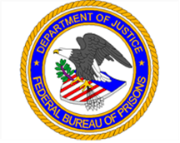
U. S. Department of Justice
Federal Bureau of Prisons
Central Office
320 First St., NW
Washington, DC 20534

Event Date:

Registration Deadline:

Event Location: FCC Coleman/UNICOR
846 NE 54th Terrace
Coleman, FL 33521

Attendee(s) Information & Registration
 | Attendee 1 | Attendee 2 | Attendee 3
Full Name
Phone Number
Email Address
FPI Presentation | Yes/No | Yes/No | Yes/No
One on One Meeting | Yes/No | Yes/No | Yes/No

