SUBJECT* | 36C24126Q0402 | Georgetown CBOC New Clinic | Sources Sought

GENERAL INFORMATION
CONTRACTING OFFICE’S ZIP CODE* | 06516
SOLICITATION NUMBER* | 36C24126Q0402
RESPONSE DATE/TIME/ZONE | 04-30-2026 3:00 PM EASTERN TIME, NEW YORK, USA
ARCHIVE | 15 DAYS AFTER THE RESPONSE DATE
RECOVERY ACT FUNDS | N
SET-ASIDE
PRODUCT SERVICE CODE* | X1DB
NAICS CODE* | 531120
CONTRACTING OFFICE ADDRESS | Department of Veterans Affairs  VA Connecticut  Minor Leasing Division - EAST  950 Campbell Avenue  West Haven CT 06516
POINT OF CONTACT* | Lease Contract Specialist  Raquel Williams  Raquel.Williams4@va.gov  203.932.5711 18725

PLACE OF PERFORMANCE
ADDRESS | Georgetown, SC
POSTAL CODE
COUNTRY | USA

ADDITIONAL INFORMATION
AGENCY’S URL | https://www.va.gov
URL DESCRIPTION | Department of Veterans Affairs
AGENCY CONTACT’S EMAIL ADDRESS | raquel.williams4@va.gov
EMAIL DESCRIPTION | Raquel Williams

DESCRIPTION
U.S. DEPARTMENT OF VETERANS AFFAIRS DESIRE TO LEASE SPACE
THERE IS NO SOLICITATION AT THIS TIME. This is a Sources Sought Notice (SSN) only and does not constitute a request for proposals. Submission of any information in response to this SSN is purely voluntary. The Government assumes no financial responsibility for any costs incurred associated with this SSN.

Notice: This notice is for market research purposes for a potential opportunity. This notice is not a solicitation for offers, nor is it a request for proposals. The purpose of this notice is to identify potential sources and suitable locations and is not intended to pre-qualify or disqualify any potential offers. The Government will not pay for any costs incurred because of this notice. The Government cannot provide any warranty, expressed or implied, as to the accuracy, reliability, or completeness of contents of the furnished information found within this notice. Respondents are advised that the Government assumes no responsibility to award a lease based upon responses to this notice.

The Department of Veterans Affairs is conducting market research/seeking capable sources for sufficient real property space that are classified and registered in www.vip.vetbiz.gov as either Service-Disabled Veteran-Owned Small Businesses (SDVOSB) or Veteran-Owned Small Businesses (VOSB) that are interested in a forecasted lease project for medical office space, to yield 10,000 net usable square feet (NUSF) for use as a Community Based Outpatient/Primary Care Clinic located in Georgetown, SC for 5-Years Firm Term, 5-Years Soft Term.

The Department of Veterans Affairs will consider existing space that complies with all current building, seismic, and ADA code requirements. On-site, 59 total dedicated parking spaces including designated ADA compliant spaces are required and 6 spaces designated for handicapped individuals with at least 2 spots being van accessible (96” wide clearance) and the other 4 having at least 60” clearance within one block of the building. The desired space should be contiguous, on no more than one floor and must meet or be able to meet the Department of Veterans Affairs Life Safety codes and other applicable regulations. The VA seeks a fully serviced lease that includes, but is not limited to the following:

Heating system maintenance and repair Electrical system maintenance and repair
Plumbing maintenance and repair All Utilities: Electricity, Heat, Sewer, Water
Real Estate Taxes Landscaping
Window cleaning Common area supplies
Garbage removal Snow removal
Pest control Lawn Sprinkler
Common area maintenance Site lighting
Insurance Alarm System

The NAICS Code is 531120 Lessors of Nonresidential Buildings (except mini warehouses), and the small business size standard is $47.0 million. using the exception of leasing space to the Federal Government. The Government anticipates this lease requiring tenant improvements between $1.0 and $2.0M estimated. Responses to this notice will assist the VA in determining if the acquisition should be set-aside for competition restricted to SDVOSB or VOSB concerns in accordance with 38 USC Sec. 8127. Although this notice focuses on SDVOSB and VOSB, we encourage ALL small businesses and other interested parties to respond for market research purposes.

The Department of Veterans Affairs desires to lease approximately 10,000 net usable square feet of medical / office space in Georgetown, South Carolina. The space will be occupied by the Charleston VHA Healthcare System and must include space for use by tenant for personnel, furnishings, and equipment. Access is required from 6:00 AM to 6:00 PM. Access to public transportation shall be located within the immediate vicinity of the building, but generally not to exceed a walkable one mile as determined by the Lease Contracting Officer. Alternatively, two or more public or campus bus lines shall be located within the immediate vicinity of the building, but generally not to exceed a walkable ¼ mile. Space shall be located on the first floor; space must be accessible by elevators if not on first floor. Proximity to gun stores, pawn shops, adult entertainment clubs, liquor stores, medical (or otherwise) marijuana distributors or methadone clinics are precluded within a walkable mile of the building.

All businesses are invited to respond to this SSN. Expressions of Interest must be submitted to the Lease Contracting Specialist or point of contact (POC) electronically to Raquel.Williams4@va.gov by the deadline publicized in the Sources Sought Notice and must include the following information:
1. Building name, address, and location of available space; or address and location/acreage of location to be developed.
2. Amount of available space and proposed rates in NUSF, RSF, and ANSI/BOMA. Sources Sought Notice Sources Sought Notice Page 7 of 7
3. Building ownership information, brokers or legal representatives must show written acknowledgement and permission to represent the property.
4. Amount of parking available on-site.
5. Business socio-economic category if other than a large business.
6. Contact information of authorized representative.

Location: Space must be located within the following geographic boundaries of Savannah, GA:

Bounded on the North: County Road-S-22-362 and Trace Drive, Pawleys Island SC
Bounded on the South: Winyah Bay and Pennyroyal Road, Georgetown, SC
Bounded on the West: Brick Chimney Road, Georgetown, SC
Bounded on the East: Atlantic Ocean

*See Map Below. Building shall be located within the above geographical boundaries, and the lines on the map are for a close, but not exact, depiction.
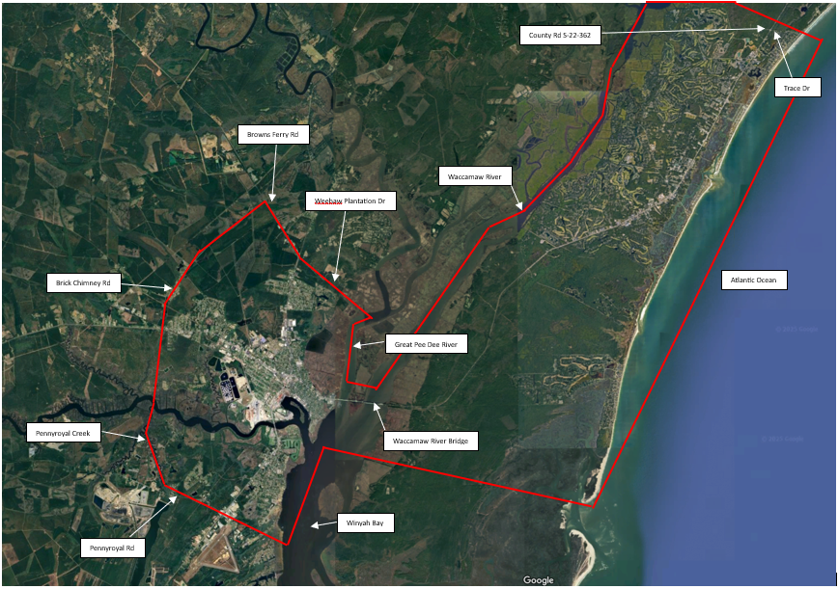

The Capabilities Statement Requirements below apply to SDVOSB and VOSB Firms:
SDVOSB and VOSB firms are invited to provide information in response to this SSN to contribute to the market research for this project. SDVOSB and VOSB firms must be registered with the Small Business Administration at https://certifications.sba.gov/ and have the technical skills and financial capabilities necessary to perform the stated requirements. Only SDVOSB and VOSB firms are requested to submit a Capabilities Statement to VA for review. SDVOSB and VOSB firms may provide a Capabilities Statement if they are interested in participating in this project.

Capabilities Statement will include:
1. Company name, address, point of contact, phone number, Dunn & Bradstreet number, System for Award Management identification (if registered at www.SAM.gov), and e-mail address.
2. Evidence of SDVOSB or VOSB status through registration with the Small Business Administration at https://certifications.sba.gov/
3. Evidence of ability to offer under NAICS Code 531120 and listing in the System for Award Management (www.SAM.gov), including a copy of the representations and certifications made in that system.
4. A summary describing up to three (3) projects of similar size and scope completed in the past five (5) years that demonstrate your experience designing, constructing, and managing Federal leased facilities or health care facilities relevant to the project described above. (3-page limit)
5. Evidence of capability to obtain financing for a project of this size. If desired, the company may also submit a narrative describing its capability.

We encourage all businesses and other interested parties to respond for market research purposes.
The Government is limited by law (40 USC 278a, as Amended 10-1-81) to pay no more than the appraised fair rental value for space.

Raquel Williams
Lease Contract Specialist
VHA Minor Leasing Division – Eastern Region

The NAICS code for this Notice is 531120
MARKET RESEARCH QUESTIONNAIRE
Response to Questionnaire is required from all interested parties.
Lessor’s Name & Contact Info (Phone & Email)_____________________________________
Building Name and Address ______________________________________________________
SAM UEI#____________________________________________________________________
Indicate your business size & socio-economic status under NAICS code 531120:
[ ] yes [ ] no Large Business (LB)
[ ] yes [ ] no Small Business (SB)
[ ] yes [ ] no Certified HUBZone
[ ] yes [ ] no Certified Small Business 8(a)
[ ] yes [ ] no Small Disadvantaged Business (SDB)
[ ] yes [ ] no Economically-Disadvantaged Women-Owned Small Business (EDWOSB)
[ ] yes [ ] no Women-Owned (WO) Small Business
[ ] yes [ ] no Certified Service Disabled Veteran Owned Small Business (SDVOSB)
[ ] yes [ ] no Veteran Owned Small Business (VOSB)
[ ] yes [ ] no Other (please specify)
[ ] yes [ ] no Registered with the System for Award Management (SAM) @
https://www.sam.gov
[ ] yes [ ] no Registered in SBA VetCert Registry @ Veteran Small Business Certification (sba.gov)
A SOLICITATION HAS NOT BEEN ISSUED. After review of responses, a solicitation may
be published at a later date. Responses to this Market Research Questionnaire will not be
considered as submission of an offer for future solicitation announcements. All interested parties
must respond to future solicitation announcements separately or in addition to this Market
Research Questionnaire. Contract award resulting from any future solicitation can only be made
to a contractor who is registered in SAM.
This notice is to assist the VA in determining sources only. A SOLICITATION IS NOT
CURRENTLY AVAILABLE. If a solicitation is issued it will be announced at a later date,
and all interested parties must respond to that solicitation announcement separately from
the responses to this announcement.
Please return this survey with your expression of interest. All responses shall be verified. Failure to provide the following shall result in elimination as an interested party:
- Market Research Questionaire.
- Site Plan Depicting the Building.
- Map with Location of Building with the Delineated Area.
- Block or Floor Plan of the Proposed VA Space.
- Identification on Site Plan Demonstrating Location of Parking dedicated for VA’s use.
- Proof of Ownership
- Authorized Letter of Engagement from the Owner if you are a Broker.

