Fabrication of Miter Gate – Meldahl L&D (Auxiliary Chamber)

The work covered by this section consists of the fabrication, assembly, and delivery of one (1) miter gate (two (2) leaves), and appurtenant items as specified and shown on the drawings. The miter gate must consist of two (2) leaves, each 61-feet 6 inches from center to center of thrust-bearing contacts. The gate must be 65 feet in height, measured from the top of sill to the top of the walkway. The top of the gate must be provided with a grated aluminum walkway and steel (galvanized) pipe handrailing. Each gate leaf must be braced on the downstream side with diagonal members extending from the pintle corner to the upper miter corner and from the lower miter corner to the gudgeon pin corner. Each diagonal must be adjustable in length by means of heavy hex nuts on each end. Each gate leaf must be provided with a pintle assembly (socket casting, bushing and pintle). Each gate leaf (two (2) required) must be a complete welded structure.

Due to the critical nature of this structure, and the fact that some members are "Fracture Critical", all welding is required to be performed to AWS D1.5M/D1.5 welding code standard by a steel fabricator certified under the AISC Quality Certification Program (AISC 207) for "Certified Hydraulic Fabricator" (HYD), "Certified Hydraulic Fabricator - Advanced" (HYDA), "Steel Bridge Fabricator - Intermediate" (IBR), or "Steel Bridge Fabricator - Advanced" (ABR) meeting supplemental requirements for "Fracture Control Endorsement" (FCE) at the time of proposal and throughout the length of the contract. These certifications are required for the prime contractor as well as any sub-contractor performing structural steel fabrication for this contract. The Contractor must possess five (5) years documented experience on projects of similar scope. Individuals that work for the Contractor, or whom are hired by the Contractor, that will require access to the Meldahl Locks and Dam will need to meet the security requirements as specified in Section 00 80 00 SPECIAL CONTRACT REQUIREMENTS. This must include the delivery truck personnel, barge crew and the Contractor's representative(s) that will perform the final inspection once the gates have been delivered to the project.

The Contractor will be required to commence work under this contract within fifteen (15) calendar days after the day of receipt of Notice of Award, to prosecute said work diligently, and to complete the entire work, and make delivery not later than 1,100 calendar days after award.

The miter gate to be furnished under this contract must be delivered by barge to the Meldahl Locks and Dam, 2443 US Highway 52, Felicity, OH 45120. The miter gate leaves must be shipped in a horizontal (flat) position with the skin plate side up. The five (5) walkway sections per leaf, must be removed from the leaves and shipped detached. The grating panels must remain attached to each walkway section except for the shared grating panels between walkway sections and each grating panel on the ends of the walkway on each leaf. The handrail sections must be removed from each walkway section prior to shipment. The appurtenance items can be delivered by river or overland means. Shipment of the gate to the Meldahl Locks and Dam by truck will not be allowed. The gate must be delivered by barge(s) to the Meldahl project at approximately River Mile 436.2 on the Ohio River, for unloading by the Government at a later date. The Contractor must moor the barge(s) to the storage/offload harbor located 1,000 feet upstream of the landward lock chamber along the right descending bank. Shipments are received between 8:00 and 3:00 pm, Monday through Friday, Federal holidays excluded. The gate must be supported on Contractor fabricated cribbing and sufficiently secured for transport. The delivery barge(s) must be available for the Government’s use for a minimum of 60 calendar days after acceptance by the Government. Upon delivery to the Meldahl Locks and Dam, the Contractor and Contracting Officer must perform a joint inspection of the gate and appurtenances prior to off-loading. The Contractor must document any additional damages that may have occurred during shipment of the gate. After this inspection is completed, the Government must off-load the gate from the Contractor’s barge within the 60 calendar day period. The Contractor must notify the Contracting Officer at least 48 hours prior to the approximate time of delivery. The Contractor must be responsible for repair of any damages that occur during shipment of the gate to the Government. All damages must be corrected to the satisfaction of the Contracting Officer at the Contractor’s expense. At the end of the 60 calendar day period, or after the gate has been offloaded, the Contractor will be notified that the barge(s) is available for pick up.

Downstream Elevation View of Miter Gate

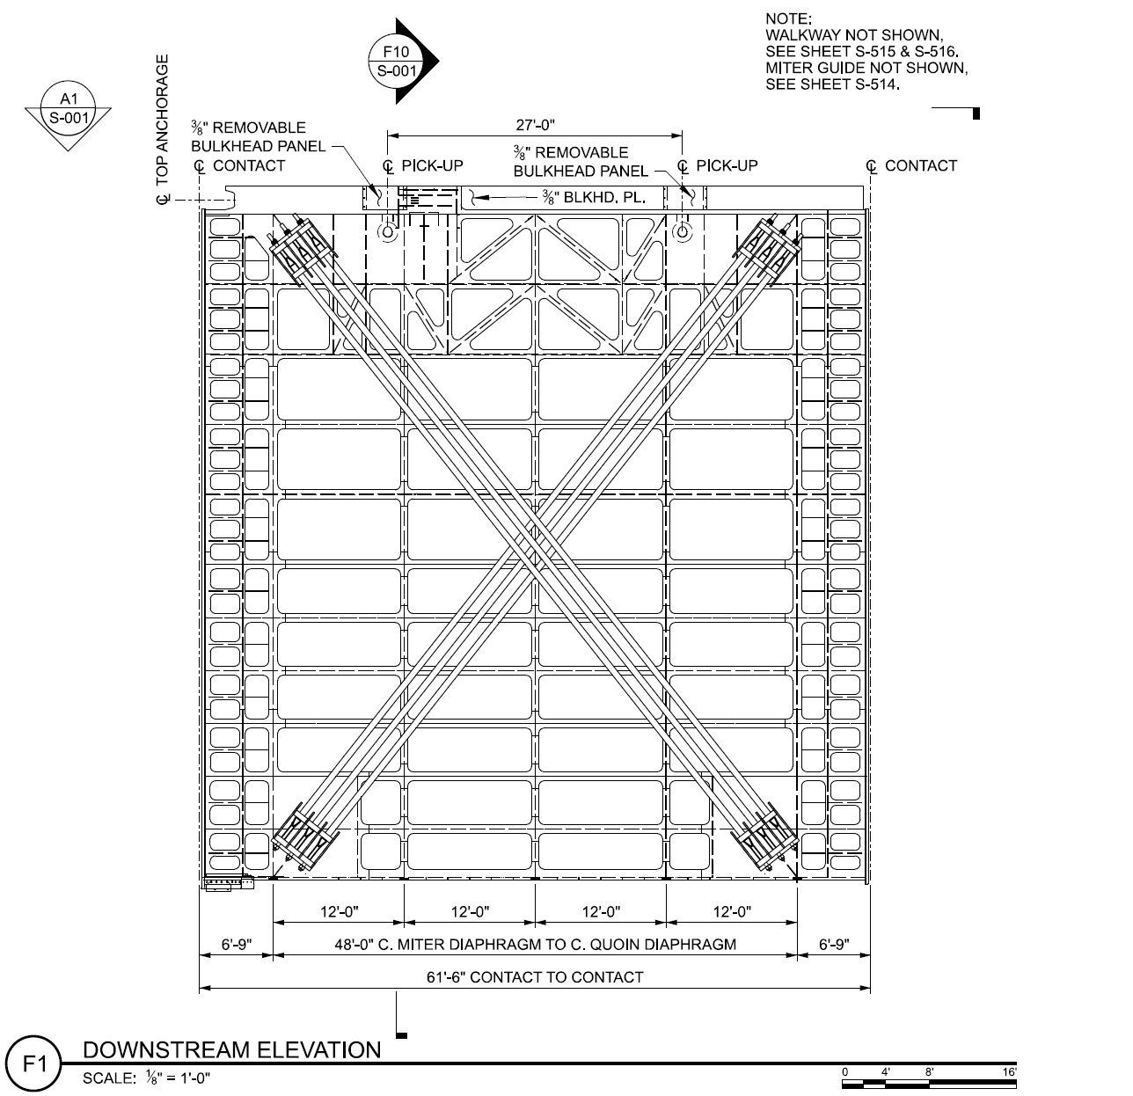

Upstream Elevation View of Miter Gate

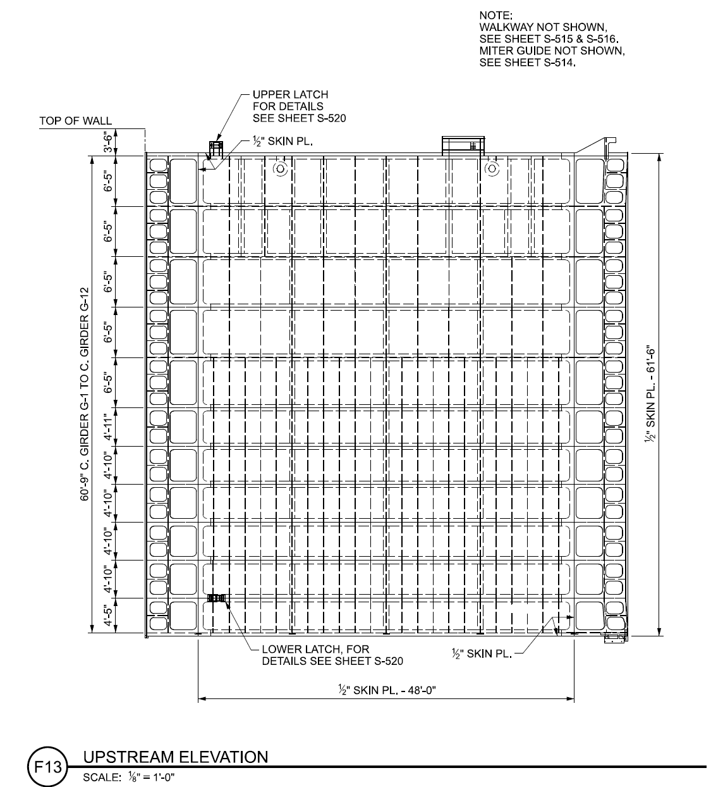

Photos of Existing Miter Gates
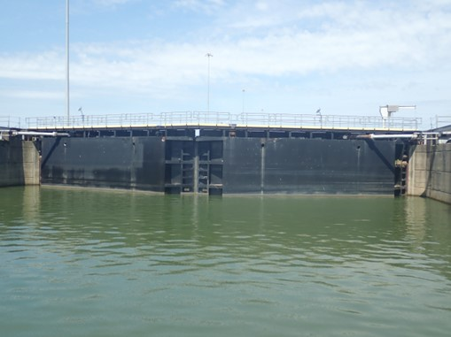

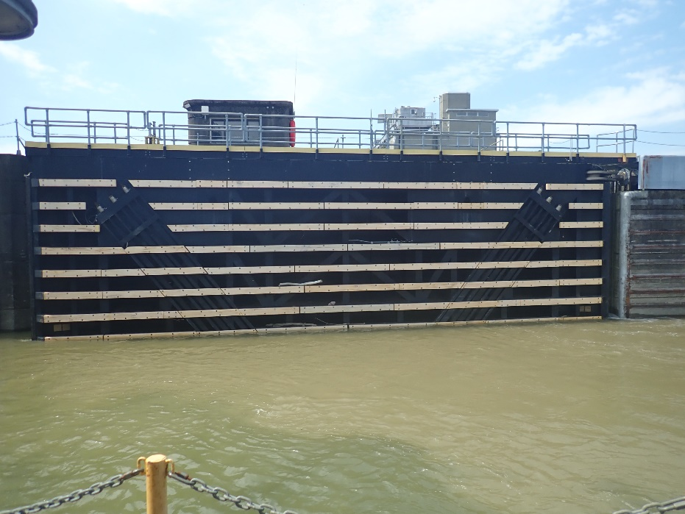

Photos of Existing Miter Gates
