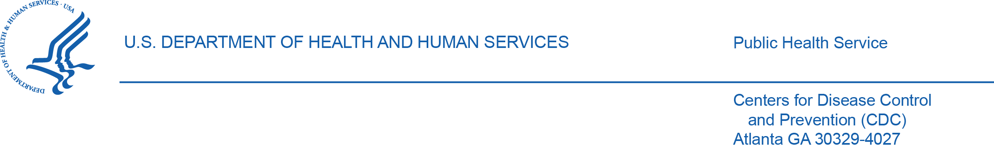
Request for Information

Title: CDC Appian Licenses & Limited Technical Support

NAICS: 541519

Introduction:
This is a general request for information from small-businesses. This is NOT a solicitation for proposals, proposal abstracts, or formal quotations. Market Research pricing is requested, but responses to RFIs are not offers and cannot be accepted by the Government to form a binding contract. (i) The Government does not intend to award a contract on the basis of the RFI or otherwise pay for the information requested; and (ii) Responses will be treated as information only and not as a proposal.

Purpose:
The purpose of this notice is to obtain information regarding: (1) the availability and capability of qualified small business sources, (2) their size classification relative to the North American Industry Classification System (NAICS) for the proposed acquisition, (3) the small business classification of any small businesses responding, (e.g. HUBZone, SDVOSB, VOSB, SDB, 8(a), WOSB, EDWOSB), and (4) any contracting methods or vehicles that any responding business may be available on (e.g. GSA MAS, GWACs, open market, etc.). Your responses to the information requested will assist the government in determining the appropriate acquisition method, including whether a set-aside is possible. Given category management requirements, the government intends to procure through a Federal Supply Schedule or GWAC, rather than open market.

Submit the Following:
- Approved Vendor: Documentation of authorization or approval to resell the relevant Appian Licenses.
- Market Reasearch Pricing: Fill in the template attached/below.
- Contract Vehicles: Any Federal Supply Schedules or GWACs.
- Capability Briefs
Information Requested:
The government is seeking approximate pricing for a small-business resellers of Appian software licenses. Pricing may be exact or a range, but the range must be limited enough to be useful. Example: A potential far market price range of $100-120 may be quoted as $90-130 and be useful, where a price range of $50-300 for that same item is too broad to tell.
Appian product(s) software and licensing for RMS should be based on #625 named users and 575 infrequent users (4 times per month) with ability to manage user licenses.

The Appian product(s) will provide software license renewal, media, documentation, and maintenance during the specified performance period. The Appian product(s) shall provide major and minor software version upgrades during performance period. The Appian product(s) will ensure software conforms to all applicable regulations and guidelines for use in a non-high security US Government environment for the performance period.
Period of Performance: Up to 5 years, so please provide a copy for each year or an escalation rate.
GSA Advantage:
- #403-11000 - https://www.gsaadvantage.gov/advantage/ws/catalog/product_detail?gsin=11000074143855
- #403-17500 - https://www.gsaadvantage.gov/advantage/ws/catalog/product_detail?gsin=11000082299282
ITEM | SUPPLIES / SERVICES | Appian Part # | QTY | Market Resarch Price Quote | Business Size/Socio-Economic | GWAC/FSS
1 | Production Cloud 4xLarge Instance | #403-53000 | 1
2 | Non-Production Cloud Large Instance | #03-50000 | 1
3 | Application Specific Users - Unlimited access | #403-11000 | 625
4 | Infrequent Users (4 times per month) | #403-17500 | 575
5 | Cloud xLarge Instances | #403-51000 | 3
6 | Non-Production Cloud 4xLarge Instance | #403-53000 | 1
7 | Premier Support (includes High Availability Instance) | #403-81000 | 1
7A | Initial Premier Base Production Cloud xLarge Instance HA | #403-49102 | 1
7B | Initial Non-Production Instance | #403-49001 | 2
8 | Additional Cloud Storage per 100GB | #403-60000 | 15
9 | Cloud Instance Upgrade - 4XL to 8XL (Optional Item) | #403-57404 | 2

