SUBJECT* | Notice of Intend to Sole Source Magnet Annual and Application Fee

GENERAL INFORMATION
CONTRACTING OFFICE’S ZIP CODE* | 77056
SOLICITATION NUMBER* | 36C25626Q0595
RESPONSE DATE/TIME/ZONE | 04-08-2026 3PM CENTRAL TIME, CHICAGO, USA
ARCHIVE | 7 DAYS AFTER THE RESPONSE DATE
RECOVERY ACT FUNDS | N
PRODUCT SERVICE CODE* | U005
NAICS CODE* | 541611
CONTRACTING OFFICE ADDRESS | Department of Veterans Affairs  Network Contracting Office 16  Galleria Financial Center  5075 Westheimer Road, Suite 750  Houston TX 77056-5643
POINT OF CONTACT* | Contract Specialist  Robert (Dustan) Arabie  robert.arabie@va.gov  713-791-1414

ADDITIONAL INFORMATION
AGENCY’S URL | https://www.va.gov/
URL DESCRIPTION | Department of Veterans Affairs
AGENCY CONTACT’S EMAIL ADDRESS | robert.arabie@va.gov
EMAIL DESCRIPTION | 36C25626Q0595_NOI SS Response_Vendor Name

DESCRIPTION
This is a Special Notice for commercial items prepared in accordance with FAR Subpart 5.2, Synopsis of Proposed Contract Actions. This announcement constitutes the only Notice of Intent (NOI) to Sole Source (SS) and synopsis of proposed action.
The Department of Veterans Affairs Michael E. DeBakey VA Medical Center (MEDVAMC) Network Contracting Office (NCO) 16 intends to issue and award a Sole Source single award Firm-Fixed Price type contract delivery order IAW FAR Overhaul Part 12 with a performance period of one (1) year to the American Nurses’ Association located at 8403 Colesville Rd STE 500, Silver Spring, MD for MAGNET Recognition at the MEDVAMC, located at 2002 Holcombe Boulevard, Houston, TX 77030.

It has been determined that through initial Market Research, only 1 (one) credentialling body exists for the MAGNET designation. The contract will be a Firm Fixed Price single award. The statutory authority for this non-competitive acquisition as implemented by FAR 6.302-1. “Only one responsible source and no other supplies or services will satisfy agency requirements”.

The North American Industrial Classification System (NAICS) code for this procurement is 541611 – Administrative Management and General Management Consulting Services, with a small business size standard of $24.5M, and the FSC/PSC is U010 – Education/Training – Certifications/Accreditations for Educational Institutions. Services to be awarded are shown below.
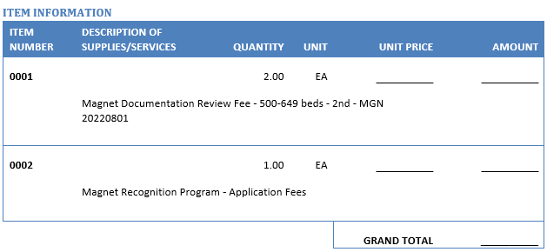

The contractor shall provide and ensure safe, secure, and careful handling and delivery of results in accordance with established guidelines from the Department of Veterans Affairs Handbook 6500 and drafted statement of work.
THIS NOTICE IS NOT A REQUEST FOR COMPETITIVE PROPOSALS OR QUOTATIONS. A SOLICITATION WILL NOT BE POSTED.
Telephone requests will not be honored. No award will be made based on quotes or offers received in response to this notice. All responsible sources may identify their interest to meet this requirement to Contract Specialist and date identified on page one of this announcement. Additionally, any response to this notice must show clear, compelling and convincing evidence that competition will be advantageous to the government by providing the following:
1.Business Size and Socio-Economic Status: (a) Indicate whether your business is large or small (b) If small, indicate if your firm qualifies as a small, emerging business, or small disadvantaged business (c) If disadvantaged, specify under which disadvantaged group and if your firm is certified under Section 8(a) of the Small Business Act (d) Indicate if your firm is a certified Hub zone firm (e) Indicate if your firm is a woman-owned or operated business (f) Indicate if your firm is a VIP verified Service-Disabled Veteran Owned Small Business (SDVOSB) or Veteran Owned Small Business (VOSB) (g) Include the DUNS number of your firm. (h) State whether your firm is registered with the System for Award Management (SAM) at www.sam.gov and/or the SBA VetCerts Registry at https://veterans.certify.sba.gov/. If not, please NOTE: any future solicitation could only be awarded to a contractor who is registered in SAM. To receive award based on VOSB or SDVOSB status you must be registered in the SBA VetCerts Registry.
The intent of this notice is for informational purposes only. Interested parties may submit information for consideration by the government to: robert.arabie@va.gov no later than the response due date/time identified above.
All responses received by the closing date specified herein will be considered by the Government, any response to this notice must show clear and convincing evidence that the responding company can provide the same services by the required date. However, a determination by the Government to not compete is solely within the discretion of the Government.
Thank you.

