SOURCES SOUGHT NOTICE / MARKET RESEARCH - KONA VET CENTER
Department of Veterans Affairs Healthcare (VHA)
Regional Procurement Office West (RPOW)

Notice: This advertisement is a notice of a potential opportunity, it is not a solicitation for offers, nor is it a request for lease proposals. The purpose of this advertisement is to identify potential sources and suitable locations and is not intended to pre-qualify or disqualify any potential offers. The Government will not pay for any costs incurred resulting from this advertisement. The Government cannot provide any warranty, expressed or implied, as to the accuracy, reliability, or completeness of contents of the furnished information found within this advertisement; Government is under no responsibility to respond to and is unable to answer any inquiries regarding this advertisement. Respondents are advised that the Government assumes no responsibility to award a lease based upon responses to this advertisement. The NAICS Code is 531120 Lessors of Nonresidential Buildings, and the small business size standard is $41.5 Million.

The Department of Veterans Affairs Healthcare (VHA) System is currently seeking to add a Vet Center leased space in the City of Kona, HI. Sources that are interested in leasing space to the Department of Veterans Affairs are advised that the Government assumes no responsibility to award a lease based upon responses to this advertisement.

Contracting Office Address: Garry Alexander, Contracting Officer, RPO West, Leasing, Office: (360) 816-2759 Email: Garry.Alexander@va.gov

Description: The Department of Veterans Affairs seeks to lease a minimum of 2308 Rentable Square Feet (RSF) not to exceed 4334 ABOA of office space and 15 reserved for VA use only parking spaces to include 3 designated ADA compliant spaces. The space shall be located within the delineated area stated below. Should a solicitation or request for lease proposals (RLP) be issued for this project, VA will provide all detailed definitions and further information.

Lease Term: 20 years, 10 firm term and 10 soft term (termination rights after 10-years).

Delineated Area: To receive consideration, submitted properties must be located within the area described below, which is bound by the following roads or must front on any of the following boundary lines:

North Boundary: Mamalahoa HWY (19), North of Kawaihae Road.
South Boundary: Hawai’i Belt Road (11), Kamehameha Road.
East Boundary: HWY 190.
West Boundary: Pacific Ocean.

The attached map of the delineated area is provided for further clarification of the boundaries of the delineated area.

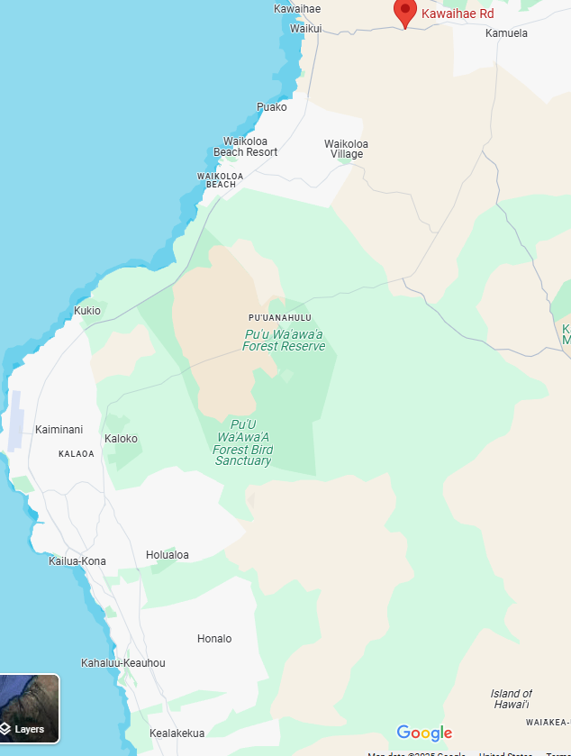

ADDITIONAL REQUIREMENTS:

- Parking: (reserved for VA only) on-site parking for a minimum of 15 vehicles is required, of which at least three (3) spaces must be ADA compliant. Parking access exit and entry must have an easy approach to accommodate special needs transportation.
- Proposed property shall not be located within the 100-year flood plain.
- The proposed property must be within the delineated area.
- A lease for up to 20 years; 10 Years Firm, 90 Day Termination Rights.
- Offered space will not be considered if located within proximity of an incompatible property. Proximity shall be evaluated by the property use, visibility, and accessibility to offered building and impact from property use. Not all-inclusive examples of use include liquor establishments, treatment centers, prisons, or jails, where firearms are sold/discharged, railroad tracks, within flight paths, industrial areas, smoke shops, or marijuana dispensaries, or agricultural areas where chemical insecticides/herbicides are sprayed.
- Offered space must meet Federal and Local Government requirements for fire safety, physical security, accessibility, seismic, and sustainability standards per the terms of the solicitation or requests for proposals.
- VA prefers a fully serviced lease to include operating costs and utilities typical for the region from a reputable third-party provider operating under regulatory or governing industry standards. Private well water and septic systems are not acceptable.
- Offered space must be compatible with VA’s intended use.
- Transportation accessibility to offered property exists consisting of one major throughfare within 1 mile of the building.

All submissions should include the Following information:
- Name, phone number and email address of Property Owner. Note: if responding and you are not the property owner, i.e. broker, provide a written statement from the property owner (on owner letterhead) authorizing you to represent the owner for either the address or described location of building.
- Location on map, demonstrating the building lies within the Delineated Area.
- Documentation evidencing that proposed property is outside the 100-year flood plain.
- Site plan depicting the property boundaries, building, and parking.

The building and parking area must be fully accessible, meeting all requirements of the Americans with Disabilities Act and the Uniform Federal Accessibility Standards. The building must comply with the Interagency Security Committee Security Design Criteria for New Federal Office Buildings and Major.

Interested offerors (owners or their legal representatives, i.e. brokers) shall submit information concerning their properties outlined above to Nicholas Williams or Dominic Mabine via email at garry.alexander@va.gov, or dominic.mabine@va.gov no later than 4:00 PM CST on Friday, May 30, 2026, including all questions or concerns. Interested offerors shall include the following title in the subject line of the email, “Kona Vet Center.” Please note, email size shall be limited to 5 MB, therefore multiple emails maybe required.

Attachment - VOSB or SDVOSB Status

This is not a request for proposals, only a request for information for planning purposes, and does not constitute a solicitation. A solicitation may or may not be issued.

The NAICS Code for this procurement is 531120 Lessors of Non-residential Buildings, and the small business size standard is $41.5 million. Responses to this notice will assist in determining if the acquisition should be set-aside for SDVOSB or VOSB concerns in accordance with 38 USC § 8127.

The magnitude of the anticipated construction/buildout for this project is:
__ (a) Less than $25,000.
__ (b) Between $25,000 and $100,000.
x__ (c) Between $100,000 and $250,000.
__ (d) Between $250,000 and $500,000.
__ (e) Between $500,000 and $1,000,000.
__ (f) Between $1,000,000 and $2,000,000.
__ (g) Between $2,000,000 and $5,000,000.
__ (h) Between $5,000,000 and $10,000,000.
__ (i) Between $10,000,000 and $20,000,000.
__ (j) Between $20,000,000 and $50,000,000.
__ (k) Between $50,000,000 and $100,000,000.
__ (l) More than $100,000,000.

VA makes monthly rental payments in arrears upon facility acceptance and may elect to make a single lump-sum payment or amortize over the course of the firm term for specified tenant improvements. VA makes no progress payments during the design or construction/build-out phases of the project.

Project Requirements: This Sources Sought Notice seeks information from Potential Offerors who are capable of successfully performing a lease contract, including design and construction of the facility described above, for a term of twenty (20) years, inclusive all firm and soft terms, as well as all maintenance and operation requirements for the duration of the lease term, at a fair and reasonable price.

SDVOSB and VOSB firms are invited to provide information to contribute to the market research for this project. SDVOSB and VOSB firms must be registered in Small Business Administration (SBA) site https://dsbs.sba.gov/ All business concerns must have the technical skills and financial capabilities necessary to perform the stated requirements. A submission checklist and information sheets are provided below for firms to fill out and submit, which will serve as the firm’s Capabilities Statement. If 2 or more VOSB firms are found, then the requirement will be set aside.

Capabilities Statement Will Include:
1. Company name, address, point of contact, phone number, Experian Business Identification Number, and e-mail address.
2. If you are, please provide evidence of SDVOSB or VOSB status through registration at SBA Dynamic Small Business Search SBA (https://dsbs.sba.gov/). Evidence of ability to offer as a small business under NAICS Code 531120 and listing in the System for Award Management (www.SAM.gov), including a copy of the representations and certifications made in that system.
4. Evidence of at least a conditional commitment of funds in an amount necessary to prepare the Space.

If desired, the company may also submit a narrative describing its capability.

All business concerns are requested to submit a Capabilities Statement if they are interested in participating in this market research.

CAPABILITIES STATEMENT
SUBMISSION CHECKLIST AND INFORMATION SHEET

Kona Vet Center Lease Sources Sought Notice

Company name: __________________________________________
Company address: __________________________________________
Dunn and Bradstreet Number: __________________________________________
UEI Number: __________________________________________
Point of contact: __________________________________________
Phone number: __________________________________________
Email address: __________________________________________

The following items are attached to this Capabilities Statement:

☐ Evidence of SDVOSB or VOSB status through registration at SBA (https://dsbs.sba.gov/).
☐ Evidence of ability to offer as a small business under NAICS Code [531120] and listing in the System for Award Management (www.SAM.gov), with representations and certifications.
☐ A summary describing at least three (3) projects of similar size and scope completed in the past five (5) years that demonstrate the company’s experience designing, constructing, and managing Federal leased facilities or health care facilities relevant to (input project specific NUSF) with a 3-page limit; and
☐ Evidence of capability to obtain financing for a project of this size.

If desired, the company may also submit a narrative describing its capability, not to exceed two (2) pages.

By: _________________________________________________
(Signature)

__________________________________________________
(Print Name, Title, Date)

