Request for Information
N64498-26-RFPREQ-PD-45-0080
Subsea Rollers and Bearings

Requirement Description/Draft Scope:
The Naval Surface Warfare Center, Philadelphia Division (NSWC PD) is hereby issuing a Request for Information (RFI) from all potential sources to provide information regarding a commercial, modified commercial, or non-commercial product/service solution(s) to the below specifications:

The design, fabrication, and testing of rollers (and any associated bearings) for use in subsea payload handling equipment is desired. It can be assumed that when the handling equipment is not in use and standing by, the rollers will be stowed in a dry environment. Note that the rollers may be statically loaded for indeterminate periods of time when stowed. It can be assumed that the rollers will be traversing across high-strength, low-alloy steel (~80 ksi yield strength). It can also be assumed the path of travel will be flat and straight.

The ideal roller design(s) should:
- Be operable in both dry and subsea environments. Operation in subsea environments should be prioritized.
- Have minimal acoustic signatures while operating in subsea environments.
- Not exceed the geometric constraints illustrated in Figure 1
  - Note that roller assembly “A” can only be supported from a single side. Necessary support/mounting structure can extend outside the noted dimensions on one side.
  - Note that roller assembly “B” can be supported on both sides (through-shaft). An additional 1.00 inch of support structure can be assumed on both sides.
  - Note that the total length available for roller travel is provided to allow for potential design solutions that may distribute loading across multiple rollers/points of contact per assembly (e.g., tracked or chained rollers).
- Support dynamic (rolling) loads of at least:
  - 25,000 lbf for roller assembly “A”
  - 58,000 lbf for roller assembly “B”
- Have a maximum coefficient of friction at the supporting shaft that does not exceed 0.150 in both dry and subsea environments.
- Support the movement of payloads at speeds of at least 30 feet/min.
- Meet the requirements of MIL-DTL-167A (Mechanical Vibrations of Shipboard Equipment)
- Maintain all performance capabilities:
  - In air temperatures from -20 to 140 degrees Fahrenheit
  - In seawater temperatures from 28 to 95 degrees Fahrenheit
  - At sea depths no less than 400 feet
- To the maximum extent possible, be impervious to corrosion, biofouling, and the introduction of foreign debris (e.g., sand, mud, etc.).
  - Note that the rollers may be stowed in an area with cathodic protection nearby.
- Maximize service life:
  - Support system operation for no less than 45 years
  - Support a minimum of 100 system cycles per year
  - Sustain all performance capabilities for no less than 18 months without requiring any maintenance
  - In general, minimize the maintenance required to achieve service life objectives
- Reduce design complexity:
  - To the maximum extent practical, minimize the number of assembly components
  - To the maximum extent practical, preclude the introduction of implodable or explodable volumes

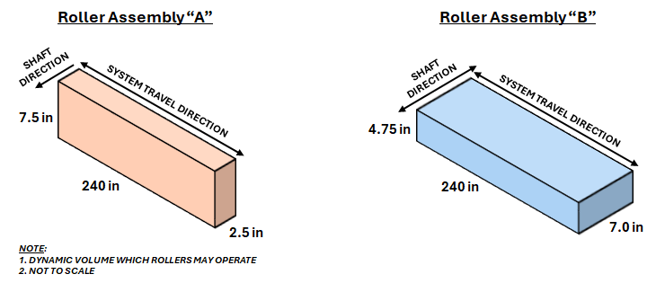
Figure 1: Geometric Constraints for Roller(s)

Submission of Responses:
Vendors are requested to provide brochures, literature and/or information on their supply/service. Vendors are further requested to provide the following information:

- Company name, address, phone number, primary contact(s), email address, ALL applicable NAICS code(s), business size (i.e., small/large), company's socioeconomics (i.e., woman-owned, service-disabled, veteran owned, HUBZone, 8(a), etc.), and DUNS Number.
- Current products that can meet or be modified to meet the requirements above.
- Feasibility of developing a bespoke product to meet the requirements above if no existing product is suitable.
- The maximum achievable performance capabilities if any of the above performance requirements are deemed infeasible.
- The design margin or safety factors included in the proposed product(s).
- The proposed roller mounting method (e.g., bolted, welded, cavity mounted, etc.).
- The minimum expected cycles/revolutions before maintenance and/or replacement is required.
- Identification of implodable or explodable volumes inherent in the proposed product(s).
- A list of all non-metallic materials to be utilized for the design and maintenance of the proposed product(s).
- Schedule estimates for:
  - Design and analysis (if required)
  - Prototype manufacturing (if required)
  - Testing (if required)
- Rough-Order-Magnitude (ROM)/Cost Estimates (for budgetary purposes only), as follows:
  - Nonrecurring engineering (if required)
  - Prototype manufacturing and testing (if required)
  - Final production of requested items (at scale)
- Equipment origin/place of manufacture and location of testing (if different).

Anticipated Contract Type (if known): TBD

Response Date: May 13, 2026

DISCLAIMER: This RFI is for informational/planning purposes only. This is not a request for quote/proposal. It does not constitute any form of solicitation and shall not be construed as a commitment by the government. Responses in any form are not offers and the government is under no obligation to make any form of award as a result of this announcement. No funds are available to pay for preparation of responses to this announcement. Any information submitted by respondents to this RFI is strictly voluntary.

All information received in response to this RFI marked “proprietary” will be safeguarded and handled accordingly. Interested parties are responsible for adequately marking proprietary or competition sensitive information that is contained in their response

