THE SUBMISSION OF PRICING, CAPABILITIES FOR PLANNING PURPOSES, AND OTHER MARKET INFORMATION IS HIGHLY ENCOURAGED AND ALLOWED UNDER THIS RFI IN ACCORDANCE WITH (IAW) FAR 10.002(b)(2).

This is a SOURCES SOUGHT ANNOUNCEMENT ONLY.
It is neither a solicitation announcement nor a request for proposals or quotes and does not obligate the Government to award a contract. Requests for a solicitation will not receive a response. Responses to this sources sought must be in writing. The purpose of this sources sought announcement is for market research to make appropriate acquisition decisions and to gain knowledge of potential qualified Service- Disabled Veteran Owned Small Businesses and Veteran Owned Small Businesses interested and capable of providing the services described below. Documentation of technical expertise must be presented in sufficient detail for the Government to determine that your company possesses the necessary functional area expertise and experience to compete for this acquisition.

The North American Classification System (NAICS) code for this acquisition is NAICS Code

562111– Solid Waste Collection (47 million)

**Responses to this notice shall include Sources Sought number “36C78626Q50134 Abraham Lincoln National Cemetery” in the subject line of the email no later than 3/10/2026 @ 4:00pm EST sent to April.Graves@va.gov

**The following shall be provided in the capabilities statement or in body of email:
- Company name
- Address
- Point of contact
- Phone, fax, and email
- DUNS number/ UIE number
- Type of Large or small business, e.g. Services Disabled Veteran Owned Small Business, Veteran-owned small business?
- Must provide a capability statement that addresses the organizations qualifications, years of experience and ability to perform as a contractor for the work described below.
- Provide any relevant FSS, NAC, GSA Contract vehicles the company holds if applicable.
  - If you are an FSS GSA/NAC or NASA SEWP contract holder or other federal contract holder, are the items/solutions you are providing information for available on your schedule/contract?
- Please review salient characteristics/ and provide feedback or suggestions. If none, please reply as N/A.
  - List any available options to meet needs as outlined in the statement of work.
  - Please include any questions about the statement of work below.
  - Please provide sample pricing of each deliverable if available.
  - Confirm exactly which deliverable you are able to offer, and which are not available through your company.

________________________________________________________________________________

STATEMENT OF WORK
TRASH AND RECYCLING REMOVAL SERVICES
ABRAHAM LINCOLN NATIONAL CEMETERY – NCA
- OBJECTIVE: The objective of this statement of work is for trash and recycling dumpsters with removal services,
Optional Services “if Available” annual septic tank pumping, street sweeping, port-o-potty rentals, and handwash station rentals at Abraham Lincoln National Cemetery.
Address: 20953 W. Hoff Road, Elwood, IL 60421

- GENERAL REQUIREMENTS: The contractor is to provide trash services, recycling services, roll of dumpster rentals, septic tank pumping, street sweeping, port-o-let rentals, and handwash station rentals in accordance with the details below.

  - Trash Service: The contractor will provide two (2) 8-yard trash containers with lids for general trash removal. 8-yard trash containers shall be serviced weekly during the work hours detailed below.

  - Recycling Service: The contractor will provide two (2) 4-yard recycling container with a lid for paper and cardboard recycling. The recycling container shall be serviced weekly during the work hours detailed below.

  - 30-yard roll off dumpster: The contractor shall provide 30-yard roll off dumpster(s) for trash and debris removal during specific special events and holidays. These dumpsters will be on an as needed basis, dependent on special scheduled and holiday events.

  - Street Sweeping: The contractor shall provide street sweeping services to sweep all cemetery roadways, curbs, and select parking lots (stand-alone restroom and behind main flagpole). The cemetery will provide water hook up services and on-site dumping location for debris collected while performing this specific service. This service is to be performed quarterly, on an approved day provided by the Contract Officer’s Representative (COR). The map below shows all roads and parking lots at the cemetery. Only the highlighted roads and parking lots are to be swept.

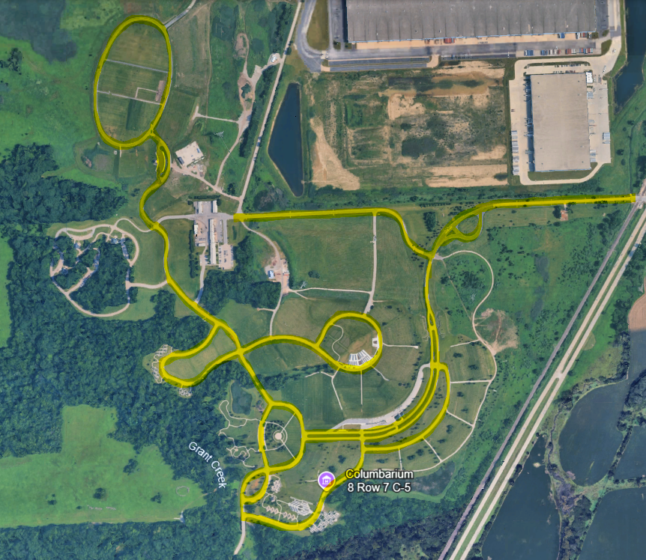

  - Standard Port-O-Lets: The contractor shall provide standard size port-o-lets with hand sanitizers mounted inside each unit for the cemetery’s Memorial Day Ceremony held on Memorial Day each year.

  - ADA Port-O-Lets: The contractor shall provide port-o-lets with hand sanitizers mounted inside each unit that are compliant with the Americans with Disabilities Act (ADA) for the cemetery’s Memorial Day Ceremony held on Memorial Day each year.

  - Handwashing Stations: The contractor shall provide handwash stations for the cemetery’s Memorial Day Ceremony held on Memorial Day each year.

  - Annual Septic Tank Pumping: The contractor shall provide septic tank pumping and inspection services annually for all septic tanks at Abraham Lincoln National Cemetery. There are three (3) septic tanks located in two (2) separate locations. The first two tanks are a combined, dual chamber, septic system with one 1500-gallon tank and one 1000-gallon tank. This septic tank is located outside of the Administration Building’s Visitor Parking lot (see image below). The third septic tank is a single tank system with one 1500-gallon tank. This septic tank is located between section 4 and section 5 and is visible from the public information center (see image below). All septic tanks will be fully pumped and accumulated sludge and scum removed.

  - Delivery / Location: Trash and Recycling containers will be delivered no later than seven (7) calendar days from the date of award and be placed in a designated area inside the maintenance yard. The Contract Officer’s Representative (COR) will show the contractor the location of placement on the day of delivery.

For roll-off dumpsters, they will be delivered on a specified date and time specified by the COR, and placed at a location specified by the COR. The COR shall give no less than 5 Calander days’ notice of a need for roll-off dumpsters regardless of size (20 yard or 30 yard).

Standard and ADA Port-o-lets and handwash stations will be delivered no later than the Thursday before Memorial Day each year. Delivery must take place between 8:30am and 1:30pm CST. All port-o-lets will be inspected by the COR for cleanliness prior to acceptance. Any port-o-let that is not clean, not empty of prior contaminants, or not supplied with necessary toiletries (toilet paper and mounted hand sanitizer) will be refused.

- WORK HOURS: Trash, recycling, roll-off dumpster delivery, and Street Sweeping may be performed between the hours of 9:00am to 3:30pm CST, Monday through Friday. Delivery of Port-o-lets and handwash stations will follow the guidelines in section 2i. above. If a scheduled pick-up day falls on one of the Federal Holidays listed below, it is the contractor's responsibility to reschedule to pick up for the day prior or day after, depending on what day of the week the Federal Holiday falls on. When rescheduling due to a Federal Holiday, the new scheduled pick-up date must still fall between the days and hours listed above.

  - Federal Holidays
- New Year’s Day (January)
- Martin Luther King Jr’s Birthday (January)
- President’s Day (February)
- Memorial Day (May)
- Juneteenth (June)
- Fourth of July (July)
- Labor Day (September)
- Columbus Day (October)
- Veteran’s Day (November)
- Thanksgiving (November)
- Christmas (December)

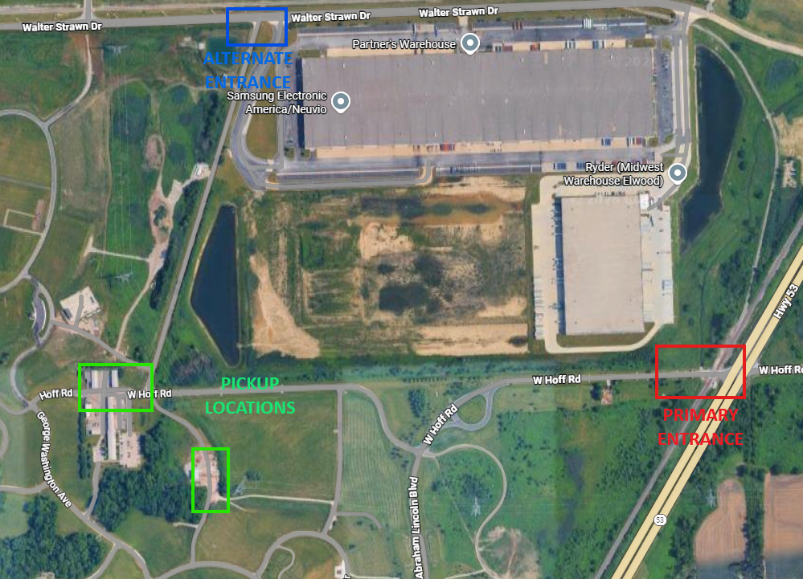
- ENTRANCE TO THE CEMETERY: Abraham Lincoln National Cemetery has two entrances. The first and primary entrance is located on Highway 53 and Hoff Road. The second, alternative entrance, is located at Walter Strawn Dr and Diagonal Road (see image below). The primary entrance has a height restriction of 12’. If the contractor’s vehicle exceeds the maximum height, they must still enter through the primary entrance and be buzzed in at the gate. The alternative entry is periodically locked throughout the year, so use of the alternative entrance shall be pre-coordinated prior to attempting to enter the cemetery and shall not be used routinely. Contractor’s failure to use the correct entrance will not constitute a valid reason for failure to perform services. If the contractor fails to pick up on the scheduled day for this reason, they must reschedule pick-up during the same work week at no additional cost to the cemetery. The pick-up location below is only for weekly trash and recycling services.

- PLACEMENT OF ORDERS: The COR will request services for roll-off dumpsters, port-o-lets, handwash stations, and/or street sweeping via email. The email will include what items are being requested, what day/time delivery is requested, and what delivery order/task order the request is from. At no time will the COR place an order for these services without an active delivery order/task order.

- SCHEDULING CONFLICTS: If for any reason the contractor cannot perform one of the general requirements on their scheduled day, the contractor must provide, in writing, a justification as to why and a firm commitment as to when the services shall be completed to the Contracting Officer (CO)and COR.

- PERFORMANCE DURING CEMETERY FUNCTIONS: The contractor is solely responsible for ensuring that no contract work causes any funeral, ceremony, procession, or visitation to be delayed, altered, or otherwise impacted in such a way that the dignity or security of the event is compromised. The contractor is solely responsible for staying abreast of all such upcoming events and must reach out to the CO and COR with any clarifying questions.

