GENERAL SYSTEM DESCRIPTION
This project is to move three existing bus ducts to new locations and move multiple conduits and communication cables closer to the building roof trusses in building 299 zone 8. This includes everything necessary to complete the project, such as conductors, conduits, support systems, bus ducts, bus plugs, and any hardware necessary to complete the relocation and installation of the existing bus ducts. The contractor must verify that the wiring and power is available in each of the newly located bus ducts when the installation is completed.

STANDARDS AND PUBLICATIONS

Clarification
Any ambiguities, questions, requests for clarification or discrepancies between sections of this purchase description, drawings, national or industry standards discovered by the contractor in reviewing this purchase description shall be reported by the bidder in writing to the contracting officer before the date scheduled for close of bidding/receipt of proposal. Submission of a proposal or bid shall be construed as evidence that such examination has been made. Therefore, later claims for labor, material, or equipment required, or for difficulties encountered, which could have been foreseen had such reasonable examination been made, may be denied.

National Standards and Specifications
The contractor shall conform and provide equipment conforming to all local and federal codes and standards applicable to the equipment they are providing based on location and purpose of equipment in effect on the date of the opening of solicitation. It is not the responsibility of the government to make modifications to ensure compliance.

DESIGN

General Design Standards
    - DEVIATION FROM PRODUCT: Modifications to the manufacturer’s standard design to achieve requirements as specified in this document are only permissible as dictated by good design practice. For example, mounting a 20-hp motor in a power train designed and normally using a 10-hp motor would not be acceptable.
    - UNITS OF MEASURE: Dimensions and capacities in this purchase description are given in the English-US (in-lb) system. All dials, gauges, and drawings shall be in the English-US system or both the English-US and the metric systems, unless otherwise specified in this document.

    - NEW EQUIPMENT: The equipment furnished under this purchase description shall be new and unused.
    - COMPONENT ENVIRONMENT: Under no circumstances shall a component be used in an application not recommended by the component manufacturer. Components shall not be subjected to conditions of operation beyond the recommendations of the manufacturer, such as excessive heat, lack of lubrication, over-loading.

Safety, Security and Environmental
    - SECURITY: The RIA-JMTC is an Army installation subject to Department of Defense safeguards, various precautions, and plant protection measures. All of the below requirements will be necessary of contractors visiting RIA to satisfy requirements of this purchase description; Additional requirements will be placed on contractors requiring access to the Army Network, or Common Access Card (CAC), as specifically detailed below. At all times during the execution of this work, contractor personnel will maintain adequate plant protection devices to minimize espionage, sabotage, and other malicious destruction and damage. The contractor shall comply with all security requirements of the Rock Island Arsenal. Rock Island Arsenal island-wide Force Protection levels may be adjusted/changed at any time, which may cause possible delays and will directly affect procedures for accessing the island.
      - Access and General Protection/Security Policy and Procedures: The contractor and any associated subcontractor employees shall provide all information required for background checks to meet installation access requirements to be accomplished by the installation Director of Emergency Services. All contractor employees must comply with all personal identity verification requirements (IAW FAR clause 52.204-9) as directed by Department of Defense (DoD), Headquarters Department of the Army (HQDA), and any local policy. If the Force Protection Condition (FPCON) changes, the Government may require changes in contractor installation access, security matters, or security processes.
        - Access to RIA: Contractor and all subcontractor employees performing work at RIA shall comply with adjudication standards and procedures using the National Crime Information Center Interstate Identification Index (NCIC-III) and Terrorist Screening Database (TSDB) and any applicable installation, facility access screening and local security policies and procedures. The JMTC COR shall provide guidance to complete the Access Control Records Check request Form though the Rock Island Arsenal Directorate of Emergency Services.
        - Random Antiterrorist Measures Program (RAMP) participation: Contractor personnel are subject to RAMP security program (i.e. vehicle searches, wearing of ID badges, etc.). Contractor shall comply with any, and all instructions issued by the Rock Island Arsenal Police Department. The RAMP is discussed in the RIA-JMTC Anti-Terrorism Training.
        - During FPCONs levels of Charlie or Delta, services may be discontinued/postponed due to a higher National or local security threat. Services will resume when FPCON Level is reduced to Bravo, or lower. FPCON levels are described in Anti-Terrorism Level I Training.
        - Contractor personnel shall return all Installation Badges and access passes as soon as possible prior to contract completion. RIA-JMTC electronic keys and access passes are accountable items, shad shall be returned within 24-hours of no longer being needed. Items will be returned to the COR, or paced in a drop box at a RIA-JMTC access point.
      - Security Training: The contractor shall complete the following training:
        - Anti-Terrorism, Level I: All contractor employees, including subcontractor employees, requiring access to Army installations, facilities, or controlled access areas shall complete Anti-Terrorism (AT) Level I Awareness training. The COR will be provided a copy of the Rock Island Arsenal –Joint Manufacturing and Technology Center (RIA-JMTC) AT Level I Awareness Training and assure that the training is complete. The contractor shall sign a memorandum of record for each contractor employees and subcontractor employee to the RIA-JMTC Operations Center prior issuing any electronic keys, or access pass being authorized.
        - iWatch (See Something, Say Something) Training: The Contractor and all associated subcontractors shall complete iWatch Training. iWatch Training shall be provided during the Anti-Terrorism Training.
      - No CAC will be issued for this project.
    - FEDERAL MARIJUANA LAWS REMAIN UNCHANGED: Note: Rock Island Arsenal is under the exclusive federal jurisdiction of the United States. Under federal law, marijuana is still defined as a Schedule I drug, and possession and use of marijuana is still illegal. Any person using or in possession of marijuana on Rock Island Arsenal may be criminally prosecuted in federal district court. In addition, such individuals may be permanently barred from entering Rock Island Arsenal.
    - REAL ID: Starting 03-May-2025 all personnel entering Rock Island Arsenal will be required to show a Real ID form of identification.
    - FIRE PREVENTION AND PROTECTION: The contractor shall comply with all fire prevention measures prescribed in the installation Fire Regulations, a copy of which is on file in the office of the Contracting Officer. A written fire permit shall be obtained from the installation Fire Marshall for use of open-flame devices, such as torches, portable furnaces, tar kettles, or gas and electric welding and cutting equipment, in, on, or within 15-ft of the building. The contractor shall be liable for any fire loss to the Government properly attributable to negligence on the part of the contractor, including failure to comp1y with fire prevention measure described by the terms of this purchase description.
    - INDUSTRY AND REGULATIONS: The equipment shall comply with the most current of all local, state, and federal laws and regulations listed in Standards and Publications.
    - MATERIAL EXCLUSIONS: The equipment shall not contain polychlorinated biphenyl (PCB), ozone depleting substances (Class I or Class II), or asbestos materials.
    - SAFETY REGULATION COMPLIANCE: The contractor shall comply with standard OSHA and RIA safety standards, including but not limited to conforming to confined space work requirements when applicable and wearing of Personal Protective Equipment (PPE) where designated.
    - SAFETY LOCKOUTS: Each point of first connection shall be designed and constructed to allow the utility to be completely isolated from the equipment. This isolation shall be insured by application of a standard key locking padlock. The device(s) shall only be lockable in the de-energized (OFF) condition.

Responsibilities
    - SITE INSPECTION: Any site inspections and/or measurements, which must be taken in order to determine the suitability of the proposed location or to perform the design of the system, are the sole responsibility of the contractor. This may begin prior to completing the bidding process. Rock Island Arsenal will support this function through the POC (point of contact) by guiding personnel, facilitating security registration, and providing general assistance. The contractor will be responsible for providing any and all equipment necessary for this process.

COMPONENT SPECIFICATION
JMTC needs three different bus ducts moved to three different locations in building 299. The contractor will need to provide conduits, conductors, and any material needed to install and support the conduit and bus installation. The contractor will also provide extra bus and bus plugs that are described below. All the installation of conduits must be located as close to the roof trusses on high and low bays. The contractor shall adhere to all national electrical codes that pertain to this installation.

- Relocate 1200-amp Square D, I-Line, existing bus which is currently located near column G5. That bus needs to be moved East between columns E17 and K17 in zone 8 of building 299. Approximate distance is 300 feet. The bus needs to be extended 50 feet, and the following materials are needed:
50 feet of Square D, I-Line Bus, 1200-amp
12 - 30-amp bus plugs
10 - 60-amp bus plugs
3 - 100-amp bus plugs
1 - 200-amp bus plugs

- Relocate 800-amp Siemens, Spectra series, existing bus which is currently located in building 299 zone 8 between columns C9 and C12. This bus needs to be moved from the center of the bay to column C12. The current configuration of the bus may need to be modified to move the bus junction close to the C12 column. This bus needs to be as close to column C12 because of a crane that will be installed in the C9 and C12 bay. Approximate distance is 110 feet.

- Relocate 800-amp Siemens, Spectra series, existing bus which is currently located in building 299 zone 6 column G24. This bus needs to be relocated to building 299 zone 8, between columns E 20 and K20. Approximate distance is 110 feet. The current bus needs to be extended 40 feet farther, and the following materials are needed:

40 feet of Siemens, Spectra Series 800-amp bus
8 - 30-amp bus plugs

5 - 60-amp bus plugs
2 - 100-amp bus plugs
1 - 200-amp bus plugs

- Relocate conduits between Columns A9 to A12 and K9 to K12. The following conduits and communication lines need to be moved above heaters in this area. The list is below:
- Move conduit that runs down the column C10 line up above the heaters
- Move the conduit that is close to column G12, relocate the conduit next to column G12.
- Move conduits and the exit sign that is in the middle of the bay between columns E9 and E12. There is a communication cable that needs to be moved also.
- Move the conduit that feeds panel PP-299-C9. The conduit needs to be run closer to the column line.
- Move all the communication lines that hang between columns A9 to A12 and C9 to C12 above heaters close to roof trusses.
- Relocate conduits between Columns A17 to A20 and P17 to P20. The following conduits and communication lines need to be moved above heaters in this area. The list is below:
- Move 4 conduits between columns G17 and G29 2 conduits are fire, and 1 conduit is for a meter on the North wall.
- Remove all drop cords and cap the wiring in a junction box that is not in the high bay area. Remove all supporting items, such as conduits, and all thread that is associated with the drop cords.
- Remove Section(s) of electrical bus that is protruding in the high bay area near columns C17 to C20.
- Remove large junction box that hangs into high bay area between columns A17 and C17.
- Move all communication wires that hang between columns A17 to A29 and
C17 and C20 above heaters close to roof trusses.

Note: The conduit near the North wall does NOT need to be moved.

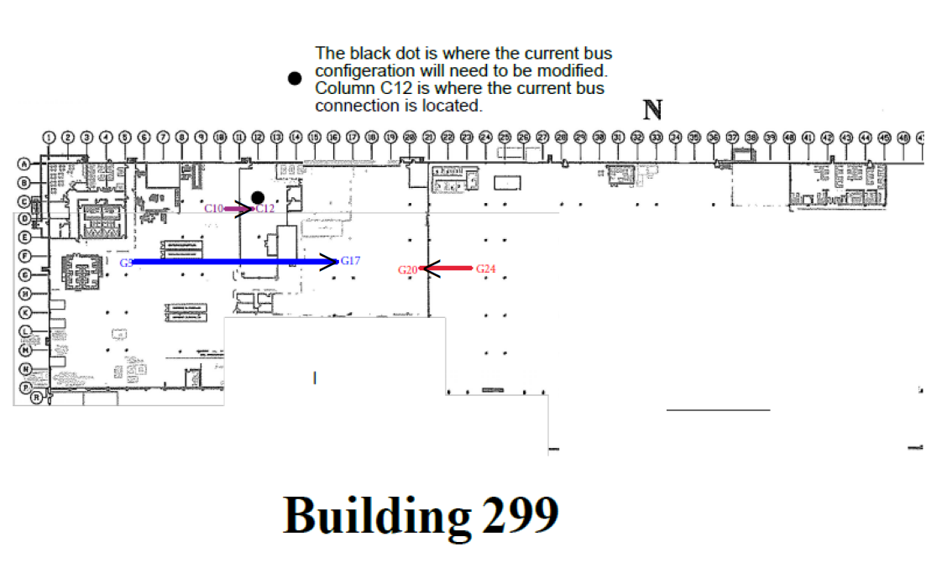

APPROVAL/SHIPPING

Shipping
    - RESPONSIBILITY: The contractor is responsible for delivery of the equipment to the Rock Island Arsenal.

Installation
    - SITE PREPARATION REQUIREMENTS: The contractor shall be solely responsible for any necessary site inspections required for determining the specifications of work that must be completed prior to final system installation. The contractor will then provide detailed information of any preparation work that the vendor must perform prior to system installation to Rock Island Arsenal.
    - PREPARATION EXECUTION SUPPORT: Rock Island Arsenal will support the preparation portion of the installation by providing utilities to the points of first connection.
    - LABOR AND MATERIAL: The supplier is solely responsible for providing all labor, materials, hardware, tools, and equipment necessary for complete installation of this system except as specifically listed in this document as being provided by the Rock Island Arsenal.
      - Any anchoring mechanisms/materials shall be the responsibility of the contractor to provide. If RIA-JMTC is installation the foundation, JMTC will be responsible for the installation of the contractor provided anchoring mechanisms in preparation for machine placement.
    - SUPERVISION: Supervision of the installation process will be the responsibility of the contractor. Rock Island Arsenal shall retain the right to periodic inspection and evaluation of the process, as it deems necessary.
    - Delivery Hours or Service Hours: Service calls, equipment installation, training, and equipment delivery (where the contractor offloads) will only be allowed from 0600 – 1530, Monday through Thursday, except for Government Holidays. Deliveries of items where the contractor has opted for Government “off-loading option”, must be received before 1200 hours. These hours are subject to change; however, the Government will notify the contractor of such changes. The vendor will contact the designated COR to obtain an electronic key for their representative (i.e. delivery driver) in order to have access to the facility. Deliveries and service calls outside the normal hours stated above will be coordinated with the COR to address any emergency situations."

Completion
    - Final acceptance of the equipment shall occur after the following:
      - Set-up completion by the contractor.
      - Successful completion of performance testing at Rock Island Arsenal.
      - Final inspection approval by the government representative or inspector. This is to verify full compliance with this description to include amendments and modifications to the final contract. The government representative shall perform any and all tests he deems necessary to ensure compliance with this description and industry standards to include, but not limited to ease of control, convenience of operation, safe operation, and adequacy of lubrication devices.
      - Complete documentation packages are delivered.

