Division of Administration (DOA) – Acquisition Services Branch (ASB)



Acquisition System – Next Generation (AS-NG)

Data Migration Business Requirements

January 11, 2026

Table of Contents
Purpose 2
Background 2
APS and its Components 3
Business Entities Relationship 3
Numbering Schemes 4
CDIS CEFile and Digital Library 5
CEFile File Structure 5
Digital Library 5
Scope of Data Migration 6
- Active and Active-Expired Awards 6
- Closed Awards 7
- In-Progress Solicitations and Awards 8
- New Requisitions 8
- Administration – Provisions and Clauses 9
- Administration – Contracting Officer (CO) & Warrant Levels 9
- OM/TM Training Data 9
- Solicitation List 9
Exclusions 10
Recommended Data Preparation/Cleanup Tasks 11
APS and its Components Data Preparation/Cleanup Tasks 11
CDIS CEFile and Digital Library Data Preparation/Cleanup Tasks 12
Appendix 14
Manual Mapping of APS Records to CEFile Documents 14
Things to Consider 16

Purpose
The purpose of this Data Migration Business Requirements document is to provide the scope and recommended data preparation/cleansing tasks for the migration of procurement data and documents to the targeted Acquisition System – Next Generation (AS-NG) solution.

Background
Acquisition Services Branch (ASB) utilizes manual operations and several systems to manage the acquisition process. The two primary systems used are:
- Automated Procurement System (APS) and its components, an Appian solution
  - APS – the electronic contract writing system used to write and manage FDIC awards
  - Milestone Schedule Component (MSC) – used for creating contract milestone schedule
  - Oversight Management Component (OMC) – used for oversight manager (OM) and technical monitor (TM) appointments
  - Contractor Performance Component (CPC) – used to evaluate contractor performance
- Consolidated Document Information System (CDIS), a Documentum solution
  - Contract Electronic Filing (CEFile) – used by ASB and OMs to maintain award files
  - Digital Library – used by ASB and OMs to view closed award files

ASB and Program Offices also use Technical Evaluation Panel (TEP) Tool, a Microsoft Access database for proposal evaluation. In addition, ASB uses SharePoint, Outlook (email), and hard-copy documents to collaborate with Program Offices on the sharing and routing of pre-solicitation and pre-award documents.
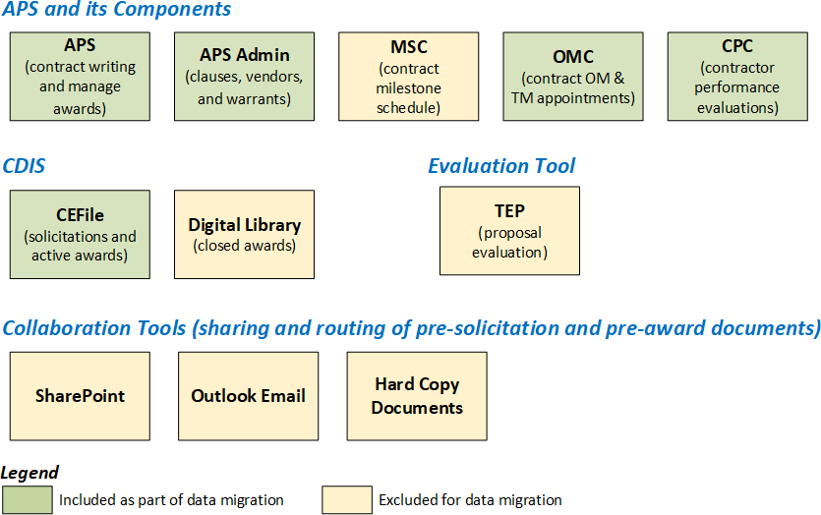

Figure 1. Acquisition Management Applications/Tools

APS and its Components

Business Entities Relationship
APS and its components contain the main entities created in the acquisition lifecycle. An acquisition typically starts with a requisition. From there, a solicitation is created, then an award (contract).
Modifications (mod) to contracts are often made via a requisition; however, there are standalone mods which have no association with a requisition.

An award can be any of the following:
- a straight contract;
- a Basic Ordering Agreements, Receivership Basic Ordering Agreements or a Blanket Purchase Agreements (BOA/RBOA/BPA); or
- a task order which is a child of a BOA/RBOA/BPA.

Also, there is a special award type – Tasking BOA (TBOA) that is an added layer between the BOA and its task orders (i.e. BOA > TBOA > Task Orders).

The next three diagrams depict the Business Entities Relationships for APS and its components. These diagrams are not intended to be comprehensive, but they are intended to help facilitate the data migration effort by showing the entities to be migrated. The relationships and statuses of the entities depicted will help with determining what needs to be migrated and how they are related to other entities that are to be migrated or not to be migrated.
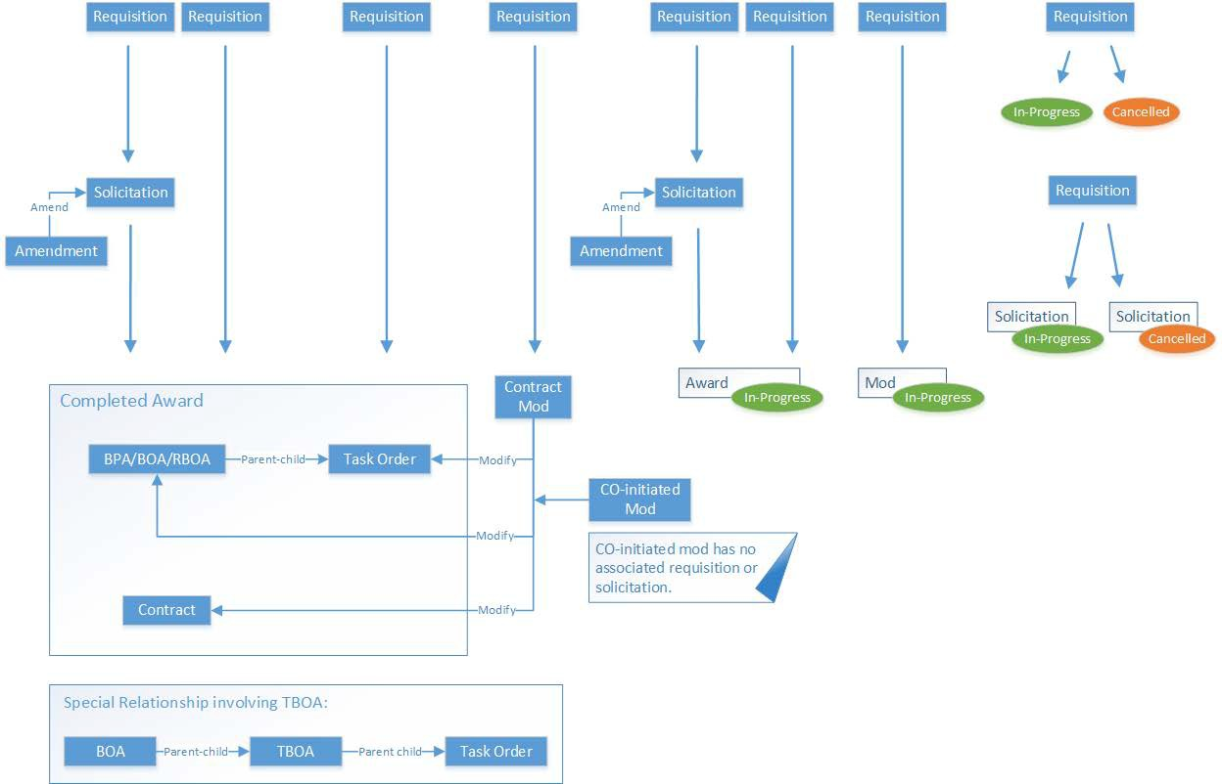

Figure 2. APS – Business Entities Relationship

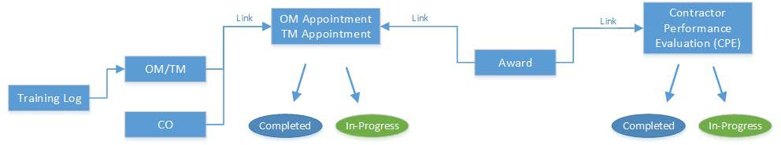

Figure 3. APS OMC and CPC – Business Entities Relationship

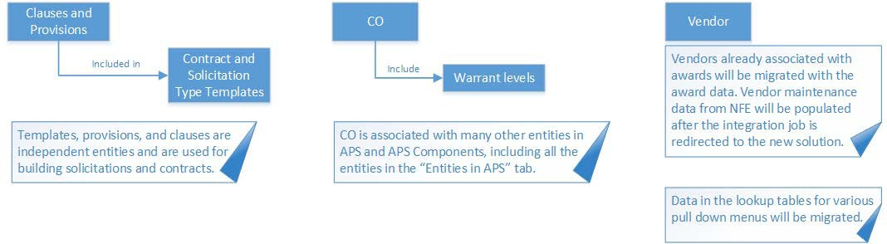

Figure 4. APS Admin – Business Entities Relationship

Numbering Schemes
There are different numbering schemes used in APS to uniquely identify entities such as solicitations and contracts. Below is a list of few but not limited to the following:
- Requisition ID / Purchase Request (PR) Number / Requisition Number
  - Received from New Financial Environment (NFE) and retained in APS.
  - Each requisition received from NFE has a unique number even if it’s a modification. Additionally, there is no association between various requisition numbers for the same contract.
- Request for Proposal (RFP) / Solicitation Number – generated in APS when a solicitation is created.
- Contract Number or BOA/RBOA/BPA Number or Award Number – generated in APS for awards
  - Contract Number for independent contracts without parent contract
  - BOA/RBOA/BPA for parent contracts were task orders will be issued
- Task Order Number is RBOA/BOA/BPA Number + 4-digit number, auto generated by APS
- Contract Mod Number
- Solicitation Amendment Number

CDIS CEFile and Digital Library

CEFile File Structure
A Contract File is created in CEFile to store solicitation, Contract or BOA/BPA, or Task Order documents. Upon creation of the Contract File, the following file structure is automatically established; however, the format/structure can be altered with the creation of subfolders and may vary.
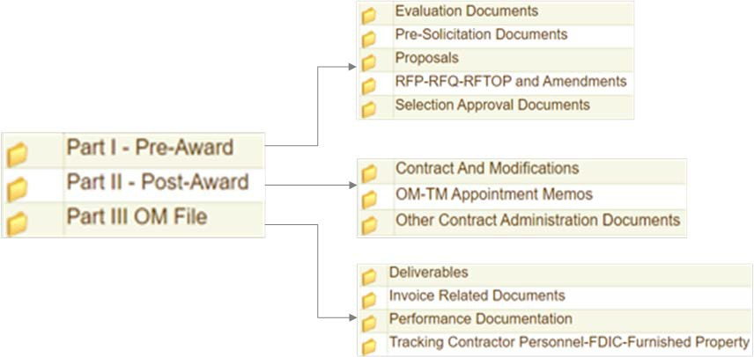

Digital Library
When a contract is closed in CEFile, the associated “pre-award,” “post-award,” and “OM File” folders are moved to the Digital Library in CDIS. The folder contents are read-only and are retained for seven (7) years from the contract close out date before they are manually purged.

Scope of Data Migration

Active and Active-Expired Awards

Definitions:
  - Active award – an award’s period of performance (POP) has not yet passed.
  - Active-expired award – an award that is expired but not yet closed.

From APS and its components | From CDIS-CEFile
Migrate the following for active and active- expired awards:  - All award data to include contracts, BOA/RBOA/BPA, and task orders in APS, OMC, and CPC  - Associated contract mod data  - Associated requisition data  - Associated pre-solicitation data  - Associated solicitation data including data related to contract writing, request for proposal & response, amendments, and evaluation  - All OM/TM appointment letters (memos) (PDF) associated with those awards in OMC  - All Contractor Performance Evaluations (PDF) associated with those awards in CPC  - All attachments associated with those awards and awards-related solicitations, contract mods, etc. | Migrate all documents associated with active and active-expired awards, currently in these three folders:  - Pre-Award  - Post-Award  - OM File

Closed Awards
Definition: Closed award – an award that has been closed out.

From APS and its components | From CDIS-CEFile
Migrate the following:  - All closed awards (historic records for reporting purposes) but limit to the 42 data fields (columns) as included in the current Award Summary Report  - CPC and OMC data (including contract numbers) and documents within the 7-year retention policy. [To be addressed internally before issuing the RFP]  - Option 1: Migrate to the new solution  - Option 2: Place them in CEFile (read- only) until the end of the retention period  - Option 3: Place them in an accessible repository until the end of the retention period  Note: OM/TM appointment letters and CPEs are official contract files and stored only in OMC and CPC. Where they should reside in the future needs to be determined before migration. | No migration  - Keep the documents associated with the closed awards read-only in CEFile or another repository (TBD)  Note: When a contract is closed in CEFile, the associated “pre-award,” “post-award,” and “OM File” folders are moved to the Digital Library in CDIS. The folder contents are read-only and it are retained for seven (7) years from the contract close out date and manually purged.

In-Progress Solicitations and Awards

Definitions:
  - In-progress solicitation – A solicitation that exists in APS, but no awards yet.
  - In-progress award – An award in APS that has not been marked signed-and-final (awarded) yet.

From APS and its components | From CDIS-CEFile
For in-progress solicitations, migrate the following:  - Solicitation – all data related to contract writing, request for proposal & response, amendments, and evaluation  - Associated requisition data  - Associated pre-solicitation data  - Individual attachments to the solicitation  For in-progress awards, migrate the following:  - Award data  - Associated requisition data  - Associated pre-solicitation data  - Associated solicitation data including contract writing, request for proposal & response, amendments, and evaluation  - Individual attachments to the solicitation and award | Migrate the associated documents in CEFile Pre- Award folder

New Requisitions
Definition: New requisition – A requisition in APS that is either in-progress with no solicitation or award or has not been processed.

From APS and its components | From CDIS-CEFile
Migrate the following:  - Requisition data  - Associated pre-solicitation data | None

Administration – Provisions and Clauses
The Provisions and Clauses Library contains provisions and clauses based on the solicitation and contract types and is maintained by the APS Admins. When a solicitation type is selected, the associated provisions will be listed. Similarly, if a contract type is selected, the associated clauses will be listed.
Migrate the following items associated with provisions and clauses:
  - The provisions and clauses library in APS (contains the latest version) to include solicitation and contract type templates.
  - All the provisions and clauses revisions (historical versions) from the Procedures, Guidance, and Information (PGI) document.

Administration – Contracting Officer (CO) & Warrant Levels
The CO warrant information is maintained in APS and SharePoint.
Migrate the following items to the new solution establishing the relationship between COs and their warrant levels and certificates:
  - CO information and warrant level data from APS.
  - CO current and historical warrant level certificates (PDF) from SharePoint.

Notes:
  - Majority of the current warrant level certificates are stored in SharePoint; however, there may be some new COs with hard copy certificates that need to be uploaded.
  - Certificates attached to the TEMPO cases are excluded for migration.
  - The CO data associated with the awards, mods, solicitations, requisitions, etc. will be migrated with the respective records as specified in above sections.

OM/TM Training Data
Once a week, Corporate University (CU) sends learning reports for three levels of OM and TM training. Those reports are consolidated into a single spreadsheet and manually uploaded to the OM training log in OMC to replace the previous one.
Migrate the OM training log from OMC to the new solution.

Solicitation List
To ensure adequate competition, COs must prepare a solicitation list which identifies the firms to be solicited. Once awarded, the data for all solicited firms is maintained in a “Solicitation for Award” spreadsheet. A spreadsheet is created and maintained for every year.
Migrate the “Solicitation for Award” list spreadsheets for every year (approximately 10 to 12 years) to the new solution.
  - Use the award numbers in the list to associate to award numbers in APS.
  - Use the award numbers to find solicitation numbers based on their relationship in APS.
Note: No need to migrate the individual solicitation list spreadsheets to the new solution.

Exclusions
The items in this section will not be migrated to the new solution; however, there are data preparation and cleanup tasks associated with some of the items.

From APS and its components | From CDIS-CEFile
Do not migrate the following:  - Milestones Schedules in MSC  - Active/in-progress milestones can be easily created in the new solution  - Completed milestones are not used after the award is made  - APS TEMPO cases – 99% APS specific and it is not applicable to the new solution  - News Feed – APS specific and it is not applicable to the new solution  - Old solicitations and attachments because they never resulted in awards  - Old requisitions because they never resulted in solicitations, awards, mods, etc.  - CPC  - CPE cover letter because it is a template  - Contractor responses because it will be migrated from CEFile  - APS Admin: Vendor maintenance data – It is replaced every night in APS via an NFE data integration job  - TEP Tool data because it will be migrated from CEFile | The following should not be migrated; instead, should be retained as read- only files in either CEFile or another repository until the end of the retention period.  - Documents associated with closed awards  - Documents associated with old solicitations that never resulted in an award  Additionally, CO, OM, and Contractor names should not be migrated because it will be part of APS data migration.

Recommended Data Preparation/Cleanup Tasks

APS and its Components Data Preparation/Cleanup Tasks
The data preparation/cleanup tasks must include but not limited to the following:
  - Cutoff Dates: Establish cut-off dates for processing requisitions, solicitations, creating awards, and conducting closeouts prior to migration.
  - In-progress Requisition/Solicitation: Identify and request COs bring in-progress requisitions/solicitations to a certain stage (TBD) to help ease migration.
  - Closeout Active-Expired Awards before 180 Days: Conduct closeout of active-expired awards that are within 180 days from expiration for the purpose of migration.
  - Contract Categories: Validate all brand new BOA/RBOA/BPA, or re-competed/follow-on RBOA/BOA/BPA, are assigned a new Category. Regular cleanup is usually done during reporting; however, it should also be validated and corrected before migration.
  - Old/Cancelled Solicitations and Attachments: Run a report to identify old/cancelled solicitations and corresponding attachments that never resulted in an award. Collaborate with users to determine if they need to be migrated, and tag appropriately.
  - Old/Cancelled Requisitions: Run a report to identify requisitions that have not been processed or never resulted in solicitations, awards, mods, etc. Request COs to work with the Program Office to determine the reasons and either cancel the requisition or tag for migration.
  - Report Attributes: Identify and flag the following for active, active-expired, and closed awards:
    - Pricing structure
    - Goods or services
    - Competitive or non-competitive award
    - Corporate capacity (receivership, corporate, subsidiary, etc.)
    - Contract modification purposes (manually typed by COs)
    - Contract types (F-GSA schedule, defined in PGI)
    - Etc.
  - RFTOPs: Consider performing the following tasks for RFTOPs since it is a manual process and the solicitations are not created in APS, meaning there is no RFP Number. However, the solicitation and related documents are uploaded to CEFile.
    - Determine if a place holder record (RFP Number) is needed for RFTOPs during transformation to the new solution.
    - Flag in progress task orders, so RFTOPs in the new solution can be sequenced correctly.
  - Contract Modifications: Determine if a mapping is needed to ensure correct association between entities because contracts can be modified via a requisition or it can be a standalone. Also, consider creating a place holder for mods containing equitable adjustments to address the association during transformation to the new solution because it is a manual process and documents are not created in APS.

  - Milestone Schedule in MSC: Reach out to COs and have them export in-progress milestone schedules to Excel. Make sure they know notes associated with the milestone schedules will not be exported; they will need to be printed or saved locally.
  - Provisions and Clauses Library: Compile a list of historical versions of clauses and provisions from PGI for migration.
  - Formulas and Business Rules: Store the formulas and business rules used to generate the Greater Oversight report.
  - TBOAs: Determine how TBOAs will be migrated to the new solution.
  - CO & Warrant Levels: Determine if there are warranted COs who left the corporation and flag or update as applicable.
    - Active and active-expired awards including contract mods – Assign an active CO to the contract with correct warrant level.
    - Closed awards within 7-year retention period – Flag the CO record to denote inactive but migrate to keep until end of retention period.
    - Closed awards beyond 7-year retention period – Delete or flag the CO record to denote exclusion from migration since these awards can no longer be audited.
  - News Feeds: Download and save all APS release bulletins, which contain all functionalities implemented over the years, to SharePoint.
  - APS TEMPO Cases: Export cases and comments to Excel and store to SharePoint.
  - APS Admin - Vendor Maintenance Data: Redirect vendor maintenance data integration job from APS to the new solution prior to go-live. This uploads the vendor maintenance/profile data and does not update the vendor data already associated with the awards.

CDIS CEFile and Digital Library Data Preparation/Cleanup Tasks
The data preparation/cleanup tasks must include but not limited to the following:
  - Cutoff Dates & Document Uploads: Establish cut-off dates and reach out to the COs and OMS requesting they upload all solicitation/contract related documents (from SharePoint, hard copies, emails, local drive, shared drive, etc.) to CEFile so they can be tagged for migration.
  - Legal Hold: There is no mechanism in APS or CEFile to mark documents as Legal Hold. Identify and tag Legal Hold documents so they can be retained until the hold is released or retention period expires, whichever is greater.
  - RFP Number in APS but not in CEFile: Compare RFP numbers in APS to those in CEFile and validate associated documents for migration. A missing RFP Number in CEFile could be due to one of the following reasons:
    - Solicitation documents were filed under Contract Number and not RFP Number. Cleanup may involve validating if the corresponding Contract Number has the associated solicitation documents and tagging (TBD) those files/folders with the RFP Number, so the relationship/association can be established prior to migration; or

    - User error (manual entry of RFP Number in CEFile). Cleanup may involve correcting/recreating RFP Number and/or deleting/uploading documents.
  - Contract Number in APS but not in CEFile: Compare Contract numbers in APS with those in CEFile and validate associated documents for migration. A missing Contract Number in CEFile could be due to user error (manual entry of Contract Number when creating Contract file or linking Contract to RFP Number). Cleanup may involve correcting/recreating Contract Number and/or deleting/uploading documents.
  - Active and Active-Expired Awards – Contract to RFP Link: Ensure RFP to Contract number in CEFile is the same as the RFP to Contract number in APS. Cleanup may involve correcting/recreating RFP/Contract Number and/or deleting/uploading documents in CEFile.
  - Active and Active-Expired Awards – Contract Modifications: Compare number of contract mods in APS with those in CEFile and validate associated documents for migration. A contract can have one or more modifications; as such, all files associated with each mod must be uploaded to CEFile. Cleanup may involve:
    - Identifying all the existing files in CEFile, validating its contents (including zip files), mapping to the correct modification, establishing possible sequence (for mods under that contract), and uploading to the correct folder in CEFile; and
    - Uploading missing mod files from APS to CEFile to reconcile the remaining differences.
  - Zip Files: CEFile allows users to upload zip files; however, there is no mechanism to know how the files are related to the contract or identify what documents are in the zip file unless it is unzipped. Cleanup may involve identifying all the zip files, validating its purpose, and mapping/uploading documents to the correct folder in CEFile.
  - Multiple Award Relationship: When multiple BOAs are awarded, the solicitation documents (RFP Number association) are filed with the first BOA contract folder and the remaining BOA contract folders do not contain any solicitation documents. Cleanup may involve identifying and tagging (TBD) those folders with the RFP Number, so that relationship/association can be established in CEFile prior to migration.
  - Requests for Task Order Proposals (RFTOPs) Association: Cleanup may involve identifying and tagging (TBD) parent-child folders/files so relationships/associations can be established in CEFile prior to migration. In addition, a place holder record (RFP Number) may need to be established for RFTOPs during transformation to the new solution. See Appendix for task order file creation and association in CEFile.
  - Closed Awards in APS but Open in CEFile: When a contract is closed in APS, the CO must close the contract in CEFile; however, that is not always the case. Since the contract closeout in CEFile is manual, cleanup may involve identifying the differences of closed contracts between APS and CEFile and conduct contract closeout in CEFile to reconcile the differences prior to migration.
  - Documents beyond 7-Year Retention Period in Digital Library: Identify and purge documents beyond 7 years from contract closed date before migration.

Appendix

Manual Mapping of APS Records to CEFile Documents
Some procurement documents are created in APS (e.g., solicitations, contracts, modifications, etc.); while, others (requirements package, RFTOPS, evaluation docs, etc.) are created outside of APS and maintained in CEFile. Below is a list of scenarios on how the APS records are mapped to CEFile:

Scenario 1: Solicitation > Pre-Award Documents > Contract > Post-Award Documents
- New procurement requisition (Requisition Number) received in APS
- Requirements package received via email
- Solicitation (RFP Number) created in APS
- Proposals received via email and evaluation conducted manually
- RFP file created in CEFile with RFP Number entered manually
- Pre-solicitation (including requirements package), solicitation, and evaluation documents uploaded to pre-award folder in CEFile
- Contract (Contract Number) awarded in APS
- Contract Number (entered manually) linked to RFP Number in CEFile
- Contract documents uploaded to post-award folder in CEFile

  - Scenario 2: Solicitation > Contract > Pre-Award & Post-Award Documents (missing RFP Number)
- New procurement requisition (Requisition Number) received in APS
- Requirements package received via email
- Solicitation (RFP Number) created in APS
- Proposals received via email and evaluation conducted manually
- Contract (Contract Number) awarded in APS
- Contract file created in CEFile with Contract Number entered manually
Issue: RFP file not created; hence no RFP Number and missing link between RFP and Contract numbers
- Pre-solicitation (including requirements package), solicitation, and evaluation documents uploaded to pre-award folder in CEFile
- Contract documents uploaded to post-award folder in CEFile

  - Scenario 3: Solicitation > Pre-Award Documents > Contract > Post-Award Documents (two file structures for a single contract)
- New procurement requisition (Requisition Number) received in APS
- Requirements package received via email
- Solicitation (RFP Number) created in APS
- Proposals received via email and evaluation conducted manually
- RFP file created in CEFile with RFP Number entered manually
- Pre-solicitation (including requirements package), solicitation, and evaluation documents uploaded to pre-award folder in CEFile
- Contract (Contract Number) awarded in APS
- Contract file created in CEFile with Contract Number entered manually
Issue: A separate contract file is created instead of linking Contract Number to RFP Number; hence, there are two file structures for a single contract
  - Pre-award and post-award documents are stored separately and/or it could be stored in both file structures
  - Missing link between RFP and Contract numbers
- Pre-solicitation (including requirements package), solicitation, and evaluation documents uploaded to pre-award folder in CEFile
- Contract documents uploaded to post-award folder in CEFile

  - Scenario 4: BOA/BPA > Task Order (missing parent-child association to documents)
- New procurement requisition (Requisition Number) for the BOA/BPA received in APS
- BOA/BPA requirements package received via email
- Solicitation (RFP Number) for the BOA/BPA created in APS
- BOA/BPA proposals received via email and evaluation conducted manually
- BOA/BPA RFP file created in CEFile with RFP Number entered manually
- Pre-solicitation (including requirements package), solicitation, and evaluation documents uploaded to pre-award folder in CEFile
- BOA/BPA Contract (BOA/BPA Number) awarded in APS
- BOA/BPA Number (entered manually) linked to RFP Number in CEFile
- BOA/BPA documents uploaded to post-award folder in CEFile
- Task Order requisition (unique Requisition Number; based on the description, COs identify the parent BOA/BPA, there is no automatic association) received in APS
- Task Order solicitation occurs manually
- Task Order (Task Order Number) is awarded directly from requisition to award in APS
Issue: Since the Task Order solicitation is manual, there is no RFP Number

- Task Order contract file created in CEFile with Task Order Number entered manually Issue: Since this is a separate contract file, there is no association to parent BOA/BPA documents
- Pre-solicitation (including requirements package), solicitation, and evaluation documents uploaded to Task Order pre-award folder in CEFile
- Contracts documents uploaded to Task Order post-award folder in CEFile

Things to Consider
  - Legacy Decommissioning: Determine when and how APS and CEFile systems will be decommissioned.
  - Historical Reports: Determine how to preserve published reports from FDIC’s external and internal sites.
  - Chairman's Quarterly Contractor Assessment Report (CQCAR): Determine if CQCAR data can be integrated to the new solution.
    - Data from APS is integrated to Enterprise Data Warehouse (EDW) and then to CQCAR, were the point-in-time or trend data is kept for historic snapshot reporting.
    - Reports generated using data in CQCAR include award profile report, trending bar graphs, etc.
  - Federal Business Opportunities (FBO or Fed Biz Opps): Determine if data migration is required for solicitations received via FBO.
  - NFE Integration Jobs: Determine which jobs should be run pre and/or post migration. Redirect all NFE integration jobs from APS to the new solution.

