U.S. Embassy Banjul
Date: January 14, 2026
Dear Prospective Quoter:

Subject: Request for Quotations- PR15756088: FAC: CMR grounds safety improvement project.

The US Embassy Banjul wishes to solicit bids for repairing the walkways, stairways, patio, and gazebo in the CMR compound. The repairs will include the removal of all existing pavers, stones, and sunken areas in the walkways and stairways, followed by their replacement with non-slip floor tiles. Additionally, the project will include repairing the storm drainage system and meeting safety requirements by installing handrails as per below scope of work (SOW). U.S. Government intends to award a contract to the responsible company submitting a technically acceptable quotation at the lowest price.
A site visit will be held on January 20, 2026 at 11:00 a.m. at house 1001 Fajara in Banjul. Interested contractors should submit no more than two names of attendees to the address BanjulGSOProcurement@state.gov with subject line Request for Site visit- PR15756088: FAC : CMR grounds safety improvement project not later than January 16, 2026 at 10:00 a.m. Gambian Time.
Quotations are due by January 26, 2026 at 10:00 a.m. Gambian time. No quotations will be accepted after this time. Proposals must be in English and incomplete proposals will not be accepted.
Your quotation must be submitted electronically to BanjulGsoProcurement@state.gov

It is important to make sure the submission is made in specific size and format; in MS-Word 2007/2010 or MS-Excel 2007/2010 or Adobe Acrobat (pdf) file format. The file size must not exceed 30MB. If the file size should exceed the 30MB, the submission must be made in separate files and attached to separate emails with less than 30MB each.

For a quotation to be considered, you must submit the following:
- Package One- Technical proposal.
- Package two - Cost proposal as per pricing table.
Attendance at the site visit prior to submission of an offer or proposal is required in accordance with FAR 52.236-27 (Site Visit). Offerors that fail to attend the site visit may be determined non-responsible, and their offer or proposal may be eliminated from further consideration. Accordingly, all offerors intending to submit a proposal are strongly encouraged to attend the site visit.
Sincerely,
John Jutte
General service Officer

STATEMENT OF WORK
For
CMR Grounds Safety Improvement
U.S. Embassy
Banjul, Gambia
06/26/2025
1.0 INTRODUCTION
1.1 OVERVIEW & DESCRIPTION: The purpose of this task is to solicit bids for repairing the walkways, stairways, patio, and gazebo in the CMR compound. The repairs will include the removal of all existing pavers, stones, and sunken areas in the walkways and stairways, followed by their replacement with non-slip floor tiles. Additionally, the project will include repairing the storm drainage system and meeting safety requirements by installing handrails.
1.2 LOCATION: The CMR facility is in the capital of The Gambia, Banjul, at 18 Atlantic Road, Fajara , St. Mary. All onsite inspections must be coordinated through the U.S. Embassy’s Contracting Officer Representative (COR).
1.3 OBJECTIVE: The contractor shall coordinate with the Contracting Officer or ORSC Project Manager to plan job sequencing for work commencing in the CMR compound. The project involves improving the stairways and walkways by replacing the existing stones and pavers with new ones, installing handrails to meet U.S. State Department safety requirements, and replacing the sink in poor condition located in the gazebo area near the swimming pool.
1.4 COMMUNICATION: The Contractor shall maintain contact with the US Embassy regarding this project through the Contracting Officer's Representative:

xxxxxx, U.S. Embassy Banjul,
email: xxxxxxx, mobile: xxxxxxx

2.0 GENERAL REQUIREMENTS
2.1 The Contractor shall provide equipment, materials, tools, and supervision as needed to complete the services that meet the technical requirements in this Statement of Work (SOW). It is expected that the Contract personnel shall partner closely with U.S. Embassy personnel.
2.2 The work shall be executed in a diligent manner in accordance with a negotiated firm fixed price contract and performance period. The period of performance for all phases of the project shall be completed in the time frame agreed upon. Work shall commence from date agreed upon by all parties after Contract Award date.
2.3 Contractor work hours will be from 0800 to 1700 each day. This is to ensure proper escort staffing during the project. Work outside of normal working hours shall be coordinated with the COR with advance notice of 2 days.
2.4 Contract personnel shall have limited access to or be admitted into any structure outside the areas designated for the project except with permission by the U.S. Embassy. The Contractor shall address the impact of the consequent disruption and provide for a continuing level of operation for continuous occupation of any CMR spaces.
2.5 Deliverables: The Contractor shall be required to prepare and submit, before the work commences; a qualifying statement, Quality Management Plan (QMP), Project Safety Plan (PSP) (4.8 below), projected phases with timelines, and total project cost. Also, refer to 6.0 below. Once these plans are completed, provide prospective phase planning, cost estimates, materials required, and required architectural, structural, electrical, and mechanical drawings and specifications of project work. These documents shall provide the necessary interfaces, coordination, and communication between the Requesting Office and COR for the successful
delivery of project plans.
3.0 CONTRACT ADMINISTRATION
3.1. The Contractor shall not perform any work outside the scope of this Statement of Work (SOW) and its accompanying specifications unless explicitly directed in writing by the Contracting Officer (CO).
Any work undertaken by contract personnel beyond the scope of this SOW and its accompanying specifications, without written authorization from the CO, will be done at their own risk and will not incur any cost to the Embassy.
3.2 The Contracting Officer (CO) shall issue a Notice to Proceed (NTP) to the Contractor.
The Contractor shall not commence any work until the NTP has been issued by the CO.
3.3 The U.S. Embassy makes no representations or warranties of any kind, whether expressed or implied, regarding the quality, level of completion, accuracy, compliance with standards, codes, and requirements described or referenced in this Statement of Work (SOW), or the degree of coordination between or among the documents provided to the Contractor.
3.4 Neither the U.S. Embassy’s review, approval, acceptance of, nor payment for the services required under this contract shall be interpreted as a waiver of any rights under this contract or as a waiver of any cause of action against the Contractor arising from the performance of this contract.
3.5. The U.S. Embassy reserves the right to inspect and test all services specified in the contract, to the extent practicable, at any time and location during the term of the contract.
Additionally, the Office of Overseas Buildings Operations (OBO), through one of its Subject
Matter Experts (SMEs), may conduct quality assurance inspections (QAI) and tests during the project to ensure that the work complies with the Statement of Work (SOW).
3.6 The Contracting Officer (CO) has the authority to issue a temporary stop order at any phase of this Statement of Work (SOW).
This authority may be exercised when the U.S. Embassy requires time for official functions or possesses specific credible information indicating an immediate threat to the lives of U.S.
Embassy personnel, and where the continuation of the project would increase the Embassy's vulnerability.
The contractor Supervision team shall promptly notify the CO when work has been stopped.
3.7. If any of the Contractor’s services fail to meet the contract requirements, the Contracting Officer’s Representative (COR) may require the Contractor’s supervision team to re-perform the services in compliance with the contract requirements.
Alternatively, the U.S. Embassy may, either through the contract or other means, perform the services itself and charge the Contractor for any costs incurred by the Embassy directly related to the performance of such services, or terminate the contract for default.
3.8 The U.S. Embassy reserves the right to terminate this contract, in whole or in part, for convenience at any time if the Contracting Officer determines that such termination is in the best interest of the U.S. Government.
4.0 RESPONSIBILITY OF THE CONTRACTOR
4.1 The Contractor shall be responsible for the professional quality, technical accuracy, and the coordination of all construction services furnished under this contract. The Contractor shall without additional compensation, correct or revise any errors or deficiencies in its construction and other services.
4.2 Quality Management Plan (QMP). The Contractor shall submit a project specific QMP for review by the COR. The Contractor shall be responsible to meet the guidelines of the QMP throughout the duration of work and shall be subject to the oversight of Contractor Supervision on all issues relating to construction quality.
4.3 The Contractor shall identify a Site Project Manager who shall be responsible for the overall management of the project and shall represent the firm on the site during construction activities.
The Site Project Manager shall be approved by the COR.
4.4 The Site Project Manager and Safety Representative (See Section 4.8) shall attend all project meetings, prepare weekly status update reports on the project, and submit them to the COR.
Status reports shall contain meeting minutes, accomplishments, arising concerns and proposed solutions, any proposed changed orders, personnel safety reports, and any other pertinent information required to report the progress of performance.
4.5 All documentation produced for this project will become the ownership of U.S. Embassy Banjul at the completion of this project.
4.6 The Contractor shall verify that all materials, equipment, and systems provide operational dependability.
4.7 Any cost associated with services subcontracted by the Contractor shall be borne by and be the complete responsibility of the Contractor under the fixed price of this contract.
4.8 Project Safety Plan (PSP): The Contractor is responsible for the safety of employees and subcontractors and shall comply with all local labor laws, regulations, customs, and practices pertaining to labor, safety and similar matters. The Contractor shall prepare a PSP and shall designate a Safety Representative, who will be on site throughout the duration of the work, to be responsible for implementation of proper health, safety, and sanitation procedures throughout
the contract period of performance. The Contractor shall promptly report all accidents resulting in lost time, disabling, or fatal injuries to the Post Occupational Health & Safety Officer (POSHO),
Assistant POSHO (APOSHO), and/or the COR. See Section 10 for items to be included in the Project Safety Plan (PSP).
4.9 The Contractor shall be and remain liable to the U. S. Embassy in accordance with applicable law for all damages to the U. S. Embassy caused by the Contractor’s negligent performance of any of the services furnished under this contract. The rights and remedies for the U. S. Embassy provided for under this contract are in addition to any other rights and remedies provided by law.
5.0 PRE-PROJECT REQUIREMENTS
5.1 The Contractor shall examine all the documents and visit the site to fully inform themselves of all the conditions and limitations applied to the survey and submit a firm, fixed-price cost proposal for all the work. No subsequent cost allowance will be made to the firm for neglect of the existing conditions.
5.2 Provide a qualifying statement that the Contractor’s company and all personnel are qualified to perform the tasks involved with the project. This will include proper lift equipment, fall protection, hand tools, uniforms, and size of staff.
5.3 The Contractor shall prepare and submit a Quality Management Plan (QMP) and Project Safety Plan (SSP) to address the project. The QMP and PSP are intended to document the entire project from beginning to end.
5.4 Submit a copy of the Contractor’s Guarantee covering the work, labor, and equipment for a period of ONE [1] year at no cost to the U. S. Embassy and signed by the contractor.
5.5 Submit a Bill of Materials [BOM], product literature, samples, and standard specification submittals of all potential materials to be used in the project provided by the Contractor (i.e.,metal siding styles, product catalogs, color samples, if needed). The BOM's shall list the equipment and materials in sufficient detail that a purchase order for the materials and equipment can be executed without further elaboration or specifications. These documents will be used by the U. S. Embassy to approve all equipment and materials.
6.0 PROJECT SPECIFICS AND REQUIREMENTS
6.1 The following list of tasks should be observed by the contractor, but not limited to:
1. Remove existing slippery tiles of the walkways/stairways leading from the residence to the southern gate-including with approved pavers.
i. Stair A & B: Attachment #1 – Figure 1&2
ii. Product Data: Basis of Design pavers
2. Provide and install ABA-compliant railing to both stairways (N and S).
i. Stair A & Stair B: Attachment #1 – Figure 3&4
ii. ABA handrail diagrams – Annex #8
iii. Product Data: Basis of Design handrail
3. Replace uneven walkway leading from the front of the residence to the back patio with a new walkway of approved pavers (N and S).
i. Walkway A: Attachment #2 – Figure 5, 6&7
ii. Product Data: Basis of Design pavers
4. Remove existing tiles of the back patio, replace them with approved outdoor tiles and provide and install an ABA-compliant stair railing along one side of the stairs.
i. Central steps to the Sunroom: Attachment #2 – Figure 8
ii. Product Data: Basis of Design patio tiles
iii. ABA handrail diagrams – Annex #8
iv. Product Data: Basis of Design handrail
5. Provide and lay pavers leading from the back patio grass area to the outside
bathrooms.
i. Attachment #7
ii. Product Data: Basis of Design pavers
6. Pool cabana patio: Repair significant floor cracks and retile floor with approved tiles
i. Attachment #3 – Figure 9, 10&11
ii. Product Data: Basis of Design floor tiles
7. Pool cabana entertainment space: Replace ceiling, countertop, hand washing sink, and reconnect plumbing.
i. Attachment #4 – Figure 12, 13&14
ii. Product Data: Prefabricated sink in cabinet
8. Construct extra step to the existing stairways leading to the pool from the southern gate and install an ADA-compliant stair railing.
i. Attachment #5 – Figure 15, 16&17
ii. ABA handrail diagrams – Annex 8
iii. Product Data: Basis of Design handrail
9. Repair/replace damaged concrete drainage blocks along the north property line running toward the beach.
i. Attachment #6 – Figure 18-28
10. Dispose of all construction debris from the compound.
6.2 No construction activities shall begin until approvals of the construction materials are accepted by the COR.
6.3 The Contractor shall be responsible for all required materials not provided by the Embassy, equipment, and personnel to manage, administer, and supervise the project. All Contractor workmanship shall be of good quality and performed in a skillful manner as determined by the COR.
6.4 All materials and equipment used for the survey shall be properly calibrated and in new or good working order, unless noted otherwise. The Contractor shall transport and safeguard all construction materials and equipment, as required, for the project.
6.5 Equipment and materials shall be carefully handled, properly stored, and adequately protected to prevent damage before and during construction activities, in accordance with the manufacturer's recommendations. Damaged or defective items shall be replaced at the Contractor’s expense. The Contractor will be responsible for security of all materials and equipment.
6.6 The Contractor will be provided with a storage and staging area as determined by the COR.
The Contractor shall be responsible for restoring the area to its original condition at the completion of the work. The Contractor shall be responsible for repair of any damage incurred to buildings or pavement as a result of storage activities. The Contractor is responsible for obtaining any additional off compound storage areas as required.
6.7 The Contractor shall always keep the work area free from accumulation of waste materials.
Upon completion, Contract personnel shall remove any temporary facilities and leave the project site in a clean and orderly condition acceptable to the COR.
6.8 Contract personnel shall perform the work at the site during the U. S. Embassy's normal workday hours, unless alternate work hours are agreed upon with the COR.
6.9 The Contractor shall be responsible for connection of temporary utilities to existing utilities including water and power lines. All temporary connections to local water and power lines sha be coordinated with the COR. The Contractor shall pay all costs incurred in connecting, converting, and transferring the utilities to the work.
6.10 At the end of each workday, or notification of a temporary stop order, Contract personnel shall lower and secure all temporary work platforms and/or harnesses. Contract personnel shall notify the COR of the temporary barricade locations. Beginning the next workday, Contract personnel shall remove the temporary barricades before continuing the project.
6.11 Protections and Damage Plan: The Contractor shall be responsible to protect all U.S. Government property to include: all furniture, furnishings, and interior and exterior architectural finishes from damage. Any damage caused by Contract personnel to architectural interior and exterior finishes will be returned to original condition by the Contractor at the firm’s expense. In addition to the architectural finishes, Contract personnel shall protect all non-included mechanical and electrical equipment and controls from damage throughout the duration of work.
Prior to commencing the work, contract personnel along with Embassy representatives shall survey the site that will be impacted by the project work and document existing conditions. It shall be the firm’s responsibility to document in writing all pre-existing damaged surfaces prior to the start of the project work and to provide a copy of the documentation to the COR prior to project start.
6.12 Storm Protection: Should warnings of wind of gale force or stronger be issued, the Contractor shall take every practicable precaution to minimize danger to persons, the work, and adjacent property. Precautions shall include, but not be limited to, closing all openings, removing all loose materials, tools, and equipment from exposed locations, and other temporary work.
6.13 Material Debris and Removal Plan: The Contractor shall keep the work area, including storage areas, free from accumulation of waste materials daily and comply with all federal, state, and local regulations pertaining to the storage, transportation, and disposal of waste materials.
The Contractor shall not use the U. S. Embassy waste disposal facilities including garbage cans, trash piles, or dumpsters.
6.14 Landscape Restoration: The surfaces of all unpaved areas disturbed by construction activities shall be sodded with an approved grass native to the sodded area as approved by the COR. These shall include areas where existing pavement is removed, areas where excavation takes place, and areas where existing sod is killed or compacted by construction activities.
Landscape shrubs killed or damaged by construction activities shall be replaced with same species and size.
7.0 GOVERNING CRITERIA
7.1 The Contractor’s work shall be in accordance with U.S. codes and standards. The COR will review and comment on the firm’s submissions using the latest, most recent versions of the following codes and standards:
· American Society for Testing & Materials (ASTM)
· International Building Code (IBC)
· National Electrical Code (NEC)
· OBO Design Standards and Permitting
· United States Army Corp of Engineers (USACE)ll
If there is conflict between local and OBO or International codes, the more stringent requirement shall be followed. New work being provided shall, at a minimum, be equal to or better than the current installation.
7.2 Statement of Work for construction services and the following accompanying manufacturer’s specifications:
· Manufacturing specifications under this Statement of Work shall be in accordance with the manufacturer chosen for metal siding. Manufacturing specifications should meet or exceed ASTM standards, federal/state/local building codes.
8.0 PERIOD OF PERFORMANCE SCHEDULE
8.1 The Contractor shall commence work under this contract promptly, execute the work diligently, and achieve final completion and acceptance including final cleanup of the premises within thirty calendar days of the date of the NTP. Events at the residence may require that work be suspended. The completion time shall be adjusted for any time the Contracting Officer’s Representative has requested that work be suspended.
8.2 Milestones:
· Contractor Pre-Proposal Site Visit: TBD
· Award of Contract: TBD
· Notice to Proceed (NTP): TBD
· Pre-Construction Submittals Within 10 days of NTP
· Project Kick-Off Meeting Within 10 days of NTP
· U. S. Embassy Submittal Review Within 20 days of receiving submittals.
· Construction activities commencement: Within 30 days of material receipt.
· Construction period of performance: As per Contractor’s project plan.
8.3 Project Closeout & Turnover: Provide to the COR, one copy of the following:
· Renovation drawings/renderings.
· Final Invoice
9.0 PROJECT-SPECIFIC SECURITY PROGRAM
9.1 The work to be performed under this contract requires that the Contractor, its employees, and sub-contractors submit required personal data material for review by the U. S. Embassy Security section for access consideration. Information submitted by the Contractor will not be disclosed beyond the U. S. Embassy.
9.2 The Contractor shall submit this information, including vehicle(s) (if vehicle required) details required to access the site, within 45 days of the Notice to Proceed.
10.0 GENERAL SAFETY REQUIREMENTS
10.0.1The contractor shall demonstrate understanding of his/her responsibilities related to the safety requirements by addressing hazards in preplanning processes and meetings.
10.0.2 Prior to starting a project, the contractor is required to review the work site and identify hazards that may occur while performing the job.
10.0.3 The contractor is expected to provide a “competent person” to implement Site health and safety plan and to oversee its compliance. A competent person is an individual who, by way of training and/or experience, is knowledgeable of applicable standards, can identify workplace hazards relating to the specific operation, is designated by the employer, and has authority to take appropriate actions.
10.0.4 The contractor is required to provide proof of payment of local insurance of all the employees that will be involved in the project. Likewise, the contractor is required to provide monthly payment documents of local insurance for the length of work.
10.0.5 The contractor will conduct a safety briefing before starting daily work.
10.0.6 Contractor personnel who have signs of drunkenness or who are under the influence of stimulants or hallucinogens will be denied entry to the work area.
10.0.7 The contractor shall ensure individuals working at the site are trained and aware of potential hazards. The contractor shall ensure that these individuals are provided with proper safety equipment to prevent accidental injury in accordance with the requirements of the contract.
10.0.8 The contractor shall accept the safety standards set by the U.S. Embassy.
10.0.9 All workers will remove all chains, rings, watches and/or bracelets during the execution of work.
10.0.10 Smoking is prohibited in the worksite area. Designated smoking areas will be identified that are away from the worksite.
10.0.11 The contractor will report accidents to the COR who will pass the proper data to the POSHO or Safety Coordinator.
10.1 BARRICADING AND WARNING SIGNS
10.1.1 The contractor shall place provisional barricades and warning signs to maintain a safe and accessible path-of-travel for all pedestrians, including those with disabilities, to avoid accidents with third parties. Barricades alert others about hazards created by construction activities and shall be used to control vehicular traffic around the work site as well.
10.1.2 Erect and maintain for the duration of the Contract proper barricades including fencing material, traffic cones, caution tape and temporary curb ramps complying with all access codes and regulations.
10.1.3 Ensure that no construction materials are stored and/or placed on the path-of travel.
10.1.4 Maintain the construction barriers in a sound, neat, and clean condition.
10.2 PERSONAL PROTECTIVE EQUIPMENT (PPE) REQUIREMENTS
10.2.1 Contractor personnel shall use personal protective equipment (PPE) required and in accordance with the contracted work.
10.2.2 The contractor is required to inspect and maintain spare PPE in case of damage, deterioration, or loss of the equipment.
10.2.3 The PPE used shall meet the technical specifications required by local regulation and international standards.
10.2.4 Sharp cutting tools shall be carried in Tools Carrying Cases; under no circumstances are they to be carried in uniform pockets.
10.2.5 In those tasks where PPE certified is required, the contractor shall provide the current certification. The contractor shall provide records of PPE received for all the employees involved in the task.
10.3 SAFETY INSPECTIONS REQUIREMENTS
10.3.1 All tools, equipment and/or machinery that will be used in the execution of the contracted work shall be inspected by a competent person before starting the project.
10.3.2 COR and/or Safety representatives may inspect equipment, tools and/or machinery of the contractor at any time and may request to change it if deemed necessary.
10.4 HAND AND POWER TOOL SAFETY
10.3.2 The contractor shall ensure the safety of tools and equipment used by its employees.
10.3.3 Inspected at regular intervals and maintain in good condition all tools in accordance with the manufacture’s specifications.
10.3.4 Ensure that tools are used for their intended purposes.
10.5 EMERGENCY RESPONSE REQUIREMENTS
10.5.1 In case of an emergency within the CMR facilities and/or during the execution of the contracted work, contractor personnel shall follow the instructions given by the U.S. Embassy representative (escort) who is supervising the work, or security personnel.
10.5.2 The contractor shall not obstruct emergency response equipment such as first aid kits, fire extinguishers, fire cabinets, defibrillators, spill kits, stretchers, eye wash stations or safety signs.
10.6 HIGH RISK WORK REQUIREMENTS
10.6.1 The contractor shall submit certificates of training for each person who will conduct the task. These certificates shall be submitted before starting the execution of the project.
10.6.2 The contractor shall prepare a work permit specifically for the task and shall be provided to the COR before the initiation of work.
10.6.3 The contractor shall send a risk assessment of the task in a minimum period of eight
(8) working days before commencement of work. The POSHO or Safety Coordinator will review the document and make any comment it deems necessary.
10.6.4 The execution of high-risk activities will be carried out with a minimum of two people present that may give first aid or notice in case of emergency.
10.7 ELECTRICAL SAFETY
10.7.1 The contractor shall fully comply with the U.S. Embassy policies related with Electrical Safety Work Practices and Work-de energized to prevent any incident that may impact the health of personnel and/or post electrical systems.
10.7.2 All personnel conducting electrical work shall be sufficiently trained and considered as competent persons prior to performing the work.
10.7.3 The contractor should identify any potential sources of electrical energy likely to cause death, injury, or serious physical harm.
10.7.4 Ensure all work is performed in accordance with local regulation and U.S. standards.
10.8 FALL PROTECTION REQUIREMENTS
10.8.1 All work performed at more than 1.2 meters (4ft) is considered work at heights based on general laws, therefore the contractor shall strictly comply with the requirements of work on elevation:
10.8.2 All equipment to work at elevated surfaces shall meet at least the ANSI Z359.1 standards or European counterparts.
10.8.3 All contractor personnel using equipment for work at heights shall follow the instructions and warnings associated with such equipment.
10.8.4 Contractor personnel will not use as an anchor point for work, ladders, piping, or pipe supports.
10.8.5 If an anchor point does not offer the recommended resistance for fall protection (5000lbs), the contractor shall provide protective equipment for heights with dampers that may decrease the impact force.
10.8.6 Scissor scaffolds are prohibited. Only use multi directional/modular scaffolding properly certified. Use dielectric ladders to work with electricity and areas with electrical influence.
10.8.7 It is forbidden to stand on or above the second top rung of the ladders.
10.8.8 All personnel performing work above 4 ft (1.2m) shall use at least the following personal protection equipment: helmet (dielectric if needed), with chin strap and three support points, safety glasses that protect eyes from impacts; hearing protection, if necessary, gloves with high resistance to abrasion, slip reinforced toe boots, work clothes according to weather conditions and risk factors and proper fall protection systems.
10.8.9 The contractor shall submit to the COR, in a minimum period of eight working days before starting the work, the training certificates of all workers who will perform the job. Retraining should be provided to employees at least once a year as required by local legislation.
10.9 SCAFFOLDING REQUIREMENTS
10.9.1 The contractor is responsible for proving safe conditions when using, erecting, and breaking down scaffolding.
10.9.2 Scaffolds should be erected and dismantled by competent workers, under the supervision of knowledgeable and experienced supervisors.
10.9.3 Scaffolds should be erected on a rigid surface, capable of carrying the maximum intended load without settling or displacement.
10.9.4 Ensure scaffold is equipped with standard guardrails and toe boards on all open sides and ends of platforms four to ten feet in height.
10.9.5 Provide an access ladder or equivalent safe access.
10.9.6 Supported scaffolds with a height to base width ratio of more than four to one (4:1) shall be restrained from tipping by guying, tying, bracing, or equivalent means.
10.10 REQUIREMENTS FOR CHEMICAL SUBSTANCE MANAGEMENT
10.10.1 If the contracted task requires the use of chemicals, the contractor shall comply with the specifications required by local law or U.S standards for storage, handling, and transportation.
10.10.2 The contractor is responsible for verifying the correct handling of each product such as storage, labeling, required PPE, and disposal of waste in compliance with safety and environment regulations.
10.10.3 Contractor shall have accessible copies of Safety Data Sheets (SDS) for each chemical brought onto Post’s property.
10.10.4 Forward SDSs of hazardous materials to the COR for review.
10.10.5 Use and store all hazardous or flammable chemicals brought on the project site in approved containers.
10.11 REQUIREMENTS FOR LIFTING LOADS, USE OF CRANES OR ELEVATING WORK
PLATFORMS
10.11.1 The contractor shall submit to the COR certificates of the equipment (issued by a certified entity) used for the work (including forklift, cranes, and elevating platforms) and required documents of the vehicles (ownership card and mechanical inspections).
10.11.2 The contractor shall send to the COR all the certificates of all the slings, chains, shackles, or other elements used for lifting loads.
10.11.3 The contractor shall send to the COR training certificates of all the personnel that will perform the task.
10.11.4 The contractor shall send to COR the Maintenance Program of the equipment and machinery that will be brought onto the compound.
10.11.5 The contractor shall forward to the COR the loading and unloading procedure prior to the operation.
10.11.6 The contractor shall plan to ensure the lifting capacity of the crane or arm relative to its load.

10.11 ROAD SAFETY REQUIREMENTS
10.12.1 The vehicle shall have the basic elements of emergency response.
10.12.2 Vans and trucks shall have vehicle back-up alarms and back-up sensors.
10.12.3 The contractor shall submit to the COR the required documents of vehicles
(ownership card and mechanical inspections).
11.0 PAYMENTS
11.1 The Contractor shall provide a fixed-priced, lump sum proposal to the Contracting Officer.
11.2 The Contractor shall submit one copy of all payment invoices, with the appropriate backup documents to the COR. The COR will determine if billed services have been satisfactorily performed. If it is determined that the amount billed is incorrect, the COR will, within seven days, request the Contractor to submit a revised invoice.
11.3 The Contractor shall specifically identify his last invoice as "Final Invoice." The Final invoice shall include the remaining payment claimed to be due under the basic contract and all modifications issued, if any. The final invoice shall also have the Contractor's Release of Claims Certificate attached.

END OF STATEMENT OF WORK

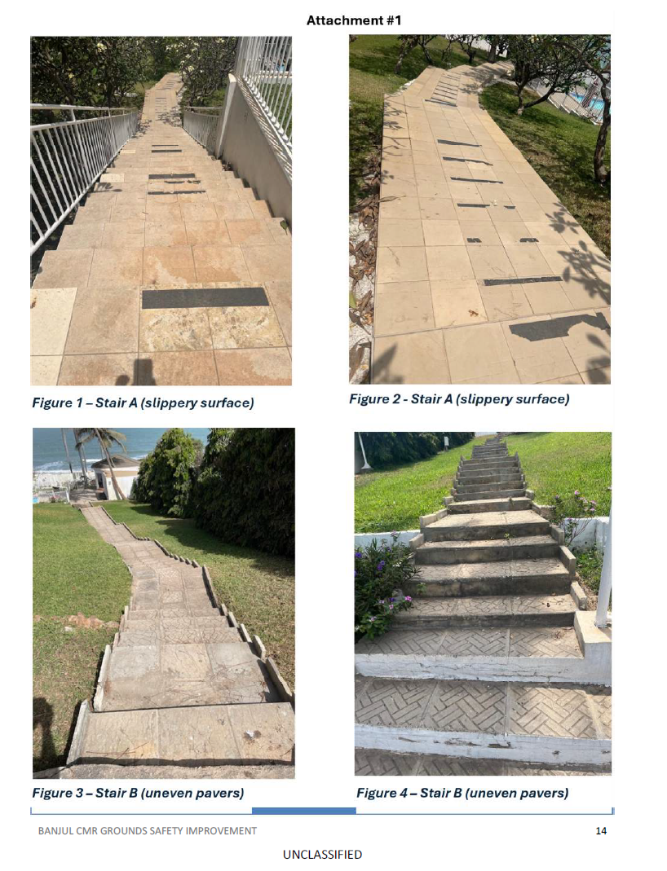
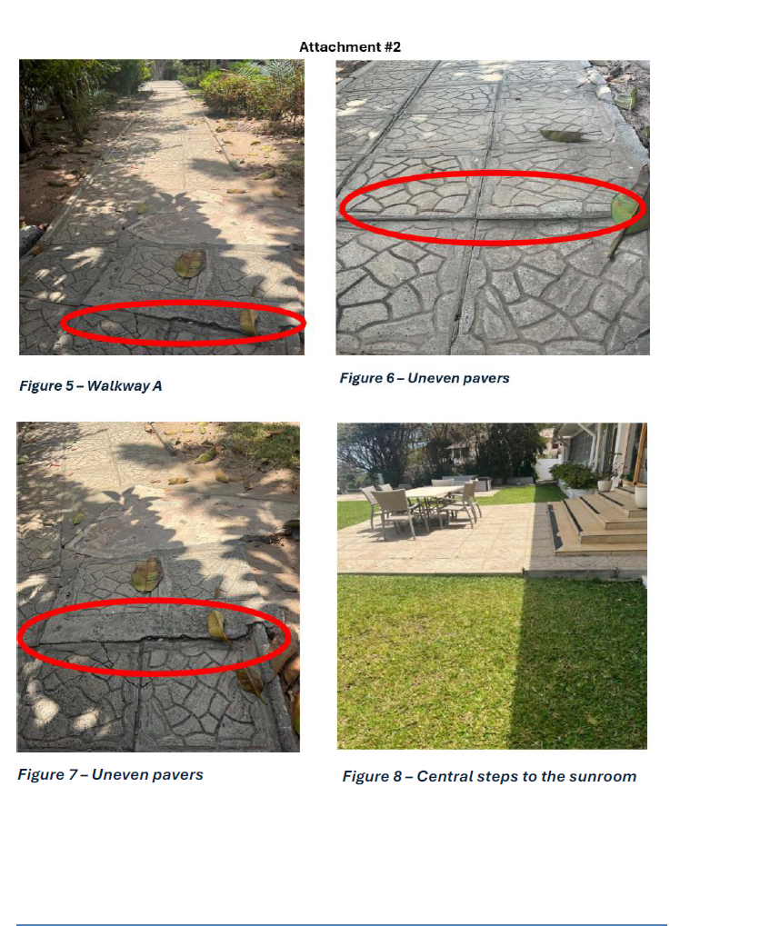
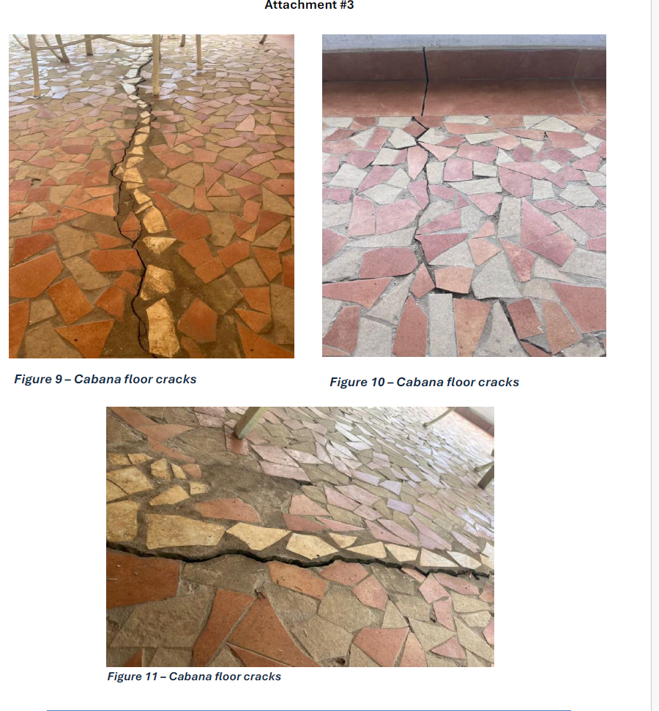
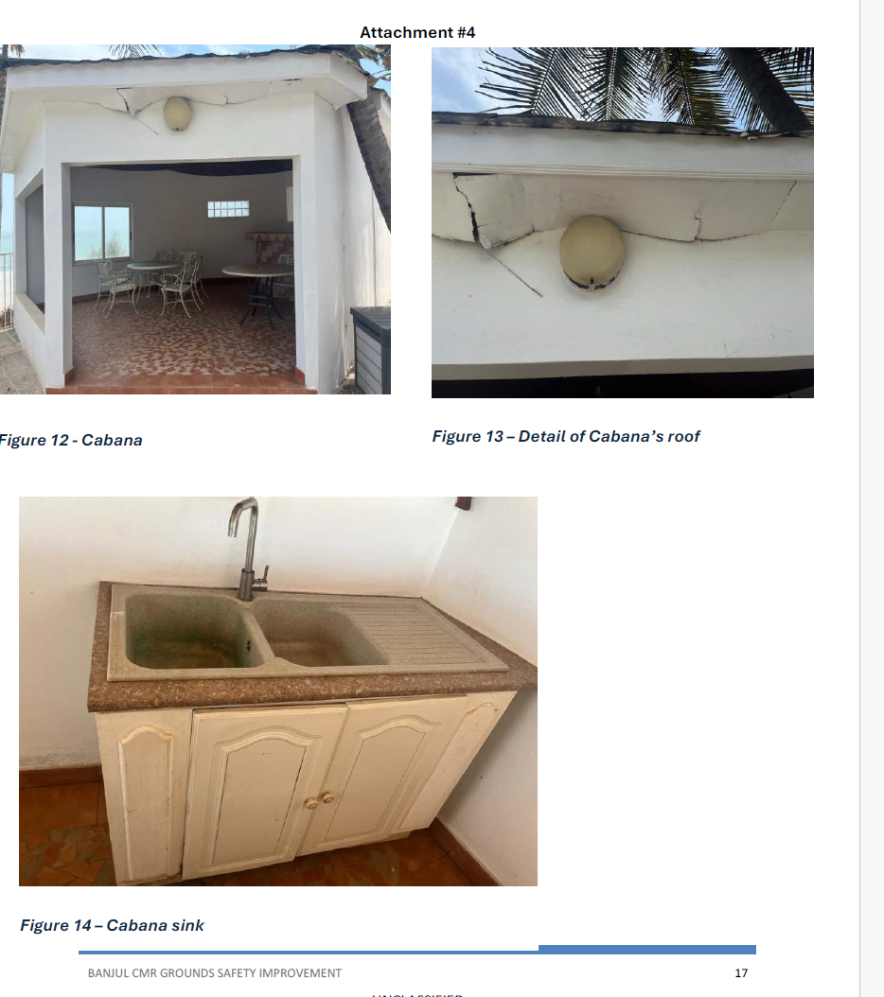
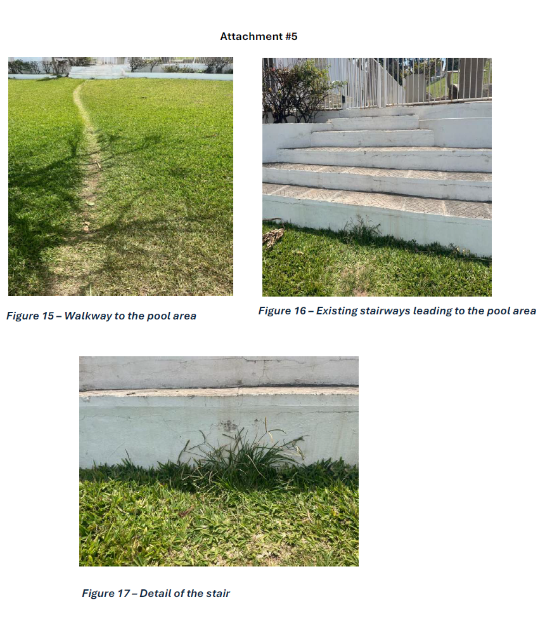
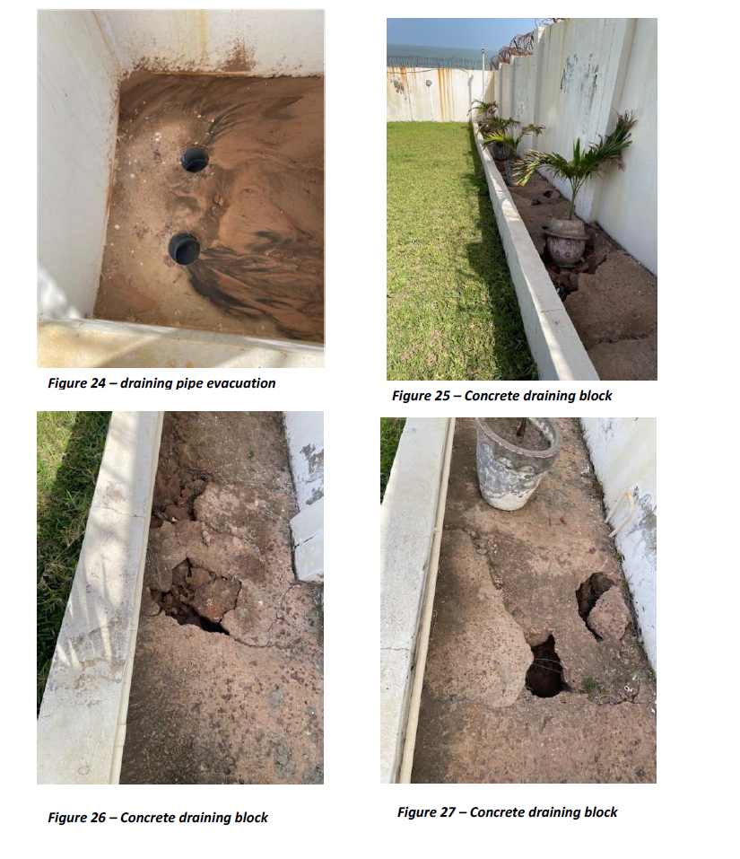
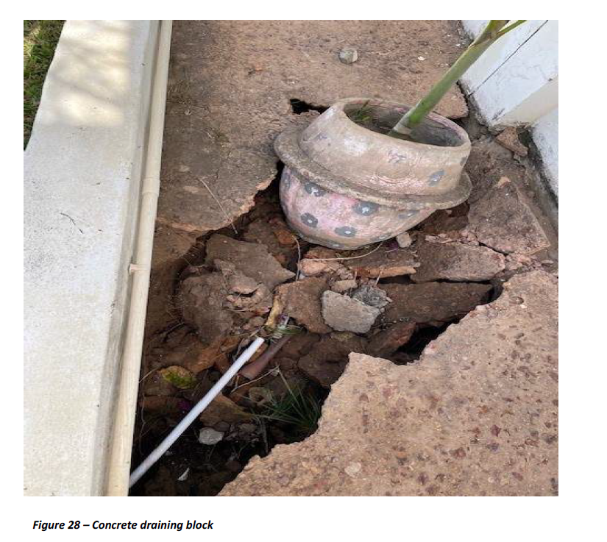

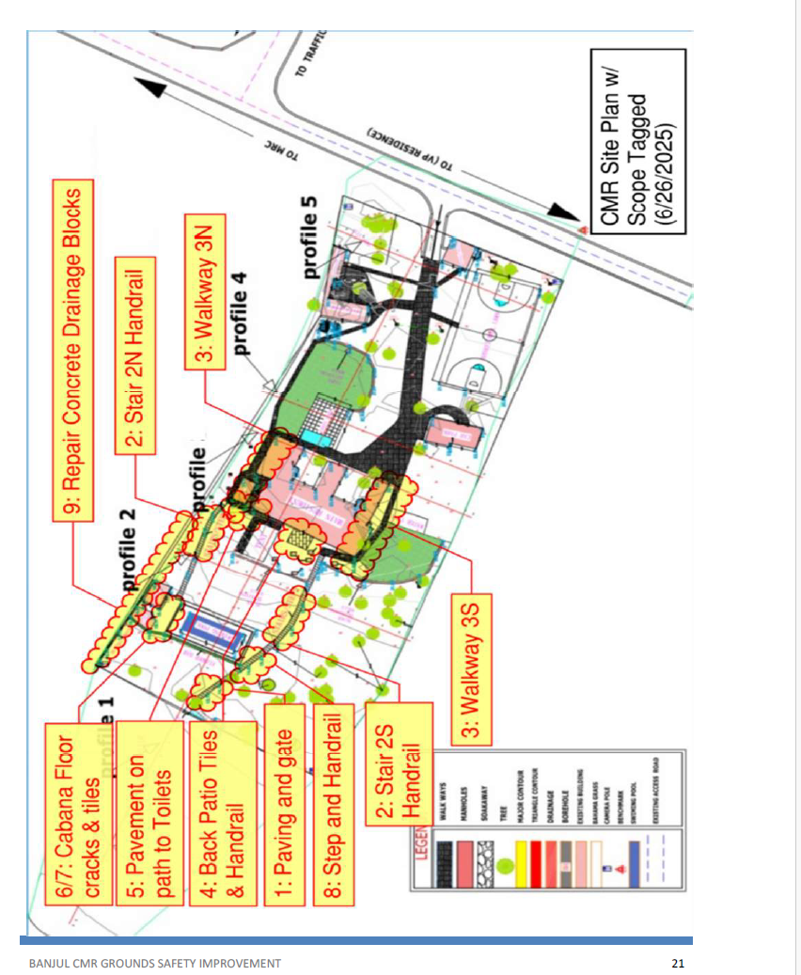
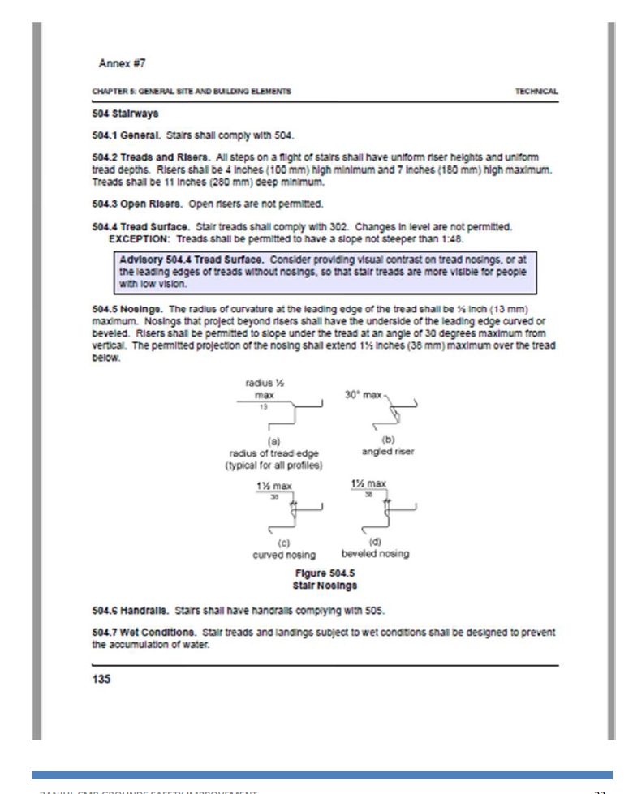
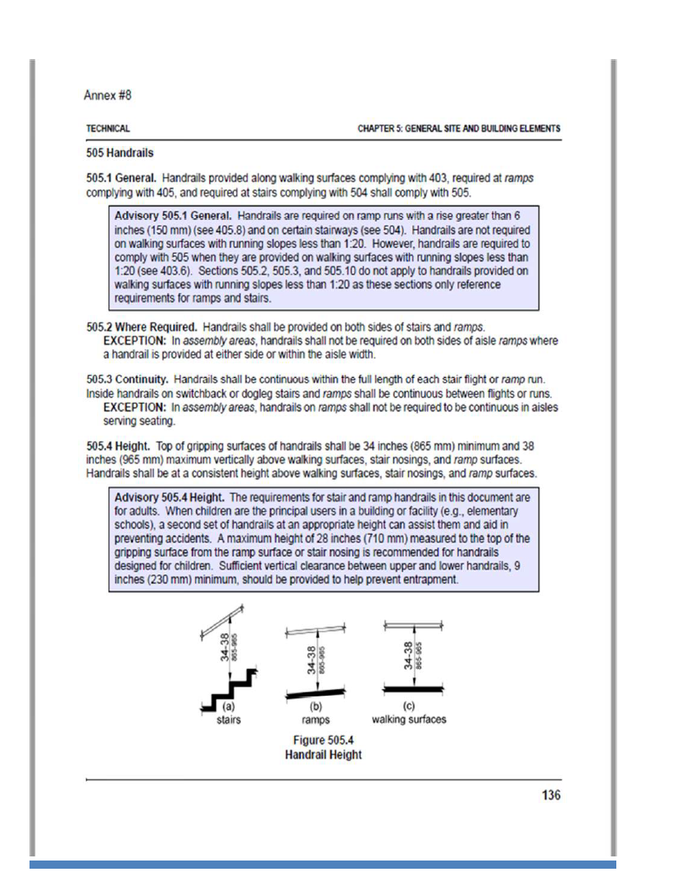
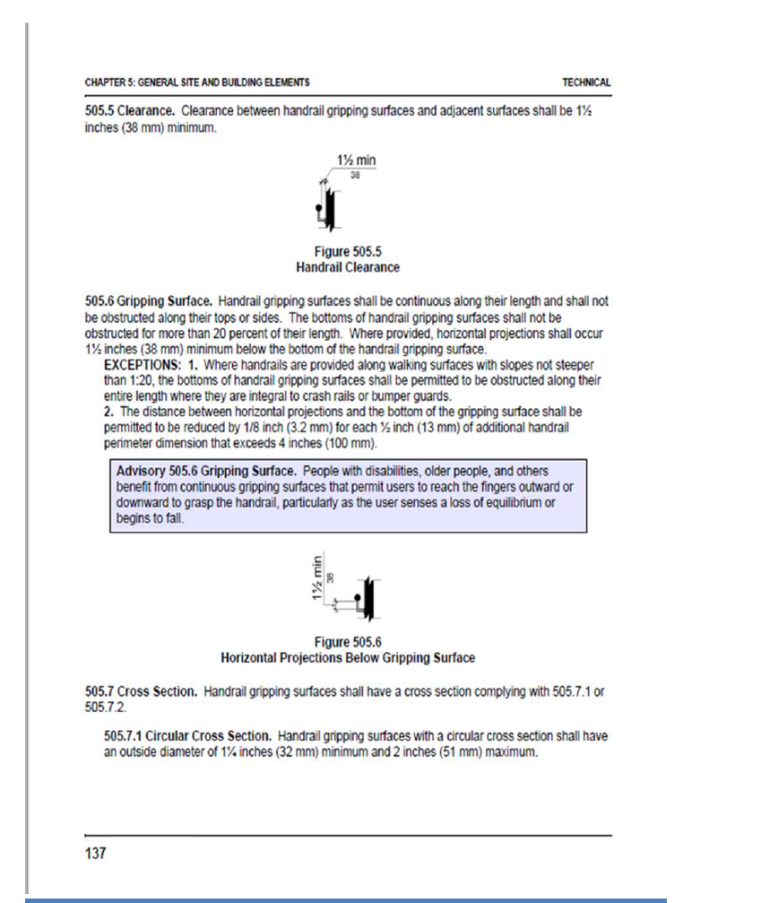
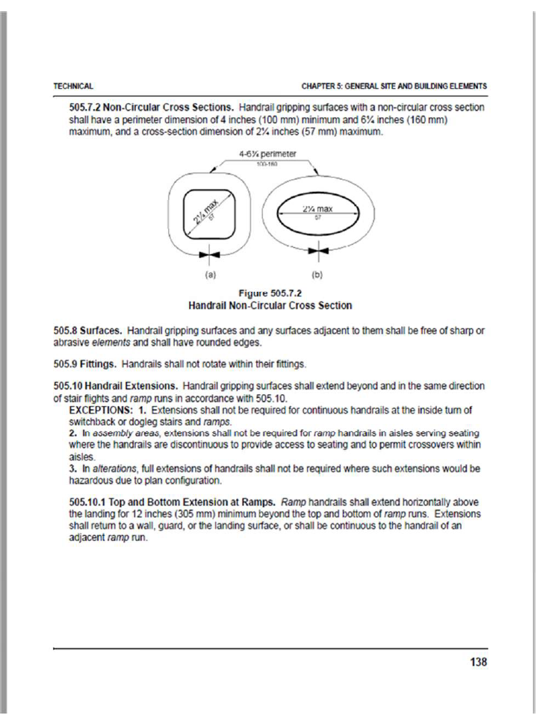
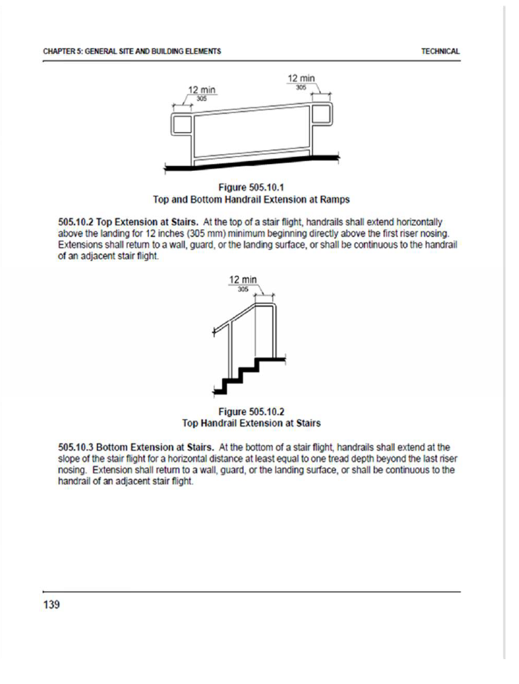
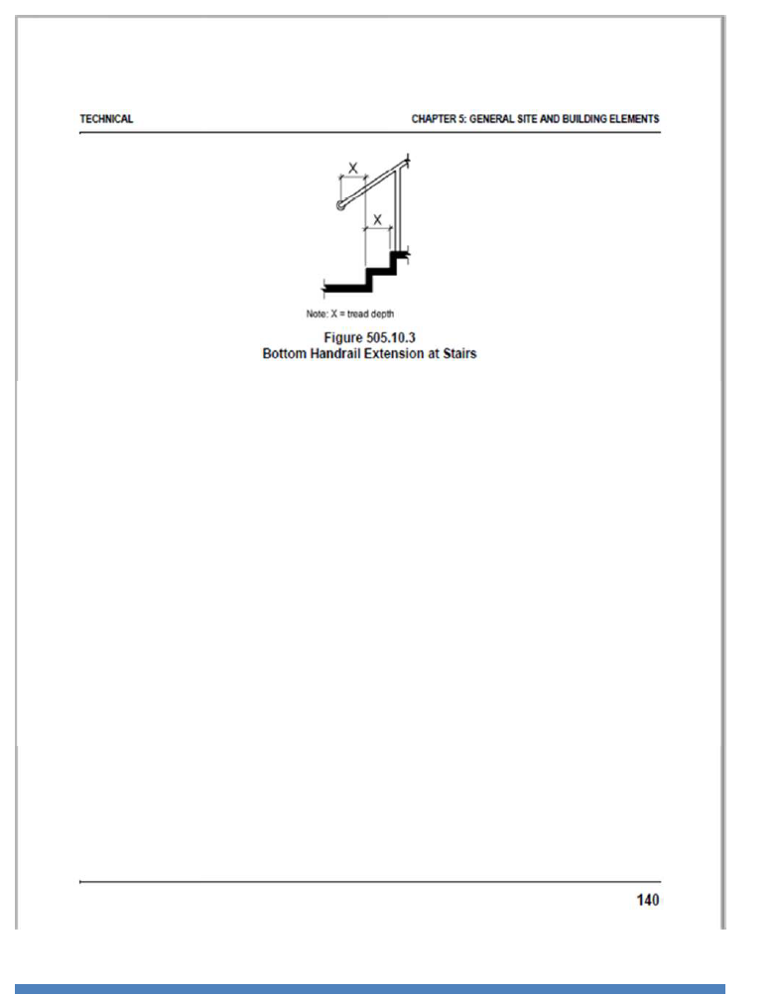

- CLAUSES FOR PURCHASE ORDERS AND BLANKET PURCHASE AGREEMENTS AWARDED BY OVERSEAS CONTRACTING ACTIVITIES
(Current thru FAC 2022-05, effective 03/2022)
COMMERCIAL ITEMS
52.2522 CLAUSES INCORPORATED BY REFERENCE (FEB 1998)
This purchase order or BPA incorporates the following clauses by reference, with the same force and effect as if they were given in full text. Upon request, the Contracting Officer will make their full text available. Also, the full text of a clause may be accessed electronically at this address: Acquisition.gov this address is subject to change.
DOSAR clauses may be accessed at: https://acquisition.gov/dosar
FEDERAL ACQUISTION REGULATION (48 CFR CHAPTER 1) CLAUSES: NUMBER | TITLE | DATE
52.204-7 | SYSTEM FOR AWARD MANAGEMENT | OCT 2018
52.204-9 | PERSONAL IDENTITY VERIFICATION OF CONTRACTOR PERSONNEL | JAN 2011
52.204-13 | SYSTEM FOR AWARD MANAGEMENT MAINTENANCE | OCT 2018
52.204-16 | COMMERCIAL AND GOVERNMENT ENTITY CODE REPORTING | AUG 2020
52.204-18 | COMMERCIAL AND GOVERNMENT ENTITY CODE MAINTENANCE | AUG 2020
52.212-4 | CONTRACT TERMS AND CONDITIONS—COMMERCIAL ITEMS | NOV 2021
52.223-17 | AFFIRMATIVE PROCUREMENT OF EPA-DESIGNATED ITEMS IN SERVICE AND CONSTRUCTION CONTRACTS | AUG 2018
52.225-19 | CONTRACTOR PERSONNEL IN A DIPLOMATIC OR CONSULAR MISSION OUTSIDE THE UNITED STATES | MAY 2020
52.227-19 | COMMERCIAL COMPUTER SOFTWARE LICENSE | DEC 2007
52.228-3 | WORKERS’COMPENSATION INSURANCE | JUL 2014
52.228-4 | WORKERS’ COMPENSATION AND WAR-HAZARD INSURANCE | APR 1984
52.244-6 | SUBCONTRACTS FOR COMMERCIAL ITEMS | JAN 2022

52.246-26 | REPORTING NONCONFORMING ITEMS | NOV 2021
The following clauses are provided in full text:
52.204-24 REPRESENTATION REGARDING CERTAIN TELECOMMUNICATIONS AND VIDEO SURVEILLANCE SERVICES OR EQUIPMENT (NOV 2021)
The Offeror shall not complete the representation at paragraph (d)(1) of this provision if the Offeror has represented that it "does not provide covered telecommunications equipment or services as a part of its offered products or services to the Government in the performance of any contract , subcontract , or other contractual instrument" in paragraph (c)(1) in the provision at 52.204-26, Covered Telecommunications Equipment or Services —Representation, or in paragraph (v)(2)(i) of the provision at 52.212-3, Offeror Representations and Certifications-Commercial Products or Commercial Services. The Offeror shall not complete the representation in paragraph (d)(2) of this provision if the Offeror has represented that it "does not use covered telecommunications equipment or services , or any equipment , system, or service that uses covered telecommunications equipment or services " in paragraph (c)(2) of the provision at 52.204-26, or in paragraph (v)(2)(ii) of the provision at 52.212-3.
(a) Definitions . As used in this provision—
Backhaul , covered telecommunications equipment or services , critical technology , interconnection arrangements , reasonable inquiry , roaming , and substantial or essential component have the meanings provided in the clause 52.204-25, Prohibition on Contracting for Certain Telecommunications and Video Surveillance Services or Equipment .
(b) Prohibition.
(1) Section 889(a)(1)(A) of the John S. McCain National Defense Authorization Act for Fiscal Year 2019 (Pub. L. 115-232) prohibits the head of an executive agency on or after August 13, 2019, from procuring or obtaining, or extending or renewing a contract to procure or obtain, any equipment , system, or service that uses covered telecommunications equipment or services as a substantial or essential component of any system, or as critical technology as part of any system. Nothing in the prohibition shall be construed to—
(i) Prohibit the head of an executive agency from procuring with an entity to provide a service that connects to the facilities of a third-party, such as backhaul , roaming , or interconnection arrangements ; or
(ii) Cover telecommunications equipment that cannot route or redirect user data traffic or cannot permit visibility into any user data or packets that such equipment transmits or otherwise handles.
(2) Section 889(a)(1)(B) of the John S. McCain National Defense Authorization Act for Fiscal Year 2019 (Pub. L. 115-232) prohibits the head of an executive agency on or after August 13, 2020, from entering into a contract or extending or renewing a contract with an entity that uses any equipment , system, or service that uses covered telecommunications equipment or services as a substantial or essential component of any system, or as critical technology as part of any system. This prohibition applies to the use of covered telecommunications equipment or services , regardless of whether that use is in performance of work under a Federal contract . Nothing in the prohibition shall be construed to—
(i) Prohibit the head of an executive agency from procuring with an entity to provide a service that connects to the facilities of a third-party, such as backhaul , roaming , or interconnection arrangements ; or
(ii) Cover telecommunications equipment that cannot route or redirect user data traffic or cannot permit visibility into any user data or packets that such equipment transmits or otherwise handles.
(c) Procedures. The Offeror shall review the list of excluded parties in the System for Award Management (SAM) ( https://www.sam.gov) for entities excluded from receiving federal awards for "covered telecommunications equipment or services ".
(d) Representation. The Offeror represents that—
(1) It □ will, □ will not provide covered telecommunications equipment or services to the Government in the performance of any contract , subcontract or other contractual instrument resulting from this solicitation . The Offeror shall provide the additional disclosure information required at paragraph (e)(1) of this section if the Offeror responds "will" in paragraph (d)(1) of this section; and
(2) After conducting a reasonable inquiry , for purposes of this representation, the Offeror represents that—
It □ does, □ does not use covered telecommunications equipment or services , or use any equipment , system, or service that uses covered telecommunications equipment or services . The Offeror shall provide the additional disclosure information required at paragraph (e)(2) of this section if the Offeror responds "does" in paragraph (d)(2) of this section.
(e) Disclosures.
(1) Disclosure for the representation in paragraph (d)(1) of this provision. If the Offeror has responded "will" in the representation in paragraph (d)(1) of this provision, the Offeror shall provide the following information as part of the offer :
(i) For covered equipment —
(A) The entity that produced the covered telecommunications equipment (include entity name, unique entity identifier , CAGE code, and whether the entity was the original equipment manufacturer (OEM) or a distributor, if known);
(B) A description of all covered telecommunications equipment offered (include brand; model number, such as OEM number, manufacturer part number, or wholesaler number; and item description, as applicable); and
(C) Explanation of the proposed use of covered telecommunications equipment and any factors relevant to determining if such use would be permissible under the prohibition in paragraph (b)(1) of this provision.
(ii) For covered services—
(A) If the service is related to item maintenance: A description of all covered telecommunications services offered (include on the item being maintained: Brand; model number, such as OEM number, manufacturer part number, or wholesaler number; and item description, as applicable); or
(B) If not associated with maintenance, the Product Service Code (PSC) of the service being provided; and explanation of the proposed use of covered telecommunications services and any factors relevant to determining if such use would be permissible under the prohibition in paragraph (b)(1) of this provision.
(2) Disclosure for the representation in paragraph (d)(2) of this provision. If the Offeror has responded "does" in the representation in paragraph (d)(2) of this provision, the Offeror shall provide the following information as part of the offer :
(i) For covered equipment —
(A) The entity that produced the covered telecommunications equipment (include entity name, unique entity identifier , CAGE code, and whether the entity was the OEM or a distributor, if known);
(B) A description of all covered telecommunications equipment offered (include brand; model number, such as OEM number, manufacturer part number, or wholesaler number; and item description, as applicable); and
(C) Explanation of the proposed use of covered telecommunications equipment and any factors relevant to determining if such use would be permissible under the prohibition in paragraph (b)(2) of this provision.
(ii) For covered services—
(A) If the service is related to item maintenance: A description of all covered telecommunications services offered (include on the item being maintained: Brand; model number, such as OEM number, manufacturer part number, or wholesaler number; and item description, as applicable); or
(B) If not associated with maintenance, the PSC of the service being provided; and explanation of the proposed use of covered telecommunications services and any factors relevant to determining if such use would be permissible under the prohibition in paragraph (b)(2) of this provision.
(End of provision)
52.204-25 PROHIBITION ON CONTRACTING FOR CERTAIN TELECOMMUNICATIONS AND VIDEO SURVEILLANCE SERVICES OR EQUIPMENT (NOV 2021)
(a) Definitions . As used in this clause—
Backhaul means intermediate links between the core network, or backbone network, and the small subnetworks at the edge of the network (e.g., connecting cell phones/towers to the core telephone network). Backhaul can be wireless (e.g., microwave) or wired (e.g., fiber optic, coaxial cable, Ethernet).
Covered foreign country means The People’s Republic of China.
Covered telecommunications equipment or services means–
(1) Telecommunications equipment produced by Huawei Technologies Company or ZTE Corporation (or any subsidiary or affiliate of such entities);
(2) For the purpose of public safety, security of Government facilities, physical security surveillance of critical infrastructure, and other national security purposes, video surveillance and telecommunications equipment produced by Hytera Communications Corporation, Hangzhou Hikvision Digital Technology Company, or Dahua Technology Company (or any subsidiary or affiliate of such entities);
(3) Telecommunications or video surveillance services provided by such entities or using such equipment ; or system, or service that uses covered telecommunications equipment or services as a substantial or essential component of any system, or as critical technology as part of any system, unless an exception at paragraph (c) of this clause applies or the covered telecommunication equipment or services are covered by a waiver described in FAR 4.2104.
(2) Section 889(a)(1)(B) of the John S. McCain National Defense Authorization Act for Fiscal Year 2019 (Pub. L. 115-232) prohibits the head of an executive agency on or after August 13, 2020, from entering into a contract , or extending or renewing a contract , with an entity that uses any equipment , system, or service that uses covered telecommunications equipment or services as a substantial or essential component of any system, or as critical technology as part of any system, unless an exception at paragraph (c) of this clause applies or the covered telecommunication equipment or services are covered by a waiver described in FAR 4.2104. This prohibition applies to the use of covered telecommunications equipment or services , regardless of whether that use is in performance of work under a Federal contract .
(c) Exceptions. This clause does not prohibit contractors from providing—
(1) A service that connects to the facilities of a third-party, such as backhaul , roaming , or interconnection arrangements ; or
(2) Telecommunications equipment that cannot route or redirect user data traffic or permit visibility into any user data or packets that such equipment transmits or otherwise handles.
(d) Reporting requirement.
(1) In the event the Contractor identifies covered telecommunications equipment or services used as a substantial or essential component of any system, or as critical technology as part of any system, during contract performance, or the Contractor is notified of such by a subcontractor at any tier or by any other source, the Contractor shall report the information in paragraph (d)(2) of this clause to the Contracting Officer , unless elsewhere in this contract are established procedures for reporting the information ; in the case of the Department of Defense, the Contractor shall report to the website at https://dibnet.dod.mil. For indefinite delivery contracts, the Contractor shall report to the Contracting Officer for the indefinite delivery contract and the Contracting Officer (s) for any affected order or, in the case of the Department of Defense, identify both the indefinite delivery contract and any affected orders in the report provided at https://dibnet.dod.mil.
(2) The Contractor shall report the following information pursuant to paragraph (d)(1) of this clause
(i) Within one business day from the date of such identification or notification: the contract number; the order number(s), if applicable; supplier name; supplier unique entity identifier (if known); supplier Commercial and Government Entity (CAGE) code (if known); brand; model number (original equipment manufacturer number, manufacturer part number, or wholesaler number); item description; and any readily available information about mitigation actions undertaken or recommended.
(ii) Within 10 business days of submitting the information in paragraph (d)(2)(i) of this clause: any further available information about mitigation actions undertaken or recommended. In addition, the Contractor shall describe the efforts it undertook to prevent use or submission of covered telecommunications equipment or services , and any additional efforts that will be incorporated to prevent future use or submission of covered telecommunications equipment or services .
(e) Subcontracts. The Contractor shall insert the substance of this clause, including this paragraph (e) and excluding paragraph (b)(2), in all subcontracts and other contractual instruments, including subcontracts for the acquisition of commercial products or commercial services.
(End of clause)
52.204-26 COVERED TELECOMMUNICATIONS EQUIPMENT OR SERVICES-REPRESENTATION (OCT 2020)
(a) Definitions. As used in this provision, “covered telecommunications equipment or services” and “reasonable inquiry” have the meaning provided in the clause 52.204-25, Prohibition on Contracting for Certain Telecommunications and Video Surveillance Services or Equipment.
(b) Procedures. The Offeror shall review the list of excluded parties in the System for Award Management (SAM) (https://www.sam.gov) for entities excluded from receiving federal awards for “covered telecommunications equipment or services”.
(c) Representations. (1) The Offeror represents that it [ ] does, [ ] does not provide covered telecommunications equipment or services as a part of its offered products or services to the Government in the performance of any contract, subcontract, or other contractual instrument.
(2) After conducting a reasonable inquiry for purposes of this representation, the Offeror represents that it [ ] does, [ ] does not use covered telecommunications equipment or services, or any equipment, system, or service that uses covered telecommunications equipment or services.
(End of provision)
52.212-3 OFFEROR REPRESENTATIONS AND CERTIFICATIONS- COMMERCIAL ITEMS (NOV 2021)
The Offeror shall complete only paragraph (b) of this provision if the Offeror has completed the annual representations and certification electronically in the System for Award Management (SAM) accessed through https://www.sam.gov. If the Offeror has not completed the annual representations and certifications electronically, the Offeror shall complete only paragraphs (c) through (v)) of this provision.
(a) Definitions . As used in this provision—
"Covered telecommunications equipment or services " has the meaning provided in the clause 52.204-25, Prohibition on Contracting for Certain Telecommunications and Video Surveillance Services or Equipment .
Economically disadvantaged women-owned small business (EDWOSB) concern means a small business concern that is at least 51 percent directly and unconditionally owned by, and the management and daily business operations of which are controlled by, one or more women who are citizens of the United States and who are economically disadvantaged in accordance with 13 CFR part 127. It automatically qualifies as a women-owned small business eligible under the WOSB Program.
Forced or indentured child labor means all work or service—
(1) Exacted from any person under the age of 18 under the menace of any penalty for its nonperformance and for which the worker does not offer himself voluntarily; or
(2) Performed by any person under the age of 18 pursuant to a contract the enforcement of which can be accomplished by process or penalties.
Highest-level owner means the entity that owns or controls an immediate owner of the offeror , or that owns or controls one or more entities that control an immediate owner of the offeror . No entity owns or exercises control of the highest level owner.
Immediate owner means an entity, other than the offeror , that has direct control of the offeror . Indicators of control include, but are not limited to, one or more of the following: ownership or interlocking management, identity of interests among family members, shared facilities and equipment , and the common use of employees.
Inverted domestic corporation , means a foreign incorporated entity that meets the definition of an inverted domestic corporation under 6 U.S.C. 395(b), applied in accordance with the rules and definitions of 6 U.S.C. 395(c).
Manufactured end product means any end product in product and service codes (PSCs) 1000-9999, except—
(1) PSC 5510, Lumber and Related Basic Wood Materials ;
(2) Product or Service Group (PSG) 87, Agricultural Supplies ;
(3) PSG 88, Live Animals;
(4) PSG 89, Subsistence;
(5) PSC 9410, Crude Grades of Plant Materials ;
(6) PSC 9430, Miscellaneous Crude Animal Products , Inedible;
(7) PSC 9440, Miscellaneous Crude Agricultural and Forestry Products ;
(8) PSC 9610, Ores;
(9) PSC 9620, Minerals, Natural and Synthetic; and
(10) PSC 9630, Additive Metal Materials .
Place of manufacture means the place where an end product is assembled out of components, or otherwise made or processed from raw materials into the finished product that is to be provided to the Government. If a product is disassembled and reassembled, the place of reassembly is not the place of manufacture .
Predecessor means an entity that is replaced by a successor and includes any predecessors of the predecessor .
Reasonable inquiry has the meaning provided in the clause 52.204-25, Prohibition on Contracting for Certain Telecommunications and Video Surveillance Services or Equipment .
Restricted business operations means business operations in Sudan that include power production activities, mineral extraction activities, oil-related activities, or the production of military equipment , as those terms are defined in the Sudan Accountability and Divestment Act of 2007 (Pub. L. 110-174). Restricted business operations do not include business operations that the person (as that term is defined in Section 2 of the Sudan Accountability and Divestment Act of 2007) conducting the business can demonstrate—
(1) Are conducted under contract directly and exclusively with the regional government of southern Sudan.
(2) Are conducted pursuant to specific authorization from the Office of Foreign Assets Control in the Department of the Treasury or are expressly exempted under Federal law from the requirement to be conducted under such authorization.
(3) Consist of providing goods or services to marginalized populations of Sudan.
(4) Consist of providing goods or services to an internationally recognized peacekeeping force or humanitarian organization.
(5) Consist of providing goods or services that are used only to promote health or education; or
(6) Have been voluntarily suspended. “Sensitive technology "—
Sensitive technology —
(1) Means hardware, software, telecommunications equipment, or any other technology that is to be used specifically—
(i) To restrict the free flow of unbiased information in Iran; or
(ii) To disrupt, monitor, or otherwise restrict speech of the people of Iran; and
(2) Does not include information or informational materials the export of which the President does not have the authority to regulate or prohibit pursuant to section 203(b)(3)of the International Emergency Economic Powers Act (50 U.S.C. 1702(b)(3)).
Service-disabled veteran-owned small business concern —
(1) Means a small business concern —
(i) Not less than 51 percent of which is owned by one or more service-disabled veterans or, in the case of any publicly owned business, not less than 51 percent of the stock of which is owned by one or more service-disabled veterans; and
(ii) The management and daily business operations of which are controlled by one or more service-disabled veterans or, in the case of a service-disabled veteran with permanent and severe disability, the spouse or permanent caregiver of such veteran.
(2) Service-disabled veteran means a veteran, as defined in 38 U.S.C. 101(2), with a disability that is service connected, as defined in 38 U.S.C. 101(16).
Small business concern —
(1) Means a concern, including its affiliates , that is independently owned and operated, not dominant in the field of operation in which it is bidding on Government contracts, and qualified as a small business under the criteria in 13 CFR part 121 and size standards in this solicitation .
(2) Affiliates , as used in this definition , means business concerns, one of whom directly or indirectly controls or has the power to control the others, or a third party or parties control or have the power to control the others. In determining whether affiliation exists, consideration is given to all appropriate factors including common ownership, common management, and contractual relationships. SBA determines affiliation based on the factors set forth at 13 CFR 121.103.
Small disadvantaged business concern , consistent with13 CFR 124.1002, means a small business concern under the size standard applicable to the acquisition , that—
(1) Is at least 51 percent unconditionally and directly owned (as defined at 13 CFR 124.105) by—
(i) One or more socially disadvantaged (as defined at13 CFR 124.103) and economically disadvantaged (as defined at 13 CFR 124.104) individuals who are citizens of the United States ; and
(ii) Each individual claiming economic disadvantage has a net worth not exceeding $750,000 after taking into account the applicable exclusions set forth at 13 CFR124.104(c)(2); and
(2) The management and daily business operations of which are controlled (as defined at 13.CFR 124.106) by individuals, who meet the criteria in paragraphs (1)(i) and (ii) of this definition .
Subsidiary means an entity in which more than 50 percent of the entity is owned—
(1) Directly by a parent corporation; or
(2) Through another subsidiary of a parent corporation
Successor means an entity that has replaced a predecessor by acquiring the assets and carrying out the affairs of the predecessor under a new name (often through acquisition or merger). The term "successor " does not include new offices/divisions of the same company or a company that only changes its name. The extent of the responsibility of the successor for the liabilities of the predecessor may vary, depending on State law and specific circumstances.
Veteran-owned small business concern means a small business concern —
(1) Not less than 51 percent of which is owned by one or more veterans (as defined at 38 U.S.C. 101(2)) or, in the case of any publicly owned business, not less than 51 percent of the stock of which is owned by one or more veterans; and
(2) The management and daily business operations of which are controlled by one or more veterans.
Women-owned small business (WOSB) concern eligible under the WOSB Program (in accordance with 13 CFR part 127), means a small business concern that is at least 51 percent directly and unconditionally owned by, and the management and daily business operations of which are controlled by, one or more women who are citizens of the United States .
Women-owned small business concern means a small business concern —
(1) That is at least 51 percent owned by one or more women; or, in the case of any publicly owned business, at least51 percent of the stock of which is owned by one or more women; and
(2) Whose management and daily business operations are controlled by one or more women.
(b)
(1) Annual Representations and Certifications. Any changes provided by the Offeror in paragraph (b)(2) of this provision do not automatically change the representations and certifications in SAM.
(2) The offeror has completed the annual representations and certifications electronically in SAM accessed through http://www.sam.gov. After reviewing SAM information , the Offeror verifies by submission of this offer that the representations and certifications currently posted electronically at FAR 52.212-3, Offeror Representations and Certifications-Commercial Products and Commercial Services, have been entered or updated in the last 12 months, are current, accurate, complete, and applicable to this solicitation (including the business size standard(s) applicable to the NAICS code(s) referenced for this solicitation ), at the time this offer is submitted and are incorporated in this offer by reference (see FAR 4.1201), except for paragraphs ______________.
[Offeror to identify the applicable paragraphs at (c) through (v) of this provision that the offeror has completed for the purposes of this solicitation only, if any.
These amended representation(s) and/or certification(s) are also incorporated in this offer and are current, accurate, and complete as of the date of this offer .
Any changes provided by the offeror are applicable to this solicitation only, and do not result in an update to the representations and certifications posted electronically on SAM.]
(c) Offerors must complete the following representations when the resulting contract will be performed in the United States or its outlying areas . Check all that apply.
(1) Small business concern . The offeror represents as part of its offer that it □ is, □ is not a small business concern .
(2) Veteran-owned small business concern . [Complete only if the offeror represented itself as a small business concern in paragraph (c)(1) of this provision.] The offeror represents as part of its offer that it □ is, □ is not a veteran-owned small business concern .
(3) Service-disabled veteran-owned small business concern . [Complete only if the offeror represented itself as a veteran-owned small business concern in paragraph (c)(2) of this provision.] The offeror represents as part of its offer that it □ is, □ is not a service-disabled veteran-owned small business concern .
(4) Small disadvantaged business concern . [Complete only if the offeror represented itself as a small business concern in paragraph (c)(1) of this provision.] The offeror represents, that it □ is, □ is not a small disadvantaged business concern as defined in 13 CFR124.1002.
(5) Women-owned small business concern . [Complete only if the offeror represented itself as a small business concern in paragraph (c)(1) of this provision.] The offeror represents that it □ is, □ is not a women-owned small business concern .
(6) WOSB concern eligible under the WOSB Program. [Complete only if the offeror represented itself as a women-owned small business concern in paragraph (c)(5) of this provision.] The offeror represents that-
(i) It □ is, □ is not a WOSB concern eligible under the WOSB Program, has provided all the required documents to the WOSB Repository, and no change in circumstances or adverse decisions have been issued that affects its eligibility; and
(ii) It □ is, □ is not a joint venture that complies with the requirements of 13 CFR part 127, and the representation in paragraph (c)(6)(i) of this provision is accurate for each WOSB concern eligible under the WOSB Program participating in the joint venture. [The offeror shall enter the name or names of the WOSB concern eligible under the WOSB Program and other small businesses that are participating in the joint venture: __________.] Each WOSB concern eligible under the WOSB Program participating in the joint venture shall submit a separate signed copy of the WOSB representation.
(7) Economically disadvantaged women-owned small business (EDWOSB) concern . [Complete only if the offeror represented itself as a WOSB concern eligible under the WOSB Program in (c)(6) of this provision.] The offeror represents that-
(i) It □ is, □ is not an EDWOSB concern, has provided all the required documents to the WOSB Repository, and no change in circumstances or adverse decisions have been issued that affects its eligibility; and
(ii) It □ is, □ is not a joint venture that complies with the requirements of 13 CFR part 127, and the representation in paragraph (c)(7)(i) of this provision is accurate for each EDWOSB concern participating in the joint venture. [The offeror shall enter the name or names of the EDWOSB concern and other small businesses that are participating in the joint venture: __________.] Each EDWOSB concern participating in the joint venture shall submit a separate signed copy of the EDWOSB representation.
Note: Complete paragraphs (c)(8) and (c)(9) only if this solicitation is expected to exceed the simplified acquisition threshold .
(8) Women-owned business concern (other than small business concern ). [Complete only if the offeror is a women-owned business concern and did not represent itself as a small business
concern in paragraph (c)(1) of this provision.] The offeror represents that it □ is a women-owned business concern.
(9) Tie bid priority for labor surplus area concerns. If this is an invitation for bid , small business offerors may identify the labor surplus areas in which costs to be incurred on account of manufacturing or production (by offeror or first-tier subcontractors) amount to more than 50 percent of the contract price:____________________________________
(10) HUBZone small business concern . [Complete only if the offeror represented itself as a small business concern in paragraph (c)(1) of this provision.] The offeror represents, as part of its offer , that–
(i) It □ is, □ is not a HUBZone small business concern listed, on the date of this representation, on the List of Qualified HUBZone Small Business Concerns maintained by the Small Business Administration, and no material changes in ownership and control, principal office, or HUBZone employee percentage have occurred since it was certified in accordance with 13 CFR Part 126; and
(ii) It □ is, □ is not a HUBZone joint venture that complies with the requirements of 13 CFR Part 126, and the representation in paragraph (c)(10)(i) of this provision is accurate for each HUBZone small business concern participating in the HUBZone joint venture. [The offeror shall enter the names of each of the HUBZone small business concerns participating in the HUBZone joint venture: __________.] Each HUBZone small business concern participating in the HUBZone joint venture shall submit a separate signed copy of the HUBZone representation.
(d) Representations required to implement provisions of Executive Order11246-
(1) Previous contracts and compliance. The offeror represents that-
(i) It □ has, □ has not participated in a previous contract or subcontract subject to the Equal Opportunity clause of this solicitation ; and
(ii) It □ has, □ has not filed all required compliance reports.
(2) Affirmative Action Compliance. The offeror represents that-
(i) It □ has developed and has on file, □ has not developed and does not have on file, at each establishment, affirmative action programs required by rules and regulations of the Secretary of Labor (41 CFR parts 60-1 and 60-2), or
(ii) It □ has not previously had contracts subject to the written affirmative action programs requirement of the rules and regulations of the Secretary of Labor.
(e) Certification Regarding Payments to Influence Federal Transactions (31 http://uscode.house.gov/ U.S.C. 1352). (Applies only if the contract is expected to exceed $150,000.) By submission of its offer , the offeror certifies to the best of its knowledge and belief that no Federal appropriated funds have been paid or will be paid to any person for influencing or attempting to influence an officer or employee of any agency , a Member of Congress, an officer or employee of Congress or an employee of a Member of Congress on his or her behalf in connection with the award of any resultant contract . If any registrants under the Lobbying Disclosure Act of 1995 have made a lobbying contact on behalf of the offeror with respect to this contract , the offeror shall complete and submit, with its offer , OMB Standard Form LLL, Disclosure of Lobbying Activities, to provide the name of the registrants. The offeror need not report regularly employed officers or employees of the offeror to whom payments of reasonable compensation were made .
(f) Buy American Certificate. (Applies only if the clause at Federal Acquisition Regulation (FAR) 52.225-1, Buy American-Supplies , is included in this solicitation .)
(1)
(i) The Offeror certifies that each end product , except those listed in paragraph (f)(2) of this provision, is a domestic end product .
(ii) The Offeror shall list as foreign end products those end products manufactured in the United States that do not qualify as domestic end products .
(iii) The terms "domestic end product ," "end product ," "foreign end product ," and "United States " are defined in the clause of this solicitation entitled "Buy American-Supplies ."
(2) Foreign End Products : Line Item No. | Country of Origin
______________ | _________________
______________ | _________________
______________ | _________________
Line Item No. | Country of Origin
______________ | _________________
______________ | _________________
[List as necessary]
(3) The Government will evaluate offers in accordance with the policies and procedures of FAR part 25.
(g)
(1) Buy American-Free Trade Agreements-Israeli Trade Act Certificate. (Applies only if the clause at FAR 52.225-3, Buy American-Free Trade Agreements-Israeli Trade Act, is included in this solicitation .)
(i)
(A) The Offeror certifies that each end product , except those listed in paragraph (g)(1)(ii) or (iii) of this provision, is a domestic end product .
(B) The terms "Bahrainian, Moroccan, Omani, Panamanian, or Peruvian end product ," "domestic end product ," "end product ," "foreign end product ," "Free Trade Agreement country ," "Free Trade Agreement country end product ," "Israeli end product ," and "United States " are defined in the clause of this solicitation entitled "Buy American-Free Trade Agreements-Israeli Trade Act."
(ii) The Offeror certifies that the following supplies are Free Trade Agreement country end products (other than Bahrainian, Moroccan, Omani, Panamanian, or Peruvian end products ) or Israeli end products as defined in the clause of this solicitation entitled "Buy American-Free Trade Agreements-Israeli Trade Act."
Free Trade Agreement Country End Products (Other than Bahrainian, Moroccan, Omani, Panamanian, or Peruvian End Products) or Israeli End Products: Line Item No. | Country of Origin
______________ | _________________
[List as necessary]
(iii) The Offeror shall list those supplies that are foreign end products (other than those listed in paragraph (g)(1)(ii) of this provision) as defined in the clause of this solicitation entitled "Buy American-Free Trade Agreements-Israeli Trade Act." The Offeror shall list as other foreign end products those end products manufactured in the United States that do not qualify as domestic end products.
Other Foreign End Products: Line-Item No. | Country of Origin
______________ | _________________
______________ | _________________
______________ | _________________
(3) Buy American-Free Trade Agreements-Israeli Trade Act Certificate, Alternate II. If Alternate II to the clause at FAR 52.225-3 is included in this solicitation, substitute the following paragraph (g)(1)(ii) for paragraph (g)(1)(ii) of the basic provision:
(g)(1)(ii) The offeror certifies that the following supplies are Canadian end products or Israeli end products as defined in the clause of this solicitation entitled "Buy American-Free Trade Agreements-Israeli Trade Act":
Canadian or Israeli End Products: Line Item No. | Country of Origin
______________ | _________________
______________ | _________________
______________ | _________________
[List as necessary]
(5) Trade Agreements Certificate. (Applies only if the clause at FAR 52.225-5, Trade Agreements, is included in this solicitation.)
(i) The offeror certifies that each end product, except those listed in paragraph (g)(5)(ii) of this provision, is a U.S.-made or designated country end product, as defined in the clause of this solicitation entitled "Trade Agreements."
(ii) The offeror shall list as other end products those end products that are not U.S.-made or designated country end products.
Other End Products: 18
Line Item No. | Country of Origin
_______________ | __________________
_______________ | __________________
______________ | __________________
[List as necessary]
(iii) The Government will evaluate offers in accordance with the policies and procedures of FAR part 25. For line items covered by the WTO GPA, the Government will evaluate offers of U.S.-made or designated country end products without regard to the restrictions of the Buy American statute. The Government will consider for award only offers of U.S.-made or designated country end products unless the Contracting Officer determines that there are no offers for such products or that the offers for such products are insufficient to fulfill the requirements of the solicitation.
(h) Certification Regarding Responsibility Matters (Executive Order 12689). (Applies only if the contract value is expected to exceed the simplified acquisition threshold .) The offeror certifies, to the best of its knowledge and belief, that the offeror and/or any of its principals–
(1) □ Are, □ are not presently debarred, suspended, proposed for debarment, or declared ineligible for the award of contracts by any Federal agency ;
(2) □ Have, □ have not, within a three-year period preceding this offer , been convicted of or had a civil judgment rendered against them for: commission of fraud or a criminal offense in connection with obtaining, attempting to obtain, or performing a Federal, state or local government contract or subcontract ; violation of Federal or state antitrust statutes relating to the submission of offers; or commission of embezzlement, theft, forgery, bribery, falsification or destruction of records, making false statements, tax evasion, violating Federal criminal tax laws, or receiving stolen property ;
(3) □ Are, □ are not presently indicted for, or otherwise criminally or civilly charged by a Government entity with, commission of any of these offenses enumerated in paragraph (h)(2) of this clause; and
(4) □ Have, □ have not, within a three-year period preceding this offer , been notified of any delinquent Federal taxes in an amount that exceeds the threshold at 9.104-5(a)(2) for which the liability remains unsatisfied.
(i) Taxes are considered delinquent if both of the following criteria apply:
(A) The tax liability is finally determined. The liability is finally determined if it has been assessed. A liability is not finally determined if there is a pending administrative or judicial challenge. In the case of a judicial challenge to the liability, the liability is not finally determined until all judicial appeal rights have been exhausted.
(B) The taxpayer is delinquent in making payment. A taxpayer is delinquent if the taxpayer has failed to pay the tax liability when full payment was due and required. A taxpayer is not delinquent in cases where enforced collection action is precluded.
(ii) Examples.
(A) The taxpayer has received a statutory notice of deficiency, under I.R.C. §6212, which entitles the taxpayer to seek Tax Court review of a proposed tax deficiency. This is not a delinquent tax because it is not a final tax liability. Should the taxpayer seek Tax Court review, this will not be a final tax liability until the taxpayer has exercised all judicial appeal rights.
(B) The IRS has filed a notice of Federal tax lien with respect to an assessed tax liability, and the taxpayer has been issued a notice under I.R.C. §6320 entitling the taxpayer to request a hearing with the IRS Office of Appeals contesting the lien filing, and to further appeal to the Tax Court if the IRS determines to sustain the lien filing. In the course of the hearing, the taxpayer is entitled to contest the underlying tax liability because the taxpayer has had no prior opportunity to contest the liability. This is not a delinquent tax because it is not a final tax liability. Should the taxpayer seek tax court review, this will not be a final tax liability until the taxpayer has exercised all judicial appeal rights.
(C) The taxpayer has entered into an installment agreement pursuant to I.R.C. §6159. The taxpayer is making timely payments and is in full compliance with the agreement terms. The taxpayer is not delinquent because the taxpayer is not currently required to make full payment.
(D) The taxpayer has filed for bankruptcy protection. The taxpayer is not delinquent because enforced collection action is stayed under 11 U.S.C. §362 (the Bankruptcy Code).
(i) Certification Regarding Knowledge of Child Labor for Listed End Products (Executive Order 13126). [The Contracting Officer must list in paragraph (i)(1) any end products being acquired under this solicitation that are included in the List of Products Requiring Contractor Certification as to Forced or Indentured Child Labor , unless excluded at 22.1503(b).]
(1) Listed end products . Listed End Product | Listed Countries of Origin
___________________ | ___________________
___________________ | ___________________
(2) Certification. [If the Contracting Officer has identified end products and countries of origin in paragraph (i)(1) of this provision, then the offeror must certify to either (i)(2)(i) or (i)(2)(ii) by checking the appropriate block.]
(i) The offeror will not supply any end product listed in paragraph (i)(1) of this provision that was mined, produced, or manufactured in the corresponding country as listed for that product.
(ii) The offeror may supply an end product listed in paragraph (i)(1) of this provision that was mined, produced, or manufactured in the corresponding country as listed for that product. The offeror certifies that it has made a good faith effort to determine whether forced or indentured child labor was used to mine, produce, or manufacture any such end product furnished under this contract . On the basis of those efforts, the offeror certifies that it is not aware of any such use of child labor.
(j) Place of manufacture . (Does not apply unless the solicitation is predominantly for the acquisition of manufactured end products .) For statistical purposes only.
the offeror shall indicate whether the place of manufacture of the end products it expects to provide in response to this solicitation is predominantly-
(1) □ In the United States (Check this box if the total anticipated price of offered end products manufactured in the United States exceeds the total anticipated price of offered end products manufactured outside the United States ); or
(2) □ Outside the United States .
(k) Certificates regarding exemptions from the application of the Service Contract Labor Standards (Certification by the offeror as to its compliance with respect to the contract also constitutes its certification as to compliance by its subcontractor if it subcontracts out the exempt services.) [The contracting officer is to check a box to indicate if paragraph (k)(1) or (k)(2) applies.]
(1) Maintenance, calibration, or repair of certain equipment as described in FAR 22.1003-4(c)(1). The offeror □ does □ does not certify that–
(i) The items of equipment to be serviced under this contract are used regularly for other than Governmental purposes and are sold or traded by the offeror (or subcontractor in the case of an exempt subcontract ) in substantial quantities to the general public in the course of normal business operations ;
(ii) The services will be furnished at prices which are, or are based on, established catalog or market prices (see FAR 22.1003-4(c)(2)(ii)) for the maintenance, calibration, or repair of such equipment ; and
(iii) The compensation (wage and fringe benefits) plan for all service employees performing work under the contract will be the same as that used for these employees and equivalent employees servicing the same equipment of commercial customers.
(2) Certain services as described in FAR 22.1003-4(d)(1). The offeror □ does □ does not certify that-
(i) The services under the contract are offered and sold regularly to non-Governmental customers, and are provided by the offeror (or subcontractor in the case of an exempt subcontract ) to the general public in substantial quantities in the course of normal business operations ;
(ii) The contract services will be furnished at prices that are, or are based on, established catalog or market prices (see FAR 22.1003-4(d)(2)(iii));
(iii) Each service employee who will perform the services under the contract will spend only a small portion of his or her time (a monthly average of less than 20 percent of the available hours on an annualized basis, or less than 20 percent of available hours during the contract period if the contract period is less than a month) servicing the Government contract ; and
(iv) The compensation (wage and fringe benefits) plan for all service employees performing work under the contract is the same as that used for these employees and equivalent employees servicing commercial customers.
(3) If paragraph (k)(1) or (k)(2) of this clause applies–
(i) If the offeror does not certify to the conditions in paragraph (k)(1) or (k)(2) and the Contracting Officer did not attach a Service Contract Labor Standards wage determination to the solicitation , the offeror shall notify the Contracting Officer as soon as possible; and
(ii) The Contracting Officer may not make an award to the offeror if the offeror fails to execute the certification in paragraph (k)(1) or (k)(2) of this clause or to contact the Contracting Officer as required in paragraph (k)(3)(i) of this clause.
(l) Taxpayer Identification Number (TIN) ( 26 U.S.C. 6109, 31 U.S.C. 7701). (Not applicable if the offeror is required to provide this information to the SAM to be eligible for award.)
(1) All offerors must submit the information required in paragraphs (l)(3) through (l)(5) of this provision to comply with debt collection requirements of 31 U.S.C. 7701(c) and 3325(d), reporting requirements of 26 U.S.C. 6041, 6041A, and 6050M, and implementing regulations issued by the Internal Revenue Service (IRS).
(2) The TIN may be used by the Government to collect and report on any delinquent amounts arising out of the offeror ’s relationship with the Government ( 31 U.S.C. 7701(c)(3)). If the resulting contract is subject to the payment reporting requirements described in FAR 4.904, the TIN provided hereunder may be matched with IRS records to verify the accuracy of the offeror ’s TIN.
(3) Taxpayer Identification Number (TIN).
TIN: ________________________________.
TIN has been applied for.
TIN is not required because:
Offeror is a nonresident alien, foreign corporation, or foreign partnership that does not have income effectively connected with the conduct of a trade or business in the United States and does not have an office or place of business or a fiscal paying agent in the United States ;
Offeror is an agency or instrumentality of a foreign government;
Offeror is an agency or instrumentality of the Federal Government.
(4) Type of organization.
Sole proprietorship;
Partnership;
Corporate entity (not tax -exempt);
Corporate entity (tax -exempt);
Government entity (Federal, State , or local);
Foreign government;
International organization per 26 CFR1.6049-4;
Other ________________________________.
(5) Common parent .
Offeror is not owned or controlled by a common parent ;
Name and TIN of common parent :
Name ________________________________.
TIN _________________________________.
(m) Restricted business operations in Sudan. By submission of its offer , the offeror certifies that the offeror does not conduct any restricted business operations in Sudan.
(n) Prohibition on Contracting with Inverted Domestic Corporations.
(1) Government agencies are not permitted to use appropriated (or otherwise made available) funds for contracts with either an inverted domestic corporation , or a subsidiary of an inverted domestic corporation , unless the exception at 9.108-2(b) applies or the requirement is waived in accordance with the procedures at 9.108-4.
(2) Representation. The Offeror represents that–
(i) It □ is, □ is not an inverted domestic corporation ; and
(ii) It □ is, □ is not a subsidiary of an inverted domestic corporation .
(o) Prohibition on contracting with entities engaging in certain activities or transactions relating to Iran.
(1) The offeror shall e-mail questions concerning sensitive technology to the Department of State at CISADA106@state.gov.
(2) Representation and Certifications. Unless a waiver is granted or an exception applies as provided in paragraph (o)(3) of this provision, by submission of its offer , the offeror -
(i) Represents, to the best of its knowledge and belief, that the offeror does not export any sensitive technology to the government of Iran or any entities or individuals owned or controlled by, or acting on behalf or at the direction of, the government of Iran;
(ii) Certifies that the offeror , or any person owned or controlled by the offeror , does not engage in any activities for which sanctions may be imposed under section 5 of the Iran Sanctions Act; and
(iii) Certifies that the offeror , and any person owned or controlled by the offeror , does not knowingly engage in any transaction that exceeds the threshold at FAR 25.703-2(a)(2) with Iran’s Revolutionary Guard Corps or any of its officials, agents, or affiliates , the property and interests in property of which are blocked pursuant to the International Emergency Economic Powers Act (et seq.) (see OFAC’s Specially Designated Nationals and Blocked Persons List at https://www.treasury.gov/resource-center/sanctions/SDN-List/Pages/default.aspx).
(3) The representation and certification requirements of paragraph (o)(2) of this provision do not apply if-
(i) This solicitation includes a trade agreements certification (e.g., 52.212-3(g) or a comparable agency provision); and
(ii) The offeror has certified that all the offered products to be supplied are designated country end products .
(p) Ownership or Control of Offeror . (Applies in all solicitations when there is a requirement to be registered in SAM or a requirement to have a unique entity identifier in the solicitation ).
(1) The Offeror represents that it □ has or □ does not have an immediate owner . If the Offeror has more than one immediate owner (such as a joint venture), then the Offeror shall respond to paragraph (2) and if applicable, paragraph (3) of this provision for each participant in the joint venture.
(2) If the Offeror indicates "has" in paragraph (p)(1) of this provision, enter the following information :
Immediate owner CAGE code: ____________________.
Immediate owner legal name: _____________________.
(Do not use a "doing business as" name)
Is the immediate owner owned or controlled by another entity: □ Yes or □ No.
(3) If the Offeror indicates "yes" in paragraph (p)(2) of this provision, indicating that the immediate owner is owned or controlled by another entity, then enter the following information :
Highest-level owner CAGE code: __________________.
Highest-level owner legal name: ___________________.
(Do not use a "doing business as" name)
(q) Representation by Corporations Regarding Delinquent Tax Liability or a Felony Conviction under any Federal Law.
(1) As required by sections 744 and 745 of Division E of the Consolidated and Further Continuing Appropriations Act, 2015 (Pub. L. 113-235), and similar provisions, if contained in subsequent appropriations acts, The Government will not enter into a contract with any corporation that–
(i) Has any unpaid Federal tax liability that has been assessed, for which all judicial and administrative remedies have been exhausted or have lapsed, and that is not being paid in a timely manner pursuant to an agreement with the authority responsible for collecting the tax liability, where the awarding agency is aware of the unpaid tax liability, unless an agency has considered suspension or debarment of the corporation and made a determination that suspension or debarment is not necessary to protect the interests of the Government; or
(ii) Was convicted of a felony criminal violation under any Federal law within the preceding 24 months, where the awarding agency is aware of the conviction , unless an agency has considered suspension or debarment of the corporation and made a determination that this action is not necessary to protect the interests of the Government.
(2) The Offeror represents that–
(i) It is □ is not □ a corporation that has any unpaid Federal tax liability that has been assessed, for which all judicial and administrative remedies have been exhausted or have lapsed, and that is not being paid in a timely manner pursuant to an agreement with the authority responsible for collecting the tax liability; and
(ii) It is □ is not □ a corporation that was convicted of a felony criminal violation under a Federal law within the preceding 24 months.
(r) Predecessor of Offeror . (Applies in all solicitations that include the provision at 52.204-16, Commercial and Government Entity Code Reporting.)
(1) The Offeror represents that it □ is or □ is not a successor to a predecessor that held a Federal contract or grant within the last three years.
(2) If the Offeror has indicated "is" in paragraph (r)(1) of this provision, enter the following information for all predecessors that held a Federal contract or grant within the last three years (if more than one predecessor , list in reverse chronological order):
Predecessor CAGE code: (or mark "Unknown").
Predecessor legal name: ____.
(Do not use a "doing business as" name).
(s) [Reserved].
(t) Public Disclosure of Greenhouse Gas Emissions and Reduction Goals. Applies in all solicitations that require offerors to register in SAM ( 12.301(d)(1)).
(1) This representation shall be completed if the Offeror received $7.5 million or more in contract awards in the prior Federal fiscal year. The representation is optional if the Offeror received less than $7.5 million in Federal contract awards in the prior Federal fiscal year.
(2) Representation. [Offeror to check applicable block(s) in paragraph (t)(2)(i) and (ii)].
(i) The Offeror (itself or through its immediate owner or highest-level owner ) □ does, □ does not publicly disclose greenhouse gas emissions, i.e., makes available on a publicly accessible website the results of a greenhouse gas inventory, performed in accordance with an accounting standard with publicly available and consistently applied criteria, such as the Greenhouse Gas Protocol Corporate Standard.
(ii) The Offeror (itself or through its immediate owner or highest-level owner ) □ does, □ does not publicly disclose a quantitative greenhouse gas emissions reduction goal, i.e., make available on a publicly accessible website a target to reduce absolute emissions or emissions intensity by a specific quantity or percentage.
(iii) A publicly accessible website includes the Offeror 's own website or a recognized, third-party greenhouse gas emissions reporting program.
(3) If the Offeror checked "does" in paragraphs (t)(2)(i) or (t)(2)(ii) of this provision, respectively, the Offeror shall provide the publicly accessible website(s) where greenhouse gas emissions and/or reduction goals are reported:_________________.
(u)
(1) In accordance with section 743 of Division E, Title VII, of the Consolidated and Further Continuing Appropriations Act, 2015 (Pub. L. 113-235) and its successor provisions in subsequent appropriations acts (and as extended in continuing resolutions), Government agencies are not permitted to use appropriated (or otherwise made available) funds for contracts with an entity that requires employees or subcontractors of such entity seeking to report waste, fraud, or abuse to sign internal confidentiality agreements or statements prohibiting or otherwise restricting such employees or subcontractors from lawfully reporting such waste, fraud, or abuse to a designated investigative or law enforcement representative of a Federal department or agency authorized to receive such information .
(2) The prohibition in paragraph (u)(1) of this provision does not contravene requirements applicable to Standard Form 312 (Classified Information Nondisclosure Agreement), Form 4414 (Sensitive Compartmented Information Nondisclosure Agreement), or any other form issued by a Federal department or agency governing the nondisclosure of classified information .
(3) Representation. By submission of its offer , the Offeror represents that it will not require its employees or subcontractors to sign or comply with internal confidentiality agreements or statements prohibiting or otherwise restricting such employees or subcontractors from lawfully reporting waste, fraud, or abuse related to the performance of a Government contract to a designated investigative or law enforcement representative of a Federal department or agency authorized to receive such information (e.g., agency Office of the Inspector General).
(v) Covered Telecommunications Equipment or Services -Representation. Section 889(a)(1)(A) and section 889 (a)(1)(B) of Public Law 115-232.
(1) The Offeror shall review the list of excluded parties in the System for Award Management (SAM) ( https://www.sam.gov) for entities excluded from receiving federal awards for "covered telecommunications equipment or services ".
(2) The Offeror represents that–
(i) It□ does, □ does not provide covered telecommunications equipment or services as a part of its offered products or services to the Government in the performance of any contract , subcontract , or other contractual instrument.
(ii) After conducting a reasonable inquiry for purposes of this representation, that it □ does, □ does not use covered telecommunications equipment or services , or any equipment , system, or service that uses covered telecommunications equipment or services .
(End of Provision)
52.212-5 CONTRACT TERMS AND CONDITIONS REQUIRED TO IMPLEMENT STATUTES OR EXECUTIVE ORDERS—COMMERCIAL ITEMS (JAN 2022)
(a) The Contractor shall comply with the following Federal Acquisition Regulation (FAR) clauses, which are incorporated in this contract by reference, to implement provisions of law or Executive orders applicable to acquisitions of commercial products and commercial services:
(1) 52.203-19, Prohibition on Requiring Certain Internal Confidentiality Agreements or Statements (Jan 2017) (section 743 of Division E, Title VII, of the Consolidated and Further Continuing Appropriations Act, 2015 (Pub. L. 113-235) and its successor provisions in subsequent appropriations acts (and as extended in continuing resolutions)).
(2) 52.204-23, Prohibition on Contracting for Hardware, Software, and Services Developed or Provided by Kaspersky Lab and Other Covered Entities (Nov 2021) (Section 1634 of Pub. L. 115-91).
(3) 52.204-25, Prohibition on Contracting for Certain Telecommunications and Video Surveillance Services or Equipment . (Nov 2021) (Section 889(a)(1)(A) of Pub. L. 115-232).
(4) 52.209-10, Prohibition on Contracting with Inverted Domestic Corporations (Nov 2015).
(5) 52.233-3, Protest After Award (Aug 1996) ( 31 U.S.C. 3553).
(6) 52.233-4, Applicable Law for Breach of Contract Claim (Oct 2004) (Public Laws 108-77 and 108-78 ( 19 U.S.C. 3805 note)).

(b) The Contractor shall comply with the FAR clauses in this paragraph (b) that the Contracting Officer has indicated as being incorporated in this contract by reference to implement provisions of law or Executive orders applicable to acquisitions of commercial products and commercial services:
__ (1) 52.203-6, Restrictions on Subcontractor Sales to the Government (Jun 2020), with Alternate I (Nov 2021) ( 41 U.S.C. 4704 and 10 U.S.C. 2402).
__ (2) 52.203-13, Contractor Code of Business Ethics and Conduct (Nov 2021) ( 41 U.S.C. 3509)).
__ (3) 52.203-15, Whistleblower Protections under the American Recovery and Reinvestment Act of 2009 (Jun 2010) (Section 1553 of Pub. L. 111-5). (Applies to contracts funded by the American Recovery and Reinvestment Act of 2009.)
__ (4) 52.204-10, Reporting Executive Compensation and First-Tier Subcontract Awards (Jun 2020) (Pub. L. 109-282) ( 31 U.S.C. 6101 note).
__ (5) [Reserved].
__ (6) Not applicable
__ (7) Not applicable
__ (8) 52.209-6, Protecting the Government’s Interest When Subcontracting with Contractors Debarred, Suspended, or Proposed for Debarment . (Nov 2021) ( 31 U.S.C. 6101 note).
__ (9) 52.209-9, Updates of Publicly Available Information Regarding Responsibility Matters (Oct 2018) ( 41 U.S.C. 2313).
__ (10) [Reserved].
__ (13) [Reserved]
_X_ (28) 52.222-19, Child Labor-Cooperation with Authorities and Remedies (Jan 2022) (E.O.13126).
__ (29) 52.222-21, Prohibition of Segregated Facilities (Apr 2015).
__ (30)
(i) 52.222-26, Equal Opportunity (Sep 2016) (E.O.11246).
__ (ii) Alternate I (Feb 1999) of 52.222-26.
__ (31)
(i) 52.222-35, Equal Opportunity for Veterans (Jun 2020) ( 38 U.S.C. 4212).
__ (ii) Alternate I (Jul 2014) of 52.222-35.
__ (32)
(i) 52.222-36, Equal Opportunity for Workers with Disabilities (Jun 2020) ( 29 U.S.C. 793).
__ (ii) Alternate I (Jul 2014) of 52.222-36.
__ (33) 52.222-37, Employment Reports on Veterans (Jun 2020) ( 38 U.S.C. 4212).
__ (34) 52.222-40, Notification of Employee Rights Under the National Labor Relations Act (Dec 2010) (E.O. 13496).
_X_ (35) (i) 52.222-50, Combating Trafficking in Persons (Nov2021) ( 22 U.S.C. chapter 78 and E.O. 13627).
__ (ii) Alternate I (Mar 2015) of 52.222-50 ( 22 U.S.C. chapter 78 and E.O. 13627).
__ (36) 52.222-54, Employment Eligibility Verification (Nov 2021) . (Executive Order 12989). (Not applicable to the acquisition of commercially available off-the-shelf items or certain other types of commercial products or commercial services as prescribed in FAR 22.1803.)
__ (37)
(i) 52.223-9, Estimate of Percentage of Recovered Material Content for EPA–Designated Items (May 2008) ( 42 U.S.C. 6962(c)(3)(A)(ii)). (Not applicable to the acquisition of commercially available off-the-shelf items.)
__ (ii) Alternate I (May 2008) of 52.223-9 ( 42 U.S.C. 6962(i)(2)(C)). (Not applicable to the acquisition of commercially available off-the-shelf items.)
__ (40)
(i) 52.223-13, Acquisition of EPEAT®-Registered Imaging Equipment (Jun 2014) (E.O.s 13423 and 13514).
__ (ii) Alternate I (Oct 2015) of 52.223-13.
__ (41)
(i) 52.223-14, Acquisition of EPEAT®-Registered Televisions (Jun 2014) (E.O.s 13423 and 13514).
__ (ii) Alternate I (Jun2014) of 52.223-14.
__ (42) 52.223-15, Energy Efficiency in Energy-Consuming Products (May 2020) ( 42 U.S.C. 8259b).
__ (43)
(i) 52.223-16, Acquisition of EPEAT®-Registered Personal Computer Products (Oct 2015) (E.O.s 13423 and 13514).
__ (ii) Alternate I (Jun 2014) of 52.223-16.
_X_ (44) 52.223-18, Encouraging Contractor Policies to Ban Text Messaging While Driving (Jun 2020) (E.O. 13513).
__ (47)
- 52.224-3 Privacy Training (Jan 2017) (5 U.S.C. 552 a).
- __ (ii) Alternate I (Jan 2017) of 52.224-3.
- (i) 52.225-3, Buy American-Free Trade Agreements-Israeli Trade Act (Nov 2021) ( 41 U.S.C.chapter83, 19 U.S.C. 3301 note, 19 U.S.C. 2112 note, 19 U.S.C. 3805 note, 19 U.S.C. 4001 note, Pub. L. 103-182, 108-77, 108-78, 108-286, 108-302, 109-53, 109-169, 109-283, 110-138, 112-41, 112-42, and 112-43.
- __ (ii) Alternate I (Jan 2021) of 52.225-3.
- __ (iii) Alternate II (Jan 2021) of 52.225-3.
- __ (iv) Alternate III (Jan 2021) of 52.225-3.
- __ (50) 52.225-5, Trade Agreements (Oct 2019) ( 19 U.S.C. 2501, et seq., 19 U.S.C. 3301 note).
- _X_ (51) 52.225-13, Restrictions on Certain Foreign Purchases (Feb 2021) (E.O.’s, proclamations, and statutes administered by the Office of Foreign Assets Control of the Department of the Treasury).
- __ (53) 52.226-4, Notice of Disaster or Emergency Area Set-Aside (Nov2007) ( 42 U.S.C. 5150).
- __ (54) 52.226-5, Restrictions on Subcontracting Outside Disaster or Emergency Area (Nov2007) ( 42 U.S.C. 5150).
- __ (55) 52.229-12, Tax on Certain Foreign Procurements (Feb 2021).
- _X_ (56) 52.232-29, Terms for Financing of Purchases of Commercial Products and Commercial Services (Nov 2021) ( 41 U.S.C. 4505, 10 U.S.C. 2307(f)).
- __ (57) 52.232-30, Installment Payments for Commercial Products and Commercial Services (Nov 2021) ( 41 U.S.C. 4505, 10 U.S.C. 2307(f)).
- _X_ (58) 52.232-33, Payment by Electronic Funds Transfer-System for Award Management (Oct2018) ( 31 U.S.C. 3332).
- __ (59) 52.232-34, Payment by Electronic Funds Transfer-Other than System for Award Management (Jul 2013) ( 31 U.S.C. 3332).
- __ (60) 52.232-36, Payment by Third Party (May 2014) ( 31 U.S.C. 3332).
- __ (63)
- (i) 52.247-64, Preference for Privately Owned U.S.-Flag Commercial Vessels (Nov 2021) ( 46 U.S.C. 55305 and 10 U.S.C. 2631).
- __ (ii) Alternate I (Apr 2003) of 52.247-64.
- __ (iii) Alternate II (Nov 2021) of 52.247-64.
- (c) Not Applicable
- (d) Comptroller General Examination of Record. The Contractor shall comply with the provisions of this paragraph (d) if this contract was awarded using other than sealed bid , is in excess of the simplified acquisition threshold , as defined in FAR 2.101, on the date of award of this contract , and does not contain the clause at 52.215-2, Audit and Records-Negotiation.
- (1) The Comptroller General of the United States , or an authorized representative of the Comptroller General, shall have access to and right to examine any of the Contractor ’s directly pertinent records involving transactions related to this contract .
- (2) The Contractor shall make available at its offices at all reasonable times the records, materials , and other evidence for examination, audit, or reproduction, until 3 years after final payment under this contract or for any shorter period specified in FAR.
- subpart 4.7, Contractor Records Retention, of the other clauses of this contract . If this contract is completely or partially terminated, the records relating to the work terminated shall be made available for 3 years after any resulting final termination settlement. Records relating to appeals under the disputes clause or to litigation or the settlement of claims arising under or relating to this contract shall be made available until such appeals, litigation, or claims are finally resolved.
- (3) As used in this clause, records include books, documents, accounting procedures and practices, and other data , regardless of type and regardless of form. This does not require the Contractor to create or maintain any record that the Contractor does not maintain in the ordinary course of business or pursuant to a provision of law.
- (e)
- (1) Notwithstanding the requirements of the clauses in paragraphs (a), (b), (c), and (d) of this clause, the Contractor is not required to flow down any FAR clause, other than those in this paragraph (e)(1) in a subcontract for commercial products or commercial services. Unless otherwise indicated below, the extent of the flow down shall be as required by the clause-
- (i) 52.203-13, Contractor Code of Business Ethics and Conduct (Nov 2021) ( 41 U.S.C. 3509).
- (ii) 52.203-19, Prohibition on Requiring Certain Internal Confidentiality Agreements or Statements (Jan 2017) (section 743 of Division E, Title VII, of the Consolidated and Further Continuing Appropriations Act, 2015 (Pub. L. 113-235) and its successor provisions in subsequent appropriations acts (and as extended in continuing resolutions)).
- (iii) 52.204-23, Prohibition on Contracting for Hardware, Software, and Services Developed or Provided by Kaspersky Lab and Other Covered Entities (Nov 2021) (Section 1634 of Pub. L. 115-91).
- (iv) 52.204-25, Prohibition on Contracting for Certain Telecommunications and Video Surveillance Services or Equipment . (Nov 2021) (Section 889(a)(1)(A) of Pub. L. 115-232).
- (v) 52.219-8, Utilization of Small Business Concerns (Oct 2018) ( 15 U.S.C. 637(d)(2) and (3)), in all subcontracts that offer further subcontracting opportunities. If the subcontract (except subcontracts to small business concerns) exceeds the applicable threshold specified in FAR 19.702(a) on the date of subcontract award, the subcontractor must include 52.219-8 in lower tier subcontracts that offer subcontracting opportunities.
- (vi) 52.222-21, Prohibition of Segregated Facilities (Apr 2015).
- (vii) 52.222-26, Equal Opportunity (Sep 2015) (E.O.11246).
- (viii) 52.222-35, Equal Opportunity for Veterans (Jun 2020) ( 38 U.S.C. 4212).
- (ix) 52.222-36, Equal Opportunity for Workers with Disabilities (Jun 2020) ( 29 U.S.C. 793).
- (x) 52.222-37, Employment Reports on Veterans (Jun 2020) ( 38 U.S.C. 4212).
- (xi) 52.222-40, Notification of Employee Rights Under the National Labor Relations Act (Dec 2010) (E.O. 13496). Flow down required in accordance with paragraph (f) of FAR clause 52.222-40.
- (xii) 52.222-41, Service Contract Labor Standards (Aug 2018) ( 41 U.S.C. chapter 67).
- (xiii)
- (A) 52.222-50, Combating Trafficking in Persons (Nov 2021) ( 22 U.S.C. chapter 78 and E.O 13627).
- (B) Alternate I (Mar 2015) of 52.222-50 ( 22 U.S.C. chapter 78 and E.O. 13627).
- (xiv) 52.222-51, Exemption from Application of the Service Contract Labor Standards to Contracts for Maintenance, Calibration, or Repair of Certain Equipment -Requirements (May2014) ( 41 U.S.C. chapter 67).
- (xv) 52.222-53, Exemption from Application of the Service Contract Labor Standards to Contracts for Certain Services-Requirements (May 2014) ( 41 U.S.C. chapter 67).
- (xvi) 52.222-54, Employment Eligibility Verification (Nov 2021) (E.O. 12989).
- (xvii) 52.222-55, Minimum Wages for Contractor Workers Under Executive Order 14026 (Jan 2022).
- (xviii) 52.222-62, Paid Sick Leave Under Executive Order 13706 (Jan 2022) (E.O. 13706).
- (xix)
- (A) 52.224-3, Privacy Training (Jan 2017) ( 5 U.S.C. 552a).
- (B) Alternate I (Jan 2017) of 52.224-3.
- (xx) 52.225-26, Contractors Performing Private Security Functions Outside the United States (Oct 2016) (Section 862, as amended, of the National Defense Authorization Act for Fiscal Year 2008; 10 U.S.C. 2302 Note).
- (xxi) 52.226-6, Promoting Excess Food Donation to Nonprofit Organizations (Jun 2020) ( 42 U.S.C. 1792). Flow down required in accordance with paragraph (e) of FAR clause 52.226-6.
- (xxii) 52.247-64, Preference for Privately Owned U.S.-Flag Commercial Vessels (Nov 2021) ( 46 U.S.C. 55305 and 10 U.S.C. 2631). Flow down required in accordance with paragraph (d) of FAR clause 52.247-64.
- (2) While not required, the Contractor may include in its subcontracts for commercial products and commercial services a minimal number of additional clauses necessary to satisfy its contractual obligations.
(End of clause)
DEPARTMENT OF STATE ACQUISITION REGULATION (48 CFR Chapter 6) CLAUSES NUMBER | TITLE | DATE
652.225-71 | SECTION 8(a) OF THE EXPORT ADMINISTRACTION ACT OF 1979, AS AMENDED (if order exceeds simplified acquisition threshold) | AUG 1999
652.229-70 | EXCISE TAX EXEPTION STATEMENT FOR CONTRACTORS WITHIN THE UNITED STATES. (for supplies to be delivered to an overseas post) | JUL 1988
652.229-71 | PERSONAL PROPERTY DISPOSITION A POSTS ABROAD | AUG 1999
652.237-72 | OBSERVANCE OF LEGAL HOLIDAYS AND ADMINISTRATIVE LEAVE | FEB 2015
652.239-71 | SECURITY REQUIREMENTS FOR UNCLASSIFIED RESOURCES | SEP 2007
The following clause is provided in full text, and is applicable for orders for services that will require contractor employees to perform on-site at a DOS location and/or that require contractor employees to have access to DOS information systems:
652.204-70 DEPARTMENT OF STATE PERSONAL IDENTIFICATION CARD POLICY AND PROCEDURES (FEB 2015)
(a) The Contractor shall comply with the Department of State (DOS) Personal Identification Card Policy and Procedures for all employees performing under this contract who require frequent and continuing access to DOS facilities, or information systems. The Contractor shall insert the substance of this clause in all subcontracts when the subcontractor's employees will require frequent and continuing access to DOS facilities, or information systems.
(b) The DOS Personal Identification Card Policy and Procedures may be accessed at: http://www.state.gov/m/ds/rls/rpt/c21664.htm.
(End of clause)

