SUBJECT* | LV VA decommssion Sources Sought

GENERAL INFORMATION
CONTRACTING OFFICE’S ZIP CODE* | 66048-5012
SOLICITATION NUMBER* | 36C77026Q0074
RESPONSE DATE/TIME/ZONE | 02-20-2026 5:00 PM CENTRAL TIME, CHICAGO, USA
ARCHIVE | 60 DAYS AFTER THE RESPONSE DATE
RECOVERY ACT FUNDS | N
SET-ASIDE
PRODUCT SERVICE CODE* | Z1AZ
NAICS CODE* | 236210
CONTRACTING OFFICE ADDRESS | Department of Veterans Affairs  NCO 15 Contracting Ofc - CMOP  3450 S. 4th St. Trafficway  Leavenworth KS 66048-5012
POINT OF CONTACT*

PLACE OF PERFORMANCE
ADDRESS
POSTAL CODE
COUNTRY | USA

ADDITIONAL INFORMATION
AGENCY’S URL
URL DESCRIPTION
AGENCY CONTACT’S EMAIL ADDRESS
EMAIL DESCRIPTION

DESCRIPTION
This is a Sources Sought notice. This is NOT a solicitation for proposals, proposal abstracts, or quotations. The purpose of this notice is to obtain information regarding the availability and capability of all qualified sources to perform a potential requirement.
Purpose and Objectives: Your responses to the information requested will assist the Government in determining the appropriate acquisition method.
NAICS code: 236210 and size standard is $43M.
NOTE: Respondent claiming SDVOSB and VOSB status must be registered, and CVE verified at www.sba.gov.

Department of Veterans Affairs CMOP
5000 S. 13th Street Leavenworth, KS 66048
Building and APFS Decommissioning and Disassembly Support
1.0 GLOSSARY
VA – U.S. Department of Veterans Affairs
CMOP – Consolidated Mail Outpatient Pharmacy – VA’s high-volume prescription filling unit
APFS – Automated Prescription Fulfillment System
TCA - Tablet and Capsule Automation Subsystem
UUA - Unit of Use Automation.
UoU – Unit of Use
TSP – Tote Semi-Auto Packer – A type of staffed packing workstation assisted by electro-mechanical devices commonly used in order fulfillment operation.

2. OVERVIEW
The United States Department of Veterans Affairs Leavenworth Consolidated Mail Outpatient Pharmacy (VA CMOP) located at 5000 S. 13th Street, Leavenworth, KS 66048, processes over 500,000 prescriptions per day at seven regional sites. Prescriptions are entered into the patient’s Electronic Health Record (EHR) at VA hospitals and clinics, then transmitted to the assigned CMOP for processing and mailing to the veteran.
Currently, the Leavenworth CMOP processes an average of 55,000 scripts per day. The operations are relocating to a new site and the lease in Leavenworth is expiring.
This RFP is intended to solicit proposals from contractors that will support the VA in disassembly, demolition, relocating and staging for disposal of existing APFS equipment. In addition, the contractors will demolish building related items such as walls, bollards, furniture, smoke shed, and fencing.
Proposals will be evaluated to select the best, most reliable support, and the most cost-effective means of providing a best value solution for the Leavenworth VA CMOP.
2.1. Site Location
US Department of Veterans Affairs
Leavenworth VA CMOP
5000 S. 13th Street, Leavenworth, KS 66048

2.2. Definitions
1. RFQ - Request for Quotation. This document constitutes a solicitation for quotations of technical support to remove existing equipment.
2. VA CMOP - US Department of Veterans Affairs Consolidated Mail Outpatient Pharmacy.
3. Contractor -This term refers to those contractors from whom quotations are being solicited. From this potential Contractor base, a Contractor will be selected, and a contract awarded. Also referred to as Bidders, Vendors, and Contractors.
4. Project – APFS Decommission and Disassembly Support
2.3. Confidentiality
VA CMOP considers all equipment, systems, distribution processes, and documentation relating to such equipment, systems, and processes to be confidential and proprietary information. The Contractor will not distribute, disclose, or disseminate, in any way, such information to anyone except its employees who are involved in this proposal response effort.
All information relating to the project described in the Request for Quotation documents is considered confidential information. This includes not only technical and requirements information but also non-technical information such as costs, prices, material, etc. The Contractor agrees to keep such information in confidence. No information relative to the project shall be released by the Contractor, either before or after completion of the project, for publication or advertising purposes without the prior written consent of the VA.
2.4. Purpose of Document
This document provides functional criteria, descriptions, and instructions to solicit quotations and award a contract for the demolition support described in this document. Additionally, this document describes the format to which the submitted quotation shall conform. Following this format will expedite the evaluation and selection process.
2.5. RFQ Examination and Interpretation
Contractor shall be responsible for its own review and familiarization with the Request for Quotation documents. Contractor shall promptly notify the VA Contracting Officer of any ambiguity, inconsistency, or error they may discover upon examination of the Request for Quotation document or of the site and local conditions.
Contractors requiring clarification or interpretation of the Request for Quotation document shall make a written request to the Contracting Officer at least two (2) business days prior to the quotation deadline. All questions and answers will be issued to all offerors. The Contractor asking the question will not be revealed.
Any significant interpretation, correction, or change in the Request for Quotation documents will be by written addendum or clarification. Interpretation, corrections, or changes of the Request for Quotation documents made in any other manner will not be binding, and the Contractors shall not rely upon such interpretations, corrections, and changes. Written addendums or clarifications made by the VA CMOP will be fully documented and distributed to all parties by VA personnel.
2.6. Drawings Supplied With RFQ
Plan views of the existing Leavenworth pharmacy are provided to scale in the attached drawing. This plan view is provided as both and ACAD DWG. As well as a PDF version. Contractors will be afforded the opportunity to visit the site in advance of the due date of this proposal. See section 3.2.3 Attachments for list of drawings and supplemental information.
2.7. Contractor Qualifications
References are to be submitted in the required attachments to the quotation.
Contractors should recognize that the VA CMOP’s selection team may wish to contact past performance references without the Contractor being present.
2.8. Submission of Quotation Documents
Quotations shall made on the Proposal Form as included in the Request for Quotation document with attachments specified in the following section. The Proposal Form shall have all blanks completed. An authorized officer of the Contractor shall sign quotations.
2.9. Exceptions and Alternates
Exceptions taken to the base scope, working conditions, project management requirements, or commercial terms and conditions are to be clearly noted in the Contractor Quotation.
2.10. Proposal Contents
Contractors are required to follow the prescribed format and supply all required information to be considered in the evaluation. Furthermore, all quotations must reflect the requirements identified in this request with no deviations. The quotation format will be as follows:
2.10.1. Attachment 1 - Project Overview
A narrative summary identifying the Contractor’s understanding of the job content, and an overview of the proposed system shall be provided.
2.10.2. Attachment 2- Subcontractors and Contractors
A list of all planned subcontractors shall be attached to the Proposal Form. The list shall contain the names and addresses of tentative subcontractors and identify major services that would be provided. The socio-economic status of any proposed subcontractor should be provided. Written confirmation from key subcontractors that they have agreed to be part of the contractor’s team should be provided. Prior to the award of any contract, the VA CMOP must approve the actual contractors/subcontractors.
2.10.3. Attachment 3- Company Profile
The Contractor will need to be registered in SAM.gov to have a contract awarded. Information related to that registration should be provided within the proposal package.
2.10.4. Attachment 4 - References and Qualifications
A list of current and/or recently completed projects of similar scope and nature showing contract value, shall be provided in the quotation. A contact’s name and phone number for each project shall be included. A minimum of three such projects are to be listed. Contacts provided should be knowledgeable in the history of the project. If applicable, federal government procurements should be included.
2.10.5. Attachment 5 - Proposal Form
A copy of the Proposal Form to be used for this project is contained in the RFQ. Spaces are provided in the form for information on total price, price breakdown, and schedule. All blanks must be completed.
2.11. Oral Interviews/Presentations
In addition to the written response Contractors may be invited to conduct oral interview/presentations. Such invitations will be at the discretion of the VA and will take place at the Leavenworth VA CMOP, unless public health conditions dictate doing so remotely.
Travel and labor funding for oral presentations will be the responsibility of the Contractor. The Government will not provide any reimbursement for oral presentations.
3.0 Scope of Demolition
The following section describes the equipment and details for breaking down and removing the existing equipment within the Leavenworth space.
Disassembly work shall include electrical and pneumatic lines feeding the APFS equipment. Such lines and cabling will be removed back to their respective panel. Remove CAT V/coaxial cables; remove and account for GSA turn of security cameras and black IT cabinets; remove and scrap office furniture (unless otherwise marked), file cabinets, and workstations; remove fiber optic cables; remove Unistrut and threaded rods; remove power poles. Other items to be demolished are interior and exterior fencing, interior cages, modular walls, interior bollards, safety railing, stairs, exterior smoke shed, duct work, lighting for cages (all high bay lighting will remain), Baxter I & II lighting (TCA). All floors will be left in a condition conducive to an open space acceptable by the Lessor for future use by others. This includes:
- Clean, bare, swept floors with no materials or debris
- Cut floor bolts flush, no obstructions
In the drawings below, highlighting signifies equipment to be removed. Pictures of the target portion of the system have been included to provide a better visual of the work to be accomplished, but they are not all inclusive.
The phases are intended to maintain organization of the equipment and components. They will occur sequentially without the need to demobilize.
3.1 Disassembly, Description, and Identification
3.1.1 Removal of A-Frames (Flex I & II)
Demolish the existing APFS UoU system and floor mounted belt conveyor systems and controls panels. The electrical shall be removed back to the distribution panel. The wire storage racks and shelving surrounding the A-Frames shall be removed as well. VA will relocate the inventory. Photos are examples and not all inclusive:
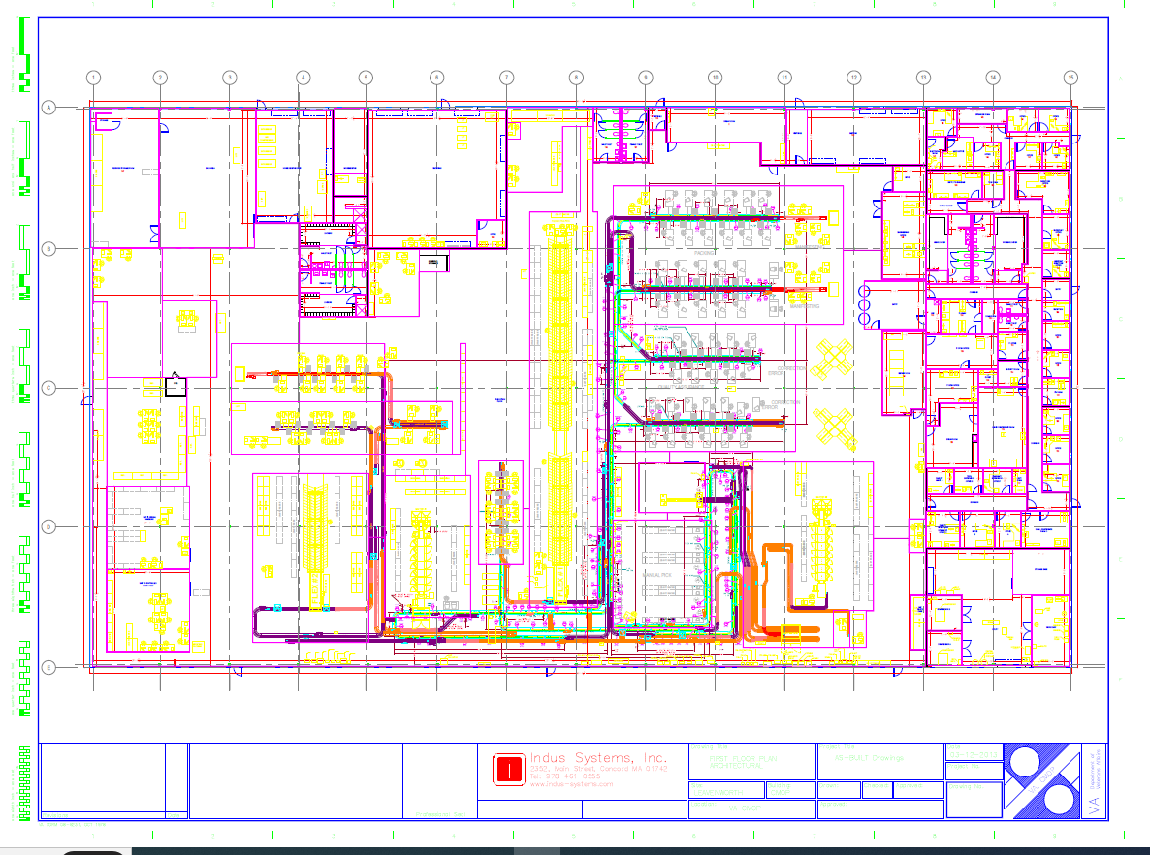

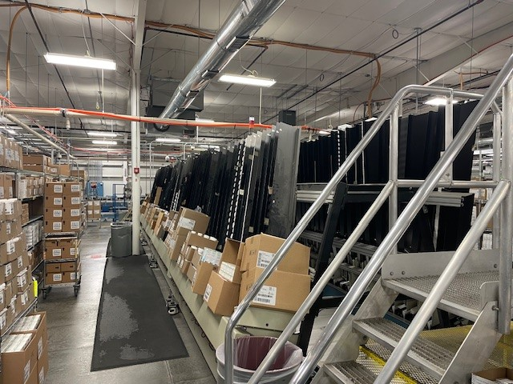
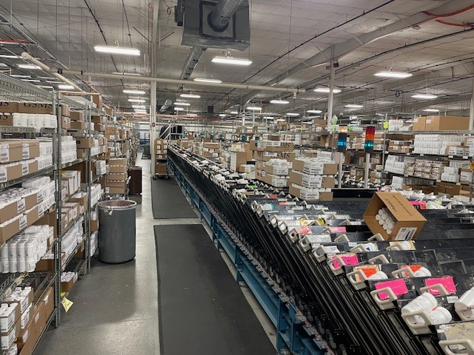
A-Frame
Flex I

Electrical Panel
Flex II
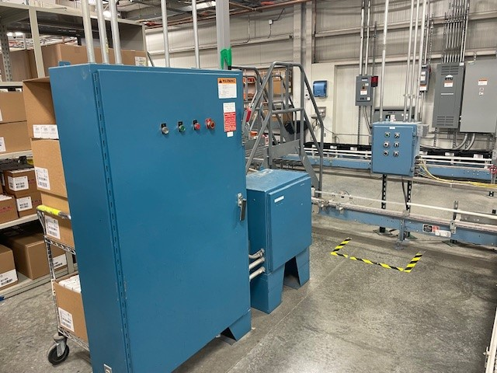
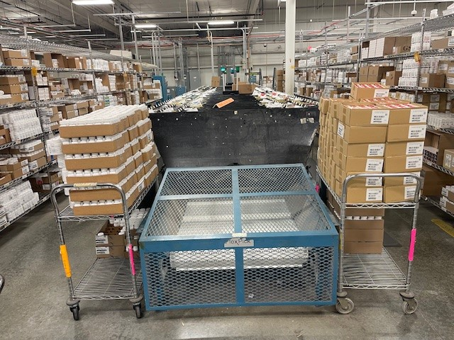

3.1.2 Removal of Labeling, Verification, Packing, and Tote Line
Demolish the existing conveyor (roller and belt), workstations, packing stations, automated packing equipment, package takeaway conveyor, and bridges/stairs. The electrical shall be removed back to the distribution panel. The compressed air shall be removed back to the air tank. Leave electrical panels and compressed air tanks in place. The tote line includes all the enclosed black area conveyor on the drawing, the VA will remove the computers and monitors. The photos are examples and not all inclusive: 

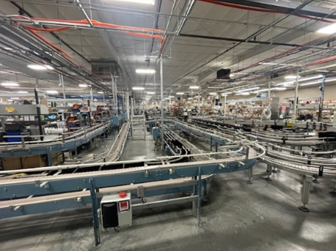
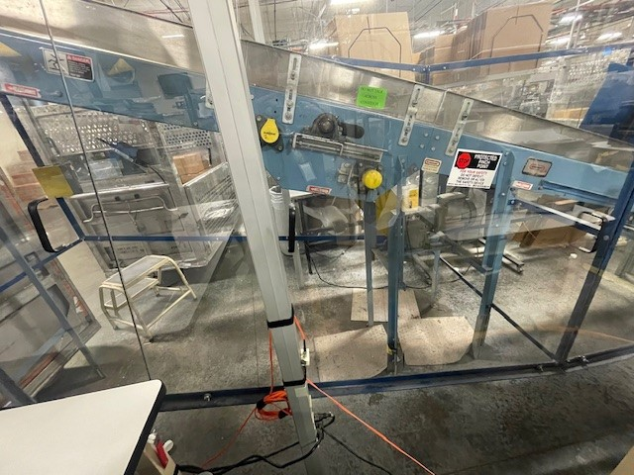
Conveyor 2
Conveyor 1

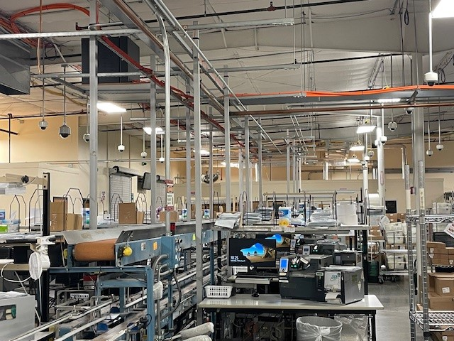
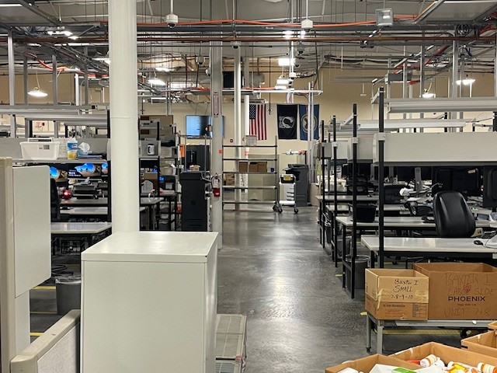
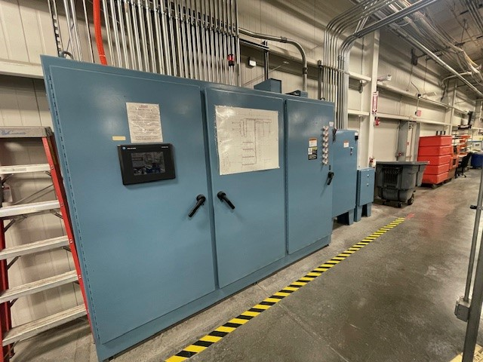
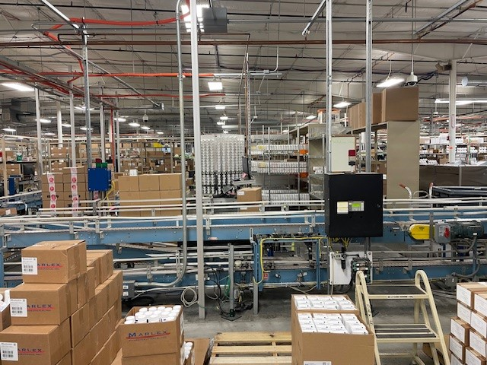
Workstations 2 (Packing Stations)
Workstations 1 (Packing Stations)
PLC
Conveyor 1

3.1.3 Baxter 1 & 2: Removal of Equipment
The Tablet Counting Automation will be partially removed along with the conveyor. The drawing shows equipment outlined in black. The contractor will be responsible for removing the equipment, shelving, and conveyor in the highlighted blue area. The photos are examples and not all inclusive.


Bottle Hopper
Baxter 1
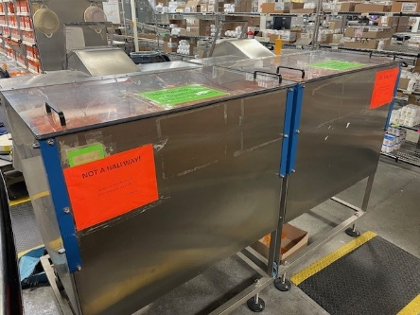
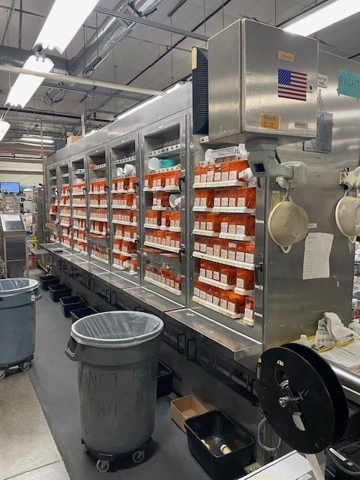

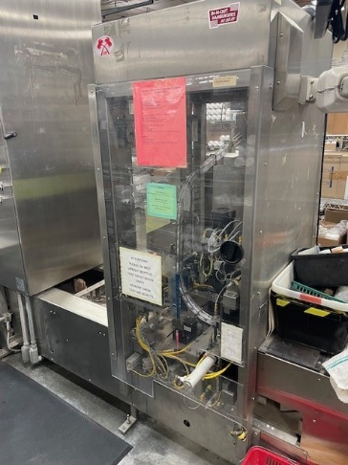
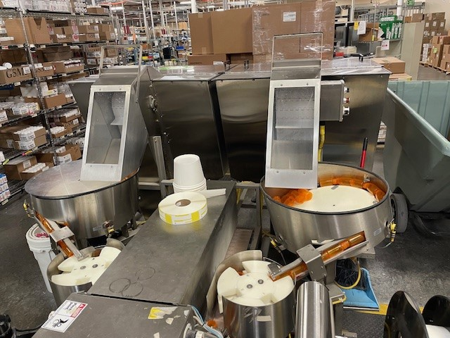
Capper
Bottle Hopper

    - Removal of Furnishings (Systems Furniture, Cabinets, & Chairs) and Mobile Partitions
Rooms/locations with furnishings and partitions (Offices A, B, C, D, E, F, 100, 101, 102, 103, 105, 116, 117, 118, 119, 120, 121, 123, 124, 126, 127, 139,140, 141, 142, 143, 144, 145, 146, 147 (Records Storage), 149, Engineering Manager, Housekeeping, Special Handling Cages North and South, Supply Closest, on the Pharmacy Floor there are 2x quad partitioned work areas, two partitioned workstation areas. All workstations, shelving, and file cabinets on the Pharmacy floor, Receiving, and Housekeeping. The main conference room table and cabinets will be turned into GSA and may need to move to offsite storage area. Photos are examples and not all inclusive.



Office Furniture 2
Office Furniture 1
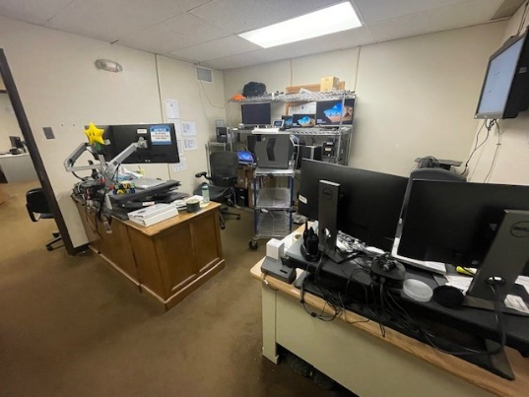
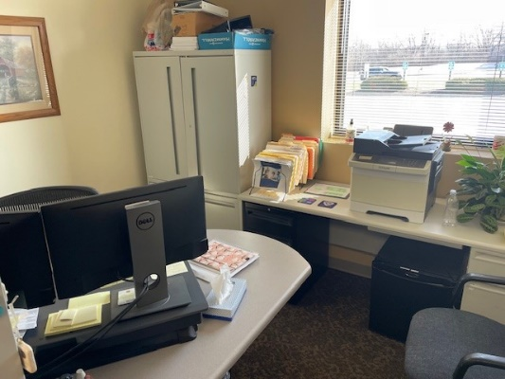

Main Conference Room Furniture
Office Furniture 3

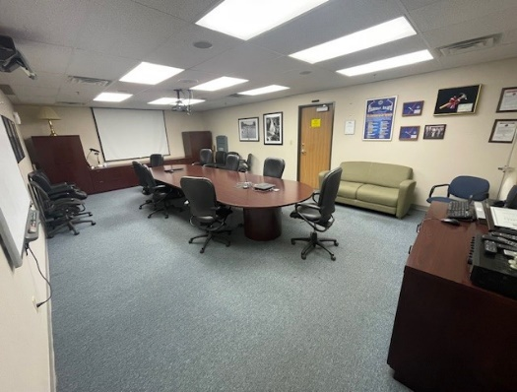
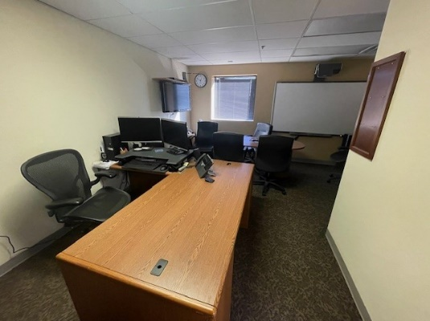

Quad Partition Furniture
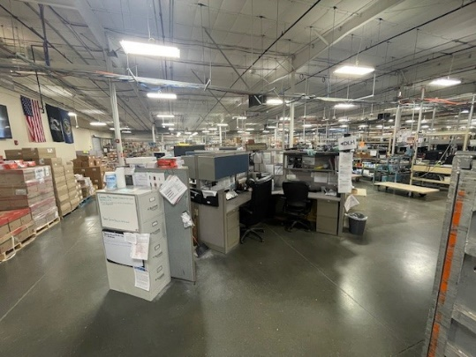

3.1.5 Removal of Miscellaneous Equipment
Refrigerators and freezer will be relocated to storage site located TBD and excessed by Logistics. Photos are examples and not all inclusive. Contractor shall be responsible for moving the items identified as GSA turn to the storage site.
Freezer 8'x8'x8' (1 each)
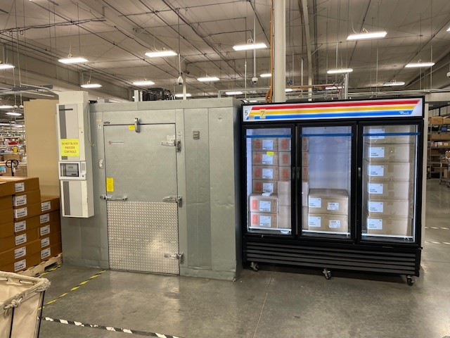
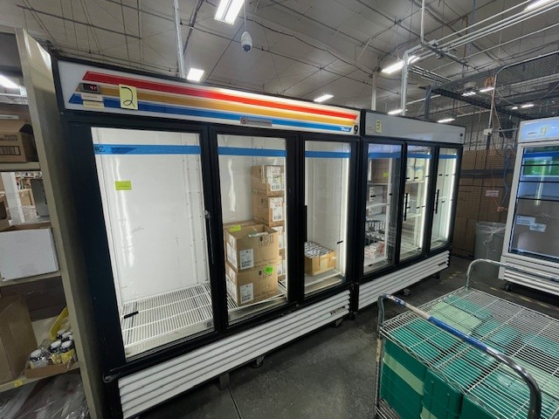

    - Garage Area: Removal of Air Compressors, Tank, and Dryer
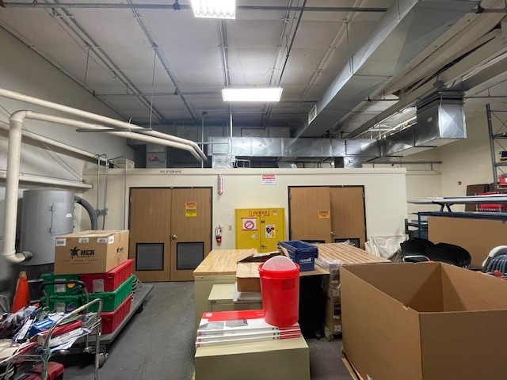
Air Compressor, Tank (1 Each), and Dryer (1 Each)
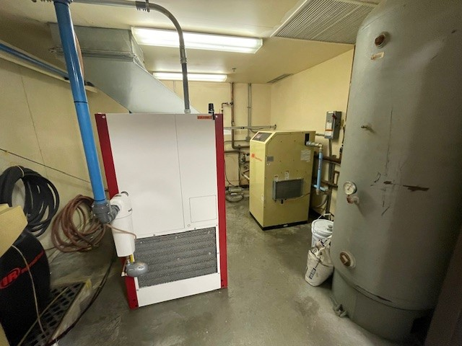
Air Compressor Rooms (2 Each)

    - Receiving Area:
Note: The fork lift and charging station shall be moved to offsite storage site if the VA is not able to excess on GSA after demolition is complete.
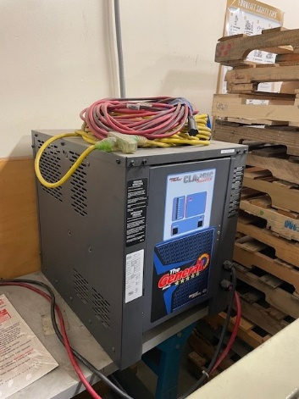
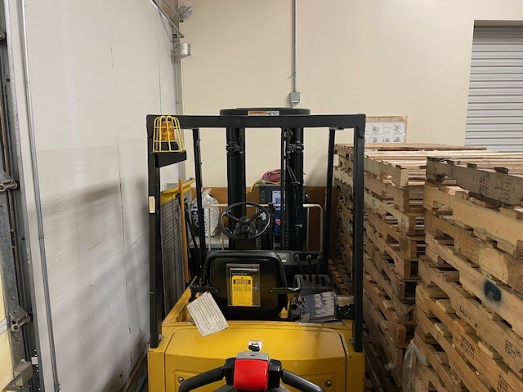
Forklift 1
Charger

Workstations
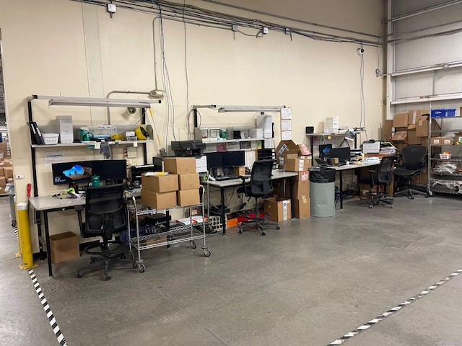

3.1.8 Demolition of Exterior Items
- Fencing, satellite dishes, benches, tables, bike rack, smoke shed and chairs. Photos are examples and not all inclusive.
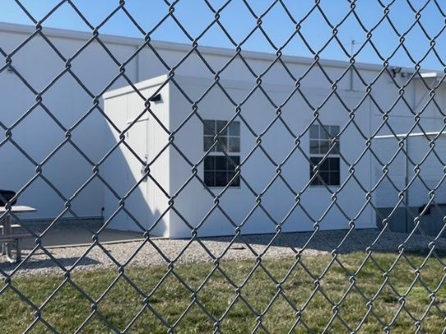
Exterior Break Area 1 (Fencing)
Exterior Break Area 2 (Smoke Shed)
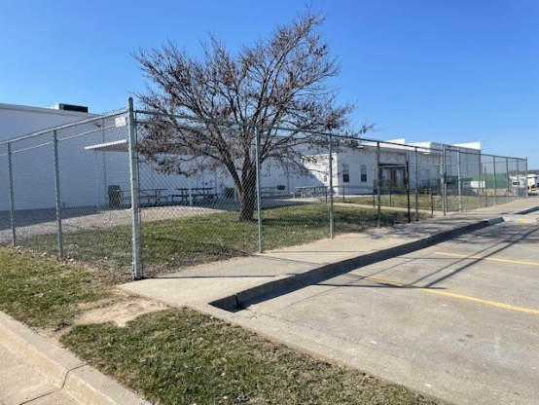

Exterior Break Area 4 (Fencing)
Exterior Break Area 3
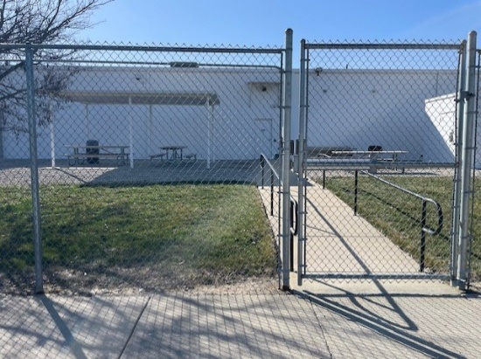
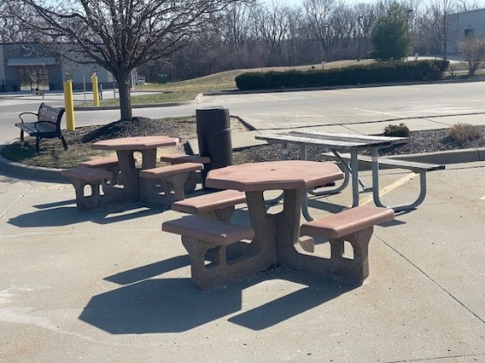

3.1.9 Demolition of Interior Walls, Bollards, Turnstiles, Duct, and Cages
HAZMAT Storage Cage
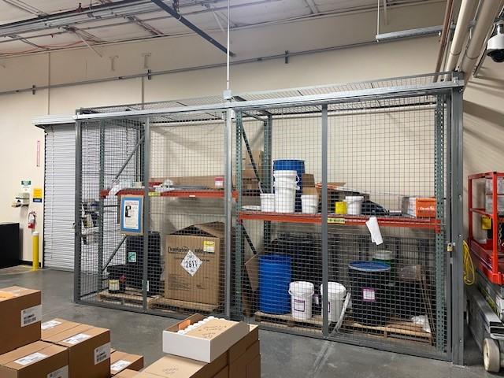
Shipping (Fence)
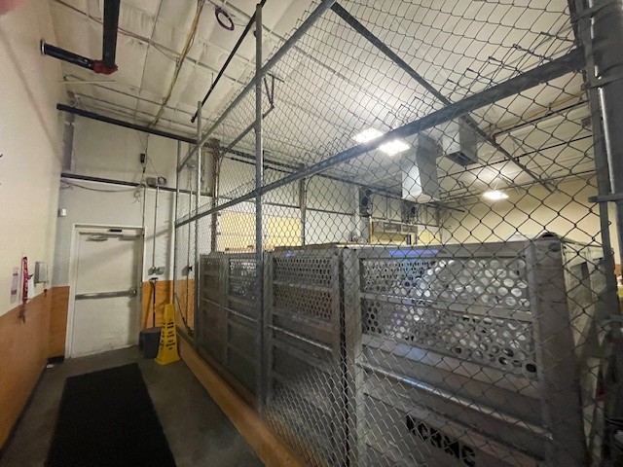
Special Handling Interior

Special Handling 1
GIP Cage

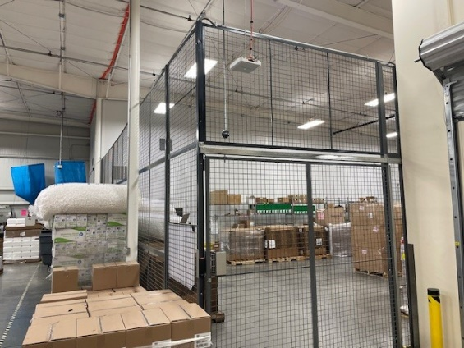
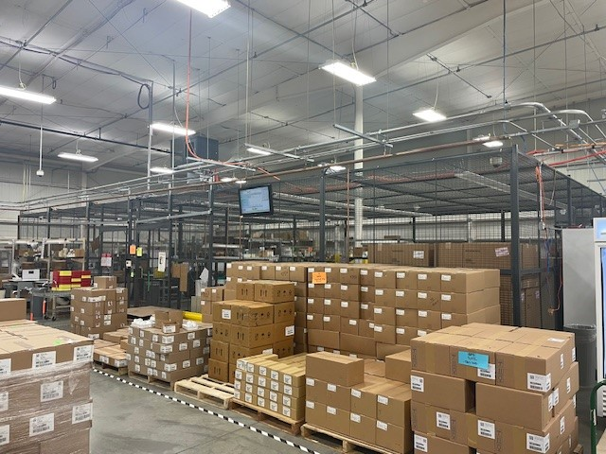

LSS Cage
Engineering Shop Wall
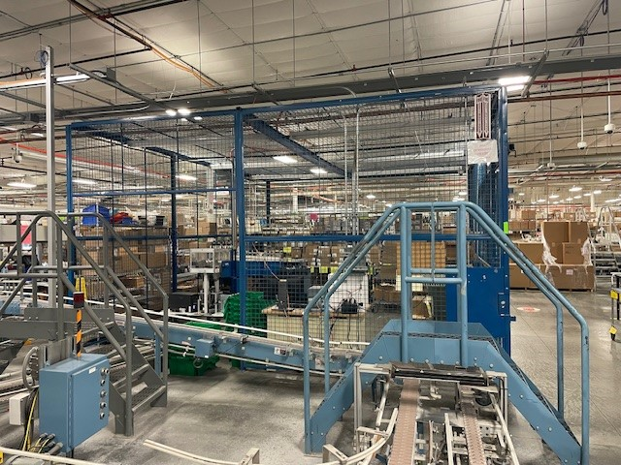
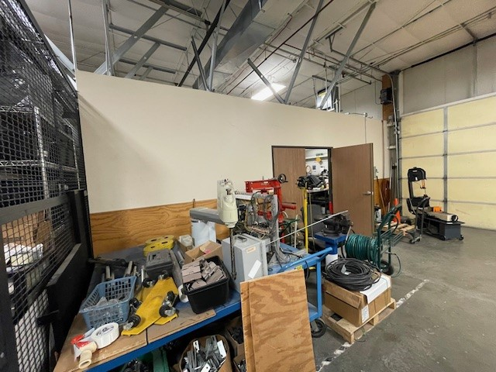
Turnstiles with Cage (Interior View)
Turnstiles with Cage (Exterior View)
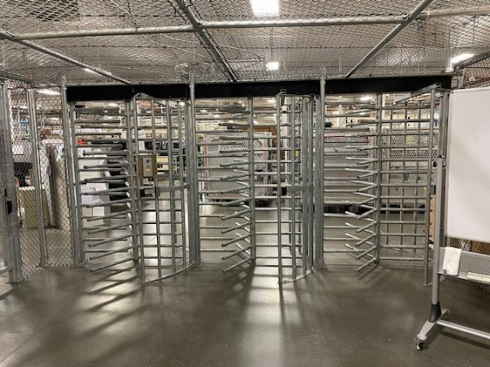
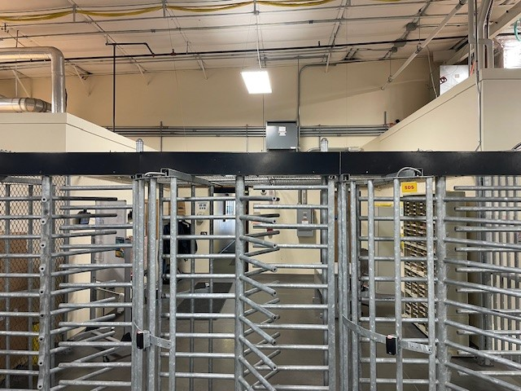

Cage Outside of Receiving
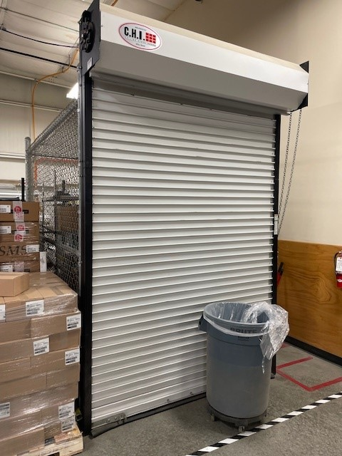

3.1.10 Items and structures that will remain in place:
Air Compressor Rooms
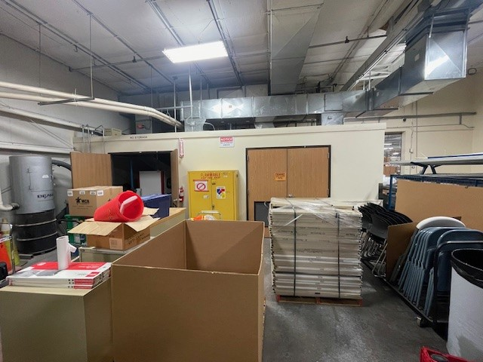
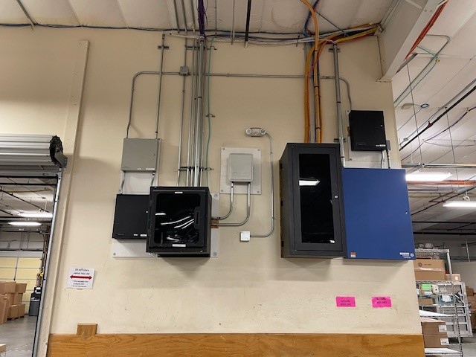
Engineering Workshop (Walls & Lighting Only)
JCI Equipment (Outside of Receiving)
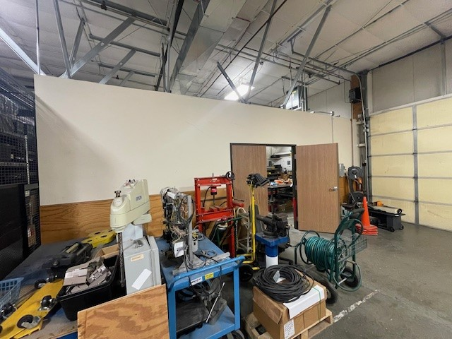

Axillary Break Room 1
JCI Equipment (Security Room)
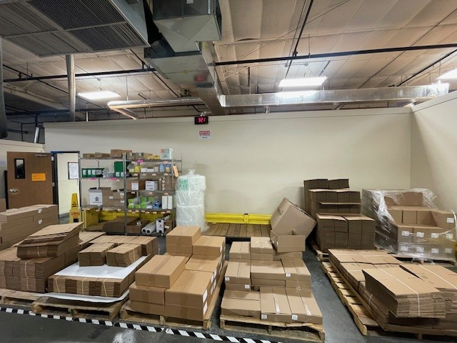
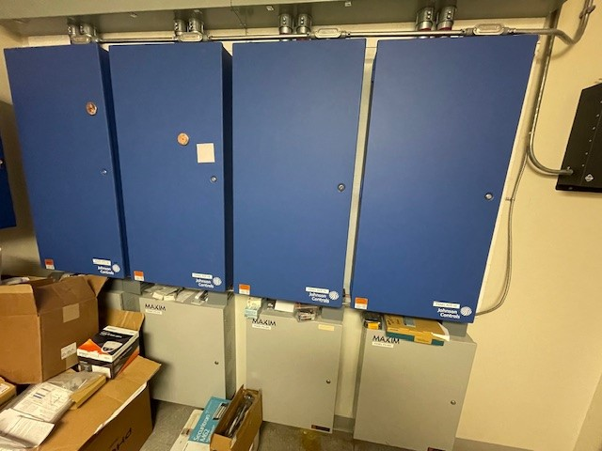

Server Room (Exterior)
Engineering Offices
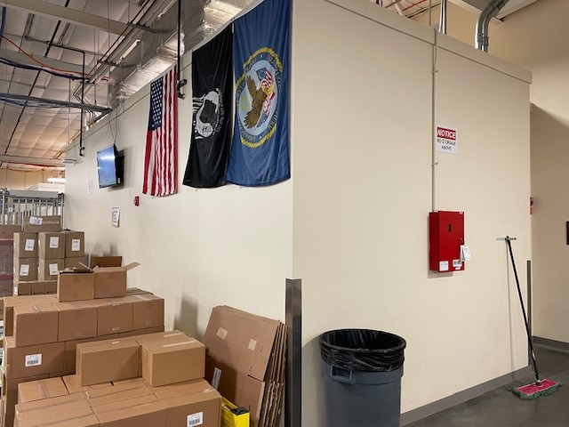
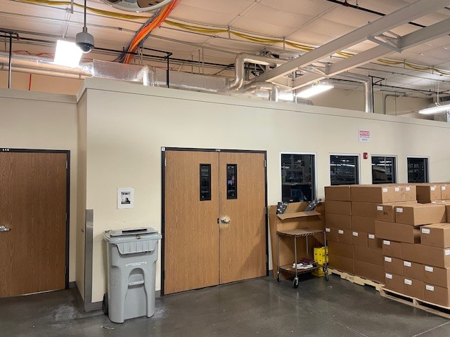

Server Room (Interior) 1
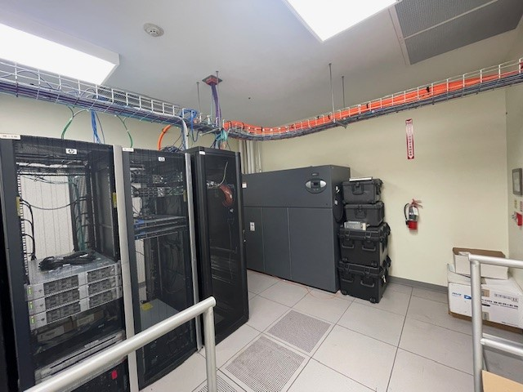

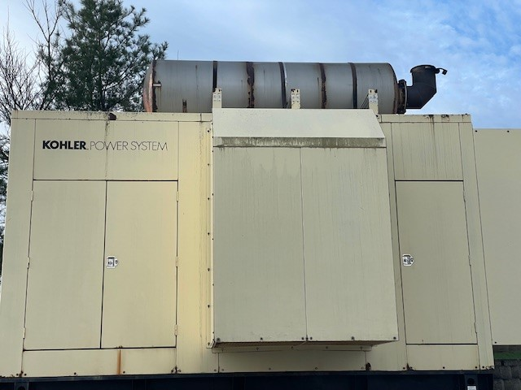
1000 Kw Generator
30k Generator
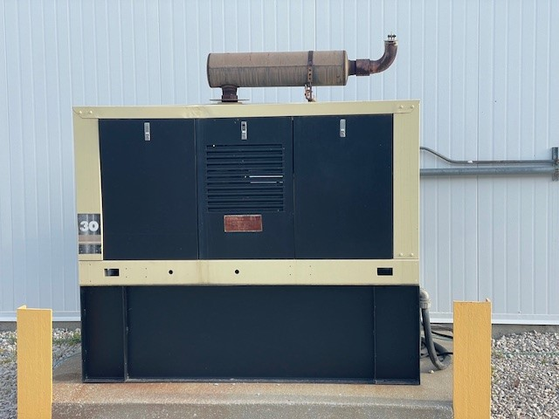
  - Removal of Decommissioned Equipment:
The Government will attempt to dispose of decommissioned equipment from the Leavenworth site via appropriate means for possible resale or relocation to other CMOP sites. To that end decommissioned equipment will need to be fully inventoried (including photos), palletized and stretch wrapped, etc. to protect it for this subsequent disposal effort. The Contractor’s scope shall include time and materials to support this effort for all major pieces of decommissioned automation equipment.
Disassembly of the system must be done with care and by skilled individuals to ensure that the integrity of the system components is maintained. This includes the necessary provisions for disassembly of electrical, electronic, control and robotic components. In all cases these items shall be packaged in accordance with the manufacturers requirements to ensure they can be transported without damage. For electronic related components, these should be removed in a manner that prevents static discharge or damage to the component and they should be packaged in a manner that is consistent with protecting the electronic integrity of the device (boards, controller cards, PLC, etc.).
3.2.1 Equipment/Electronic Component Removal and Packaging
Since electronic products are considered fragile, the electronics product packaging must consider protection from extreme temperatures, mechanical damage, electrostatic discharge and high frequency noise emission. Care should be taken by trained technicians to disassemble these components, inventory and package them for future use. The contractor should provide packaging information for approval by VA PROJECT MANAGER to ensure it is appropriate for the needed application. In most instances the level of packaging will conform to an industry standard at a Level 3, Level 4 or Level 5 as needed.
3.2.2 Packaged and Palletized Equipment and Materials
All items identified for packaging and palletization in accordance with manufacturers requirements to ensure the integrity of the equipment and materials remains in good working condition for future use or shipping. For all items determined to be handled in this manner the contractor will be required to be inventoried and documented in a manner that simplifies the process for final disposition of the item. The contractor will be required to take pictures in accordance with the GSA guidelines including the naming convention for these pictures, to expedite the final disposition of these items. These guidelines have been provided as attachments.
Use of cameras and pictures at the CMOP site is prohibited except for this intended purpose. All pictures taken shall be reviewed and approved by the local CMOP Project Manager to ensure no private patient or employee information or images are present in the photographs.
3.2.3 Attachments – below is a list of the filenames and attachments included in the statement of work and referenced in this section:
- Attachment: Photo Taking Guidelines
- Attachment: GSAXcess Photo Naming Conventions
- Attachment: XCS Picture Guidelines PowerPoint
- Attachment: Scrap metal list
- Attachment: GSA Turn In
- Attachment: Items to move to Shawnee
- Attachment: Items to move to Storage Site
  - Miscellaneous Demolition Work (Option Items)
Contractor shall provide a provision for additional miscellaneous assembly, disassembly, packaging, and relocation of various items.
    - Unit Priced General Work (Option 1) - The nature of this work could include the breakdown and or assembly of items like automation or replenishment workstations, shelving, pallet racking and other furnishings or equipment. The contract will set aside an initial estimated number of hours for this type of work to support the decommissioning of the lease. Contractor should provide a unit cost (Hourly Rate) within the proposal for this type of work. For any work performed under this option, the contractor will provide a pre-approved estimate of the hours needed for the requested work and the hours expended by the contractor will be verified by the local project manager once the work commences.

    - Unit Priced Building Repairs (Option 2) - The nature of this work could include the breakdown of building materials and or repairs to the building, such as general mechanic or carpentry work. Examples are removal of wall hung items and patching of walls or flooring. The contract will set aside an initial estimated number of hours for this type of work to support decommissioning of the lease. Contractor should provide a unit cost (Hourly Rate) within the proposal for this type of work. For any work performed under this option, the contractor will provide a pre-approved estimate of the hours needed for the requested work and the hours expended by the contractor will be verified by the local project manager once the work commences.

Project Management Requirements/Site Conditions
All the work can be accomplished during normal operating hours. If the contractor prefers working during non-operating hours or weekends, then it should be coordinated and approved by the local VA PROJECT MANAGER in advance of this work taking place.
Project Schedule
A project schedule shall be submitted to the VA CMOP PM or their designated representative as part of the contract award. The schedule shall be revised and re-issued bi-weekly. A detailed listing of the de-installation shall be included in the schedule starting no later than one month before the de-installation is scheduled to begin to enable any required local scheduling. This detailed schedule shall include all time required for the de-installation for approval by the PM or their representative prior to being approved. All site preparation requirements shall be established in advance.
Disassembly of components should be inspected and approved for each type of equipment identified within the job. An overall review of work accomplished, and upcoming schedule shall be done at least weekly with the local VA Project Manager and any items or deficiencies documented and maintained until corrected. Approval of completion of any phase will require completion of all punch list items and final sign off by the local VA Project Manager.
Operating Hours
Standard operating hours are M-F 7:30 A.M. to 4:00 PM Central Time.
Permits
The successful Contractor shall be responsible for obtaining all permits and approvals, paying all fees (including disposal fees), and complying with all applicable governmental statutes, codes, and regulations, except as otherwise specified by the VA.
Use of Premises by Contractor Personnel
The Contractor shall confine operations and those of any subcontractors to the project area of the site. The Contractor shall limit the use of the premises for work and storage, to allow for work by other Contractor’s personnel on the project. The Contractor shall coordinate the use of the premises with the CMOP Project Manager or their designated representative. All employees of the Contractor and their subcontractors shall be restricted to the project area. They shall not enter other areas of the building except as required to complete the work covered by this project.
The Contractor shall supervise and direct the project, using their best skill and attention, and shall be solely responsible for all construction means, methods, techniques, sequences, and procedures and for coordinating all portions of the project under Contract. The Contractor shall be responsible to the VA CMOP for the acts and omissions of the Contractor employees, subcontractors and their agents and employees, and other persons performing any of the work under a contract with the Contractor.
The Contractor shall, always, enforce strict discipline and good order among Contractor employees and shall not employ on the project any unfit person or anyone not skilled in the task assigned to them.
The Contractor shall supply the VA CMOP with the names of all personnel to be admitted to the job site. The Contractor’s personnel shall follow security procedures (name tags, check-in, etc.) as directed by the VA CMOP. Contractor's personnel shall enter and exit at locations designated by the VA CMOP. The Contractor's employees shall confine themselves to the immediate work area on the site.
The Contractor may be required to “cordon” off the work area via visible barriers or some other means of containment.
All Contractor personnel may be subject to additional health related screening measures. Guidance will be provided at the time of award.
Coordination of Laydown
- Demolition storage and laydown of materials is to be coordinated with the Project Manager.
- Crews shall have access, light, and good working space. Days and hours of access will need to be planned and approved by the CMOP Project Manager.
Site Cleanliness and Order
The Contractor shall be responsible for the overall cleanliness of the work area during deinstallation and shall make daily cleanup of the area, removing the collected materials to an approved dump site. Combustible materials shall not be allowed to accumulate and shall be removed from the installation site daily. All working areas shall broom cleaned regularly. If the Contractor fails to clean up at the completion of the workday, the VA CMOP may do so, and the cost thereof shall be charged to the Contractor.
The Contractor is to provide containers for all their collection and transfer of materials and trash. The Contractor is responsible for all trash disposals. The Contractor shall provide dumpsters for the removal of all trash from the site.
The Contractor shall store material, equipment, and tools only at locations designated by the VA CMOP and shall not obstruct any roads, aisles, doors, or passageways. The VA CMOP assumes no responsibility for losses due to theft of the Contractor's stored materials.
Scrap and External Storage
Items identified for disposal will be coordinated with the local Project Manager. The contractor will be required to provide an off-site storage site to house items both palletized and non-palletized equipment and material while final disposition is being resolved. The contractor shall ensure the off-site space is within 15 minutes of the Shawnee CMOP which is located at 23501 W. 84th Street, Shawnee, KS and available for a month to month lease up to 1- year. Any need for storage of materials past the 1-year period will be the responsibility of the CMOP. The offsite storage shall be temperature controlled, require a burglar and fire alarm, have restroom access, and have security cameras at the entrance/exit. The VA will require a storage site between 5,000-10,000 sq ft. The contractor will be responsible for the lease payment, which includes all utilities payments e.g. gas, water, sewer, electric, burglar, and fire alarm monitoring.
Site Storage
The Contractor shall store material, equipment, and tools only at locations designated by the VA CMOP and shall not obstruct any roads, aisles, doors, or passageways. VA CMOP assumes no responsibility for losses due to theft of the Contractor's stored materials.
Sanitation
The contractor shall be responsible for all housekeeping which includes trash, cleaning of restrooms and breakrooms, mopping, sweeping, vacuuming carpeted area, and pick up trash in the interior and exterior of the site. The contractor will be responsible for all cleaning supplies, microfiber towels, mops, brooms, buckets, etc.
VA CMOP Access and Cooperation
The VA CMOP shall always have access to the project and storage areas.
Equipment Contractor's Personnel and Workmanship
The Contractor shall supervise and direct the project, using their best skill and attention, and shall solely be responsible for all deconstruction means, methods, techniques, sequences, and procedures and for coordinating all portions of the project under the Contract. The Contractor shall be responsible to the VA CMOP for the acts and omissions of Contractor, Contractor employees, subcontractors and their agents and employees, and other persons performing any of the work under a contract with the Contractor.
The Contractor shall, always, enforce strict discipline and good order among Contractor employees and shall not employ on the project any unfit person or anyone not skilled in the task assigned. All employees of the Contractor and their subcontractors shall be restricted to the immediate work site and only where they have proper business.
- No cameras are allowed within the site without permission from the VA CMOP.
- The equipment Contractor shall supply the VA CMOP with the names of all personnel to be admitted to the job site. The equipment Contractor's personnel shall enter and exit at locations designated by the VA CMOP.
Working Hours
All work at the job site will be performed by indicated labor under the proper supervision of a qualified representative of the Contractor. Regularly scheduled hours of work may be agreed upon by both the VA CMOP and the Contractor. Work areas will be identified and readied for use based on a project completion schedule submitted by the contractor.

Materials Handling and Unloading
The equipment Contractor shall provide their own forklift or other power equipment for unloading and spotting equipment or packing supplies if one is not available from the VA CMOP. All equipment furnished under this specification shall be handled with care from the point of receipt through final installation. All handling shall by means of wheeled vehicles. Sliding the componentry directly on the floor is not permitted.
VA Information Security
The C&A requirements do not apply, and that a Security Accreditation Package is not required.
Safety
The Contractor shall be responsible for maintaining a safe work environment at the installation site. The Contractor shall be responsible for ensuring that the Contractor's employees, subcontractors, and agents are furnished with proper safety equipment and that all equipment and work methods are in complete conformance to national, state, and local laws and the VA CMOP's standard safety procedures. All public health precautions (masks, virus testing, etc.) applicable to the CMOP site will be observed by the Contractor. The contractor will provide the VA CMOP Project Manager with a safety plan for this project and any safety related training provided. This includes not only general safety training, but any training and certificates related to lift truck operation, fall protection, electrical safety, or other OSH related operation. In addition, the contractor is required to provide and ensure the use of all personal protective equipment (gloves, hard hats, safety shoes, hearing protection, etc.) for its personnel.

Information sought: Response to this announcement shall not exceed 10 pages and should include the following information: (1) A tailored capability statement indicating the firm’s ability to provide a product and related services; (2) The respondents’ DUNS number, organization name, address, point of contact, and size and type of business (e.g., SDVOSB/VOSB, etc.,) pursuant to the applicable NAICS code; (3) Information should be provided electronically in a Microsoft Word or Adobe PDF format.
Please e-mail your response with the above information to Christina.Smith7@va.gov with the subject line “Sources Sought Notice # 36C77026Q0074 by 5:00pm on 6 April 2026. Any questions should be emailed to Christina.Smith7@va.gov.
Disclaimer and Important Notes. This notice does not obligate the Government to award a contract or otherwise pay for the information provided in response. The Government reserves the right to use information provided by respondents for any purpose deemed necessary and legally appropriate. Any organization responding to this notice should ensure that its response is complete and sufficiently detailed to allow the Government to determine the organization’s qualifications to perform the work. Respondents are advised that the Government is under no obligation to acknowledge receipt of the information received or provide feedback to respondents with respect to any information submitted. After a review of the responses received, a pre-solicitation synopsis and solicitation may be published in Federal Business Opportunities. However, responses to this notice will not be considered adequate responses to a solicitation.
Confidentiality. No proprietary, classified, confidential, or sensitive information should be included in your response. The Government reserves the right to use any non-proprietary technical information in any resultant solicitation(s).

