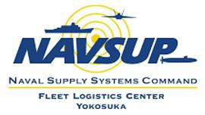

ATTACHMENT IV: REQUEST FOR INFORMATION (RFI)
DATE OF REQUEST: 13 Jan 2025 |  |  | CONTRACTOR:
RFP Number: N6264926RA009 |  |  | PAGE Number(s): 1/1
CONTRACTOR QUESTION(s):

Q7
I would like to clarify the intent of my previous inquiry. My question was focused on eligibility regarding the contractor's nationality.
Previously, I understood that for non-CMAV (Continuous Maintenance Availability) repair projects, only U.S. companies were eligible to bid.
However, since DFARS 252.225-7042 primarily discusses the legal authority to operate within Japan, I wanted to confirm whether Japanese or South Korean companies are also eligible to participate in this specific solicitation.
As my inquiry was related to administrative eligibility rather than the technical scope of work, I reached out via email.

DO NOT WRITE BELOW THIS LINE (FOR GOVERNMENT USE ONLY)
TECHNICAL REVIEWER: |  | DATE: | TGI NO: |  | DATE:
SPEC CHG: Y/N | DWG/REF CHG: Y/N |  | RQMTS CHG: Y/N | MAT'L CHG: Y/N
RESPONSE TO CODE 200:

A7
Please confirm Section A, L, and M in the solicitation about eligibility for bidding. Regarding this questions, the language in Section A has been updated. Please confirm for the changes as well.

