ATTACHMENT 2
EXPERIENCE QUESTIONNAIRE
1. Name of Entity: _________________________________________________________
Address: ____________________________________________________________________________________
Phone Number: __________________________________SAM UEI: ________________________________
Point of Contact: _________________________________Contact Phone Number: _____________________

a. If the Entity (named above) that performed the project has been acquired and is no longer a separate legal entity, provide the name of the Acquiring Firm and an explanation of the acquisition.

Name of Acquiring Firm: ___________________________________UEI of Acquiring Firm: ______________

Acquisition Terms:

b. Name of Entity that Performed Work that Experience is Claimed for (i.e.; if the project was performed by a Joint Venture (JV) and Offeror is claiming experience of one of the J/V members that performed work on the project, state the exact legal name of the JV member the Offeror claims experience for): ___________________________________________________________________________________________
Address: ___________________________________________________________________________________________
Phone Number: ___________________________________Entity Identifier (DUNS #): ___________________
Point of Contact: __________________________________Contact Phone Number: _____________________

2. Work Performed as: Prime Contractor Joint Venture Other (Explain)

3. Project Management Service Contracts: Only identify individual service contracts that were responsible to oversee Construction Portfolios executing at least $200M of work in place annually for the last 5 years.
Period of Performance (POP) Start Date | POP End Date | Description of Services Provided (Identify by numerical code shown in section 4) | Location | Service Contract Value | Total Value of Construction Managed
Sample 5/5/23 | 5/5/2024 | 1, 4, 7, 17 | Hawaii | $238M | $1B

(attach additional sheet if necessary)
4. PROJECT MANAGEMENT SERVICES PROVIDED (Check all that apply):
1. ☐ CONSTRUCTION SITE VISITS AND INSPECTIONS
2. ☐ CONSTRUCTION ADMINISTRATION AND ACCESS COORDINATION
3. ☐ QUALITY ASSURANCE SUPPORT
4. ☐ SAFETY PROGRAM AUDIT
5. ☐ STAKEHOLDER COMMUNICATION AND COORDINATION
6. ☐ REQUEST FOR INFORMATION (RFI) REVIEW
7. ☐ SUBMITTAL REVIEW
8. ☐ SCHEDULE REVIEW AND ANALYSIS
9. ☐ COST ENGINEERING AND CHANGE MANAGEMENT
10. ☐ MANAGEMENT OF PERFORMANCE GUARANTEES AND LIQUIDATED DAMAGES
11. ☐ COMMISSIONING SYSTEM INSPECTION
12. ☐ PROGRAM MANAGEMENT SUPPORT
13. ☐ PROCUREMENT AND CONTRACT ADMINISTRATION SERVICES
14. ☐ COMMISSIONING AND ACCEPTANCE OVERSIGHT
15. ☐ ENTERPRISE PROGRAM MANAGEMENT COORDINATION
16. ☐ UTILITY OUTAGE COORDINATION AND SUPPORT
17. ☐ CONSTRUCTION PROJECT RISK ANALYSIS
5. Type of construction portfolio that was managed (check all that apply): New Construction Renovation Repair Other (explain):

6. Type of SERVICE Contract/Task Order Experience: (Check ALL that apply)

Firm-Fixed Price Cost Plus /Time and Material Other (explain):

7. Type of Project/Program Management Experience (Check ALL that apply):
Design-Build Design-Bid-Build CM at Risk Accelerated Design Build
Public Private Partnerships (PPP) Other (explain):
8. Experience working with Government Owner’s Representatives: (Check ALL that apply)

NAVFAC USACE AFCEC State DOT/DPW Foreign Government (Defense)
Other (explain):

9. Project Management Capabilities & Capacity: Please quantify your project management volume (quantity and composition of your workforce) in the matrix below showing the service contract volume of active construction projects ($M) per region. See Map below for delineation of regions. Ensure this table matches your answers to section 3.

FY | Workforce Composition  Permanent Employees (W-2) /  Independent Contractors (1099) | Oversight of Construction Volume ($M)
 |  | CONUS (NW) | CONUS (SW) | CONUS (NE) | CONUS (SE) | OCONUS Pacific | OCONUS EURAFCENT
Sample | 150 (W-2)  25 (1099) | $350M | $450M |  |  | $200M
2025
2024
2023
2022
2021

10. Please describe your firm's capacity to oversee numerous construction contracts simultaneously on a global scale. Include details on your staffing and management plan, such as how you would source additional personnel to support this work worldwide.

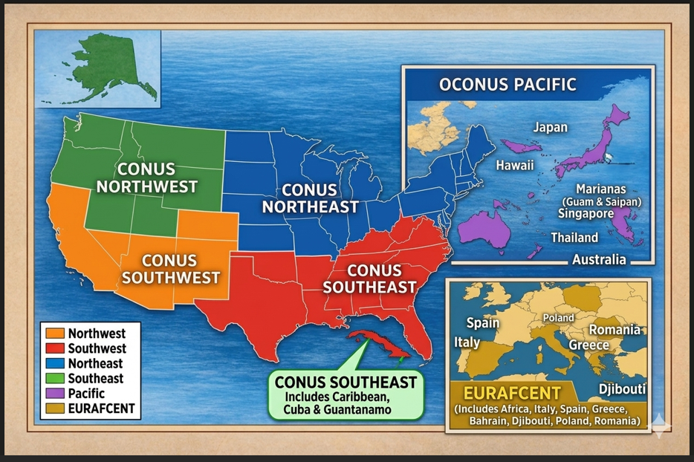
Map Delineating Regions

