Section J – Attachment 2

Photographic Examples

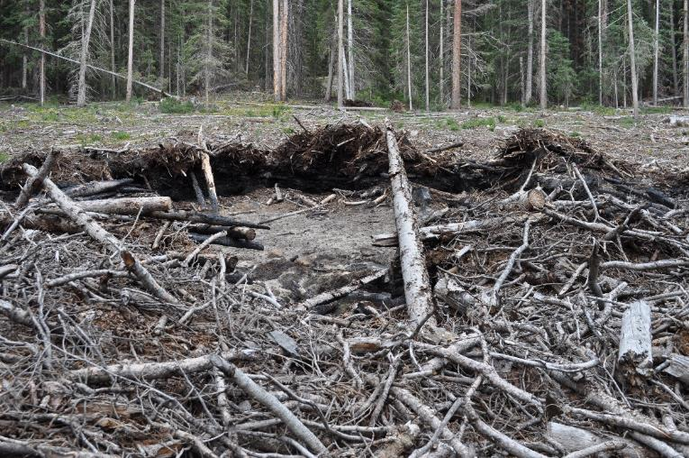

Image 1–Footprint of burned logging slash pile requiring rehabilitation. Notice the collar of woody debris around the ash pit. Collar is three-feet deep here. Ridgestock Timber Sale, August 31, 2015.

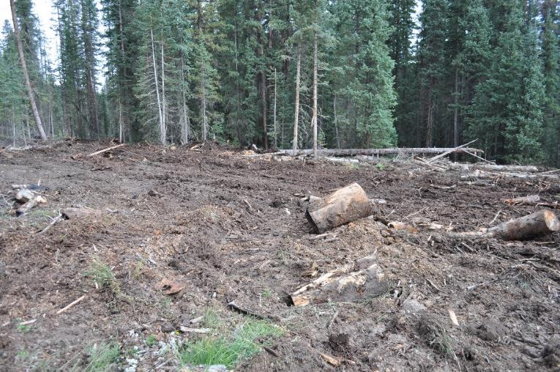

Image 2 -- Example of a thoroughly mixed and dispersed ash pit. Notice that mineral soil and charcoal have been mixed, with charred debris mat broken-up and mixed into the matrix. Large accumulations of slash are scattered. Ridgestock Timber Sale, September 2, 2015.

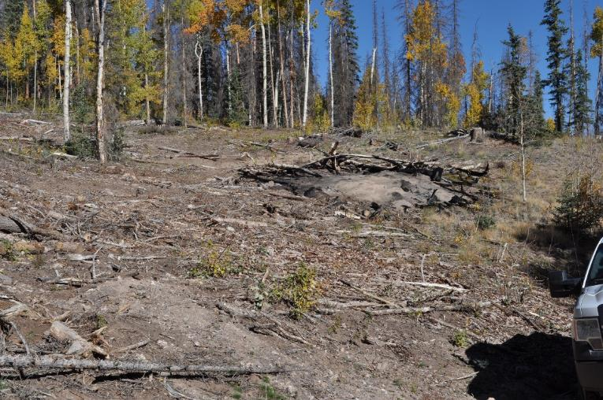

Image 3 -- This is a road side ash pit example from the Los Pinos area. A ripping and mixing of the charred collar is required. Scattering of residual debris is sufficient in this case as there is little slash loading in the surrounding areas. Beetle-Pinos Roadside Salvage, September 27, 2016.

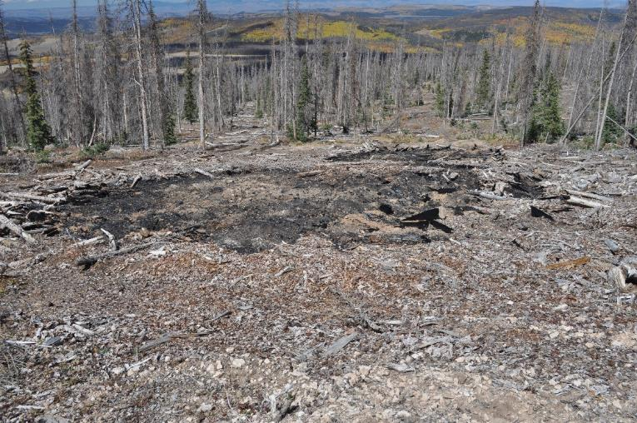

Image 4 -- This is another slash pile that needs to be ripped and scattered. Piles like this can be treated quickly because not a lot of work needs to be done. Beetle-Pinos Salvage, September 27, 2016.

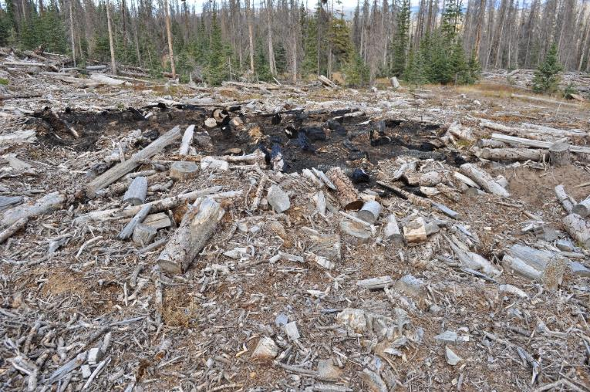

Image 5 -- Burned landing slash pile that is in need of rehabilitation. The pile collar and surround slash mat will require breaking up and piling. The woody debris mat is about two-feet deep. Caution is advised, hidden stumps, and other debris may cause damage to the dozer. Beetle-Pinos Salvage, September 27, 2016.

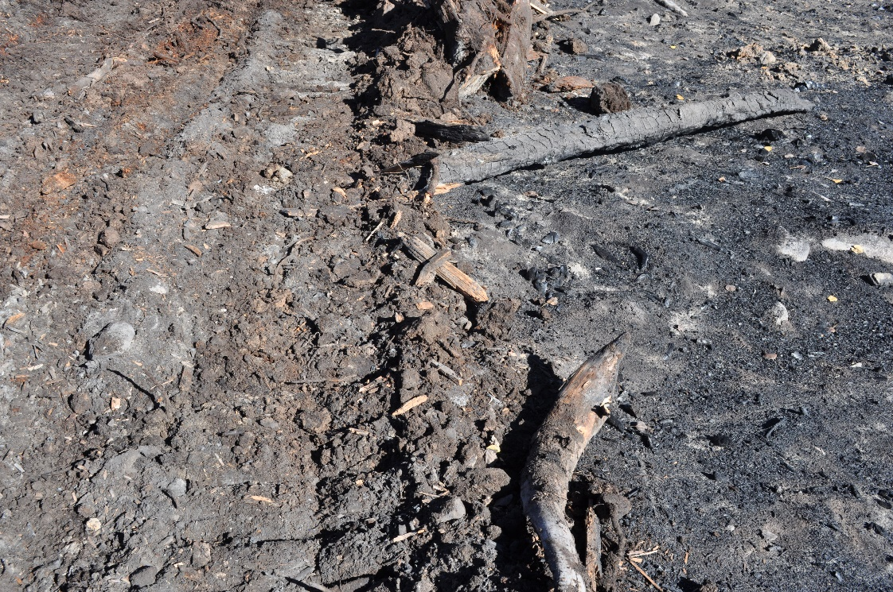

Image 6 -- Example of a partly treated slash pile ash pit. The left side has been treated, the right side has not been treated yet. This ash pit was shallow given smaller slash pile size and good burn consumption. September 28, 2016.

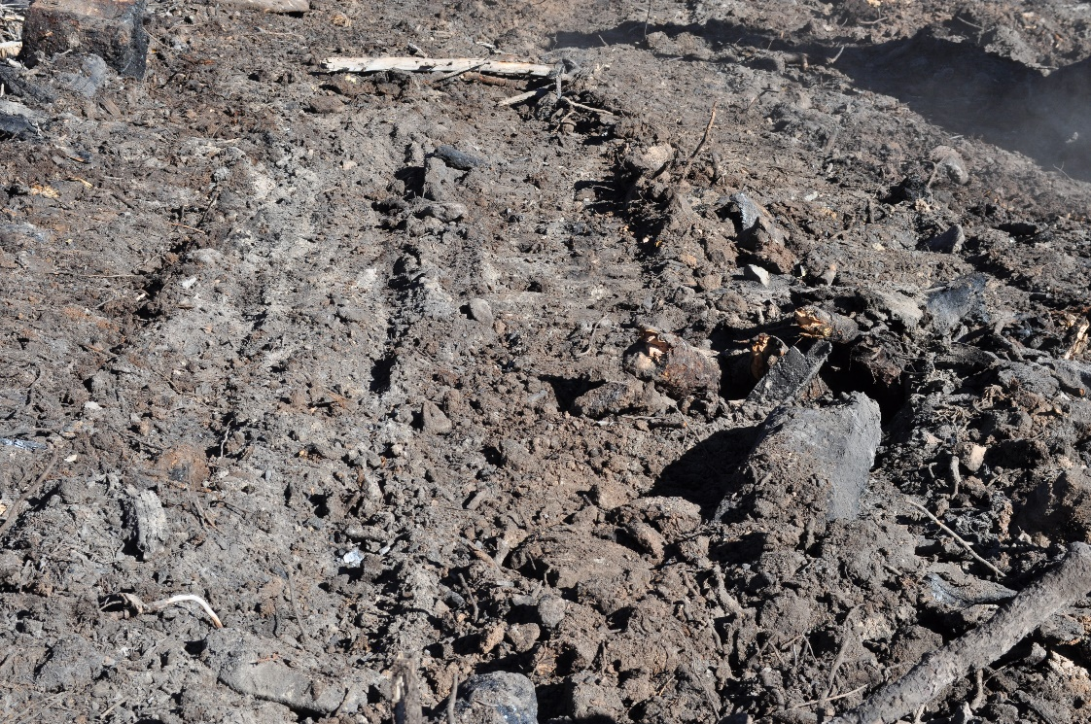

Image 7 – Treated landing slash ash pit. Next step will be application of a certified weed-free mixture of grass species by Forest Service employees. September 28, 2016.

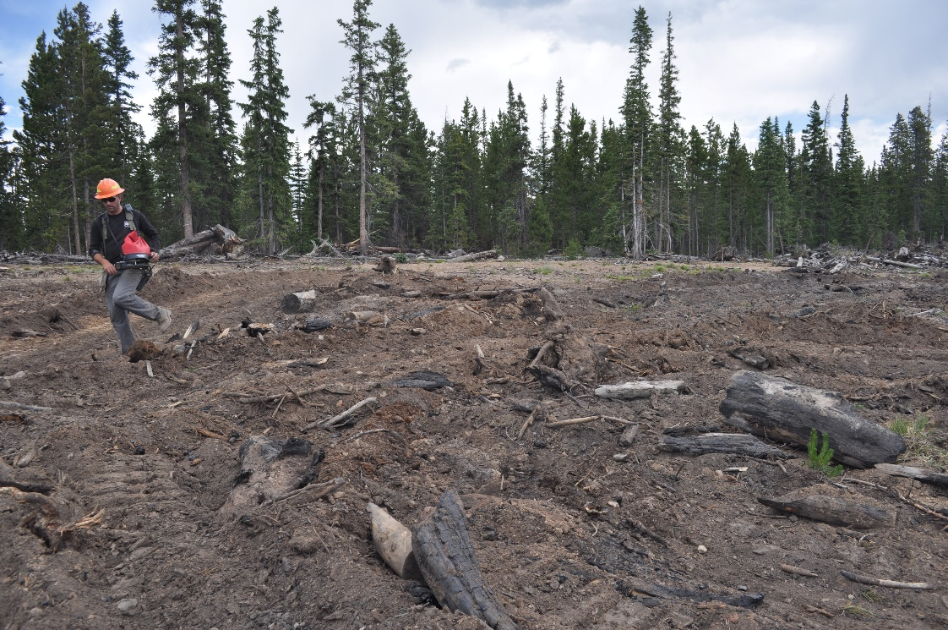

Image 8 -- This is an example of a ripped and mixed ash pit. This is what the end result should be, notice the collar has been scattered and the woody debris is mixed into the soil. Buffalo Fork TS, June 29, 2012.

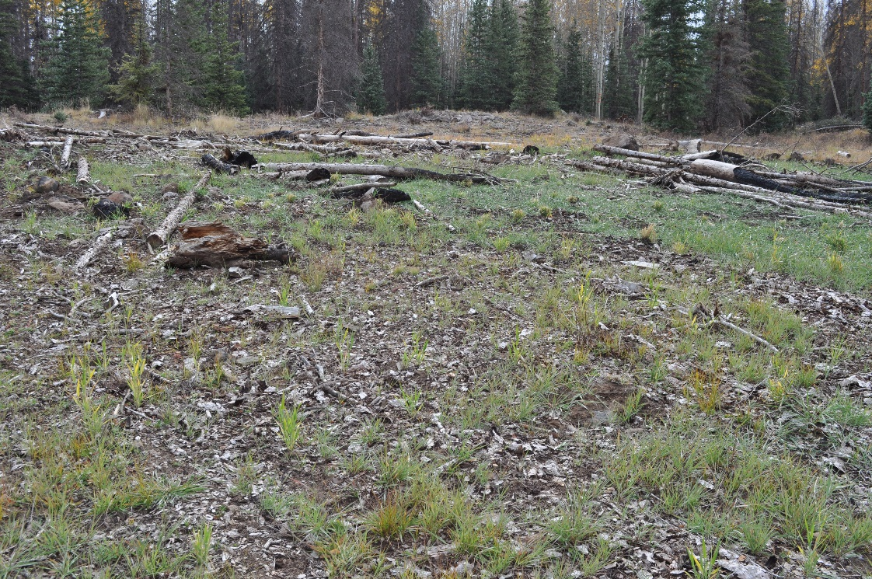

Image 9 – Treated ash pit at the end of the first growing season after a June, 2016 treating. Near Deer Lakes Campground, September 29, 2016.

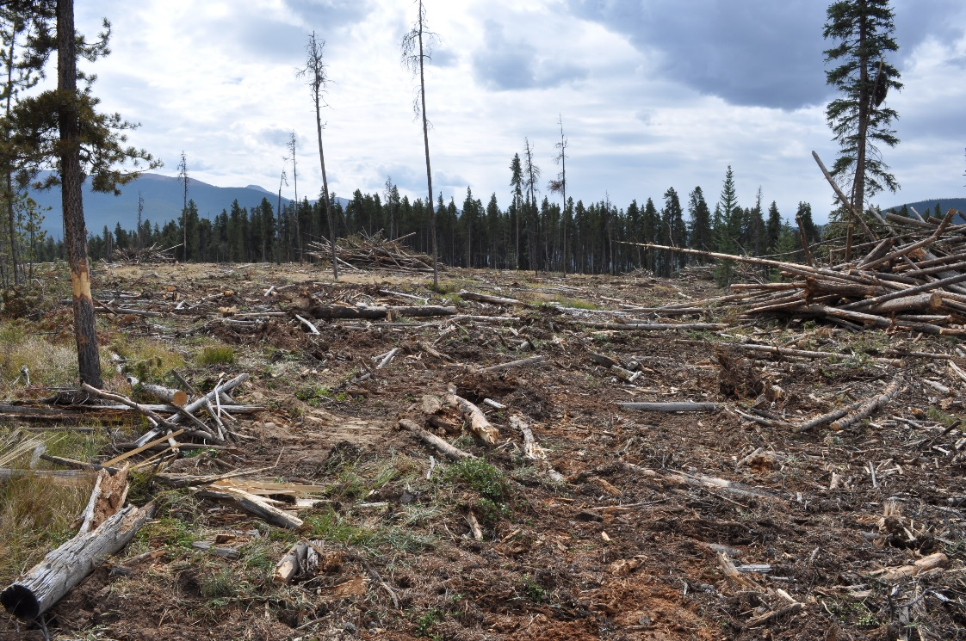

Image 10 – Example of a completed full machine piling of logging slash in a lodgepole pine clearcut. Stagestop TS, September 14, 2015.

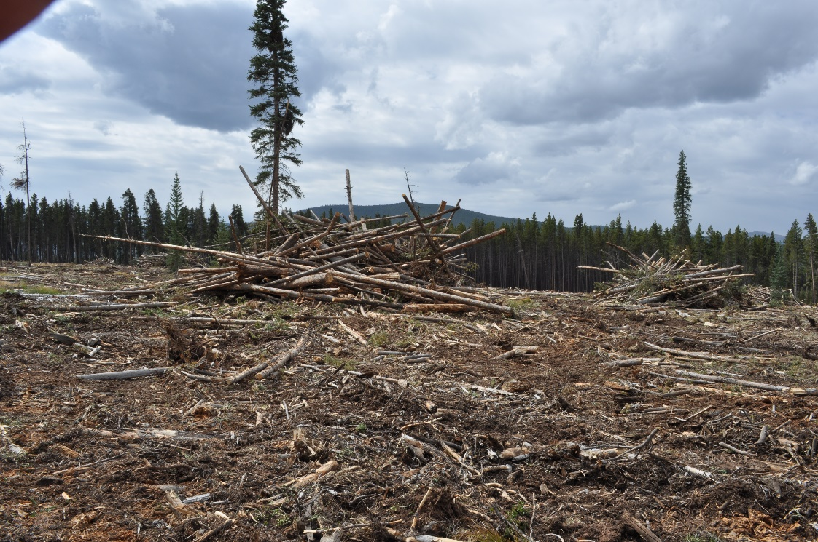

Image 11 –Completed full machine piling of logging slash in a lodgepole pine clearcut. In the 2023 site preparation contract, only spot piling of heavy slash concentrations is called for, so there will be fewer slash piles and they should be of smaller size. Stagestop TS, September 14, 2015.

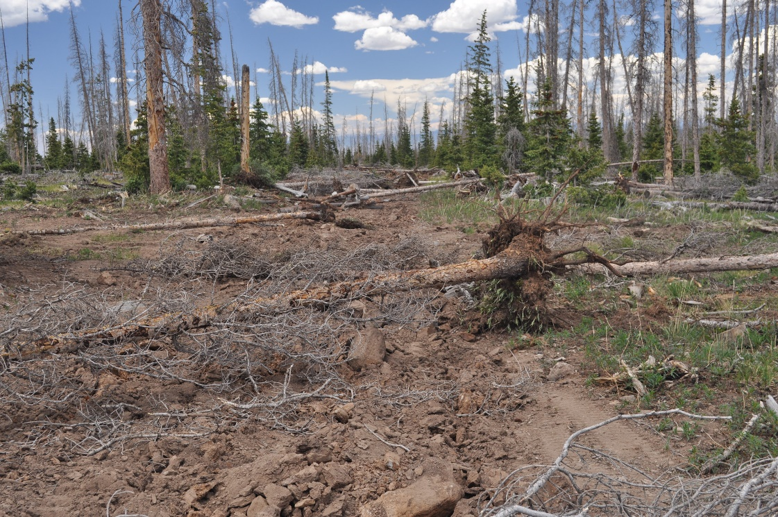

Image 12 -- An example of a completed road closure in an open spruce bark beetle salvage clearcut. The road bed has been dozer ripped, reducing soil compaction and pulling up large rocks. The roadway has been obstructed with down trees and logging debris. A weed-free grass seed mixture has been applied by the contract inspector. Stewie Salvage Sale, June 24, 2022.

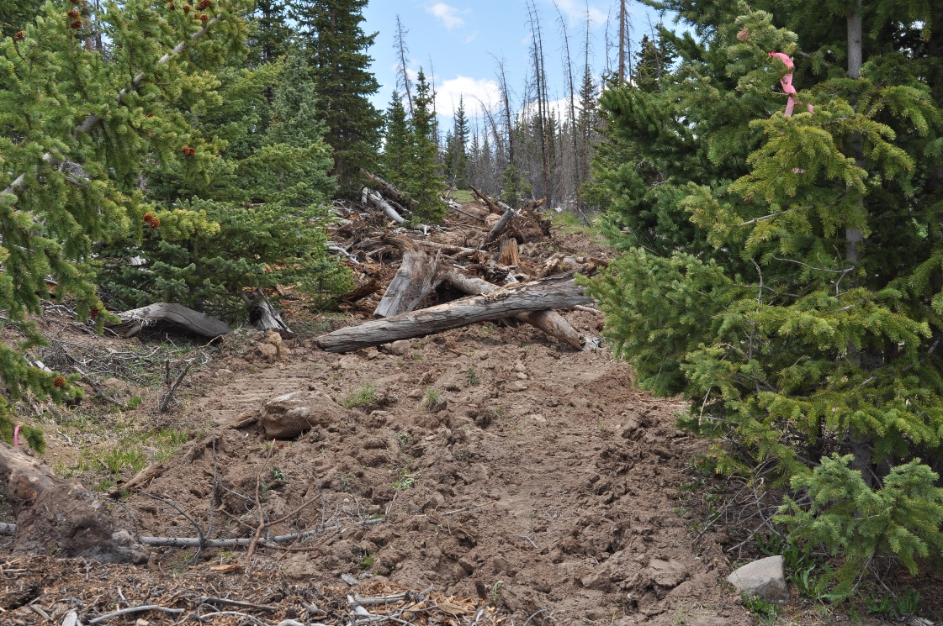

Image 13 – Closed road in a dense stand of young spruce. Road dozer ripped, closure berm built, slash spread onto road way, and grass seeded. Stewie Salvage, June 26, 2020.

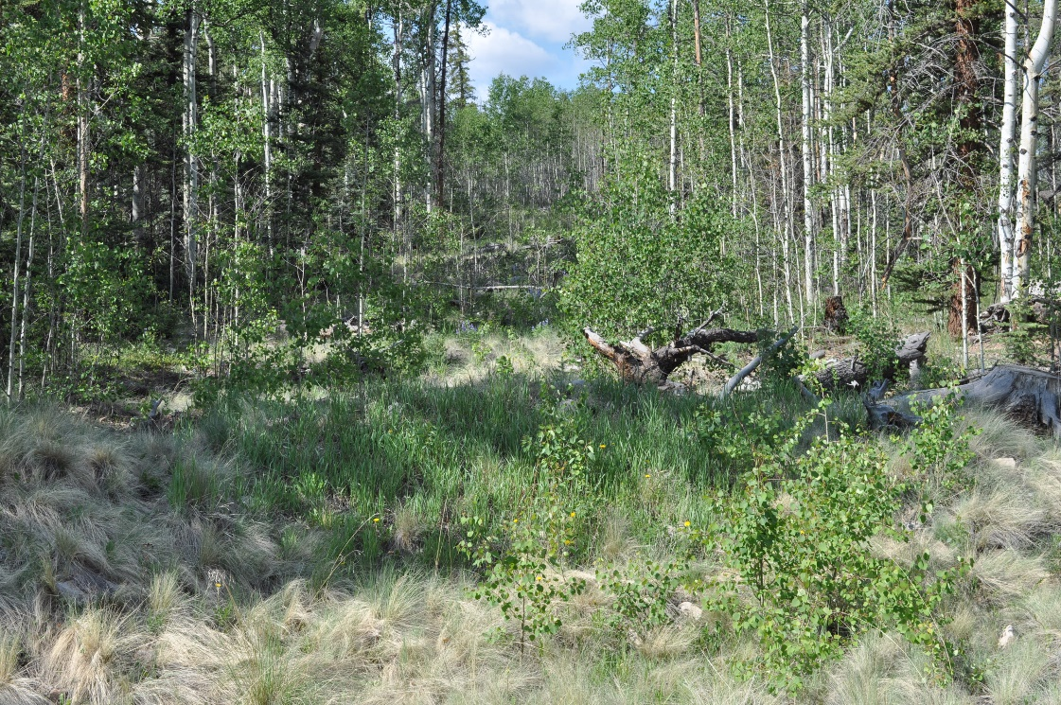

Image 14 – Desired end result of road closed by standard ripping, berms, waterbars, slashing, and grass seeds in 2006, fourteen years prior. Killdeer TS, June 19, 2020.

