PERFORMANCE WORK STATEMENT FOR DEMOLITION SERVICES
Joint Base San Antonio Lackland AFB, Texas 20 February 2026
- DESCRIPTION OF SERVICES / GENERAL INFORMATION. This is a non-
personal services requirement. The Contractor shall provide all management, tools, supplies, equipment, and labor necessary for the demolishment of seven(7) buildings at JBSA Lackland: B2988, B2989, B4395, B5584, B7362, B7561 and B140 at JBSA
LAK-Chapman Training Annex. The Contractor shall perform initial and post work topographic surveys, and pre demolition photographic records provided by a Registered Professional land Surveyor. The contractor shall furnish all equipment, labor, layouts of work features, and supervision needed to demolish and remove all material of all the buildings including all above and below ground structures to a depth of three feet, concrete slabs, foundations, and vaults. The contractor shall locate, disconnect, cap, and plug all overhead and underground utilities (water, wastewater, electrical, gas, etc.) to the nearest acceptable point as determined on site by applicable service provider, and Project Manager (PM) during the execution of the contract. The Contractor shall remove and dispose of all demolition debris and materials from the sites, and in accordance with (IAW) JBSA Environmental Protection Standard 1 57 20.
- PROJECT INFORMATION. These buildings are at the end of their life cycle. The facilities are currently vacant due to their deteriorating condition. Contractor employees shall not enter any of the structures except in the process of executing the necessary tasks included in this PWS. The 802 CES does not guarantee the condition of the property prior to demolition. Contractor shall develop a grading plan for demolition grading and submit for approval a grading plan for the post work site. Work shall include seeding and establishment of grass in affected areas. Shrubs and scrub trees that are near the buildings are to be entirely removed from the premises in accordance with JBSA Environmental Protection Standard 1 57 20. Larger, more established trees are to be protected during the demolition of the building as much as possible. If large established trees are damaged beyond saving, then it must be removed from the premises to include the trunk to a depth of six inches below grade.
  - Building Descriptions. The contractor shall conduct field verifications for all of the As Built Plan drawings provided for each of the following buildings within this Performance Work Statement (PWS). Each of the buildings is listed below with the associated JBSF project number, four (4) attachments (Atch), and a brief description.

CLINS for each Facility Demo Description:

    - CLIN 0001 – MPLS238121- Demo Training Lodge Support Building B2988. This is a 2256-sf approximately (approx.) single-story open bay steel frame and roof storage facility; it has one existing metal wall on its east side. The facility is enclosed by chain link fence. This storage facility was constructed in 1963, due to its deteriorated state and excessive cost to restore, it must be demolished. Demolition of this facility shall result in restoration of

facility footprint to its most natural state. Contractor shall Abate any hazardous materials as indicated in the hazardous material (HazMat) survey.

    - CLIN 0002 - MPLS238119- Demo Training Lodge Support Building B2989 is an 198-sf (apx.) abandoned kennel facility; it was constructed in 1987. Due to its deteriorating condition and excessive cost to restore, it must be demolished. This is a wood frame construction with exterior wall made of “hardboard” planks; the roof is metal on wood frame. Demolition of this facility shall result in restoration of facility footprint to its most natural state. Contractor shall Abate any hazardous materials identified in the hazardous material (HazMat) survey. Demolition of this facility shall result in restoration of facility location to its most natural state.

    - CLIN 0003 - MPLS238146 – Demo Abate Demolition B4395 Old
Bergquist Entry Gate “Guard Shack” and its concrete base/foundation. It is a one (1) story, 210-sf approx. split face Concrete Masonry Unit (CMU) and metal roof structure with concrete foundation. The building was constructed with a brick exterior and metal roof. The interior building materials include floor tile, tile, wall textures, and sheetrock. Abate any hazardous materials identified in the hazardous material (HazMat) survey. Demolition of this facility shall result in restoration of facility location to its most natural state.
    - CLIN 0004 – MPLS238118- Demo RG Small Arm Indoor B5584. This is a 7645-sf approx. small arms indoor shooting range; it was built in 1961. Due to this facility having run out of its useful life span, continued deterioration and excessive restoration cost must be demolished. This facility is composed of a cinder block building with glass & metal windows and doors, with a flat concrete roof covered with tar material, the shooting range portion of this facility is made of 5ft approx. concrete cylinders with 3 ea target points that include an electric motor-powered target lift. In preparation for demolition activities, the Contractor shall install a fence to isolate the demolition site from the End User’s compound to ensure recruit trainees safety while
reducing Contractor’s liabilities. The Contractors shall install 20ft (approx.) wide double gate in the existing fence line to establish access in/out to the demolition site. The interior of the building materials includes floor tile, ceiling/wall acoustic tiles.
Contractor shall abate any hazardous materials identified in the hazardous material (HazMat) survey. Demolition of this facility shall result in restoration of facility location to its most natural state.

    - CLIN 0005 – MPLS190023 -- Demo Building 7561. This facility consist of Steel Superstructure covered with R-type steel panels on walls and roof, to include rake trim, these 3,600 SF 2 stories it was a Military Working Dog (MWD) training facility and AF Security Forces Training Aide Its interior consists of wood frame and walls partitions, with a metal stairway. This training aid facility was built in 1984 and is at the end if its life cycle; due to excessive restoration costs must be demolished. Contractor shall Abate any hazardous materials identified in the hazardous material (HazMat) survey. Demolition of this facility shall result in restoration of facilitylocation to itsmost naturalstate.

    - CLIN 0006- MPLS237883 – Demo Abate Demolition B7362. It is two
(2) stories, 13,643 square feet approx. wood frame structure on a concrete foundation. The building was constructed with a stucco exterior and metal roof. The interior building materials include floor tile, wall covers, concrete, wood, ceiling tile, wall textures, and sheetrock. Contractor shall abate any hazardous materials identified in the hazardous material (HazMat) survey. Demolition of this facility shall result in restoration of
facility location to its most natural state.

    - CLIN 0007-MPYJ237884 – Demo Abate Demolition B140, Gymnasium at JBSA LAK Chapman Training Annex. B140 is a one (1) story, 14,618 square feet approx. mixed concrete walls and cinder blocks on a concrete foundation. The building was constructed with a cinder block exterior and a flat concrete roof covered with tar material. The interior building materials include floor tile, wall covers, concrete, wood, ceiling tile, wall textures, and sheetrock. Contractor shall abate any hazardous materials identified in the hazardous material (HazMat) survey. Demolition of this facility shall result in restoration of facility location to its most natural state.
Demolition. The Contractor shall provide all labor, materials, and equipment to demolish the buildings identified in this PWS, associated attachments, and the Contractor’s demolition plan. Remove rubbish and debris from the project site; do not allow accumulations inside or outside the building. The work includes demolition and removal of resulting rubbish and debris, including excess soil from Government property for legal disposal in accordance with JBSA Environmental Protection Standards, Federal, and State hauling and disposal regulations. Remove rubbish, waste, and debris from Government property daily, unless otherwise directed. Remove and transport the debris in a manner that prevents spillage on streets or adjacent areas. Contractor shall submit to the Government NLT 14 calendar days prior to starting demolition a Soil Management Plan prior grading and disposal operations. Contractor shall dispose of excess soil in accordance with approved Soil Management Plan presented. Soil to be tested for hazardous materials as required by JBSA Environmental. Store materials that cannot be removed daily in areas specified by the Contracting Officer Representative (COR).
The contractor shall demolish structures in their entirety. The contractor shall remove existing structures to three feet below grade.

The contractor shall remove concrete and asphaltic concrete paving and slabs including aggregate base to a depth of 8 inches below existing adjacent grade. Remove sidewalks, curbs, and gutters as indicated.
Contractor shall coordinate with the CEPM and Contracting officer prior demolition of any HVACR equipment to ensure that the Government does not want it. NOTE: All refrigerant is the property of the Government and must be reclaimed by current and duly licensed Refrigeration Technicians. The Contractor shall provide the necessary refrigerant containers for each refrigerant type e.g. R22, R134a, R12 and notify the CEPM when those containers are ready to be transported by the Contractor to the JBSA Lackland Refrigeration management Shop. The shop is no more than 7 miles 1 way from any location covered by this PWS. The contractor shall coordinate with theHVACshopon base forany equipment parts

that they would like to havethe contractor capture and turn over to them. The contractor shall remove air conditioning, refrigeration, and other equipment containing refrigerants without releasing chlorofluorocarbon refrigerants to the atmosphere in accordance with the Clean Air Act Amendment of 1990. All removed/ evacuated refrigerants shall be turned over to the government as coordinated with COR.
Items to remain in place. The contractor shall take necessary precautions to avoid damage to existing items to remain in place, to be reused, or to remain the property of the Government. The contractor shall repair or replace items to remain in place at no cost to the Government. The contractor shall: protect trees within the project site which might be damaged during demolition or deconstruction, and which are indicated to be left in place; maintain existing utilities indicated to stay in service and protect against damage during demolition; protect electrical and mechanical services and utilities.

Existing Conditions. Prior to any demolition or deconstruction work, the contractor shall visit the site and examine the drawings and specifications to determine the extent of the work, no later than (NLT) fourteen (14) calendar days after award. The contractor shall document existing conditions showing the condition of structures and other facilities adjacent to areas of alteration or removal. Digital photographs will be acceptable as a record of existing conditions. It is the Contractor's responsibility to verify and document all required outages which will be required during the course of work, and to note these outages on the record document. The site visit results shall be submitted to the COR.
The use of burning at the project site for the disposal of refuse and debris is prohibited.

In regard to rubbish, waste, and debris disposal, the contractor shall provide trip tickets documenting disposal location. Waste manifests and profile sheets shall be emailed/delivered to the COR. The COR will distribute to the appropriate entities and personnel.
    - The contractor shall control the spread of dust and debris, while maintaining clean roads, free of mud and rocks at all times around the demolition site.

    - The contractor shall provide the necessary traffic and pedestrian control signs. The contractor shall provide traffic barricades with flashing lights where pedestrian and driver safety is endangered in the area of removal work. Any anticipated road closures shall be coordinated with the government COR/ PM and approved prior to any road closure.

    - The contractor shall provide a minimum of 2 FAA type L-810 steady burning red obstruction lights on temporary structures (including cranes) over 100 feet, but less than 200 ft, above ground level. The use of LED based obstruction lights is not permitted.
    - The contractor shall provide protection of personnel. Before, during and after the demolition, the contractor shall continuously evaluate the condition of the structure being demolished and

take immediate action to protect all personnel working in and around the project site. No area, section, or component of floors, roofs, walls, columns, pilasters, or other structural element will be allowed to be left standing without sufficient bracing, shoring, or lateral support to prevent collapse or failure while workmen remove debris or perform other work in the immediate area. This protection is to be outlined in the Activity Hazard Analysis, as required by the Safety and Health Requirements Manual: EM385-1-1.
  - Utilities. The Contractor shall check to determine that all utility services are disconnected at the service mains. No work shall commence on any building before utilities are properly disconnected. The work includes capping and plugging of all utilities, using equipment, materials, and labor in accordance with local, state, and federal regulations. The Contractor is responsible for disconnection of all utilities, plugging or sewer taps, or connection to septic tank. The contractor is responsible for covering all fees associated with this work directly with CPS. The contractor shall not interrupt existing utilities serving occupied or used facilities, except when authorized in writing by the COR. Disconnection of all utilities shall be coordinated by the Contractor with the appropriate local service providers and a utility outage form (Atch 6) is approved. The Contractor shall contact the PM to have the PM coordinate with the local utility companies prior to commencing work to coordinate termination of gas, water, electric, phone, cable TV, and any other utility services to the nearest acceptable point. The contractor shall shut off and cap utilities for future use. Sewer taps shall be plugged with screw type expanding plug inserts or other means approved by the local sewer authority, to prevent intrusion of ground water into the existing sewer system. Any anticipated utility outages shall be coordinated with the government COR/PM and approved prior to the outage.

2.3.9. Special Utility Considerations. The contractor shall identify and mark all utilities not managed and/or located by the local utility companies. If abandoned storm water pipes are discovered & no longer managed by the utility company, then the utility shall be capped a minimum of five (5) feet from the building. If septic tanks are encountered, the contractor shall ensure that damage does not occur to any septic tanks if still in use. Septic tanks no longer in use shall be pumped dry, crushed and backfilled in accordance with local, state, and federal regulations. Dig Permits/ Utility Locates shall be coordinated with the government COR/ PM and approved prior to any digging.

  - Salvage Materials. No salvageable materials have been identified
  - Demolition and Environmental Plans. The Contractor shall submit demolition, grading plan for each building, and environmental protection plans with Proposal. NLT 10 calendardays prior to starting demolition make applicable notifications to JBSA Environmental, State and Federal agencies.
  - Accident Prevention Plan (Safety Plan). The Contractor shall submit an Accident Prevention Plan (APP) with Proposal demolition per requirements in EM 385-1-1 which outlines the occupational safety and health policy, responsibilities, and program requirements. EM 385-1-1 paragraph 4 (2) states that service contracting actions may use the abbreviated APP listed in Appendix A of that document.
  - Hazardous Waste Management Plan. The contractor shall prepare a Hazardous Waste Management Plan NLT 14 calendar days after contract award detailing the manner in which hazardous wastes will be managed and describing the types and volumes of hazardous wastes anticipated to be managed. At a minimum, the plan shall include the contractor’s procedures

to handle all HAZMAT to include asbestos remediation, lead remediation, and the proper disposal of PCBs and Mercury.

1.1.1. Offsite Hazardous Waste Management. The contractor shall coordinate the offsite transfer of all hazardous materials and waste with the 802 CES Environmental Flight. The contractor shall provide hazardous material trip tickets NLT 10 calendar days after signed by receiving landfill. Upon award CE Project Manager (CEPM) will provide most recent list of approved landfills.

2.7.9. Hazardous Material Activities. Prior to conducting hazardous materials activities, the contractor is responsible for pre-transportation activities and must either certify to the Government that a security plan is in place which meets the requirements of 49 CFR 172, Subpart I or in the event that the types or amounts of hazardous materials are excluded from the security planning requirements, a written statement to that effect detailing the basis of the exception. All construction debris, hazardous waste, and non-hazardous waste, to include all construction recycling and spoils, shall be characterized by a lab, profiled, reviewed by the JBSA Hazardous Waste Media Team, manifested as required and signed by appropriately appointed 802 CES/CEIE personnel before leaving any JBSA properties. The following tests are required for every 200 cubic yards of soil/waste spoils that are to be removed from JBSA: RCRA 11 metals (method SW 7000 series, TCLP extraction), Organochlorine Pesticides/Polychlorinated Biphenyl (PCBs) (method SW 8081a/8080, TCLP extraction), Semi- Volatile Organic Compounds (SVOCs) (method SW 8270, TCLP extraction), Volatile Organic Compounds (VOCs) (method SW 8260 TCLP extraction) to include BTEX, Total Petroleum Hydrocarbons (TPH) (TX method 1005), Non-halogenated Organics (SW 8015, TCLP extraction), and Reactivity, Corrosivity, Ignitibility (RCI).

  - Storm Water Pollution Prevention Plan. The Contractor shall prepare a storm water pollution prevention plan (SWPPP) and provide drawings of temporary erosion control measures. SWPPP shall be submitted within fourteen (14) calendar days of contract award. The plan shall include, as a minimum, the method for protecting all storm drains and waterways adjacent to the demolition area.
  - Materials Testing and Inspections. The contractor shall provide a Hazard Analysis Plan, and Asbestos Abatement Plan for each building with Proposal. The Contractor shall have current annual PersonalRespiratorFitnessTestresultsforallworkersonthesiteavailableforreviewatalltimes. Thecontractor shall be responsible for the coordination of all tests and inspections and shall schedule and request tests and inspections to be conducted as necessary to avoid any interference with the progress of work. All test results to be provided to the COR and Base Environmental NLT 5 calendar days after the test results are received. Environmental POC: Edward Vogel, Email: edward.vogel@us.af.mil

  - Insurance and Permit Requirement. The Contractor shall be properly insured in accordance with the Federal Acquisition Regulation (FAR) 28.3 requirements. Contractor shall obtain all necessary permits NLT 10 calendar days prior to starting demolition and conduct field verification visits prior to beginning work and as required by federal, state, and local agencies. The Contractor shall be responsible for preparing, filing, and paying for fees required for all necessary permits for this project.

  - Licenses and Certification. Employees under Contactor authorization are required to have a Texas license or certification to perform hazardous waste testing, sampling, removal, and disposal tasks; at least the lead craftsman for each construction discipline involved in each

facility demolition (i.e. Electrical, Plumbing, heating Ventilation & Air Conditioner (HVAC), Structures, Masonry, Carpentry, etc.) shall be Texas Licensed or Certified.

  - Safety Data Sheet. The Contractor shall address, by submittal, the plans to prevent and control fugitive dust through specific mitigation and preventative measures, including Material Safety Data Sheet or (MSDS) for soil binder to be used. The Contractor shall, at a minimum, maintain records indicating dust control measures taken. The information provided shall be sufficient to answer any questions regarding control methods utilized, products used, application rates, and inspections performed. Dust control shall be performed as the work proceeds to minimize vehicle off-site tracking of sediment and generation of dust.
  - Work Plans and Related Documents. The Contractor shall prepare and submit for acceptance by the COR, a set of Work Plans and Related Documents required for the project. These plans and documents shall be prepared in accordance with all applicable Federal, State, and local regulations. The Contractor shall incorporate information and data from the pre-bid site visit, the pre-demolition Environmental Hazmat Survey, and other documents within the time frames specified on the schedule of deliverables. Pré-construction deliverables to include Certificates of Insurance, Quality Control Plan, and Environmental Protection Plan.
  - Special Procedures – Surveying. The contractor shall perform pre-and-post surveying proceduresincluding, but not limited to, control points, temporary control points, topographic information filing, existing utilities left in place, location of utility termination points, water, sanitary sewer, electrical and communication equipment, and gas. The contractor shall coordinate and conduct a kick-off meeting prior to the initiation of the field survey.

    - All survey work shall utilize a localized scale factor.

    - The draft and final survey data shall be submitted either on a DVD or CD and a transmittal letter shall accompany each submittal.
    - The contractor shall include AutoCad files in their survey submittal package
  - Special Project Procedures – GIS. All INTERIM and all FINAL review plans shall include NATIVE format files, i.e CAD files, in AutoCAD drawing format compliant with government requirements. Email usaf.jbsa.502-abw.mbx.502-ces-cad-manager@mail.mil for current version, native format documents (*.doc, *.xls) and PDF files of same.

2.14.9. GIS files must meet the following technical requirements:
- Horizontal Control for Texas State Plane, South Central Zone (4204), NAD 83; shall comply with Corps of Engineers 3rd Order, Class I standards.
- Vertical Control for NAVD 88; shall comply with Corps of Engineers 3rd Order.
- All measurements shall be collected using an electronic data collector; all elevations will be measured at hundredths-of-feet (0.00).
- Unit of Measure shall be U.S. Survey Feet.
- Map scale shall be 1-inch equals 30-feet.
- Contour interval shall be 1-foot.

  - Activity Hazard Analysis. The Contractor shall check the structures prior to demolition to ensure that the property is vacated. Contractor shall conduct an Activity Hazard Analysis at the site taking into account overhead power lines, underground utilities, and other structures which are not scheduled for demolition. Contractor shall submit an activity hazard analysis plan prior to starting demolition to the PM. NLT fourteen
(14) calendar days after award.

  - Extermination. Before starting demolition, the Contractor shall employ a certified rodent and vermin exterminator and treat the facilities in accordance with governing health laws and regulations. Any rodent, insects, or other vermin appearing before or during the demolition shall be killed or otherwise prevented from leaving the immediate vicinity of the demolition work.
  - Temporary Structures. The Contractor shall furnish and erect all temporary side, barricade covers and temporary structures necessary for the proper and safe conduct of the work. The Contractor shall erect a suitable perimeter fence around the work site. All such temporary structures shall be removed upon the completion of the work at no additional cost to the Government. Fencing shall be installed around the perimeter of the project site, for the duration of the work and removed before the project is considered complete. Inlet protection and slit fencing may be necessary at time s during some of the project operations.
  - Debris Removal and Disposal. The Contractor shall provide all labor and equipment necessary for the removal and disposal of the structures, in accordance with all applicable federal, state and local regulations. The work shall consist of removing the debris generated from demolishing the identified structures. All other demolition debris shall be collected and transported to the local licensed disposal site. Disposal fees are the responsibility of the contractor. Under this contract all debris generated from demolition work shall include:

    - Waste material characterization and testing. Testing laboratories must be accredited by a laboratory accreditation authority. The contractor will be required to submit a copy of the Certificate of Accreditation and Scope of Accreditation to the COR NLT 14 days before the start of demolition. Laboratories engaged in Hazardous Materials Testing shall meet the requirements of OSHA and EPA. The policy applies to the specific laboratory performing the actual testing, not just the "Corporate Office”. The CTR shall Provide actual results and include a statement that the item tested or analyzed conforms or fails to conform to specified requirements. Prior to soil removal contractor shall perform the following test methods and analytical parameters for every 200cyd of soil that is to be removed from JBSA:
- RCRA 11 metals (method SW 7000 series with TCLP extraction)
- Organochlorine Pesticides/Polychlorinated Biphenyl (PCBs) (method SW 8080 with TCLP extraction)
- Semi-Volatile Organic Compounds (SVOCs) (method SW 8270 with TCLP extraction)
- Volatile Organic Compounds (VOCs) (method SW 8260 with TCLP extraction) to include BTEX
- Total Petroleum Hydrocarbons (TPH) (TX method 1005)
- Non-halogenated Organics (SW 8015, TCLP extraction)
- Reactivity, Corrosivity, Ignitibility (RCI)
    - A “competent person” who is trained in a manner consistent with the National Emissions Standard for Hazardous Air Pollutants (NESHAP) and EPA requirements must be present on site when contaminated debris removal and disposal is taking place.

    - Any contaminated debris collected for disposal by the contractor shall be disposed of at the contractor expense. Any loads rejected at the dump site shall be the Contractor's responsibility. Contractor shall provide with their location where the debris from this demolition will be dumped. State licensed site(s) for dumping rubble or any other private site where clean debris and asbestos will be accepted must be listed. The Contractor shall leave the premises and streets in such condition that it will not constitute a public nuisance.

  - Hazardous Toxic Waste. Hazardous or toxic materials or waste such as petroleum products, electrical transformers, tires and known or suspected hazardous materials shall be removed and disposed of by the contractor. The Contractor shall take sufficient measures to prevent spillage of hazardous and toxic materials during dispensing and shall collect waste in suitable containers observing chemical compatibility requirements.
2.18.9. The contractor shall designate a single individual that will serve as the main point of contact for all environmental regulatory matters and have overall responsibility for identification of marking, labeling and packaging; completion of hazardous waste manifests, asbestos waste shipment records, PCB manifests, bill of ladings, exception and discrepancy reports; and all other environmental documentation.

  - Excavated Soil. All excavated soil must be reused on site or removed from the installation at the completion of the project. No permanent stockpiling of soil is authorized. Based on waste characterization performed by the 802 CES/ CEIE which at a minimum will be classified as Type II Non-hazardous Waste; soil must be transported to an approved TCEQ permitted disposal location approved by 8012 CES/ CEIE. Prior to soil removal, contractor shall perform the following test methods and analytical parameters for every 200 CY of soil that is to be removed from JBSA:

    - RCRA 11 metals (method SW 7000 series, Totals analysis with TCLP extraction).

    - Organochlorine Pesticides/Polychlorinated Biphenyl (PCBs) (method SW 8080, total analysis with TCLP extraction).

    - Semi-Volatile Organic Compounds (SVOCs) (method SW 8270, with TCLP extraction).

    - Volatile Organic Compounds (VOCs) (method SW 8260 TCLP extraction).
    - Total Petroleum Hydrocarbons (TPH) (TX method 1005).3

    - Reactivity, Corrosivity, Ignitibility (RCI).

Contractor shall submit all analytical results to 802 CES/CEIE for review prior to removal of soil from area specific location.
  - Post Demolition. The contractor shall clean up and remove all signs of temporary facilities, work areas, structures, foundations or temporary structures, stockpiles of excess waste materials, or any other vestiges of demolition. All restored areas shall be smoothly and evenly dressed and sloped to drain. The Contractor shall fill and compact all voids left by the removal of pipe, structures, etc. The Contractor shall provide all fill materials to the site as needed. The contractor shall provide approved fill material and complete final grading in

such a way to ensure the site has proper drainage, there is no ponding of water, and that run off does not cause damage to adjacent properties. Fill material shall conform to the definition of satisfactory soil material as defined in AASHTO M 145, Soil Classification Groups A-1, A-2-4, A-2-5 and A-3. In addition, fill material shall be free from roots and other organic matter, trash, debris, frozen materials, and stones larger than 2 inches in any dimension. The contractor shall submit documentation as proof of soil classification NLT 14 calendar days prior to this work phase (reminder to schedule source location field visit with CES). Compaction of fill shall match the compaction of adjacent undisturbed material. The entire parcel shall be left in a natural grade, neat, safe and sanitary condition.

  - Site Restoration. All areas to be seeded/hydro-mulch shall have a minimum of 6 inches topsoil. Topsoil to be natural, fertile, friable, and free of clay lumps, stones, stumps, roots, or substances 2 inches or more in diameter. The Contractor shall assume maintenance responsibilities until grass is established or until second cutting, whichever is longer. Maintenance shall include watering, weeding, reseeding, and other operations necessary to keep all lawn areas in a
thriving condition. Gray water is available on base for the contractor to fill their watering trucks for use in watering the seeded areas. After lawn areas have germinated, areas which fail to show a uniform stand of grass for any reason, shall be reseeded repeatedly until all areas are covered with a satisfactory stand of grass. Minimum acceptance of seeded lawn areas may include scattered bare spots, none of which are larger than 1 square foot, and when combined do not exceed 2% of total seeded area. All earth work shall be planned and conducted to minimize the duration of exposure of unprotected soils. Side and back slopes shall be protected as soon as practicable upon completion of rough grading. The contractor shall restore to original condition existing turf areas which have been damaged. Clean other paving when work in adjacent areas is complete.

  - DD-1354. The contractor shall submit form DD-1354 to 802 CES/CENMPR NLT 14 calendar days upon completion of the project and final acceptance. The contractor shall provide a record of waste Generated NLT 10 calendar days after contract completion.

  - Progress Reports. The contractor shall submit weekly progress reports to include schedule updates on Mondays to include the previous week’s activities. These submissions shall enable the contracting officer and project manager to assess the contractor’s progress.

GENERAL INFORMATION
  - Hours of Operation/Holidays All work shall be performed during the normal duty day, 7:00 A.
M. to 5:00 P. M., Monday thru Friday, except for federal holidays and unforeseen requirements. When access to a facility permits, service may begin earlier, upon approval of authorized government personnel. The contractor is not required to provide routine services on the following approved holidays:

New Year’s Day 1st of January
Martin Luther King’s Birthday Third Monday in January
President’s Day Third Monday in February
Memorial Day Last Monday in May
Juneteenth 19th of June
Independence Day 4th of July

Labor Day First Monday in September
Columbus Day Second Monday in October
Veteran’s Day 11th of November
Thanksgiving Day Fourth Thursday in November
Christmas Day 25th of December
NOTE: Any of the above holidays falling on a Saturday will be observed on the preceding Friday. Holidays falling on a Sunday will be observed on the following Monday.

  - SECURITY REQUIREMENTS. Obtaining and Retrieving Identification Media. The contractor shall comply with all requirements and procedures IAW AFFARS clause 5352.242- 9000 "Contractor Access to Air Force Installations." Contractor employees shall be required to obtain and display identification badges. Anticipate delays in getting commercial vehicles on base and allow time for commercial vehicles to reach their destination by driving designated routes at posted speed limits throughout the base. Procedures for commercial vehicle access to the base are subject to change without prior notice. The Contractor shall also obtain personnel and vehicle identification and passes as required for entry to the installation. The government will provide all forms and procedures to the Contractor to obtain personnel identification, and vehicle passes during the pre-performance conference. It is the contractor's responsibility to renew passes/badges in a timely manner to ensure no interruption of service. During performance of the contract, the Contractor shall be responsible for obtaining required identification for newly assigned personnel and for prompt return of credentials and vehicle passes for any employee who no longer requires access to the work site. Upon completion or termination of the contract or expiration of the identification passes, the Contractor ensures that all base identification passes issued to contractor employees are returned to the issuing office. If a contractor employee has been terminated, the pass will need to be retrieved and returned to Security Forces so that employee does not have base access. If the pass is not retrieved, then SF will need to be notified so base access is not allowed. Failure to comply with these requirements may result in the withholding of final payment.

3.3.9. Pass and Identification Items. Non-DOD persons (Contractors, vendors, etc.) requiring entry to JBSA installation Lackland AFB, Randolph AFB, Fort Sam Houston, or Camp Bullis shall be sponsored by an authorized DBIDS registered DOD ID card holder. Sponsors must notify the Security Forces Visitor Control Center for the installation that access is required NLT ten (10) days prior to the requested entry date. Sponsors or Authorizing Official must request the permit in writing or via email from a .mil address to the Visitor Control Center. An Application for the Installation Access Credential form (see Atch 5) will be submitted by the Sponsor or Official to the Pass and Registration Office. Contractor and vendor companies requiring access to Joint Base San Antonio shall provide the credential information for their employees to the sponsor in order to process the access. All demolition contractor employees shall have:
- One form of picture identification
- Provide personal (full name, date of birth, place of birth, home address, and driver license number) and vehicle information. Foreign Nationals are submitted independently of natural U.S. Citizens
- A memo from the demolition company on business letterhead stating the reason for entry, contract number, project start and end date, and the location at JBSA of where the jobsite is located.

  - Base Passes/Listing of Employees. The contractor shall maintain a current listing of employees. The contractor shall provide the COR a current list of employees NLT 3 calendar days (as applicable) after contract award and upon change in personnel for base
pass access. The list must include employee's name, date of birth, state driver's
license/state ID number, and state of issue. Notifications of Contractor employee additions and deletions must be provided with the same information listed above and within three (3) working days. Base pass requests and the Base pass spreadsheet shall be submitted to the COR 14 Calendar days prior to the start of demolition on any building and upon changes in personnel.

  - Reporting Requirements. The contractor shall comply with AFI 71-101, Volume- 1, Criminal Investigation s, and Volume-2, Protective Service Matters, requirements. Contractor personnel shall report to an appropriate authority, any information or circumstances of which they are aware may pose a threat to the security of DOD personnel, contractor personnel, resources, and classified or unclassified defense information. Contractor employees are to be briefed by their immediate supervisor upon initial on-base assignment and as required thereafter.

  - Physical Security. Areas controlled by Contractor employees shall comply with base Operations Plans/instructions for Force Protection Conditions (FPCON) procedures, Random Anti-terrorism Measures (RAMS) and local search/identification requirements. The Contractor shall safeguard all government property, including controlled forms, provided for contractor use. At the close of each work period, government training equipment, ground aerospace vehicles, facilities, support equipment, and other valuable materials will be secured.
  - Traffic Laws. The Contractor and their employees shall comply with base traffic regulations. If for any reason the Contractor must close access to a road, the Contractor must submit request for a minimum of 60 days in advance and may not close until approved and base notification is made.
  - Special Qualifications. The Contractor shall hold a demolition contractor's license and registration by the state of Texas. In addition, Contractor shall be certified by appropriate federal and state regulatory agencies to meet federal and local certification requirements in demolition services.
  - Hot Work Permit. Prior to performing "Hot Work" (welding, cutting, etc.) or operating other flame-producing/spark producing devices, a written permit shall be requested from the JBSA Fire Department. Contact the JBSA Fire Department for instructions at phone number (210) 221-2727.
  - Road Closure Requests. Road closings will not be permitted without approval. To get approval for a proposed road closure contractor shall submit a traffic control plan to the 802D CES Project Manager prior to anticipated need for closure. The Contractor traffic control plan will include each section of road that will be worked on or impacted as a result of this contract. The traffic control plan shall be in accordance with "Traffic Controls for Street and Highway Construction and Maintenance Operations" of the latest edition of the "Texas Manual on Uniform Traffic Control Devices." Contractor will provide traffic control signs and barricades for all street widening and extensions. At least one lane of traffic must

be maintained at all times. Contact the Government’s COR or PM to obtain the
requirements for the traffic control plan.
  - Records Management. The Contractor shall manage all data created for Government use or legally controlled by the Government, in support of the functional activity or required by AF publication, IAW with the AF records management procedures in Air Force Instruction (AFI) 33
- 322, Records Management Program, paragraph 10 and Air Force Manual (AFMAN) 33-363 and the Air Force Records Disposition Schedule (AF RDS) located at the link below. https://afrims.amc.af.mil/rdsseries.cfm.
  - Air Force Antiterrorism (AT) Program. The AT program seeks to deter or limit the effects of terrorist acts against the AF by giving guidance on collecting and disseminating timely threat information, providing training to all AF members, developing comprehensive plans to deter and counter terrorist incidents, allocating funds and personnel and implementing AT measures. In accordance with AFI 10-245 paragraphs 2.18 and paragraph 2.25, DOD contractors and sub- contractor personnel shall be offered Level 1 - AT Awareness Training. AT Awareness Training may be accomplished by either a Level I - qualified instructor, or by completing the "Force Protection" computer-based training (CBT) course on the Advanced Distributed Learning System (ADLS) https://goleam.csd.disa.miVkc/login/login.asp or at https://jkodirect.jten.mil for individuals without access to NIPR, possessing a CAC card, nor enrolled in DEERS. Compliance with the training will be monitored by the contracting officer's representative.

- SERVICE SUMMARY. The contract service requirements are summarized in performance objectives that relate directly to essential items. The performance threshold briefly describes the minimally acceptable levels of service required for each requirement. The Services Summary (SS) provides information on contract requirements, the expected level of contractor performance and the expected method of government validation and confirmation of services provided. These thresholds are critical to mission success. Procedures as set forth in the FAR 52.212-4 (a), Contract Terms and Conditions - Commercial Items, Inspection/Acceptance, will be used to remedy all deficiencies.
Performance Objective | Description | PWS Paragraph | Performance Threshold
01 | - Site survey Plans  - Demolition Plan  - Environmental/ Waste Management plans | Para 2.13  Para 2.5-2.7 | No more than one defect per project site.
02 | Submit activity hazard analysis plan | Para 2.15 | No more than one defect per project site
03 | Proper termination of utilities. | Para 2.3 | Safe termination complete with zero defects.
04 | Submit Existing Conditions Documentation | Para 2.2.5 | Digital photos of existing conditions submitted to the COR prior to any demolition or deconstruction. Zero defects.

05 | Demolition of building and associated structures | Para 2.2-2.2.2 | Structures are removed IAW PWS. Zero defects
06 | Site restoration is completed | Para 2.22 | Site is 100% properly graded and seeded IAW PWS. Zero defects.
07 | Weekly Progress Reports | Para 2.24 | No more than one defect per month
08 | DD-1354, Transfer and Acceptance of DoD Real Property | Para 2.23 | No more than 1 defect per project site.

  - QUALITY CONTROL. The Contractor shall be responsible for quality control for all work accomplished during the performance of the task. The Contractor shall provide and maintain a Quality Control Plan (QCP) NLT 14 calendar days after contract award, which ensures the requirements in this PWS are met. The contractor’s project superintendent will be the point of contact to discuss the quality of work specified in this PWS. The project superintendent must maintain a physical presence on base at all times and be available within an hour at any of the sites, if multiple sites are being worked on at the same time and is responsible for all activities at the site(s), except as otherwise acceptable to the COR.
  - FRAUD, WASTE, AND ABUSE. The Contractor shall make sure their employees practice utilities conservation. The Contractor shall be responsible for operating under conditions that prevent the waste of any utilities used. The Contractor shall be responsible for maintaining proper conduct and good discipline within the Contractor occupied work area(s). Contractor personnel shall be encouraged to be alert to report any suspected situations of fraud, waste, and abuse, or other intentionally dishonest conduct against the Government observed during, or in the performance of this contract.
  - QUALITY ASSURANCE. The government shall inspect and evaluate the contractor’s performance to ensure services are received in accordance with the requirements set forth in this contract. The COR shall inspect by validating actual work performance, physically checking the attribute of the completed task, checking a management information report, investigating customer complaints, conferring with facility managers, or otherwise inspecting the task or its results to determine whether or not performance meets the standards contained in this PWS. Any unsatisfactory inspection (defect) result shall be recorded, and the Contractor shall re-perform the service within 24 hours of notification, at no additional cost to the government after notification by the CO or COR. Results of the validation then become the official Air Force record of the Contractor’s performance. When a performance threshold has not been met or contractor performance has not been accomplished, the COR will initiate and provide the Contracting Officer a Contract Discrepancy Report (CDR) DD Form 2772 for issuance to the contractor. The contractor shall respond to the CDR IAW instructions provided and return it to the Contracting Officer within 10 calendar days of receipt. Failing to meet the performance threshold as outlined in the SS for any of these performance objectives in anyone-month period shall constitute an immediate Progress Meeting with members of the Multi-functional Team. All remedies shall be in accordance with the FAR 52.212-4(a), Contract Terms and Conditions - Commercial Items,

Inspection/Acceptance.

CONTRACTING OFFICER (CO) AND CONTRACTING OFFICER REPRESENTAVITE
(COR) (QUALITY ASSURANCE PERSONNEL). The CO will appoint a primary and alternate COR(s) for managing the day-to-day activities of the contract. The identity, title, and authority of this representative will be provided in writing to the contractor after contract award.

  - PERIODIC PROGRESS MEETINGS. The CO reserves the right to schedule periodic meetings with the Functional Commander, COR, other government personnel as appropriate, and the contractor to discuss the Contractor’s performance. The following issues will be discussed, opportunities to improve the contract, any modifications required of the contract, unsatisfactory inspections and trends against each performance objective observed, positive performance and steps taken by the contractor to prevent unsatisfactory occurrences in the future.
  - DELIVERABLES. The contractor shall submit all deliverables in electronic form and shall produce reports using the Microsoft Office suite of applications. All deliverables must meet professional standards, and the requirements set forth in contractual documentation. The contractor shall be responsible for delivering all end items specified.

Schedule of Deliverables
Deliverable | Frequency of Submission | Due Date
Contractor's Quality Control Plan (QCP) | At contract award | With Contractor Proposal
Current Employee Listing | Afterinitial submission, as required. | NLT 3 calendar days (as applicable) after contract award and upon change in personnel
Base Pass Spreadsheet | Afterinitial submission, as required. | NLT 14 calendardays prior to starting  demolition work on any building

Storm Water Pollution Prevention Plan. | Shall be | SWPPP shall be submitted
 | provided for | with Contractor Proposal
 | eachbuilding
 | after
 | award.
Soil Management Plan | Shall be provided for each at Contract Award | Shall be submitted with Contractor Proposal
State and Local Permits | Shall be | NLT 10 calendardaysprior to
 | provided for | starting
 | eachbuilding | demolition/abatement work
 | after
 | award.
Documented proof of fill soil | Shall be | NLT 14 calendar days prior to
classification | provided for | this work phase (reminder to
 | eachbuilding | schedule source location field

 | after award. | visit with CES)
Accident Prevention Plan (Safety Plan) | Atcontract award | Shall be submitted with Contractor Proposal
Demolition Plan | Shall be provided for eachbuilding after award | Shall be submitted with Contractor Proposal
Hazard Analysis Plan | Shall be provided for each building after award | Shall be submitted with Contractor Proposal
Hazardous Waste Management Plan | Shall be provided for eachbuilding after  award | Shall be submitted with Contractor Proposal
Asbestos Abatement Plan along with Personnel Respirator Fitness Test | Shall be provided for eachbuilding after Task Order award | Shall be submitted with Contractor Proposal
Test Results | Shall be provided after each test | NLT 5 calendar days after the test results are received
Manifests for Disposal of Materials | On-going | As Required

Grading Plan. One for each building. May be combined with Erosion and Sediment Control Plan, or another submittal, or provided separately. | Shall be provided for each building after award | NLT 14 calendardayspriorto starting demolition of the building.
Hazardous Material Trip Tickets | On-going | NLT 10 calendardays after signed by receiving landfill
Progress Reports | Weekly | Mondays with the previous  week’s activities
Waste material characterization and testing laboratories Certificate of Accreditation and Scope of Accreditation | Shall be provided after award | NLT 14 days before the start of demolition
Record of Waste Generated | At contract completion | NLT 10 calendardaysafter contract completion
DD 1354 | At contract completion | NLT 14 calendar days after contract completion

Attachments:
- B2988 Data
- B2989 Data
- B4395 Data
- B5584 Data
- B7362 Data
- B7561 Data
- B140 Data

Attach. 1

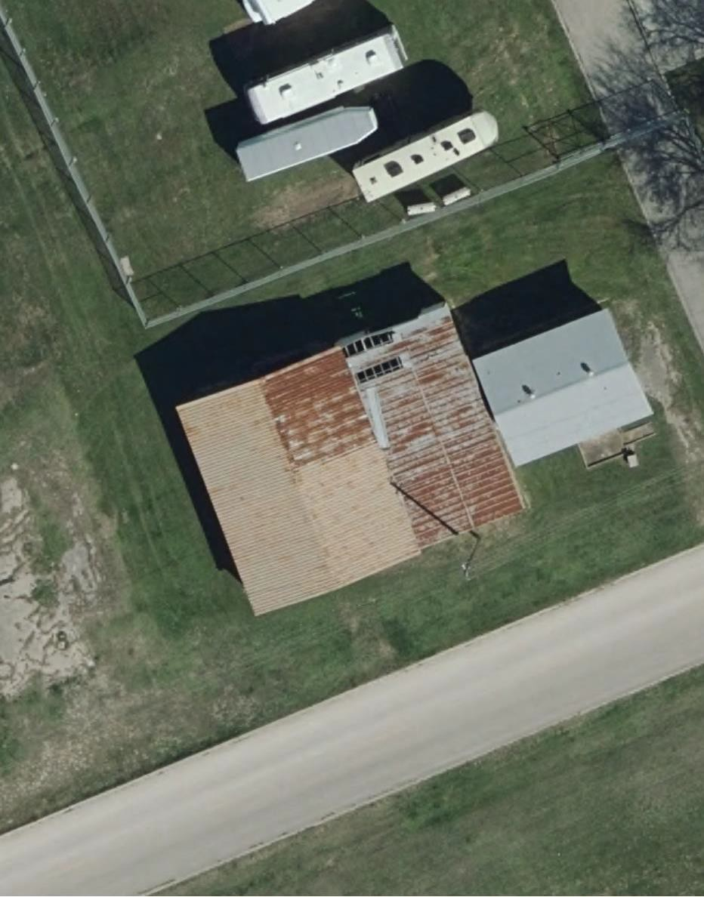  2988  µ | Facility 2988 - MPLS
 | Name
 | LODGE SUPPORT BUILDING
 | Description
 | TRAINING LODGE SUPPORT BUILDING
 | Size
 | 2256.0 SF
 | Address
 | FOSTER AVE
 | RPUID
 | 463766
 | CAT Code
 | 740459
 | FAC Code
 | 7443
 | Placed In Service
 | 1963-01-01 00:00:00
 | Acquisition
 | 1963-01-01 00:00:00
 | Built
 | 1963-01-01 00:00:00
 | Floors Above Ground
 | 1.0
 | Floors Below Ground
 | 0.0
 | Facility Height
 | 14.0 FT
 | Facility Length
 | 70.0 FT
 | Facility Width
 | 50.0 FT
 | Interest Code
 | 1 - AF Owned - Other Than Donated
 | Status
 | CARE
 | Latitude
 | 29.39974
 | Longitude
 | -98.613775
 | Date
 | 1/9/2024
 | SharePoint URL
 | https://usaf.dps.mil/teams/aetc-502isg-502cen/CENM/CENMT/SitePages/Home.aspx#/facility/MPLS/2988

Attach. 2

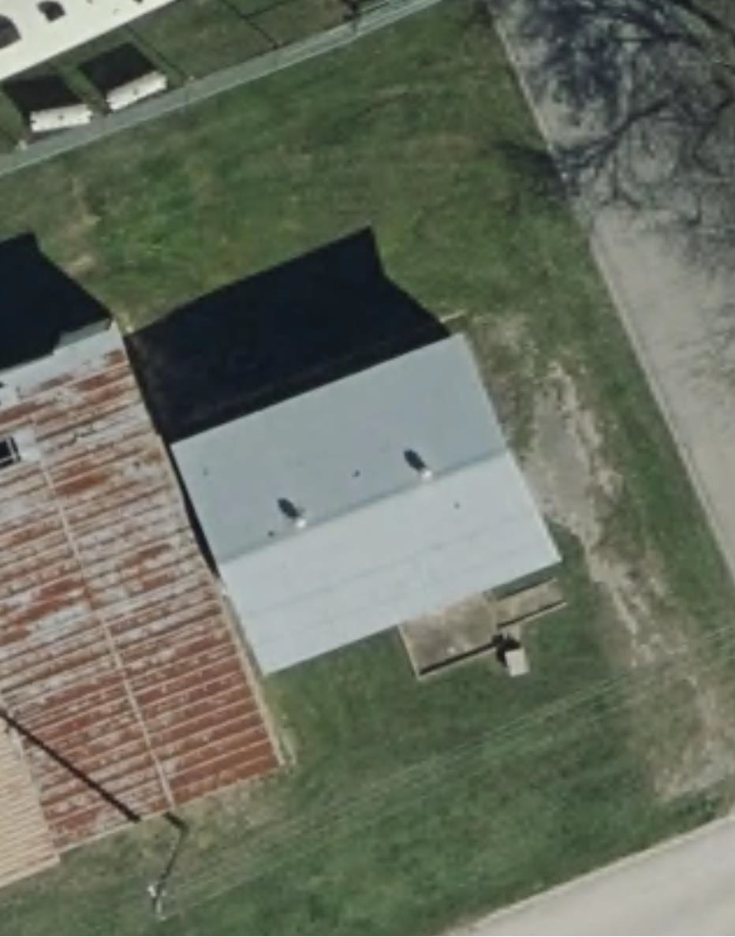  2989  µ | Facility 2989 - MPLS
 | Name
 | Training Support Building
 | Description
 | TRAINING LODGE SUPPORT BUILDING
 | Size
 | 198.0 SF
 | Address
 | FOSTER AVE
 | RPUID
 | 463767
 | CAT Code
 | 740459
 | FAC Code
 | 7443
 | Placed In Service
 | 1987-01-01 00:00:00
 | Acquisition
 | 1987-01-01 00:00:00
 | Built
 | 1987-01-01 00:00:00
 | Floors Above Ground
 | 1.0
 | Floors Below Ground
 | 0.0
 | Facility Height
 | 13.0 FT
 | Facility Length
 | 40.0 FT
 | Facility Width
 | 30.0 FT
 | Interest Code
 | 1 - AF Owned - Other Than Donated
 | Status
 | CARE
 | Latitude
 | 29.399788
 | Longitude
 | -98.613623
 | Date
 | 1/9/2024
 | SharePoint URL
 | https://usaf.dps.mil/teams/aetc-502isg-502cen/CENM/CENMT/SitePages/Home.aspx#/facility/MPLS/2989

Attach. 3

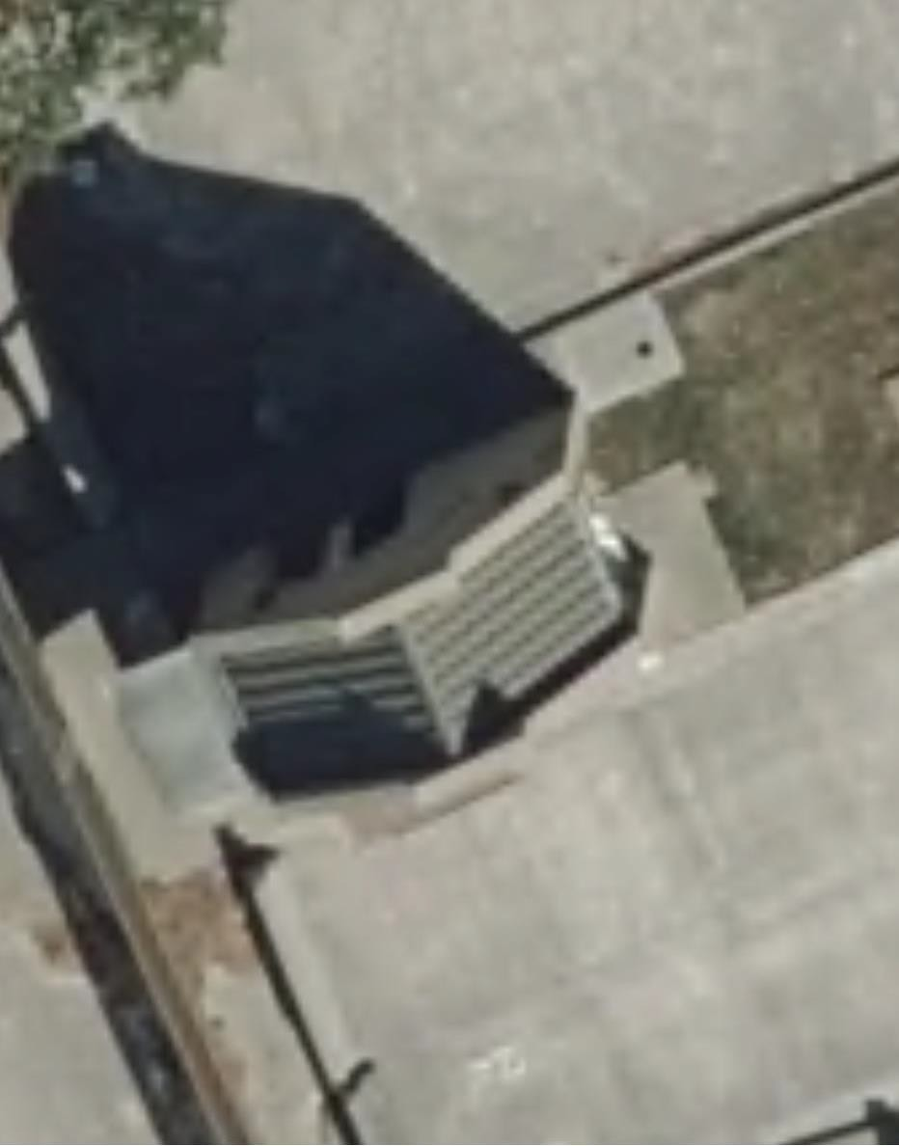  4395  µ | Facility 4395 - MPLS
 | Name
 | GATE HOUSE
 | Description
 | ACCESS CONTROL FACILITY
 | Size
 | 210.0 SF
 | Address
 | ST
 | RPUID
 | 460789
 | CAT Code
 | 730839
 | FAC Code
 | 1498
 | Placed In Service
 | 1997-01-01 00:00:00
 | Acquisition
 | 1997-01-01 00:00:00
 | Built
 | 1997-01-01 00:00:00
 | Floors Above Ground
 | 1.0
 | Floors Below Ground
 | 0.0
 | Facility Height
 | 12.0 FT
 | Facility Length
 | 21.0 FT
 | Facility Width
 | 16.0 FT
 | Interest Code
 | 1 - AF Owned - Other Than Donated
 | Status
 | CARE
 | Latitude
 | 29.39835
 | Longitude
 | -98.624967
 | Date
 | 1/8/2024
 | SharePoint URL
 | https://usaf.dps.mil/teams/aetc-502isg-502cen/CENM/CENMT/SitePages/home.aspx#/facility/MPLS/4395

Attach. 4

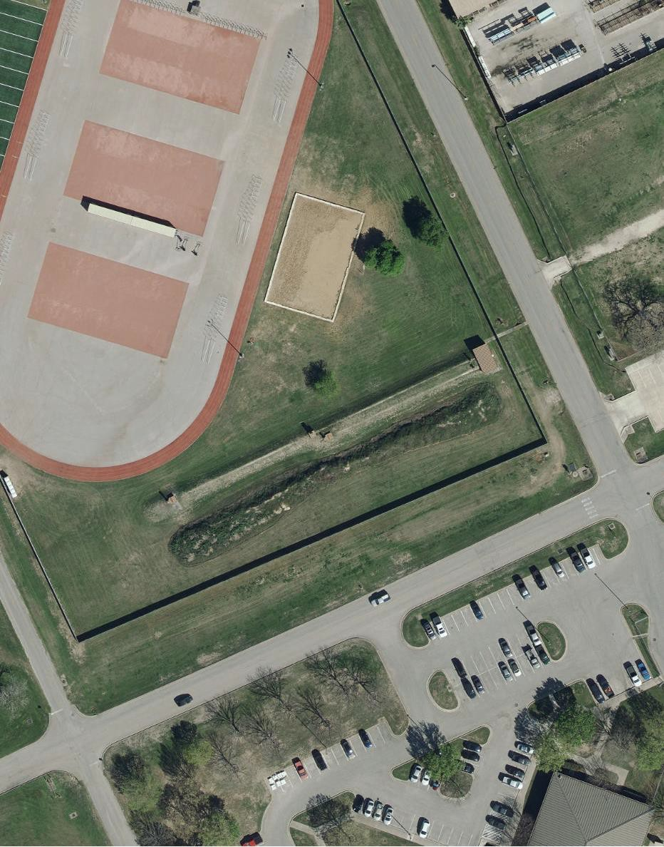  5584  µ | Facility 5584 - MPLS
 | Name
 | RG SM ARM INDOOR
 | Description
 | RANGE, SMALL ARMS, INDOOR
 | Size
 | 7645.0 SF
 | Address
 | WALKER AVE
 | RPUID
 | 463489
 | CAT Code
 | 171475
 | FAC Code
 | 1718
 | Placed In Service
 | 1961-01-01 00:00:00
 | Acquisition
 | 1961-01-01 00:00:00
 | Built
 | 1961-01-01 00:00:00
 | Floors Above Ground
 | 1.0
 | Floors Below Ground
 | 1.0
 | Facility Height
 | 9.0 FT
 | Facility Length
 | 302.0 FT
 | Facility Width
 | 153.0 FT
 | Interest Code
 | 1 - AF Owned - Other Than Donated
 | Status
 | CARE
 | Latitude
 | 29.375438
 | Longitude
 | -98.620214
 | Date
 | 1/9/2024
 | SharePoint URL
 | https://usaf.dps.mil/teams/aetc-502isg-502cen/CENM/CENMT/SitePages/home.aspx#/facility/MPLS/5584

Attach. 5

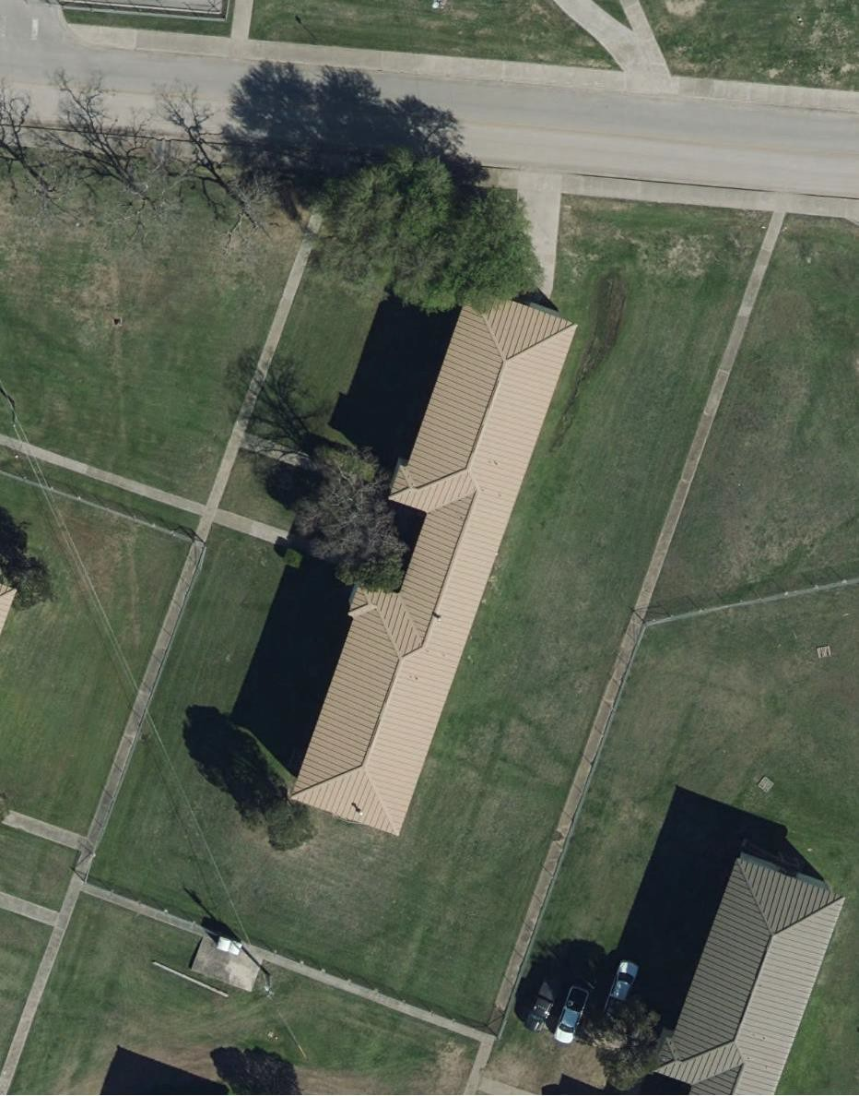  7362  µ | Facility 7362 - MPLS
 | Name
 | TV PRODUCTION FAC.
 | Description
 | Proposed for FY25 BCAMP (Stand-Alone) Demolition Approval.
 | Size
 | 13643.0 SF
 | Address
 | 1359 TINKER AVE
 | RPUID
 | 460869
 | CAT Code
 | 721313
 | FAC Code
 | 7210
 | Placed In Service
 | 1951-01-01 00:00:00
 | Acquisition
 | 1951-01-01 00:00:00
 | Built
 | 1951-01-01 00:00:00
 | Floors Above Ground
 | 2.0
 | Floors Below Ground
 | 0.0
 | Facility Height
 | 25.0 FT
 | Facility Length
 | 187.0 FT
 | Facility Width
 | 40.0 FT
 | Interest Code
 | 1 - AF Owned - Other Than Donated
 | Status
 | CARE
 | Latitude
 | 29.373606
 | Longitude
 | -98.623269
 | Date
 | 1/9/2024
 | SharePoint URL
 | https://usaf.dps.mil/teams/aetc-502isg-502cen/CENM/CENMT/SitePages/Home.aspx#/facility/MPLS/7362

Attach. 6

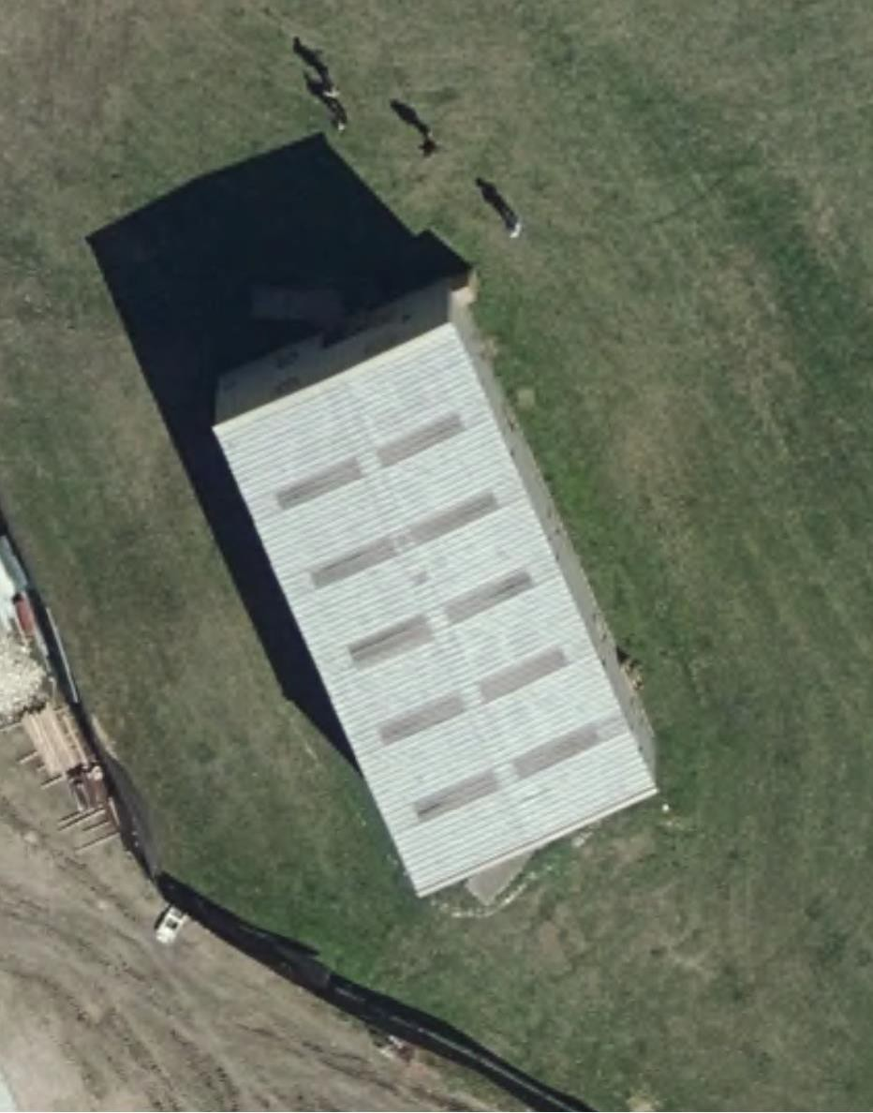  7561  µ | Facility 7561 - MPLS
 | Name
 | TNG AID
 | Description
 | TECHNICAL TRAINING LABORATORY/SHOP
 | Size
 | 3600.0 SF
 | Address
 | 1239-33 KNIGHT ST
 | RPUID
 | 462236
 | CAT Code
 | 171623
 | FAC Code
 | 1712
 | Placed In Service
 | 1984-01-01 00:00:00
 | Acquisition
 | 1984-01-01 00:00:00
 | Built
 | 1984-01-01 00:00:00
 | Floors Above Ground
 | 2.0
 | Floors Below Ground
 | 0.0
 | Facility Height
 | 19.0 FT
 | Facility Length
 | 60.0 FT
 | Facility Width
 | 30.0 FT
 | Interest Code
 | 1 - AF Owned - Other Than Donated
 | Status
 | ACT
 | Latitude
 | 29.372388
 | Longitude
 | -98.628068
 | Date
 | 1/9/2024
 | SharePoint URL
 | https://usaf.dps.mil/teams/aetc-502isg-502cen/CENM/CENMT/SitePages/Home.aspx#/facility/MPLS/7561

Attach7

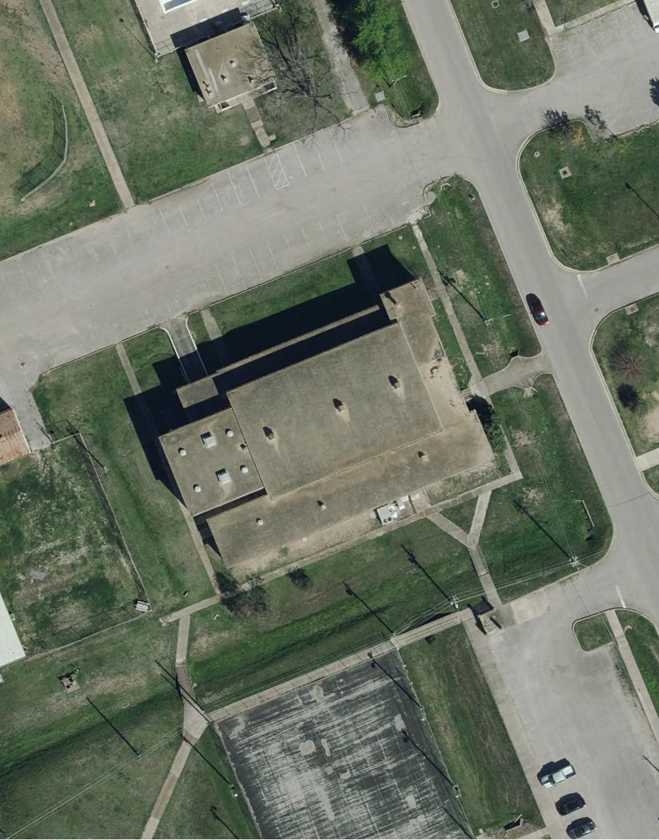  140  µ | Facility 140 - MPYJ
 | Name
 | GYMNASIUM
 | Description
 | Proposed for FY25 BCAMP (Stand-Alone) Demolition Approval.
 | Size
 | 14618.0 SF
 | Address
 | 1117 EAGLE DR
 | RPUID
 | 462017
 | CAT Code
 | 740674
 | FAC Code
 | 7421
 | Placed In Service
 | 1955-01-01 00:00:00
 | Acquisition
 | 1955-01-01 00:00:00
 | Built
 | 1955-01-01 00:00:00
 | Floors Above Ground
 | 1.0
 | Floors Below Ground
 | 0.0
 | Facility Height
 | 18.0 FT
 | Facility Length
 | 178.0 FT
 | Facility Width
 | 154.0 FT
 | Interest Code
 | 1 - AF Owned - Other Than Donated
 | Status
 | CARE
 | Latitude
 | 29.376665
 | Longitude
 | -98.654449
 | Date
 | 1/8/2024
 | SharePoint URL
 | https://usaf.dps.mil/teams/aetc-502isg-502cen/CENM/CENMT/SitePages/home.aspx#/facility/MPYJ/140

