
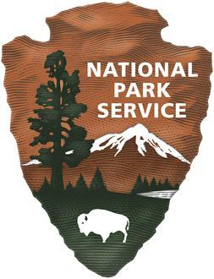
United States Department of the Interior

NATIONAL PARK SERVICE
Contracting Operations - Central
1849 C Street
NW Washington, DC 20240
Notice of Intent to Sole Source
This is a notice of intent to award a sole source contract to Hebgen Fire District, Gallatin County, Montana. This is not a competitive Request for Quote.
The Contracting Operations – Central, Northern Rockies Major Acquisition Buying Office (MABO), intends to issue a Sole Source award for the National Park Service for responses to fire and emergency medical services (EMS) on the West side of Yellowstone National Park.
This acquisition will be conducted in accordance with FAR 13.106-1(b) (Soliciting from a Single Source) as a commercial item procurement using simplified acquisition procedures. The applicable North American Industry Classification System (NAICS) code is 561990 – All Other Support Services.
The Hebgen Fire District is the only organization capable of meeting the required emergency response times for this area. Due to geographic constraints, no other entities are able to initiate timely fire and EMS responses. The nearest alternative fire engine and ambulance are located at Old Faithful, with an estimated response time of approximately one hour to the West Entrance. The National Fire Protection Association (NFPA) and State and Local EMS standards have established benchmark response times for emergency services, which cannot be met by any provider other than Hebgen Fire District. Due to its proximity, Hebgen Fire District is uniquely positioned to deliver the required services within these established timeframes.
This notice is for informational purposes only and is not a request for competitive quotations. However, any firm that believes it can meet this requirement may submit a capability statement for consideration. Responses must demonstrate the ability to provide fire and emergency medical services in the required response times.
All capability statements shall be submitted to Contract Specialist Stacy Vallie at stacy_vallie@nps.gov and stacy_vallie@ios.doi.gov.
A determination not to compete this requirement will be based on responses received as a result of this notice, at the sole discretion of the Government. Information received will be used to support the Government’s decision to proceed with a noncompetitive acquisition.

