EXHIBIT 4
SMALL BUSINESS SUBCONTRACTING PLAN

SMALL BUSINESS SUBCONTRACTING PLAN: Exhibit 4, reference clauses 552.219-71, Notice to Offerors of Subcontracting Plan Requirements, and 52.219-9, Small Business Subcontracting Plan, complete and return with offer if applicable. This only needs to be completed by large businesses, where the estimated value of the contract will exceed $550,000.

Subcontracting Plan period: through

DATE:

CONTRACTOR:
SUBSIDIARIES INCLUDED:
ADDRESS:
ITEM/SERVICE:

The following, together with any attachments, is hereby submitted as a Subcontracting Plan to satisfy the applicable requirements of Federal Acquisition Regulation (FAR) clause 52.219-9, Small Business Subcontracting Plan.

(1) The following percentage goals (expressed in terms of a percentage of total planned subcontracting dollars) are applicable to the plan cited in 2(i) below or to the contract awarded under the solicitation cited above.

(a) Small business concerns: % of total planned subcontracting dollars that will go to subcontractors who are small business concerns.

(b) Veteran-owned small business concerns: % of total planned subcontracting dollars will go to subcontractors who are small business concerns owned and controlled by a veteran(s).

(c) Service-disabled veteran-owned small business concerns: % of total planned subcontracting dollars will go to subcontractors who are small business concerns owned and controlled by a service-disabled veteran(s). (Subset of (b)Veteran-owned small business concerns)

(d) Small disadvantaged business (SDB) concerns: % of total planned subcontracting dollars under this contract will go to subcontractors who are small business concerns owned and controlled by socially and economically disadvantaged individuals.

(e) Small women-owned business concerns: % of total planned subcontracting dollars under this contract will go to subcontractors who are small business concerns owned and controlled by a woman or women who are U.S. citizens and who also control and operate the business.

(f) HUBZone small business concerns: % of total planned subcontracting dollars under this contract will go to subcontractors who are small business concerns located on the List of Qualified HUBZone Small Business Concerns maintained and published on SBA’s website at https://eweb1.sba.gov/hubzone/internet/general/approved-firms.cfm (HUBZone means a historically under utilized business zone, which is an area located within one or more qualified census tracts, qualified nonmetropolitan counties, of lands within external boundaries of an Indian reservation.)

(2) (i) The total estimated dollar value of all planned subcontracting (to all types of business concerns) under this (select only one of the three):

(a) Individual Plan (This Contract Only) is $
(Contract #/Solicitation # )

(b) Commercial Division-wide Plan $
(Represents % of Total Annual Sales)

(c) Commercial Company-wide Plan $
(Represents % of Total Annual Sales)

The following dollar values correspond to the percentage goals shown in (1) above.

(ii) Total dollars planned to be subcontracted to small business concerns: $

(iii) Total dollars planned to be subcontracted to veteran-owned small business concerns: $

(iv) Total dollars planned to be subcontracted to service-disabled veteran-owned small business concerns: $

(v) Total dollars planned to be subcontracted to small disadvantaged business concerns: $

(vi) Total dollars planned to be subcontracted to women-owned small business concerns: $

(vii) Total dollars planned to be subcontracted to HUBZone small business concerns: $

(3) List proposed dollars attributed to each product/service category (fill in product/service column):

Product / Service | Large Business | Small Business | Veteran-owned Small Business | Service-Disabled Veteran-owned Small Business | Disadvantaged-Small | Woman – owned  Small Business | HUBZone Small Business
TOTAL $ |  | $ | $ | $ | $ | $ | $
(Examples of products/services: Janitorial Services, Computer/Network Equipment & Support, Warehouse Equipment, Facilities & Building Maintenance, Printing, Packaging, HR Services, Misc. Products & Services)

Please note that Totals will automatically populate from (2)(ii) through (2)(vii) above when you perform a print preview from either. The icon above in the toolbar 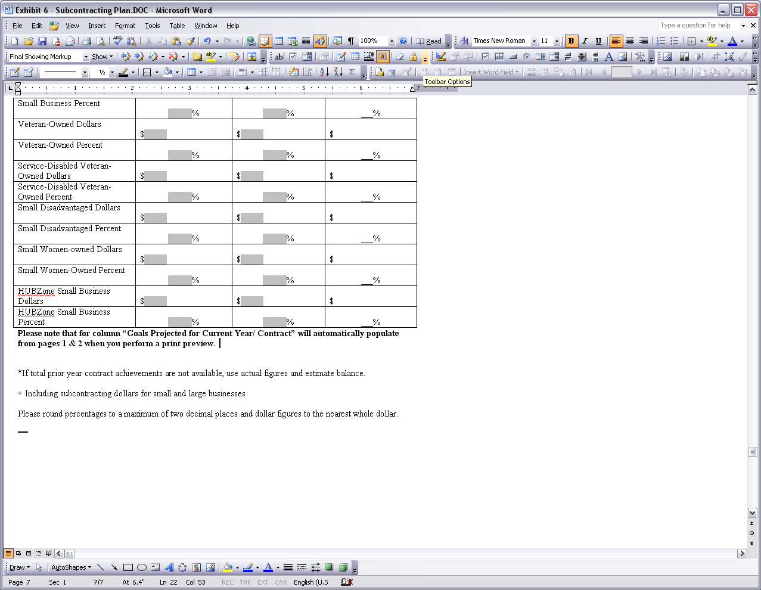 or going to File – Print Preview from the drop down menu.

(4) The following method was used in developing subcontracting goals:

(5) The following methods were used to identify potential sources for solicitation purposes:
(See FAR 52.219-9(d)(5) for examples of methods that may be used.)

(6) Indirect and overhead costs (check one below): (N/A FOR COMMERCIAL PLANS – APPLIED AT 100%)

have been have not been included in development of the goals.

If "have been" is checked, explain the method used in determining the proportionate share of indirect costs to be incurred with small business, veteran-owned small business, service-disabled small business, small disadvantaged business, women-owned small business concerns and HUBZone small business.

(7) The following individual will administer the subcontracting program:

NAME: TITLE:

ADDRESS:

TELEPHONE: ( ) - E-MAIL:

This individual's specific duties, as they relate to the firm's subcontracting program, are as follows:

(8) The following efforts will be taken to assure that small business, veteran-owned small business, service-disabled small business, small disadvantaged business, women-owned small business concerns and HUBZone small business will have an equitable opportunity to compete for subcontracts:

\

(9) 4. The offeror agrees that the FAR clause of this contract entitled ’Utilization of Small Business Concerns’ will be included in all subcontracts which offer further subcontracting opportunities, and all subcontractors (except small business concerns) that receive subcontracts of $550,000 or more will be required to adopt a subcontracting plan that complies with the requirements of FAR clause 52.219-9.

(10). The offeror agrees to

(i) cooperate in any studies or surveys as may be required,

(ii) submit periodic reports in order to allow the Government to determine the extent of compliance by the offeror with the subcontracting plan,

(iii) submit eSRS (Electronic Subcontracting Reporting System) reports on-line at www.esrs.gov. Reports are to be submitted in conjunction with the Government’s fiscal year (October through September). For Individual Plans, submit an Individual Report twice a year for each six-month period (October to March) and a Summary Report for the entire 12 month fiscal year (October to September) along with the Year-End Supplementary Report for Small Disadvantaged Business. Reports are due 30 days after the close of each reporting period. For Commercial Plans, submit the Summary Subcontract Report (SSR) along with the Year-End Supplementary Report for Small Disadvantaged Business within 30 days after the end of the Government’s fiscal year. All SSRs are due at this time, regardless of the Subcontract Plan reporting period. For example, for a company whose fiscal year coincides with the calendar year, a Summary Subcontract Report is due October 31st.

(iv) ensure that its subcontractors agree to enter reporting data into eSRS.

(11) Following is a description of the types of records that will be maintained concerning procedures that have been adopted to comply with the requirements and goals in the plan, including establishing source lists and a description of efforts to locate small business, veteran-owned small business, service-disabled small business, small disadvantaged business, women-owned small business concerns and HUBZone small business and award subcontracts to them.

The records shall include at least the following (on a plant-wide or company-wide basis, unless otherwise indicated:
(i) Source lists, guides, and other data that identify small business, veteran-owned small business, service-disabled small business, small disadvantaged business, women-owned small business concerns and HUBZone small business concerns.
(ii) Organizations contacted in an attempt to locate sources that are small business, veteran-owned small business, service-disabled small business, small disadvantaged business, women-owned small business concerns and HUBZone small business concerns.
(iii) Records on each subcontract solicitation resulting in an award of more than $100,000, indicating—
(A) Whether small business concerns were solicited and, if not, why not;
(B) Whether veteran-owned small business concerns were solicited and, if not, why not;
(C) Whether service-disabled veteran-owned small business concerns were solicited and, if not, why;
(D) Whether small disadvantaged business concerns were solicited and, if not, why not;
(E) Whether women-owned small business concerns were solicited and, if not, why not; and
(F) Whether HUBZone small business concerns were solicited and, if not, why not;
(G) If applicable, the reason award was not made to a small business concern.
(iv) Records of any outreach efforts to contact—
(A) Trade associations;
(B) Business development organizations;
(C) Conferences and trade fairs to locate small, small disadvantaged, women-owned small and HUBZone small business sources; and
(D) Veterans service organizations.
(v) Records of internal guidance and encouragement provided to buyers through—
(A) Workshops, seminars, training, etc.; and
(B) Monitoring performance to evaluate compliance with the program’s requirements.
(vi) On a contract-by-contract basis, records to support award data submitted by the offeror to the Government, including the name, address, and business size of each subcontractor. Contractors having commercial plans need not comply with this requirement.

Effective period of this subcontracting plan is: (Individual plans should cover the entire period of performance and commercial plans should coincide with the company’s fiscal year)

TO
Month Day Year Month Day Year

In the event your company's fiscal year is for a period other than the proposed contract period of this solicitation, you will be required to submit a new subcontracting plan for approval sixty (60) days prior to expiration of the existing subcontracting plan. In the event an acceptable plan cannot be negotiated prior to expiration of the existing subcontracting plan, your contract may be terminated.

Signed: _____________________________________________
Typed Name:
Title:
Date:

Plan Approved By: _____________________________________________

Typed Name:
Contracting Officer
Date Approved:

(ATTACHMENTS MAY BE USED IF ADDITIONAL SPACE IS REQUIRED)

 | Prior Year / Contract Goals | *Prior Year / Contract Achievements | Goals Projected for Current Year / Contract
Total Subcontracting Dollars+ | $ | $ | $
Small Business Dollars | $ | $ | $
Small Business Percent | % | % | %
Veteran-Owned Dollars | $ | $ | $
Veteran-Owned Percent | % | % | %
Service-Disabled Veteran-Owned Dollars | $ | $ | $
Service-Disabled Veteran-Owned Percent | % | % | %
Small Disadvantaged Dollars< | $ | $ | $
Small Disadvantaged Percent | % | % | %
Small Women-owned Dollars | $ | $ | $
Small Women-Owned Percent | % | % | %
HUBZone Small Business Dollars | $ | $ | $
HUBZone Small Business Percent | % | % | %
Please note that column “Goals Projected for Current Year/ Contract” will automatically populate from pages 1 & 2 when you perform a print preview from either.
The icon above in the toolbar or going to File – Print Preview from the drop down menu.

*If total prior year contract achievements are not available, use actual figures and estimate balance.

+ Including subcontracting dollars for small and large businesses

<Certified, Small Disadvantaged Business

Please round percentages to a maximum of two decimal places and dollar figures to the nearest whole dollar.

