PERFORMANCE WORK STATEMENT
Appendix
Current Freezer Pictures
Installation of New Freezer Unit
Department of Veterans Affairs CMOP in Dallas Tx
- Inside Freezer door entrance
  - 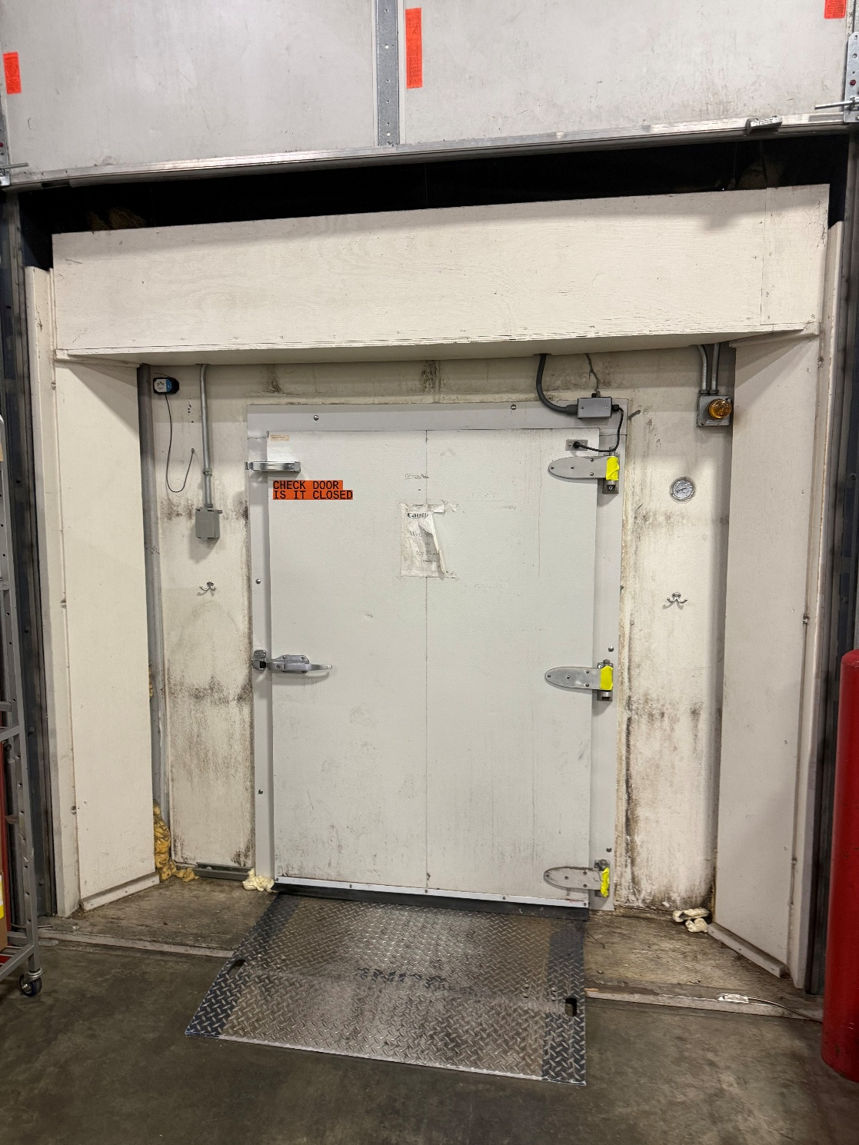

- South side of freezer trailer
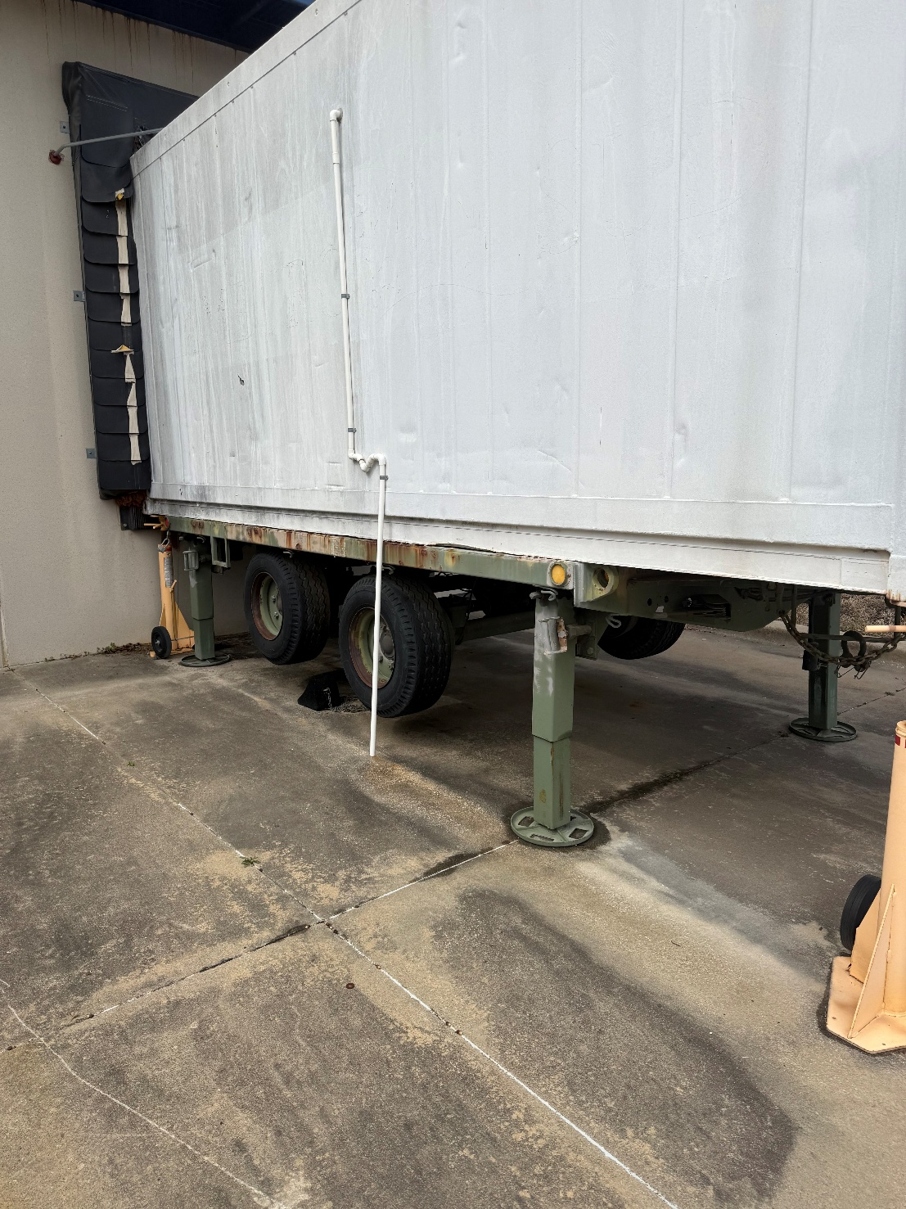

- Outside wall transition
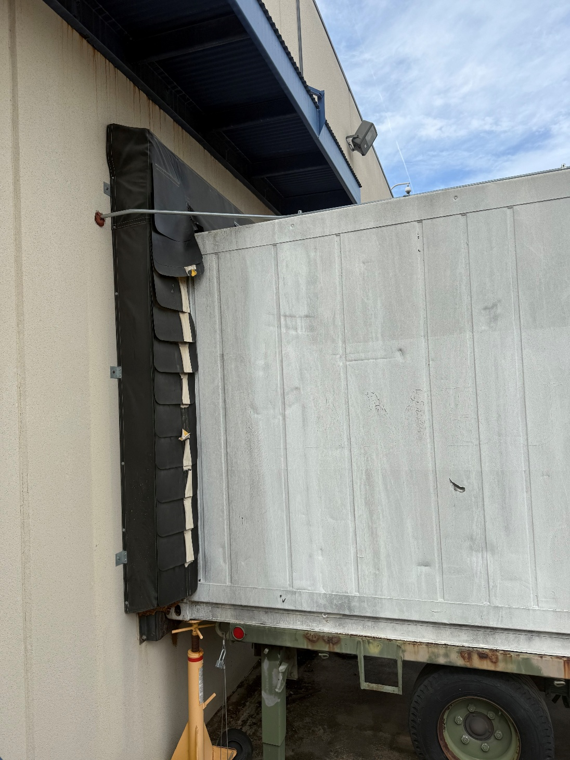

- North side view of freezer Trailor.
