

Program Level

Agile Process

Version 4.4
4 September 2014

Table of Contents
1 Introduction 1
2 Assumptions 1
3 Big Picture 3
4 Process Overview 6
4.1 What is a Program? 8
4.2 Inputs/Outputs 11
4.3 Roles and Responsibilities 12
4.3.1 Product Management Team 14
4.3.2 Release Management Team 18
4.3.3 Mission Owner 18
4.3.4 User Subject Matter Expert 19
4.3.5 DBT Team 19
4.3.6 Verification & Validation Group 20
4.3.7 DevOps Team 21
4.3.8 Research & Development 22
4.3.9 Integrated Product Team 22
4.4 Governance 23
4.4.1 Configuration Management Process 23
4.4.2 Control Boards 25
4.4.3 Operations Readiness 25
5 Process Details 26
5.1 Vision 26
5.1.1 Roles and Responsibilities 27
5.1.2 Process Steps 27
5.1.3 Template 28
5.2 Design Artifacts 28
5.2.1 Roles and Responsibilities 29
5.2.2 Process Steps 30
5.2.3 Template 31
5.3 Nonfunctional Requirements 31
5.3.1 Roles and Responsibilities 31
5.3.2 Process Steps 31
5.3.3 Template 32
5.4 Features 32
5.4.1 Roles and Responsibilities 33
5.4.2 Process Steps 35
5.4.3 Template 41
5.5 Roadmap 42
5.5.1 Roles and Responsibilities 42
5.5.2 Process Steps 42
5.5.3 Template 43
5.6 Agile Release Train 43
5.6.1 Roles and Responsibilities 44
5.6.2 Process Steps 45
5.6.3 Template 54
5.7 Testing 56
5.7.1 Roles and Responsibilities 56
5.7.2 Process Steps 57
5.7.3 Template 61
5.8 Metrics 61
5.8.1 Value Streams 62
6 Conclusion 62

List of Figures
Figure 3-1: Scaled Agile FrameworkTM Big Picture 5
Figure 4-1: Program and Team Level Process Overview 8
Figure 4-2: SAFeTM Data Model 12
Figure 4-3: RACI Matrix 13
Figure 4-4: Configuration Management Process 24
Figure 5-1: Epic, Feature, and Story Decomposition 34
Figure 5-2: Sample Scrum of Scrums Agenda 47
Figure 5-3: Typical Calendar for an IP Sprint 48
Figure 5-4: Agile Release Train Cadence for 8 Week Cycle 55
Figure 5-5: Testing for 8 Week Cycle 58

List of Tables
Table 5-1: Minimum Use Case Contents 30
Table 5-2: Estimating Process 37
Table 5-3: Fields for Discrepancy Reports 40
Table 5-4: Testing Roles and Responsibilities 56

Appendices
Acronyms 79
Agile Release Train Template 75
Feature Template 72
Nonfunctional Requirements Checklist 71
References 80
Roadmap Template 74
Use Case Report Template 69
Vision Document Template 64

Revision History
CHANGE STATUS LOG
DOC. NO. |  |  |  | Page No. | 89
TITLE: | Program Level Agile Process
SCN | Date | Revised By | Sections Affected | Remarks
v1.0 | 19 July 2013 | Greg Geosits | All | Initial version
v2.0 | 25 October 2013 | Greg Geosits | - Used 2.5 Big Picture (section 3)  - Updated Figure 4-1 (section 4)  - Clarified Roles and Responsibilities (section 4.3)  - Features are created by Product Management Team (section 4.3.1)  - Testing is completed by System Team (section 4.3.1.4)  - Added DevOps Team (section 4.3.3)  - Added Research & Development (section 4.3.8)  - Updated Configuration Management (section 4.4.1)  - Added Operations Readiness Checklist (section 4.4.3)  - Added Test Readiness Checklist (section 5.7.2.4) | Other comments addressed
v2.1 | 4 November 2013 | Greg Geosits | - Updated RACI Matrix (section 4.3)  - Updated Features (section 5.4)  - Roles and Responsibilities (section 5.4.1)  - Added Estimating (section 5.4.2.3)  - Added Prioritizing (section 5.4.2.4)  - Added Grooming (section 5.4.2.5)  - Updated Feature Template (Appendix D) | Other comments addressed
v2.2 | 25 December 2013 | Greg Geosits | - Updated Figure 4-1 (section 4)  - Updated Features Roles and Responsibilities (section 5.4.1)  - Updated Operations Readiness (section 4.4.3)  - Updated Design Artifacts (section 5.2)  - Added User Subject Matter Expert (section 4.3.4)  - Updated Figure 5-1 (section 5.4.1)  - Updated RACI Matrix (section 4.3)  - Updated Estimating (section 5.4.2.3)  - Updated Acronyms (Appendix I)  - Updated RACI Matrix (section 4.3)  - Updated Configuration Management (section 4.4.1)  - Removed Service Concept Document (Appendix F) | Other comments addressed
v2.3 | 4 March 2014 | Greg Geosits | - Updated DevOps Team (section 4.3.7)  - Added Configuration Management (section 4.3.7.1)  - Updated Figure 5-4 (section 5.6.3)  - Updated Testing (section 5.7)  - Updated Roles and Responsibilities (section 5.7.1)  - Updated Process Steps (section 5.7.2)  - Updated Figure 5-5 (section 5.7.2) | Other comments addressed
v4.1 | 12 May 2014 | Greg Geosits | - Changed Final Release Planning Event to Release Planning Event (all sections)  - Updated Roles and Responsibilities (section 4.3)  - Updated System Team (section 4.3.1.4)  - Added Verification & Validation Group (section 4.3.6)  - Added Infrastructure Service Provider (section 4.3.7.2)  - Added Integrated Product Team (section 4.3.9)  - Updated Figure 5-4 (section 5.6.3)  - Updated Testing (section 5.7)  - Updated Figure 5-5 (section 5.7.2)  - Added Unit Test (section 5.7.2.1)  - Added System Test (section 5.7.2.2)  - Added Independent Verification & Validation (section 5.7.2.3) | Other comments addressed
v4.2 | 7 August 2014 | Greg Geosits | - Updated Big Picture (section 3)  - Updated Figure 4-3 (section 4.3)  - Updated Figure 4-1 (section 4)  - General updates
v4.3 | 20 August 2014 | Greg Geosits | - Updated with Scaled Agile Framework, version 3.0 | Other comments addressed
v4.4 | 4 September 2014 | Greg Geosits | - Updated Error! Reference source not found. (section Error! Reference source not found.) | Other comments addressed

Introduction
The purpose and intent of this document is to define the process required for the execution of Agile development of information technology (IT) at the National Geospatial-Intelligence Agency (NGA). NGA has adopted a 3-tiered hierarchical approach as its framework for Agile Engineering. Agile Engineering is executed through 3 levels of abstraction, the Portfolio, Program and Team levels, with activities at the lower levels dependent on activities at the higher levels for successful execution.
This Program Level Agile Process contains the roles and responsibilities, process steps, templates, checklists and other relevant information for the successful implementation of Agile Engineering at the Program level, which involves the following:
- Vision
- Design Artifacts
- Nonfunctional Requirements
- Features
- Roadmap
- Agile Release Train
- Testing
- Metrics

Assumptions
The following are the Program level assumptions in order for this Program Level Agile Process to succeed:
- The Portfolio Level Agile Process exists and clearly defines the artifacts, roles, and integration with this Program Level Agile Process.
- The Team Level Agile Process exists and clearly defines the artifacts, roles, and integration with this Program Level Agile Process.
- The Program level receives Epics from the Portfolio level.
  - The Portfolio level makes the determination as to whether or not an Epic is to be considered, and to which programs an Epic gets allocated.
  - Features that fit in programs are funded by Budgets at the Portfolio level.
- Contract actions are performed by the appropriate Contracting Officer (CO)/Contracting Officer’s Technical Representative (COTR) in accordance with the Agency Agility Strategic Initiative (A2SI) within the NGA Agile Contracting approach.
  - There is at least one Agile program for which to allocate Epics. Where an appropriate program does not exist, a new Agile program may be created: utilizing the NGA (Agile) Acquisition process, improving an Agile program framework like an IDIQ (Indefinite Delivery, Indefinite Quantity), leveraging an existing contract vehicle by adding an ad-hoc CLIN (Contract Line Item Number), etc.
  - The contract for an Agile program allows for it to follow this Program Level Agile Process.
  - The contract for a Define, Build, Test (DBT) Team allows for it to follow the Team Level Agile Process.
- At some point in the future, there will be multiple programs for which to allocate Epics at the Program level.
- There is at least one DBT Team for which to allocate Features. Where an appropriate team does not exist, a new team may be created through the NGA (Agile) Acquisition process.
- The National System for Geospatial-Intelligence (NSG) Online Workspace (NOW) Alpha/Beta environments are available to be used by the Program level.
- JIRA is being used by the Portfolio, Program, and Team levels to track backlog items.
- Architectural Design Artifacts include use cases (Unified Modeling Language (UML) diagrams and/or Department of Defense Architectural Framework (DoDAF) views), interface artifacts (e.g. Interface Control Documents (ICDs), service specifications, Service Level Agreements (SLAs), Memorandums of Understanding (MOUs), etc.), and/or metadata.

- The term User Stories is used to reference all types of Stories. There exists several types of Stories (as described in the Team Level Agile Process), such as User Stories and Refactors.

Big Picture
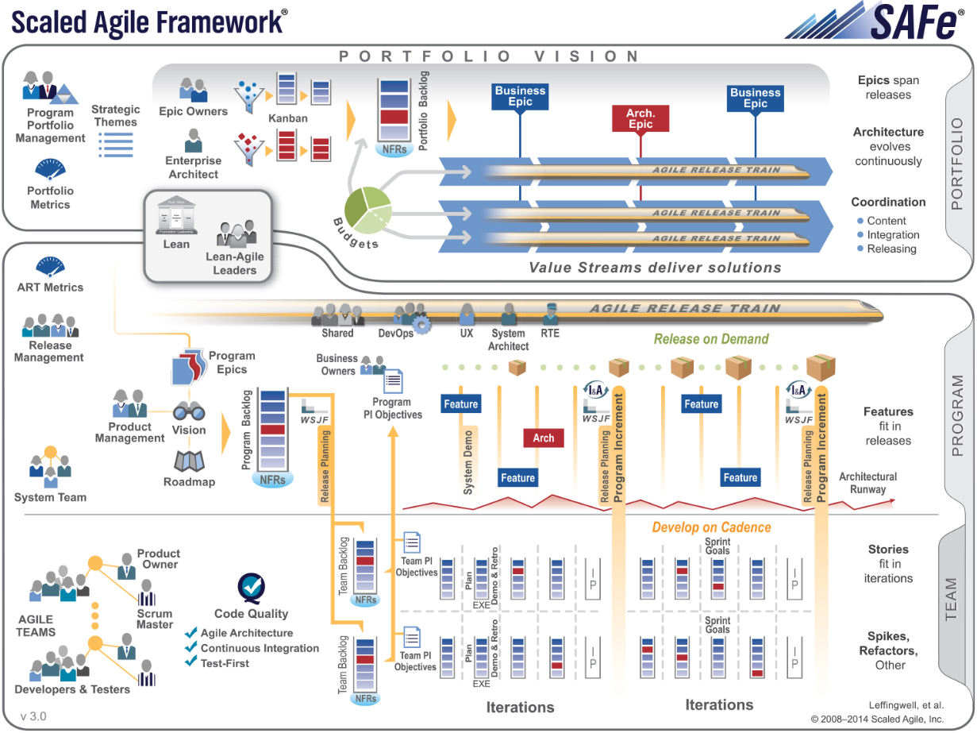
Figure 3-1 shows the high-level overview of the entire NGA Agile Engineering process. The purpose and intent of this document is to define the process required for the execution of Agile Engineering of IT at NGA. NGA has adopted a 3-tiered hierarchical approach as its framework for Agile Engineering. Agile Engineering is executed thru 3 levels of abstraction, the Portfolio, Program and Team levels, with activities at the lower levels dependent on activities at the higher levels for successful execution.
At the Portfolio level, NGA strategizes on its missions and initiatives to create Epics in the Portfolio Backlog, and determines the programs where the Epics are allocated based on priority, funding, and value. NGA’s budget is divided into Budgets, which fund the continual operation of programs/products that the agency wants to run at the Program level. Each program, once it has been approved for development and the resources have been identified, is allocated a Budget and is responsible for delivering Enterprise value via changes to the NSG product/domain (known as a Value Stream) for which the program is responsible. For more information about the Portfolio level, please see the Portfolio Level Agile Process.
The Program level addresses how the content (Features) of each program’s releases are determined, prioritized, planned, managed, and ultimately delivered via time-boxed, iterative releases. The NGA programs create Features in the Program Backlog based on various inputs: Epics, Use Case Model, Design Artifacts, Feedback, Mission Owners/User Subject Matter Experts (stakeholder/users to review the Feature acceptance criteria), and engineering studies. The Features are then allocated to Product Owners at the Team level to be implemented during releases. The Program and Team levels combined are commonly referred to as an Agile Release Train. Unlike programs following a sequential/waterfall change paradigm (e.g. definite beginning and end, start/stop processes), NGA’s scaled Agile paradigm treats Agile Release Trains as vehicles for collaboratively providing value to the NSG following a cadence. Each Agile Release Train can apply the Agile self-organizing principle to determine how to best organize to support their Vision. This Program Level Agile Process focuses on the Program level.
The Team level addresses how changes to the NSG are actually made, utilizing the inputs from the Program level. It includes the management and operation (define, develop, and test) of the DBT Team(s) assigned to each Agile Release Train, and the prioritization and determination of what software development changes will be included in the next Team level iteration of the release using User Stories in the Team Backlog. For more information about the Team level, please see the Team Level Agile Process.


Figure 3-1: Scaled Agile FrameworkTM Big Picture

Process Overview
This Program Level Agile Process supports aligning and integrating the value (User Stories) created via the Team Level Agile Process into larger compositions of value (Features) necessary to achieve broader NGA Enterprise objectives and value (Epics). The roles and activities at this level are organized around, and in support of, an ongoing series of incremental releases of product capabilities. Ultimately, the Program level process will support multiple products, each with its own cadence of continual releases.
As depicted in Figure 4-1 (broken up into phases to facilitate readability), this Program Level Agile Process involves the Vision, Design Artifacts, Nonfunctional Requirements, Features, Roadmap, Agile Release Train, and Testing. This entire process needs to be able to adapt quickly over time, as Budgets are created, new Epics are received from the Portfolio level, Features are defined at the Program level, and User Stories are developed at the Team level. The items in blue are artifacts, and the items red are Metrics.
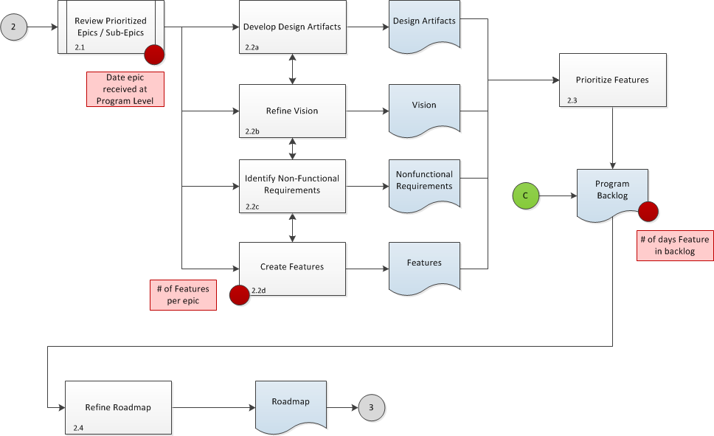

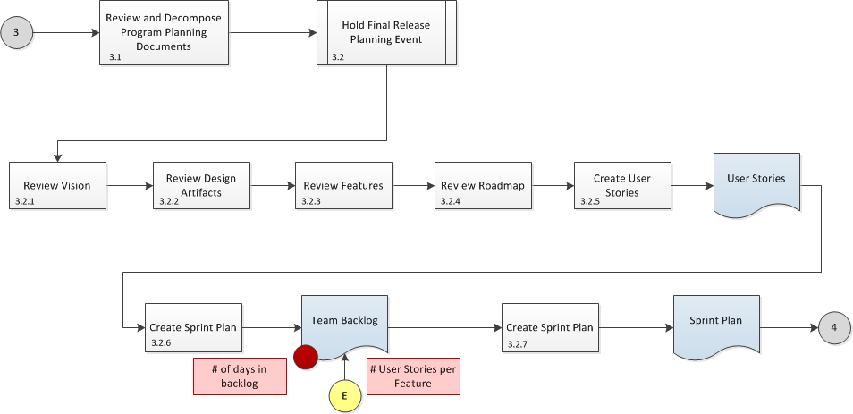

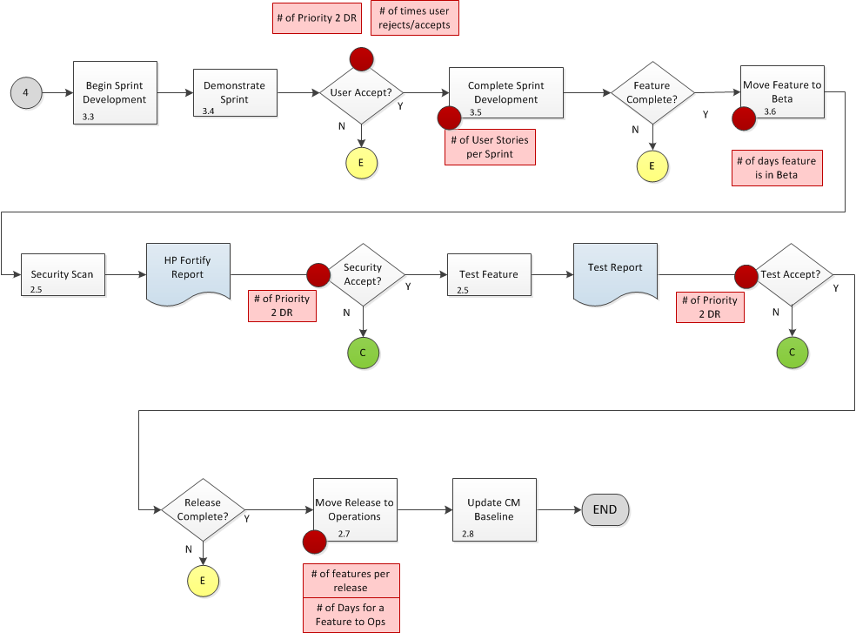
Figure 4-1: Program and Team Level Process Overview
The first phase of work at the Program level involves the creation of the Vision, Design Artifacts, Nonfunctional Requirements, and Features in parallel (all of these activities feed each other), the Features being prioritized to create the Program Backlog, and the creation of the Roadmap. The second phase involves the Features being decomposed into User Stories by the Team level, and the Agile Release Train planning (which includes the Release Planning Event). Both the first and second phases combined take 8 to 10 weeks. The third phase involves the Agile Release Train execution (which includes sprint development by the DBT Teams), sprint demonstration to users (at the Team level), security scans and Testing of completed Features (at the Program level), and release to operations (at the Program level).

What is a Program?
A program manages a development team and has a release train.

- Throughout this document, the term program is used to describe an Agile program.

An Agile program manages DBT Teams, has an Agile Release Train, and follows the NGA Agile Engineering process. However, the term program should not be confused with the term Program of Record (POR). A POR is a funded NGA contract that may or may not follow Agile processes. A POR could have two (or more) different areas of focus: one that is responsive to the Product Manager/Program Backlog priorities, and a second that might deliver capability independent of the Product Manager/Program Backlog priorities.
Once Epic level architecture has been created, there should be a high level understanding of the intent of the system and components necessary to realize the functionality. At this point there should be an assessment of the current capabilities and an Analysis-of-Alternatives (AOA) must be performed to determine the appropriate path forward. It is during this AOA that a decision is made to create a new component or to enhance an existing component. Once this decision has been made, a capability provider (DBT Team or POR) should be identified. By identifying the capability provider at this point in the process, they can contribute their understanding of the solution space, the existing architecture, and contribute to the development of Features. This enhances their understanding of the Features and aids in the decomposition of User Stories during the Release Planning Event (FRPE). In some cases, the POR may indicate that the functionality being requested was already planned for in their POR requirements/roadmap. In the event that this occurs, the Product Manager must make a decision as to whether the program is going to wait for the POR to deliver the capability, or if a DBT Team needs to develop a stop gap. If a POR is planning to provide the capability in a release beyond the current, these future deliveries can be tracked on the Roadmap and the necessary dependencies can also be tracked.
In the event that a POR is planning to provide a capability that was not based on a program-defined Feature, they must communicate this plan with the Product Manager to ensure that the program is fully aware of the development, it is aligned to the Vision of the program, and it has been incorporated in the Roadmap. If the POR were to develop a functionality without alerting the Product Manager prior to development, an assessment must be made by the Product Manager as to whether or not the functionality should be included. In this case, the functionality should be treated in the following manner:
- Promote into the NOW Beta environment for User Subject Matter Expert evaluation.
- If the and User Subject Matter Experts determines it is a value added capability, an engineering study must be performed.
- Study to determine if the capability should be included as-is, or if it should be incorporated with another current capability.
- A standalone capability is included in the next Agile Release Train release to operations, and incorporation is captured as a Feature to be prioritized and worked in a future release.
The following checklist should be used to determine if a project is an Agile program. Does the project have:
- A high amount of uncertainty?
  - Needs/capabilities are not all known/defined up front
  - There is a need to vary the needs/capabilities
    - “In agile, the business owner/sponsor can add to the backlog or reorder the priority any way they want, as long as the current iteration in progress is sacrosanct.”
    - “During each project, the less valuable functionality sifts to the bottom of the backlog (capability/requirements/features/stories) and is never implemented.”
- The need to leverage the artifacts developed using the Program Level Agile Process?
  - Vision
  - Design Artifacts
  - Nonfunctional Requirements
  - Features
  - Roadmap
  - Agile Release Train (schedule)
  - Testing (Test Report Template)
- The resources to support the Program Level Agile Process?
  - Product Manager
  - System Architect
  - User Experience Designer
  - System Team
  - Product Owner
  - Release Manager
  - Release Train Engineer
  - Mission Owner
  - User Subject Matter Expert
  - DBT Team
  - Verification & Validation Group
  - Security Engineer
  - Infrastructure Service Provider
  - Configuration Management
  - Readiness
  - Research & Development
  - Integrated Product Team
- An Agile contract with the appropriate language?
  - Adherence to the Program Level Agile Process
  - Acquisition strategy that is adaptive
  - Reduction in acquisition life cycle time
  - Requirements prioritization based on value
  - Ability of CO/COTR to change priorities and direction
  - Minimum documentation that is just-in-time/good enough
  - “Establish disincentives within the participating organizations where they must pay any costs associated with lack or participation or delayed decision making.” An example would be an award fee deduction.
  - “Agile delivery cycles require contract vehicles to be written to allow the flexibility to allow the value of agile practices to be realized and employ incentives for early quality delivery.”
- Funding?
  - Ability to receive Epics from the Portfolio level for which to decompose into Features
  - Budgets fund the Agile Release Trains

Inputs/Outputs
Inputs to the Program level are Epics, Feedback, and engineering studies. Items created to support the Program level are the Vision, Design Artifacts, Nonfunctional Requirements, Features, Roadmap, Agile Release Train, and Testing. The Mission Owners/User Subject Matter Experts (stakeholders/users to review the Feature acceptance criteria) and System Team/Verification & Validation Group (to create and review the Feature acceptance criteria) (see the Feature Acceptance Criteria field below in the Feature Template) provide an evaluation and recommendation of Feature acceptance criteria to the Product Manager during the Release Planning Event. Outputs from the Program level are Features (from business and architectural Epics) and completed capabilities delivered to operations. Features decompose into User Stories. The relationship from the Portfolio level down to the Program level is one-to-many; the relationship from the Program level to the Team level is one-to-many.
Figure 4-2 depicts the data of the Program level (as shown in green) in the perspective of the Scaled Agile FrameworkTM (SAFeTM) model. The numbers next to the boxes show the relationship of the items (e.g. 1 Feature is realized by 1 to many User Stories).
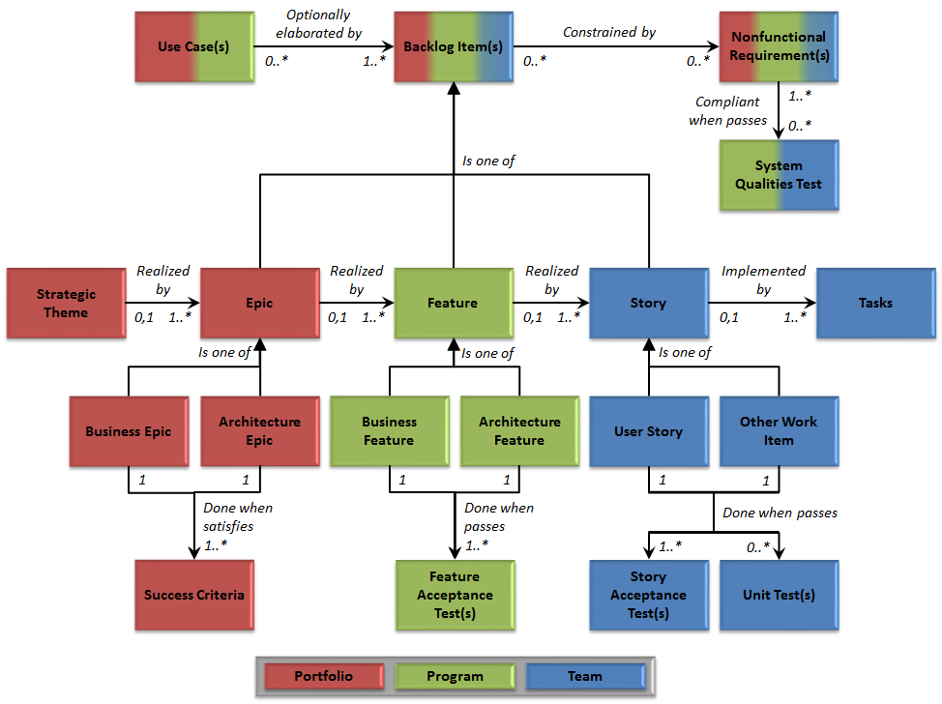
Figure 4-2: SAFeTM Data Model

Roles and Responsibilities
This section defines the roles and responsibilities associated with the Program level. Figure 4-3 depicts a RACI matrix that relates these roles and responsibilities to the Program level process workflow steps from Figure 4-1. A Responsible, Accountable, Consulted, Informed (RACI) matrix is an acronym that associates process activities with the following types of roles:
- Responsible (R – who performs the work)
- Accountable (A – who has approval authority of the work)
- Consulted (C – who provides feedback and/or contributes to the work)
- Informed (I – who requests to be informed of the work)

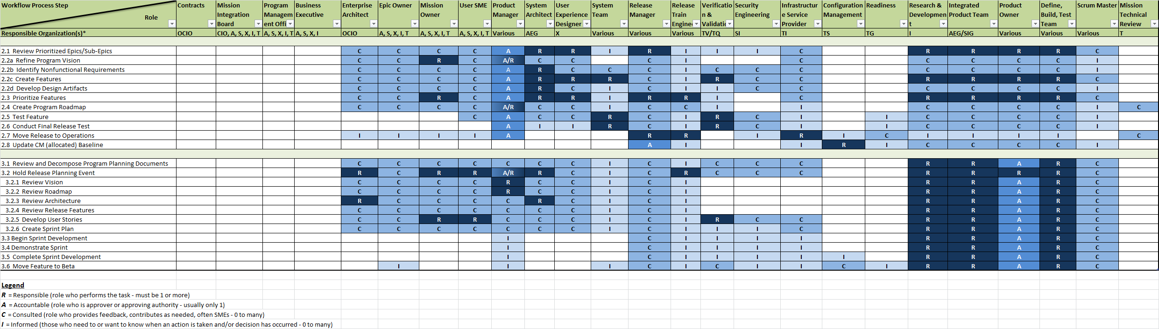
Figure 4-3: RACI Matrix

Product Management Team
The Product Management Team includes the Product Manager, System Architects, User Experience Designers, System Team, and Product Owners. In general, the Product Management Team acts as the authority for the content of a release on the Agile Release Train to maximize the successful delivery of Features, and is the owner of the Program Backlog, Features, priorities, and acceptance criteria for Features.
The Product Management Team has the responsibility to scope, bound, define, design, and prioritize the Program Backlog, as well as to work with the Release Management Team, Epic Owners, and DBT Teams to optimize Feature delivery to the customers in balance with the enterprise’s technical and economic objectives. The Product Management Team is also responsible for identifying JARM Technical Services Taxonomy (TST)/Technical Services Category (TSC) and JARM Geospatial Intelligence (GEOINT) Reference Architecture (GRA) TSCs. NGA Systems Engineering and architecture support is required to support building and maintaining the program Vision, Program Backlog, and Roadmap. Systems Engineering support is also needed for defining Nonfunctional Requirements that contain standards and guidelines, as well as developing and maintaining program Design Artifacts.

Product Manager
The Product Manager is the government lead in charge of the Program Backlog, Features, and priorities. The Product Manager works with the Mission Owners and Epic Owners to understand user priorities, works with the Release Management Team to approve the prioritized list of Features for the release, and works with the Product Owners during the Release Planning Event by arbitrating resource conflicts. The Product Manager works with the Release Management Team prior to and during the Release Planning Event to ensure that Features from the Program Backlog are being worked by individual DBT Teams for development. The Product Manager serves as the “content authority” for the Agile Release Train. The Product Manager is accountable for the following:
- Formulate a unified Vision based on input from multiple stakeholders
- Develop the product Roadmap with support from the Product Management Team and Release Management Team
- Approve all Features, ensuring that each Feature has clear and complete acceptance criteria
- Determine what is built through the Program Backlog
- Prioritize the Program Backlog
- Define done for Features
- Accept or reject work results for the program
The Product Manager also works with the Program Portfolio Management Team (described in the Portfolio Level Agile Process). In this role, the Product Manager provides support to help the Portfolio level estimate Epics as needed.

System Architect

- When defining architectural Features, the System Architect is the main point of contact for creating the Features and pulls in the DBT Team members as needed to elaborate any technical components of the Features (see Figure 5-1).

The System Architect supports “Programs, and has the responsibility for maintaining a high level understanding of the user’s Vision for what the subject system needs to do, as well as maintaining and evolving an understanding of the implementation framework necessary to support current and upcoming user needs.
… System Architects … fulfill the following primary responsibilities:
- Work with customers, stakeholders, Product Manager and Product Owner to understand and maintain a high level understanding of the current and upcoming requirements for the system
- Understand and communicate the Nonfunctional Requirements for the system
- Evaluate design alternatives, and perform cost benefit analysis
- Develop and maintain whatever models and documentation are necessary to describe how the system does what it is intended to do, including recommended … [Design Artifacts]
- Define and split architectural Epics into Features for the Program Backlog, and allocating respective items to the individual Team Backlogs for implementation
- Present the technological Vision for the solution during … [Potentially Shippable Increment (PSI)]/Release Planning, provide domain models and exemplary Design Artifacts that describe larger system behavior, and participate actively and interactively during the PSI planning process
- Serve as a resource to help the teams make appropriate system and component level design decisions during implementation
- Work with Enterprise Architects at the Portfolio level to establish Architectural Runway in support of upcoming user and business needs”
The System Architect needs to work with the Enterprise Architect and DBT Teams to ensure that it creates designs that advocate a highly cohesive and loosely coupled architecture. High cohesion means that a specific component should be focused on performing strongly-related tasks. Loose coupling means that a change in one component does not require a change in all the components that use that one component.

User Experience Designer
The User Experience Designer is involved with the quality of the end-users’ interactions with a website or application. The User Experience Designer ensures that the end product has a consistent NGA user experience, look-and-feel, and behavior (rewarding, simple, and intuitive). The User Experience Designer is concerned with presentation, functionality, content, language, help and support, Feedback, consistency, error management, visual clarity, navigation, and interaction in the use of products, applications, and services.
The User Experience Designer is a software engineer that integrates user knowledge, user-centered design, and user testing into a methodology that works. The acid test of the quality of the user experience is that the user should want to return to the online capability because of the Features it offers, its ease of use, and the frequency that the user is interacting online. The value delivered is a product that the user finds easy to learn, intuitive, has reduced errors, has reduced training time and effort, and has reduced user reported defects.
User experience is an important factor in Graphical User Interface (GUI)/widget design, and in web and product design. User experience is factored in as early as possible before the freezing of the User Interface (UI) design, and ideally, even before freezing of the requirements and scope. The User Experience Designer is responsible for creating GUI mock-ups for inclusion in the Design Artifacts; they are also be involved in the creation of the Nonfunctional Requirements.
X provides leadership and commitment to the User Experience Designer. The Product Owner should understand the users’ specific usability requirements. DBT Teams must be able to apply usability guidelines throughout the design and development of User Stories. The System Team and Verification & Validation Group evaluate products for usability defects.

System Team
The primary focus of the System Team is to ensure that Features work as required to satisfy the stated system-level objectives, and that the current release/iteration did not break other Features. The System Team is also responsible for providing assistance with integrating code from the DBT Teams, testing platforms, test automation frameworks, performance testing, and performing end-to-end system testing.
Throughout the Program Level Agile Process, the System Team is included in Feature elaboration discussions conducted by Epic and Product Owners. The System Team is informed about decisions regarding the content of a release, which includes the Program Backlog, Features, and prioritizations through the Release Planning Event. The Mission Owners/User Subject Matter Experts (stakeholders/users to review the Feature acceptance criteria) and System Team/Verification & Validation Group (to create and review the Feature acceptance criteria) (see the Feature Acceptance Criteria field below in the Feature Template) provide an evaluation and recommendation of Feature acceptance criteria to the Product Manager during the Release Planning Event.

Product Owner

- The Product Owner is a Team level role; each DBT Team has a Product Owner.
- The Product Owner is to the DBT Team, as the Product Manager is to the Program.
- When defining Features, the Product Owner pulls in the DBT Team members as needed to elaborate any technical components of the Features (see Figure 5-1).

The Product Owner is the team's key stakeholder: a government representative that has the ability to convey this Vision and understand what needs to get built. The Product Owner defines the DBT Teams’ priorities for each sprint. The Product Owner is accountable for the following at the Team level:
- “Gather input about what to build
- Understand the relative value of each item
- Create prioritized list based on value, size, risk and other considerations
- Provide context to the team
- Allow the team to make their commitments
- Inspect functionality to identify done
- Adjust the [Team] Backlog and release dates based on opportunities, constraints and risks to optimize ROI
- Maintain & communicate a clear release acceptance criteria and release burndown
- Abnormally terminate sprint in extreme circumstances [(under the direction of the Product Manager)], otherwise don’t disrupt the team during a Sprint except when termination is required”
- Approve all User Stories (including Spikes), ensuring that each User Story has clear and complete acceptance criteria
- Organize and prioritize the Team Backlog
- Define done for User Stories
- Accept or reject work results for the team
- Develops Sprint and Release Objectives for the team
- Responsible for the ROI (mission value) of the team’s products
- Managing Discrepancy Reports (DRs) from operations and Verification & Validation Group, and coordinate the work-off of Discrepancy Reports with the appropriate Scrum Master
- Inspect and ensure that the Apps Tracker Spreadsheet (ATS), deployment package ZIP file, and supporting documentation is thorough and complete in support of Testing and Configuration Management; once the package has been verified as complete, it is forwarded to the Product Manager for review and placement in JIRA
More details are defined in the Team Level Agile Process.

Release Management Team
The main jobs of the Release Management Team are to assist the Product Manager with planning releases, negotiate the set of Features that get allocated to releases, roll up DBT Team Sprint Objectives into Release Objectives, communicate release burn down, ensure that Testing is passed, and obtain approval to release to operations. The Release Management Team is also responsible for managing and scheduling synchronized PSIs/releases across one or more programs. Members of this team could also be called “Release Coordinators” or “Release Facilitators” because their main responsibility is to coordinate and facilitate the delivery of productized software developed by the Agile Release Train to NGA operations for deployment into the production or staging environments.

Release Manager
The Release Manager has the primary objectives of ensuring the release commitments are delivered, and supporting the creation of the Roadmap. The Release Manager performs release management of all scrum teams, and coordinates with the Product Manager. The Release Manager works with the Product Manager and Product Owner to ensure the Program Backlog has complete Features, and teams have generated User Stories during the Release Planning Event. The Release Manager also facilitates meetings to identify cross team synergies, conflicts, and bottlenecks. The Release Manager is responsible for negotiating the alignment of Features into releases to be worked on by the individual teams at the Team level. After development is complete, the Release Manager is responsible for ensuring that the PSI/release has been accepted by the users, System Team, Verification & Validation Group, Security Engineers, and is approved to go to operations.

Release Train Engineer
The Release Train Engineer is responsible for ensuring that the Features in the Program Backlog are prioritized, supporting the creation of the Roadmap, and facilitating the cadence of the Agile Release Train. The Release Train Engineer is the Scrum of Scrum Master for the Agile Release Train. “Generally the Release Train Engineer reports progress to the Release Management Team on a weekly basis, with working system software being the primary measure of progress. With proper tooling, reporting is also facilitated by the release burn down chart and feature status report.”

Mission Owner
The analysts from Analysis (A), Source (S), Xperience (X) and IT Services (T) are the most relevant stakeholders, but due to their other roles and responsibilities they are represented in this process by their corresponding Technical Executives (TXs). Mission Owners (normally A, S, X, and T TXs) have the ultimate responsibility for the value delivered by a specific Agile Release Train. They are responsible for understanding the Budgets that drive the train, have knowledge of the current mission and business context, and are involved in driving or reviewing the program Vision and Roadmap. The Mission Owners are also responsible for assigning mission value to Sprint and Release Objectives.
TX designated representatives are also referred to as Mission Owners. The Mission Owner is responsible for identifying User Subject Matter Experts that understand specific user needs, beyond the expertise of the TXs. The Mission Owner also collaborates with the Epic Owners, Program Portfolio Team, Product Management Team, Product Owners, and DBT Teams, as needed, to support the elaboration of Epics into Features and Features into User Stories. The Mission Owner is accountable for the following:
- Develop the program Vision
- The Mission Owners/User Subject Matter Experts (stakeholders/users to review the Feature acceptance criteria) and System Team/Verification & Validation Group (to create and review the Feature acceptance criteria) (see the Feature Acceptance Criteria field below in the Feature Template) provide an evaluation and recommendation of Feature acceptance criteria to the Product Manager during the Release Planning Event
- Assign mission value for the objectives at the Release Planning Event
- Determine mission value for the objectives at the PSI demo to the users
A Mission Owner is a separate role from an Epic Owner; however, a Mission Owner can be an Epic Owner as well. The role of the Epic Owner is be defined in the Portfolio Level Agile Process.

User Subject Matter Expert
The Mission Owner is also responsible for identifying and providing users that understand specific User Stories beyond the expertise of the TXs. The User Subject Matter Experts are the most relevant stakeholders, but their time must be utilized judiciously due to their other roles and responsibilities. Ideally, each Feature would have a User Subject Matter Expert which developers could coordinate with to answer any questions and ensure that the development is headed in the right direction. The User Subject Matter Experts assist with the following areas:
- Be able to address a specific Feature from an enterprise view versus a working group view
- Assist with developing acceptance criteria for the Features and User Stories
- Assist with clarification of acceptance criteria
- Assist with development Testing (Unit Tests done prior to System Test and Independent Verification & Validation)
- Provide Feedback on Features

DBT Team
The DBT Teams are found at the Team level. NGA DBT Teams are cross functional teams consisting of a Product Owner, Scrum/Agile Master, Systems Engineer, and Developers and are fully capable of defining, building, and testing increments of customer mission value in a short time box. Including System Engineers enhances the DBT Teams' ability to support the Product Manager and Product Owner for Feature and User Story decomposition, increases program efficiency and transparency by engaging teams early in emerging design and architecture. Systems Engineers also improve communication, as well as reduce hand-off interactions between the Program level (engineering) and Team level (development).
DBT Teams can be organized into Feature Teams or Component Teams, and should be co-located. A Feature Team focuses its efforts on developing code for a single Feature, or set of Features. The Feature Team works on the Features, cutting across the various components in the Architectural Runway. In this situation, a single Feature is allocated to a single DBT Teams for decomposition and implementation. A Component Team focuses its efforts on implementing all of the User Stories for a specific, specialized component. The Component Team is usually comprised of SME developers that are very familiar with the component code. In this situation, a single Feature is allocated to multiple DBT Teams for decomposition and implementation.

Verification & Validation Group
The Verification & Validation Group is comprised of two offices: the TV office is the NGA Test Organization (NTO), and the TQ office is the NGA Image Quality and Utility (NIQU). Throughout the Program Level Agile Process, the Verification & Validation Group is included in Feature elaboration discussions conducted by Epic and Product Owners. The Verification & Validation Group is informed about decisions regarding the content of a release, which includes the Program Backlog, Features, and prioritizations through the Release Planning Event. The Mission Owners/User Subject Matter Experts (stakeholders/users to review the Feature acceptance criteria) and System Team/Verification & Validation Group (to create and review the Feature acceptance criteria) (see the Feature Acceptance Criteria field below in the Feature Template) provide an evaluation and recommendation of Feature acceptance criteria to the Product Manager during the Release Planning Event.
The primary focus of the NTO is to ensure that the new interfaces work as required to satisfy the stated system-level objectives, and that the current release/iteration did not break any interfaces to other systems or Features. The NTO is also responsible for providing assistance with testing platforms, test automation frameworks, performance testing, and performing end-to-end system testing. NTO Agile Independent Verification & Validation is be led by the Agile engineering Test Director (TD) and Deputy Test Director (DTD). Each Agile Release Train has a TD and DTD. Enterprise Independent Verification & Validation has its own separate TD and DTD. Available NTO test engineers (including a cast of test support roles, Discrepancy Reports management, document Quality Assurance (QA), etc.) are tasked to assist the TD and DTD in Testing.
On the other hand, the primary focus of the NIQU quality assurance activities, separate from the NTO, is to verify the accuracy and utility of the delivered software products subject to use by the Intelligence Community (IC) for intelligence based decision-making. NIQU maintains an informed presence within the Team level (sprint) and is postured to provide surge support to TV as needed. TQ provides and advises developers of enterprise image product quality data standards to aid in the development of effective capabilities. An informed presence at the Team level affords TQ the insight to determine what capabilities fall within their area of core responsibility. The Nonfunctional Requirements that deal with product quality are provided through the PQ ORC. The PQ ORC documents the enterprise standards that TQ uses to assess capabilities, and developers use to build capabilities. TQ has points of contacts for the PQ ORC. Utility is assessed by such measures as National Image Interpretability Rating Scale (NIIRS), which defines the utility achieved at different levels of quality. NIQU achieves its mission by providing unbiased system engineering, test and evaluation services to the IC. NIQU specialties include: imagery analysis/science, statistical/metric analysis, systems engineering, imagery standards and scales. In support of the IAE, Desktop Environment, and the IC ITE, NIQU performs the following tasks:
- Ensures widget & application output accuracy
- Assesses pre-release and post-release apps and widgets
- Assesses usability and utility of the IAE, from the perspective of both the GEOINT producer and the GEOINT consumer

DevOps Team
The DevOps Team is a primary interface between development and operations, and includes the Security Engineers, Infrastructure Service Provider, Configuration Management, and Readiness. The DevOps Team ensures that the system is ready for deployment to NGA operations, coordinates infrastructure, provides assistance with managing versions of code from the programs, and facilitates the Operations Readiness process for deployment in operations.
The DevOps Team is also responsible for enabling the flow of products from the NOW Alpha environment to the NOW Beta environment to operations. This team manages and maintains the development application service platforms, including development platforms (NOW Alpha environment), test platforms (NOW Beta environment), Configuration Management, version control, and governance and management tools (e.g. JIRA, Greenhopper, Bamboo, Fisheye, Crucible, Confluence).

Security Engineer
The Security Engineer works in the Office of the Chief Information Officer (OCIO) and has the responsibility to coordinate with the Product Management Team to ensure that the aims of information security management are met. The Security Engineer can stop functionality from proceeding to operations whenever the PSI/release does not meet security processes and standards. These include the Certification and Accreditation (C&A) process, Hewlett-Packard (HP) Fortify scans, the Agile Application Assurance (AAA) form, as well as Certification to Field for capabilities being deployed to operations.

Infrastructure Service Provider
The Infrastructure Service Provider (ISP) is responsible for developing and maintaining
IT infrastructure and Information Services (IS) for the NSG. The Infrastructure Service Provider delivers IT infrastructure services such as application hosting, transport, storage, enterprise management, and common services and applications (e.g., email, office automation). The Infrastructure Service Provider is consulted by the System Architect to help define Nonfunctional Requirements, create architectural Features, and develop Design Artifacts.

Configuration Management
The Configuration Management group is comprised of members from the Schedule & Configuration Management Division (TTK) within AEG at NGA. This group is responsible for ensuring that the Configuration Management Process is being followed at each of the respective levels within the Agile process. Each individual playing a role in the Agile process is also responsible for their own piece of the Configuration Management Process. As an idea (Epic, Feature, Story, etc.) evolves and is worked though the NGA Agile process, each person who touches that idea must be sure to document their piece as outlined in section 4.4.1. Whether you are a System Architect, Developer, or tester, the Configuration Management group must ensure that you have documented your piece and point to it.

Readiness
Readiness is a major component of the mitigation and management of risk. Prior to the completion of a PSI/releases, the Product Manager will complete a prescribed checklist (see section 4.4.3) which identifies the key functionalities and assesses an overall readiness to move the software forward into operations. The checklist ensures that the product meets the user’s needs and the NGA strategic implementation of the DoD acquisition best practices.

Research & Development
The existing model has InnoVision as its own Agile DBT Team (with a Product Owner). An alternative approach is to include a Subject Matter Expert (SME) from InnoVision sitting on an existing DBT Team (supporting the Product Owner) and providing guidance. The intent is that InnoVision matrixes in-and-out of Agile DBT Teams. While InnoVision may not be the expert for how to deliver code, they are the SMEs of how to improve the code (e.g., algorithms). In this new model, InnoVision acts as the forward thinking pieces vice the actual development. InnoVision can “deliver” a prototype to end-users as a DBT Team approaches a PSI, though the prototype might not be delivered to NGA operations. The idea is to have InnoVision evaluate early and often using users (e.g. NOW Beta environment, GIAT servers). InnoVision should also be leveraging interactions with the Mission Owners at the Portfolio level.

Integrated Product Team
For Agile, the role of the Integrated Product Team is to staff the DBT Teams on the Agile Release Trains, provide a venue to coordinate between Agile Release Trains, and manage Operations and Sustainment (O&S) of capabilities that have completed development and are fully deployed to NGA operations. O&S occurs when an Agile Release Train ceases to exist, yet the functionality is still in used by NGA.

Governance
Governance is imposed on the Program level via a Configuration Management Process, Control Boards, and Operations Readiness.

Configuration Management Process
Figure 4-4 shows a high-level overview of the Configuration Management Process at all three levels. In order to completely capture the appropriate baseline management at the Program level, every product must maintain versions of the following documents for each release baseline using a Configuration Management Process tool:
- Vision – This document are maintained using Microsoft© SharePoint, or another file system Configuration Management Process tool.
- Design Artifacts – These documents may be captured in a separate tool, but the use cases, interface artifacts, and/or metadata files are be maintained in Microsoft© SharePoint. These documents may be updated based on input by the DBT Teams after the Release Planning Event.
- Nonfunctional Requirements – These items are maintained in JIRA.
- Features – These items are managed in JIRA as Program Backlog items.
- Roadmap – This document is a dashboard maintained using JIRA and/or Microsoft© SharePoint; it shows the high-level Features for the releases.
- Agile Release Train – This project file is maintained using Microsoft© SharePoint/Project Server, or another file system Configuration Management Process tool.
- Testing – The outcome of these activities is managed in JIRA and/or Microsoft© SharePoint.
All of these documents are explained in greater detail in the sections that follow. If the development code for a particular release needs to be rolled back a previous state, then the documentation for that previous state should be able to be rolled back as well.

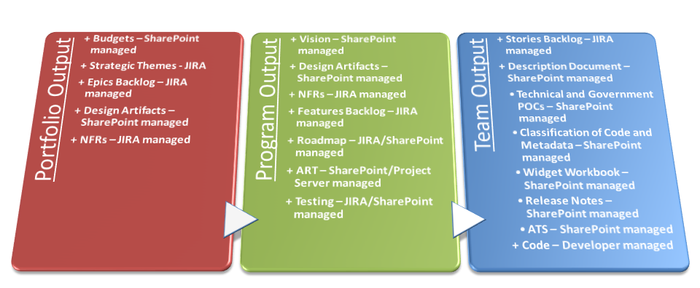
Figure 4-4: Configuration Management Process
- The ATS identified at the Team level was previously named the ER2 Spreadsheet.
- The Description Document identified as output at the Team level is the responsibility of the Release Manager from the Program level. This document will be maintained in the CM Library.

The NGA Agile engineering process does not involve the creation of a Request for Change (RFC) to act as approval to make changes to the release baseline. It does, however, involve the creation of a virtual RFC at the end of major milestones (e.g. version 1.0, 2.0, etc.) to “snap the line” on the baseline (documentation and code) after the fact; this type of RFC is considered “as built.” The virtual RFC process allows updates, modifications, and developments to be coordinated and approved in an expedited process. The steps of the traditional RFC process are modified to allow adequate coordination as required, without the need for the RFC to move through unnecessary steps.

Control Boards
The Program level seeks feedback for the Roadmap from the Mission Technical Review Board (MTRB). The purpose of this meeting is to get another perspective on the current and planned technical outlook of the product. A detailed view of the Roadmap is depicted in Appendix E: Roadmap Template.
The Program level also seeks Operations Readiness approval to promote a PSI/release to operations. The purpose of this approval is to ensure that the product meets the NGA strategic implementation best practices, as well as to help mitigate and manage risks.

Operations Readiness
Prior to sending a PSI/release to operations, the DevOps Team completes the following governance checklist which assesses an overall readiness to promote the Features from the NOW Beta environment into the operational environment:

- With respect to the Integrated Analytic Environment (IAE), the Application Services Governance Board (ASGB) performs the function of the DevOps Team to declare operational readiness.

- Has the Product Manager accepted the promotion of the Features to operations?
- Do the components being exposed and/or delivered (e.g. thick client applications, web apps, user-facing web services, mobile web, native mobile apps, scripts, plug-ins, widgets, etc.) have complete descriptions and/or metadata?
- Do the Features function as described, with all priority 1 and 2 Discrepancy Reports resolved and closed?
- Have the assets (e.g. applications and their endpoints, widgets and their launch URLs and icon endpoints, web services (Web Services Description Language (WSDL), Extensible Markup Language (XML) Schema Definition (XSD), and endpoints), etc.) being exposed and/or delivered been registered in the Enterprise Registry and Repository (ER2) (e.g. ATS)?
- Have all applicable legal analysis/approvals (e.g. Office of General Council (OGC), etc.) been completed?
- Have all applicable security analysis/approvals (e.g. C&A, HP Fortify scans, AAA form, Certification to Field, etc.) been completed?
- Has all applicable Testing (Unit Test, System Test, and Independent Verification & Validation) been completed?
- If applicable, are the appropriate web metrics (e.g. Open Web Analytic (OWA) code snippet, etc.) being captured?
- Are there appropriate licenses and/or operational support agreements in place and under Configuration Management Process control (e.g. SLAs, MOUs, etc.)?
If all of the items on the Operations Readiness checklist are not met, then the PSI/release is returned to the Program and does not go to operations.

Process Details
The following sections provide high level descriptions, the actors, detailed instructions, and the templates used to create the Program level artifacts required for Agile engineering.

Vision
The Vision focuses efforts related to the system, application, or product. When defining the Features or high-level capabilities, it should also answer the following questions:
- What is the problem?
- Who does this benefit?
- What are the capabilities provided?
- What system qualities (Nonfunctional Requirements) are included?
- What browsers, standards, applications, and baseline functions does it support?
The Vision is an outcome of NGA’s business and portfolio investment strategy. The Vision should communicate the strategic intent for the program and answer the questions as to what the end environment should be. The Vision should be at the Program level and contain a set of prioritized capabilities or Features that provide a solution to the problem and benefit the users. Included in the Vision are the system qualities, which are the Nonfunctional Requirements (e.g. reliability, accuracy, performance, quality, compatibility standards) that also support the solution. The Vision is critical in defining the capabilities or Features, as well as aligning the teams to a common objective.

- If a new program is being stood up (see section 2, 4.a.), the first Vision is created to articulate the need for the program.

The Product Management Team must continually define and communicate the Vision at the Program and Roadmap level, so that all have the same focus. Since Agile is not using Product Requirements Documents (PRDs) or Software Requirements Specifications (SRSs), communicating the Vision directly to the DBT Teams becomes a critical function.
The high-level capabilities or Features are defined as: services provided by the system that solve the problem. The Features are at a level above software requirements, and provide a high-level description that simplifies the solution while still communicating the full scope and intent of the proposed solution.
The high-level capabilities or Features also provide a focus. Features or high-level capabilities can be described in a user story form because the user role and benefit are more clearly described. Understand that the Features identified in the Vision are written at a higher level of abstraction—consider them estimating Features, high-level capabilities, or objectives.

Roles and Responsibilities
The Product Manager is accountable for the Vision. The Product Manager and representatives from the Mission Owners group are responsible for creating, owning, and maintaining the Vision of the products, systems, or applications. The Mission Owner is responsible for ensuring that the Vision meets the needs of the stakeholders within their area of interest. The Product Owner works closely with the DBT Teams and User Subject Matter Experts to implement the Vision. The Product Owner sets the priorities based on the Vision and where the team needs to be a few iterations later.

Process Steps
At the Program level, the Vision is used to continuously update and communicate the intent of the program, and uses a number of different documents for capturing this critical information:
- Create Vision Document: A Vision document is a well-defined document that teams use to communicate the individual components of the Vision. By building this document, the team is allowed to test their own understanding of what they are about to develop, who uses it, and how they use it to do their jobs. The document should be about 5 to 10 pages (20 maximum for a large system).
- Create Basic Data Sheet: The Basic Data Sheet can be developed in parallel with the Vision document. The sheet builds the business case and includes an understanding of the user’s needs; the key benefits a proposed solution is to provide; the platforms and operating environments that must be supported in the user’s environment; and the key performance, compatibility claims. It is a very preliminary, basic data sheet that is used to start to define, at a high-level, what the product does and for whom it is intended to do it. The sheet should be 2 pages and focus on what is critical to communicate.
- Create Preliminary NGA Release: Drafting a Preliminary NGA Release causes the team to think through the Vision from the standpoint of the way the solution will be described to NGA and IC. Included in the document is the clear articulation of the benefits to NGA analysts and IC. This document allows them to paint the Vision in the minds of those key stakeholders who are involved as the product approaches readiness. This document should be 2 pages.
- Create “Anticipated Feature Backlog” with Briefing: The Product Manager provides information as to where the project is headed, while simultaneously laying in priorities and estimates for future scoping of work. This includes a set of high-level Features that the Product Management Team anticipates would make it into this release.
- Refine the Vision.
These documents are used to build the Roadmap and communicate the Vision at the release planning meetings. These documents can be combined with a Vision briefing by the Product Manager, so the stakeholders and developers can visualize the outcome. Product Managers provide daily, face-to face Vision communication with Product Owners and the development teams in the periodic release planning events. Product Managers communicate the Vision in a stream of continuous and frequent small releases (typically, every 60 to 120 days), as dictated by the Agile Release Train. To support release planning, Product Managers should be well prepared for such events by meeting with Product Owners to discuss the preliminary Vision for the upcoming release. Product Managers should also update any Vision artifacts, and prepare a Vision briefing.
During the Release Planning Event, Product Managers should provide a briefing of the Vision. The briefing is followed by initial planning by the teams. If the Vision does not fit into the release time frame provide, then Product Managers need to work as a team to manage how to scope the priorities. Product Managers should also use the Roadmap as a primary way to communicate the way in which the teams intend to implement the Vision over time.

Template
The Vision Template is provided in Appendix A.

Design Artifacts
Architecture needs to be created at the Program level for Features. Architectural Design Artifacts include use cases (UML diagrams and/or DoDAF views), interface artifacts (e.g. ICDs, service specifications, SLAs, MOUs, etc.), and/or metadata.

- Not all Features need to have Design Artifacts. Design Artifacts should be created as needed, to convey to the development teams an understanding of what to build. If Design Artifacts already exists for a set of Features, then the architecture does not need to be recreated.

“For many years systems engineers have produced traditional system requirements specifications containing shall-statement requirements. The rapid adoption of use case modeling for capturing functional requirements in the software community has caused systems engineers to examine the utility of use case[s] ... for capturing system-level functional requirements.” “Use cases have been proposed and almost universally accepted by the software community as a requirements gathering and documentation tool that captures system requirements through generalized, structured scenarios that convey how the system operates to provide value to at least one of the system’s actors.”
There exists two methodologies that are currently used at NGA to create use cases: the UML diagrams and the DoDAF views. UML is lightweight, standard in industry, and industry engineers are typically familiar with this design approach. DoDAF is standard in government/military, and government engineers are typically familiar with this design approach.

Roles and Responsibilities
It is the responsibility of the System Architect to create and maintain the Design Artifacts for a product. The DBT Teams and Infrastructure Service Provider also play a role in developing the architecture. Once the initial versions of use cases are generated, they are then used as a tool to generate User Stories that can be implemented by iterations in the software. “To the agile developer or Product Owner, this can be helpful in understanding the larger context that can be lost when the teams focus on understanding ‘just one user story at a time.’” Use cases help the various stakeholders understand the context of a system including the customer, users, and development team. The use cases act as a bridge between the developer (since the Class Diagrams can be decomposed into code) and the customer (since the description, actors, and flow of events are high-level).

- Design Artifacts are created in collaboration with the Product Management Team; having this work done in parallel maximizes this collaboration. “There is no monopoly on innovation.”

Process Steps
Use cases are developed with the intent to capture the user actions, system responses, and flow of events that occur within a system. “A use case describes a sequence of actions that provide something of measurable value to an actor and is drawn as a horizontal ellipse.” Table 5-1 shows the minimum information that each use case must contain.

Description | UML Diagram | DoDAF Views
Shows the system/program broken up into object components, and depicts how the actor(s) are associated to the use case(s) | Use Case Diagram | - Operational View (OV)-1
Shows the various tasks and actions that a user takes for a particular use case | Activity Diagram | - OV-5  - Service View (SV)-4
Shows the interactions between the objects of a use case | Sequence Diagram | - OV-6c  - SV-10c
Table 5-1: Minimum Use Case Contents
The Use Case Report Template below should be followed in order to write the use case reports, which can be worked on in SharePoint and/or attached to Features in JIRA. The specific process used to complete the Use Case Report Template proceeds as follows:
- “Discover the system actors and their goals with respect to the system under design. The business model, also known as a Use Case Model (see the Portfolio Level Agile Process),] is a valuable input in accomplishing this task. The IBM RUP [2003] provides a nearly mechanical process for deriving system use cases from a business model.
- Use the actor goals to sketch out the use case report, concentrating on use case names and brief descriptions.
- Iterate on the important or architecturally significant use cases, filling out more and more detail in the reports and capturing alternative sequences of events, preconditions, and post conditions.
- In each use case report, document the nonfunctional requirements, typically performance, in the Specific Requirements section as they apply to each use case.”
- Whenever an interface is documented, include the appropriate interface artifacts (e.g. ICDs, service specifications, SLAs, MOUs, etc.), and/or metadata that will enable the DBT Teams to effectively develop the interface. This is particularly important for external interfaces.
- Work in collaboration with the Product Management Team to ensure that the use case relates to the Joint Architecture Reference Model (JARM). This means that the use case reduces duplication of effort, leverages existing architectural components, and new architectural components are accurately documented.
- Save the use case in JIRA.
- “Iterate on the use case set to ensure consistency and completeness as the program progresses”, repeating steps 1 through 7.

Template
The Use Case Report Template is provided in Appendix B.

Nonfunctional Requirements
Nonfunctional Requirements are the “ilities” that bound (influence) the Features in the Program Backlog. Nonfunctional Requirements focus on Reliability, Maintainability, and Availability (RMA), including numerous other “ilities” that can be considered. Nonfunctional Requirements are closely related to the Architectural Runway and architectural Features, since the Nonfunctional Requirements are considered design constraints on the system/program. The Nonfunctional Requirements are often necessary in order to meet certain rules that are imposed by regulations or standards that the system must meet.
Program level Nonfunctional Requirements can be broken down into Team level Nonfunctional Requirements. If the Nonfunctional Requirements for a system/program are not met, then Discrepancy Reports are often created which spawn other Program Backlog items.

Roles and Responsibilities
The System Architects are responsible for creating and maintaining the Nonfunctional Requirements. The System Team, Verification & Validation Group, DBT Teams, and Infrastructure Service Provider also play a role in developing these requirements. The Nonfunctional Requirements that deal with product quality fall within the purview of Verification & Validation Group/Image Quality and Utility (TQ), and are provided through the Product Quality Operational Readiness Criteria (PQ ORC). The PQ ORC documents the enterprise standards that TQ uses to assess capabilities, and developers use to build capabilities. The Verification & Validation Group ensures that the software satisfies the Nonfunctional Requirements through Testing.

Process Steps
The process for creating Nonfunctional Requirements proceeds as follows:
- Develop an initial set of Nonfunctional Requirements in the form of shall statements in JIRA.
  - Verify that the Nonfunctional Requirements are:
    - Bounded: If the Nonfunctional Requirements do not have bounds, then they can be irrelevant, too expensive, or impossible to meet.
    - Independent: Each of the Nonfunctional Requirements should be able to be tested without the consideration of other qualities or Nonfunctional Requirements of the system.
    - Negotiable: The Nonfunctional Requirements should be as specific as necessary, but not too specific that they are too expensive to meet. The creator of the Nonfunctional Requirements must be able to make a cost-benefit judgment to negotiate how specific the Nonfunctional Requirements require.
    - Testable: Each of the Nonfunctional Requirements must be able to be tested. A good way to ensure this is to make sure that they follow the Specific, Measurable, Achievable, Repeatable, and Testable (SMART) methodology, meaning that the Nonfunctional Requirements must use SMART criteria.
  - Perform an analysis to determine if the Nonfunctional Requirements will be implemented:
    - All-at-once: Some Nonfunctional Requirements must be implemented immediately, usually in order to meet some specific required business need.
    - Incremental story-by-story path: Other Nonfunctional Requirements can be implemented over a longer period of time or over many increments.
- At meetings, fill out the Nonfunctional Requirements Checklist, as described below, for each Feature.
- Transcribe the information from the Nonfunctional Requirements Checklist into JIRA (see the Nonfunctional Requirements ID field below in the Feature Template) for each Feature.
- Perform Testing of the Nonfunctional Requirements using performance and load testing, security testing, or other “ilities” testing. These tests usually involve the use of a set of testing tools.

Template
The Nonfunctional Requirements Checklist is provided in Appendix C.

Features
Features are “services provided by the system that fulfill one or more stakeholder needs.” Features are written as “key phrase[s] or user story voice form[s]. [Also, Features] may be elaborated with system use cases.” Additionally, Features are testable entities.
Budgets (identified at the Portfolio level) are realized by Epics (created at the Portfolio level), both mission and architectural. Epics are realized by Features (created at the Program level), which in turn are realized by User Stories (created at the Team level). All of these items, except for Budgets, are tracked as backlog items. The Program Backlog tracks the Features.
A User Story gets closed (see the Status field below in the Feature Template) when the Product Owner (at the Team level) marks the User Story as complete after approval from the Mission Owners. A Feature gets closed when the Product Manager marks the Feature as complete after all of the User Stories that are decomposed from the Feature are closed and Testing has validated and verified that the Feature passes its acceptance criteria (see the Feature Acceptance Criteria field below in the Feature Template). An Epic gets closed when all of the Features that are decomposed from the Epic are closed after approval from the Epic Owners.

- The Product Manager has the final decision as to whether or not a Feature is “good enough” to be marked as closed.

Roles and Responsibilities
It is the responsibility of the Product Management Team to create and maintain mission and architectural Features.

- The Product Manager has the final decision on what Features are within scope.

There are many inputs that are used by the Product Management Team to create Features: business Epics, architectural Epics, Use Case Model, Design Artifacts, Feedback, Mission Owners/User Subject Matter Experts (stakeholders/users to review the Feature acceptance criteria), System Team/Verification & Validation Group (to create/review the Feature acceptance criteria), DevOps Team (Infrastructure Service Provider to consult on hardware), and engineering studies, as illustrated in Figure 5-1. The Mission Owners/User Subject Matter Experts (stakeholders/users to review the Feature acceptance criteria) and System Team/Verification & Validation Group (to create and review the Feature acceptance criteria) (see the Feature Acceptance Criteria field below in the Feature Template) provide an evaluation and recommendation of Feature acceptance criteria to the Product Manager during the Release Planning Event. The System Team, Verification & Validation Group, and stakeholders need to be involved in the creation of Features early on in the process; this ensures a smoother transition to Testing for a program.

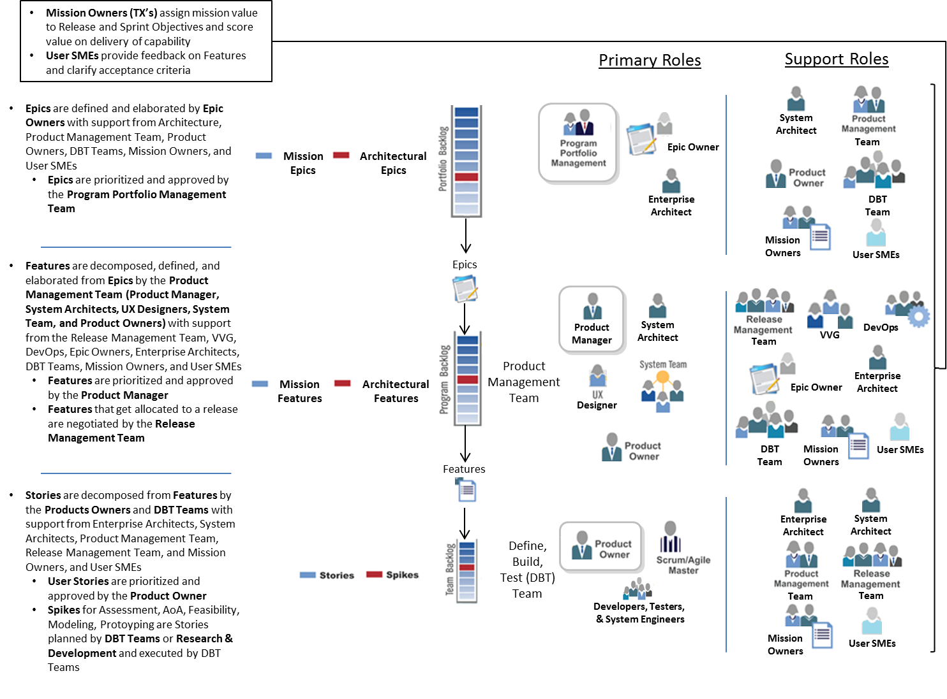
Figure 5-1: Epic, Feature, and Story Decomposition
Once assigned, the Product Management Team assumes the responsibility for decomposing the Epic into Features. Features are decomposed from Epics and defined in JIRA by the Product Management Team with support from the Release Management Team, Epic Owners, Enterprise Architects, DBT Teams, and User Subject Matter Experts. Features are prioritized by the Product Management Team and approved by the Product Manager.

- Features are created in collaboration with the System Architects; having this work done in parallel maximizes this collaboration. “There is no monopoly on innovation.”

It is the responsibility of the various Agile (DBT Teams) and non-Agile teams to work with the Program level (Product Management Team) to take ownership of Features, and the Release Manager to negotiate the alignment of Features into releases. The Release Train Engineer supports setting the teams responsible to implement the Features in JIRA (see the Team field below in the Feature Template). It is the responsibility of the Product Management Team to set the priority of the Features (see the Technical Value field below in the Feature Template), with the help of the Release Management Team Epic Owners, Enterprise Architects, DBT Teams, and User SMEs based on user input and a technical understanding of the Features.

Process Steps
The JIRA tool is used to track Epics, Features, and User Stories. The process for creating Features proceeds as follows:
- Gather input from the following various sources:
  - Business Epics – JIRA
  - Architectural Epics – JIRA
  - Vision
  - Design Artifacts – JIRA
  - Feedback – JIRA
  - Mission Owners/User Subject Matter Experts – talking to stakeholders/users to review the Feature acceptance criteria (see the Feature Acceptance Criteria field below in the Feature Template)
  - System Team/Verification & Validation Group – creating/reviewing the Feature acceptance criteria (see the Feature Acceptance Criteria field below in the Feature Template)
  - DevOps Team – Infrastructure Service Provider to consult on hardware
  - Engineering Studies – trade studies, analysis of alternatives, or other studies performed by the DBT Teams.
- Derive Features from the input. Features are written as short statements that describe a value-oriented need. Features fit into a single release (8 or 10 weeks), and are sized in story points (see the Estimated Story Points field below in the Feature Template).
An example Epic may be:
Create a word processing application.
An example Feature that would consequently be realized from that Epic may be:
Check spelling as you type.
Features or high-level capabilities can be described in a user story form since the user role and benefit are more clearly described:
As a …, I can get … so that I can … .
The previous Feature can be written in a user story voice form as:
“As a writer, I can get automatic notification of spelling errors as I write so that I can correct them immediately.”
The user story voice form looks very similar to a User Story, however the User Story focuses more on how the Feature will be developed.
An example User Story that would consequently be realized from that Feature may be:
As a writer, I would like to have misspelled words underlined in red and suggested spelling corrections provided in a pop-up menu so that I can correct them immediately.
- Complete the fields in JIRA for each Feature that is to be created based on the Feature Template below (see the JIRA Documentation).

- The collection of these Features in JIRA is known as the Program Backlog.

Architectural Runway
There are two types of Features: architectural and business Features. For new systems, architectural Features typically would be implemented first, whereas business Features would be implemented second. Typically, business Features would have dependencies on architectural Features (see Dependency IDs field below in the Feature Template) because business Features rely on the infrastructure and frameworks described by architectural Features. The idea that the architectural Features constitute the infrastructure and frameworks that the business Features ride on is known as the Architectural Runway.
Architectural Features are generated from architectural Epics, as well as the System Architects, Security Engineers, and other Program level engineering activities. An architectural Epic usually decomposes into mainly architectural Features. Architectural Features can also come from the Vision, Design Artifacts, Nonfunctional Requirements, other Features, engineering studies, and C&A requirements.

Program Backlog
The collection of these Features in JIRA is known as the Program Backlog. The Release Train Engineer is responsible for scheduling current Features into releases using the Agile Release Train. If the DBT Team has completed working on their current Team Backlog items for the current release, it is the responsibility of the Product Owner to notify the Release Management Team to get additional work (from the Program Backlog or other teams’ current backlog items). See the Agile Release Train section for more information.

Estimating
Story points are a “good enough” estimation which allows the team to quickly and fairly accurately estimate the amount of effort required to complete a work objective. Over time, the program will improve their ability to estimate, as they perform more releases and become more familiar with the Agile process. Table 5-2 shows the stages and input that the Product Management Team uses to estimate Features at the Program level.

Estimating Stage | Input | Output
Preliminary | - Product Management Team | - Estimated Story Points field below in the Feature Template
Refined | - Preliminary estimates  - Product Owners  - DBT Teams | - Estimated Story Points field below in the Feature Template
Final | - Refined estimates used by the Team level to create User Stories  - Automatically calculated in JIRA by summing the time spent of all User Stories that are decomposed from each Feature | - Actual Time Spent field below in the Feature Template
Table 5-2: Estimating Process
The Product Management Team can consider splitting complex Features, with high story points, into smaller Features, rated with lower story points. Appendix 1 – Method of Estimation in the Team Level Agile Process provides examples of how estimation is performed at the Team level. It is important to normalize estimating to understand what a story point means, so that performance metrics can be understood at the Program and Portfolio levels. Estimates of story points are made by comparing Features to one another, and leveraging story point estimates from similarly sized Features.
User Stories fit in sprints (2 weeks); Features fit in releases (8 or 10 weeks). Epics are independent and do not fit into a defined time box, however, Epics should not be more than 1 year in duration. Any Epic, Feature, or User Story that is larger than these durations should be considered for splitting.

Prioritizing
Prioritizing Features (see the WSJF Value field below in the Feature Template) can be a challenge where small decisions can have big impacts on implementation cost and timeliness of value delivery. Quantifying the value of Features is made even more complex by comparing and prioritizing items that are very unrelated. The Weighted Shortest Job First (WSJF) method is used by the Product Management Team and Release Management Team to prioritize Features:
- Work with the Mission Owner to assign a mission value for the Feature (see the Mission Value field below in the Feature Template). A 1 is the lowest, a 21 is the highest. If the Mission Owner provides a 1 to 3 bucket value:
  - A bucket value of 1 maps to a 21
  - A bucket value of 2 maps to a 5
  - A bucket value of 3 maps to a 1
- Leveraging the Architectural Runway (see the Architectural Runway section) and dependencies (see the Dependency IDs and Dependencies fields below in the Feature Template) for each Feature, work with the Product Management Team to assign a technical value for the Feature (see the Technical Value field below in the Feature Template). A 1 is the lowest, a 21 is the highest.
- Perform estimating (refer to the Estimating section) to assign estimated story points for the Feature (see the Estimated Story Points field below in the Feature Template).
- Using the WSJF value calculated by JIRA (see the WSJF Value field below in the Feature Template) and the dependencies (see the Dependency IDs and Dependencies fields below in the Feature Template) for each Feature, rearrange all of the Features in the Program Backlog in descending order from highest to lowest.

- If the WSJF method is not going to be used by the Product Management Team to prioritize Features, then the WSJF Value, Mission Value, and Technical Value fields can be replaced by a Priority field in the Feature Template.

Grooming
At the start of release planning, the Product Management Team and Release Management Team must tactically perform Grooming on the Program Backlog. This activity involves re-prioritizing the set of old Features; old Features are items that were not completed in previous releases. The teams follow steps 1 to 4 (see the Prioritizing section) to review the Features in the Program Backlog, update the appropriate fields in JIRA, and determine the new ranking of all Features.

- Any old Features that the Product Management Team and Release Management Team re-prioritizes in the Program Backlog are not worked until the next release. The teams are not allowed to re-prioritize the current set of Features being executed.
- In terms of the Agile Release Train, once the “train” has left the “station,” the “passengers” cannot be changed.

Discrepancy Reports

- Discrepancy Reports are not Features.
- Discrepancy Reports are linked to Features.
- Discrepancy Reports are an indication that a Feature has not been fully completed.

There are currently 2 sources of Discrepancy Reports:
- Verification & Validation Group (NTO and NIQU)
- Operations
Both sources of Discrepancy Reports use Remedy to track their Discrepancy Reports. It is necessary to identify those Discrepancy Reports in JIRA so that they can be included as "work to do," and map them to the correct Features and User Stories so that they can be worked off in the appropriate sprint. Discrepancy Reports can be worked off by the DBT Teams in any sprint during a release, but must be worked off prior to the end of the Error! Reference source not found. to be included in the current release.

- Once Discrepancy Reports are entered into JIRA by VVG, the intent of their meaning cannot be changed.

The Verification & Validation Group prioritizes Discrepancy Reports identified in Independent Verification & Validation based on the severity of the Discrepancy Reports’ impact; this priority is a primary consideration in determining the release/non-release of the discrepant work product. No capability with a Priority 1 or Priority 2 Discrepancy Report filed against it is allowed to proceed to Operations Readiness (see section 4.4.3) for recommended entry into the operational environment.
The Product Manager or Product Owner needs to map the Discrepancy Reports to Features or User Stories, respectively. The Release Management Team has the responsibility to map the Discrepancy Reports to the correct release according to the Agile Release Train. The prioritization of the Discrepancy Reports (as defined by the Product Manager with the help of the Product Owner and Mission Owners) determines where the Discrepancy Reports fit in the Agile Release Train.

- The Product Manager has the final decision as to whether or not Discrepancy Reports need to get worked off.

Discrepancy Reports that come from the Verification & Validation Group or operations and are of high enough priority need to be linked to Features in the Program Backlog and planned for in the Agile Release Train. Testing needs to occur for these Discrepancy Reports (refer to the Testing section).
At a minimum, Discrepancy Reports should contain at least the following fields in Table 5-3. The fields marked with an asterisk (*) are required.

Field | Description
*DR ID | A system generated unique identification number used to track Discrepancy Reports (system generated).
*DR Title | This is a high-level name used to identify the Discrepancy Report.
*Description | This is a detailed description used to understand the discrepancy for a Feature. It includes a description of how the Feature is currently working, as well as how the Feature should be working.
Program | The name of the program for which the submitter believes this Discrepancy Report applies (drop-down).
*Creator Name | The name of the creator of the Discrepancy Report (Product Manager, Product Owner, or user) (system derived).
*Creator Phone Number | The phone number of the creator of the Discrepancy Report (Product Manager, Product Owner, or user) (system derived).
*Creator Email | The email address of the creator of the Discrepancy Report (Product Manager, Product Owner, or user) (system derived).
*Date Submitted | The date that the DR was submitted (mm/dd/yyyy) (system derived).
*Priority | Number that indicates the urgency for which the Discrepancy Report needs to get implemented (drop-down: 1-4).  - Priority 1 is used for security and safety issues and operational activities where mission operations, production, or other priority activity cannot be performed.  - Priority 2 is used for activities relating to maintenance of existing operational capabilities, correcting deficiencies, prevention of personnel hazards and meeting program schedule commitments.  - Priority 3 is used for items that directly impact development and/or test activities and operational activities that are not of a priority nature.  - Priority 4 is for routine operational activities and improvements that have no direct impact on operations or production.
Table 5-3: Fields for Discrepancy Reports

- The complete definition of the data model to be used for Discrepancy Reports is out of scope of this document.

A fix for a Discrepancy Report can be developed by the DBT Team in any sprint, at the discretion of the Product Manager, Release Manager, and Product Owner. The completed fix then goes to Testing to be verified. After the System Team and Verification & Validation Group have verified the fix, the completed Feature gets promoted to operations according to the process in Figure 4-1. Patches are emergency fixes for Discrepancy Reports that cannot wait until the end of a sprint to make it into operations. This is typically the case with priority 1 and 2 Discrepancy Reports. The Product Manager, Release Manager, Product Owner, System Team, and Verification & Validation Group must work closely together to accept the need for a patch, and coordinate the development and testing of the patch.

Feedback

- Feedback collectively refers to all feedback and enhancement requests.
- Feedback is not Features.
- Feedback is linked to Features.
- Feedback is a request by a user or other stakeholder to improve or create a Feature.

All Feedback (from A, S, X, T, or any other NGA organization) needs to be entered into JIRA. Within JIRA, the Feedback maps to an existing Feature (Program level)/User Story (Team level). Feedback that does not map to an existing Feature, as determined by the Product Management Team, still gets entered into JIRA. The Product Management Team then needs to adjudicate the Feedback and make a decision whether or not to create a new Feature. If the priority of the new Feature is high enough and it does not map to an existing Epic, the Product Manager or Product Owner needs to flow the new Feature up to the Portfolio level to create a new Epic.
Feedback feeds into the Program level as sources to influence the creation of the Vision and Program Backlog Features. Feedback should be captured in a single location on each domain, such as a SharePoint web form. The Feedback from SharePoint eventually needs to be entered into JIRA. Any Feedback that is sent to the Product Management Team via email or face-to-face also needs to be entered into JIRA. A user can also enter Feedback into JIRA, if the user has been given access by the JIRA administrators. If the user enters the Feedback into JIRA, it needs to be edited and approved by the Product Management Team. Otherwise, the Product Management Team needs to use the information from the Feedback to map it to a Feature in JIRA and complete the remaining information in the Feature Template as described below.

Template
The Feature Template is provided in Appendix D; this table acts as the data model for JIRA. The fields marked with an asterisk (*) are required for creating a Feature. The fields marked with two asterisks (**), along with the fields marked with an asterisks (*), are required for submitting a Feature to the DBT Teams.

Roadmap
A Roadmap is a high-level plan that describes how the product is likely to grow. It is a “plan of intent” and communicates how the program is expected to unfold. It is subject to change as development facts, business context, and customer needs change. The Roadmap can provide the following key benefits to an organization:
- Help the organization communicate how to see the product develop.
- Help align the product and the organization strategy. By anticipating how the product is likely to grow makes it easier to secure a budget for the next fiscal year.
- Facilitates effective portfolio management and help synchronize the development efforts of different products.
- It supports and compliments the Program Backlog.

Roles and Responsibilities
The Product Manager is accountable and responsible for the product Roadmap and socializing it within NGA. The Product Management Team, Release Management Team, Enterprise Architects, and Epic Owners contribute. The Product Management Team sets the priorities based on the scope of the Epics, Program Backlog, and where the team needs to be a few iterations later.

Process Steps
The Roadmap is a continuously evolving artifact that is updated by the Product Manager as the Vision evolves and the release strategy forms. If a typical release is 8-10 weeks in length, the corresponding Roadmap provides roughly 6 months of dependable visibility (which includes the Committed Release and the Next Release). Anything beyond 6 months is unrealistic given the rate of change to business priorities. The Roadmap represents key release milestones and includes: high confidence visibility into the current and next release; medium confidence visibility into the release thereafter; and relatively lower confidence in the longer term commitment as business factors will likely change before that timeframe. Each milestone is described in terms of its objectives and/or those Epics/Features to be implemented.
In order to maintain the Roadmap, prioritized Features are grouped into four categories:
- Committed Release: Teams commit to one, and only one, release at the Release Planning Event via the Agile Release Train.
- Next Release (likely Release): The next targeted set of Features that are defined in a way to communicate intent, while also being abstract enough to allow teams to successfully commit and deliver functionality in a future release planning session. Roadmap detail for the next release is only provided at the level of Features.
- Next Release + 1 (Possible Release): Similar in nature to the Next Release, but further out on the horizon. Planned Features have a higher likelihood of being deprioritized in favor of a different set of Features as a result of a business, customer, or industry shift.
- Beyond: Anything beyond the Possible Release is difficult to accurately predict.
The first three categories comprise the program’s Roadmap.

Template
The Roadmap Template, provided in Appendix E, consists of the following:
- Each vertical box represents an upcoming release
- The label at the bottom represents the theme or primary objective of the release
- The Features are listed in prioritized order

Agile Release Train
“Framework’s primary scaling mechanism, the Agile Release Train, is to the program what an iteration is to the team. It follows the same pattern—plan, commit, execute, demo, and reflect—but at the Program Level where it produces system-level working software every two weeks, and full, potentially shippable increments of software every 4-5 iterations. In so doing [the Program level scales]:
- The backlog—by introducing Features and Nonfunctional Requirements as higher level artifacts
- The teams—by introducing Release Train Engineer, Product Management Team, System Team, Release Management Team, User Experience Designer and System Architect
- The timebox—scaling up to an 8-10 week timeframe
Release trains are organized around the enterprise’s significant Value Streams—those long-lived flows of value wherein an optimized development and delivery strategy creates the greatest economic benefit. From a lean perspective, the Agile Release Train aligns teams to a common mission, schedule, and cadence and helps implement continuous product development flow.”

- It is the responsibility of the program to define the length and number of iterations in a release.
- Agile Release Trains should try to synchronize their cadences where it makes sense to do so, in order to facilitate the completion of work (Epics, Features, and User Stories) and the delivery of releases.

The Program level “use[s] the ‘train’ metaphor to communicate a few key concepts.
- The train departs the station and arrives at the next destination on a reliable schedule (fixed cadence; standard velocity, predictable releases)
- It delivers its cargo to customers (release) or is used for internal evaluation and proof of incremental system robustness and quality (PSI/release).
- If an Agile Team wants its ‘cargo’ (code, documentation, etc.) to go, it has to put it there on time. The train will not come to them nor wait to get their content.
In this way, the Agile Release Train aligns the teams and helps manage risk and variability by providing program level cadence and synchronization. It is based on set of common operating principles:
- Frequent, periodic planning and release (or PSI/release) dates for the solution are fixed

- Dates are fixed – quality is fixed – scope is variable

- Scope and schedule are determined by the teams and the program (decentralized planning)
- Teams apply common iteration lengths and standardized velocities to support program level estimating, planning and integration
- Continuous integration is implemented at the system (Program), as well as at the Feature and Component (Team) level
- Tested system increments are available at sprint and PSI intervals
- … IP iterations may be used for specialized release level validation and testing
- Certain infrastructure components, such as User Experience Designer designs, interfaces, and common components must typically track ahead”

Roles and Responsibilities
“In addition to the Agile Teams, there are a number of key roles in this process.
- The full-time Release Train Engineer serves as the uber-Scrum Master for the train[.]
- The Release Management Team has the relevant governance authorities to make hard decisions on scope management and to understand and plan for the market impact of a release.
- Product Managers remain directly involved as well, and they work with Product Owners to actively manage scope and quality[.]
- The System Team … performs end-to-end system testing … [and] evaluates compliance with Nonfunctional Requirements… .
- User Experience Designer designers and System Architects help build and apply the Architectural Runway that supports new feature development as well as providing for common behaviors, common components, and separation of concerns through APIs.”
- The DevOps Team ensures that the system is ready for deployment to NGA operations, coordinates infrastructure, provides assistance with managing versions of code from the programs, and facilitates the Operations Readiness process for deployment in operations.
It is the responsibility of the Product Manager, Product Owner, Release Manager, and the development teams’ Scrum Masters to may make changes based on the current project context to ensure the priority Features are captured in a release.
The Agile Release Train is responsible for scheduling current and old Features into releases using the Agile Release Train. Old Features are items that were not completed in their original scheduled release. If the Product Owner’s team has completed working on their current Team Backlog items for the current release, it is the responsibility of the Product Owner to notify the Release Management Team to get additional work (other teams’ current backlog items).
At some point in the future, there will be multiple programs for which to allocate Epics at the Program level, and multiple DBT Teams for which to allocate Features at the Team level. Each DBT Team must effectively manage its own developers. If a team has any resource issues, the issues need to be raised to the development team’s Scrum Master and program’s Release Train Engineer at the Scrum of Scrums meeting described in Figure 5-2 (refer to section 5.6.2). The Release Train Engineer must also status and raise the issues to the Product Management Team and Release Management Team. It is the responsibility of the Release Management Team to ensure there exists synchronization (delivery of Features) between the multiple Agile Release Trains. The Release Management Team must work across programs to align their respective Agile Release Trains to achieve a higher goal.

Process Steps
The following steps are taken to maintain the Agile Release Train:
- Design the Train: “When implementing the Framework, one key activity is to determine the release train domain – i.e. who will be planning and working together, and what products, services, features, or components the train will deliver. In the smaller enterprise (or business unit within an enterprise) the domain consists of everyone on the team who will participate in the outcome. That is the easy case.
In the larger enterprise, there may be many dozens (or more) of such teams working on different solutions, and planning everything together may not be feasible or even desirable. In that case, multiple trains will be needed (one enterprise has 18 such trains), and it may also be convenient to align them on the same boundaries, so as to facilitate the implementation of cross-program epics. … Teams with Features and components that have a high degree of inter-dependencies should be on the same train. Wherever possible, train teams should be co-located, or as geographically proximate as feasible”.
- Plan the Release: This covers planning for the next release; the release planning activity should take approximately 8 to 10 weeks of time. The following activities are included in the next release planning:
  - Create/update the Vision
  - Create/update the Design Artifacts
  - Create/update the Nonfunctional Requirements
  - Decompose the Portfolio Epics into Features
    - Perform Program Backlog Grooming
    - Prioritize Features
  - Create/update the Roadmap

- If the Design Artifacts, Nonfunctional Requirements, and Feature are not completed in time, then the associated Feature does not go into the next release.
  - In this situation, the DBT Teams should plan for Spikes in the next release to complete the Design Artifacts, Nonfunctional Requirements, and Feature.
  - If no Features are completed in time, then the next release would contain only Spikes.

  - Attend the 2 day Release Planning Event to create User Stories with the DBT Teams (described in step 3.c.iii. below).
- Execute the Release: “Once planned, the responsibility for PSI execution resides with the [Agile Release Train] itself. Many of the specialty roles, responsibilities, and activities for keeping the train on the tracks are described in the section” above. Release execution involves the following steps:
  - The Agile teams develop the code to meet the Features that they committed to in the 2 day Release Planning Event (described in step 3.c.iii. below).
  - The Release Train Engineer runs a Scrum of Scrums meeting on a twice-weekly basis to obtain status from the DBT Teams. A suggested agenda for such a meeting is described in Figure 5-2.

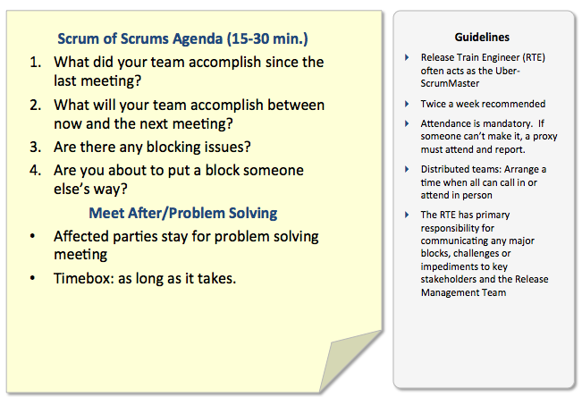
Figure 5-2: Sample Scrum of Scrums Agenda
  - The last iteration in a release is called the Innovation and Planning (IP) sprint. “Advanced scheduling of routine time for continuous education, Inspect and Adapt workshops and PSI/Release Planning is a hallmark of a maturing Agile enterprise. In many cases, this means that the two week … IP sprint takes on a standard schedule and format,” as is depicted in Figure 5-3.

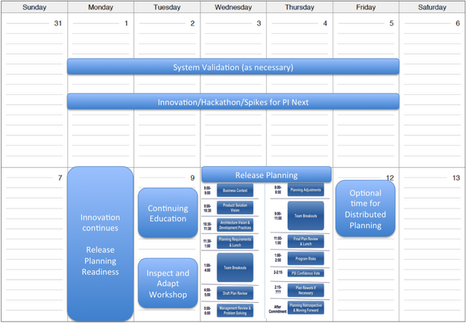
Figure 5-3: Typical Calendar for an IP Sprint

    - Innovation: “Many maturing Agile enterprises also recognize that Agile, as powerful as it is, is optimized for reliably delivering end-user value on a fixed cadence. Finding time for free association and innovation can be difficult as teams routinely operate under the ‘tyranny of the urgent’ iteration or PSI/release. To this end, many agile enterprises use periodic … IP sprints for research spikes, infrastructure work and even ‘hackathons’.”
“Hackathons” allow for creative solutions to be developed by members of the team, as long as they collaborate with other team members and build something mission related. This follows Google’s “20% time” philosophy that allows creativity, which ultimately creates a better product.
    - Planning: This step is also known as the Release Planning Event, and is the last step in the … IP sprint. This step involves hosting a 2 day Release Planning Event to allocate Features to the DBT Teams, as shown on the 10th and 11th in Figure 5-3. It is at this meeting that the DBT Teams commit to the Features that they will develop. More detailed information pertaining to the Release Planning Event is available below.
- Inspect and Adapt: “The PSI is ‘done’ when the PSI time box expires. (PSIs are analogous to Sprints; when the timebox is over, the Sprint/PSI is done). Each PSI is followed by a demonstration of results, determination of the Release Predictability Metric and other qualitative measures, and followed by a structured problem solving and corrective action workshop, all as described in Inspect and Adapt.” This activity involves hosting a 4 hour meeting to review and document lessons learned during the execution of the release.

Release Planning Event
The Release Planning Event (illustrated in Figure 5-3 and mentioned above) is a 2-day meeting where the DBT Teams commit to the Features that they will develop during the next release. The participants of the Release Planning Event are all of the people involved in delivering mission value to NGA and include: the Portfolio level (Epic Owners and Enterprise Architects), Program level (Product Managers, System Architects, User Experience Designers, System Team, Release Managers, Release Train Engineer, Verification & Validation Group, Security Engineers, and Infrastructure Service Provider), Team level (Product Owners and DBT Teams), and Mission Owners/User Subject Matter Experts. The high-level inputs to the Release Planning Event are: a defined product Vision, a prioritized Program Backlog, and completed Features, Design Artifacts, and Nonfunctional Requirements. The high-level outputs from the Release Planning Event are: prioritized User Stories in the Team Backlogs, a defined set of objectives for the release for each DBT Team, and any risks to completing development documented with mitigation plans.
More specific inputs to the Release Planning Event include:
- Scrum Master and Product Owner are identified for each DBT Team.
- All ART members are present. This includes a roll call and utilization of a Face Chart.
  - Mandatory:
    - Product Manager
    - System Architects
    - User Experience Designers
    - System Team
    - Product Owner
    - Release Manager
    - Release Train Engineer
    - Verification & Validation Group
    - Security Engineers
    - Infrastructure Service Provider
    - Epic Owners
    - Enterprise Architects
    - DBT Teams
    - Scrum/Agile Master
    - Developers, Testers, & Systems Engineers
    - Mission Owners
    - User Subject Matter Experts
  - Optional:
    - Configuration Management
    - Readiness
    - Research & Development
- Teams know their velocity, and have the ability to do story point estimating.
- The product Vision is defined, including the Architectural Runway.
- Design Artifacts and Nonfunctional Requirements have been created by the program.
- Design Artifacts and Nonfunctional Requirements have been reviewed by the DBT Teams.
- The program has decomposed Epics into complete Features.
- Product Management Team has agreed on the priorities of the Features. This includes a 1 to n list of priorities.

- If all of these inputs are not satisfied prior to the Release Planning Event, then it is the responsibility of the Product Manager to postpone the meeting until all of the items are completed.

More specific outputs of the Release Planning Event include:
- The content of all iterations has been planned, including prioritized User Stories in the Team Backlogs (see the Team Level Agile Process).
- The teams have identified dependencies (Features, User Stories, Architectural Runway, etc.), including critical dates and milestones.
- Each DBT Team has a defined set of objectives for the release.
- The Product Management Team has approved the DBT Teams’ release objectives.
- The IP iteration needs to be left open for innovation and planning appropriate work.
- Features that have not been committed to during the Release Planning Event remain in the Program Backlog to be re-prioritized/groomed.
- The DBT Teams have identified any risks to completing development.
- The Definition of Done has been communicated to the ART.

- If all of these outputs are not satisfied during the Release Planning Event, then it is the responsibility of the Product Manager to continue the meeting until all of the items are completed.

The Release Planning Event is described in detail below:
- DAY 1
  - 8:00 to 8:30 – NGA Context
    - The executive briefing is presented by the Mission Owner(s). The executive briefing contains high-level slides discussing the long-term direction of NGA and an introduction to the Product Manager(s) responsible for the product.
  - 8:30 to 9:00 – Product Vision
    - The current Vision for the product/solution is presented by the Product Manager(s) with support from X.
  - 9:00 to 10:30 – Architecture
    - The enterprise architecture is presented by the Enterprise Architect(s). The enterprise architecture should focus on the Design Artifacts for the Epics (see the Portfolio Level Agile Process) within the context of NGA at large.
    - The product architecture is presented by the System Architect(s), leveraging the Architectural Runway, Vision, and completed Features, Design Artifacts, and Nonfunctional Requirements. The product architecture should focus on the Design Artifacts for the Features that have been decomposed from the Epics, not on the Epics alone.
    - The Nonfunctional Requirements are presented by the System Architect(s), leveraging the Nonfunctional Requirements Checklists.
  - 10:30 to 11:00 – Program Backlog
    - The Product Management Team presents an overview of the Program Backlog, leveraging the Roadmap, previous technical debt, JIRA, Vision, and the completed Features, Design Artifacts, and Nonfunctional Requirements.
  - 11:00 to 12:00 – Development Practices and Planning Requirements
    - Changes that will be made to the development process that support agile engineering, such as continuous integration amongst all groups and standard practices, are presented by the Release Manager with support from senior development managers and/or Product Owners. This includes the Agile Release Train’s Definition of Done.
    - Changes that will be made to Testing, such as automation of Testing, are presented by the System Team and Verification & Validation Group.
    - Changes that will be made to security, such as HP Fortify being made available to developers and scan compliance, will be presented by a Security Engineer on the DevOps Team.
    - Changes that will be made to the ISP, such as the hardware and infrastructure needs of the product, are presented by the DevOps Team.
    - The planning process and success criteria are presented by the Release Train Engineer. The planning process success criteria are: the content of all iterations has been planned, the Users Stories are prioritized, the teams have identified dependencies (Features, User Stories, Architectural Runway, etc.) including critical dates and milestones, each DBT Team has a defined set of objectives for the release with Mission Owner assigned value for each objective, and the DBT Teams have identified any risks to completing development.
  - 12:00 to 12:30 – Lunch
    - Participants may bring their lunches back to the meeting.
  - 12:30 to 3:30 – Team Breakouts #1
    - The group divides up into their respective teams, along with the appropriate stakeholders (from A, S, X, and/or T), Enterprise Architect(s), System Architect(s), System Team, and Verification & Validation Group members to begin drafting their plans for the release. The planning process involves the teams (including both DBT Teams and non-Agile teams) estimating their velocity, agreeing on the Features assigned to them, creating Stories/Spikes based on their review of the Program level planning documents, raising any risks/concerns/dependencies that the Program level did not capture, and developing their Team PSI Objectives (see the Team Level Agile Process).
  - 3:30 to 4:30 – Draft Plan Review
    - The teams present their draft plan outputs to the entire group during this tight timeframe. This includes User Stories, dependencies, release objectives, and risks. The stakeholders (from A, S, X, and/or T), Product Manager(s), and other peers offer adjustments to the teams to be used during the Team Breakouts #2 the next day (see below).
  - 4:30 to 5:30 – Management Review and Problem Solving
    - The stakeholders (from A, S, or X), Product Manager(s), and Product Owner(s) meet to resolve any challenges that arose during the day, including agreeing on any scope questions. The Release Train Engineer facilitates this discussion, and all participants are required to stay until all challenges are resolved.
- DAY 2
  - 8:00 to 9:00 – Planning Adjustments
    - The Product Manager(s) describe any changes that were agreed upon the day before during the Management Review and Problem Solving (see above), and are necessary to ensure that the outputs can be achieved. This may include scope changes or resource adjustments.
  - 9:00 to 12:00 – Team Breakouts #2
    - Each team continues to develop their plans, utilizing the appropriate adjustments received during the Draft Plan Review from the previous day (see above). All of the teams’ outputs are finalized, and the stakeholders work with the teams to assign value to the User Stories so that the teams can produce prioritized Team Backlogs (Technical Value, Mission Value, and Estimated Story Points).
  - 12:00 to 12:30 – Lunch
    - Participants may bring their lunches back to the meeting.
  - 12:30 to 1:30 – Final Plan Review
    - The teams present their final plan outputs to the entire group during this tight timeframe. This includes User Stories, dependencies, release objectives, and risks.

- The teams must not attempt to resolve all impediments and risks during the Release Planning Event.

The stakeholders review and approve the final plans, and the Team’s Sprint/Release Objectives (see the Team Level Agile Process) and risks are aggregated together for all participants to see.
  - 1:30 to 2:30 – Addressing Program Risks
    - The Product Manager(s) lead a broader discussion and review of the aggregate risks and impediments that the various teams have raised. These risks and impediments are categorized into one of the following buckets:
      - “Resolved – The teams agree that the issue is no longer a concern.
      - Owned – The item cannot be resolved in the meeting, so someone takes ownership.
      - Accepted – Some risks are facts or potential occurrences that simply must be understood and accepted.
      - Mitigated – Teams can identify a plan to mitigate the impact of an item.”
  - 2:30 to 3:00 – Confidence Vote
    - Each member of each team provides a five-finger vote on the confidence that their team can meet its Team Sprint/Release Objectives (see the Team Level Agile Process), and deliver the User Stories that were developed. A vote of 5 is higher than a vote of 1. If the average vote for the team is 3 or above, then the Product Manager(s) should accept the team’s commitment. If the average vote for the team is below 3, then the team reworks their plan in the next step.
  - 3:00 to 3:30 – Plan Rework If Necessary
    - The teams rework their plans as long as necessary until the team is able to reach a commitment (average vote of 3 or above).
  - 3:30 to 4:30 – Planning Retrospective & Moving Forward
    - The Release Train Engineer facilitates a discussion with the whole group to go over what went well with the Release Planning Event, what did not go well, and what can be done in the future to improve the event.
    - The Release Manager provides an overview of the next major activities for the Program and Teams levels.

Template
Appendix F is a sample Agile Release Train Template, which shows how an Agile Release Train should execute. The template shows how development and Testing occur within iterations (two week sprints).
Figure 5-4 shows the Agile Release Train Template overlaid with the Portfolio and Team level cadence. This provides a clear understanding of the relationships and dependencies between all levels. All levels are operating on different releases in parallel; while the Team level and System Team are working on the current release (n), the Program level is working on planning the next release (n+1), and the Portfolio level is working on planning the next release after that (n+2). Figure 5-4 shows a notional 8 week cycle, however the Program and Team levels can also work on a 6, 8, or 10 week cycle, based on the Product Manager’s discretion.

Figure 5-4: Agile Release Train Cadence for 8 Week Cycle

Testing
This section provides an overview of the test process across the Team (Unit Testing), Program (System Testing), and Verification & Validation Group (Independent Verification & Validation) levels. Testing is a phased approach that occurs at all of these levels, and concludes when the Verification & Validation Group tests completed Features. Specific details are provided in subsequent subparagraphs. Prior to Testing, the Mission Owners/User Subject Matter Experts (stakeholders/users to review the Feature acceptance criteria) and System Team/Verification & Validation Group (to create and review the Feature acceptance criteria) (see the Feature Acceptance Criteria field below in the Feature Template) provide an evaluation and recommendation of Feature acceptance criteria to the Product Manager during the Release Planning Event. The acceptance criteria for all of the complete Features feed the Testing process.

Roles and Responsibilities

Role | Responsibility
DBT Team | Unit Test
System Team | System Test
Verification & Validation Group | Independent Verification & Validation
Table 5-4: Testing Roles and Responsibilities
In a continuous build system, the DBT Teams build capabilities and continuously test the software throughout the iteration/sprint process. Developers use automated tools for continuous Unit Testing and integration, and conduct online developer peer reviews. As soon as a testable User Story is completed, the developer completes Story acceptance testing. Story acceptance testing is at the internal Team level in the Alpha development environment within the NOW.
Once all of the User Stories are completed for a Feature (including final peer review and documentation) in the Alpha environment, the Feature is moved to the NOW Beta environment and is available for the System Team to test and assess.
Once System Test is completed for a Feature, it is available for the Verification & Validation Group/Assurance (TV) and TQ offices to test and assess. The focus is on areas or items that TV and TQ assess as having an elevated risk, a sample of other component interfaces, and a demonstration that the software satisfies the Nonfunctional Requirements. TV is also referred to as the NTO. TQ is also referred to as NIQU; NIQU is the official arm of the NGA used to ensure the quality and utility of both imagery and Full Spectrum GEOINT (FSG). TQ participates when image products or geo-locational outputs are involved, and is postured to provide surge support to TV as needed. TQ takes a Program level stance, and conducts testing of developed capabilities that deal with pixel processing, image display, and geo-locational outputs used for analysis. All capabilities are assessed to ensure that they meet the enterprise’s image product quality data standards. TQ also maintains an informed presence within the Team level (sprint). TQ provides and advises developers on enterprise image product quality data standards to aid in the development of effective capabilities. An informed presence at the Team level affords TQ the insight to determine what capabilities fall within their area of core responsibility.

- The primary focus of NTO is to ensure that the new interfaces work as required to satisfy the stated system-level objectives and that the current release/iteration did not break any interfaces to other systems or Features.
- The primary focus of the NIQU quality assurance activities, separate from the NTO, is to verify the accuracy and utility of the delivered software products subject to use by the IC for intelligence based decision-making.
- Internal functionality of the components should have been verified during ing and System Testing, however at the Feature and system level using user operational workflows may also drive out previously undiscovered functionality issues.

The Verification & Validation Group performs enterprise Independent Verification & Validation to validate the integration and interoperability of the Feature within the enterprise. This is the final validation that the delivered Feature provides the expected overarching capabilities, has been effectively integrated into the mission production enterprise, functions effectively as a system of systems, application, and service to support the intended user workflows, and satisfies the Nonfunctional Requirements. The Verification & Validation Group either passes or fails the Feature. The identification of a priority 2 or higher discrepancy normally results in a failure. Features that fail Independent Verification & Validation are flowed back to the program by being mapped to the Program Backlog for rework and test in future releases/sprints. Based on the Independent Verification & Validation results, the Verification & Validation Group issues a “go”/”no-go” recommendation for deployment to production (operational servers) as part of the formal Operations Readiness decision event. The recommendations of all applicable process owners are documented at this time.

- Once the priority of a Discrepancy Report is adjudicated by the Verification & Validation Group, it cannot be set to another value by another group.

Process Steps
Figure 5-5 depicts the Testing process for Features at the Program level. Figure 5-5 is based on the premise that there will be 3 development sprints and 1 Error! Reference source not found..

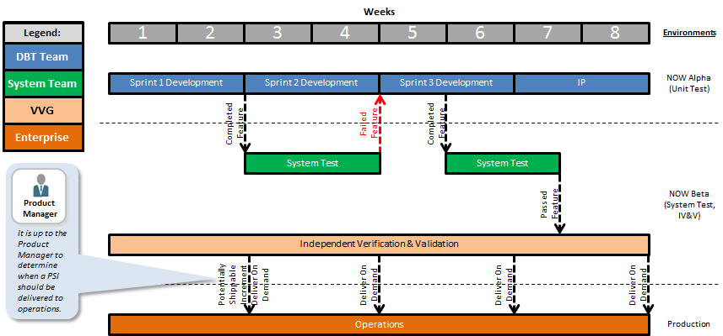
Figure 5-5: Testing for 8 Week Cycle

Unit Test
For information about Unit Testing, please see the Team Level Agile Process.

System Test

- Features are not to be sent to the System Team for System Test until all of the User Stories that are derived from the Features are ready for Error! Reference source not found..

The purpose of System Test is to perform integration of the new or enhanced Features in the Beta environment. As depicted in Figure 5-4 and Figure 5-5, System Testing for Features completed in a sprint should be completed within the same sprint. In accordance with Agile tenets, the schedule is fixed. Any System Test that is needed and cannot be completed in the two-week sprint (as shown in Figure 5-5 for the Feature completed in week 4) gets finished as soon as possible. It is ultimately up to the System Team to determine the appropriate amount of testing to be performed on a Feature.
During the times that the System Team is not actively testing Features, they should be building test plans, procedures, and harnesses. They should also be reviewing all of the acceptance criteria for the Features (see the Feature Acceptance Criteria field in the Features section) (and possibly User Stories) that were committed to during the Release Planning Event, and identifying any shortfalls in the acceptance criteria to pass on to the Product Owners and DBT Teams.

Independent Verification & Validation

- Features are not to be sent to the Verification & Validation Group for Independent Verification & Validation until the Test Readiness Checklist is completed.

Features to be tested by the Verification & Validation Group are prioritized for accomplishment during the Testing schedule, and the lowest priority Features may be deferred to future releases in order to maintain the schedule. The following paragraphs describe the steps taken by the Verification & Validation Group:
- Features that are identified as completed in sprint 1 are moved to Independent Verification & Validation directly after they are completed. In order to qualify for Independent Verification & Validation, a Feature must be completed and ready for the Verification & Validation Group to verify whether or not it satisfies its acceptance criteria (see the Feature Acceptance Criteria field in the Features section). The Verification & Validation Group builds its test objectives from each Feature’s acceptance criteria, the acceptance criteria for each User Story that comprises each Feature, developer information about the operation and intended use of the Feature, and knowledge or available information about the user’s work flows. If the product is a refactor to correct one or more discrepancies, a list of the Discrepancy Reports to be verified is also required prior to Independent Verification & Validation.
When Discrepancy Reports are identified during Independent Verification & Validation, these Discrepancy Reports are provided back to the appropriate programs/teams via the Discrepancy Reports backlog. If priority 1 and 2 Discrepancy Reports exist for a previously tested Feature, they are verified as fixed during the re-testing of the Feature. The discrepancies that are not corrected within the release stay in the Discrepancy Reports backlog. The Product Manager determines which discrepancies are to be worked-off, and maps them to Features in the Program Backlog. The Product Manager determines the priority order that discrepancies are to be worked-off by the DBT Teams according to urgency, and the Product Owner maps them to User Stories in the Team Backlog. Once correction of the discrepancy is assigned to the DBT Teams for a new release, it is worked and verified by the developer and tester. If it is a priority 1 or 2, it is (re)tested by Verification & Validation Group.

- Fixes to priority 1 and 2 Discrepancy Reports are verified. Fixes to lower priority Discrepancy Reports are accepted as developer or vendor verified.

- Features that are identified as completed in sprint 2 are moved to Independent Verification & Validation directly after they are completed. Discrepancy Reports are fed back to the DBT Teams to be worked off during the release. If a team does not have enough time during the release to work off the previous Discrepancy Reports, they are included for future release planning.
- Features that are identified as completed in sprint 3 are moved to Independent Verification & Validation directly after they are completed. Discrepancy Reports are fed back to the DBT Teams to be worked off during the release. If a team does not have enough time during the release to work off the previous Discrepancy Reports, they are included for future release planning.
- Features that are identified as completed in sprint 4 (IP) are moved to Independent Verification & Validation directly after they are completed. Discrepancy Reports are fed back to the DBT Teams to be worked off during the release. If a team does not have enough time during the release to work off the previous Discrepancy Reports, they are included for future release planning.
During the times that the Verification & Validation Group is not actively testing Features (steps 1 through 4), they should be building test plans, procedures, and harnesses. They should also be reviewing all of the acceptance criteria for the Features (see the Feature Acceptance Criteria field in the Features section) (and possibly User Stories) that were committed to during the Release Planning Event, and identifying any shortfalls in the acceptance criteria to pass on to the Product Owners and DBT Teams.

Test Readiness Checklist
The following checklist should be used to determine if a Feature is ready to go to Independent Verification & Validation:
- Do all Features contain adequate Feature acceptance criteria to be tested?
- Has the developer verified the satisfaction of all User Story acceptance criteria, to the extent supported in the Alpha environment?
- Has the System Team verified the satisfaction of all Feature acceptance criteria, to the extent supported in the Beta environment?
- Are the software versions documented, described, and under Configuration Management Process control?
- Are the Widget Workbooks complete?
- Is the software loaded in the NOW Beta environment, locked down, and ready to test?
- Has a list of any Discrepancy Reports that are fixed in the software been provided at least 5 working days prior to start of Independent Verification & Validation?
- Has the AAA Form been verified by the Security Engineers?
If all of the items on the Test Readiness Checklist are not met, then the Feature is returned to Program Backlog and is not tested.

Template
Appendix G shows the new Test Report Template that has been developed to capture the Testing results for each sprint, rolled up and included with the results for the overall release.

Metrics
Metrics are valuable to the Agile Engineering processes because they allow the enterprise to perform root cause analysis and promote continuous process improvements. When a release is completed, metrics should be analyzed, and the causes of any impediments to the process identified. Changes should then be made in the process to minimize these impediments. Both process and operational performance measures should be collected to support associated metrics. Since all fields are tracked in JIRA, numerous metrics can be generated from JIRA in the form of reports or graphs for analysis.
Examples of useful process and operational metrics are:
- Time to deliver capability – from the time the users’ request is accepted to the time the capability is delivered and available in the App Store
- Release Burndown Chart
  - Sprints in a release
  - Planned User Stories in a release
  - Completed User Stories in a release
- Feature Status Report – allows for the tracking of Features which comprise the objectives for the release
  - Planned Features in a release
  - Completed Features in a release
- Decomposed User Stories in Features
Figure 4-1 shows additional Metrics (items in red) that should be captured in the Program and Team level process flow.

Value Streams
A Value Stream is defined in the American Production and Inventory Control Society (APICS) Dictionary as, “the processes of creating, producing, and delivering a good or service to the market.” In understanding the Value Stream, it is important to identify the steps in the process that produce the product or service; the process steps define the Value Stream. To identify a Value Stream, a matrix should be created that crosses process steps in the Agile Release Train with products or services. Those products that use the same processes belong in the same Value Stream. The fact that products may have different end users or go to completely different customers is not relevant. Once the Value Stream is identified, the next task is to map the Value Stream.
Value Stream mapping is an agile technique derived from lean manufacturing to document, analyze and improve the process required to develop a capability or service for a user. The purpose of a Value Stream map is to identify activities that do not add value to the end-product. By eliminating these activities, a faster throughput, higher level of quality, and reduced inventory will be gained. The way value added is determined is by asking three simple questions: 1) was it done correctly the first time, 2) does it fundamentally change the product or service, and 3) is the customer willing to pay for it? If the answer to any one of the three questions is no, then there is an increased chance the step is not value added. Some examples may include: having an entity external to the process (like Quality Assurance) test or inspect the product, having a board review or approval step as part of the process, or having multiple offices performing the same or similar tasks.
Understanding Value Streams and Value Stream mapping can be used at the Portfolio, Program, and Team levels.

Conclusion
The purpose and intent of this document is to define the process required for the execution of Agile development of IT at NGA. NGA has adopted a 3-tiered hierarchical approach as its framework for Agile Engineering. Agile Engineering is executed thru 3 levels of abstraction, the Portfolio, Program and Team levels, with activities at the lower levels dependent on activities at the higher levels for successful execution.
This Program Level Agile Process contains the roles and responsibilities, process steps, templates, checklists and other relevant information for the successful implementation of Agile Engineering at the Program Level, which involves the following:
- Vision
- Design Artifacts
- Nonfunctional Requirements
- Features
- Roadmap
- Agile Release Train
- Testing
- Metrics

Vision Template

Vision Template

NGA
[Program Name]

Revision History

Date | Revision | Description | Author
mm/dd/yyyy | 1.0 | Initial version | Author name

Table of Contents

1 Introduction ……………………………………………………………………………………………………………………………… 2
1.1 Purpose ……………………………………………………………………………………………………………………….. 2
1.2 Solution Overview ……………………………………………………………………………………………………….. 2
1.3 References ……………….………………………………………………………………………………………………….. 3
2 User Description ………………………………………………………………………………………………………………………. 3
2.1 User/Market Demographics …………………………………………………………………………………………. 3
2.2 User Personas ………………………………………………………………………………………………………………. 3
2.3 User Environment ………………………………………………………………………………………………………… 4
2.4 Key User Needs ……………………………………………………………………………………………………………. 4
2.5 Alternatives and Competition ………………………………………………………………………………………. 4
2.6 DBT Teams …………………………………………………………………………………………………………………… 4
3 Stakeholders …………………………………………………………………………………………………………………………….. 5
4 Product Overview …………………………………………………………………………………………………………………….. 5
4.1 Product Perspective …………………………………………………………………………………………………….. 5
4.2 Product Position Statement …………………………………………………………………………………………. 5
4.3 Summary of Capabilities ………………………………………………………………………………………………. 6
4.4 Assumptions and Dependencies ………………………………………………………………………………….. 6
4.5 Cost and Pricing …………………………………………………………………………………………………………… 6
5 Product Features ………………………………………………………………………………………………………………………. 6
5.1 Feature 1 ……………………………………………………………………………………………………………………… 6
5.1 Feature 2 ……………………………………………………………………………………………………………………… 6
6 Exemplary Use Cases ………………………………………………………………………………………………………………… 7
7 Nonfunctional Requirements ……………………………………………………………………………………………………. 7
7.1 Usability ………………………………………………………………………………………………………………………. 7
7.2 Reliability …………………………………………………………………………………………………………………….. 7
7.3 Performance ………………………………………………………………………………………………………………… 7
7.4 Supportability ………………………………………………………………………………………………………………. 7
7.5 Other Requirements ……………………………………………………………………………………………………. 7
8 Glossary ……………………………………………………………………………………………………………………………………. 8

1 Introduction

This section provides an overview of the Vision document.

1.1 Purpose

This document defines the strategic intent of the program. It defines high-level user needs, any applicable user personas, key stakeholders, and the general system capabilities needed by the users.

1.2 Solution Overview

State the general purpose of the product, system, application or service, and any version identification.

- Identify the product or application to be created or enhanced.
- Describe the application of the product, including its benefits, goals, and objectives.
- Provide a general description of what the solution will and, where appropriate, will not do.

1.3 References
List other documents referenced, and specify the sources from which the references can be obtained. If a business case was developed to drive the program, refer to it or attach it.

2 User Description

To provide products and services that meet users’ needs, it is helpful to understand the challenges they confront when performing their jobs. This section should profile the intended users of the application and the key problems that limit the user's productivity. This section should not be used to state specific requirements; just provide the background for why the features specified in Section 5 are needed.

2.1 User/Market Demographics

Summarize the key market demographics that motivate your solution decisions. Describe target-market segments. Estimate the market's size and growth by the number of potential users or the amount of money your customers spend, trying to meet needs that your product/enhancement would fulfill. Review major industry trends and technologies. Refer to market analysis, where available.

2.2 User Profiles

Describe the primary and secondary user personas. A thorough analysis might cover the following topics for each persona:

- Technical background and degree of sophistication
- Key responsibilities
- Deliverables the user produces and for whom
- Trends that make the user's job easier or more difficult
- The user's definition of success and how the user is rewarded
- Problems that interfere with success

2.3 User Environment

Describe the working environment of the target user. Here are some suggestions.

- How many people are involved in completing the task? Is this changing?
- How long is a task cycle? How much time is spent in each activity? Is this changing?
- Are there any unique environmental constraints: controlled environment, mobile, outdoors, and so on?
- Which system platforms are in use today? Future platforms?
- What other applications are in use? Does your application need to integrate with them?

2.4 Key User Needs

List the key problems or needs as perceived by the user. Clarify the following issues for each problem.

- What are the reasons for this problem?
- How is it solved now?
- What solutions does the user envision?

Ranking and cumulative-voting techniques for these needs indicate problems that must be solved versus issues the user would like to be solved.

2.5 Alternatives and Competition

[OPTIONAL] Identify any alternatives available to the user. These can include buying a competitor's product, building a homegrown solution, or simply maintaining the status quo. List any known competitive choices that exist. Include the major strengths and weaknesses of each competitor as perceived by the end user.

2.5.1 Competitor 1

2.5.2 Competitor 2

2.6 DBT Teams

This section identifies any DBT Teams that will deliver capabilities to the product. This section includes the major purpose of each DBT Team as perceived by the end user. For a complete picture of all of the people participating in the product Agile Release Train (ART), please see the product face chart.

2.5.1 DBT Team 1

2.5.2 DBT Team 2

3 Stakeholders

Identify the program stakeholders, their needs, and their degree of involvement with the system. A table such as the following can be effective:

Project Stakeholder | Degree of Involvement | Product Needs | Program Needs
Stakeholder 1
Stakeholder 2

4 Product Overview

This section provides a high-level view of the solution capabilities, interfaces to other applications, and systems configurations. This section usually consists of five subsections, as follows.

4.1 Product Perspective

This subsection should put the product in perspective to other related products and the user's environment. If the product is independent and totally self-contained, state so. If the product is a component of a larger system, this subsection should relate how these systems interact and should identify the relevant interfaces among the systems. One easy way to display the major components of the larger system, interconnections, and external interfaces is via a system context block diagram.

4.2 Product Position Statement

Provide an overall statement summarizing, at the highest level, the unique position the product intends to fill in the marketplace. Moore [1991] calls this the product position statement and recommends the following format.

For | (target customer)
Who | (statement of the need or opportunity)
The (product name) | is a (product category)
That | (statement of key benefit, that is, compelling reason to buy)
Unlike | (primary competitive alternative)
Our product | (statement of primary differentiation)

A product position statement communicates the intent of the application and the importance of the program to all stakeholders.

4.3 Summary of Capabilities

Summarize the major benefits and features the product will provide. Organize the features so that the list is understandable to any stakeholder. A simple table listing the key benefits and their supporting features, as shown below, might suffice.

Solution Features | Customer Benefit
Feature 1 | Benefit 1
Feature 2 | Benefit 2

4.4 Assumptions and Dependencies

List any assumptions that, if changed, will alter the vision for the product.

4.5 Cost and Pricing

Describe any relevant cost and pricing constraints, because these can directly impact the solution definition and implementation.

5 Product Features

This section documents the intended product features. Features provide the system capabilities that are necessary to deliver benefits to the users. Feature descriptions should be short and pithy, a key phrase, perhaps followed by one or two sentences of explanation.

Use a level of abstraction high enough to be able to describe the system with a maximum of 25 to 50 features. Each feature should be perceivable by users, operators, or other external systems.

5.1 Feature 1

5.2 Feature 2

6 Exemplary Use Cases

[OPTIONAL] You may want to describe a few exemplary use cases, perhaps those that are architecturally significant or those that will most readily help the reader understand how the system is intended to be used.

7 Nonfunctional Requirements

This section records other product requirements including nonfunctional requirements (constraints) imposed on the system.

9 Glossary

The glossary defines terms that are unique to the program. Include any acronyms or abbreviations that need to be understood by users or other readers.

Use Case Report Template

USE CASE ID: NGA_SUC_01
USE CASE NAME: System Overview

CONTRIBUTORS: Example: author name, System Architect, Mission Owner, User Subject Matter Expert, Systems Engineer
DATE LAST UPDATED: mm/dd/yyyy

DESCRIPTION:
This use case describes the high-level system overview of …
<Or>
This use case describes the process by which a user …

DEFINITIONS:
Term – This term is defined as …

REFERENCES:
Example: Amazon©, www.amazon.com

ASSUMPTIONS:
Example: “Update” refers to create, modify, and delete.

SPECIFIC REQUIREMENTS:
This use case satisfies the following functional and nonfunctional requirements: …

RISKS:
Example: None

USES:
Example:
NGA_SUC_02
NGA_SUC_03

ACTORS:
Example: User

PRECONDITIONS:
The user is ready to …

POSTCONDITIONS:
… has been …
NORMAL FLOW:

Step | User Action | System Response
1 | The user …
2 | The user … | The system …
3 | The user … | The system …
4 |  | System used

ALTERNATIVE FLOWS:

Step | User Action | System Response
2.1  … Changed | The user … | The system …
 |  | Return to Step 3

CONTEXT DIAGRAM: (only for high-level Use Cases)
<Diagram>

USE CASE DIAGRAM:
<Diagram>

ACTIVITY DIAGRAM:
<Diagram>

SEQUENCE DIAGRAM:
<Diagram>

COMPONENT DIAGRAM: (only for low-level Use Cases; optional)
<Diagram>

GUI MOCK-UPS: (optional)
<Diagram>

NOTES:
Example: None

Nonfunctional Requirements Checklist

Nonfunctional Requirements Checklist

NGA
[Program Name]

Super Category | NFR Category | Applicable NFRs
1.0 Availability | 1.1 Availability
 | 1.2 Backup
 | 1.3 Disaster Recovery
 | 1.4 Fault Tolerance
 | 1.5 Recovery
 | 1.6 Reliability
 | 1.7 Resilience
 | 1.8 Robustness
2.0 Compliance | 2. 1 Certification
 | 2.2 Regulatory Compliance
 | 2.3 Interoperability
 | 2.3 Interoperability
 | 2.4 Open Source
 | 2.5 Platform Compatibility
 | 2.6 Software Tools/Standards
3.0 Configuration Management | 3.1 Configuration Management
 | 3.2 Documentation
 | 3.3 Source Code Escrow
4.0 Legal and Licensing | 4.1 Legal and Licensing
 | 4.2 Patent infringement avoid-ability
5.0 Maintainability/Code Design | 5.1 Extensibility
 | 5.2 Maintainability
 | 5.3 Portability
 | 5.4 Scalability
 | 5.5 Testability
6.0 Performance | 6.1 Capacity
 | 6.2 Effectiveness
 | 6.3 Efficiency
 | 6.4 Operability
 | 6.5 Performance
 | 6.6 Quality
 | 6.7 Response Time
 | 6.8 Usability
7.0 Security | 7.1 Accessibility
 | 7.2 Audit
 | 7.3 Privacy
 | 7.4 Security

Feature Template

Field | Description
*Feature ID | A system generated unique identification number used to track Features (system generated).
*Feature Title | This is a high-level name used to identify the Feature.
*Description | This is a detailed description of the Feature. This description is used to understand and decompose the Feature.
**Feature Acceptance Criteria | The specific criteria that are used to determine whether or not a Feature has been considered done.
Feature Acceptance Test IDs | System generated unique identification numbers used to track the tests that the Feature passed based on the feature acceptance criteria.
*Program | The name of the program that will implement this Feature (drop-down).
*Team | The team that has the responsibility to implement the Feature (drop-down).
*Creator Name | The name of the creator of the Feature (Product Management Team).
*Creator Phone Number | The phone number of the creator of the Feature (Product Management Team).
*Creator Email | The email address of the creator of the Feature (Product Management Team).
*Date Submitted | The date that the Feature was submitted (mm/dd/yyyy) (system derived).
Discrepancy Report IDs (optional) | Unique identification numbers used to track the DRs that this Feature satisfies (drop-down).
Feedback Origination | Whether or not the Feature is derived from Feedback (drop-down: Yes, No).
Date Due | The date that the Feature needs to be implemented (mm/dd/yyyy).
**Epic IDs | System generated unique identification numbers used to track the Epics that the Feature satisfies (drop-down).
User Story IDs | System generated unique identification numbers used to track the User Stories that satisfy the Feature (system derived).
**Use Case IDs | Unique identification numbers used to track the Design Artifacts that the Feature satisfies.
**Nonfunctional Requirement IDs | Unique identification numbers used to track the Nonfunctional Requirements that the Feature satisfies.
Requirement IDs (optional) | Unique identification numbers used to track the requirements that satisfy the Feature.
**JARM IDs | Unique identification numbers used to track the JARM items that this Feature describes (e.g. ESLs and TSTs).
**Dependency IDs | System generated unique identification numbers used to track any Feature IDs that are required to be implemented before this Feature (drop-down).
Dependencies | List any dependencies not otherwise noted in the Feature. This includes any external interfaces that the Feature is dependent on for completion, and serves as a mechanism to begin SLAs, MOUs, or agreements with providers/partners.
**WSJF Value | Estimate of the rank of the Feature; WSJF = (Mission Value + Technical Value) / Estimated Story Points (from the Mission Value, Technical Value, and Estimated Story Points fields below) (system derived).
**Mission Value | Mission Owner assigned value for the importance of the Feature (drop-down: 1, 2, 3, 5, 8, 13, or 21).
**Technical Value | Product Management Team assigned value for the importance of the Feature (drop-down: 1, 2, 3, 5, 8, 13, or 21).
**Estimated Story Points | “Good enough” estimate which allows the team to quickly and fairly accurately estimate the amount of effort required to complete a work objective (drop-down: 1, 2, 3, 5, 8, 13, or 21) (1 day = 1 story point, 1 week = 8 story points).
Actual Time Spent | The sum of the duration of time used to implement all User Stories (from the User Story IDs field above) (system derived).
*Status | The disposition of the Feature (drop-down: Opened, Being Worked, Closed, Not Being Implemented, Ready For Test, In Test, etc.)
**Release | The release number of the program/product in which the Feature is implemented.
*Classification | The Classification of the Feature (drop-down: U/FOUO, SECRET, S/REL USA FVEY, S/NF, etc.)
Widget/Capability Name | To store at the Feature level for tracing Features to widgets and vice versa.
Service/Endpoint | To store at the Feature level for documenting the services and endpoints used to implement this Feature.
Notes | Notes to describe the Feature.

- If the WSJF method is not going to be used by the Product Management Team to prioritize Features, then the WSJF Value, Mission Value, and Technical Value fields can be replaced by a Priority field in the Feature Template.

Roadmap Template

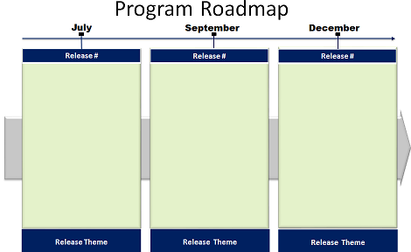
Lower Confidence
Medium Confidence
High Confidence

Agile Release Train Template

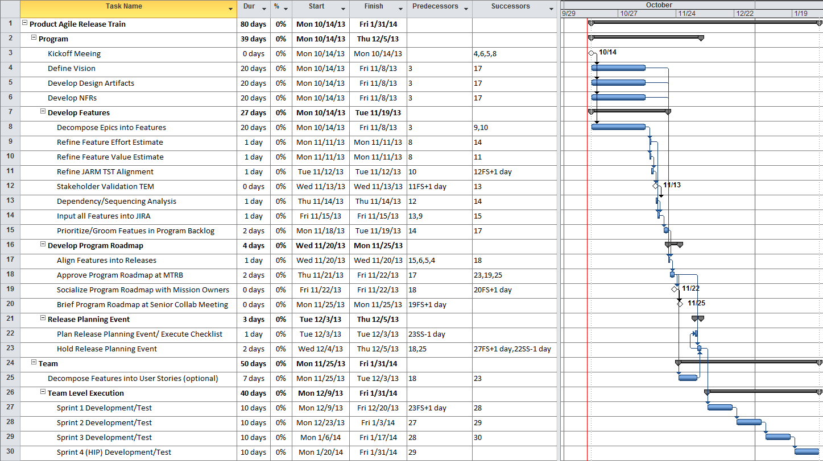

Test Report Template

(U) Test Summary
for
[Program Name] – Release x.x
RFS #####
DATES FOR RELEASE

SPECIFIC DATE OF SUMMARY

- (U) EXECUTIVE SUMMARY:
(U) Sprint 1 – Date
- Summary of delivered capability
(U) Sprint 2 – Date
- Summary of delivered capability
(U) Sprint 3 – Date
- Summary of delivered capability
(U) IP – Date
- Summary of delivered capability
(U) Release Test – Date
- Summary of delivered capability

- (U) RESULTS:
Sprint 1:
Sprint 2:
Sprint 3:
IP:
Release Test:

Table 1. (U) Widget Status Table
New and Updated Widgets
Widget Name | NTO Recommendation | Significant Issues
Sprint 1
Sprint 2
Sprint 3
IP
Release Test

- (U) OVERALL RECOMMENDATION: Determined when testing concludes.

- (U) DRS WRITTEN DURING TESTING

Table 2. (U) DRs Opened
Date Written | DR Number | Pri-ority | Status | Group/ System | Title | Remarks
Sprint 1
Sprint 2
Sprint 3
IP
Release Test

Table 3. (U) DRs Closed
Date Written | DR Number | Pri-ority | Status | Group/ System | Title | Remarks
Sprint 1
Sprint 2
Sprint 3
IP
Release Test

- (U) DRS IDENTIFIED FOR VERIFICATION

Table 4. (U) DRs Identified for Verification
Date Written | DR Number | Pri-ority | Status | Group/ System | Title | Remarks
Sprint 1
Sprint 2
Sprint 3
IP
Release Test

- (U) POINT OF CONTACT

(U) Please contact NAME, PHONE NUMBER, EMAIL ADDRESS with any questions.

References

This Program Level Agile Process was created using the following references:
- National Geospatial-Intelligence Agency (NGA) (DOCID-4514), “NGA Strategy 2013 to 2017,” May, 2012, accessed July 19, 2013, http://home.nga.ic.gov/docs/19639_NGA_strategy.pdf.
- Government Accountability Office (GAO) Report (GAO-12-681), “Effective Practices and Federal Challenges in Applying Agile Methods,” July, 2012, accessed July 19, 2013, http://www.gao.gov/products/GAO-12-681.
- The Scaled Agile Framework (SAFe)TM, www.ScaledAgileFramework.com.
- Dean Leffingwell, Agile Software Requirements (New York: Addison-Wesley, 2011).
- Jesse Daniels and Terry Bahill, “The Hybrid Process That Combines Traditional Requirements and Use Cases,” 2004, accessed July 19, 2013, www.interscience.wiley.com.
- Scott W. Ambler, The Object Primer 3rd Edition: Agile Model Driven Development with UML 2 (New York: Cambridge University Press, 2004).
- Chris Widney, “An IBM Rational Approach to the Department of Defense Architecture Framework (DoDAF),” January, 2006, accessed June 25, 2014, ftp://ftp.software.ibm.com/software/applications/plm/ekit/G507-1903-00_v5_LoRes.pdf.

Acronyms

Term | Definition
A | Analysis
AAA | Agile Application Assurance
AOA | Analysis of Alternatives
API | Application Programming Interface
ASGB | Application Services Governance Board
ATS | Apps Tracker Spreadsheet
A2SI | Agency Agility Strategic Initiative
CLIN | Contract Line Item Number
CO | Contracting Officer
COTR | Contracting Officer’s Technical Representative
C&A | Certification and Accreditation
DBT | Define, Build, Test
DoDAF | Department of Defense Architectural Framework
DR | Discrepancy Report
DTD | Deputy Test Director
ER2 | Enterprise Registry and Repository
FSG | Full Spectrum GEOINT
GAO | Government Accountability Office
GEOINT | Geospatial Intelligence
GRA | GEOINT Reference Architecture
GUI | Graphical User Interface
IP | Innovation and Planning
HP | Hewlett-Packard
HP ALM | Hewlett-Packard Application Lifecycle Management
IAE | Integrated Analytic Environment
IC | Intelligence Community
ICD | Interface Control Document
IDIQ | Indefinite Delivery, Indefinite Quantity
IT | Information Technology
IV&V | Independent Verification & Validation
JARM | Joint Architecture Reference Model
JIRA | Gojira = Godzilla
MOU | Memorandum of Understanding
MTRB | Mission Technical Review Board
NFR | Nonfunctional Requirement
NIIRS | National Image Interpretability Rating Scale
NIQU | NGA Image Quality and Utility
NOW | NSG Online Workspace
NGA | National Geospatial-Intelligence Agency
NSG | National System for Geospatial-Intelligence
NTO | NGA Test Organization
OGC | Office of General Council
OV | Operational View
OWA | Open Web Analytic
O&S | Operations and Sustainment
POR | Program of Record
PQ ORC | Product Quality Operational Readiness Criteria
PRD | Product Requirements Document
PSI | Potentially Shippable Increment
QA | Quality Assurance
RACI | Responsible, Accountable, Consulted, Informed
RFC | Request for Change
RMA | Reliability, Maintainability, and Availability
ROI | Return On Investment
RPE | Release Planning Event
S | Source
SAFeTM | Scaled Agile FrameworkTM
SLA | Service Level Agreements
SMART | Specific, Measurable, Achievable, Repeatable, and Testable
SME | Subject Matter Expert
SRS | Software Requirements Specifications
SUC | System Use Case
SV | Service View
T | IT Services
TD | Test Director
TQ | Image Quality and Utility
TSC | Technical Services Category
TST | Technical Services Taxonomy
TV | Assurance
TX | Technical Executive
UI | User Interface
UML | Unified Modeling Language
VVG | Verification & Validation Group
WSDL | Web Services Description Language
WSJF | Weighted Shortest Job First
X | Xperience
XML | Extensible Markup Language
XSD | XML Schema Definition

“Scaled Agile FrameworkTM Big Picture,” version 3.0, http://www.scaledagileframework.com/.
Cindy Shelton, “Agile Acquisition – In Progress,” 2013, www.interscience.wiley.com, 30.
Cindy Shelton, “Agile Acquisition – In Progress,” 2013, www.interscience.wiley.com, 30.
Shelton, 25.
Shelton, 29.
Dean Leffingwell, “Agile Software Requirements,” Addison-Wesley, 2011, www.scaledagileframework.com, 489.
“Scaled Agile FrameworkTM System Architect Abstract,” last modified January 15, 2013, http://www.scaledagileframework.com/system-architect/.
“Certified Product Owner Training,” LitheSpeed, www.lithespeed.com.
“Scaled Agile FrameworkTM Release Management Team Abstract,” last modified January 15, 2013, http://www.scaledagileframework.com/release-management-team/.
“Scaled Agile FrameworkTM Agile Release Train Abstract,” last modified January 14, 2013, http://www.scaledagileframework.com/agile-release-train/.
Leffingwell, 476.
Jesse Daniels and Terry Bahill, “The Hybrid Process That Combines Traditional Requirements and Use Cases,” Wiley InterScience, 2004, www.interscience.wiley.com, 303.
Daniels and Bahill, 306.
Leffingwell, 377.
Scott W. Ambler, The Object Primer 3rd Edition: Agile Model Driven Development with UML 2, Cambridge University Press, 2004.
Daniels and Bahill, 309-310.
Daniels and Bahill, 309-310.
Leffingwell, 255.
Leffingwell, 455.
Leffingwell, 257.
“Scaled Agile FrameworkTM Agile Release Train Abstract,” last modified January 14, 2013, http://www.scaledagileframework.com/agile-release-train/.
“Scaled Agile FrameworkTM Agile Release Train Abstract,” last modified January 14, 2013, http://www.scaledagileframework.com/agile-release-train/.
“Scaled Agile FrameworkTM Agile Release Train Abstract,” last modified January 14, 2013, http://www.scaledagileframework.com/agile-release-train/.
“Scaled Agile FrameworkTM Agile Release Train Abstract,” last modified January 14, 2013, http://www.scaledagileframework.com/agile-release-train/.
“Scaled Agile FrameworkTM Agile Release Train Abstract,” last modified January 14, 2013, http://www.scaledagileframework.com/agile-release-train/.
“Scaled Agile FrameworkTM Agile Release Train Abstract,” last modified January 14, 2013, http://www.scaledagileframework.com/agile-release-train/.
“Scaled Agile FrameworkTM Hardening | Innovation | Planning Abstract,” last modified March 14, 2013, http://www.scaledagileframework.com/hardening-innovation-planning/.
“Scaled Agile FrameworkTM Innovation & Planning Abstract,” last modified July 15, 2014, http://www.scaledagileframework.com/innovation-planning/.
“Scaled Agile FrameworkTM Agile Release Train Abstract,” last modified January 14, 2013, http://www.scaledagileframework.com/agile-release-train/.
“Scaled Agile FrameworkTM Agile Release Train Abstract,” last modified January 14, 2013, http://www.scaledagileframework.com/agile-release-train/.
“Scaled Agile FrameworkTM Release Planning Abstract,” last modified July 20, 2013, http://www.scaledagileframework.com/release-planning/.
“Scaled Agile FrameworkTM Release Planning Abstract,” last modified July 20, 2013, http://www.scaledagileframework.com/release-planning/.
Copyrighted material used with permission from Dean Leffingwell.
Copyrighted material used with permission from Dean Leffingwell.

