IPF Standard

S3 Object Lifecycle Management
2023-05-17

Purpose
This is the IPF standard for Intelligent Tiering & a Standard Lifecycle Rule for all S3 buckets. Lifecycle rules can be used to manage object storage classes in S3 buckets which can result in a reduced cost for object storage. The goal of this document is to establish a global baseline configuration to manage object storage classes and perform related maintenance. Use of additional Lifecycle rules or programmatic control of storage classes is still encouraged.

Standard for S3 Intelligent Tiering & Standard Lifecycle Rule
- All S3 buckets shall have S3 Intelligent Tiering applied as described in list item #2.
  - Objects in the Intelligent-Tiering storage class are handled in the following manner and the configuration is immutable:
    - Frequent Access – Objects that are uploaded or transitioned to S3 Intelligent-Tiering are automatically stored in the Frequent Access tier.
    - Infrequent Access – Objects that have not been accessed in 30 consecutive days move to the Infrequent Access tier.
    - Archive Instant Access – Objects that have not been accessed for 90 consecutive days are automatically moved to the Archive Instant Access tier.
    - Once an object is accessed it moves back to the Frequent Access Tier and the 30 and 90 day counts start over again.
  - Mission Owners may also designate the use of Archive Access and Deep Archive Access if desired and are encouraged to do so for data that is not planned to be accessed.
  - For missions desiring to transition objects to Glacier Instant Retrieval (GIR), Glacier Flexible Retrieval (GFR), or Glacier Deep Archive (GDA) less than 90 days after objects are created, they are approved to not implement the S3 Intelligent Tiering and instead implement a Lifecycle Rule to move objects to Glacier Instant Retrieval, Glacier Flexible Retrieval, or Glacier Deep Archive less than 90 days after objects are created.
    - If GIR, GFR, or GDA are used in lieu of S3 Intelligent Tiering on filtered set of a bucket, then an additional rule shall be configured to apply the S3 Intelligent Tiering to remainder of the bucket.

- All S3 Buckets shall have a Lifecycle rule applied to cover the entire bucket. The rule will have the following configuration:
  - Lifecycle rule configuration
    - Lifecycle rule name: S3-IT_0-Day_and_Maintenance
      - Name must be exact
    - Choose a rule scope: Apply to all objects in the bucket
    - Acknowledge: (Checked)
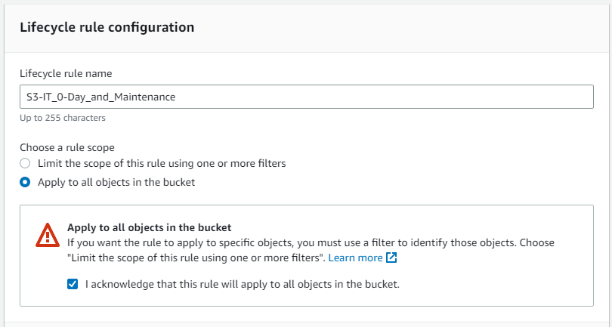
  - Lifecycle rule actions
    - Move current versions of objects between storage classes: (Checked)
    - Delete expired object delete markers or incomplete multipart uploads: (Checked)
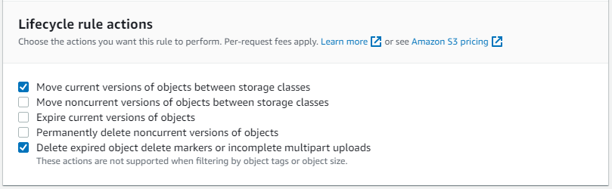
  - Transition current versions of objects between storage classes
    - Choose storage class transitions: Intelligent-Tiering
    - Days after object creation: 0
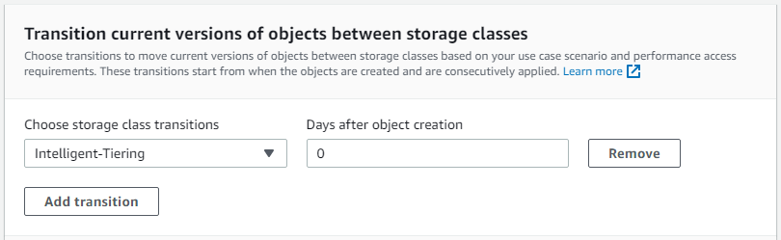
  - Delete expired object delete markers or incomplete multipart uploads
    - Delete expired object delete markers: (Checked)
    - Delete incomplete multipart uploads
    - Number of days: 7
      - The 7-day period can be reduced with mission owner concurrence.
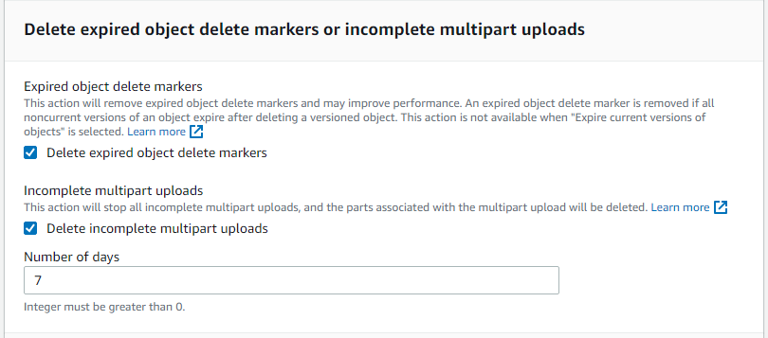

- These are minimum configuration requirements. Not implementing requires approval from DD/IPF.

