IPF Standard
EBS Volume Encryption
2023-07-27

Purpose
Historically within IPF, monthly data has shown there are a number of unencrypted EBS volumes being used in the cloud environments on all domains. This goes against agency best practices for securing data. The goal of this document is to ensure all new, and existing EBS volumes will be properly encrypted to better improve the security posture of the IPF program going forward.

Standard for EBS Encryption
- All new EC2 instances that are spun up, need to have storage configured to use encryption. This can be configured in the ‘Advanced’ options of the storage settings when launching an EC2.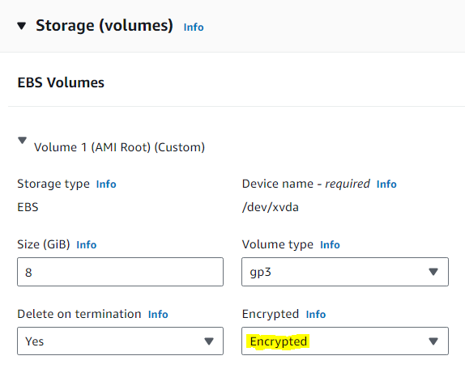
- All new EBS volumes that are created from the EBS console need to be encrypted.
- A default AWS KMS (Key Management Service) key, or an existing customer managed KMS key can be used for the encryption.
  - Customer managed keys are preferred due to more flexibility, including the ability to create, rotate, and disable KMS keys.
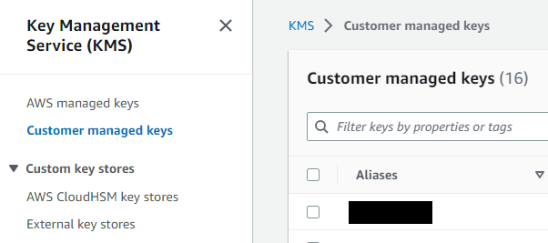
- All existing unencrypted EBS volumes attached to running instances need to be encrypted. This cannot be done directly.
  - Stop your EC2 instance.
  - Create an EBS snapshot of the volume you want to encrypt.
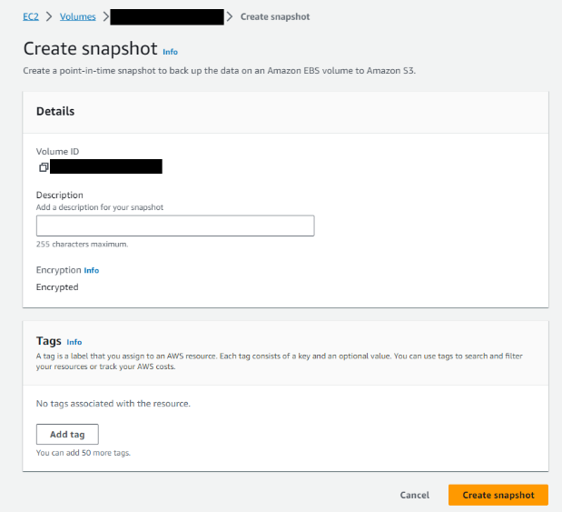
  - Copy the EBS snapshot, encrypting the copy in the process using either the default AWS KMS, or your customer managed KMS key.
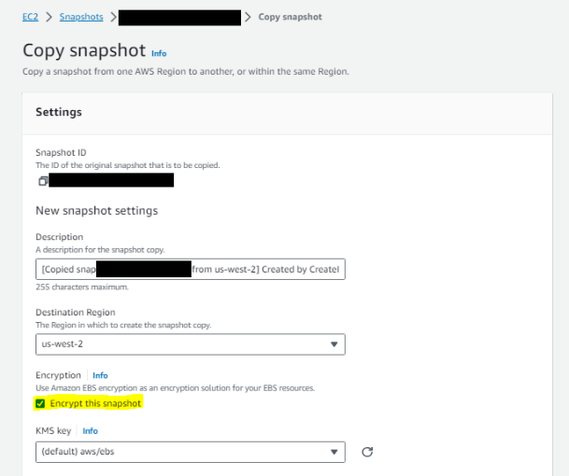
  - Create a new EBS volume from your new encrypted EBS snapshot. The new EBS volume will be encrypted.
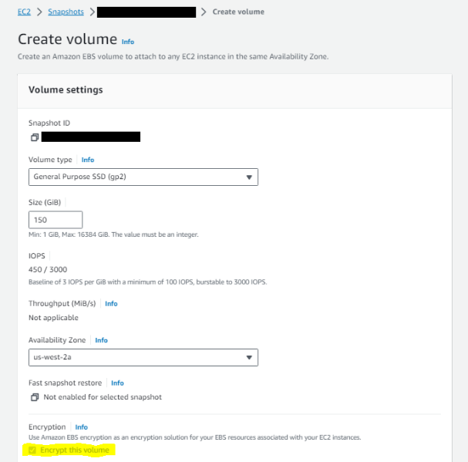
  - Detach the original EBS volume and attach your new encrypted EBS volume, making sure to match the device name (/dev/xvda1, etc.)
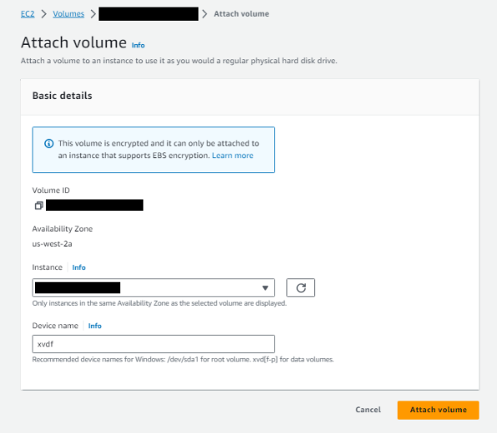
  - Start the EC2 instance.
Supporting documentation can be found here: https://docs.aws.amazon.com/AWSEC2/latest/UserGuide/EBSEncryption.html

