Draft Statement of Need
Therapeutic Patient Bathing Units
Coatesville VA Medical Center

The Coatesville VA Medical Center has a need for replacement therapeutic patient bathing units for use within the Community Living Center (CLC). Two new therapeutic patient bathing units are required which must meet the salient characteristics as outlined for this Brand Name or Equal requirement; the Cascade Alcove Spa (model 361910-1A) manufactured by Penner Patient Care is identified as acceptable, equivalent alternatives must meet the salient characteristics outlined within this Statement of Need. This will include disconnecting the plumbing and electricity of the two existing ARJO bath units (Freedom Bath II) as well as the purchase, delivery, and installation of two new therapeutic patient bath units. After installation, a product demonstration must be provided for VAMC staff training.

- Salient Characteristics: Therapeutic Patient Bathing System – Quantity 2

  - Dimensions/Specifications:
    - The tub must accommodate patients weighing at least 353 lbs while in use.
    - The tub must fit within a 90”x33”x41” length x width x height installation space.
    - The tub must have a maximum hydrostatic water pressure of 6 bars, and a minimum operating hydrostatic water pressure of 1 bar.
    - The tub must be fully functional on 55 psi water pressure.
      - If higher water pressure is needed, the contractor must provide and install a pressure reducing valve at the time of installation which would allow for 80 psi max.

  - The tub must be safe and accessible for patients with lower body mobility issues. Patients should be able to safely support themselves while sitting in the tub using only their upper body.
  - The tub must be equipped with a control panel for ease of adjustments featuring a digital display with scalding protection sensors to prevent overheating, indicates water/fill shower temperature & allows caregivers to monitor/control the warmth the patient is exposed to. The tubs must have a shower wand with holder and temperature-regulated mixing valve that adjusts the temperature of hot and cold water.
  - The tubs must have a side door or roll down door that provides wide access and be safely accessible and smooth transitions for residents who are able to access independently or with support using a walking aid or standing and allow access with use of patient lifts/raising equipment (maxi move).
  - The tubs must have a contoured base that serves as a comfortable seat for patients and hydromassage to remove dirt/particles gently from the patients while bathing.
  - The tubs must have a minimum 1-year warranty covering defects in material and workmanship from the date of installation including replacement parts and service for any parts found defective. Any manufacturer’s warranty must be provided as well as technical service or maintenance manuals.
  - Tub must include a means for VAMC staff to access the internal hardware for maintenance.
  - The tub must be installed in the existing space without any significant plumbing or construction requirements. Installation must be completed within 1 day for each unit.
    - Attachment A is provided to show existing hot/cold supply and drain locations.

  - The tub must allow for urgent patient removal by opening the door while in use and filled with water.
  - Replacement parts for the tubs must be separately available for purchase if needed.

- Performance Requirements:
  - The new bathing units can be shipped in advance to the delivery location listed in Section 3 so VAMC staff can inspect and submit into the equipment database. Actual installation must be scheduled with the VA Program Manager after bathtubs are received.
  - The contractor is responsible for plumbing/electrical disconnections on the existing patient baths located within the Coatesville VAMC Campus, Building 138, Rooms 127 and 227. The contractor must remove the tubs from the installation area and move them to another area within the VAMC campus at the VA Program Manager’s direction. The contractor will then unpack the new bathing units, transport the units to the installation areas, and complete all installation and adjustments as needed so the bath systems are ready for use.

    - Removal of existing baths and installation of new bathing units will include electrical and plumbing disconnection/hookups. Existing bath unit is pictured below:
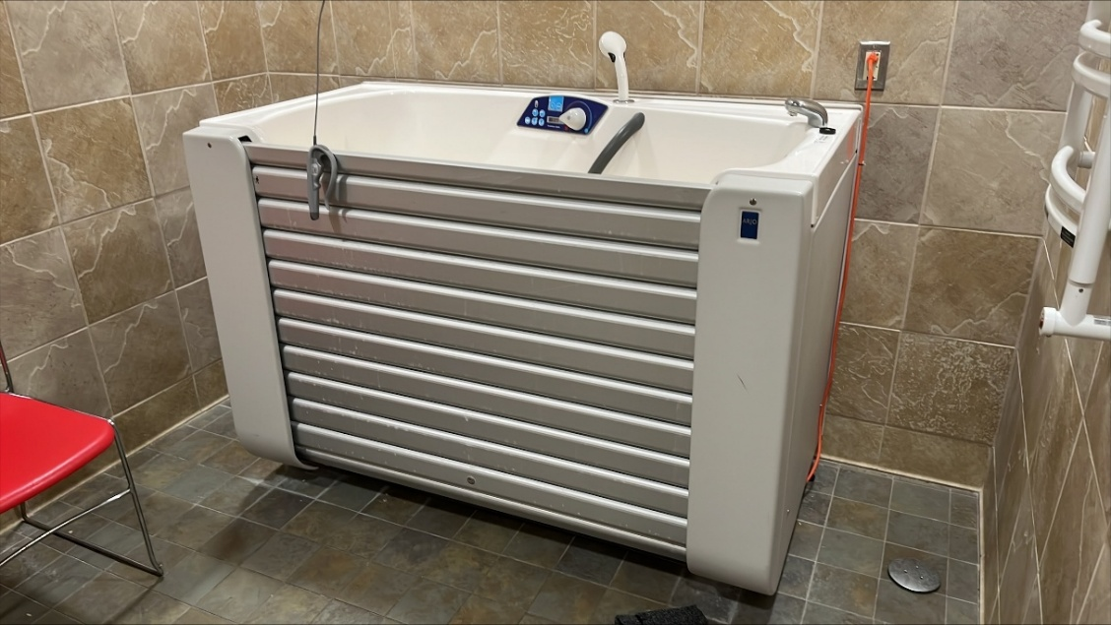
    - The contractor is responsible for removing and disposing of all trash and debris resulting from unpacking the new bath units and installation for each. Debris must not be disposed of on VA property.

  - The contractor shall provide a demonstration and training on use of the new bath systems for the VA Program Manager and the CLC staff. Copies of user and technical manuals must be provided to the VA Program Manager upon completion of installation.

- Delivery Location:
  - Freight on Board Destination to:
Coatesville VA Medical Center CLC – Warehouse Building 13
- Black Horse Hill Road
Coatesville, PA 19320

- Security
  - All Contractor workers are required to sign in and out at the VA Police Service as directed by the POC or designee. A valid state driver’s license or state identification card is mandatory for all employees to have access to these facilities.

