SUBJECT* | New Lease | Bay Shore CBOC

GENERAL INFORMATION
CONTRACTING OFFICE’S ZIP CODE* | 11209
SOLICITATION NUMBER* | 36C24226Q0427
RESPONSE DATE/TIME/ZONE | 03-27-2026 3PM EASTERN TIME, NEW YORK, USA
ARCHIVE | 90 DAYS AFTER THE RESPONSE DATE
RECOVERY ACT FUNDS | N
SET-ASIDE
PRODUCT SERVICE CODE* | X1DZ
NAICS CODE* | 531120
CONTRACTING OFFICE ADDRESS | Department of Veterans Affairs  Network Contracting Office 2  NYHHS - Brooklyn Campus  800 Poly Place  Brooklyn NY 11209
POINT OF CONTACT* | Lease Contracting Officer  Christopher Coker  christopher.coker@va.gov  718-836-6600 x-21919

PLACE OF PERFORMANCE
ADDRESS | Bay Shore, NY
POSTAL CODE
COUNTRY | USA

ADDITIONAL INFORMATION
AGENCY’S URL
URL DESCRIPTION
AGENCY CONTACT’S EMAIL ADDRESS
EMAIL DESCRIPTION

DESCRIPTION
The Department of Veterans Affairs currently occupies clinical space for use as a Veterans Community-Based Outpatient Clinic in a building under lease in Bay Shore, NY that will be expiring 31 August 2026. VA is seeking to lease sufficient rentable square footage to yield approximately 5,660 ANSI/BOMA (ABOA) square feet within the 2nd Congressional District, geographical area encompassing the Bay Shore New York area. Occupancy is required by 1 September 2026.

Access to public transportation shall be located within the immediate vicinity of the building, but generally not to exceed a walkable one mile as determined by the Contracting Officer. Alternatively, two or more public or campus bus lines shall be located within the immediate vicinity of the building, but generally not to exceed a walkable mile.

PLEASE NOTE: Although this notice contains detailed information for interested SDVOSB and VOSB parties, VA encourages all other business types of offerors (Small Businesses, Other Than Small Business) to respond for market research purposes.

The purpose for this notice is to conduct market research and identify capable resources from Service-Disabled Veteran-Owned Small Businesses (SDVOSB), Veteran-Owned Small Businesses (VOSB) and/or capable Open Market sources. The NAICS Code for use is 531120, Lessors of non-residential buildings (except mini warehouses), and the small business size standard for 531120 is $41.5 million.

Responses to this notice will assist VA in determining whether this acquisition should be set aside for competition restricted to SDVOSB, VOSB or Small Business concerns in accordance with 38 USC Sec. 8127 or proceed with Full and Open competition from capable sources.

Delineated Area: To receive consideration, submitted buildings must be located within the following area described below, which is bound by the following roads, or must front on any of the following boundary lines:

North: Southern State Parkway
East: Route 111
South: Great South Bay
West: Wellwood Avenue in West Babylon

The following map of the delineated area is provided for further clarification of the boundaries of the delineated area.

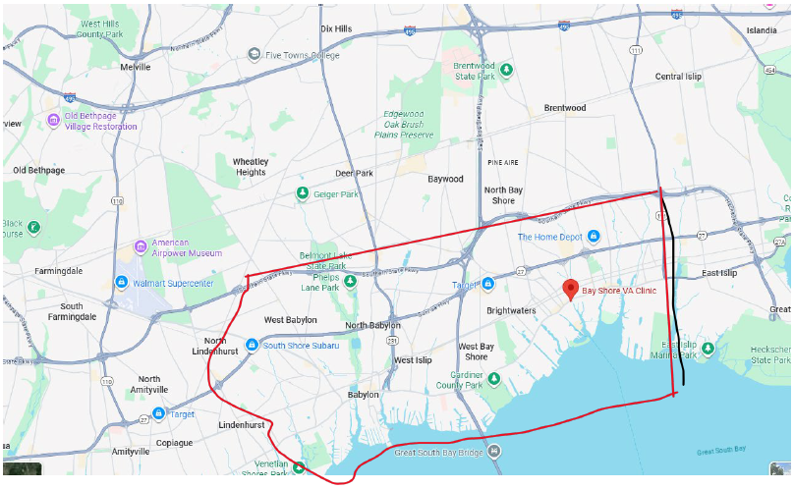

The space must be handicapped accessible, ADA compliant, and can be provided by new construction or modification to an existing space. If not a new building, the space offered shall be in a building that has undergone, or will complete by occupancy, modernization, or adaptive reuse for the space with modern conveniences.

The space must be contiguous, on no more than one floor (ground floor preferably) and must meet or be able to meet the Department of Veterans Affairs Life Safety codes and other applicable regulations. A 15-year lease (10-year firm) will be considered. The VA seeks a full-service lease with services paid for/provided by the Lessor through the annual rent; that includes, but is not limited to the following:

a. Utilities.
b. Janitorial.
c. Basic Cable to include local channels in the Waiting Area (Lobby) and three Group Rooms.
d. Guest Business High-Speed Internet Wi-Fi.
e. System and CCTV Monitoring and Maintenance provided by the Lessor and paid through the annual rent.
f. Security system tested quarterly by the Lessor; a copy of the report sent to VA.
g. Preventative and corrective maintenance, to include software/ hardware updates and upgrades, if required, for all equipment, fixtures, systems, and signage listed in Lease and/or Exhibits.
h. All overtime HVAC usage shall be included in the annual rental rate.
i. Garbage removal
j. Common Area Maintenance/supplies
k. Insurance
l. Window cleaning
m. Snow removal
n. Pest control
o. On site parking spaces (50)

Capabilities Statement Should Include:
1. Company name, address, point of contact, phone number, Dunn & Bradstreet number,
and e-mail address.
2. If you are an SDVOSB / VOSB, provide current registration / status at VIP
https://www.vetbiz.va.gov/)
3. Evidence of ability to offer under NAICS Code 531190 and/or 531120 and listing in the
System for Award Management (https://sam.gov/content/home), including a copy of the
representations and certifications made in that system
4. A summary describing at least three (3) projects of similar size and scope completed in
the past five (5) years that demonstrate your company’s experience designing,
constructing, and/or managing Federal leased facilities or health care facilities relevant
to the project described above. (3-page limit)
5. Evidence of your company’s bonding capacity to meet a bid bond of $100,000, and
evidence from a surety of capability to obtain payment and performance bonds in values
based on the project magnitude listed above
6. Evidence of capability to obtain financing for a project of this size.
If desired, the company may also submit a narrative describing its capability, not to exceed two (2) pages.

Required Information for Submission of Capabilities Statements:
Company name:
Company address:
Unique Entity Identifier:
Point of contact:
Phone number:
Email address:

Expressions of interest shall include the following:
• Building name, address, and age
• Location of the available space within the building
• Rentable Square Feet (RSF) available and expected rental rate per RSF
• ABOA Square Feet to be offered and expected rental rate per ABOA SF
• Building ownership information
• Amount of parking available on-site; include its cost and indicate whether the expected rental rate includes such requirements for Government parking (if applicable).
• Date of space availability
• Energy efficiency and renewable features exist within the building
• Contact information of authorized representative

Only space that is identified as economically advantageous to the Government will be considered relative to relocation, potential build-out and/or rent. In making this determination, the Government will consider, among other things, the availability of alternate space that potentially can satisfy the Government's requirements, as well as costs likely to be incurred through relocating, such as physical move costs, replication of tenant improvements and telecommunications infrastructure, and non-productive agency downtime. A cost comparison will be performed in relation to the expenses incurred at the current location.
A market survey of the properties offered for lease will be conducted by the Department of Veterans Affairs. All interested offerors (owners, brokers, or their legal representatives) must provide written acknowledgement NO LATER THAN Friday, March 27th, 2026, by 3:00pm. EST.
Expressed interest may be sent electronically to the following e-mail address christopher.coker@va.gov

