JPEO CBRND:
https://forms.osi.apps.mil/r/JzJGK7QCKG
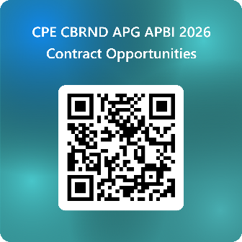

CPE ISW:
https://forms.osi.apps.mil/r/5aMqiuvPnP
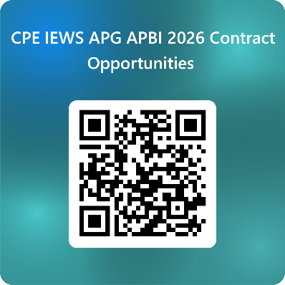

CPE C2IN:
https://forms.osi.apps.mil/r/RaLdKGACur
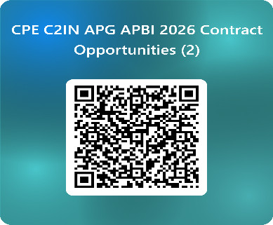

ATEC:
https://forms.osi.apps.mil/r/zqc5e8YE3z


DEVCOM C5ISR Center
https://forms.osi.apps.mil/r/USkSwsJ2zs
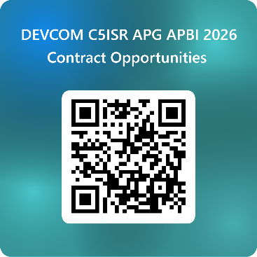

CPE ST3
https://forms.osi.apps.mil/r/9jRU1zpjcq
