Drivable Aluminum Monument for Wetlands
Drivable aluminum monument, designed for use in wetlands, swamps, riverbanks and lake shores - anywhere a substantial monument is needed and digging a hole is impossible due to constant water cover
- 3 ¼" diameter aluminum survey cap
- 2" diameter aluminum pipe, 30” long
- Cast aluminum base point
- Cone-shaped point is fluted for easy installation
- Point tapers out to a diameter larger than the diameter of the pipe to deter removal
- Cap and base are held to the pipe with aluminum rivets
- Permanent ceramic magnet located in the survey cap

Drivable Steel Monument with Bronze Cap
Drivable monument with stainless steel rod and bronze cap
- 3 ½" diameter forged bronze survey cap
- 9/16" diameter stainless steel rod, 30” long with pointed tip
- Powerful magnet installed on top of rod
- Stainless steel flange that anchors the monument firmly in the ground welded to the rod

Aluminum Drive-in Survey Monument
- 3¼" (83mm) diameter series 6000 aluminum survey cap
- 1" (50mm) diameter aluminum pipe, 30" long with pointed tip.
- Cast aluminum base point
- Cap and base are held to the pipe with aluminum rivets
- Permanent ceramic magnet located below the break-off point in the base.
- Cap should be stamped as shown below
  - 3/16" Letters
  - Optional stamped center point
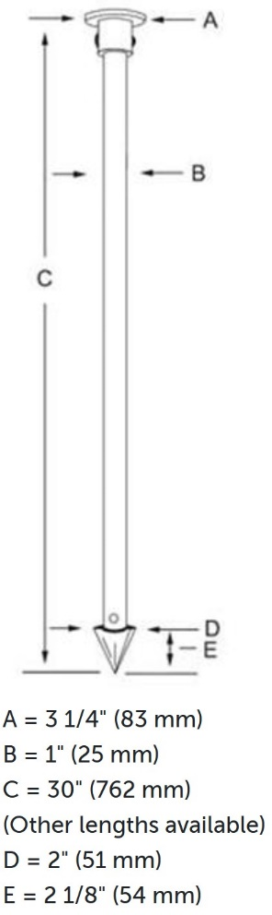
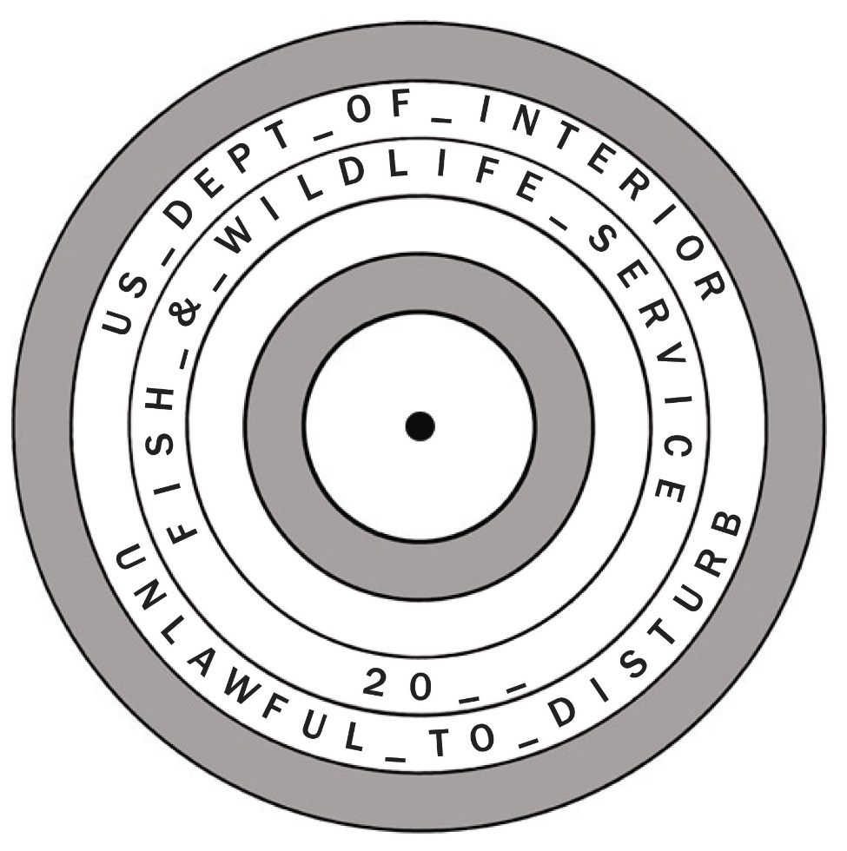

2" diameter Aluminum Cap for 5/8" Rebar
- Survey cap for rebar forged from 6000 series aluminum which is highly resistant to chipping, cracking and breaking.
- Feature SureGripT plastic insulator that locks the cap tight on to the rebar or pipe and helps prevent dissimilar metal corrosion.
- Feature a deep hex socket that won't "wobble" when tapped on to the rebar.
- Cap should be stamped as shown below
  - 1/8" Letters
  - Optional stamped center point
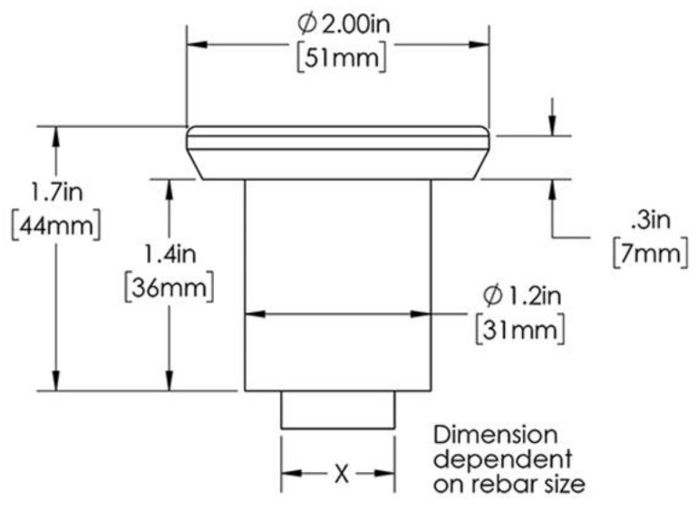
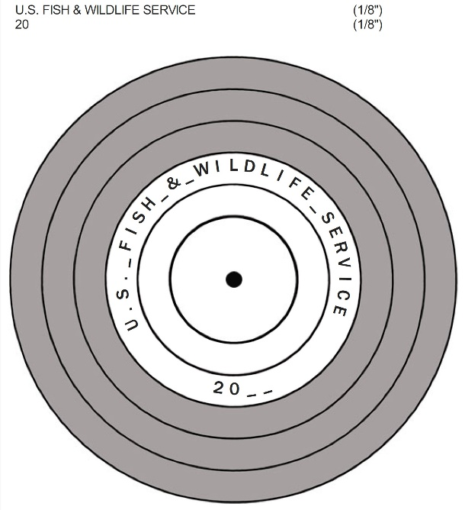

2" diameter Aluminum Cap for 3/4" Rebar
- Survey cap for rebar forged from 6000 series aluminum which is highly resistant to chipping, cracking and breaking.
- Feature SureGripT plastic insulator that locks the cap tight on to the rebar or pipe and helps prevent dissimilar metal corrosion.
- Feature a deep hex socket that won't "wobble" when tapped on to the rebar.
- Cap should be stamped as shown below
  - 1/8" Letters
  - Optional stamped center point



Steel Nail Marker with SURVEY MARK imprint
- Strong solid steel and drives easily into blacktop.
- "SURVEY MARK" is imprinted on top of nail for easy identification as a survey mark.
- 3" in length with a 1" (25mm) convex top and conical recessed center chamfer for pinpoint accuracy.
