DRAFT

Statement of Work
Memorial Day Weekend Event Support
Willamette National Cemetery

1. SCOPE OF WORK: The contractor shall provide tents, chairs, and traffic control (flaggers), and porta-potties. The contractor shall set up install tents, chairs, and Porta-Potties on May 22, 2026. The contractor shall tear down, and remove all tents, chairs, and porta potties on May 26, 2026. The contractor shall provide these services in a manner that will ensure the safety and general wellbeing of attendees. The contractor shall provide all personnel, equipment, tools, materials, supervision, licenses, quality control, and other items and services necessary to complete this contract. Contractors shall comply with all federal, state and local laws and regulations.

2. HOURS OF OPERATION: All event tents, chairs, and Porta Potties will be delivered and installed at predetermined locations at Willamette National Cemetery on 22 May 2026
between the hours of 08:30AM and 3:00PM. Following the event, the tents, chairs, and
porta-potties will be removed on 26 May 2026. Any deviations from this schedule need to be coordinated and authorized by the Contracting Officer or Contracting Officer Representative (COR).

3. LOCATIONS: Willamette National Cemetery, located at 11800 SE Mt Scott Blvd., Portland Oregon.

4. CONTRACTOR EMPLOYEES: The contractor’s foreman or representative(s) shall
present a neat appearance and shall have the capability of writing, speaking and understanding the English language. The contractor shall identify an employee who has the authority to act on all contractual matters.

5. SAFETY: The Contractor shall conform to all safety regulations to include but not limited to: Occupational Safety and Health Administration (OSHA).

6. DESCRIPTION OF WORK: In support of the 2026 Willamette National Cemetery Memorial Day Weekend Event. The Contractor shall provide all tents, chairs and tent supports as listed below. The location of the tent and chairs setup area is shown in the attached map.

6.1 The vendor will provide the following below items:

(100 each) Beige Plastic Folding Chair
(1 each) 15 ft. X 30 ft. White Tent on 10 ft. Legs
(1 each) 15 ft. X 30 ft. Ballasts
(1 each) 20 ft. X 40 ft. White Tent on 10 ft. Legs
(1each) 20 ft. X 40 ft. Ballasts
(4 each) 8 ft. x 20 ft White Sidewalls
(2 each) 10 ft x 10 ft White Tent on 10 ft. Legs
(2 each)10 ft x 10 ft Ballasts

  - Delivery and set up will take place on Friday, May 22, 2026, between the hours of 8:30 am and 3:00 pm.
  - Tear down will take place on Tuesday, May 26, 2026, between the hours of 8:30 am and 1:00 pm.

Porta-Potties –The Contractor shall provide Porta-Potties as listed below. The location of the Porta-Potties setup areas is shown in the attached map and the description is mentioned as well.

  - The vendor will provide the following below items at the stated location:

(2) ADA toilets, 2 reg toilets and 1 hand wash. Location - Rostrum: Edge to section U
(1) Reg toilet, 1 hand wash. Location - Shelter 4: at the turn around point:
(1) Reg toilet, 1 hand wash. Location – Columbarium 2
(1) Reg toilet, 1 hand wash. Location – Columbarium 9

  - Delivery and set up will take place on Friday, May 22, 2026, between the hours of 8:30 am and 3:00 pm.
  - Daily cleaning of all toilets and daily servicing of wash stations.
  - Tear down will take place on Tuesday, May 26, 2026, between the hours of 8:30 am and 1:00 pm

Traffic Control (Flaggers) – The Contractor shall provide daytime flaggers for traffic control from 8AM until 3 PM at two entry/exit points at Willamette National Cemetery. The locations of the Flagger locations are shown in the attached map and the description is mentioned as well.
  - The vendor will provide the following below items at the stated location:

Three (3) flaggers to direct traffic into the cemetery. Location – Gate 1, Mt Scott Blvd
Two (2) flaggers to direct traffic to exit the cemetery. Location – Gate 3, Mt Scott Blvd

8.2 The flaggers will be required only on Memorial Day, Monday, 5/25, between the hours of 8AM and 3PM.

DRAFT

EXHIBIT 3

CEMETERY MAPS


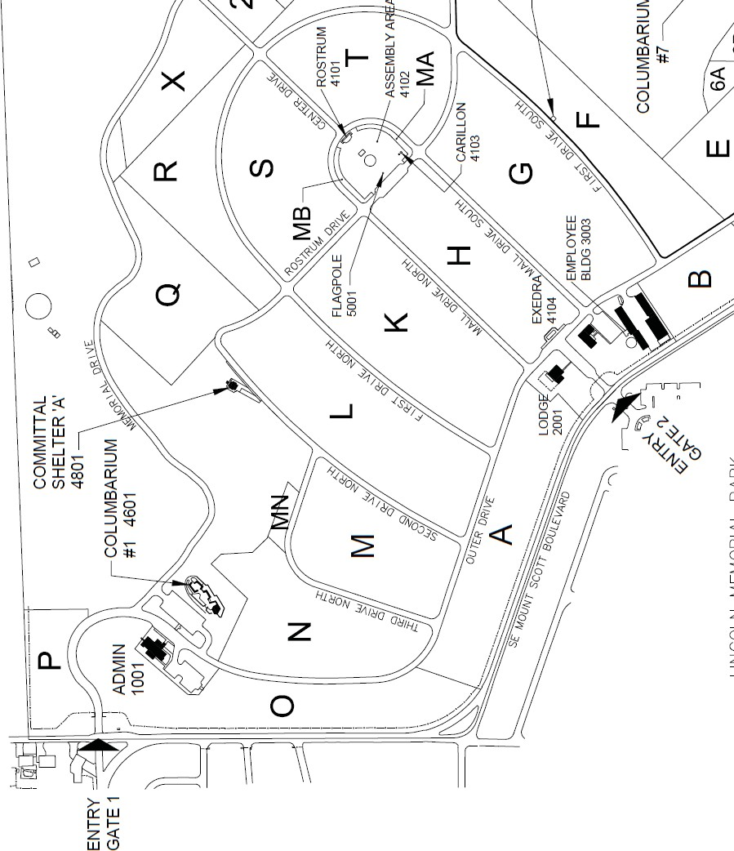
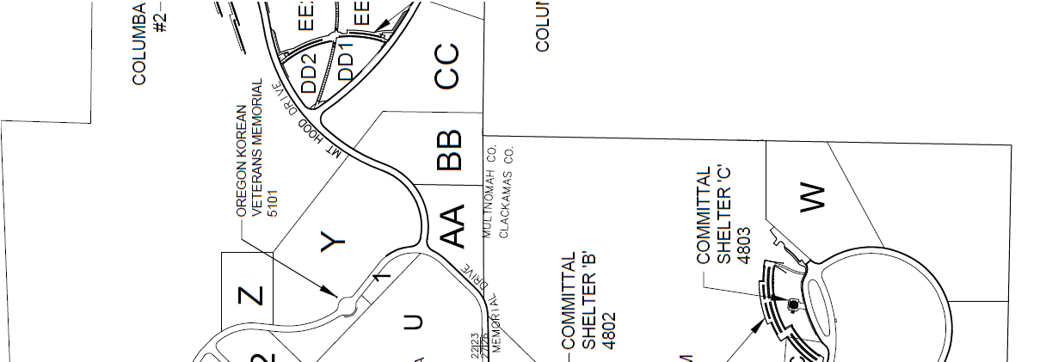
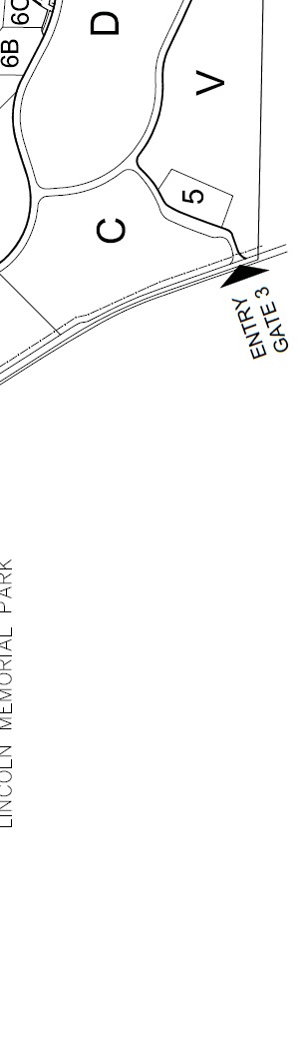


Location of Shelter 4 Porta-Potties
Location of Rostrum Porta-Potties
Location of all Tents & Chairs



Gate 1, 3 (three) Flaggers
Gate 3, 2 (two) Flaggers
Location of Columbarium 2 Porta-Potties
Location of Columbarium 9 Porta-Potties

