STATEMENT OF WORK
for the
Architect Engineering Services for the Electron Injector Complex Preliminary and Detailed Design
Quality Classification: A-3

Prepared By:

_________________________________ Date: __________________
Joseph Mondillo, EIC Lead Architect/Engineer for Design

Reviewed By:

_________________________________ Date: __________________
Maggie Haviland, EIC Procurement Liaison Engineer

_________________________________ Date: __________________
Tom Nehring, EIC Group Leader Electrical Power Systems

_________________________________ Date: __________________
Kevin Reilly, EIC Mechanical Engineer

_________________________________ Date: __________________
Chuck Schaefer, EIC ESH Manager

_________________________________ Date: __________________
Joseph Zipper, EIC Quality Assurance Representative

_________________________________ Date: __________________
Dirul Nassar, EIC Infrastructure Division Deputy Director

_________________________________ Date: __________________
Qiong Wu, Subproject Manager Electron Injector (EIN)

Approved By:

_________________________________ Date: __________________

Charles Folz, EIC Infrastructure Division Director

REVISION HISTORY
Revision | Effective Date | Summary of Change
00 |  | Initial Release

Table of Contents
LIST OF ACRONYMS 6
1. SCOPE 8
1.1 Synopsis 8
1.2 Project Background 8
1.3 EIC EIN Subproject Goals and Objectives 9
1.4 EIC EIN Complex Design Background 10
2 APPLICABLE DOCUMENTS 11
3 APPLICABLE CODES, RULES AND REGULATIONS 13
3.1 Codes of Record 13
3.2 Guiding Principles for Sustainable Design 13
3.3 Federal, State and Local Laws, Codes and Standards 14
3.4 New York State Codes 15
3.5 Local Codes 16
4 ARCHITECT/ENGINEER Scope of Work 17
4.1 General 17
4.2 Quality 17
4.3 EIC Interaction Region (IR) 4 Electron Injector Complex Location and Configuration 18
4.4 Preliminary Design Requirements 21
4.5 Final Detailed Design Requirements 37
4.6 A/E Services During Construction (Option Work) 46
4.7 Project Budget 48
4.8 Schedule Requirements 48
5 SCHEDULE MILESTONES 50
5.1 Preliminary Engineering Design Schedule Milestones (through 60% Preliminary Engineering Design) 50
6 PROJECT ADMINISTRATION 52
6.1 General 52
6.2 Project Team Directory 52
6.3 Coordination and Communication 53
7 PROJECT DELIVERABLES 56
7.1 Quality Assurance Plan 56
7.2 Preliminary Design Phase 56
7.3 Final Design Phase 56
7.4 Electronic Submittals 57
8 VALUE ENGINEERING 58

LIST OF ACRONYMS

ABL | As-Built Listing
AC | Alternating Current
ADA | Americans with Disabilities Act
A/E | Architectural - Engineering
ANSI | American National Standards Institute
ASME | American Society of Mechanical Engineers
ATP | Acceptance Test Procedure
BIM | Building Information Modeling
BNL | Brookhaven National Laboratory
BSA | Brookhaven Science Associates
Cat | Category
CDR | Conceptual Design Report
CFR | Code of Federal Regulations
COTS | Commercial Off-The-Shelf
CM | Construction Manager
CMU | Concrete Masonry Unit
CSI | Construction Specifications Institute
DC | Direct Current
DCS | Distributed Control System
DOE | Department of Energy
EIC  EIN | Electron-Ion Collider  Electron Injector Complex
ESH | Environment, Safety and Health
FDR  FFP | Final Design Review  Firm Fixed Price
GC | General Contractor
HPSB | High Performance Sustainable Building
HVAC | Heating, Ventilation and Air Conditioning
IBC | International Building Code
ICC | International Code Council
IPR | Independent Project Review
LEED | Leadership in Energy and Environmental Design
LIDAR | Light Detection and Ranging
MRP | Material Requirements Planning
M&TE | Measuring and Test Equipment
NEC  NESC | National Electric Code  National Electric Safety Code
NFPA | National Fire Protection Association
NRTL | Nationally Recognized Test Laboratory
NTP | Notice to Proceed
NYS | New York State
OSHA | Occupational Health and Safety Administration
O&M | Operating and Maintenance
PDR | Preliminary Design Review
PFD | Process Flow Diagram
PLC | Programmable Logic Controller
PO | Purchase Order
P&ID | Piping and Instrumental Diagram
QA | Quality Assurance
RDS | Room Data Sheets
RF | Radio Frequency
RFPA | Radio Frequency Power Amplifier
RHIC | Relativistic Heavy Ion Collider
SLM | Synchrotron Light Monitor
SOW | Statement of Work
TIA | Telecommunication Industry Association
UL | Underwriters Laboratories
WBS | Work Breakdown Structure

Architect Engineering Services for the Electron Injector Complex Preliminary and Detailed Design

SCOPE
This Statement of Work (SOW) will be the basis for the procurement of Architectural/Engineering (A/E) design services to be used at the Electron-Ion Collider (EIC) at Brookhaven National Laboratory (BNL) managed by Brookhaven Science Associates (BSA). This document outlines the Contractor’s responsibilities and obligations necessary for completing the requirements as set forth herein.

Synopsis
Architectural/Engineering (A/E) design services are required to develop the preliminary and detailed designs, services and documents as well as to provide construction support services for the Electron-Ion Collider (EIC) Electron Injector Complex (EIN) Subproject. Designs shall include Infrastructure Systems, Structures and Components required to support the proposed new Electron Injector Complex.

The Construction Support Services are included as option work and will be awarded at the discretion of Brookhaven Science Associates (BSA).

The conceptual design has been completed and the conceptual design report, when combined with this Statement of Work (SOW), will serve as the basis of the A/E’s scope of services.

Project Background
The Electron-Ion Collider (EIC) will be a particle accelerator that collides an electron beam with a beam of ions. It will produce comprehensive data on the internal structure of protons and nuclei to reveal unprecedented details of the arrangement and interactions of the quarks and gluons that make up the building blocks of nuclei.
The EIC will be built to leverage the existing Relativistic Heavy Ion Collider (RHIC) and its infrastructure. Enhancements to the infrastructure will be required to accommodate the planned new facilities. A significant enhancement will be the design and construction of the Electron Injector Complex to provide suitable beam parameters for use in the Electron-Ion Collider. The purpose of this project is to construct a 750MeV electron linear accelerator (LINAC) approximately 100 m in length, along with a rapid-cycling synchrotron (RCS) approximately 1500 m in circumference, consisting of two 130 m straight sections and end arcs with a bending radius of approximately 196 m. These structures are proposed to be constructed of conventional reinforced concrete and steel. Associated support buildings are planned to consist of two power supply and mechanical service buildings, radio-frequency klystron (power supply) building along and adjacent to the Linac, a laser room associated with the Linac and a cryogenic system with connection to the existing RHIC cryogenics system. Electrical power will be provided by an overhead line from the EIC distribution system.

EIC EIN Subproject Goals and Objectives
The EIN ring tunnel comprises 12 key segments: Two main straight segments (D2 and H2) and ten smaller segments (A1, B1, B2, C1, D1, E1, F1, F2, G1, and H1). Major EIN facilities are sited next to the straight segments, while smaller support buildings are located near the smaller tunnel segments. The EIN subproject is intended to be operated with a schedule: 9 months on (Oct-Jun) and 3 months off (Jul-Sep).

The largest structure within the EIN Complex is the Rapid Cycling Synchrotron (RCS) Tunnel, which is directly interconnected with the LINAC Complex - a facility designed to accommodate the linear particle accelerator. The LINAC Complex located between H1 and H2 includes an Electron Gun Structure (GUN), LINAC Gallery, Bunch Accumulation Ring (BAR), Local Injection Control Room, and various supporting equipment rooms.

The second largest facility is the RF Complex, located at D2, houses the Radio Frequency (RF)
Support Gallery, Kicker Power Supply equipment, Cryogenic Building, and other supporting
infrastructure.

The project also includes expansion of the Medium Voltage infrastructure to accommodate new
EIN power supply requirements.

EIC EIN Complex Design Background

The EIN Complex is designed to support high-intensity particle acceleration through
a staged process that begins with a Linear Particle Accelerator (LINAC) and transitions into a
circular synchrotron ring optimized for rapid cycling. The LINAC provides initial beam acceleration and accumulation, delivering electrons into the RCS for further acceleration to the desired energy levels.

The complex includes a network of interconnected facilities: the LINAC Complex, RF Complex, transfer lines, and the RCS tunnel organized in two straight and two curved sections of precast
concrete segments. Straight sections of the tunnel are enlarged to accommodate critical systems
such as injection and extraction equipment, RF cavities, and beam diagnostics. The curved
sections are more compact, focused on guiding the beam along the ring path.

Supporting infrastructure includes Power Supply buildings, Radio Frequency Support Gallery
buildings, Pumphouses, and other service buildings, all integrated with utility systems for cooling, cryogenics and electrical distribution.

Site grading differentiates between above-grade service buildings and below-grade beam
enclosures to optimize shielding and operational efficiency.

The overall layout is driven by beam physics, operational safety, and maintenance access, with
careful coordination between accelerator requirements, architectural design, and civil
infrastructure. The facility is engineered for high reliability, longevity, flexibility, maintainability, efficient installation, and lifecycle cost.

APPLICABLE DOCUMENTS
In the event of a conflict between the Technical Documentation and this SOW, the Contractor (known as the A/E hereafter) shall immediately notify the BSA Contractual Representative who will in each instance determine which document takes precedence and advise the A/E accordingly. Failure to notify BSA of a document conflict shall not relieve the A/E’s responsibility to ensure full compliance to all requirements.
The following documents are an integral part of the SOW; the applicable revision level will be the latest that is in effect at the time of award:

Document Number | Document Title
EIC-ORG-RSI-026 Rev2, September 2025 | EIC’s Code of Record
 | EIC Fire Hazard Analysis202307.pdf - Preliminary Fire Protection Assessment EIC Complex
EIC-QAG-PLN-002 | EIC Quality Assurance Plan
EIC-ESH-PLN-008 | 2020 Codes of Record Gordon 9-221 - EIC Preliminary Hazard Analysis Report and Codes of Record Letter
 | NEPA - DOE BHS Environmental Assessment for the Construction & Operations of the EIC-March2021.pdf
 | NEPA- BHSO letter (June 2025) “No further NEPA review is required”
 | Finding of No Significant Impact (FONSI) - Finding of No Significant Impact Letter—March 26, 2021
 | Basis of Design Document - 11062020_BNL_EIC_100%_BOD_Posting.pdf
 | Concept Design - EIN Infrastructure Concept Design: HDR Basis of Design, Drawings and Cost Estimate
 | Systems Requirements Spreadsheet - EIN Infrastructure Utilities Requirements
 | EIC Infrastructure: HDR Basis of Design, Drawings and Cost Estimate - EIC Infrastructure 100% Complete Plans, Specifications, and BOD (See note)
BNL-QA-101 | Brookhaven National Laboratory Supplier Quality Assurance Requirements

Note: The EIC Infrastructure 100% Complete Plans are for reference, only. These 100% Detailed Plans are expected to undergo design refresh and quality improvements. Designs should be used only to understand basic concepts, understand BNL material preferences and anticipated construction practice.

APPLICABLE CODES, RULES AND REGULATIONS
The A/E shall follow the applicable codes, rules and regulations summarized and listed below:

Codes of Record
The Architect/Engineer shall be responsible for preparing design drawings and specifications which are in conformance with the latest edition of the codes, rules and regulations of the State of New York, including the reference standards. It is noted that all applicable Department of Energy (DOE) standards for facility safety and construction are also included for reference.

Guiding Principles for Sustainable Design
BNL, as a Federal facility is required to comply with statutory requirements in a manner that increases efficiency, optimizes performance, eliminates unnecessary use of resources, and protects the environment. The Department of Energy requires projects to incorporate and document compliance with climate adaptation, resilience, and sustainability requirements (refer to DOE O 413.3B Appendix C, Paragraph 5.), support for the Site Sustainability Plan(s) per DOE O 436.1 (current version), and/or other high performance and sustainable building considerations (refer to DOE G 413.3-6, current version and Guiding Principles for Sustainable Federal Buildings).

The tailored and simplified approach to be taken by the project toward this initiative includes:
Meet High Performance and Sustainable Buildings practices for new construction and renovations in the conventional facility scope for the Electron Injection complex.
Integrate energy efficient, sustainable, healthy, climate-ready measures and climate-resilient building practices into the early stages of building design when designing, locating, constructing, and renovating Federal buildings per the applicable requirements in DOE O 413.3B Appendix C, Paragraph 5.

Federal, State and Local Laws, Codes and Standards
The EIC buildings shall be designed in accordance with all applicable federal laws, codes, and standards. Particular attention must be paid to compliance with radiological and personnel safety requirements of 10 CFR 835 and 851 respectively, and OSHA requirements of 29 CFR 1910 and electrical safety requirements of NFPA 70E-2021. Additional DOE orders and standards for Environment, Safety and Health (ESH) and accelerator facilities are also applicable as indicated in the EIC Hazard Analysis Report.

In addition to all applicable DOE Orders, the design shall be in compliance with all applicable latest published versions of the following codes, regulations, standards, acts, and manuals. In case of any conflicts, the most stringent requirement shall apply. Any conflict between codes and standards will be sent to BSA and resolved by DOE, if applicable. The EIC Requirements, Specifications, and Interfaces Code of Record, identifies the codes and regulations in effect for all projects at BNL. The following list identifies the codes and regulations in effect for all projects at BNL.
- International Code Council (ICC) International Building Code (IBC), and Supplements
- NFPA 72 Fire Alarm and Signaling Codes
- NFPA Standard 13, “Standard for the Installation of Sprinkler Systems”
- NFPA 80 Fire Doors and Other Opening Protectives
- NFPA 80A Recommended Practice for Protection of Buildings from Exterior Fire Exposures
- NFPA 90A Standard for the Installation of Air-Conditioning and Ventilating Systems
- NFPA 92 Standard for Smoke Control Systems
- National Electrical Safety Code, ANSI C2
- NFPA 70, National Electric Code (For the design of facilities and equipment and purchase of equipment)
- NFPA 70E: Standard for Electrical Safety in the Workplace
- NFPA 101 Life Safety Code
- NFPA 101A Guide on Alternative Approaches to Life Safety
- NFPA 105 Standard for Smoke Door Assemblies and other Opening Protectives
- NFPA 110 Emergency and Standby Power Systems
- NFPA 214 Standard on Water-Cooling Towers
- NFPA 220 Standards on Types of Building Construction
- NFPA 241 Standards for Safeguarding Construction, Alteration, and Demolition Operations
- NFPA 780 Standard for Installation of Lightning Protection Systems
- Occupational Safety and Health Act (OSHA)
- Underwriters Laboratory (UL)
- Americans with Disabilities Act (ADA)
- DOE G 413.3-6 “High Performance Sustainable Building”
- American National Standards Institute (ANSI) Standards
- The American Society of Heating, Refrigerating and Air Conditioning Engineers (ASHRAE) Handbooks and Standards
- Sheet Metal and Air Conditioning Contractors' National Association (SMACNA) Standards, 4th edition
- The American Society of Mechanical Engineers (ASME) Standards and Codes
- Telecommunication Industry Association (TIA)
- 29 CFR 1910 Occupational Safety and Health Standards
- 29 CFR 1926 Safety and Health Regulations for Construction
- 10 CFR 851 Worker Safety and Health Program
- 10 CFR 1021 National Environmental Policy Act (NEPA) Implementing Procedures (*)
- DOE O 420.1C, Chg. 3 Facility Safety
- DOE-STD-1066 Fire Protection
- DOE O 414.1E Quality Assurance
- Buy American Act (BBA)
- The Build America, Buy America Act (BABA)
- Executive Order 14005, Ensuring the Future is Made in all of America by all American’s workers.
(*) The Final EIC NEPA Environmental Assessment for the EIC (DOE/EA-2138) was completed March 2021 is incorporated by reference. A NEPA RE-Evaluation was performed for the Rapid Cycling Synchrotron/Linear Complex for Electron Ion-Collider (a.k.a. Electron-Ion Complex) in the Spring 2025. The DOE findings upheld the original NEPA Environmental Assessment (Finding of No-Significant Impact (FONSI). DOE, by letter dated June 4, 2025, found that “the changes in potential environmental impacts from the proposed modifications are negligible.”

New York State Codes
The construction and workmanship shall be in conformance with the latest published edition of the codes, rules and regulations of the State of New York, including the reference standards. In particular, the following shall apply to this project.
- Building Code of New York State, and Supplements
- Energy Conservation Construction Code of New York State
- Fire Code of New York State
- Fuel Gas Code of New York State
- Mechanical Code of New York State
- Plumbing Code of New York State

Local Codes
Design work shall conform to the latest published requirements of the Suffolk County Department of Health Services Sanitary Code as applicable.

ARCHITECT/ENGINEER Scope of Work

General
The scope of work for A/E services shall include all professional services to furnish Preliminary and Final Detailed Design services as described herein. The work shall include site/project familiarization, detailed site surveys and analysis, engineering, alternatives analysis, value engineering, preparation of electronic drawings, graphics, renderings, specifications, comprehensive reports and cost estimates, and field inspection. The design shall include all design and engineering work that is required for the design, installation, startup, commissioning, and testing of the new EIC conventional facilities unless otherwise noted below.

Quality
4.2.1 Quality Standards
The A/E deliverables shall meet high-quality standards. All submittals shall be comprehensive, clear, and coordinated sets of documents that effectively and accurately communicate all the information required to build the project that meets the functional, safety, and regulatory criteria (see section 3.3 Federal, State and Local Laws, Codes and Standards.) The A/E shall prepare detailed drawings and comprehensive specifications using clear, plain language and consistent terminology to prevent misinterpretation, conflicts between drawings and specifications, and the need for frequent contractor Requests for Information (RFIs) or costly rework. The clarity and completeness of the plans and specifications must be the basis for accurate bidding (i.e., cost estimates and schedules) leading to fewer change orders and disputes during construction.
All design information shall be consistent and compatible across different disciplines (architectural, civil, structural, mechanical, electrical, etc.).
4.2.2 Quality Assurance Program
The A/E shall prepare a project-specific quality assurance (QA) plan and submit the plan to BSA for approval. The QA plan shall conform to the “Contractor Requirements Document” as defined in DOE Order 414.1E, Quality Assurance (available at http://www.directives.doe.gov) and describe the A/E’s QA program, including implementing procedures, to be implemented and maintained for the scope of services.
The purpose of the QA plan is to give the A/E’s QA requirements for the scope of services and describe how they will be satisfied. The goal is to assure that all aspects of this project are performed in a controlled manner, comply with applicable codes, and that all components and systems are designed and developed according to sound engineering standards, quality practices, and technical performance requirements for the project.
Design Effort Phase: Elements to be included during the design effort by the A/E are indicated below:
- Review of proposed materials of construction and installed equipment for availability, economy, compatibility with other components, performance, and maintainability.
- Continuous review of the design to ensure that this project can be constructed as designed using the most efficient available techniques within available funds and based on the proposed phased funding and phased construction schedule. Design review shall assess the operability of the project after completion.
- Review for coordination of required elements and systems to ensure that the design reflects the latest approved version of the project scope description.
- Establish and maintain a configuration control system to assure the design reflects the current approved scope and is not changed without BSA approval.
- Submit the A/E’s project-specific QA plan and implementing procedures to BSA for review and approval prior to start of preliminary design. The A/E program must comply with applicable elements of the Quality Assurance Plan for the Electron-Ion Collider.

EIC Interaction Region (IR) 4 Electron Injector Complex Location and Configuration
The current location of the EIC Electron Injector Complex (EIN) with linear particle accelerator (LINAC) and new Rapid Cycling Synchrotron is located east of the existing RHIC tunnel at the Sector 3 location as shown below:
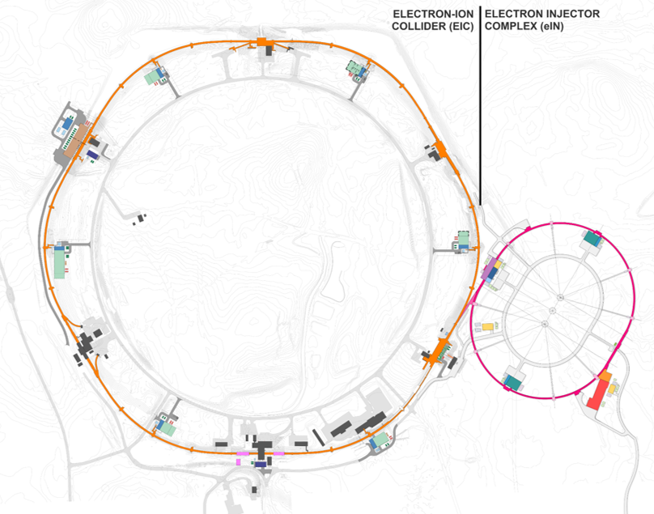

Figure 1: Location of Electron Injector Complex with LINAC and Rapid Cycling Synchrotron (EIN)

The current configuration for the Electron Injector Complex (EIN) is shown below.

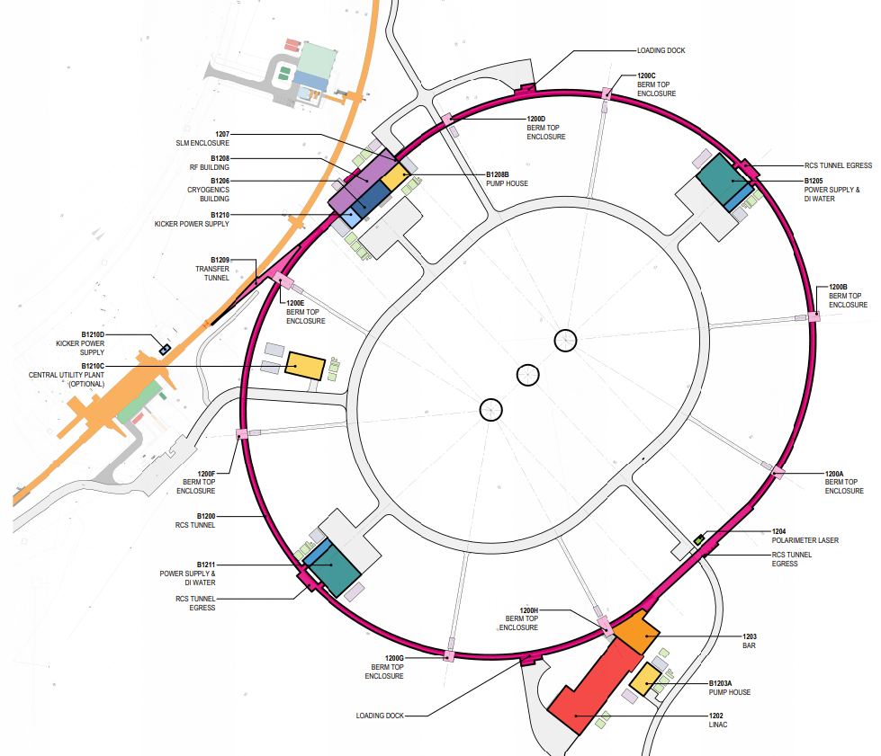
N
Figure 2: Electron Injector Complex with LINAC and Rapid Cycling Synchrotron (EIN) Configuration

The above sketch was developed and contained in the Conceptual Design. Building sizes and geometry as shown in the Conceptual Design Report may change as the machine design matures. The A/E shall collaborate with BSA to develop the Preliminary Design. An iterative design process will be required throughout the Preliminary Design Process. However, it is the project goal to converge on the geometry and dimensions of the infrastructure elements by the completion of the Preliminary Design Phase.

Building Sizes
The EIN will be built to leverage designs developed for the EIC project. Enhancements to the Infrastructure will be required to accommodate the planned facilities. BSA expects the A/E to follow the principles of “Value Engineering” throughout their design development (see section 8). That is, to achieve essential functions at the lowest cost with required performance, reliability, quality, maintainability, environmental protection and safety.

The Square footage as indicated in the table below is anticipated to be approximate. The building footprints were based on similar functionality for the main EIC Project buildings. However, more detailed A/E design required under this contract will dictate the final configurations. The A/E shall include in the design tunnel penetrations for RF transmission waveguide, cooling piping, electrical power (AC and DC) conduits and cooling to compensate for heat dissipation of conductors or waveguide

Building Sizes (Square foot) 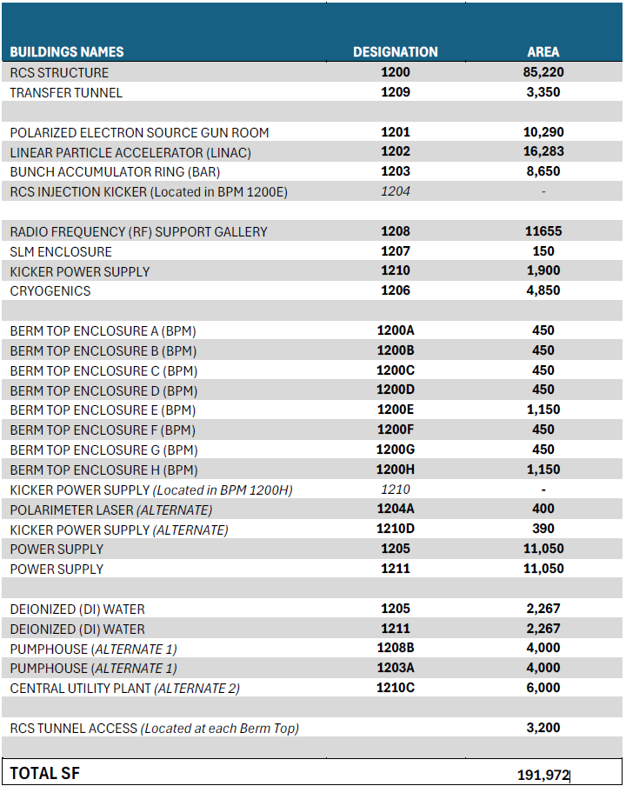

4.4 Preliminary Design Requirements
4.4.1 Preliminary Design Report
The A/E shall perform design development to bring the existing EIN Conceptual Design to a state of development suitable to begin definitive construction documents. The A/E shall prepare a comprehensive Preliminary Design Report presenting the scope, cost, and schedule baselines to be used for the final detailed design. The data in the Preliminary Design Report shall be revised and supplemented as required for each design submittal up to and including the final construction document submission. The report shall present drawings and specifications in sufficient detail to represent a 30% complete final detailed design in civil, architectural, structural, mechanical and electrical disciplines. The report shall also include a construction schedule, construction cost estimate, and supporting scope description by Subproject WBS, basis of design, alternatives analyses and functional requirements document supporting the rationale for the design.
The Preliminary Design Report shall include the following sections:
- Basis of Design (BOD) - General Project Description.
- Construction Cost Estimate(s).
- Project Execution and Phasing Strategy.
- Preliminary Construction Schedule.
- The calculations supporting the design shall be submitted calculations. All references, codes, and design data used in the calculations shall be included and source indicated in the calculations. Allowable loads and design factors are to be clearly stated.
- Sustainable Design / High Performance Sustainable Buildings and climate resiliency design compliance.
- Energy conservation aspects of design resulting from investigation of the complete power/cooling strategy systems must be discussed. A description shall be included of each feature as appropriate.
- A brief synopsis identifying the logical alternatives for power, emergency power, cooling, redundancy and reliability considerations, and rationale used to determine the best solution. Attention shall be given to all factors such as life-cycle cost, local conditions, construction schedule and methods, and availability of materials.
- Room Data Sheets (RDS)
- Life Safety, Fire Protection/Detection, and Security.
- Safety Hazards and Risks.
- Design Data Handbook – A separate section shall be dedicated for the inclusion of all specified products and equipment (cut sheets). This shall be continually updated throughout the design process.
The Conceptual Design Report (CDR), BOD and Conceptual Design Cost Estimate for the EIN Project were completed August/September 2025. The A/E shall review these documents and become familiar with the project expectations and prepare for the 1st Immersion Workshop with Project Stakeholders. The foundation for the Preliminary Design shall be the Conceptual Design Report, Basis of Design (BOD) and Conceptual Design Cost estimate and the discoveries made during the 1st Immersion Workshop and Preliminary Investigation of Existing Conditions. BSA shall provide Conceptual Design and Cost Estimate comments to the A/E at the beginning of this scope (i.e. Notice to Proceed (1) or NTP(1)* shown in the Schedule Milestones in section 5 below) to provide further guidance for Preliminary Design development.
4.4.2 Preliminary Design Effort
The Preliminary Design Effort shall include the following services:

- Consult with EIC Project Team and Environment, Safety & Health Services personnel to determine all requirements that will govern the design and establish engineering and operating criteria for such design.
- BSA will provide the programming information to date including but not limited to, proposed equipment lists and requirements, staffing requirements, and other special requirements. The A/E shall validate this information and use it to form the basis for preliminary floor plan layouts.
- The A/E shall prepare designs, floorplans, elevations, system schematics and profiles based on proposed construction packages developed from the CDR. Identify recommended scope of separate construction packages and coordinate and identify scope interface points between packages.
- Although most of the EIN Project site is clear of existing underground utilities, BSA will provide plans showing existing underground utilities in the vicinity of the EIN Project. The A/E shall conduct site investigations to verify locations and capacities of utilities and develop plans for utility service modifications as required. BSA Engineering will provide field assistance for verification as necessary. The EIN Project site is shown on the BNL land-use maps as an ordinance area, once used by the military. The A/E shall make recommendations regarding the subsurface investigation to analyze safe building practices for the proposed project.
- The A/E shall conduct all field surveys of existing conditions and existing building systems and prepare as-built documents based on these investigations. BSA will provide all existing building documentation available and 100% Detailed Designs for the main EIC Construction project. The A/E shall participate in a 2nd immersion workshop to discuss the requirements for the interface and connection of the new transfer beamline with the EIC beamline constructed in the RHIC tunnel in the IR4 area. The A/E must ensure the 3D computer models align and intersect at the required geometry. This includes X, Y, Z floor location and tunnel approach angles.
- The A/E shall develop a digital terrain model using total station equipment and LIDAR measurements. Topographic surveys shall be developed to show land elevation, natural features, man-made structures using contour lines, spot elevations, and symbols, essential for construction, engineering, and planning. They are to be used for grading, design, and identifying drainage issues. All surveys shall be in NYS Plane coordinates in US survey feet. The datum for the RHIC tunnel is a central coordinate system. This coordinate system will be provided with corresponding survey conversions to the A/E by BSA. Topographic surveys must include sufficient coverage for Detailed design and construction documents.
- The A/E shall conduct a soils investigation to gather information about the site's subsurface conditions to inform the safe, economical, and effective design and construction of the project. The A/E shall prepare a geotechnical report containing the design characteristics of the subsurface conditions. The geotechnical report shall contain the soil classification descriptions, groundwater depth(s), design parameters for engineering analysis and specific recommendations for the project among others such as foundation design, drainage, and electrical resistivity for electrical grounding. Grab samples and sieve analysis on the site in the EIN Complex area to confirm suitability for fill at potential borrow areas shall be performed by the A/E and included in the geotechnical report. Sufficient geotechnical investigation shall be included for Preliminary, Detailed design and construction bid documents.
- Prepare technical specifications based on Construction Specifications Institute (CSI) format. BSA’s General Conditions and Supplementary Conditions will be provided in MS Word format and shall be included in the specification. Technical Specifications shall include the manufacturer and model or type for each product specified and should enable competitive source of supply wherever feasible to the extent that performance objectives are not compromised. BSA’s standard specifications and the specifications used in the construction of the main EIC project will be provided to the A/E for incorporation in the specification where feasible. They reflect satisfactory performance history at BNL and help to standardize maintenance and repair requirements. To promote continuous improvement, the A/E shall provide suggestions to modify these Technical Specifications wherever applicable.
- Prepare a preliminary Electrical Arc Flash Compliance Report indicating how the electrical design meets the requirements of OSHA 29 CFR 1910 and NFPA 70E-2021. Using a circuit analysis software system approved by BSA, demonstrate that proposed equipment, cabling, and protective settings indicated in the design drawings and specifications meet the OSHA and NFPA criteria above. Each time-current curve shall include the associated “one-line diagram”. This report shall also be submitted with the 60% preliminary design review package and updated in the 90% and 100% final detailed design submittals. Include all electrical one-line drawings, calculations, and equipment and cabling data to substantiate the report findings.

- Prepare and submit a detailed water balance diagram(s) and a detailed thermal hydraulic analysis that show compliance with performance requirements for various operating conditions and necessary chillers in accordance with the requirements provided by BSA. Provide the native input files for any analysis performed using commercially available software.
- Prepare and submit process flow diagrams (PFDs), intelligent piping and instrumentation diagrams (P&IDs) for all systems. The intelligent P&IDs shall be capable of generating outputs such as line lists, valve lists, equipment lists and other process and equipment parameters, The inputs for such intelligence would be from process flow data, instrumentation schematics, equipment data sheets, valve and instrumentation specification sheets, piping material specifications, etc. The P&IDs shall be able to communicate with the plant 3D model. From Intelligent P&ID databases, plant operating and maintenance (O&M) personnel should be able to retrieve attributes of equipment, nozzles, pipelines, valves, etc.
- Prepare and submit mechanical site plans, specifications, mechanical equipment arrangement drawings, piping and ductwork layout drawings piping and ductwork tie in points that will be generated via a 3D model.
- Prepare and submit a complete equipment list, specialty list, mechanical equipment and load schedule, complete detailed valve and line schedules with relevant Cv (flow coefficient) values, system descriptions, sequence of operations, DCS (distributed control system) I/O list, control narrative documents and control logic diagrams and DCS architecture drawings.
The controls design shall clearly delineate two independent control systems with distinct scope and functionality:

- ALC-Based Building Management System (BMS):
Dedicated to building-related systems including, but not limited to, HVAC systems, water and electrical utility metering, general building utilities, and associated mechanical and electrical infrastructure.
- PLC-Based Industrial Control System:
Dedicated to industrial water systems, VFD’s, cooling towers, process cooling systems, air compressors, and other process-related mechanical utilities.
The design documentation shall clearly define system boundaries, points of integration (if any), communication interfaces, network architecture, and segregation between the BMS and PLC systems. Any required data exchange between systems shall be explicitly identified, including protocols, gateways, and responsibility demarcation.
Pump schedules to include but not limited to design operating points, impeller diameters and material construction.
The design package shall include comprehensive utility detail drawings clearly depicting all utility service points for each building, including but not limited to electrical, water, sanitary, storm, and communications. Drawings shall illustrate both internal and external utility routing, explicitly identifying points of entry and exit through the building envelope, slab, foundation, and walls.
The design shall include elevation and section drawings at all utility transitions to clearly define vertical relationships, penetrations, sleeves, clearances, and coordination with structural and architectural elements. These drawings shall be sufficiently detailed to eliminate ambiguity and to enable the General Contractor to accurately construct, coordinate, and install all utility connections without reliance on assumptions or field interpretation.
- The Preliminary Construction Cost Estimate shall be developed as a “bottom-up” estimate using the Preliminary Design plans and specifications as the basis for quantity take-offs. The estimate shall include costs for material, labor and equipment for all construction activities to the extent defined at this level of design. The estimate shall be developed using nationally recognized methods but shall also reflect conditions of the local material and labor markets. The estimate shall predict as accurately as possible the value of the lump sum bid(s) for all work associated with construction of EIN Complex. Contingency shall not be included as part of the estimate.
The project cost will be estimated by three different organizations, the CMa, A/E, and an independent estimator hired by BSA. BSA will contract with a CMa to provide a constructability review of the design at various milestone stages, provide a “bottoms-up” cost estimate and perform material and market surveys related to the construction bidding environment. BSA will contract with an independent estimating company to perform estimating services at the various milestone stages and provide market analysis for the project area. The A/E shall develop an estimate at the same various milestone stages using nationally recognized methods and will be reconciled with the CMa and BSA estimator throughout the project. All estimates and materials will be subject to review by an independent project review committee appointed by DOE. The estimate format shall be based on specification Division and correlated with EIC WBS Structure for easy reconciliation with BSA independent estimates. The A/E will support the CMa and any third-party estimator estimating efforts as required and provide necessary clarifications and additional information as requested.

- Conduct focused immersion workshops for the following EIN topic areas:
  - Building controls
  - PLC controls
  - Fire protection
  - Fiber Networking
  - Storm water
  - Potable water
  - Topographic Survey and CAD modeling (See section 4.4.2 Preliminary Design Effort paragraph 4, 5, & 6 above)
  - Connection of Injector Complex to RHIC tunnel
  - Milestone Kick-off Meetings

- Conduct bi-weekly progress meetings with BSA project staff. Progress meetings shall be held virtually, at the BSA site, and at the A/E site at the discretion of BSA. Key architectural and engineering personnel shall be represented at the meetings based on the meeting agenda. Provide a record of discussion for each progress meeting and identify action items and responsible party for each action. Track each item to completion.
- Drawings shall be prepared with a minimum scale of 1/8” = 1-0’ for general construction plans. Detail plans and sections shall be drawn at other scales as appropriate. Entire architectural floor plans shall be shown once on a single sheet at the largest scale practicable. The BNL title-box shall be used on all drawings in addition to the A/E title-box. Drawings shall be prepared utilizing an industry standard 3D modeling capable BIM platform. Submittal of the proposed design package is required with bid submission. Drawings and models shall depict the scope and intent of the design in sufficient detail to enable quantity take-offs, material quality and method of construction determination for estimate purposes. Quantities shall be auto generated from the BIM model. All plans, specifications, and reports relating to the construction or alteration of buildings or structures, or geologic drawings and reports shall be stamped with a professional engineer seal under New York State law Article 145. Each building shall be stored as a separate design file to allow updates and changes on individual buildings without disruption to other building design files.
- Three progress review submittals are required during Preliminary Design. Furnish one (1) sets of full-size drawings and specifications and three (3) half-size drawings and specifications at approximately 30% completion and again at 60%. Include the report narrative, design basis, functional requirements document, construction schedule, construction cost estimate, drawings for site, structural, architectural, mechanical, plumbing and electrical work, and technical specifications. The 90% submittal shall be comprehensive for incorporation of BSA’s final comments.
- Provide a 3D rendering of the facility design showing the physical features of the selected design and state of development at 90% detailed design submittal. Provide a 3D virtual animated fly-over video showing what the completed facility might look like. Video to be 3-4 minutes, and clearly depict significant features of buildings and structures and their relationships to the existing facility. Interior views of the RF Power Amplifier facility and LINAC facility (or facilities) shall be required.
- The A/E shall incorporate constructability review comments and recommendations of the CMa as approved by the BSA IDD. The A/E shall participate in cost estimate reconciliation meetings to discern the basis for discrepancies between the A/E estimate, the CMa estimate and the BSA Independent estimate.
- A Value Engineering (VE) study of the A/E preliminary design (based on 60% documents) shall be performed by the A/E, CMa, and an independent committee established by BSA and the A/E. The A/E shall provide all professional services to furnish a VE report to meet the intent and criteria set forth in Public Law 104-106 (Value Engineering) Section 4306 and OMB Circular A-131, dated December 26, 2013. In advance of the VE study, the A/E shall prepare members of the VE team, both BNL and A/E participants, by providing work aids and preparatory guidance with respect to the EIN project and the VE process. The A/E shall facilitate the meeting, document the discussions, and prepare an executive summary. Once the Evaluation and Development Phase breakout sessions of the VE study have begun, A/E Civil, Mechanical and Electrical lead members shall provide facilitation assistance, as well as technical guidance during the Evaluation and Development Phase of the VE study. The A/E is expected to incorporate the accepted recommendations from the VE study into the design cycle, including cost validation, as the design process progresses. The CMa shall collaborate with the A/E to prepare a cost estimate for each accepted VE recommendation.

The A/E shall investigate design implications and incorporate the committee’s recommendations, as accepted by the BSA IDD, into the final Preliminary Design.

The A/E shall incorporate and record all informal VE suggestions into the Study up to and following the 90% design phase.

- Coordinate with the CMa the preparation and submittal of a preliminary construction schedule reflective of project phasing and/or early procurement considerations. The project shall be multi-year funded. Project phasing will be required to reflect the availability of funding and shall be incorporated into the design documentation.

4.4.3 Preliminary Design Services – Other Technical Design Requirements
The RCS tunnel and LINAC are to be constructed of reinforced concrete equipped with embedded Unistrut with a maximum spacing of 5 feet capable of supporting heavy water piping and electrical cable loads. The Transfer Line structure shall be either reinforced concrete or corrugated metal ─ whichever is most cost effective and preferred from a constructability perspective. The Preliminary Design shall continue to refine the material and construction technique options to reduce costs. The tunnel floor shall be level with a finished surface void of ruts and imperfections. The RCS and LINAC and Transfer Tunnel structure floor levels are to be set so that the RCS beam elevation meets the beam height in the RHIC tunnel. Tunnel design should include sufficient penetrations/sleeves to allow for future expansion of services into the RCS tunnel. A minimum of 5 feet earthen berm shielding should be expected. However, this cost shall be itemized separately and may vary since the shielding analysis has not yet been determined.

As outlined in the approved CDR, the LINAC and RCS Pre-injector complex shall be designed to accommodate a LINAC with new structures. Buildings are to be designed for cryogenics equipment, Radio Frequency (RF) equipment, electron gun laser structure, beam-line structure, and a Bunch Accumulator Ring (BAR) Structure and Labyrinth, LINAC RF Mechanical/Service Room, Mechanical Equipment room, Switch Gear Room, Local Injection Control Room, Electrical Equipment Room, appropriate air or water cooling, and shielding. Cryomodules will be housed in the tunnel. A small cryogenics facility will be needed; requirements are currently under development. Cryogenics equipment is to be designed by others, but the facility is to be part of this scope. In addition to the building and structure, the design shall include:
- Power and distribution facilities. Power distribution includes connection to the 13.8 kilovolt (kV) distribution system, design of the substations, switchgear and duct banks for the structure, design of motor control centers and switchgear for machine electrical distribution and building electrical distribution. Assume the structural requirements for the Power Supply Buildings will be similar to Building 1001A of the current EIC project.
- Chilled water, closed loop cooling water systems and cooling tower systems to the accelerator support systems (process cooling) throughout the facility including:
- Chilled water systems that include equipment such as chillers, pumps, and associated water treatment systems to supply low temperature cooling water (and associated water treatment) for low temperature process cooling needs.
- Closed loop deionized or ionized cooling water systems that include equipment such as water treatment systems, pumps, piping and heat exchangers for process cooling needs. These systems are cooled by the cooling tower systems.
- Cooling tower water systems including equipment such as evaporative cooling towers, pumps, piping and associated water treatment for rejecting heat from the closed loop cooling water systems.
- Assume the structural requirements will be similar to Building 1001A of the current EIC project (i.e. Power supply and Deionized Water (DI) within the same building).
- A means of providing interior climate control within the RCS tunnel is required to satisfy equipment operational requirements and ensure operational stability. During Preliminary Design, anticipated thermal loads, equipment environmental tolerances, heat rejection characteristics, and relevant ambient boundary conditions shall be analyzed to define the required interior environmental parameters (e.g., temperature range, allowable gradients, humidity limits, and stability criteria). The resulting environmental criteria and associated thermal loads shall be allocated to the project mechanical cooling systems, including HVAC systems and process water systems, as applicable. These requirements shall be formally documented and incorporated into the project Basis of Design (BOD). Completion of the design of the RCS Tunnel HVAC system shall be completed by the A/E included in Detailed Design

- A means of mitigating potential Oxygen Deficiency Hazard (ODH) where cryogens are present. This means will most likely be ventilation fans integrated into the ODH system. Fans capacity guidance will be provided by BSA ODH calculations.
- Life Safety Systems
- Compressed air systems for instrumentation and control, and purge air for RF if needed.
- Potable and fire service plumbing, sanitary and storm drain systems and their connections to existing site services.
- Data and communication systems design for each building and outside plant to support the communication needs as shown below.
- Provide tunnel sections with niches (assume every 100 ft) for vacuum, electrical disconnect switches, and other miscellaneous equipment.
- Provide fiber optic communications design as shown in the EIN Fiber diagram and telecommunications room layouts below.

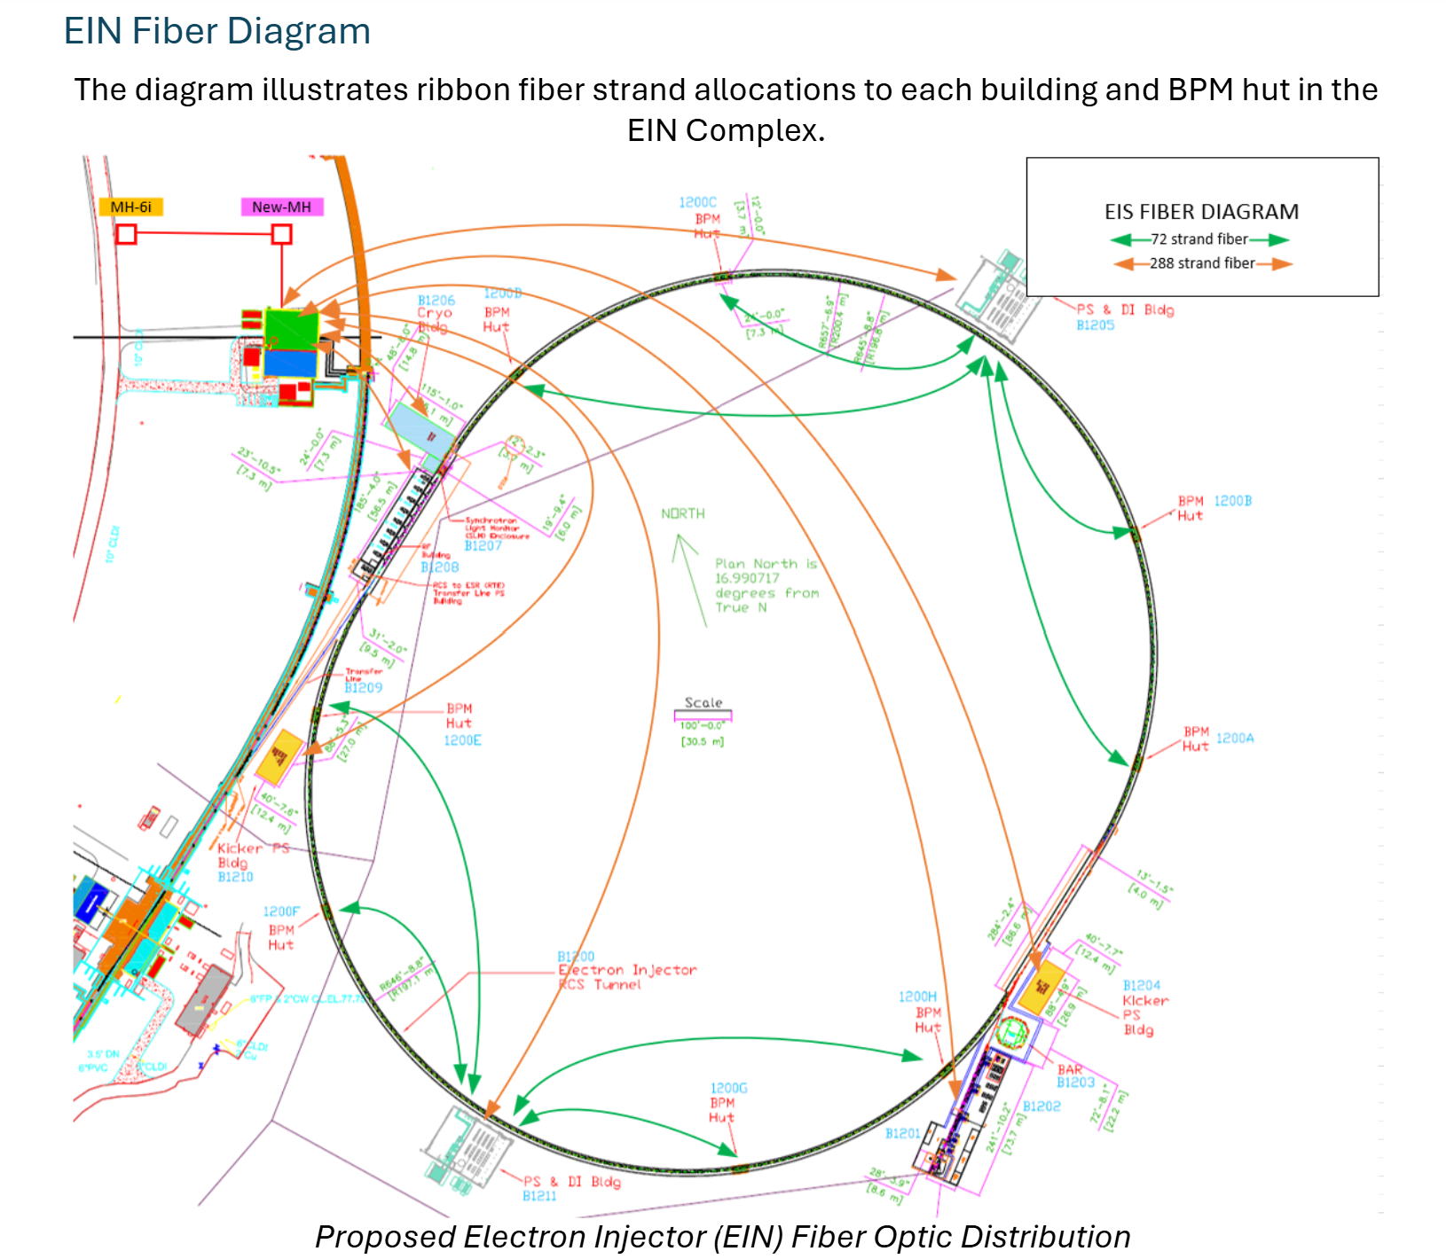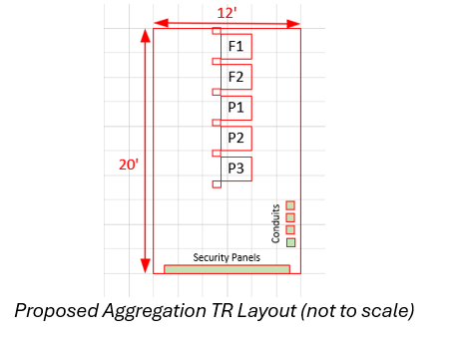

The A/E shall design B1205 and B1211 with an “aggregation” telecommunications room as shown above. The A/E shall design B1202, B1204, B1206, B1208 and B1210 with “edge” Telecommunications rooms as shown below:
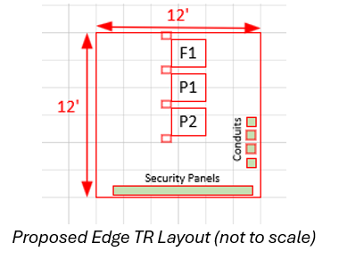

- Provide eight (8) Berm Top Enclosures for Beam Position Monitoring equipment located symmetrically around the RCS structure as shown above Section 4.3, Figure 2: Electron Injector Complex with LINAC and Rapid Cycling Synchrotron (EIN) Configuration.

Berm Top Enclosures 1200A, 1200B, 1200C, 1200D, 1200E, 1200F, 1200G, 1200H

  - (8) Berm Top Enclosures located directly above the RCS Structure
  - The A/E shall design each Berm Top Enclosure to incorporate Egress Stairs from the RCS structure below.
  - The Berm Top Enclosures shall contain Beam monitoring equipment, designed by others and not in this SOW.
  - Typical layout – 475 SF
  - Larger Layout at 1200E and 1200H – 1150 SF. Note: 1200E and 1200H incorporate Kicker Power Supplies.

The Berm Top Enclosures are small, prefabricated metal structures positioned above the RCS Tunnel Structure. They provide critical functions for access, ventilation, and infrastructure support to the RCS below. The A/E shall design eight Berm Top Enclosures evenly distributed along the curved sections of the RCS at 37.5-degree intervals. Egress access points shall be designed by the A/E to be located at these enclosures to ensure compliance with maximum travel distance requirements. Each enclosure houses beam monitoring equipment, designed by others.

The A/E firm shall provide sufficient design to ensure code compliance of the planned Berm-Top Enclosure layout, adequate site preparation, Berm-Top Enclosure foundations and structural performance, and fibers from the new power supply buildings to the respective Berm-Top Enclosures. The A/E firm shall design power and cooling systems according to the requirements for the Berm-Top Enclosures. The Enclosures will house the electronics to control the Beam, monitor performance during operation, and house communication equipment for Laboratory protection. Fire, and smoke protection systems, and security systems shall be designed by the A/E. Fiber Equipment racks and internal cabling within the Berm-Top Enclosures for the BPM and communication equipment will be designed and constructed by others and are not part of this SOW.

. The A/E shall optimize the final size(s) of the Berm Top Enclosures during the preliminary design stage. The A/E firm shall take into consideration economies of scale when sizing the Berm-Top Enclosures to provide a practical and cost-effective design. Each enclosure will be fully insulated and constructed with steel tube framing and floor joists. Each Enclosure shall be pre-wired with a 480V/208Y transformer and circuit breaker for 100 amp, 208Y/120VAC, service panel, LED interior/exterior lights and 20 amp rated receptacles. A 480 V circuit breaker shall be located in the Berm Top Enclosure. Service load shall be designed from a 480V circuit breaker fed from the closest building. Each Enclosure will have an integral packaged HVAC unit to provide a conditioned space for the BPM electronics.

- Site preparation, including restoration of RHIC access road extensions (capable of highway loads and reduced vibration at new RCS structure overpasses), new access and parking for the LINAC complex, the cryogenics building area loading areas for the RF Building mid-arc loading docks, clearing/grubbing and provisions for adequate drainage and storm water retention.
- Adequate RCS tunnel egress and tunnel access for experimental equipment installation and future modifications.
- Beamline Transport structure and existing RHIC tunnel modification for beamline transport connection.
- Demolition plan and sketches for existing facilities and infrastructure that require removal or relocation.
- An independent Kicker Power Supply building shall be placed on top of the existing RHIC berm near IR4 area, midway of extraction line.
- The design shall provide for two beam dump areas: one at the end of the LINAC to provide for the LINAC and the BAR beam loss and one near the entry to the Transfer line from the EIN into the RHIC tunnel.
- Delegated design must be submitted by the A/E to BSA for approval before design begins. "Delegated design" shall be reviewed by BSA and approved for specialized or proprietary systems where a subcontractor's specific expertise and means/methods are best leveraged.
For Delegated Design the A/E shall set the overall performance specifications for the contractor to assume responsibility for the detailed design and engineering of that specific component through their own licensed professionals. Delegated designs shall meet the applicable professional standard of care and be coordinated with the overall project design.
The following delegated designs will be considered for review and approval by BSA for use on the design of the EIN Complex project.
- Fire Suppression Systems
- Specialty Structural Elements:
  - Steel Connections
  - Precast Concrete
  - Metal Stairs and Handrails
  - Foundations and Shoring
- Pre-Fabricated buildings
4.4.4 60% Preliminary Engineering Design Services:
The primary purpose of Preliminary Design is to provide a clear segue to the Final Design stage in the project. Scope definition and cost estimations are important to the successful completion of the Preliminary Design Phase.
The construction range for the Injector Complex is shown in section 4.6.1 below. The A/E shall provide alternative design options to stay within this cost range.
The A/E shall begin the 60% Preliminary Design by participating in an Immersion Workshop. The intent of this meeting is to serve as a design kick-off to reaffirm the scope and provide a seamless transition from the Conceptual Design to 60% Preliminary Design.
The development of the design shall be made with the expectation of approximately five (5) construction packages. Early in Preliminary Design, the A/E shall conduct a construction sequencing meeting with BSA to determine the best way to split up the design documents. As the design progresses, this split shall be used to guide the preparation of the plans so that the eventual construction documents can be packaged in the most efficient manner.

The A/E shall provide design plans and specifications at the 60% Preliminary Design level of the preferred concept developed in the CDR, including all the engineering requirements defined above under sections 4.4.1 through 4.4.3 above (i.e. Civil, Structural, Electrical, Mechanical systems, and Life Safety, etc.). The 60% Preliminary Design level of detail must be sufficient to provide a cost estimate aligned with the BNL EIC Subproject Work Breakdown Structure (WBS) dictionary, detailing labor, materials and equipment costs formatted at the activity level (level 4) of the WBS. The A/E shall follow the Design Quality Control Plan (DQCP) as described and developed under 4.2.2 Quality Assurance Program.
4.4.4.1 Required Drawings
EIC Electron Injector Complex Preliminary Design Conventional Facilities Drawing List (60% Preliminary Design level of detail)
- Site Plan - Layout of preferred site plan for EIC Injector Complex buildings
- Preliminary Grading Plans - Composite of building locations considered on BNL Injector Complex site
- Site Utility Plans - Site plans indicating utility runs required to serve EIC Injector Complex, including all service connections. Plans should include
  - Potable Water plans
  - Fire Protection water supply including hydrant locations
  - Storm Sewer plans
  - Sanitary sewer plans
  - Electric Distribution plans
  - Communication routing plans
- Demolition Plans
- Utility relocation plans
- Foundation Plans - Preliminary foundation plan to indicate structural basis
- Floor Slab Plans - Preliminary floor slab plan to indicate methods to support equipment and prevent differential settlement
- Tunnel Plans, profiles and sections, including all anticipated penetrations and piping penetration types and sizes
- Structural Steel Plans - Preliminary plan for structural steel
- Structural Elevations - Preliminary elevation for structural steel, show sections in key areas, may be incorporated in architectural plans
- Floor Plan(s) - Proposed floor plan, may require multiple sheets
- Programming Plans - Color coded floor plan indicating programming & space allocations by category
- Architectural Elevation(s) - Elevations indicating building appearance, vertical and horizontal relationships, and sections
- Fire Protection Plans - Floor Plan indicating occupancy types, method of protection and egress routes
- Heating, Ventilation, and Air Conditioning (HVAC) Plans - General schematic layout of HVAC systems and method to achieve temperature stability in accelerator and experimental areas
- Process Piping Plans - General schematic layout of process piping systems to support lab, experimental and accelerator areas
- Building Support Piping Plans - General schematic layout of building support piping systems for sanitary, potable water, chilled water, steam and condensate
- Electrical Substation Plans - General arrangement of power substation and major electrical utilities
- Electrical Distributions - General schematic, layout, one-line diagram & riser diagrams of electrical distribution
- Lighting Plans - General layout of lighting methods to be used in each area
- Grounding Plans – General grounding plans and details in accordance to electrical code.
- Emergency Power Plans - General layout of emergency power source(s) and major connected equipment
- Communications/Data Plans - General layout of communications and data systems and equipment rooms including outside plant and service connections
- Security/Access Control Plan - General layout of location of devices used for security and access control
- Control Room Plan - General layout of control room equipment and systems (where required)

4.4.5 Preliminary Engineering Design 60% to 90%

Once the 60% Preliminary Design for the Electron Injector Complex is complete and comments reconciled, the A/E firm shall provide engineering services to complete the design of the Electron Injector Complex from the 60% Preliminary Design level to the 90% Preliminary Design level of detail. The goal is to have the design sufficiently complete at the end of the Preliminary Design stage so that Final Design efforts focus on detailed design. At the end of the Preliminary Design stage, a full and complete understanding of the facilities shall be well defined to allow proper attention to detailing during the Final Design Stage.

The 90% Preliminary Design level shall include all the engineering requirements defined above (i.e. Civil, Structural, Electrical, Mechanical systems, and Life Safety, etc.). All the required drawings identified in section 4.4.4 and prepared to the 60% Preliminary Design Level shall be further developed to the 90% level of detail, including specifications aligned with the intended construction.

The 90% Preliminary Design level of detail must be sufficient to provide a cost estimate aligning with the BNL Subproject Work Breakdown Structure (WBS) dictionary, detailing labor, materials, and equipment costs formatted at the activity level (level 4) of the WBS. The A/E shall follow the approved Design Quality Control Plan (DQCP) developed in conjunction with this SOW.

Final Detailed Design Requirements
- The A/E shall prepare contract drawings and technical specifications covering all aspects of the work for the construction, startup, and commissioning to normal operation of the EIC new conventional facilities. All necessary design elements shall be assembled into the construction contract documents and sufficiently detailed to solicit lump sum construction bids. Contract drawings shall illustrate the work and contract specifications shall define and detail equipment, materials, and methods of construction to be employed for the work.
Divide the project scope into separate construction packages as designated by BSA. Coordinate and identify interface points between construction packages.

- All delegated designs must be submitted by the A/E to BSA for approval before design begins.
- Design drawings shall include but not be limited to the following:

- Sitework includes clearing and grubbing, pavement demolition, grading, landscaping, storm water collection and rerouting, pavement, sidewalk and curbs, trenching, excavation and backfill. Provide separate site drawings for civil, mechanical and electrical work. Indicate space available for contractor mobilization, parking and material staging and lay-down.

- Structural work includes, but is not limited to, concrete footings, slabs and walls, structural steel columns and beams, and metal decking. Identify special construction required for tunnel work, new tunnel installation, radiological shielding, vibration reducing design or minimization of EMI/RFI. Show soil boring logs and design loads and factors on the structural drawings.

- Architectural work includes building plans, sections and details. Provide finish schedules, furniture and equipment layout and schedules, building directories and signage. Identify features required for Sustainable Design compliance.

- Mechanical work including ductwork, piping, valves, equipment arrangement plans and sections, flow diagrams and controls. Identify features required for beam tunnel, laser, and cathode room (and other spaces) requiring specialized environmental control, vibration reduction and /or sustainable design compliance.

- Building code compliance data to be shown on the drawing sheets to include square footage and useable area calculations, occupant load calculations, egress capacity chart, travel distances tabulation/chart, windstorm resistance, roof, and floor (live, snow, dead) loads, plumbing fixture calculations and any other relevant calculation performed in development of building code compliance. Travel distances, dead end distances, and common path of travel distances are to be shown on a building layout in addition to the summary tables.

- The controls and instrumentation for all equipment and systems shall be designed to seamlessly integrate into the Owner's existing PLC based system to create a complete, functional, and integrated plant DCS for the site.

- Electrical work including:
    - Overhead distribution lines, from the new EIC power line on Renaissance Circle, new 13.8kV switchgear to unit substations serving the new EIN facilities. Overhead lines include sectionalizing and distribution switches. Lines will have additional clearances when crossing roadways, allowing for mobile cranes to pass under. Sitework includes tree clearing, gravel road, excavation, conduits, manholes and associated hardware for overhead distribution work.
    - Unit Substations distributed around the EIN site at new facilities including buildings and load centers and cabling from a substation to the adjacent EIN facilities. Unit substations include: 15kV loop switches, a 15kV circuit breaker, 13.8kV to 480V transformers and 480V switchgear with breakers, concrete slab on grade, oil containment, fencing, grounding, and 480V feeders to building.
    - Motor control centers for mechanical pumps and cooling tower fans in buildings. Include feeders to mechanical loads. Also includes feeders from existing service buildings to select buildings with low power requirements.
    - UPS and Back-up Generator installation and related cabling and controls for Infrastructure life safety power requirements and select process equipment protection. Sitework includes site clearing, excavation, conduits, and manholes for generator installations.
    - Cable trays and tray supports to provide basic cable trays in EIC tunnel areas and new support buildings to meet projected future technical equipment cabling requirements provided by BSA.
    - Ground fault monitoring systems and remote control of major load circuit breakers shall be utilized for personnel protection where directed.
    - Fire alarm system including pull-stations, smoke detectors, PIV monitor switch, fire alarm control panel and connection to the sitewide alarm system. BNL utilizes a Simplex fire alarm control panel for compatibility with existing systems.
    - Communications including communication equipment closets, cabling, public address and telephone and data connections to the site distribution systems. Data shall utilize fiber-optic cable in concrete encased duct bank to connect the EIC to the site fiber-optic network. A fiber-optic backbone shall be provided in the building for key data intensive devices, however copper based (Cat 6e) systems may be used for standard workstations throughout the buildings.

- Coordinate the work between design disciplines to ensure that the design provides adequate space, tie in points, system, and structural capacity etc. for all existing and new utilities and services. A/E shall incorporate these utilities into the computer design model for design clarity. Indicate the intended location and routing for all major ducting, piping, conduit, and cabling. Identify and resolve interferences during design using the 3D modeling or digital twin capabilities of the BIM platform.
- Prepare an Electrical Arc Flash Compliance Report indicating how the electrical design meets the requirements of OSHA 29 CFR 1910, and NFPA 70E-2021. Using a circuit analysis software system approved by BSA, demonstrate that proposed equipment, cabling, and protective settings indicated in the design drawings and specifications meet the OSHA and NFPA criteria above. Each time-current curve shall include the associated “one-line diagram”. Revise the 60% preliminary review Arc Flash Compliance Report to update the 90% and 100% final detail design Ard Flash Compliance Report submittals. Include all electrical one-line drawings, calculations and equipment and cabling data to substantiate the report findings.
- Prepare and submit a detailed water balance diagram(s) and a detail thermal hydraulic analysis that show compliance with performance requirements for various operating conditions and necessary chillers. Provide the native input files for any analysis performed using commercially available software.
- Prepare and submit process flow diagrams (PFDs), intelligent piping and instrumentation diagrams (P&IDs) for all systems. The intelligent P&IDs shall be capable of generating outputs such as line lists, valve lists, equipment lists and other process and equipment parameters. The inputs for such intelligence would be from process flow data, instrumentation schematics, equipment data sheets, valve and instrumentation specification sheets, piping material specifications, etc. The P&IDs be incorporated into an AE provided plant 3D model. From Intelligent P&ID databases, plant operating, and maintenance (O&M) personnel must be able to retrieve attributes of equipment, operating points, material construction, valves, etc. The A/E shall complete all data entries for a contractor to build a fully operational system.
- Prepare and submit mechanical site plans, specifications, mechanical equipment arrangement drawings, piping and ductwork layout drawings, and piping and ductwork tie in points that will be generated via a 3D model.
- Prepare and submit a complete equipment list, specialty list, mechanical equipment and load schedule and calculations, valve and line schedules, system descriptions, sequence of operations, DCS I/O list, control narrative documents and control logic diagrams and DCS architecture drawings.
- Provide Room Data Sheets and interior design and coordination drawings for all accelerator and building services equipment proposed for installation, providing for interfacing, installation, service, and operating clearances. 3D models shall be utilized that will be able to import the CAD models (such as CREO) from EIC Accelerator Engineers for the accelerator and equipment to identify clearances, interfacing, and compatibility of installation.
- One (1) review submittal required at each design milestone during Detailed Design. Furnish One (1) full size and five (5) half size sets of specifications, drawings, cost estimate and construction schedule with each review submittal. An independent review of the 100% final detailed design and cost estimate will be conducted by a DOE review committee. Incorporate all comments as directed into the 100% final detailed design and prepare a report for the Critical Decision 3 review.
- A Value Engineering (VE) study of the A/E detailed design (based on 30% final detailed design completion) will be performed by the A/E, CMa, and an independent committee established by BSA and the A/E. The A/E shall provide all professional services to furnish a VE report to meet the intent and criteria set forth in Public Law 104-106 (Value Engineering) Section 4306 and OMB Circular A-131. In advance of the VE study, the A/E shall prepare members of the VE team, both BSA and A/E participants, by providing work aids and preparatory guidance with respect to the EIN project and the VE process. The A/E shall facilitate the meeting, document the discussions, and prepare an executive summary. Once the Evaluation and Development Phase breakout sessions of the VE study have begun, A/E Civil, Mechanical and Electrical lead members shall provide facilitation assistance, as well as technical guidance during the Evaluation and Development Phase of the VE study. The A/E is expected to incorporate the accepted recommendations from the VE study into the design cycle, including cost validation, as the design process progresses. The A/E shall facilitate the meeting, document the discussions, and prepare an executive summary. The CMa shall collaborate with the A/E to prepare a cost estimate for each accepted VE recommendation. The A/E shall collaborate with BSA on the disposition of the VE recommendations. VE Committee recommendations accepted by the BSA IDD are to be incorporated into the Final Detailed design by the A/E.
The A/E shall investigate design implications and incorporate the committee’s recommendations into the Final Detailed Design.

The A/E shall incorporate and record all informal VE suggestions into the Study up to and following the 90% Detailed Design phase.

- When comments on the 100% review have been addressed, furnish five (5) additional sets of drawings and specifications for BSA approval prior to printing the Construction Bid Issue. When final Construction Bid Issue is approved, the A/E shall furnish to BSA copies of all documents (drawings, specifications) on suitable electronic media for reproduction. The A/E shall prepare a final Conformed Set of Documents (Construction Documents modified to include any addenda issued during the bidding or negotiation process and accepted alternates) that will incorporate adjustments in the design and specifications needed to bring the project to budget when final FFP is received for construction.
- A Project Design Book that includes a compilation of drawings, specifications and other design documents that are generated during the design phase and updated during construction and start-up of the Project. The Architect/Engineer shall maintain the Project Design Book and shall update and revise the Project Design Book upon equipment selection and final design of the Facility.
    - The Architect/Engineer shall maintain a historical file of all revisions of the Project Design Book from the initial issue of the documents until the documents have been completed in a “RECORD DOCUMENT” condition. The Architect/Engineer shall provide the number of copies of the Project Design Book to the EIC Project Team at project closeout.

    - The specific organization of the Project Design Book shall be submitted to the EIC Project Team for acceptance within thirty (30) days of the Final Notice to Proceed. The Project Design Book shall have the following organization:
- Copies of all design specifications, criteria, and drawings with latest revision status by specification/drawing number
- Complete set of Room Data Sheets for all design spaces
- Copies of all design studies, calculations, and performance criteria for equipment.
- Copies of report of evaluations performed by 3rd party consultants
- Copies of Startup and Test procedures
- Copies of all materials lists, equipment lists, and other design schedules
- Copies of all safety data for the plant
- Electronic media for all documents that were developed using commercially available software.

- The A/E shall engage a Geotechnical firm to perform final soil testing and geotechnical analysis as needed and provide a Geotechnical report for the Electron Injector Complex. This investigation should include construction suitability (sieve analysis) in borrow areas for construction.
- The A/E shall update the digital terrain model to include final topographic survey.

- BSA will contract with a CMa to provide a constructability review of the design at various stages, provide a “bottoms-up” cost estimate and perform material and market surveys related to the construction bidding environment. The A/E shall develop estimates at the various milestone stages using nationally recognized methods and will be reconciled with the CMa and will be subject to review by an independent project review committee appointed by DOE. The estimate format shall be based on specification Division for easy reconciliation with BSA independent estimates. The A/E will support the CMa estimating efforts as required and provide necessary clarifications and additional information as requested.

  - The A/E shall incorporate comments and recommendations of the CMa as approved by the BSA IDD. The A/E shall participate in cost estimate reconciliation meetings to discern the basis for discrepancies between the CMa estimate, A/E estimates, and BSA independent estimates.

Final Detailed Design - Other Technical Design Requirements
The A/E firm’s cost proposal shall include a cost proposal to carry forward the design from the approved 90% Preliminary Design to Final Detailed Design in accordance with Section 4.5 Final Detailed Design Services.

Final detailed design shall include supplemental details including cross sections at 25-foot intervals for buildings, and 50-foot intervals for roads. Cross sections shall be prepared with the purpose of communicating the design intent to builders, contractors and stakeholders. Cross sections shall include tunnel construction details, wall construction details, roof construction details, stair construction, labyrinth and equipment access details, interior details, door details, footing and foundation details, drainage design details, utilities including tie-ins and roadway design details. Designs shall include niches for recessing electrical equipment to be loaded in the tunnel on the aisle/access side of the tunnel. The cross sections shall tie together the plans and specifications especially regarding structural components, topographic characteristics, material layering and special relationships. The cross sections shall define all elements and materials needed to properly construct the Electron Injector Complex facility. Cross sections are important to completing the design. They provide a detailed, vertical view of the infrastructure internal components, revealing how different parts of the infrastructure elements connect and relate to one another. There should be no ambiguity as to the A/E’s responsibility. Cut and fill calculations shall be consistent with the cross sections. Items of work and materials shown on the plans must correspond with the nomenclature from the specifications. In the event there are multiple specifications for similar work, there must be a clear linkage to the intended specification identified on the plans.
The plans and specifications must include the sequence of operations for the project in general. Specific sequence of operations shall identify how the A/E lays out the survey and identifies the corner points and spot elevations required to build the facility. The A/E shall provide the sequence of operation and details regarding the mechanical and electrical control systems and the commissioning requirements.
Final Design shall provide Storm water design and calculations in accordance with NYS Department of Environmental Conservation requirements. The A/E shall provide a complete State Pollutant Discharge Elimination System (SPDES) and Stormwater Pollution Prevention Plan SWPPP and assist BSA with the notification and coordination with NYSDEC. In addition, the A/E shall include the preparation of submittals for Suffolk County Dept of Health Services necessary for back flow assemblies and main water connections.
The A/E shall provide Final Detailed Design progress submittals and Cost Estimates at the following stages: 60% Final Detailed Design, 90% Final Detailed Design, Final Construction Bid Issue, and Conformed Set of Documents (Construction Documents modified to include any addenda issued during bidding or negotiation process and accepted alternates). Assume at least five (5) construction packages will be prepared and coordination shall be required among the A/E, BSA and the CMa to determine the division of scope of the construction packages. The A/E shall maintain continuity between the packages; detailing future work or work by others as needed to delineate scope within each package.
The start of 90% Final Detailed Design is dependent upon the quality of the 60% Detailed Design and is contingent upon BSA review and approval of the 60% Final Detailed Design as well as the Final Design Review (FDR) Report in association with the Final Design Review.. The A/E shall prepare the FDR Report with the goal of providing sufficient assessment of infrastructure design maturity to ensure all technical, safety and operational requirements are met before proceeding to construction. The Final Design Review (FDR) Report shall provide summaries detailing 1) appropriateness of proposed systems, 2) impacts on existing systems and operations, 3) specific technical requirements to be incorporated into the design and 4) compliance with best and required BNL practices and those authorities having jurisdiction in the area of fire protection, building code, environment, safety, and health. The A/E shall prepare an itemized list of gaps in the design documents and the proposed pathway to successfully complete the 100% Detailed Design Submittal.

The functional and performance requirements for the RCS tunnel interior environment will be formally communicated to the A/E by BNL through a Utilities Requirements Document (URD), Record of Decision (ROD), or equivalent controlled project document. These documents shall establish the governing environmental design criteria for the A/E to complete the HVAC design outlined in Preliminary Design, section 4.4.3 Preliminary Design Services – Other Technical Design Requirements.

The RFPA and Injection LINAC Buildings will serve as the largest and most critical buildings for the EIN and will house the major RF equipment, pre-injector LINAC, the new accelerator - Rapid Cycling Synchrotron (RCS ) beamlines, laser and cathode facilities and provide a means for RF power transmission to the tunnel via waveguide. Full design integration is needed to provide for all support functions for these buildings. Potential for radiation exposure to the accelerator and its components will require provisions for shielding the accelerator from occupied areas.

Building design shall be based on the maximum probable loads to which the structure will be subjected and shall not be less than the loads specified by the NYS building code. Building design shall accommodate auxiliary loads from overhead cranes for the buildings that are equipped with material handling systems.
Buildings’ design shall incorporate life safety requirements specified by the NYS building code and in the NFPA101 “Life Safety Code”. Buildings designed for normal occupancy shall be designed with air conditioning systems for comfort cooling for the conditioned space (i.e., break rooms and control rooms). All other buildings and areas shall be designed with thermal controls and equipment for the applicable accelerator systems or laboratory environment. The successful firm shall provide a cost analysis of utilizing a different building type as there may be promising alternatives, i.e., pre-engineered steel, concrete masonry unit (CMU), or concrete construction.
Although the building design will generally involve standard commercial design and construction techniques, there are some additional considerations due to the specific requirements of the integration required with the existing accelerator facility. Unique types of equipment will be installed and operated in these buildings. For example, RF power equipment, lasers, cryogenics, large quantities of magnets and power supplies, and vacuum chambers required to perform at an ultra-high vacuum are all planned for installation in these spaces. The installation of RF power amplifiers, DC current power supplies, and electronics require sufficient head room, long clear spans, and provisions for heating, cooling, and humidity controls. Design is required to account for these applications. Building’s housing RF Power Amplifiers, for example, will require long interior clear spans to enable routing of transmitter waveguide assemblies through the building. Experienced BSA engineers will be available to provide guidance and parameters. The EIC Conceptual Design Report, Engineering Basis of Design and Conceptual design drawings set are provided for reference.
In addition to buildings and structure design, the successful A/E will be required to design:
        - Power and distribution facilities. Power distribution includes expansion of the existing 13.8 kV distribution system, design of the substations, switchgear and ductbanks for each building and design of motor control centers and switchgear for EIC and building loads.
        - Chilled water, closed loop cooling water systems and cooling tower systems to the accelerator support systems (process cooling) throughout the EIC facility including:
a. Closed loop deionized cooling water systems that include equipment such as water treatment systems, pumps, piping and heat exchangers for process cooling needs. These systems are cooled by the cooling tower systems.
b. Cooling tower water systems including equipment such as evaporative cooling towers, pumps, piping and associated water treatment for rejecting heat from the closed loop cooling water systems.
c. Provide alternative analysis to minimize capital, maintenance and operating cost of the cooling systems costs while maintaining reliability. All evaporative water system designs shall take into consideration BSA standards and guidelines, and state and local permits and regulations for protection and control against legionella while minimizing water consumption, chemical usage, corrosion, and biological growth potential.
4. Compressed air systems for instrumentation and cooling for RF Amplifiers.
5. Potable and fire service plumbing, sanitary and storm drain systems and their connections to existing site services.
6. Data and communication systems design for each building.
7. Site preparation requirements including access road extensions and clearing/grubbing.
8. Tunnel access ports for piping, cable, and wire.
Special consideration shall be given to the integrity of the existing buried arch-plate tunnel structure at IR 4 to eliminate instability by asymmetric unloading and loading of the tunnel during excavation and reburial and penetrations. In addition, the A/E shall provide designs and construction notes required to protect the equipment installed in the tunnel in the IR4 area under the ASR subproject. Consideration shall also be made in some of the building designs to minimize sources of vibration and transmission of vibration that would impact beam stability in certain accelerator and beamline areas and laser spaces. There will also be specific air cleanliness, temperature and humidity stability requirements in the accelerator, laser, cathode production, and other laboratory spaces that will require HVAC system and control design that exceeds standard commercial practices. Building and tunnel designs and orientation shall be such that future expansion or extension will cause minimal disruption; designs shall be readily extensible using standard techniques (i.e., modularity). Provisions for future extensions shall be shown clearly on design documents.
The EIC will be connected to BNL’s medium voltage power distribution system, sanitary system, potable water system, fiber telecommunication and data system constructed in the ASR Subproject, sitewide fire alarm and suppression systems, wastewater treatment plant and storm drainage system.
The entire EIC location is already served by BNL’s existing underground utility systems provided for the recently decommissioned RHIC operations. Utility maps are available for these services along with the new facilities constructed under other subprojects. Where tie-ins or capacities are critical, the successful firm will be responsible for due-diligence field verification.
The EIC Project shall utilize a Construction Manager Advisor (CMa)and a Commissioning Agent (Cx) to assist with the project development. The A/E shall coordinate efforts with the CMa to promote the partnership and collaborative working environment established between the A/E, CMa, Cx and Brookhaven Science Associates (BSA). The expectation is that all parties shall collaborate and cooperate as required to achieve a successful outcome. The responsibilities of the CMa will have three major phases of work. Phase 1 shall be pre-construction support services which will be aligned to the A/E’s Preliminary and Final Design phases.

Project Budget

Target Construction Budget
The targeted construction contract price for the purposes of design shall be $271M direct construction costs in February 2026 dollars. Based upon the Conceptual Design Report, it is estimated that the required square footage of facilities will be approximately 192,000 gross square feet.

Alternates: The A/E shall include 8 to 12 additive/deduct alternates of varying size to support incremental Construction Bid Options ranging from 90% to 109% of the targeted construction contract price. BSA and the A/E will work collaboratively to identify the specific add/deduct alternates.

Economic Balance: The elements of the design shall attain economic balance, commensurate with available funds and design objectives, between initial construction costs, building permanence, and operational maintenance costs.
The A/E shall provide a project cost management program for BSA approval that identifies the steps that will be taken during the execution of this contract to ensure that project cost and scope are within available budget. Elements of this program shall include at a minimum:
- Monthly reporting on the status of approved scope and estimated construction costs for the scope as part of a monthly design progress report to be provided to BSA.
- Designated staff or resources to provide estimating expertise on a real-time basis to rapidly assess cost impacts of potential design or scope change decisions. Estimates to be provided with and at each 60%, 90% Design and Final Design Report/Review submittal.
- Identification and execution of value engineering reviews utilizing independent experts trained in value engineering methods. Reviews shall be conducted during the Preliminary Design and Final Design phases to provide recommendations for design to cost decisions versus the functional requirements.

Schedule Requirements
The Preliminary and Final Designs must be completed in accordance with the schedule milestones indicated in Section 5.0. Construction schedule shall conform with the current BSA approved EIN Subproject schedule.
Milestones indicated in Section 5.0 Schedule Milestones form the basis for contract schedule performance. These milestones must be met to support key approvals, budget submissions, and technical objectives of the project.
A monthly design status report will be required indicating design cost expended to the end of the month and percent completion of each design task at the end of the month. Monthly reports will be used by BSA to fulfill DOE reporting requirements.

SCHEDULE MILESTONES
NOTE: These will be updated as timeline is clarified.
The following key milestones are presented to enable the A/E to properly staff the project in order to meet project schedule requirements:

Preliminary Engineering Design Schedule Milestones (through 60% Preliminary Engineering Design)

The A/E shall provide engineering services to complete the preferred design of the Electron Injector Complex as conceptualized to the 60% Preliminary Design level.

ID | Milestone Task Description | Milestone Date
1 | Conduct 1st Immersion Workshops with Project Stakeholders | NTP(1)* + 2 weeks
2 | Preliminary Investigation of Existing Conditions | NTP(1)* + 4 weeks
3 | Conduct 2nd Immersion Workshops for connection of Injector to existing RHIC tunnel | NTP(1)* + 6 weeks
4 | Conduct Value Engineering (VE) Study | NTP(1)* + 8 weeks
5 | 60% Preliminary Design Submittal & Cost Estimate | NTP(1)* + 10 weeks
6 | BSA 60% Preliminary Design & Cost Estimate Review comments to A/E | NTP(1)* + 12 weeks
7 | 60% Preliminary Design Reconciliation Meeting | NTP(1)* + 13 weeks

5.2 Preliminary Engineering Design Schedule Milestones (60% Preliminary Engineering Design through Final Detailed Design

ID | Milestone Task Description | Milestone Date
8 | 3rd Immersion Workshops Kick-off meeting for 90% Preliminary Design (see note 3 below) | NTP(1)* + 13 weeks
9 | 90% Preliminary Design Submittal & Cost Estimate | NTP(1)* + 20 weeks
10 | BSA 90% Preliminary Design & Cost Estimate Review comments to A/E | NTP(1)* + 22 weeks
11 | Final Preliminary Design Report reconciliation meeting | NTP(1)* + 23 weeks
12 | Final Preliminary Design Report (PDR) submittal | NTP(1)* + 25 weeks
13 | BSA PDR & Cost Estimate Review Comments to A/E | NTP(1)* + 27 weeks
14 | Final (Reconciled) Preliminary Design Report & Cost Estimate submittal | NTP(1)* + 29 weeks
15 | BSA- PDR Approval, NTP(2) start | NTP(1)* + 33 weeks
16 | 4th Immersion Workshops Kick-off meeting for Final Detailed Design | NTP(2)**+ 2 weeks
17 | 60% Detailed Design Submittal & Cost Estimate | NTP(2)** + 12 weeks
18 | BSA 60% Detailed Design & Cost Estimate Review comments to A/E | NTP(2)** + 14 weeks
19 | Reconciliation Meeting 60% Detailed Design | NTP(2)** + 16 weeks
20 | BSA Approval of 60% Detailed Design | NTP(2)** + 18 weeks
21 | Issue Final Design Review (FDR) Report | NTP(2)** + 20 weeks
22 | Conduct Value Engineering (VE) Study | NTP(2)** + 26 weeks
23 | 90% Detailed Design Submittal & Cost Estimate | NTP(2)** + 28 weeks
24 | BSA 90% Detailed Design & Cost Estimate comments to A/E | NTP(2)** + 30 weeks
25 | Reconciliation Meeting 90% Detailed Design | NTP(2)** + 32 weeks
26 | 100% Detailed Design Submittal | NTP(2)** + 36 weeks
27 | BSA 100% Detailed Design & Cost Estimate comments to  A/E | NTP(2)** + 38 weeks
28 | Final 100% Detailed Design & Cost Estimate submittal | NTP(2)** + 40 weeks
29 | Final Construction Packages Bid Issue and Cost Estimates | NTP(2)** + 42 weeks
30 | Conformed Set of Documents (Construction Documents modified to include any addenda issued during bidding or negotiation process and accepted alternates)** | NTP(3)*** + 6 weeks
*NTP(1) Notice to proceed with Preliminary Design of the preferred concept
**NTP(2) Notice to proceed with Final Detailed Design
***NTP(3) Notice to Proceed with preparation of Conformed Set of Documents; Dependent upon project construction package procurement schedule.
**Conformed Set of Documents shall contain sufficient level of detail for open competitive bidding by contractors. All design details must be explicitly included in these documents.
Note: Milestone 7 from section 5.1 and Milestone 8 section 5.2 above are intended to be concurrent.

PROJECT ADMINISTRATION

General
The purpose of this section is to outline specific requirements for the project coordination process and for interaction between BSA and the Architect/Engineer (A/E). The A/E shall submit monthly progress reports of sufficient detail to track design and engineering progress to date.

Project Team Directory
Brookhaven Science Associates (BSA)/ Electron-Ion Collider (EIC):

- BSA/EIC Project Director (PD)
- BSA/EIC Project Manager (PM)
- BSA/EIC Infrastructure Division Director (IDD)
- BSA/EIC Contract Administrator
- Quality Assurance Manager
- ES&H Manager
- Architect/Engineer (A/E) EIN Infrastructure Preliminary & Detailed Design
- A/E Project Executive
    - A/E Project Manager
    - A/E Project Engineer
Note: It is expected that the A/E design team, including Sr. Architects and Engineers will remain constant for the duration of the design. Any substitutions shall be submitted in advance to BSA/EIC for approval.
Other noted Project participants provided by BSA:
- Construction Manager/Advisor (CMa)
- Base EIC Project Infrastructure Designer of Record: Architect /Engineer (A/E)
- Base EIN Infrastructure Conceptual Design A/E of record
- Commissioning (Cx) Agent

Coordination and Communication

Primary A/E Contact
For contractual issues, the primary A/E contact will be the BSA/EIC Contract Administrator and for technical issues, the primary contact is BSA/EIC IDD.

Coordination
The A/E shall coordinate design and technical issues with the BSA/EIC IDD and the designated CMa and Cx representatives. All decisions shall be documented by the A/E and copied to the BSA/IDD.
All work performed by the A/E firm and sub-contractors, including field work must be coordinated and supervised with an appropriate managerial level, by the A/E firm.
The A/E design team members may communicate directly with corresponding BSA/EIC & CMa design team members concerning coordination of efforts, systems selection, coordination of information on drawings and specifications, and other design and technical issues. All decisions shall be made by the EIC IDD and documented by the A/E and copied to the BSA IDD.

Meetings
At the beginning of the Preliminary Design Phase, the A/E team and any consultants shall visit the project site to become familiar with existing site conditions and building systems.

The A/E team shall be responsible for participating in regular meetings at BNL throughout each phase of the project for the purpose of project design reviews and project progress and presentation meetings. Meetings shall be scheduled at agreed-upon locations as required in this document.

If not noted, meetings shall be as follows:
- Preliminary and Final Detailed Design Progress: Every two weeks.

In addition, the schedule shall specifically identify the following required meetings:
- Project Kick-Off Meeting – Conceptual Design / Program Validation.
- Concept Floor Plan / MEP Design Review – two (2) meetings.
- A/E & CMa Kick-Off Meeting – Project Overview.
- Design Review Meetings at 60% and 90% Preliminary Design and 60% and 90% Detailed Design submittals.
- Budget Reconciliation Meetings for Preliminary and Detailed Design submittals and for each Value Engineering study.
All meetings shall be documented by the A/E and minutes distributed to the BSA IDD within 48 hours of a meeting.
Meeting minutes shall clearly describe key items discussed and identify action items with responsible parties. A record of outstanding action items shall be maintained in the meeting minutes and updated with each meeting.
The A/E shall maintain a log of completed action items as a record of decisions made.

Telephone Communication
The A/E shall document in writing to the BSA IDD all telephone conversations that result in interpretation, changes, additions, or deletions, to the program and/or design criteria requirements.

Transmittals
All correspondence and submittals shall be electronically routed through the BSA IDD and shall be accompanied by a written and dated transmittal that describes the information submitted and action required. Each transmittal shall include BSA subcontract and job numbers.

Information Provided by BSA
Documents provided by BSA at the beginning of the project:
- (*) BSA Standard General Conditions and Supplementary Conditions
- (*) BSA Installation Standards (where available)
- (*) Existing As-Built Drawings (where available)
- (*) Existing Site, Survey and Topography Maps
- (*) Existing Fire Water Flow Information
- (*) Existing Arc Flash Diagrams and Calculations
(*) = Shall be provided during the design on an "as needed" basis.

Reviews and Approvals

Internal BSA Design Reviews
Internal BSA Design Reviews are performed by:
- BSA EIC Project Team
- BSA User Representatives
- BSA Subject Matter Experts
- BSA Project Manager
- BSA Fire Protection Engineers
- BSA Environment, Safety and Health Team Members
- BSA Facility Operations Staff
- BSA/EIC Quality Assurance
- BSA/EIC Procurement
- CMa Staff

External Design Reviews
External Design Reviews are performed by:
- DOE Independent Project Review (IPR)
- Independent Reviews by other National Laboratories
Design Review Procedures
For each review listed in the design review schedule (60% and 90%), the A/E team shall spend one full day at BNL to make presentations of the design to the internal review team members, and another full day at BNL to meet and discuss review comments after the review is complete. The BSA IDD shall return written comments and/or marked-up set to the A/E. Each new submittal shall incorporate the comments from previous reviews unless otherwise agreed and documented between the A/E and BSA IDD. All comments shall be responded to by the A/E with specific specification sections or drawings revision to document the resolution of the comments. The A/E shall maintain a log summarizing comment dispositions.
Submitted plans and specifications that are incomplete, incorrect, or uncoordinated are not acceptable, nor are comment responses without specific references to their associated specification sections or drawings. They shall be returned to the A/E with a request for compliance with these requirements before the review is resumed by BSA.

PROJECT DELIVERABLES

Quality Assurance Plan
The A/E shall submit a quality assurance (QA) plan to BSA for approval. The QA plan shall meet the "Contractor Requirements Document” as defined in the DOE Order 414.1E, Quality Assurance.

Preliminary Design Phase
The design drawings and specification review submittals are required at 60%, 90% and 100% completion. The A/E shall submit the following to BSA for each review submittal during the preliminary design phase.
- One (1) bound full-size sets of drawing prints and specifications.
- Three (3) half-size sets of drawing prints.
- Two (2) bound copies of the preliminary design report and basis of design, calculations, and Design Data Handbook.
- Electronic transmission of all items mentioned above (in both PDF and native formats).
- Original files electronically transferred via file sharing protocol.
BNL title box shall be used on all drawings in addition to the A/E title box.
Prior to the Preliminary Design phase, 60% review, the A/E shall evaluate HPSB compliance and complete the HPSB DOE checklist. A/E to provide an alternatives analysis to indicate the cost and/or operational trade-offs associated with each item where appropriate.

Final Design Phase
The design drawings and specification review submittals are required at 60%, 90% and 100% completion. The A/E shall submit the following to the BSA IDD for each submittal during the final design phase.
- One (1) bound full-size sets of drawing prints and specifications.
- Three (3) half-size sets of drawing prints.
- Two (2) bound copies of the preliminary design report and basis of design, calculations, and Design Data Handbook.
- Electronic transmission of all items mentioned above (in both PDF and native formats).
- Original files electronically transferred via file sharing protocol.
When comments on the 100% submittal review have been addressed, the A/E shall furnish three (3) additional sets of drawings and specifications for BSA approval prior to printing the Construction Documents and Record Drawings.
When the Construction Documents are approved, the A/E shall furnish to BSA:
- Three (3) sets of drawings.
- Three (3) loose set of specifications.
- Three (3) bound sets of specifications.
- Electronic transmission of all items mentioned above (in both PDF and native formats).
- Original files electronically transferred via file sharing protocol.

Electronic Submittals
All drawing files shall be submitted via secure electronic file transfer. for each submittal phase. Provide an index of electronic file drawings for each file submitted. Unused layers and blocks shall be purged from CAD drawing files. Electronic CAD drawings shall be identical to the required hardcopy submittals while adhering to the BNL CAD Standards.
The Construction Documents and Record Drawings shall be submitted in PDF format, native electronic format compatible with Creo, and the latest AutoCAD 2D format (.DWG) with x-refs bound to drawing file. The A/E shall submit plot files and a narrative detailing the layering and logic behind the drawing structure and organization. The specifications and supporting documents shall be submitted in MS Word or Adobe .pdf format.

VALUE ENGINEERING
The A/E is encouraged to make recommendations for changes that might lead to an improvement in performance, reliability, quality, safety, or reduction in cost. Simplicity in design and improvement in the performance and reliability beyond the requirements of this specification are objectives which shall be considered in the design work. Where it appears a substantial improvement in simplicity of design, performance, reliability will result from the use of materials, parts and processes other than those specified, it is desirable that their use be investigated. When investigations point to advantages that may be realized, the recommendation for change shall be presented to BSA for review.

